

Probing Neuro-Glial Interactions via Over-Exteremities stimulation and hybrid fNIRS/EEG neuroimaging

Adam Emile Aske

ACIT4300 – Masters Project

XX.XX.XXXX

Supervisors

Peyman

Ali

Haroon

**Contents**

1. Introduction 4

2. Background 4

3. Methods 4

4. Conclusion 4

5. References 4

**Figures**

Figure 1 AI Generated Brain Art. 2

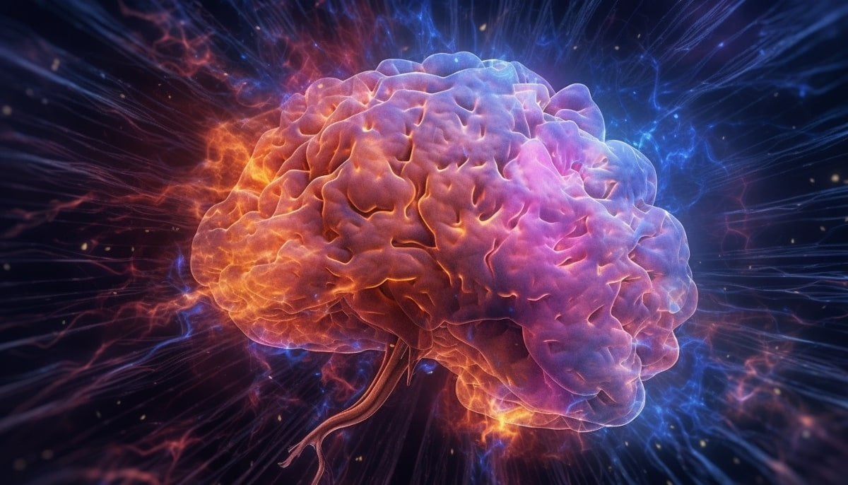

Figure 1 AI Generated Brain Art.

# Introduction

# Background

# Methods

# Conclusion

# References

1. (Sedrak, 2020)
2. (Khan et al., 2021)
3. (Khan H, 2023)
4. (Si Chen, 2023)
5. (Kassab, 2018)
6. (Patel, 2019)
7. (Bourguignon et al., 2022)
8. (Teo et al., 2023)
9. (Mathis Fleury, 2023)
10. (Zhou, 2023)

Bourguignon, N. J., Bue, S. L., Guerrero-Mosquera, C., & Borragán, G. (2022). Bimodal EEG-fNIRS in Neuroergonomics. Current Evidence and Prospects for Future Research [Review]. *Frontiers in Neuroergonomics*, *3*. <https://doi.org/10.3389/fnrgo.2022.934234>

Kassab, A., Le Lan, J., Tremblay, J., Vannasing, P., Dehbozorgi, M., Pouliot, P., Gallagher, A., Lesage, F., Sawan, M., & Nguyen, D. K. . (2018). Multichannel wearable fNIRS-EEG system for long-term clinical monitoring. *Human Brain Mapping*, *39*(1), 7-23. <https://doi.org/10.1002/hbm.23849>

Khan, H., Naseer, N., Yazidi, A., Eide, P. K., Hassan, H. W., & Mirtaheri, P. (2021). Analysis of Human Gait Using Hybrid EEG-fNIRS-Based BCI System: A Review [Review]. *Frontiers in Human Neuroscience*, *14*. <https://doi.org/10.3389/fnhum.2020.613254>

Khan H, P.-O. M., Mirtaheri P. (2023). Brain Connectivity Analysis in Distinct Footwear Conditions during Infinity Walk Using fNIRS. *Sensors*, *23*(9). <https://doi.org/10.3390/s23094422>

Mathis Fleury, P. F., Athanasios Vourvopoulos, Anatole Lécuyer. (2023). Two is better ? Combining EEG and fMRI for BCI and Neurofeedback : A systematic review. <https://inria.hal.science/hal-04038069> ( hal-04038069)

Patel, D. T., Bhanu & Chaunsali, Lata & Sontheimer, Harald. (2019). Neuron–glia interactions in the pathophysiology of epilepsy. *Nature Reviews Neuroscience*, *20*(1). <https://doi.org/10.1038/s41583-019-0126-4>

Sedrak, M., Alaminos-Bouza, A. L., & Srivastava, S. (2020). Coordinate Systems for Navigating Stereotactic Space: How Not to Get Lost. *Cureus*. <https://doi.org/https://doi.org/10.7759/cureus.8578>

Si Chen, K. L., Xiaoqi Qiao, Weimin Ru, Lin Xu. (2023). Tactile perception of fractal surfaces: An EEG-fNIRS study. *Tribology International*, *180*. <https://doi.org/10.1016/j.triboint.2023.108266>.

Teo, W.-P., Tan, C. X., Goodwill, A. M., Mohammad, S., Ang, Y.-X., & Latella, C. (2023). Brain activation associated with low- and high-intensity concentric versus eccentric isokinetic contractions of the biceps brachii: An fNIRS study. *Scandinavian Journal of Medicine & Science in Sports*. <https://doi.org/https://doi.org/10.1111/sms.14499>

Zhou, X., Li, Y., Tian, Y. et al. (2023). Friction and neuroimaging of active and passive tactile touch. *Sci Rep*, *13*. <https://doi.org/10.1038/s41598-023-40326-y>