1. 4c = L, 6f = o, 76 = v, 65 = e, 20 = “space”, 6e = n, 65 = e, 76 = v, 65 = e, 72 = r, 20 = “space”, 66 = f, 61 = a, 69 = i, 6c = l, 73 = s, 21 = !

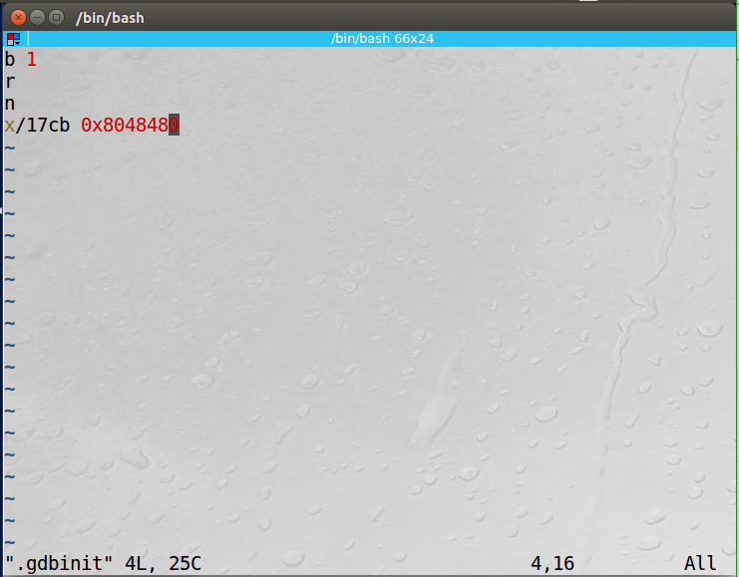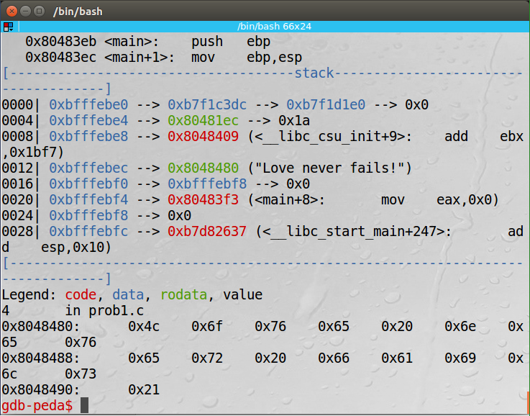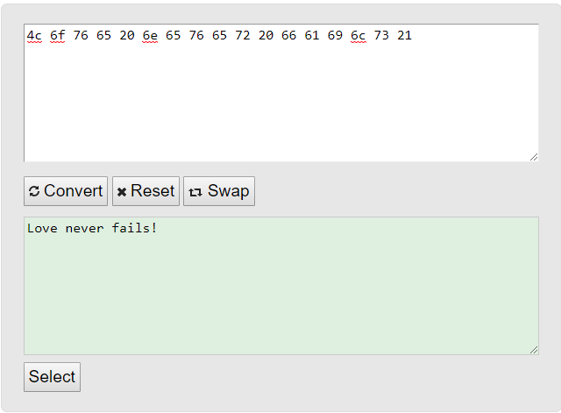

1. I could not get a script to search in one second to find the secret number, but my script should find the if it didn’t change. I tried a few search algorithms but I couldn’t get them to work. The shell script I’m turning in is a binary search that divides the pool of values in two and searching the checking the middle value. Then if the secret value is larger or smaller it will calculate the new middle point and search from there.

