SCASI: Wheat

Table of Contents

Load the working packages 1

Load the data 1

Overview of the data 2

Extract data per crops 2

Descriptive statistics 2

Yield accorss treatments 2

Yield accorss locations 3

Yield accorss locations and treatments 4

Factorial analysis 8

Posthoc test 8

Best treatment per location 10

For every woreda, what are the 3 best treatment? 10

## Load the working packages

library(AgroR)  
library(tidyverse)  
library(agricolae)  
library(lme4)  
library(emmeans)  
library(reshape)  
library(reshape2)  
library(car)

## Load the data

setwd("~/Code/R/SCASI")  
library(tidyverse)  
library(skimr)  
  
df <- readxl::read_excel("./input/SCASI_Field_Trials_Data_2022ALL_20230409_Adama_v2.xlsx",sheet = "MergePart2Part1")  
# First rows  
#knitr::kable(head(df))  
  
# Convert to factor  
df$Rep <- as.factor(df$Rep)  
df$Treatment <- as.factor(df$Treatment)  
df$Woreda <- as.factor(df$Woreda)

## Overview of the data

Number of observations and variables:

## [1] 709 153

## Extract data per crops

# Wheat  
wheat <- df %>% filter(Plot_crop=="Wheat")

## Descriptive statistics

### Yield accorss treatments

yield_trt_summary<- wheat %>% group_by(Treatment) %>% summarize(across(.cols = c(GY_kg_ha,SY_kg_ha),list(min=min,max=max,mean=mean,sd=sd),na.rm=T,.names = "{.fn}_{.col}"))  
knitr::kable(yield_trt_summary)

|  |  |  |  |  |  |  |  |  |
| --- | --- | --- | --- | --- | --- | --- | --- | --- |
| Treatment | min_GY_kg_ha | max_GY_kg_ha | mean_GY_kg_ha | sd_GY_kg_ha | min_SY_kg_ha | max_SY_kg_ha | mean_SY_kg_ha | sd_SY_kg_ha |
| 1 | 216 | 3300 | 931.32 | 642.21 | 100 | 3280 | 1649.4 | 830.54 |
| 2 | 352 | 4800 | 1108.5 | 831.25 | 400 | 7200 | 2105.6 | 1322 |
| 3 | 390 | 5200 | 2159.2 | 1113.9 | 500 | 11033 | 4151.3 | 2292.4 |
| 4 | 300 | 4500 | 2019.2 | 1037.8 | 500 | 11893 | 3839.6 | 2108.1 |
| 5 | 380 | 4920 | 1933.3 | 1080.5 | 500 | 9666.7 | 3623.9 | 1952.6 |
| 6 | 58.416 | 4700 | 1396.4 | 893.81 | 186.14 | 5700 | 2571.4 | 1398 |
| 7 | 320 | 5000 | 1495.4 | 1067.5 | 400 | 6000 | 2658.7 | 1523.9 |
| 8 | 420 | 4235 | 1842.3 | 982.31 | 1000 | 6500 | 3338.1 | 1596.6 |

#yield_trt_summary  
#with(wheat, desc(Treatment, GrainYield, ylab = "Grain Yield ", xlab = "Treatment", ylim = NA))  
  
#boxplot  
wheat %>% select(GY_kg_ha, SY_kg_ha, Treatment) %>% gather(key = "Yields",value= "Value", -Treatment) %>%   
ggplot(aes(x=Treatment,y=Value, fill=Yields)) +  
 geom_boxplot() +  
 scale_fill_manual(values = c("GY_kg_ha" = "#dfc27d", "SY_kg_ha" = "#80cdc1"), labels=c("Grain", "Stover")) +  
 labs(y="Yield (Kg/ha)")+  
 theme_bw()+  
 theme(legend.title = element_text(size = 18),  
 legend.text = element_text(size = 16),  
 axis.title = element_text(size = 24),  
 axis.text = element_text(size = 20))

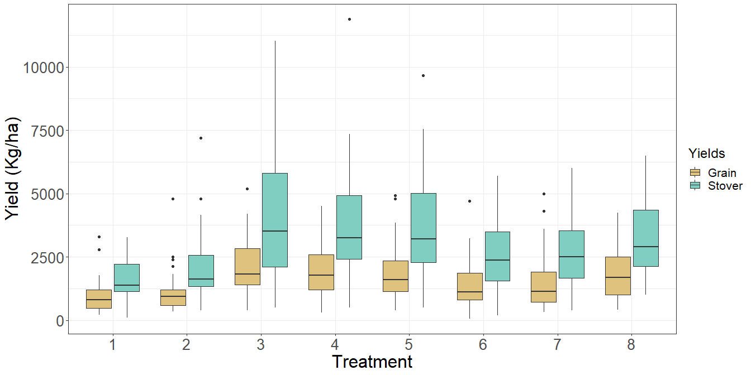

### Yield accorss locations

yield_location<- wheat %>% group_by(Woreda) %>% summarize(across(.cols = c(GY_kg_ha,SY_kg_ha),list(min=min,max=max,mean=mean,sd=sd),na.rm=T,.names = "{.fn}_{.col}"))  
knitr::kable(yield_location)

|  |  |  |  |  |  |  |  |  |
| --- | --- | --- | --- | --- | --- | --- | --- | --- |
| Woreda | min_GY_kg_ha | max_GY_kg_ha | mean_GY_kg_ha | sd_GY_kg_ha | min_SY_kg_ha | max_SY_kg_ha | mean_SY_kg_ha | sd_SY_kg_ha |
| Bibugn | 300 | 5000 | 1848.3 | 1113.9 | 100 | 5000 | 1680.9 | 997.82 |
| Bure Zuria | 58.416 | 3350 | 1326.3 | 786.23 | 186.14 | 7550 | 3219.8 | 1667.6 |
| Leka Dulecha | 216 | 5200 | 1801.5 | 1206.5 | 712 | 11893 | 4036 | 2043.4 |

#yield_trt_summary  
#with(wheat, desc(Treatment, GrainYield, ylab = "Grain Yield ", xlab = "Treatment", ylim = NA))  
  
#boxplot  
wheat %>% select(GY_kg_ha, SY_kg_ha, Woreda) %>% gather(key = "Yields",value= "Value", -Woreda) %>%   
ggplot(aes(x=Woreda,y=Value, fill=Yields)) +  
 geom_boxplot() +  
 scale_fill_manual(values = c("GY_kg_ha" = "#d01c8b", "SY_kg_ha" = "#4dac26"), labels=c("Grain", "Stover")) +  
 labs(y="Yield (Kg/ha)")+  
 theme_bw()+  
 theme(legend.title = element_text(size = 18),  
 legend.text = element_text(size = 16),  
 axis.title = element_text(size = 24),  
 axis.text = element_text(size = 20))

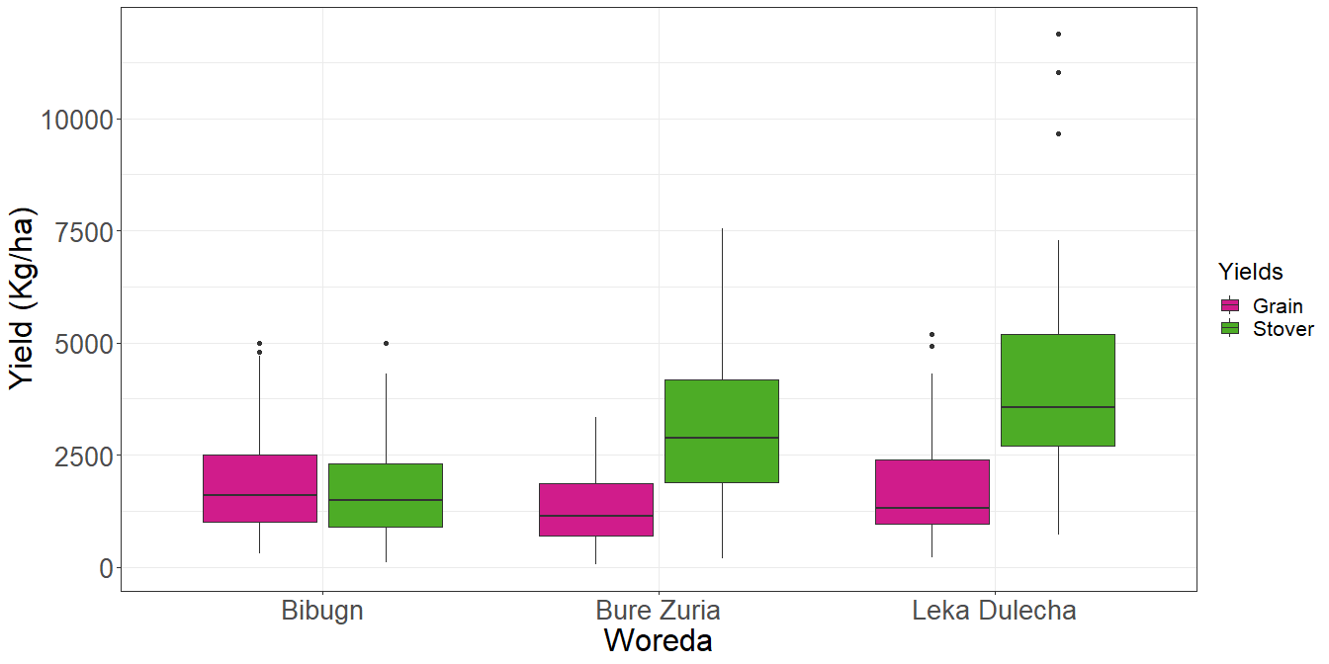

### Yield accorss locations and treatments

* Summary table

yield_location_trt<- wheat %>% select(GY_kg_ha, SY_kg_ha, Woreda,Treatment) %>% group_by(Woreda,Treatment) %>% summarize(across(.cols = c(GY_kg_ha, SY_kg_ha),list(min=min,max=max,mean=mean,sd=sd),na.rm=T,.names = "{.fn}_{.col}"))

## `summarise()` has grouped output by 'Woreda'. You can override using the  
## `.groups` argument.

knitr::kable(yield_location_trt)

|  |  |  |  |  |  |  |  |  |  |
| --- | --- | --- | --- | --- | --- | --- | --- | --- | --- |
| Woreda | Treatment | min_GY_kg_ha | max_GY_kg_ha | mean_GY_kg_ha | sd_GY_kg_ha | min_SY_kg_ha | max_SY_kg_ha | mean_SY_kg_ha | sd_SY_kg_ha |
| Bibugn | 1 | 500 | 3300 | 1263.6 | 924.42 | 100 | 2200 | 954.55 | 677.29 |
| Bibugn | 2 | 500 | 4800 | 1610 | 1256.5 | 400 | 3200 | 1280 | 871.52 |
| Bibugn | 3 | 500 | 4000 | 2190.9 | 1021.2 | 500 | 5000 | 2309.1 | 1176.8 |
| Bibugn | 4 | 300 | 4500 | 2309.1 | 1134.4 | 500 | 5000 | 2263.6 | 1140.4 |
| Bibugn | 5 | 500 | 4800 | 2108.3 | 1043.1 | 500 | 3700 | 1983.3 | 854.76 |
| Bibugn | 6 | 700 | 4700 | 1645.5 | 1175 | 600 | 4300 | 1463.6 | 1085.6 |
| Bibugn | 7 | 500 | 5000 | 1616.7 | 1305.8 | 400 | 2500 | 1316.7 | 784.9 |
| Bibugn | 8 | 1000 | 3500 | 2018.2 | 917.41 | 1000 | 2900 | 1845.5 | 612.15 |
| Bure Zuria | 1 | 300 | 1350 | 775 | 396.22 | 1000 | 3000 | 1856.3 | 679.77 |
| Bure Zuria | 2 | 390 | 1450 | 731.88 | 309.71 | 1130 | 4150 | 2083.1 | 942.46 |
| Bure Zuria | 3 | 390 | 3100 | 1876.9 | 916.43 | 1880 | 6900 | 4502.5 | 1878.1 |
| Bure Zuria | 4 | 600 | 3350 | 1652.5 | 788.6 | 2130 | 7350 | 4028.1 | 1534.6 |
| Bure Zuria | 5 | 380 | 3250 | 1676.3 | 787.55 | 1500 | 7550 | 3962.5 | 1637.3 |
| Bure Zuria | 6 | 58.416 | 2500 | 1080.5 | 632.66 | 186.14 | 5700 | 2625.4 | 1362.4 |
| Bure Zuria | 7 | 320 | 2450 | 1210.6 | 672.21 | 1400 | 6000 | 2921.3 | 1422.6 |
| Bure Zuria | 8 | 420 | 2650 | 1606.9 | 784.57 | 1500 | 6200 | 3779.4 | 1594.5 |
| Leka Dulecha | 1 | 216 | 1775 | 815.9 | 495.34 | 712 | 3280 | 2082.9 | 777.37 |
| Leka Dulecha | 2 | 352 | 2400 | 1200.4 | 659.54 | 1344 | 7200 | 2888.8 | 1708.4 |
| Leka Dulecha | 3 | 1253.3 | 5200 | 2538.2 | 1414.7 | 1384 | 11033 | 5482.5 | 2624.7 |
| Leka Dulecha | 4 | 946.67 | 4080 | 2262.7 | 1180 | 2186.7 | 11893 | 5141.4 | 2637.7 |
| Leka Dulecha | 5 | 696 | 4920 | 2116.2 | 1459.4 | 2520 | 9666.7 | 4921.1 | 2097.5 |
| Leka Dulecha | 6 | 800 | 3225 | 1606.6 | 835.65 | 2200 | 5600 | 3600.5 | 865.61 |
| Leka Dulecha | 7 | 600 | 4300 | 1777.2 | 1241.8 | 1800 | 6000 | 3740.7 | 1245.5 |
| Leka Dulecha | 8 | 432 | 4235 | 2025.3 | 1313.4 | 2820 | 6500 | 4273.9 | 1225 |

#yield_trt_summary  
#with(wheat, desc(Treatment, GrainYield, ylab = "Grain Yield ", xlab = "Treatment", ylim = NA))

* Grain

#boxplot  
wheat %>% select(GY_kg_ha, Woreda,Treatment) %>%   
ggplot(aes(x=Treatment,y=GY_kg_ha, fill=Woreda)) +  
 geom_boxplot() +  
 scale_fill_brewer(palette = "Set1") +  
 labs(y="Grain Yield (kg/ha)")+  
 theme_bw()+  
 theme(legend.title = element_text(size = 18),  
 legend.text = element_text(size = 16),  
 axis.title = element_text(size = 24),  
 axis.text = element_text(size = 20))

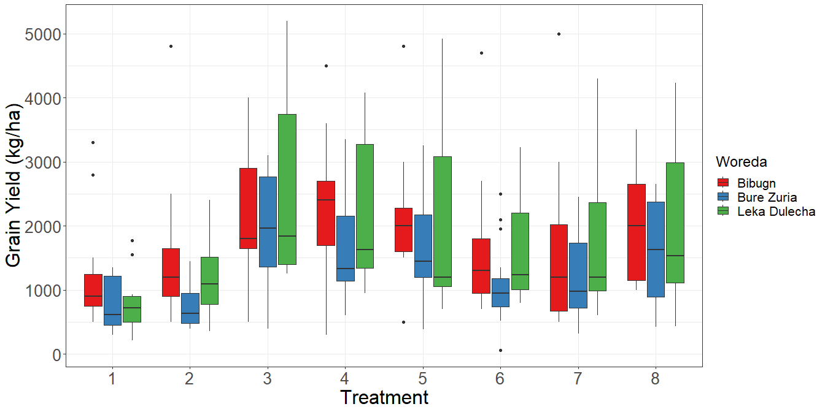

* Stover

#boxplot  
wheat %>% select(SY_kg_ha, Woreda,Treatment) %>%   
ggplot(aes(x=Treatment,y=SY_kg_ha, fill=Woreda)) +  
 geom_boxplot() +  
 scale_fill_brewer(palette = "Set2") +  
 labs(y="Grain Yield (kg/ha)")+  
 theme_bw()+  
 theme(legend.title = element_text(size = 18),  
 legend.text = element_text(size = 16),  
 axis.title = element_text(size = 24),  
 axis.text = element_text(size = 20))

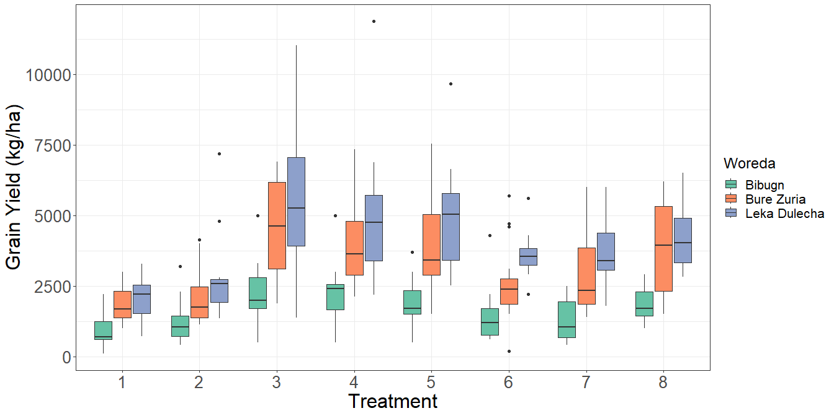

## Factorial analysis

# Analysis of variance  
model <- lm(GY_kg_ha~ Treatment + Woreda + (Treatment:Woreda) +  
 (Woreda:Rep),data=wheat)  
anova(model)

## Analysis of Variance Table  
##   
## Response: GY_kg_ha  
## Df Sum Sq Mean Sq F value Pr(>F)   
## Treatment 7 52485595 7497942 9.5269 1.376e-10 ***  
## Woreda 2 18013080 9006540 11.4437 1.688e-05 ***  
## Treatment:Woreda 14 3665685 261835 0.3327 0.9893   
## Woreda:Rep 6 40905303 6817551 8.6624 1.226e-08 ***  
## Residuals 273 214859575 787031   
## ---  
## Signif. codes: 0 '***' 0.001 '**' 0.01 '*' 0.05 '.' 0.1 ' ' 1

## Posthoc test

# Compute the estimated marginal means  
emmeans_result <- emmeans(model, ~ Treatment)

## NOTE: A nesting structure was detected in the fitted model:  
## Rep %in% Woreda

## NOTE: Results may be misleading due to involvement in interactions

# Perform pairwise comparisons using Tukey's adjustment  
pairwise_result <- pairs(emmeans_result, adjust = "tukey")  
  
# Display the pairwise comparisons  
knitr::kable(pairwise_result)

|  |  |  |  |  |  |
| --- | --- | --- | --- | --- | --- |
| contrast | estimate | SE | df | t.ratio | p.value |
| Treatment1 - Treatment2 | -213.20143 | 210.9984 | 273 | -1.0104408 | 0.9726136 |
| Treatment1 - Treatment3 | -1278.38325 | 210.0544 | 273 | -6.0859625 | 0.0000001 |
| Treatment1 - Treatment4 | -1107.18754 | 209.1061 | 273 | -5.2948600 | 0.0000068 |
| Treatment1 - Treatment5 | -1022.99090 | 207.0419 | 273 | -4.9409858 | 0.0000369 |
| Treatment1 - Treatment6 | -520.58005 | 210.0544 | 273 | -2.4783105 | 0.2092149 |
| Treatment1 - Treatment7 | -590.91388 | 207.0419 | 273 | -2.8540792 | 0.0863763 |
| Treatment1 - Treatment8 | -931.95126 | 210.5236 | 273 | -4.4268248 | 0.0003656 |
| Treatment2 - Treatment3 | -1065.18182 | 209.5775 | 273 | -5.0825208 | 0.0000189 |
| Treatment2 - Treatment4 | -893.98611 | 208.6270 | 273 | -4.2850932 | 0.0006612 |
| Treatment2 - Treatment5 | -809.78947 | 207.4344 | 273 | -3.9038333 | 0.0029737 |
| Treatment2 - Treatment6 | -307.37861 | 209.5775 | 273 | -1.4666587 | 0.8244636 |
| Treatment2 - Treatment7 | -377.71245 | 207.4344 | 273 | -1.8208763 | 0.6064152 |
| Treatment2 - Treatment8 | -718.74983 | 210.9984 | 273 | -3.4064224 | 0.0170737 |
| Treatment3 - Treatment4 | 171.19571 | 207.6722 | 273 | 0.8243555 | 0.9916272 |
| Treatment3 - Treatment5 | 255.39235 | 206.4741 | 273 | 1.2369220 | 0.9201884 |
| Treatment3 - Treatment6 | 757.80321 | 206.7129 | 273 | 3.6659688 | 0.0070801 |
| Treatment3 - Treatment7 | 687.46937 | 206.4741 | 273 | 3.3295671 | 0.0218515 |
| Treatment3 - Treatment8 | 346.43199 | 210.0544 | 273 | 1.6492488 | 0.7197609 |
| Treatment4 - Treatment5 | 84.19664 | 205.5093 | 273 | 0.4096975 | 0.9999091 |
| Treatment4 - Treatment6 | 586.60750 | 207.6722 | 273 | 2.8246803 | 0.0931896 |
| Treatment4 - Treatment7 | 516.27367 | 205.5093 | 273 | 2.5121671 | 0.1947069 |
| Treatment4 - Treatment8 | 175.23628 | 209.1061 | 273 | 0.8380257 | 0.9907561 |
| Treatment5 - Treatment6 | 502.41085 | 206.4741 | 273 | 2.4332875 | 0.2296232 |
| Treatment5 - Treatment7 | 432.07702 | 203.4829 | 273 | 2.1234075 | 0.4025162 |
| Treatment5 - Treatment8 | 91.03964 | 207.0419 | 273 | 0.4397161 | 0.9998537 |
| Treatment6 - Treatment7 | -70.33383 | 206.4741 | 273 | -0.3406424 | 0.9999741 |
| Treatment6 - Treatment8 | -411.37122 | 210.0544 | 273 | -1.9584032 | 0.5120470 |
| Treatment7 - Treatment8 | -341.03738 | 207.0419 | 273 | -1.6471905 | 0.7210522 |

#plot(pairwise_result, pch = "*", cex = 1.5)  
as_tibble(pairwise_result) %>%   
ggplot(aes(x=estimate,y=contrast)) +  
 geom_point(shape=23, size = 3, fill = "red") +  
 geom_errorbar(aes(xmin = estimate - SE, xmax = estimate + SE),  
 width = 0.2) +  
 labs(x = "Estimate", y = "Contrast")+  
 theme_bw()+  
 theme(axis.title = element_text(size = 16),  
 axis.text = element_text(size = 11))

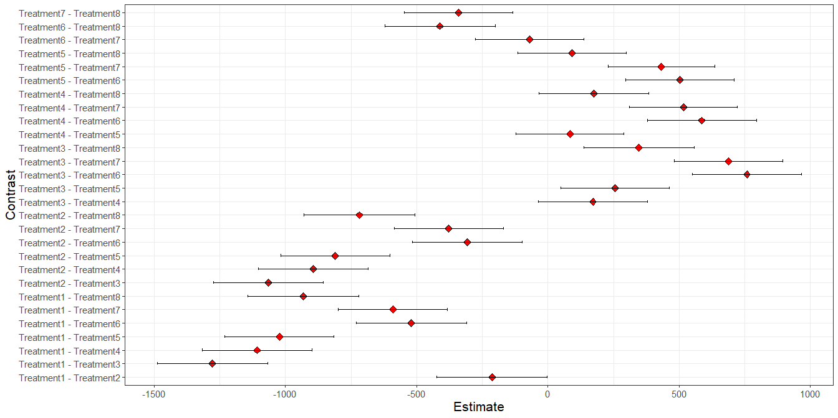

## Best treatment per location

### For every woreda, what are the 3 best treatment?

* Grain

best_comb<-yield_location_trt %>% select(Woreda, Treatment, mean_GY_kg_ha) %>%   
 group_by(Woreda) %>%  
 slice_max(mean_GY_kg_ha, n=3)  
knitr::kable(best_comb)

|  |  |  |
| --- | --- | --- |
| Woreda | Treatment | mean_GY_kg_ha |
| Bibugn | 4 | 2309.091 |
| Bibugn | 3 | 2190.909 |
| Bibugn | 5 | 2108.333 |
| Bure Zuria | 3 | 1876.875 |
| Bure Zuria | 5 | 1676.250 |
| Bure Zuria | 4 | 1652.500 |
| Leka Dulecha | 3 | 2538.242 |
| Leka Dulecha | 4 | 2262.667 |
| Leka Dulecha | 5 | 2116.182 |

* Stover

best_comb<-yield_location_trt %>% select(Woreda, Treatment, mean_SY_kg_ha) %>%   
 group_by(Woreda) %>%  
 slice_max(mean_SY_kg_ha, n=3)  
knitr::kable(best_comb)

|  |  |  |
| --- | --- | --- |
| Woreda | Treatment | mean_SY_kg_ha |
| Bibugn | 3 | 2309.091 |
| Bibugn | 4 | 2263.636 |
| Bibugn | 5 | 1983.333 |
| Bure Zuria | 3 | 4502.500 |
| Bure Zuria | 4 | 4028.125 |
| Bure Zuria | 5 | 3962.500 |
| Leka Dulecha | 3 | 5482.545 |
| Leka Dulecha | 4 | 5141.364 |
| Leka Dulecha | 5 | 4921.061 |