Soybean

Table of Contents

## Load the working packages

library(AgroR)  
library(tidyverse)  
library(agricolae)  
library(lme4)  
library(emmeans)  
library(reshape)  
library(reshape2)  
library(car)

## Load the data

setwd("~/Code/R/SCASI")  
library(tidyverse)  
library(skimr)  
  
df <- readxl::read_excel("./input/SCASI_Field_Trials_Data_2022ALL_20230409_Adama_v2.xlsx",sheet = "MergePart2Part1")  
# First rows  
#knitr::kable(head(df))  
  
# Convert to factor  
df$Rep <- as.factor(df$Rep)  
df$Treatment <- as.factor(df$Treatment)  
df$Woreda <- as.factor(df$Woreda)

## Overview of the data

Number of observations and variables:

## [1] 709 153

## Extract data per crops

# crop_data  
crop_data <- df %>% filter(Plot_crop==params$crop)

## Descriptive statistics

### Yield accorss treatments

yield_trt_summary<- crop_data %>% group_by(Treatment) %>% summarize(across(.cols = c(GY_kg_ha,SY_kg_ha),list(min=min,max=max,mean=mean,sd=sd),na.rm=T,.names = "{.fn}_{.col}"))  
knitr::kable(yield_trt_summary)

|  |  |  |  |  |  |  |  |  |
| --- | --- | --- | --- | --- | --- | --- | --- | --- |
| Treatment | min_GY_kg_ha | max_GY_kg_ha | mean_GY_kg_ha | sd_GY_kg_ha | min_SY_kg_ha | max_SY_kg_ha | mean_SY_kg_ha | sd_SY_kg_ha |
| 1 | 800 | 1150 | 1000.000 | 145.7738 | 1600 | 2400 | 1920.0 | 305.3686 |
| 2 | 1400 | 2325 | 1915.000 | 412.9165 | 1750 | 4350 | 3390.0 | 1005.8578 |
| 3 | 1150 | 2000 | 1500.000 | 331.6625 | 2250 | 3150 | 2620.0 | 329.0137 |
| 4 | 1000 | 1800 | 1470.833 | 315.6013 | 1800 | 3750 | 2800.0 | 712.0393 |
| 5 | 500 | 1325 | 995.000 | 338.3785 | 850 | 2550 | 2010.0 | 764.3625 |
| 6 | 750 | 1425 | 1081.250 | 282.3820 | 1400 | 2700 | 2137.5 | 540.6401 |
| 7 | 700 | 1375 | 1085.000 | 253.4758 | 1250 | 2150 | 1890.0 | 366.4014 |

#yield_trt_summary  
#with(crop_data, desc(Treatment, GrainYield, ylab = "Grain Yield ", xlab = "Treatment", ylim = NA))  
  
#boxplot  
crop_data %>% select(GY_kg_ha, SY_kg_ha, Treatment) %>% gather(key = "Yields",value= "Value", -Treatment) %>%   
ggplot(aes(x=Treatment,y=Value, fill=Yields)) +  
 geom_boxplot() +  
 scale_fill_manual(values = c("GY_kg_ha" = "#dfc27d", "SY_kg_ha" = "#80cdc1"), labels=c("Grain", "Stover")) +  
 labs(y="Yield (Kg/ha)")+  
 theme_bw()+  
 theme(legend.title = element_text(size = 18),  
 legend.text = element_text(size = 16),  
 axis.title = element_text(size = 24),  
 axis.text = element_text(size = 20))

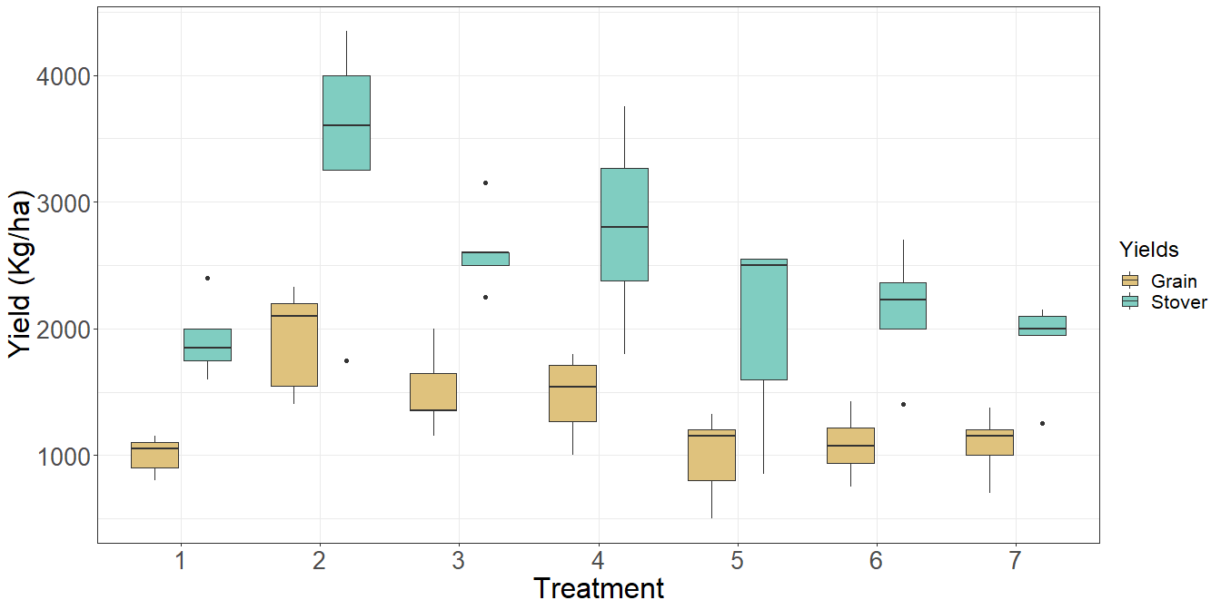

### Yield accorss locations

yield_location<- crop_data %>% group_by(Woreda) %>% summarize(across(.cols = c(GY_kg_ha,SY_kg_ha),list(min=min,max=max,mean=mean,sd=sd),na.rm=T,.names = "{.fn}_{.col}"))  
knitr::kable(yield_location)

|  |  |  |  |  |  |  |  |  |
| --- | --- | --- | --- | --- | --- | --- | --- | --- |
| Woreda | min_GY_kg_ha | max_GY_kg_ha | mean_GY_kg_ha | sd_GY_kg_ha | min_SY_kg_ha | max_SY_kg_ha | mean_SY_kg_ha | sd_SY_kg_ha |
| Assosa | 500 | 2325 | 1303.571 | 429.1811 | 850 | 4350 | 2414.286 | 780.7021 |

#yield_trt_summary  
#with(crop_data, desc(Treatment, GrainYield, ylab = "Grain Yield ", xlab = "Treatment", ylim = NA))  
  
#boxplot  
crop_data %>% select(GY_kg_ha, SY_kg_ha, Woreda) %>% gather(key = "Yields",value= "Value", -Woreda) %>%   
ggplot(aes(x=Woreda,y=Value, fill=Yields)) +  
 geom_boxplot() +  
 scale_fill_manual(values = c("GY_kg_ha" = "#d01c8b", "SY_kg_ha" = "#4dac26"), labels=c("Grain", "Stover")) +  
 labs(y="Yield (Kg/ha)")+  
 theme_bw()+  
 theme(legend.title = element_text(size = 18),  
 legend.text = element_text(size = 16),  
 axis.title = element_text(size = 24),  
 axis.text = element_text(size = 20))

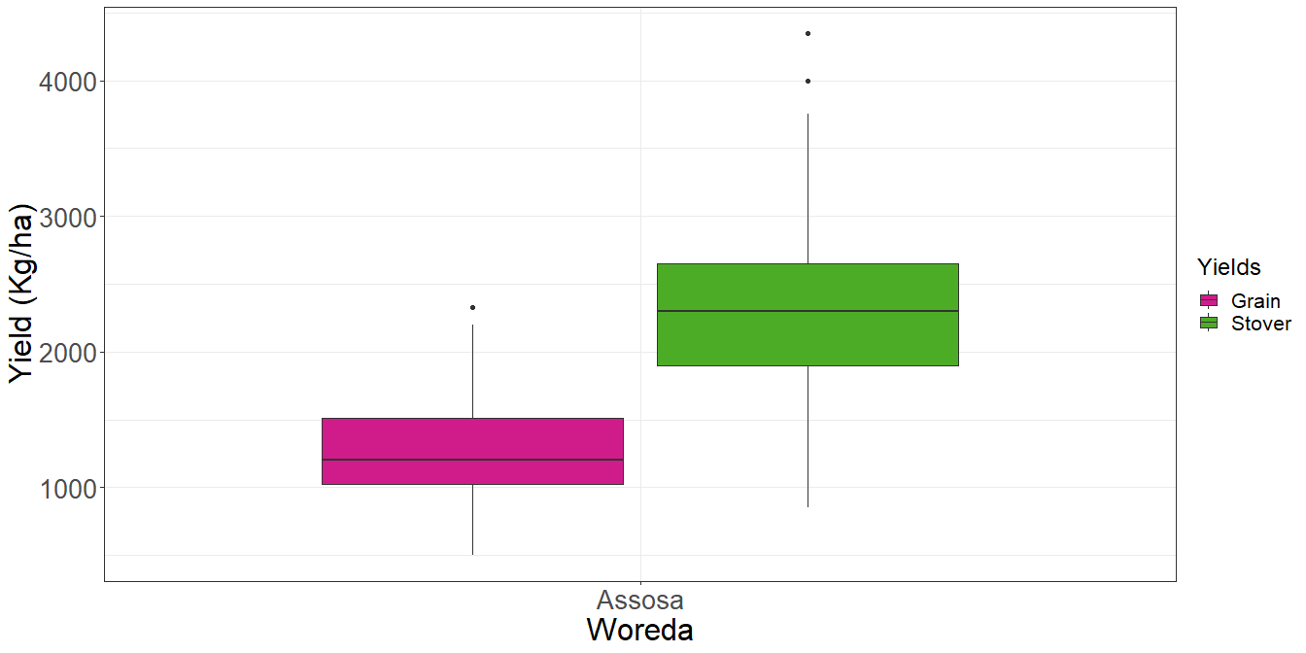

### Yield accorss locations and treatments

* Summary table

yield_location_trt<- crop_data %>% select(GY_kg_ha, SY_kg_ha, Woreda,Treatment) %>% group_by(Woreda,Treatment) %>% summarize(across(.cols = c(GY_kg_ha, SY_kg_ha),list(min=min,max=max,mean=mean,sd=sd),na.rm=T,.names = "{.fn}_{.col}"))

## `summarise()` has grouped output by 'Woreda'. You can override using the `.groups` argument.

knitr::kable(yield_location_trt)

|  |  |  |  |  |  |  |  |  |  |
| --- | --- | --- | --- | --- | --- | --- | --- | --- | --- |
| Woreda | Treatment | min_GY_kg_ha | max_GY_kg_ha | mean_GY_kg_ha | sd_GY_kg_ha | min_SY_kg_ha | max_SY_kg_ha | mean_SY_kg_ha | sd_SY_kg_ha |
| Assosa | 1 | 800 | 1150 | 1000.000 | 145.7738 | 1600 | 2400 | 1920.0 | 305.3686 |
| Assosa | 2 | 1400 | 2325 | 1915.000 | 412.9165 | 1750 | 4350 | 3390.0 | 1005.8578 |
| Assosa | 3 | 1150 | 2000 | 1500.000 | 331.6625 | 2250 | 3150 | 2620.0 | 329.0137 |
| Assosa | 4 | 1000 | 1800 | 1470.833 | 315.6013 | 1800 | 3750 | 2800.0 | 712.0393 |
| Assosa | 5 | 500 | 1325 | 995.000 | 338.3785 | 850 | 2550 | 2010.0 | 764.3625 |
| Assosa | 6 | 750 | 1425 | 1081.250 | 282.3820 | 1400 | 2700 | 2137.5 | 540.6401 |
| Assosa | 7 | 700 | 1375 | 1085.000 | 253.4758 | 1250 | 2150 | 1890.0 | 366.4014 |

#yield_trt_summary  
#with(crop_data, desc(Treatment, GrainYield, ylab = "Grain Yield ", xlab = "Treatment", ylim = NA))

* Grain

#boxplot  
crop_data %>% select(GY_kg_ha, Woreda,Treatment) %>%   
ggplot(aes(x=Treatment,y=GY_kg_ha, fill=Woreda)) +  
 geom_boxplot() +  
 scale_fill_brewer(palette = "Set1") +  
 labs(y="Grain Yield (kg/ha)")+  
 theme_bw()+  
 theme(legend.title = element_text(size = 18),  
 legend.text = element_text(size = 16),  
 axis.title = element_text(size = 24),  
 axis.text = element_text(size = 20))

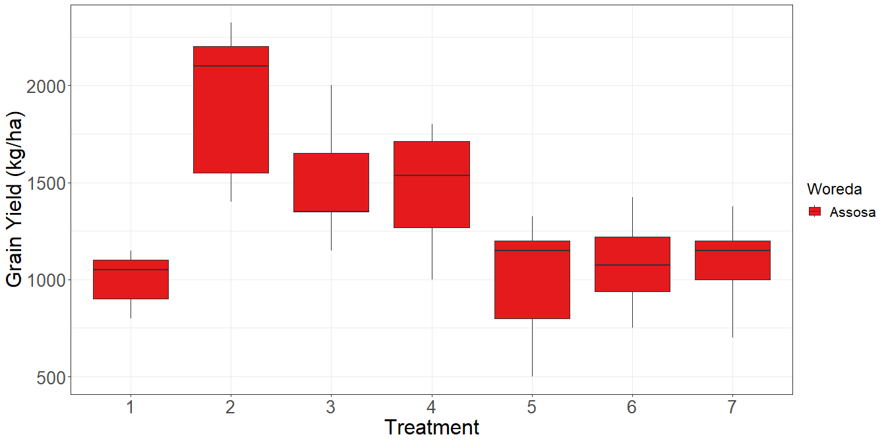

* Stover

#boxplot  
crop_data %>% select(SY_kg_ha, Woreda,Treatment) %>%   
ggplot(aes(x=Treatment,y=SY_kg_ha, fill=Woreda)) +  
 geom_boxplot() +  
 scale_fill_brewer(palette = "Set2") +  
 labs(y="Grain Yield (kg/ha)")+  
 theme_bw()+  
 theme(legend.title = element_text(size = 18),  
 legend.text = element_text(size = 16),  
 axis.title = element_text(size = 24),  
 axis.text = element_text(size = 20))

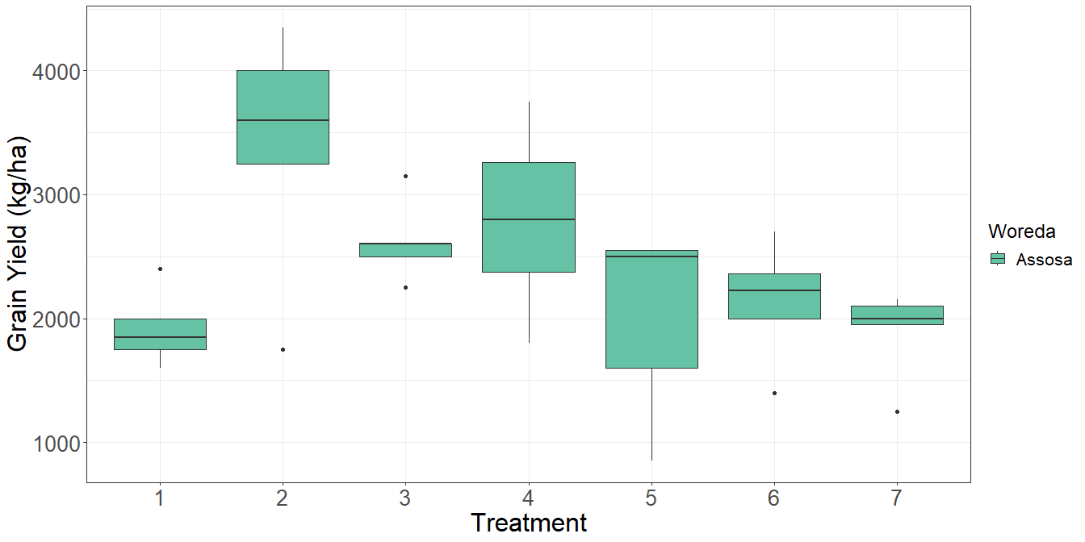

## Factorial analysis

# Analysis of variance  
  
#  
if (length(unique(crop_data$Woreda))<=1) {  
 model <- lm(GY_kg_ha~ Treatment, data=crop_data)  
 anova(model)  
} else {  
 model <- lm(GY_kg_ha~ Treatment + Woreda + (Treatment:Woreda) + (Woreda:Rep),data=crop_data)  
 anova(model)  
}

## Analysis of Variance Table  
##   
## Response: GY_kg_ha  
## Df Sum Sq Mean Sq F value Pr(>F)   
## Treatment 6 3603439 600573 6.3236 0.0002714 ***  
## Residuals 28 2659240 94973   
## ---  
## Signif. codes: 0 '***' 0.001 '**' 0.01 '*' 0.05 '.' 0.1 ' ' 1

## Posthoc test

# Compute the estimated marginal means  
emmeans_result <- emmeans(model, ~ Treatment)  
  
# Perform pairwise comparisons using Tukey's adjustment  
pairwise_result <- pairs(emmeans_result, adjust = "tukey")  
  
# Display the pairwise comparisons  
knitr::kable(pairwise_result)

|  |  |  |  |  |  |
| --- | --- | --- | --- | --- | --- |
| contrast | estimate | SE | df | t.ratio | p.value |
| Treatment1 - Treatment2 | -915.00000 | 194.9080 | 28 | -4.6945220 | 0.0011200 |
| Treatment1 - Treatment3 | -500.00000 | 194.9080 | 28 | -2.5653126 | 0.1752428 |
| Treatment1 - Treatment4 | -470.83333 | 186.6102 | 28 | -2.5230843 | 0.1894436 |
| Treatment1 - Treatment5 | 5.00000 | 194.9080 | 28 | 0.0256531 | 1.0000000 |
| Treatment1 - Treatment6 | -81.25000 | 206.7312 | 28 | -0.3930225 | 0.9996582 |
| Treatment1 - Treatment7 | -85.00000 | 194.9080 | 28 | -0.4361031 | 0.9993793 |
| Treatment2 - Treatment3 | 415.00000 | 194.9080 | 28 | 2.1292094 | 0.3640597 |
| Treatment2 - Treatment4 | 444.16667 | 186.6102 | 28 | 2.3801840 | 0.2439634 |
| Treatment2 - Treatment5 | 920.00000 | 194.9080 | 28 | 4.7201751 | 0.0010465 |
| Treatment2 - Treatment6 | 833.75000 | 206.7312 | 28 | 4.0330153 | 0.0062606 |
| Treatment2 - Treatment7 | 830.00000 | 194.9080 | 28 | 4.2584189 | 0.0035100 |
| Treatment3 - Treatment4 | 29.16667 | 186.6102 | 28 | 0.1562973 | 0.9999985 |
| Treatment3 - Treatment5 | 505.00000 | 194.9080 | 28 | 2.5909657 | 0.1670279 |
| Treatment3 - Treatment6 | 418.75000 | 206.7312 | 28 | 2.0255774 | 0.4218762 |
| Treatment3 - Treatment7 | 415.00000 | 194.9080 | 28 | 2.1292094 | 0.3640597 |
| Treatment4 - Treatment5 | 475.83333 | 186.6102 | 28 | 2.5498782 | 0.1803346 |
| Treatment4 - Treatment6 | 389.58333 | 198.9272 | 28 | 1.9584220 | 0.4613893 |
| Treatment4 - Treatment7 | 385.83333 | 186.6102 | 28 | 2.0675895 | 0.3979344 |
| Treatment5 - Treatment6 | -86.25000 | 206.7312 | 28 | -0.4172085 | 0.9995182 |
| Treatment5 - Treatment7 | -90.00000 | 194.9080 | 28 | -0.4617563 | 0.9991405 |
| Treatment6 - Treatment7 | -3.75000 | 206.7312 | 28 | -0.0181395 | 1.0000000 |

#plot(pairwise_result, pch = "*", cex = 1.5)  
as_tibble(pairwise_result) %>%   
ggplot(aes(x=estimate,y=contrast)) +  
 geom_point(shape=23, size = 3, fill = "red") +  
 geom_errorbar(aes(xmin = estimate - SE, xmax = estimate + SE),  
 width = 0.2) +  
 labs(x = "Estimate", y = "Contrast")+  
 theme_bw()+  
 theme(axis.title = element_text(size = 16),  
 axis.text = element_text(size = 11))

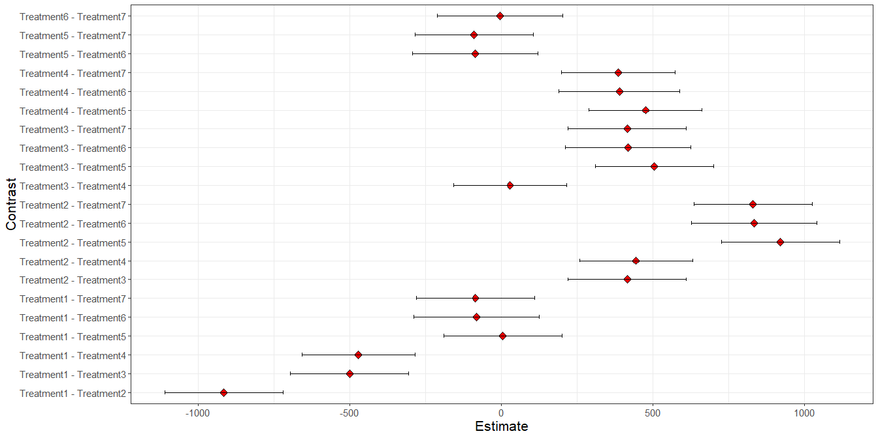

## Best treatment per location

### For every woreda, what are the 3 best treatment?

* Grain

best_comb<-yield_location_trt %>% select(Woreda, Treatment, mean_GY_kg_ha) %>%   
 group_by(Woreda) %>%  
 slice_max(mean_GY_kg_ha, n=3)  
knitr::kable(best_comb)

|  |  |  |
| --- | --- | --- |
| Woreda | Treatment | mean_GY_kg_ha |
| Assosa | 2 | 1915.000 |
| Assosa | 3 | 1500.000 |
| Assosa | 4 | 1470.833 |

* Stover

best_comb<-yield_location_trt %>% select(Woreda, Treatment, mean_SY_kg_ha) %>%   
 group_by(Woreda) %>%  
 slice_max(mean_SY_kg_ha, n=3)  
knitr::kable(best_comb)

|  |  |  |
| --- | --- | --- |
| Woreda | Treatment | mean_SY_kg_ha |
| Assosa | 2 | 3390 |
| Assosa | 4 | 2800 |
| Assosa | 3 | 2620 |