Analysis

Adama NDOUR

2024-07-16

## Load package

library(tidyverse)  
library(readxl)  
library(paletteer)  
library(meta) # meta-analysis  
library(nnet) # Multinomial logit model  
library(GGally) # plot model coefficients  
library(recipes)  
library(recipeselectors)  
library(embed) # encoding  
library(report) # report statistical results  
library(stargazer) # formatting statistical results  
library(kableExtra) # format table  
library(DHARMa) # plot residuals of a linear model

## Load the data

df <- read_excel("uav_review_data.xlsx")

## Overview of the data

#str(df)

## Data manipulation: create a model class variable

df <- df %>% mutate(  
 Model_Class = case_when(  
 RPD < 1.4 ~ "unrealiable models",  
 RPD >= 1.4 & RPD < 2 ~ "reasonable models",  
 RPD >=2 ~ "excellent models"  
 )  
)  
  
# Remove special characters  
df$Sensor <- str_replace_all(df$Sensor, "\r", " ")  
df$Sensor <- str_replace_all(df$Sensor, "\n", " ")  
df$Sensor <- str_replace_all(df$Sensor, "\\s+", " ")

## Exploratory Data Analysis (EDA)

### Which UAV platform maximize the performance of ML models

df_trait <- df %>% filter(Problem=="trait estimation")  
#df_trait %>% group_by(Crop,Algorithm)  
n_shape_var <- length(unique(df_trait$Sensor))  
p<-df_trait %>%   
 group_by(DOI, Trait, UAV_Type, Sensor, Algorithm,Model_Class) %>%   
 summarise(RPD=mean(RPD)) %>%   
 ggplot(aes(y=Algorithm, x=RPD, color=UAV_Type)) +  
 geom_point(aes(shape=Sensor))+  
 scale_shape_manual(values = 0:n_shape_var) +  
 scale_color_paletteer_d("ggthemes::calc")+  
 facet_grid(Trait~ Model_Class, scales = "free_y")+  
 theme_bw()+  
 theme(  
 legend.text = element_text(size = 8.5)  
 )  
ggsave("output/figure1.png",plot = p,dpi = 300)  
p

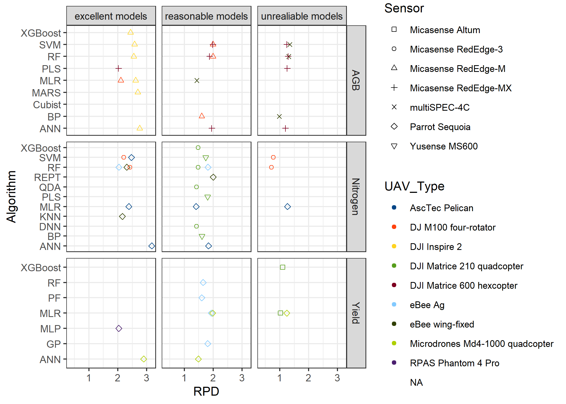

### Forest plot for the biomass

# Install and load necessary packages  
# Load necessary libraries  
  
# Example RPD data  
biomass_data <- df_trait %>% filter(Trait=="AGB")  
  
# Calculate summary statistics  
biomass_rpd_summary <- biomass_data %>%  
 group_by(Algorithm) %>%  
 summarize(  
 mean_RPD = mean(RPD),  
 sd_RPD = sd(RPD),  
 n = n(),  
 SEM_RPD = sd_RPD / sqrt(n),  
 CI_Lower = mean_RPD - 1.96 * SEM_RPD,  
 CI_Upper = mean_RPD + 1.96 * SEM_RPD  
 )  
  
# Print the summary  
print(biomass_rpd_summary)

## # A tibble: 9 × 7  
## Algorithm mean_RPD sd_RPD n SEM_RPD CI_Lower CI_Upper  
## <chr> <dbl> <dbl> <int> <dbl> <dbl> <dbl>  
## 1 ANN 1.97 0.782 3 0.452 1.08 2.85  
## 2 BP 1.29 0.439 2 0.310 0.684 1.90  
## 3 Cubist 1.11 1.06 2 0.748 -0.356 2.58  
## 4 MARS 2.69 NA 1 NA NA NA   
## 5 MLR 2.05 0.596 3 0.344 1.38 2.73  
## 6 PLS 1.64 0.543 2 0.384 0.886 2.39  
## 7 RF 1.80 0.528 5 0.236 1.34 2.26  
## 8 SVM 1.83 0.546 5 0.244 1.35 2.30  
## 9 XGBoost 2.44 NA 1 NA NA NA

# Combine data for all models  
biomass_meta_combined <- metagen(  
 TE = biomass_rpd_summary$mean_RPD,  
 lower = biomass_rpd_summary$CI_Lower,  
 upper = biomass_rpd_summary$CI_Upper,  
 studlab = biomass_rpd_summary$Algorithm,  
 sm = "Mean"  
)  
  
# Forest plot for all models  
# png(file = "output/forestplot_biomass.png", width = 10, height = 5, res = 300, units = "in")  
forest(biomass_meta_combined,  
 main = "Forest Plot of RPD for All Models of Biomass Estimation",  
 xlab = "RPD",  
 label.left = "Models",  
 studlab = biomass_rpd_summary$Algorithm,  
 print.tau2 = FALSE,  
 col.diamond = "blue",  
 col.predict = "red",  
 leftlabs = c("Models", "Mean", "SE(Mean)"))

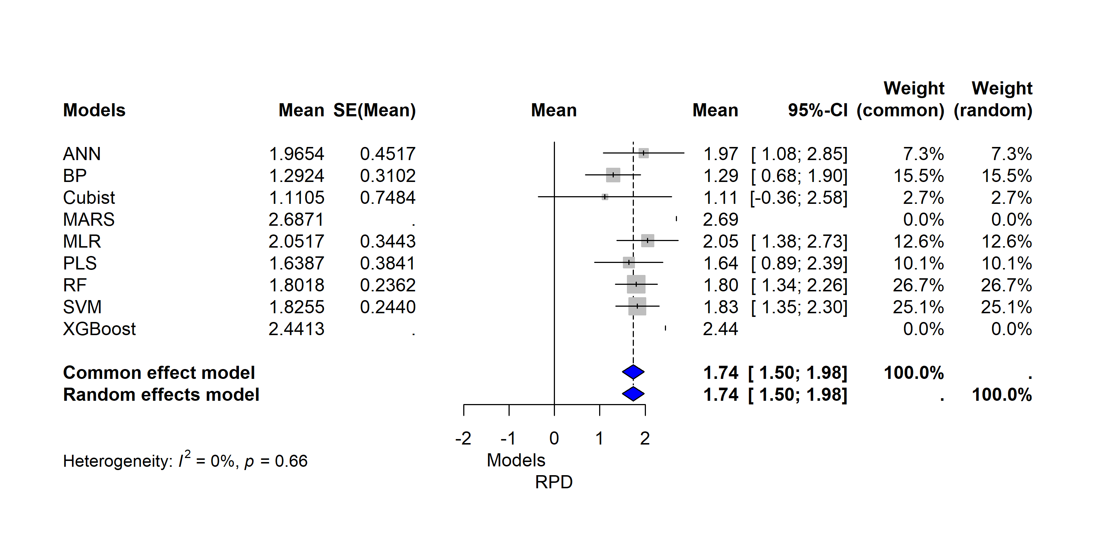

### Forest plot for the yield

# Install and load necessary packages  
# Load necessary libraries  
  
# Example RPD data  
yield_data <- df_trait %>% filter(Trait=="Yield")  
  
# Calculate summary statistics  
yield_rpd_summary <- yield_data %>%  
 group_by(Algorithm) %>%  
 summarize(  
 mean_RPD = mean(RPD),  
 sd_RPD = sd(RPD),  
 n = n(),  
 SEM_RPD = sd_RPD / sqrt(n),  
 CI_Lower = mean_RPD - 1.96 * SEM_RPD,  
 CI_Upper = mean_RPD + 1.96 * SEM_RPD  
 )  
  
# Print the summary  
print(yield_rpd_summary)

## # A tibble: 7 × 7  
## Algorithm mean_RPD sd_RPD n SEM_RPD CI_Lower CI_Upper  
## <chr> <dbl> <dbl> <int> <dbl> <dbl> <dbl>  
## 1 ANN 2.42 1.05 3 0.608 1.23 3.61  
## 2 GP 1.81 NA 1 NA NA NA   
## 3 MLP 2.03 NA 1 NA NA NA   
## 4 MLR 1.48 0.449 5 0.201 1.09 1.88  
## 5 PF 1.6 NA 1 NA NA NA   
## 6 RF 1.65 NA 1 NA NA NA   
## 7 XGBoost 1.10 NA 1 NA NA NA

# Combine data for all models  
yield_meta_combined <- metagen(  
 TE = yield_rpd_summary$mean_RPD,  
 lower = yield_rpd_summary$CI_Lower,  
 upper = yield_rpd_summary$CI_Upper,  
 studlab = yield_rpd_summary$Algorithm,  
 sm = "Mean"  
)  
  
# Forest plot for all models  
# png(file = "output/forestplot_yield.png", width = 10, height = 5, res = 300, units = "in")  
forest(yield_meta_combined,  
 main = "Forest Plot of RPD for All Models for Yield Estimation",  
 xlab = "RPD",  
 label.left = "Models",  
 studlab = yield_rpd_summary$Algorithm,  
 print.tau2 = FALSE,  
 col.diamond = "blue",  
 col.predict = "red",  
 leftlabs = c("Models", "Mean", "SE(Mean)"))

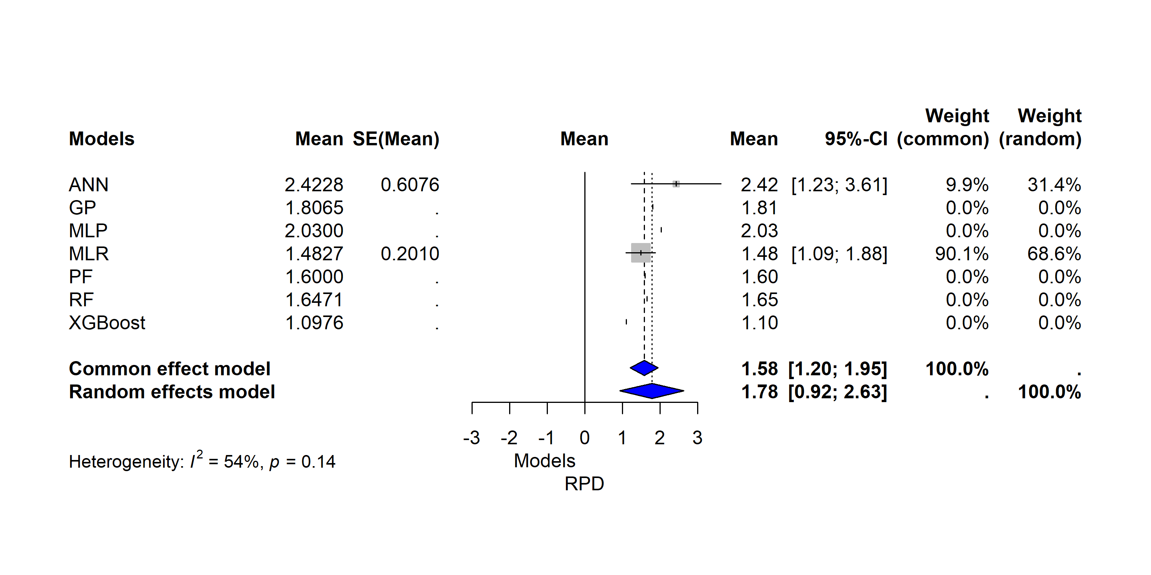

### Forest plot for the nitrogen

# Install and load necessary packages  
# Load necessary libraries  
library(meta)  
  
# Example RPD data  
nitrogen_data <- df_trait %>% filter(Trait=="Nitrogen")  
  
# Calculate summary statistics  
nitrogen_rpd_summary <- nitrogen_data %>%  
 group_by(Algorithm) %>%  
 summarize(  
 mean_RPD = mean(RPD),  
 sd_RPD = sd(RPD),  
 n = n(),  
 SEM_RPD = sd_RPD / sqrt(n),  
 CI_Lower = mean_RPD - 1.96 * SEM_RPD,  
 CI_Upper = mean_RPD + 1.96 * SEM_RPD  
 )  
  
# Print the summary  
print(nitrogen_rpd_summary)

## # A tibble: 11 × 7  
## Algorithm mean_RPD sd_RPD n SEM_RPD CI_Lower CI_Upper  
## <chr> <dbl> <dbl> <int> <dbl> <dbl> <dbl>  
## 1 ANN 2.73 0.793 3 0.458 1.83 3.62  
## 2 BP 1.61 NA 1 NA NA NA   
## 3 DNN 1.42 NA 1 NA NA NA   
## 4 KNN 2.16 NA 1 NA NA NA   
## 5 MLR 1.68 0.608 3 0.351 0.996 2.37  
## 6 PLS 1.80 NA 1 NA NA NA   
## 7 QDA 1.42 NA 1 NA NA NA   
## 8 REPT 2.00 NA 1 NA NA NA   
## 9 RF 1.80 0.632 6 0.258 1.29 2.30  
## 10 SVM 2.02 0.684 6 0.279 1.47 2.57  
## 11 XGBoost 1.48 NA 1 NA NA NA

# Combine data for all models  
nitrogen_meta_combined <- metagen(  
 TE = nitrogen_rpd_summary$mean_RPD,  
 lower = nitrogen_rpd_summary$CI_Lower,  
 upper = nitrogen_rpd_summary$CI_Upper,  
 studlab = nitrogen_rpd_summary$Algorithm,  
 sm = "Mean"  
)  
  
# Forest plot for all models  
#png(file = "output/forestplot_nitrogen.png", width = 10, height = 5, res = 300, units = "in")  
forest(nitrogen_meta_combined,  
 main = "Forest Plot of RPD for All Models of nitrogen Estimation",  
 xlab = "RPD",  
 label.left = "Models",  
 studlab = nitrogen_rpd_summary$Algorithm,  
 print.tau2 = FALSE,  
 comb.random = FALSE,  
 col.diamond = "blue",  
 col.predict = "red",  
 leftlabs = c("Models", "Mean", "SE(Mean)"))

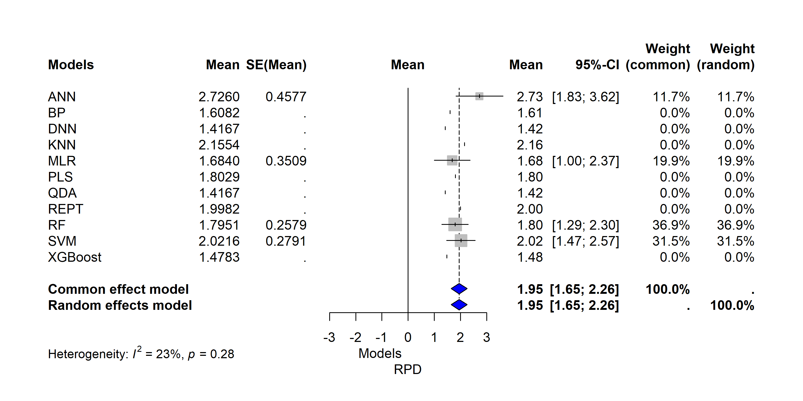

## Multivariate Linear Regression: Key drivers of ML model performance

# Recode RPD variable to convert to factor predictors  
df_trait_model <- df_trait %>%   
 mutate(  
 RPD_rec = recode_factor(Model_Class,   
 "unrealiable models" = "Bad",  
 "reasonable models" = "Reliable",  
 "excellent models" = "Excellent"),  
 Crop = as_factor(Crop),  
 Stage = as_factor(Stage),  
 Trait = as_factor(Trait),  
 UAV_Type = as_factor(UAV_Type),  
 Sensor = as_factor(Sensor),  
 Band = as_factor(Band),  
 Algorithm = as_factor(Algorithm)  
 )  
df_trait_model <- df_trait_model %>%   
 select(RPD, Crop, Stage, Trait, UAV_Type, Sensor, Band, Altitude_m, Algorithm)

# Drop Na  
df_trait_model <- df_trait_model %>% drop_na(UAV_Type)

### Biomass

# Example data  
biomass_model_data <- df_trait_model %>% filter(Trait=="AGB")  
  
# Remove trait  
biomass_model_data <- biomass_model_data %>% select(-Trait)  
  
# Standardize predictor variables  
recipe <- recipe(RPD ~ ., data=biomass_model_data) %>%  
 # convert string to factor  
 #step_string2factor(all_nominal()) %>%  
 # remove no variance predictors   
 #recipes::step_nzv(all_nominal()) %>%  
 # factor to dummy variables  
 #step_dummy(all_nominal(), one_hot=T) %>%  
 step_lencode_mixed(all_nominal_predictors() , outcome=vars(RPD)) %>%  
 # remove non-variance variables  
 step_nzv(where(is.numeric)) %>%  
 #step_dummy(all_nominal_predictors(), one_hot=F) %>% # Convert categorical variables to dummy variables  
 prep()

## boundary (singular) fit: see help('isSingular')

# juice recipe  
biomass_model_data_final <- juice(recipe)  
  
# Fit the multinomial logistic regression model  
biomass_model <- lm(RPD ~. , data = biomass_model_data_final)

### Yield

# Example data  
yield_model_data <- df_trait_model %>% filter(Trait=="Yield")  
  
# Remove trait  
yield_model_data <- yield_model_data %>% select(-Trait)  
  
# Standardize predictor variables  
recipe <- recipe(RPD ~ ., data=yield_model_data) %>%  
 # convert string to factor  
 #step_string2factor(all_nominal()) %>%  
 # remove no variance predictors   
 #recipes::step_nzv(all_nominal()) %>%  
 # factor to dummy variables  
 #step_dummy(all_nominal(), one_hot=T) %>%  
 step_lencode_mixed(all_nominal_predictors() , outcome=vars(RPD)) %>%  
 # remove non-variance variables  
 step_nzv(where(is.numeric)) %>%  
 #step_dummy(all_nominal_predictors(), one_hot=F) %>% # Convert categorical variables to dummy variables  
 prep()

## boundary (singular) fit: see help('isSingular')  
## boundary (singular) fit: see help('isSingular')

# juice recipe  
yield_model_data_final <- juice(recipe)  
  
# Fit the multinomial logistic regression model  
yield_model <- lm(RPD ~. , data = yield_model_data_final)

### Nitrogen

# Example data  
nitrogen_model_data <- df_trait_model %>% filter(Trait=="Nitrogen")  
  
# Remove trait  
nitrogen_model_data <- nitrogen_model_data %>% select(-Trait)  
  
# Standardize predictor variables  
recipe <- recipe(RPD ~ ., data=nitrogen_model_data) %>%  
 # convert string to factor  
 #step_string2factor(all_nominal()) %>%  
 # remove no variance predictors   
 #recipes::step_nzv(all_nominal()) %>%  
 # factor to dummy variables  
 #step_dummy(all_nominal(), one_hot=T) %>%  
 step_lencode_mixed(all_nominal_predictors() , outcome=vars(RPD)) %>%  
 # remove non-variance variables  
 step_nzv(where(is.numeric)) %>%  
 #step_dummy(all_nominal_predictors(), one_hot=F) %>% # Convert categorical variables to dummy variables  
 prep()

## boundary (singular) fit: see help('isSingular')

# juice recipe  
nitrogen_model_data_final <- juice(recipe)  
  
# Fit the multinomial logistic regression model  
nitrogen_model <- lm(RPD ~. , data = nitrogen_model_data_final)

## Report results

### Biomass

* Model

report_model(biomass_model)

## linear model (estimated using OLS) to predict RPD with Crop, Stage, UAV_Type, Sensor, Band and Altitude_m (formula: RPD ~ Crop + Stage + UAV_Type + Sensor + Band + Altitude_m)

* Performance

report_performance(biomass_model)

## The model explains a statistically significant and substantial proportion of  
## variance (R2 = 0.95, F(4, 17) = 79.57, p < .001, adj. R2 = 0.94)

* Parameters

report_parameters(biomass_model)

## - The intercept is statistically non-significant and negative (beta = -0.03, 95% CI [-0.67, 0.60], t(17) = -0.11, p = 0.913; Std. beta = -1.12e-16, 95% CI [-0.11, 0.11])  
## - The effect of Crop is statistically significant and negative (beta = -1.10, 95% CI [-2.00, -0.19], t(17) = -2.56, p = 0.020; Std. beta = -0.85, 95% CI [-1.55, -0.15])  
## - The effect of Stage is statistically significant and positive (beta = 1.05, 95% CI [0.74, 1.36], t(17) = 7.14, p < .001; Std. beta = 0.92, 95% CI [0.65, 1.19])  
## - The effect of UAV Type is statistically non-significant and positive (beta = 1.07, 95% CI [-0.20, 2.34], t(17) = 1.78, p = 0.093; Std. beta = 0.91, 95% CI [-0.17, 2.00])  
## - The effect of Sensor is statistically non-significant and negative (beta = -5.72e-03, 95% CI [-0.77, 0.75], t(17) = -0.02, p = 0.988; Std. beta = -4.25e-03, 95% CI [-0.57, 0.56])  
## - The effect of Band is statistically non-significant and negative (beta = -0.03, 95% CI [-0.67, 0.60], t(17) = -0.11, p = 0.913; Std. beta = -1.12e-16, 95% CI [-0.11, 0.11])  
## - The effect of Altitude m is statistically significant and negative (beta = -1.10, 95% CI [-2.00, -0.19], t(17) = -2.56, p = 0.020; Std. beta = -0.85, 95% CI [-1.55, -0.15])

* Summary

library(flextable)

##   
## Attaching package: 'flextable'

## The following objects are masked from 'package:kableExtra':  
##   
## as_image, footnote

## The following object is masked from 'package:purrr':  
##   
## compose

library(officer)

##   
## Attaching package: 'officer'

## The following object is masked from 'package:readxl':  
##   
## read_xlsx

#stargazer(biomass_model, type = "text")  
#sjPlot::tab_model(biomass_model, show.p = T, show.ci = T)  
# Create a summary of the model  
biomass_model_summary <- summary(biomass_model)  
  
# Extract coefficients  
biomass_coefficients <- as.data.frame(biomass_model_summary$coefficients)  
  
# Create a beautiful table  
  
# Create a flextable object  
# ft <- flextable(biomass_coefficients)  
#   
# # Customize the flextable  
# ft <- theme_vanilla(ft)  
# ft <- autofit(ft)  
# ft <- set_caption(ft, caption = "Customized Sample Table")  
#   
# # Additional styling  
# ft <- bold(ft, part = "header")  
# ft <- bg(ft, part = "header", bg = "lightblue")  
# ft <- color(ft, part = "header", color = "white")  
# ft <- border_remove(ft)  
# ft <- border_outer(ft, border = fp_border(color = "black", width = 1))  
# ft <- border_inner_h(ft, border = fp_border(color = "gray", width = 0.5))  
# ft <- border_inner_v(ft, border = fp_border(color = "gray", width = 0.5))  
#   
# # Display the flextable  
# ft  
# Create beautiful table  
kable(biomass_coefficients, format = "simple")

|  |  |  |  |  |
| --- | --- | --- | --- | --- |
|  | **Estimate** | **Std. Error** | **t value** | **Pr(>|t|)** |
| (Intercept) | -0.03 | 0.30 | -0.11 | 0.9130069 |
| Crop | -1.10 | 0.43 | -2.56 | 0.0204846* |
| Stage | 1.05 | 0.15 | 7.14 | 0.0000017*** |
| UAV_Type | 1.07 | 0.60 | 1.78 | 0.0930132 |
| Sensor | -0.01 | 0.36 | -0.02 | 0.9875179 |
| Signif. codes: 0 ‘***’ 0.001 ‘**’ 0.01 ‘*’ 0.05 ‘.’ 0.1 ‘ ’ 1 | | | | |
| Residual standard error: 0.1409 on 17 degrees of freedom  Multiple R-squared: 0.9493, Adjusted R-squared: 0.9374  F-statistic: 79.57 on 4 and 17 DF, p-value: 8.917e-11 | | | | |

### Yield

* Model

report_model(yield_model)

## linear model (estimated using OLS) to predict RPD with Stage, Sensor, Band, Altitude_m and Algorithm (formula: RPD ~ Stage + Sensor + Band + Altitude_m + Algorithm)

* Performance

report_performance(yield_model)

## The model explains a statistically not significant and substantial proportion  
## of variance (R2 = 0.56, F(4, 8) = 2.53, p = 0.123, adj. R2 = 0.34)

* Parameters

report_parameters(yield_model)

## - The intercept is statistically non-significant and negative (beta = -1.24, 95% CI [-13.26, 10.78], t(8) = -0.24, p = 0.818; Std. beta = 4.03e-16, 95% CI [-0.52, 0.52])  
## - The effect of Stage is statistically non-significant and positive (beta = 1.77, 95% CI [-1.28, 4.83], t(8) = 1.34, p = 0.218; Std. beta = 0.59, 95% CI [-0.42, 1.60])  
## - The effect of Sensor is statistically non-significant and negative (beta = -0.78, 95% CI [-6.34, 4.78], t(8) = -0.32, p = 0.755; Std. beta = -0.25, 95% CI [-2.00, 1.51])  
## - The effect of Band is statistically non-significant and negative (beta = -9.25e-03, 95% CI [-0.06, 0.04], t(8) = -0.45, p = 0.662; Std. beta = -0.30, 95% CI [-1.82, 1.22])  
## - The effect of Altitude m is statistically non-significant and positive (beta = 1.11, 95% CI [-2.80, 5.02], t(8) = 0.66, p = 0.531; Std. beta = 0.22, 95% CI [-0.56, 1.01])  
## - The effect of Algorithm is statistically non-significant and negative (beta = -1.24, 95% CI [-13.26, 10.78], t(8) = -0.24, p = 0.818; Std. beta = 4.03e-16, 95% CI [-0.52, 0.52])

* Summary

#stargazer(yield_model, type = "text")  
#sjPlot::tab_model(yield_model, show.p = T, show.ci = T)  
# Create a summary of the model  
yield_model_summary <- summary(yield_model)  
  
# Extract coefficients  
yield_coefficients <- as.data.frame(yield_model_summary$coefficients)  
  
# Create a beautiful table  
kable(yield_coefficients, format = "simple")

|  | Estimate | Std. Error | t value | Pr(>|t|) |
| --- | --- | --- | --- | --- |
| (Intercept) | -1.2409698 | 5.2109957 | -0.2381445 | 0.8177554 |
| Stage | 1.7717394 | 1.3243760 | 1.3377918 | 0.2177445 |
| Sensor | -0.7797305 | 2.4126842 | -0.3231797 | 0.7548449 |
| Altitude_m | -0.0092505 | 0.0203727 | -0.4540652 | 0.6618474 |
| Algorithm | 1.1117613 | 1.6962494 | 0.6554232 | 0.5305873 |

### Nitrogen

* Model

report_model(nitrogen_model)

## linear model (estimated using OLS) to predict RPD with Crop, Stage, UAV_Type, Sensor, Band and Altitude_m (formula: RPD ~ Crop + Stage + UAV_Type + Sensor + Band + Altitude_m)

* Performance

report_performance(nitrogen_model)

## The model explains a statistically significant and substantial proportion of  
## variance (R2 = 0.71, F(6, 18) = 7.21, p < .001, adj. R2 = 0.61)

* Parameters

report_parameters(nitrogen_model)

## - The intercept is statistically non-significant and negative (beta = -0.20, 95% CI [-3.17, 2.77], t(18) = -0.14, p = 0.889; Std. beta = 3.62e-16, 95% CI [-0.26, 0.26])  
## - The effect of Crop is statistically non-significant and negative (beta = -4.55, 95% CI [-55.47, 46.37], t(18) = -0.19, p = 0.853; Std. beta = -1.46, 95% CI [-17.80, 14.88])  
## - The effect of Stage is statistically significant and positive (beta = 1.35, 95% CI [0.76, 1.93], t(18) = 4.85, p < .001; Std. beta = 0.87, 95% CI [0.49, 1.24])  
## - The effect of UAV Type is statistically non-significant and positive (beta = 4.41, 95% CI [-47.18, 56.00], t(18) = 0.18, p = 0.859; Std. beta = 1.56, 95% CI [-16.70, 19.83])  
## - The effect of Sensor is statistically non-significant and positive (beta = 2.94, 95% CI [-31.09, 36.97], t(18) = 0.18, p = 0.858; Std. beta = 1.30, 95% CI [-13.72, 16.31])  
## - The effect of Band is statistically non-significant and negative (beta = -3.04, 95% CI [-38.90, 32.83], t(18) = -0.18, p = 0.861; Std. beta = -1.44, 95% CI [-18.46, 15.58])  
## - The effect of Altitude m is statistically non-significant and negative (beta = -4.25e-04, 95% CI [-7.29e-03, 6.44e-03], t(18) = -0.13, p = 0.898; Std. beta = -0.02, 95% CI [-0.33, 0.29])

* Summary

#stargazer(nitrogen_model, type = "text")  
#sjPlot::tab_model(nitrogen_model, show.p = T, show.ci = T)  
# Create a summary of the model  
nitrogen_model_summary <- summary(nitrogen_model)  
  
# Extract coefficients  
nitrogen_coefficients <- as.data.frame(nitrogen_model_summary$coefficients)  
  
# Create a beautiful table  
kable(nitrogen_coefficients, format = "simple")

|  |  |  |  |  |
| --- | --- | --- | --- | --- |
|  | **Estimate** | **Std. Error** | **t value** | **Pr(>|t|)** |
| (Intercept) | -0.1995 | 1.4136 | -0.1411 | 0.88934 |
| Crop | -4.5532 | 24.2372 | -0.1879 | 0.85309 |
| Stage | 1.3486 | 0.2779 | 4.8527 | 0.00013 |
| UAV_Type | 4.4134 | 24.5559 | 0.1797 | 0.85937 |
| Sensor | 2.9388 | 16.1974 | 0.1814 | 0.85805 |
| Band | -3.0355 | 17.0713 | -0.1778 | 0.86086 |
| Altitude_m | -0.0004 | 0.0033 | -0.1302 | 0.89783 |

## Plot the residuals

### Biomass

biomass_simulationOutput <- simulateResiduals(fittedModel = biomass_model)  
plot(biomass_simulationOutput)

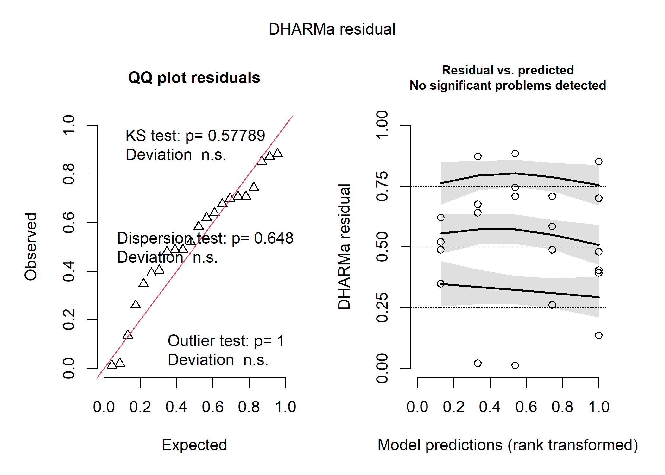

### Yield

yield_simulationOutput <- simulateResiduals(fittedModel = yield_model)  
plot(yield_simulationOutput)

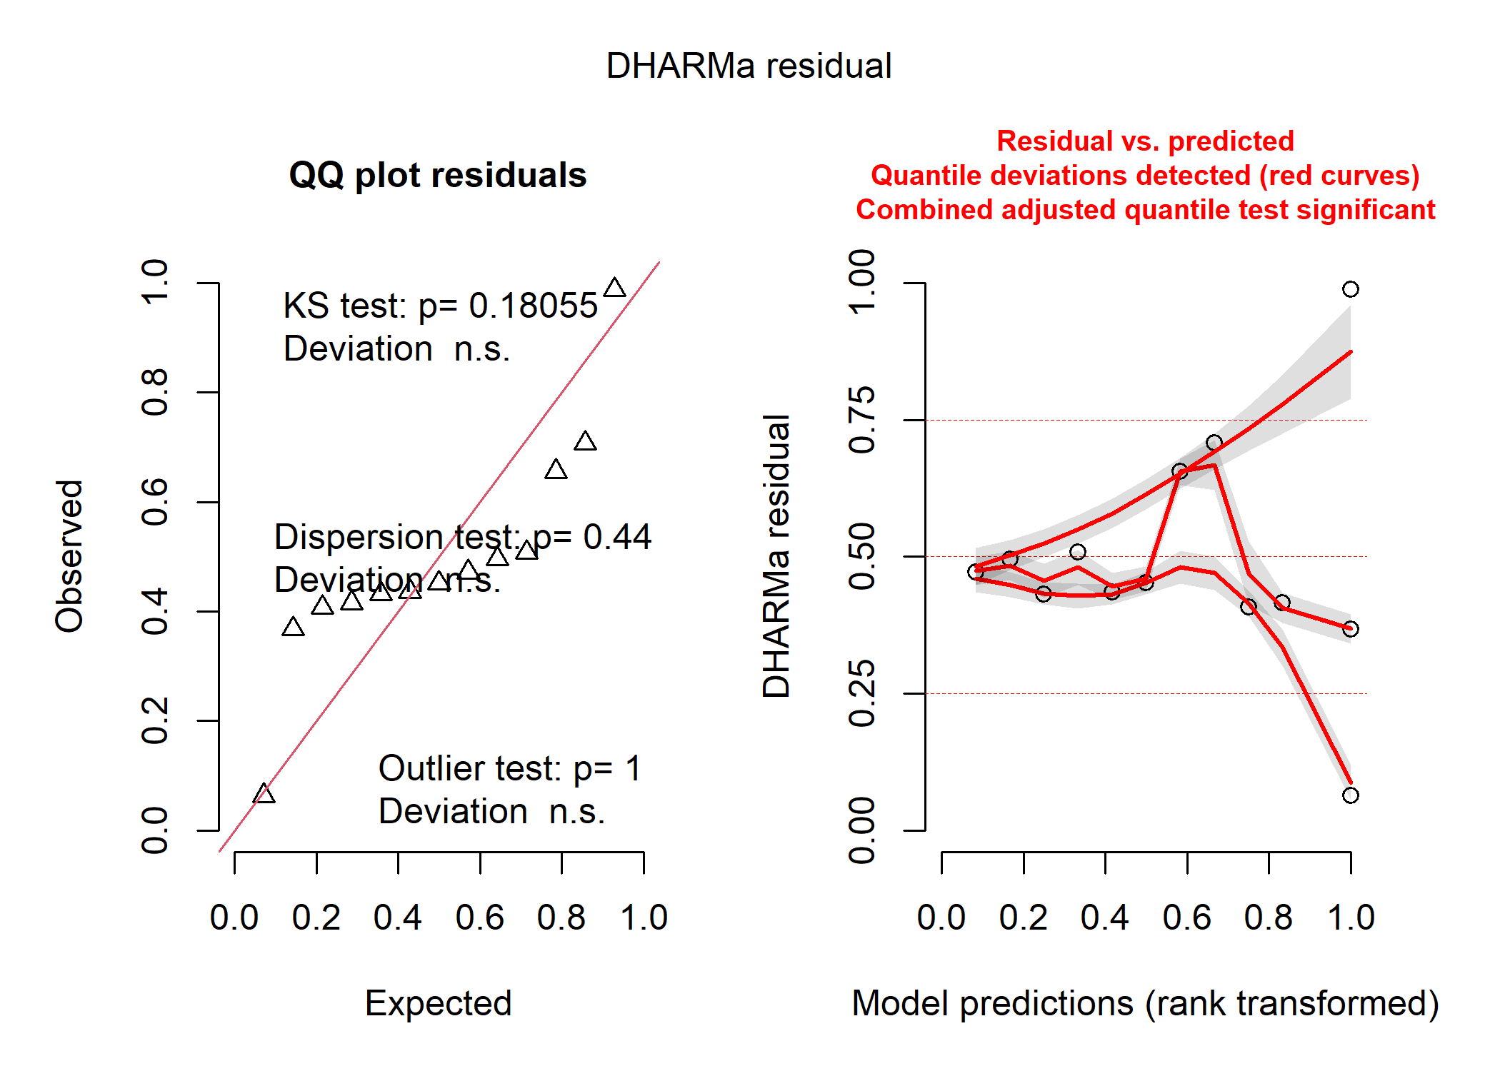

### Nitrogen

nitrogen_simulationOutput <- simulateResiduals(fittedModel = nitrogen_model)  
plot(nitrogen_simulationOutput)

