CST 370 Design and Analysis of Algorithms

Spring 2020

Quiz 0 (Sample Quiz)

Name: __________________________________________

Four-digits ID: ___________________________________

- This is a closed book exam. You can’t use a calculator during the exam.
- If possible, enter your answers directly into the Word file to increase the readability of your answers. However, if it is too difficult or time consuming to type in a Word file, please write down your answer on paper. Then, take a picture and insert the picture into the Word file.
- During the exam, you must stay in the Zoom session and turn on the video. However, turn off the audio on your computer. We record the whole session.
- If you have a question during the exam, please use “Chat” in Zoom. I will answer to your question using “Chat”.
- When you finish the exam, submit your Word file (and optional PDF file) on the iLearn. Keep the Word file well in case we need it.
- Use your time wisely—make sure to answer the questions you know first.
- Read the questions carefully.

1. (2 points) For the following two questions, indicate your answer (= either true or false) clearly.

(a) Is this a binary search tree? (True/False)
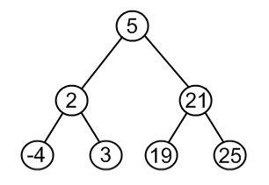

(b) Is this a binary search tree? (True/False)

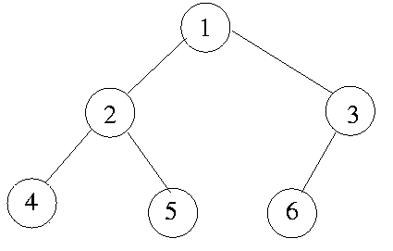

2. (3 points) Draw a binary search tree with five nodes (= vertices).

