Introduction
This document serves as an overview and comparison of the current existing genome browsers and visualization tools.

IGV
- A general purpose free and open-source interactive genome browser,
- designed to look at individual reads, check variants by eye and view one locus at time,
- reads BAM / CRAM files with .bai / .crai indexes + 30 other formats (SAM, bigwig, bedGraph, WIG, TDF, BED, bigBed, SEG, VCF, FASTA …),
- alignments load within a small window (30 kb by default) and a whole chromosome view needs pre-computed coverage (igvtools count),
- reads with MAPQ 0 are drawn hollow and reads can be shaded by MAPQ,
- coverage tracks can be overlaid, several samples are stacked tracks,
- outputs are images (PNG / SVG) and saved views (xml) and BED regions of interest,
- no sequence-class track (PAR, XTR, XDR, ampliconic, palindromes),
- igv.js (interactive genome visualization component) can be embedded in the app:
  - chromosome ideogram with current position marker,
  - search box for gene names or coordinates,
  - pan by dragging and zooming,
  - several regions side by side,
  - coverage and signal,
  - annotations, variants, mutations, copy number,
  - alignment track:
    - coverage track,
    - reads with strand arrows
    - mismatches, insertions, deletions,
    - sorting and grouping reads,
  - exports as SVG, saves session as JSON or URL,
- sources:
  - https://igv.org/doc/desktop/
  - https://igv.org/doc/desktop/UserGuide/tools/igvtools_ui/
  - https://igv.org/doc/desktop/UserGuide/loading_data/
  - https://igv.org/doc/desktop/#FileFormats/DataTracks/
  - https://igv.org/doc/desktop/#UserGuide/tracks/alignments/viewing_alignments_basics/
  - https://igv.org/doc/desktop/#UserGuide/regions/
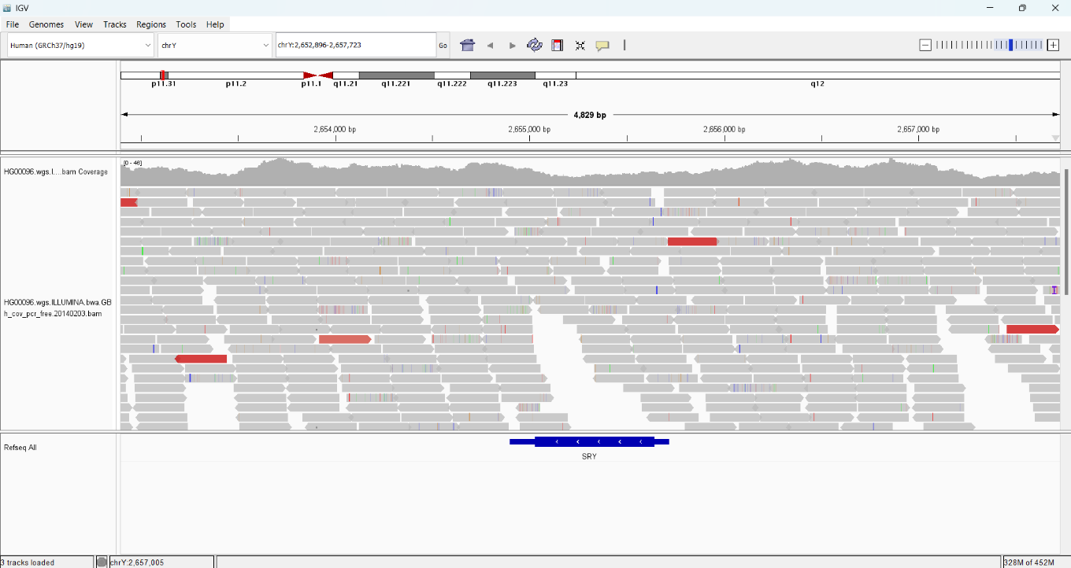

UCSC Genome Browser
- A web-based, server-side genome browser,
- annotation tracks: mappability and problematic regions,
- coverage graph of my own data (BED, bedGraph, bigwig, BAM, CRAM),
- multiple samples,
- outputs are PDF / PS images or stored sessions,
- big files cannot be uploaded, must sit on a public web server,
- no whole-chromosome read view,
- the richest set of annotations,
- sources:
  - https://genome.ucsc.edu/goldenPath/help/customTrack.html
  - https://genome.ucsc.edu/goldenPath/help/hgTracksHelp.html
  - https://genome.ucsc.edu/goldenPath/help/hgTablesHelp.html
  - https://github.com/marbl/CHM13
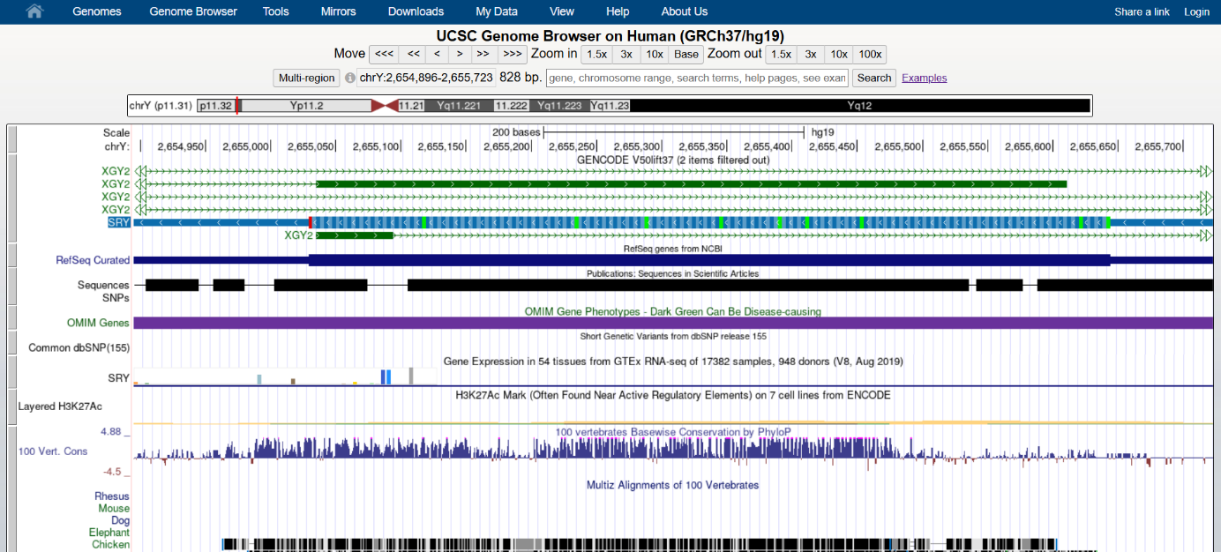
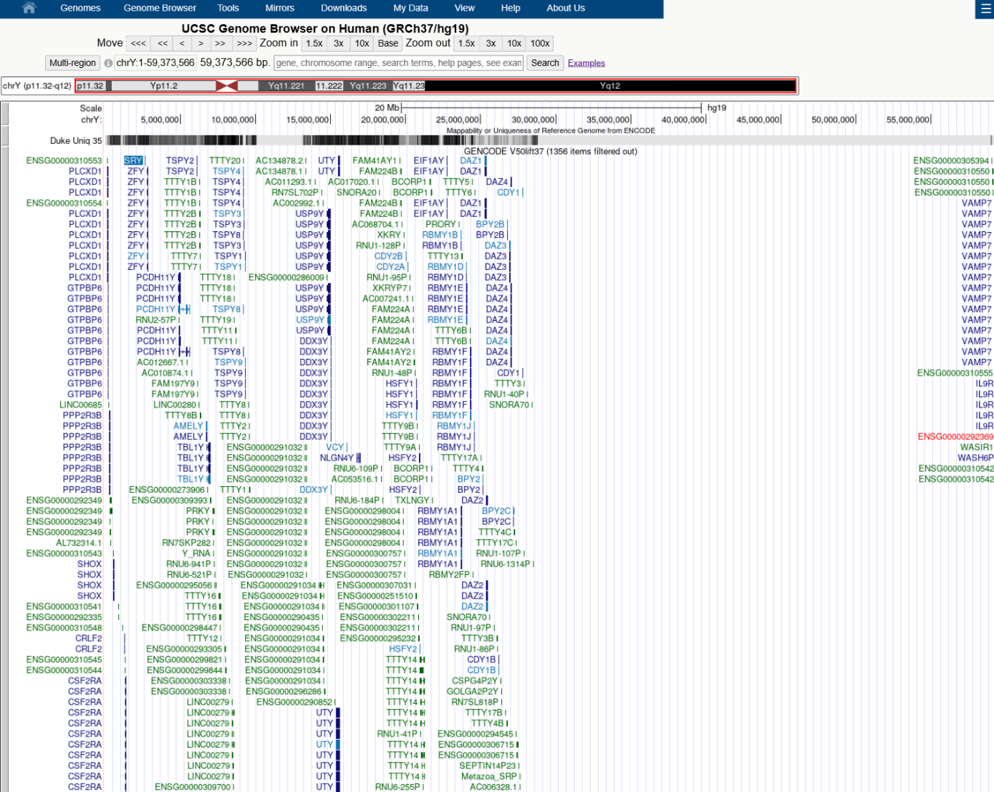

Samtools
- A set of command line tools for working with SAM, BAM and CRAM formats,
- not a viewer (no graphical interface) but tool for processing and calculating,
- reads files locally or from URL and output is text or a new BAM file,
- can show numbers and tables, ASCII histogram, a text display of reads, no mouse interaction,
- fast and can process several samples at once, data stays local,
- sources:
  - https://www.htslib.org/doc/samtools-coverage.html
  - https://www.htslib.org/doc/samtools-depth.html
  - https://www.htslib.org/doc/samtools-bedcov.html
  - https://www.htslib.org/doc/samtools-stats.html
  - https://www.htslib.org/doc/samtools-tview.html
  - https://academic.oup.com/gigascience/article/10/2/giab008/6137722
  - https://academic.oup.com/bioinformatics/article/25/16/2078/204688
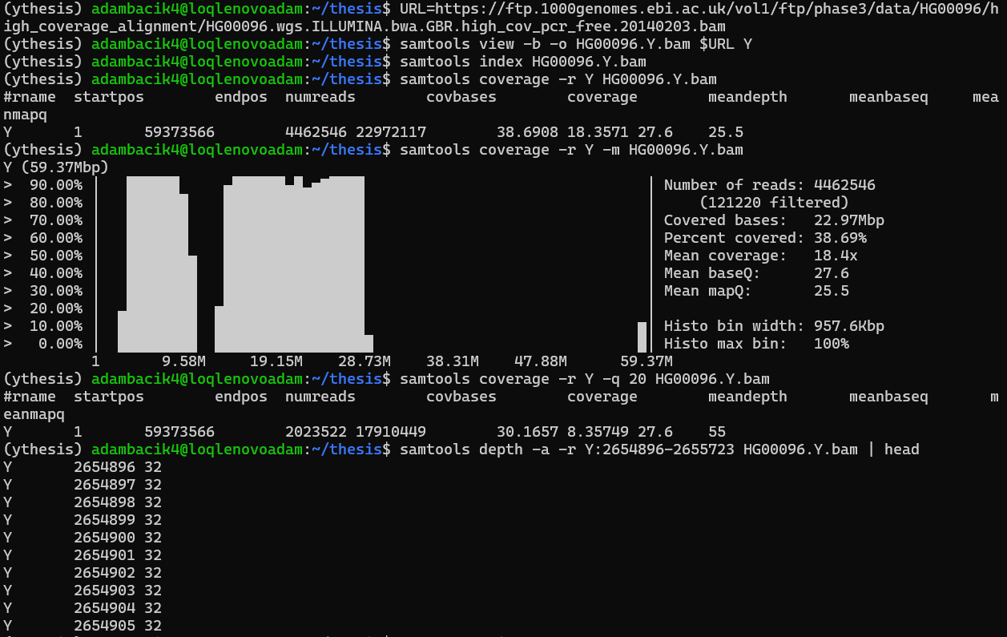
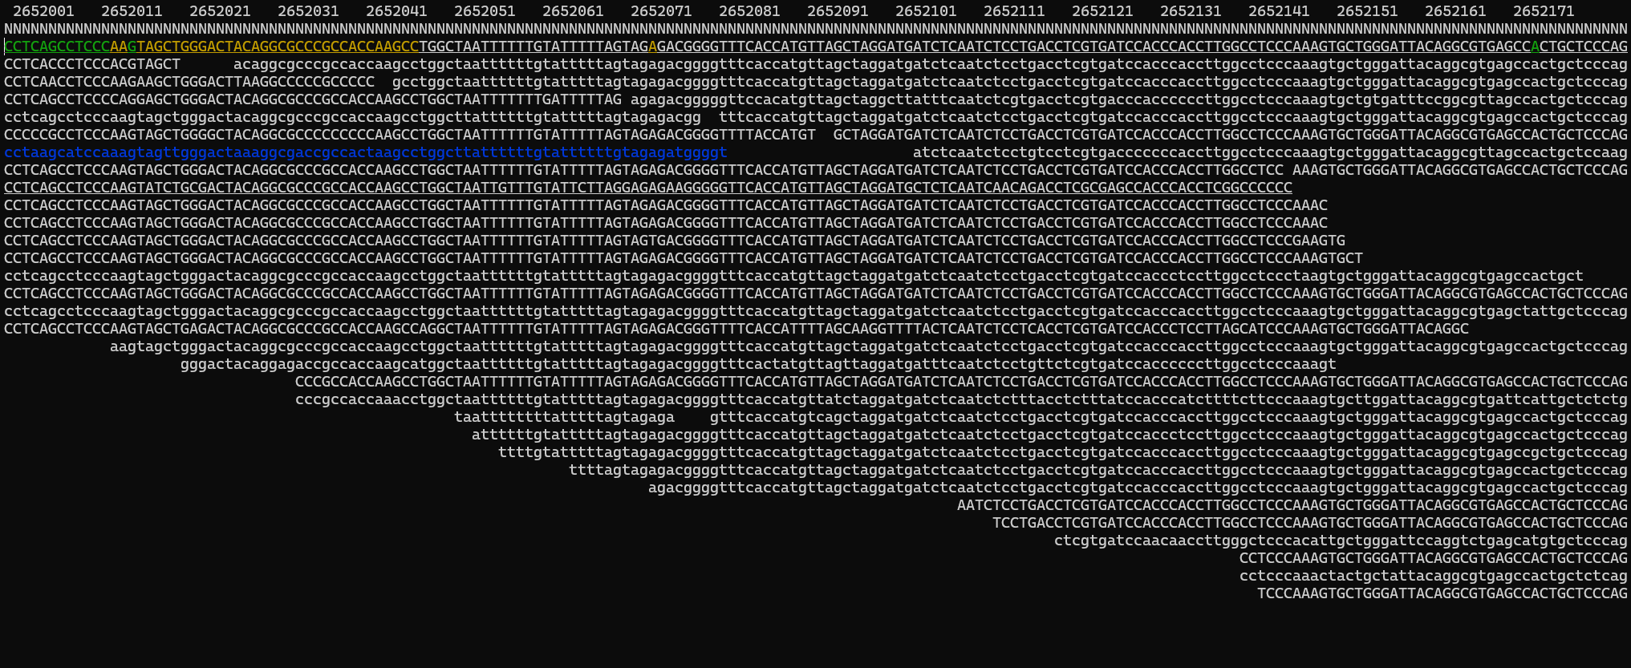

Comparison
 | IGV | UCSC | Samtools | ycov (planned)
Several samples at once | YES | YES | YES | YES
Jump to a region or gene | YES | YES | PARTIAL | YES
Images export | YES | YES | NO | YES
CSV export | NO | PARTIAL | YES | YES
HTML report | NO | NO | NO | YES
BED export | PARTIAL | PARTIAL | PARTIAL | YES
PDF export | NO | YES | NO | YES
Y chromosome sequence classes | NO | NO | NO | YES
Whole chromosome in one view | PARITAL | PARTIAL | PARTIAL | YES
MAPQ filtering / display | YES | YES | YES | YES
Statistics | NO | NO | YES | YES
Detection | NO | NO | NO | YES
Low memory use | NO | YES | YES | YES
Normalization | NO | NO | NO | YES
Summaries | NO | NO | PARTIAL | YES
Data stays local | YES | NO | YES | YES
Read-level view | YES | YES | PARTIAL | PARTIAL
Interactive interface | YES | YES | NO | YES
Load own data | YES | PARTIAL | YES | YES

