Introduction
This document summarises the key paraphrased information from the appropriate sources, limited to what is needed for the thesis. Each section summarises one source. The last section lists terminology.

Colaco & Modi (2018): Genetics of the human Y chromosome and its association with male infertility
https://rbej.biomedcentral.com/articles/10.1186/s12958-018-0330-5
Y chromosome: an acrocentric chromosome with a short arm (Yp) and a long arm (Yq) separated by a centromere, with a pseudoautosomal region at each tip.
Regions of the Y chromosome:
- Pseudoautosomal regions (PARs): PAR1 at the tip of Yp (~2.6 Mb) and PAR2 at the tip of Yq (~320 kb). They are homologous to the ends of the X chromosome. Their sequence is shared by X and Y.
- Male-specific region (MSY), formerly called the non-recombining region (NRY): the part between the PARs, which does not recombine with the X. It has two parts:
  - Heterochromatic region: the distal part of Yq, made up of the highly repetitive sequence families.
  - Euchromatic region: the short arm, the centromere and the proximal long arm. It contains the Y-linked genes, and its sequences fall into three classes: X-transposed, X-degenerate and ampliconic. The ampliconic class is organised into large palindromes.
- AZF regions (AZFa, AZFb, AZFc): three intervals on Yq that are recurrently deleted in infertile men, i.e. typical examples of partial Y loss.
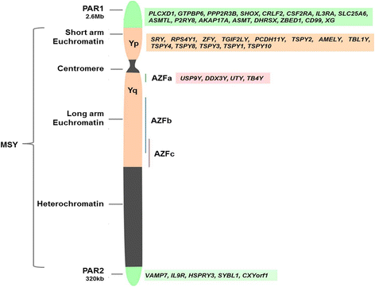
Figure 1: Structure of the human Y chromosome. Source: Colaco & Modi (2018).

Skaletsky et al. (2003): The male-specific region of the human Y chromosome is a mosaic of discrete sequence classes
https://www.nature.com/articles/Art39
The euchromatic part of the MSY (~23 Mb) is "a mosaic of heterochromatic sequences and three classes of euchromatic sequences: X-transposed, X-degenerate and ampliconic" (Skaletsky et al., 2003). The classes differ mainly in how repetitive they are, which determines how reliably reads can be mapped to them:
- X-transposed (~3.4 Mb): about 99% identical to a region of the X chromosome, so reads may map to X instead of Y.
- X-degenerate (~9 Mb): single-copy sequence with unique content, so reads map reliably. It is the best baseline for coverage.
- Ampliconic (~10.2 Mb): repeated segments whose copies are more than 99.9% identical, including eight palindromes (P1–P8, 5.7 Mb in total) with arm-to-arm identity of 99.94 - 99.997%. Reads cannot be assigned to a unique copy, so coverage there is unreliable.
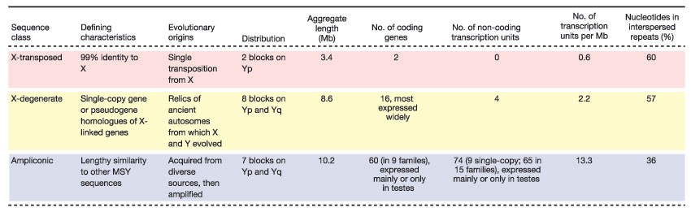
Figure 2: The three sequence classes of the MSY euchromatin (X-transposed, X-degenerate, ampliconic). Source: Skaletsky et al. (2003), Fig. 4.

Rhie et al. (2023): The complete sequence of a human Y chromosome
https://www.nature.com/articles/s41586-023-06457-y
The Y chromosome in the widely used GRCh38 reference is incomplete: it lacks more than half of the chromosome's sequence, including most of the heterochromatin and parts of the ampliconic regions. In 2023, the Telomere-to-Telomere (T2T) Consortium published the first complete Y chromosome (T2T-Y, 62.46 Mb), which adds over 30 Mb of missing sequence and corrects errors in GRCh38 (Rhie et al., 2023). In T2T-Y, the X-degenerate and ampliconic regions span 8.67 Mb and 10.08 Mb, and PAR1 and PAR2 span 2.77 Mb and 0.33 Mb. Because the two references differ in length and coordinates, annotations and results from one cannot be used directly with the other.
Short reads map better to T2T-Y: across 1,233 male genomes from the 1000 Genomes Project, on average 1.4 million more reads per sample were mapped than with GRCh38. In standard analysis references the Y-chromosome PARs are masked, so reads from the PARs are aligned to chromosome X and read depth in the Y PARs is expected to be zero even when the region is present.
Resources for the tool:
- T2T-CHM13v2.0 (including T2T-Y) is available via the UCSC Genome Browser (assembly hs1) and https://github.com/marbl/CHM13.
- The sequence-class annotation of T2T-Y is in Supplementary Table 21 of the paper.
- The reference used by a data file can be recognised from the chrY length: 57,227,415 bp in GRCh38, 62,460,029 bp in T2T.

Illumina: Sequencing coverage for NGS experiments (web page)
https://www.illumina.com/science/technology/next-generation-sequencing/plan-experiments/coverage.html
The Lander/Waterman equation is a method for computing genome coverage. The general equation is: C = LN / G
- C stands for coverage
- G is the haploid genome length
- L is the read length
- N is the number of reads
The equation originates from Lander & Waterman (1988). Because the Y chromosome is present in a single copy in males, its expected depth is about half of the autosomal depth (e.g. ~15× in a 30× genome), which is the basis for normalising Y-chromosome coverage between samples.
Note: web source from a sequencing company. In the thesis, cite Sims et al. (2014) for coverage definitions and Lander & Waterman (1988) for the equation.

Biological and technical loss
Loss of Y-chromosome sequence has real biological consequences: deletions in the male-specific region are among the most common known genetic causes of male infertility (Skaletsky et al., 2003). Three intervals on the long arm (AZFa, AZFb, AZFc) are recurrently deleted, and such microdeletions are found in about 7% of infertile men (Colaco & Modi, 2018). Partial deletions inside AZFc (e.g. gr/gr, b2/b3) arise from recombination between the near-identical ampliconic repeats (Kuroda-Kawaguchi et al., 2001). They lie in the regions where coverage is hardest to interpret. In ageing men, the whole Y chromosome can also be lost from a fraction of blood cells (mosaic loss of Y, mLOY), which lowers the read depth along the entire Y (Forsberg et al., 2014).
A decrease in read depth does not necessarily indicate that DNA is missing. Coverage in short-read sequencing is not uniform, and regions with low mappability receive fewer reliably aligned reads (Sims et al., 2014). On the Y chromosome, this affects a large part of the sequence. Reads from the ampliconic and palindromic regions cannot be assigned to a unique copy and reads from the X-transposed region may align to the X chromosome, because of the high sequence identity described by Skaletsky et al. (2003). Reads from the pseudoautosomal regions are, by convention, aligned to chromosome X, and sequence that is absent from the GRCh38 reference cannot be analysed at all (Rhie et al., 2023). In all these cases, low read depth reflects a technical limitation rather than a genuine loss of DNA.
Visualizing Y-chromosome coverage requires distinguishing genuine sequence loss from technical loss of information caused by repetitive sequence and reference limitations. This distinction is a central requirement for the tool developed in this thesis.

Terminology box
- Read depth: the number of aligned reads overlapping a given position (Illumina).
- Mapping quality (MAPQ): the aligner's confidence that a read is placed correctly. Reads that fit several positions equally well receive MAPQ 0 (Li et al., 2009).
- Sequencing depth (average depth of coverage): defined theoretically as LN / G, where L is the read length, N is the number of reads and G is the haploid genome length. It describes the whole sample, e.g. "30×" (Sims et al., 2014).
- Breadth of coverage: the percentage of target bases that have been sequenced a given number of times (e.g. 95% of bases covered at ≥10×). A deleted region has zero breadth depth (Sims et al., 2014).
- Factors affecting depth: depth of coverage is affected by the accuracy of the alignment algorithm and by the uniqueness, or mappability, of reads within the target genome. Reads from repetitive sequence cannot be placed uniquely, so such regions show reduced or unreliable depth. This applies directly to the ampliconic and X-transposed regions of the Y chromosome (Sims et al., 2014).
- Sequencing coverage: the average number of reads that align to, or "cover", the bases of the reference (Illumina).
- Mapped read depth: the number of bases sequenced and aligned at a given reference position (Illumina).
- Mean read depth: the sum of these depths over all reference positions divided by the number of known reference bases. Human whole-genome sequencing is typically performed at 30 – 50 × mean depth (Illumina).

