Introduction
This document is a short overview of the technical de–sign of the software ycov, which turns the requirements and description in software_specification.docx into architecture. The overview covers intended technology to be used both in frontend and backend, specifies main components of the code, shows initial repository structure, describes intended data structure, API architecture.

Architecture overview
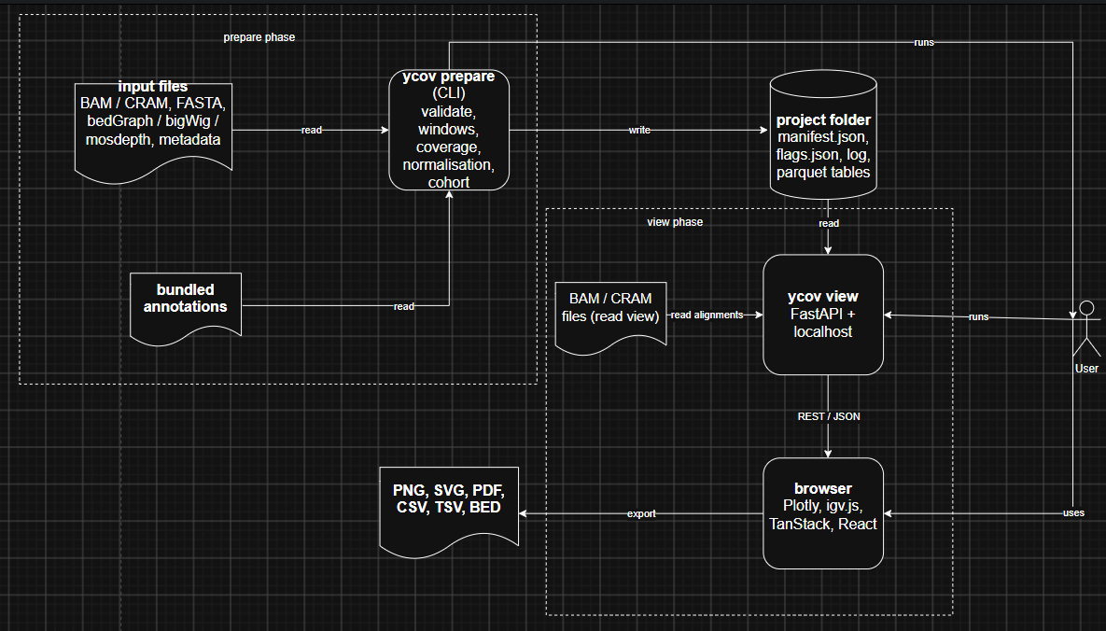

Use case diagram
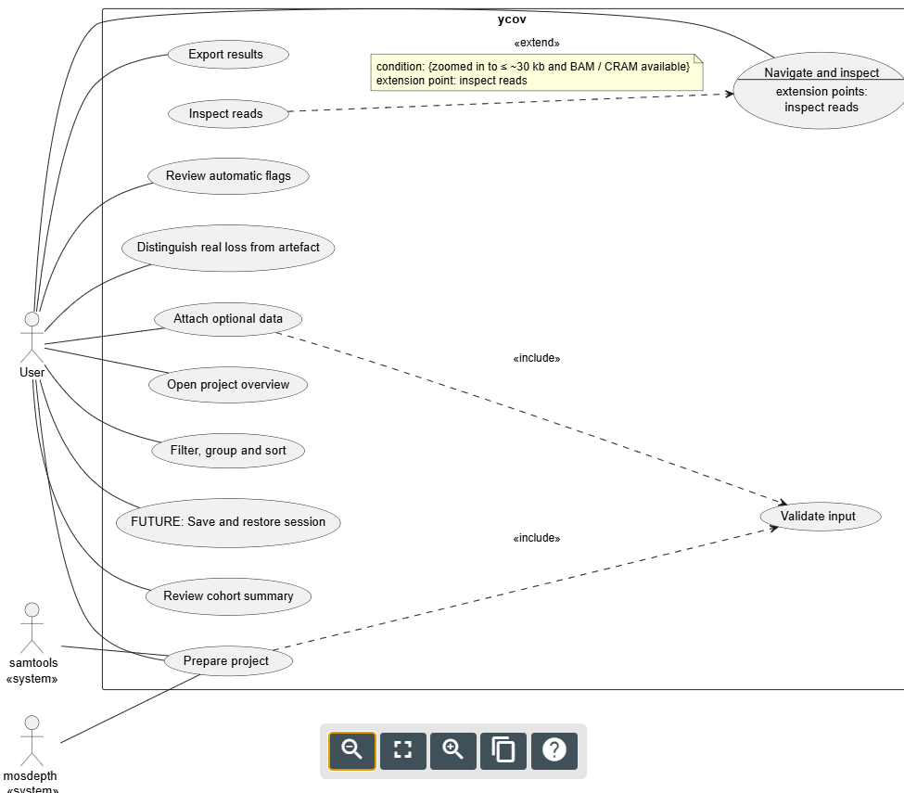
ID | Name | Description
UC01 | Prepare project | User runs `ycov prepare` on BAM/CRAM files (with indexes) or on precomputed coverage files. The system validates the inputs, computes, normalises and annotates coverage, computes summaries and flags, and saves everything into a project folder. Includes UC12.
UC02 | Review cohort summary | User reviews per-sample, per-class statistics as a table and boxplots and the sample-level X and Y ratios.
UC03 | FUTURE: Save and restore session | User saves the current view (region, selected samples, grouping, toggles …) and opens it again later.
UC04 | Filter, group and sort | User hides or selects samples, groups them by a metadata column and sorts them. Ordering by clustering is future work.
UC05 | Open project overview | User runs `ycov view` to see all samples across the whole chrY at once in browser.
UC06 | Attach optional data | User supplies an optional CSV/TSV file with sample ID, population, age, phenotype etc., so samples can later be filtered and grouped. Includes UC12.
UC07 | Distinguish real loss from artefact | User switches the MAPQ filter and the normalisation mode and checks reliability marks to decide whether low coverage means missing DNA or region not assessable on chrY.
UC08 | Review automatic flags | User reviews a list of warnings about suspicious coverage (deletion candidate, known-region loss, possible mLOY, sex check, low confidence, outlier sample) and jumps to a flagged region.
UC09 | Export results | User exports figures (PNG / SVG / PDF), tables (CSV / TSV), flagged regions (BED). The single HTML file report is future work.
UC10 | Navigate and inspect | User zooms and pans, or jumps to a coordinate, gene, sequence class or named region and inspects region (coverage lines with gene, mappability and sequence-class tracks).
UC11 | Inspect reads | User examines a selected region more closely: shows reads zoomed in to ≤ ~30 kb and BAM / CRAM available. Extends UC10.
UC12 | Validate input | Included in UC01 and UC06: the system checks input files and reports problems before any processing.

Technology stack

backend
Purpose | Technology | Reason | Alternative
programming language | Python | standard in bioinformatics, has got pysam, polars, numpy.. | R, Rust
CLI | Typer | less code, argument parse is verbose | Click
web server | FastAPI + Uvicorn | built-in OpenAPI and data validation | Django
tables | polars | faster and lower memory usage | pandas
numerics and statistics | numpy, scipy | alternatives need more dependencies | scikit-learn
BAM / CRAM | pysam | direct access without parsing output text | samtools via subprocess
coverage | mosdepth | the fastest | samtools depth
bigWig | pyBigWig | widely used | pybigtools
intervals | bioframe | works on ordinary tables | pyranges, pybedtools
config file | TOML | built into Python with comments | YAML, JSON
terminal output | rich | progress bars, coloured warnings and tables | tqdm

frontend
Purpose | Technology | Reason | Alternative
framework | React | most used framework on top of TypeScript (Plotly and igv.js is mounted manually) | Vue, Svelte, Dash
build tool | Vite | fast and simple way to produce static files | webpack
styling | Tailwind CSS | previous experience, used in shadcn/ui | plain CSS
UI components | shadcn/ui | ready dropdowns and buttons build on Tailwind CSS | MUI
charts | Plotly.js / react-plotly.js | build-in PNG / SVG export, interactive heatmap and boxplots | Apache ECharts
read view | igv.js | reusable components, mounted manually | JBrowse 2 React view
tables | TanStack Table | filterable, sortable summary and flag tables | AG Grid
server data | TanStack Query | catches | SWR, plain fetch
UI state | zustand | simple shared state | Redux Toolkit, React Context
API types | openapi-typescript | Generates types from FastAPI’s schema | orval

quality
Purpose | Technology | Reason | Alternative
packaging | uv + pyproject.toml | fast + handles environments and packaging in one tool | pip + venv
CI | GitHub Actions | project repo will be located on GitHub | GitLab CI
tests on frontend | Vitest and Playwright | Jest and Cypress | Vitest works natively with Vite, Playwright tests several browsers
lint / format | ruff | one tool instead three | flake8 + black + isort
Python tests | pytest | good plugins, less code | unittest
backend type checking | mypy | the most established in scientific Python | pyright
documentation | MkDocs Material | simple, writes in markdown | Sphinx

Main components
Component | Location | Responsibility
CLI | /src/ycov/cli | `prepare` and `view` commands
Web server | /src/ycov/server | FastAPI app, API endpoints, exports
Project I/O | /src/ycov/project | writes, reads project folder and manifest
Summary and flags | /src/ycov/analysis | statistics, summaries, flags
Coverage and normalization | /src/ycov/coverage | computes coverage and normalizes
Validation | /src/ycov/validate | validates inputs
Windows and annotation | /src/ycov/windows | creates windows grid, reliability and sequence classes
Frontend UI | /web/src/components | UI components
Frontend API | /web/src/api | API

Initial repo structure
ycov/
src/
ycov/
analysis/
coverage/
server/
cli/
project/
annotations/
validate/
windows/
web/
src/
components/
api/
state/
tests/
scripts/
example_data/
docs/
README.md
LICENSE
CITATION.cff
.gitignore
.github/workflows/ci.yml

Data design

Project folder structure
my_project/
manifest.json
ycov.log
samples.parquet
windows.parquet
coverage/
coverage_1kb.parquet
coverage_10kb.parquet
summary.parquet
flags.json
annotations/
sequence_classes.bed,
regions.bed (AZF and PAR),
genes.gtf,
mappability.bw

Table schemas
Table | One row | Columns | Purpose
samples | one sample | sample_id, source file, input type, Y ratio, X ratio, QC status, metadata, baseline depth | sample list, filtering, sorting, grouping in UI
windows | 1 kb window on chrY | chr, start, end, seq class, mappability, genes, AZF region, reliable | shared by all windows as annotation
coverage (one table per every resolution) | one sample in one window | sample_id, chrom, start, end, reads (all / mapq), depth, relative_copy, y_internal, cohort_relative | coverage plots and heatmap
summary (PAR and HET are excluded) | one sample in one sequence class | sample_id, sequence class, mean depth, median depth, relative copy, MAPQ fraction, % windows below threshold, MAPQ-0 fraction | summary panel with boxplots and export

JSON schemas
- manifest.json
  - ycov version
  - created
  - reference
    - build
    - chromosome
    - length
  - parameters
    - window size
    - mapq threshold
    - resolutions
  - list samples
  - status
  - annotations
  - per masked
  - min mappability
  - sex check limits
- flags.json
  - list of flags
    - id
    - sample_id
    - type
    - description
    - severity
    - region
      - chromosome
      - start
      - end
      - name
    - values
      - mean relative copy
      - reliable windows
    - confidence
    - sequence class

API draft
Method | Path | Returns | Purpose
GET | /api/project | manifest | top bar and compatibility check
GET | /api/samples | list of samples | sidebar, sort, group, filter
GET | /api/windows | window annotations | class strip, axis
GET | /api/coverage | array of values per sample, aligned to the windows (region, bins/resolution, mode, mapq, samples) | heatmap and ideograms
GET | /api/summary | per sample x class | summary tables and boxplots
GET | /api/flags | list of flags with severity and confidence | flags window, flag outlines
POST | /api/export | file download | create export tables, BED
GET | /api/tracks/{sample}.bedgraph | bedGraph text | igv.js coverage track
GET | /api/tracks/{name} | BED or bedGraph text | igv.js annotation tracks
GET | /api/files/{sample}/{kind} | file bytes, 206 partial content | igv.js read view
GET | /api/files/reference/{kind} | file bytes, 206 partial content | igv.js reference, CRAM decoding
Errors: 404 for an unknown sample or missing read file, 422 for invalid parameters.

