MORSS Manual

STEP 1:

On the main screen select the Create purchase order button:

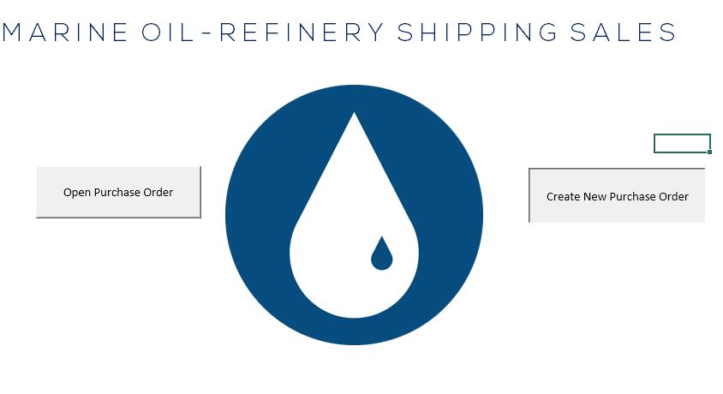

Step 2:

Fill out the Form that appears:

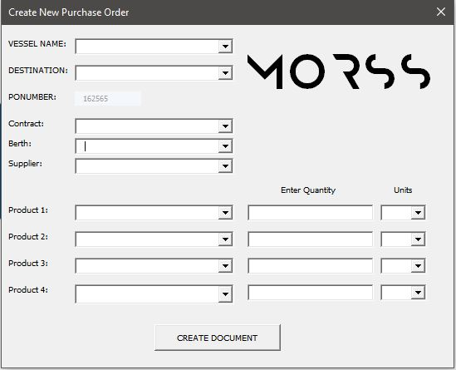

Step 3: Hit Create Document

Step 4: Open the “Open Purchase Order” button:

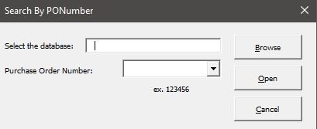

Selecting the database is optional, as if the database is in the same folder as the main document, the PONumber that you just created should show up in the dropdown menu.

Step 5:

Need to select word to open the document, as the document says read only and a file dialogue box appears. This shouldn’t be an issue though.Th

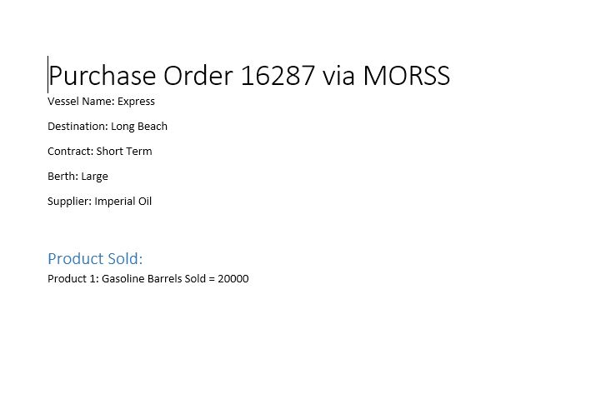

This is an example of what the file should look like. Enjoy!