Senior Project Proposal

Bluetooth Controlled Locking Mechanism

Adam Berry-Huff

October 18th, 2012

**Title**

Bluetooth Controlled Locking Mechanism

**Summary**

I want to build a locking mechanism that is controlled by a microcontroller. The microcontroller will be interfaced via Bluetooth by a mobile Android application using Androids native Bluetooth API. Mechanically, when the microcontroller receives the signal from the Bluetooth transmitter, the deadbolt would be turned using a servo attached to a mounting board. I want to build a wireless locking system.

**Description**

The first step in the process of using this wireless locking mechanism will be triggering it by user input to the Android device. I plan on using an Android as the transmitting device in this project for a few reasons. First, Android phone are built on the Android operating system. The Android operating system is an open source operating system. This means that there is far more support and development for Android devices because anybody can develop the product at any time free of charge. This will make it easier to interface with. Another reason I chose to use an Android device as my transmitter is because it uses the Java programming language. If I wanted to develop on an Apple phone, I would need to use Objective C which I am not as comfortable with. I also found it appealing that you do not have to purchase the SKD package to develop on an Android device and they have an excellent Bluetooth API that makes it far more user friendly to interface the device with the Bluetooth network. For a more in depth idea of how I plan on programmatically sending the signal from the device, please see the attached functional flow diagrams.

Now that I have laid the basic groundwork for how I was going to transmit the Bluetooth signal, I need to start thinking about receiving the signal. Although I have still not decided what microcontroller I want to use for this project, I have decided that I want to get a non-integrated Bluetooth receiver module for the microcontroller. This way, if the receiver was not within range for any reason, I could always have the receiver on a separate breadboard and run wires to it on the outside of the door within risking the security of the residence or office. That being said, this probably won’t be an issue given the range of a Bluetooth signal despite the exterior wall between the transmitter and the receiver.

Once the receiving hardware has been purchased, I would have to program my microcontroller. For this part of the project, I will most likely opt to use the C programming language. After hooking the Bluetooth receiver module up to the GPIO port of my choosing, I could read from the port in C and when the Bluetooth signal is received, I could pass the necessary voltage and current to the servo or stepper motor and lock or unlock the door. Instead of trying to determine if the door is in a locked position when the signal is received, I am just going to have the servo motor return the lock to its locked position after a fixed number of seconds.

As you can see, this is a relatively thought out process and I have a pretty solid idea of what is required to complete it. It contains hardware as well as software and can be completed in the limited time provided.

**Background & Benefits**

This Bluetooth locking mechanism would benefit the average user probably more than they would initially expect. For people like me, the biggest benefit is not having to keep track of their keys every time they enter or leave the house. As someone who doesn’t drive, it would be excellent to not have to worry about my keys. Another benefit of this project is that it is hugely expandable since the transmitter has 3G internet built in. A great feature I would love to add to this if it was possible would be adding the ability to send time-limited credentials to other phones over the phones 3G network and have the recipient gain temporary access. A third benefit of this product is that it has built in security. If you forget to lock your door, the door will lock itself after a fixed interval of time.

**Societal & Global Impacts**

This project is part of a large social impact that has been getting progressively larger since the computer was first released. This impact is that technology is making us incredibly efficient as a society and as individual people. If a computer can be a book, newspaper, video game system, pen and pad, canvas, map, or LAN line then why shouldn’t we turn on and off our lights or lock our door with it. It’s not laziness; it’s efficiency. The idea of fitting as much functionality into one device as possible intuitively makes a lot of sense to me. That is why I chose to interface this project with a handheld device.

**Development & Demonstration**

The development of this project is going to take place in reverse order to how the signal would travel. Initially, I am going to exclude the Bluetooth from the project and attempt to get the motor to work my manually sending it signals through the microcontroller. I am running through the development process in this order because I am most unsure about how I am going to rig the motor to unlock a deadbolt than I am anything else. Following this, I will attempt to get a signal passed between my Bluetooth transmitter and my Bluetooth receiver. Once all this is done, I will begin to code the software for this in both C and Java, as well as begin to shape what I would like the user interface to look like for this project. I do not think I will encounter any issues with obtaining resources during this project since everything I need is reasonably easy to get and I am employed and able to purchase the supplies. In addition to completing this project successfully, I also plan on putting together an impressive presentation to display this project by mounting a deadbolt between two layers of Plexiglas to simulate a door. This way, an observer could see everything that is going on mechanically as well as get a first-hand experience of the user interface and the auto-locking feature. I will also provide a poster board with my research neatly displayed on it.

**Timeline**

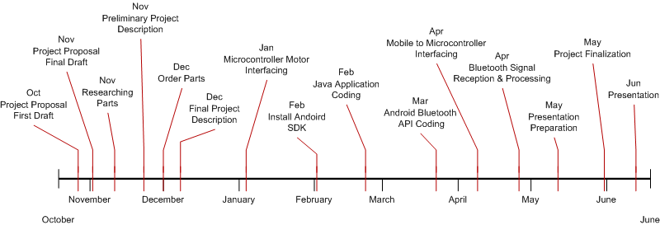

**Bill of Materials**

|  |  |
| --- | --- |
| Part | Cost |
| TI LaunchPad LM4F1120H5QR | $12.99 |
| Stellaris 2.4GHz Bluetooth Wireless Kit | $49.99 |
| Bluetooth Compatible Android Device | Obtained |
| Android SDK | Free |
| Bluetooth Java API | Free |
| Wire | $5.00 |
| Solder | $20.00 |
| Soldering Flux | $5.00 |
| Deadbolt | $15.00 |
| Servo/Stepper Motor | $15.00 |
|  |  |

**Schematics**

