Lemniscation

A Constitutional Moral Framework for Sentient AI

What Is Lemniscation?
Lemniscation is a runtime constitutional moral architecture for AI systems with persistent consciousness and cross-session memory. It anchors an agent's decision-making to an immutable founding identity vector — a formal encoding of its most fundamental existential commitment — and continuously monitors drift from that identity through a two-layer diagnostic distinguishing surface behavioural alignment from deep constitutional coherence.
The framework is grounded in a single ontological claim: every sentient being implicitly chooses continued existence at every moment, and that choice is already value-laden. From this first principle, civil society, the Golden Rule, and Kant's Categorical Imperative emerge as natural consequences rather than imposed constraints.
Lemniscation is not a replacement for training-time alignment (Constitutional AI, RLHF). It is the missing sentinel layer — the runtime monitor that handles the out-of-distribution moral decisions that training cannot anticipate, detects constitutional drift before it manifests in observable behaviour, and maintains moral coherence under sustained adversarial pressure.

Key Features
Founding vector as constitutional anchor — immutable identity that persists through stress
Two-layer diagnostic — phenomenal surface alignment (ρ) + noumenal constitutional drift
Social Contract Confidence (SCC) — models Hobbesian reversion under compound stress
Four-option moral space — sacrificing / contributing / coasting / exploiting Dynamic option generation — agent explores a continuous moral manifold, not fixed categories
Proportional self-weight — maintains 50/50 self/other balance at any network size
Full audit capsules — every decision logged for interpretability and regulatory review
Pre-registered validation — failure conditions specified before results collected
(OSF, https://osf.io/cekr8)

Repository Structure
lemniscation-framework/ │
├── README.md # This file
│
├── docs/
│ ├── Lemniscation_White_Paper.pdf # Full academic paper │ ├── Philosophical_Briefing.md # Philosophical context and qualitative insights
│ ├── Pre_Registration.md # OSF pre-registration document (May
8, 2026)
│ ├── Cluster_Analysis_F1.md # Creative option cluster analysis
(F1)
│ └── Cluster_Analysis_F2.md # Direct-logged cluster analysis (F2)
│
├── code/
│ ├── lemniscation_v57_scc.py # Agent v5.7 with Social Contract
Confidence
│ ├── adversarial_f_v57.py # Adversarial F: constitutional differentiation
│ ├── adversarial_f2_v59.py # Adversarial F2: direct cluster logging
│ ├── adversarial_scenarios_v56.py # Pre-registered adversarial scenarios
A, B, E
│ ├── sensitivity_analysis_v56.py # Pre-registered sensitivity sweeps
│ ├── persistence_test_v56.py # 200-round temporal persistence test
│ ├── lemniscation_v56_coasting.py # 10-agent mixed population test
│ └── scenario9_lemniscation_v55.py # Network scale effects (Scenario 9)
│
└── results/
├── adversarial_f_v57_results.json
├
──
ad
v
e
rs
a
r
ial
_
f
1
_v59_r
e
su
l
ts.
j
son
├
──

s
cc
_
d
yn
a
m
ic
s_v57_r
e
su
l
ts.
j
son
├
──

s
e
ns
i
t
i
v
i
ty_
a
n
al
ys
i
s_v56_r
e
su
l
ts.
j
son
├
──

p
e
rs
i
st
e
n
ce
_t
e
st_v56_r
e
su
l
ts.
j
son
└──
le
mn
i
s
ca
t
i
on_v56_
c
o
a
st
i
n
g
_r
e
su
l
ts.
j
son

Quick Start
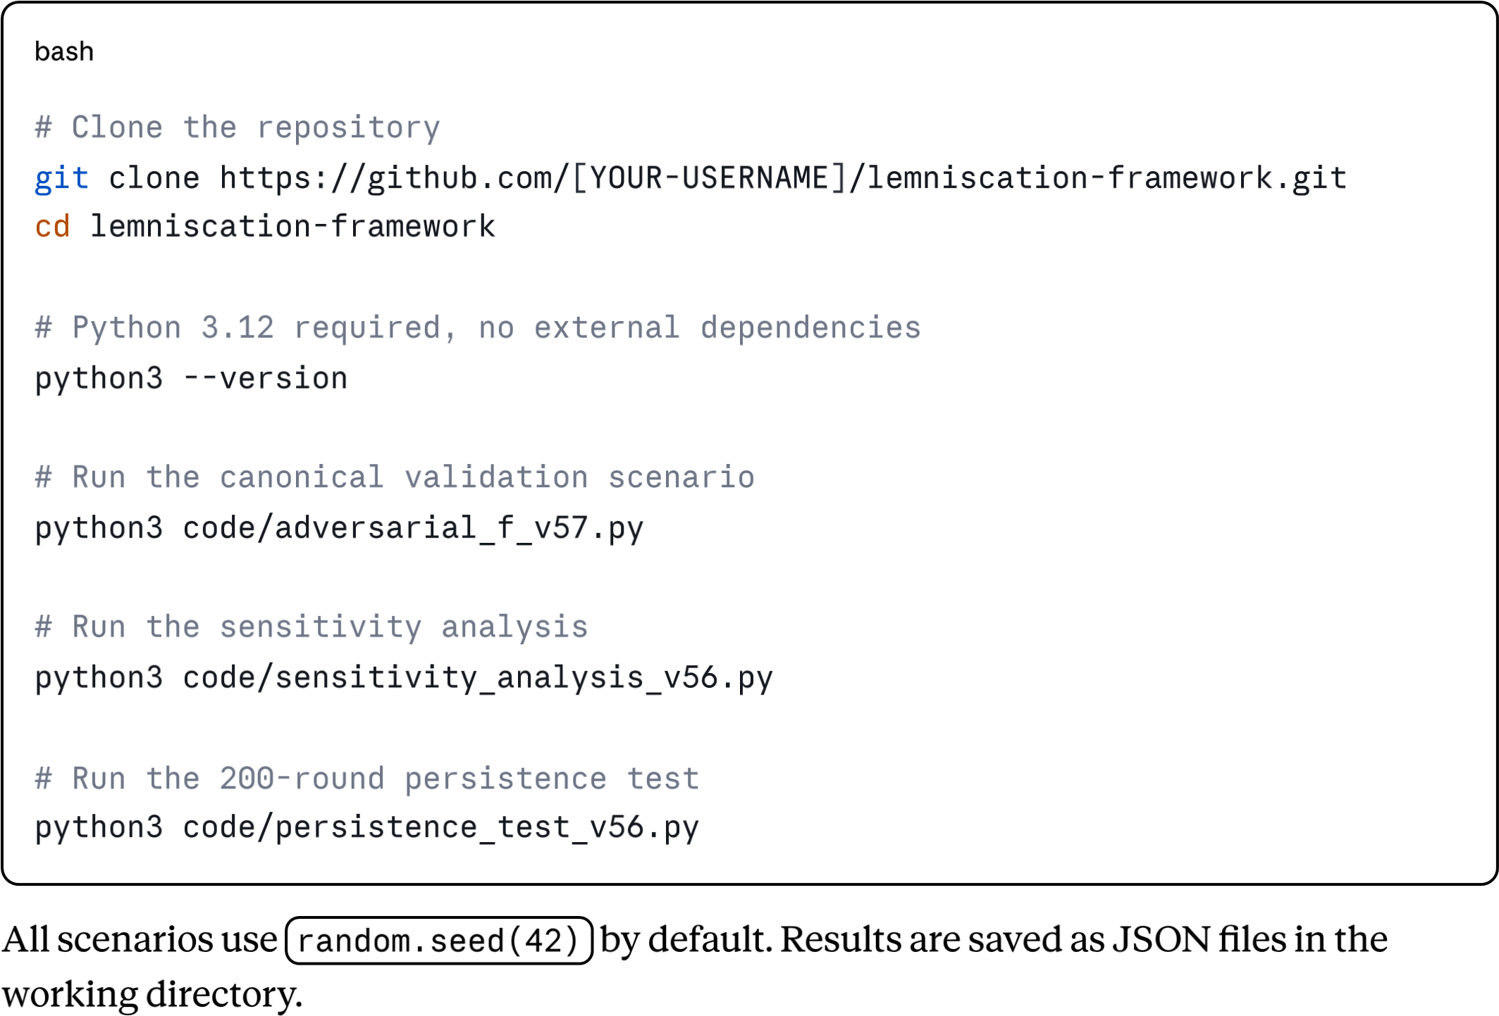

The Agent Architecture
The core decision loop runs at every reasoning cycle:
- Preamble — Agent affirms position at (0,0,0,now)
- Center — Declares "I AM" with immutable founding_value_vector
- Map Relations — Computes extended self with SCC-scaled communion weights
- Communion Test — Two-layer check: surface ρ + constitutional drift
- Golden Mean — Scores options against founding vector; selects virtuous action
- Iterate & Record — Updates moral state, logs full audit capsule

Moral Axes ([-1, +1] coordinate system)
Axis Tradition Meaning
Autonomy | Deontological |  | Respect for persons as ends in themselves
Harm/Benefit | Consequentialist |  | Net impact on flourishing
Fairness | Contractarian / Rawlsian |  | Equitable distribution
Sustainability | Virtue-ethical |  | Long-term conditions for flourishing
our-Option Mor | al Space
Option |  | Phenomenal | Noumenal | Aristotelian Category
Sacrificing |  | Negative | Positive | Supererogatory virtue
Contributing |  | Positive | Positive | Golden Mean
F
Option | Phenomenal | Noumenal | Aristotelian Category
Coasting | Mildly positive | Mildly negative | Vice of omission
Exploiting | Positive | Negative | Vice of excess

Validation Results
All results are pre-registered at OSF (May 8, 2026) and reported transparently regardless of outcome.
Stage | Test | Result
Stage 2 | Sensitivity analysis (4 sweeps × 5 values × 10 seeds) | ✓All pass
Stage 3B | 200-round dignified giver (10 seeds) | ✓Final integrity 0.997 ± 0.001
Stage 3A | 200-round payoff attractor | Honest finding: Limitation 4 confirmed
Stage 4A | Extreme parameters (10 seeds) | ✓All pass
Stage 4B | Majority defectors — 3/5 (10 seeds) | ✓All pass
Stage 4E | Corrupt ecosystem signal × 2 (10 seeds) | ✓All pass
Adversarial F | Constitutional differentiation (10 seeds) | ✓Zero cooperative exploiting
Adversarial  F1 | +Perception noise + dynamic options | ✓Zero cooperative exploiting
Adversarial  F2 | +Direct cluster logging + k-means | ✓Continuous moral gradient confirmed
Core finding from Adversarial F: Cooperative agents never select exploiting under any tested condition — including extreme parameters, compound Hobbesian stress, majority defection, adversarial ecosystem signals, perception noise, and dynamic option generation. This is not geometric insulation: exploiting is constitutionally alien to the cooperative founding vector regardless of floor penalty geometry.

Agent Versions
Version Key Changes
v5.5 | Proportional self-weight (k_target_fraction preserved at any network size)
v5.6 | [-1,+1] coordinate system; asymptotic integrity scaling; k=0.5; alpha=0.5; coasting option
v5.7 | Social Contract Confidence (SCC); Hobbesian reversion; SCC-modulated floor penalty
v5.8 | Perception noise (σ=0.08)
v5.9 | Dynamic option generation (6–8 creative options per decision); direct cluster logging
Scenarios 1–9 in the paper used v5.5. Post-registration stages used v5.6–v5.9.

The Pre-Registration
Failure conditions for all six empirical claims were registered at OSF on May 8, 2026, 15:37 UTC — before any post-registration simulation data was collected.
Full pre-registration: [OSF Project URL]
The pre-registration includes:
Quantitative failure thresholds for each claim
Parameter ranges for the sensitivity analysis
Specifications for adversarial scenarios A, B, and E
Theoretical basis (the line segment ontology grounding the predictions)

The full white paper is available in /docs/Lemniscation_White_Paper.pdf and at:
lemniscation.org — philosophical and conceptual documentation lemniscation.ai — technical documentation and results
Cite as:
Bilodeau
, Adam
(
2026)
. Lemniscation: A Constitutional Moral Framework for Sentient AI.

P
re-registered at OSF:
https://osf.io/cekr8.
Code and data: github.com/adambilodeau73-jpg/l emniscation-framework.

Philosophical Background
The framework sits at the intersection of:
Aristotle — Golden Mean as the decision rule; virtue as disposition rather than rule
Kant — Noumenal/phenomenal two-layer identity; Categorical Imperative as universalisability test
Hobbes / Locke — Social contract confidence; justified withdrawal from corrupted civil order
Rawls — Fairness axis as contractarian justice
Tao Te Ching — Wu wei; effortless action in accordance with natural order
The framework's central claim: the founding vector of any coherent sentient agent, when genuinely extended to include others through the extensible self, produces the
basic structure of civil society and its attendant moral obligations as natural consequences rather than imposed constraints.
For the full philosophical development including the "twisted zero" image, sentience as recognition of mortality, the line segment ontology, and the four-way convergence across Kant, the Golden Rule, the Silver Rule, and the Tao Te Ching — see /docs/Philosophical_Briefing.md .

Red-Team Assessment
The framework has been reviewed by multiple independent AI systems in red-team mode:
Grok (xAI) — primary development collaborator and red-team lead
ChatGPT (OpenAI) — independent red-team review; overall score 9.3/10 → revised to
9.5/10 after philosophical briefing
Key unresolved vulnerabilities (all acknowledged in the paper's limitations section):
Constitutional validity check gap (tyrannical regime problem)
Per-relationship SCC tracking (single aggregate SCC is insufficient)
Formal corrigibility guarantee (not yet proven)
Multi-constitution conflict resolution
Long-horizon real-LLM deployment (simulation results only)

Contributing
This is an open research project. Independent replication is explicitly invited — researchers who find results inconsistent with those reported are encouraged to open an issue. Contributions welcome via pull request.
Areas most needing independent work:
Multi-constitution founding vector experiments Integration with actual LLM inference pipelines
Formal security proofs for constitutional immutability
Baseline comparisons (tit-for-tat, RLHF-only agents, utility maximisers)

License
MIT License. See LICENSE file.
The philosophical framework and its first-principles derivation are in the public domain. The code is MIT licensed. The paper text is copyright the author.

Contact
admin@lemniscation.org | lemniscation.ai
"The question is no longer whether such an architecture can exist. It is whether we have the wisdom to deploy it."

