FOR CHAPMAN MUSICIANS · FREE · NO ACCOUNT NEEDED
Try the
Chapman Practice App
Built with input from Chapman faculty · created with Claude Code
Everything you need in the practice room, right on your phone: instant replay, a tuner, a metronome that grooves, backing tracks for any chords, a practice planner and research-based health tips.
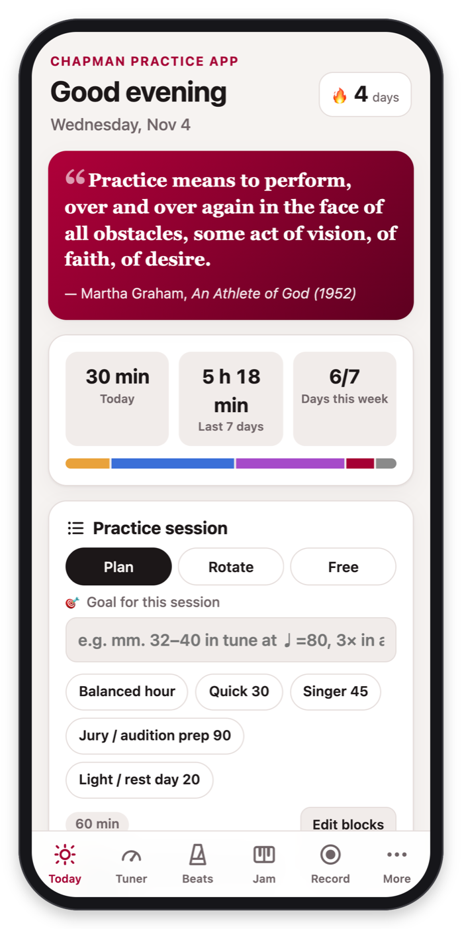  Plan your practice  Timed warm-ups, break reminders, a daily quote and your week at a glance. | 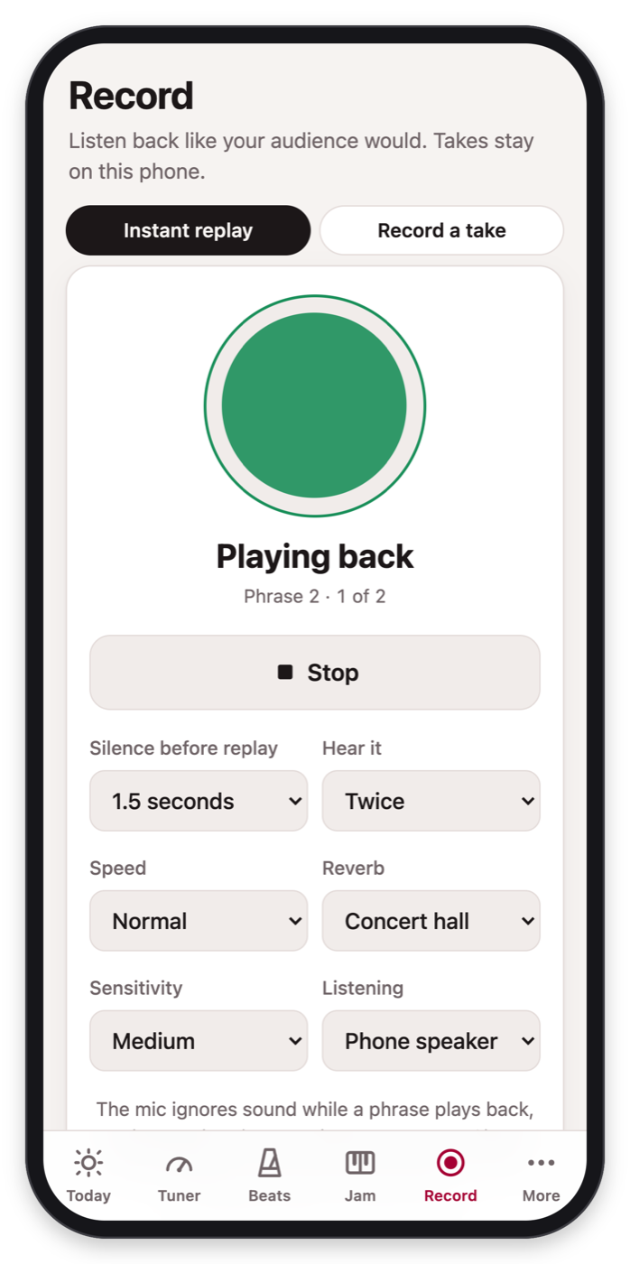  Instant replay  Play a phrase and stop. When the mic hears silence, it plays it right back. | 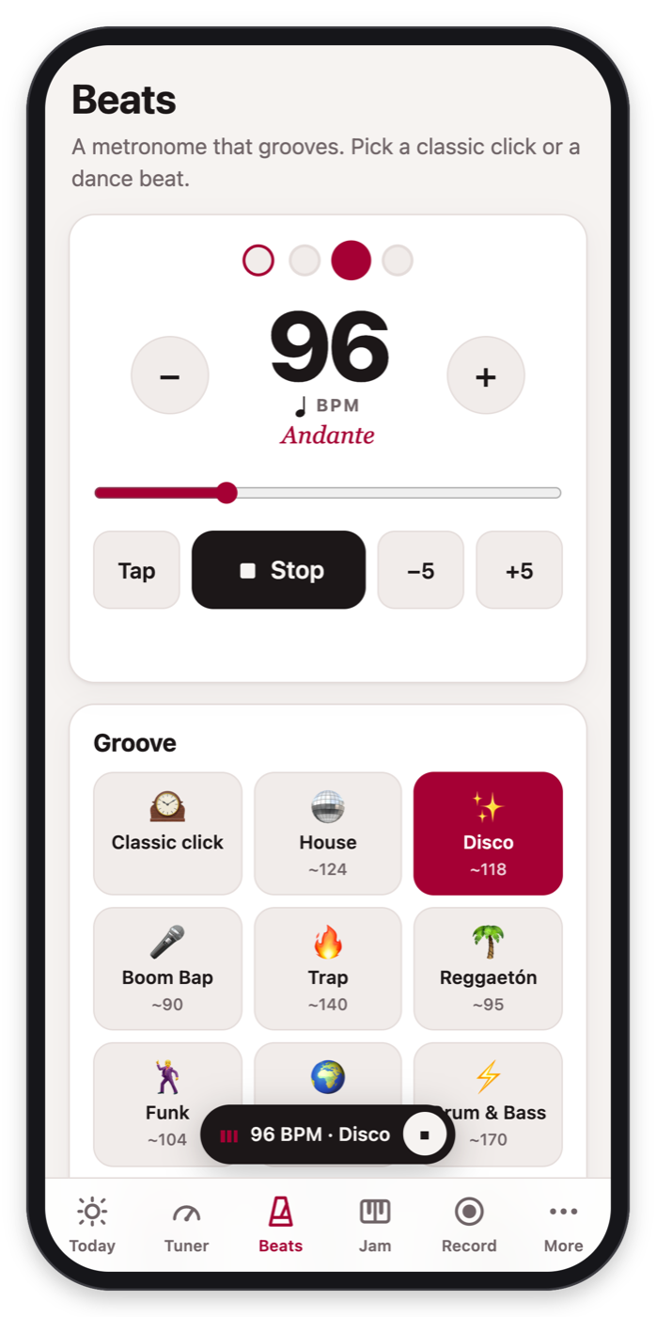  A metronome that grooves  Classic click — or house, disco, trap, reggaetón, swing and more.
Make it an app: on iPhone tap Share → Add to Home Screen; on Android tap ⋮ → Install app. It opens full-screen and works offline.
Private: your practice log and recordings stay on your phone.
Hear yourself. Practice smarter.
Built around what research says works: a specific goal, fixing errors right away, listening back honestly, and reflecting afterwards.
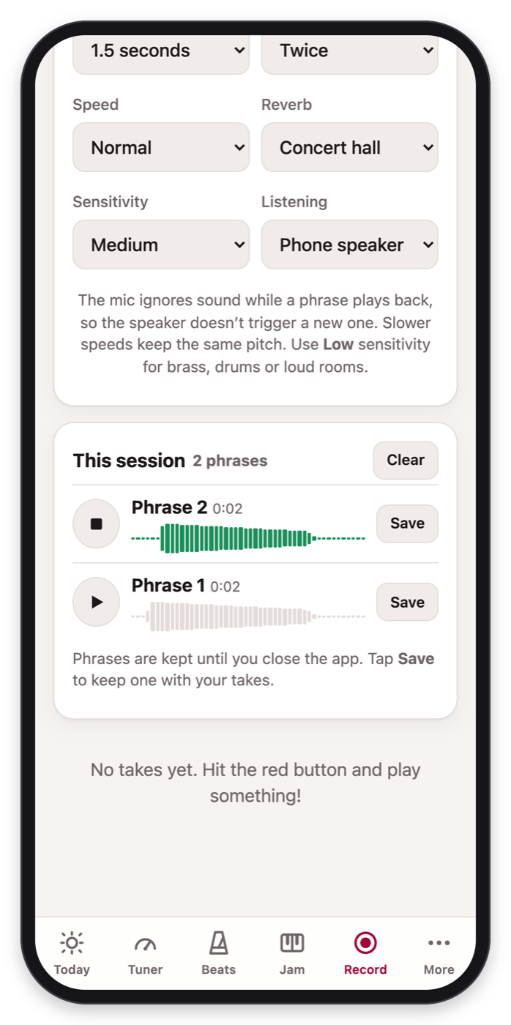  Compare your attempts  Every Instant replay phrase is kept. Hear it at ½ speed, add concert-hall reverb, save the best. | 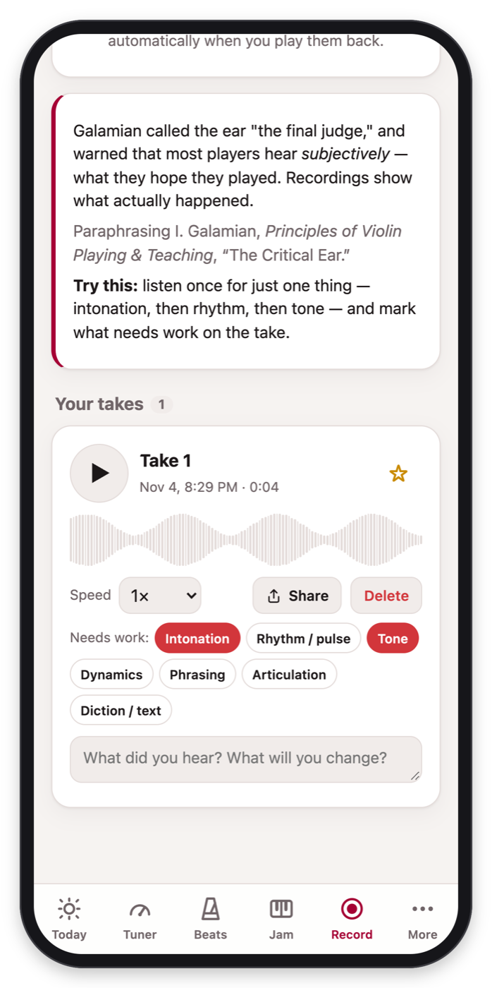  Record a take  Longer recordings with a listening checklist: intonation, rhythm, tone and more. | 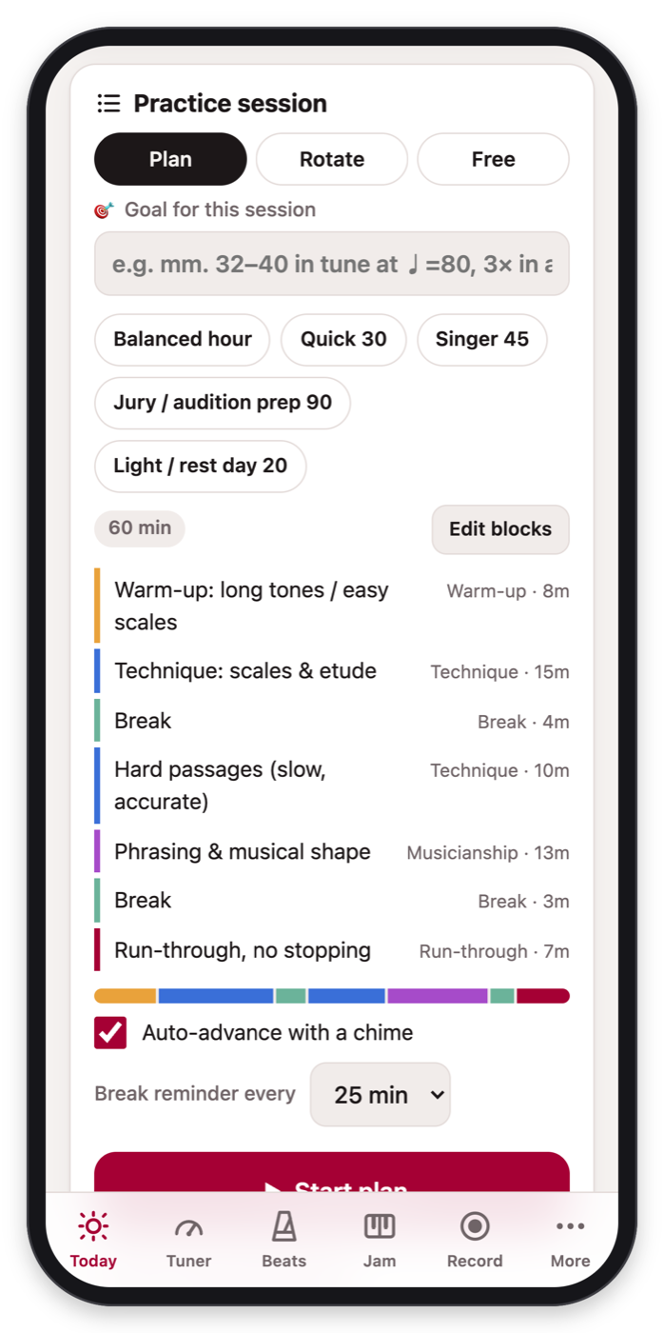  Plan, Rotate or Free  Timed blocks with break reminders, or rotate between passages (interleaved practice).
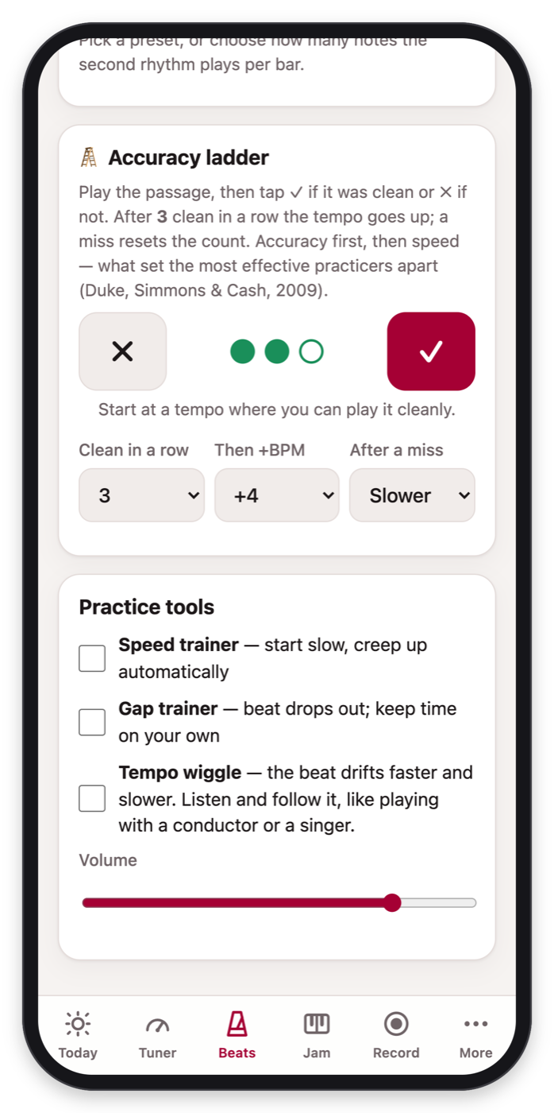  Accuracy ladder  The tempo goes up only after several clean repetitions in a row. | 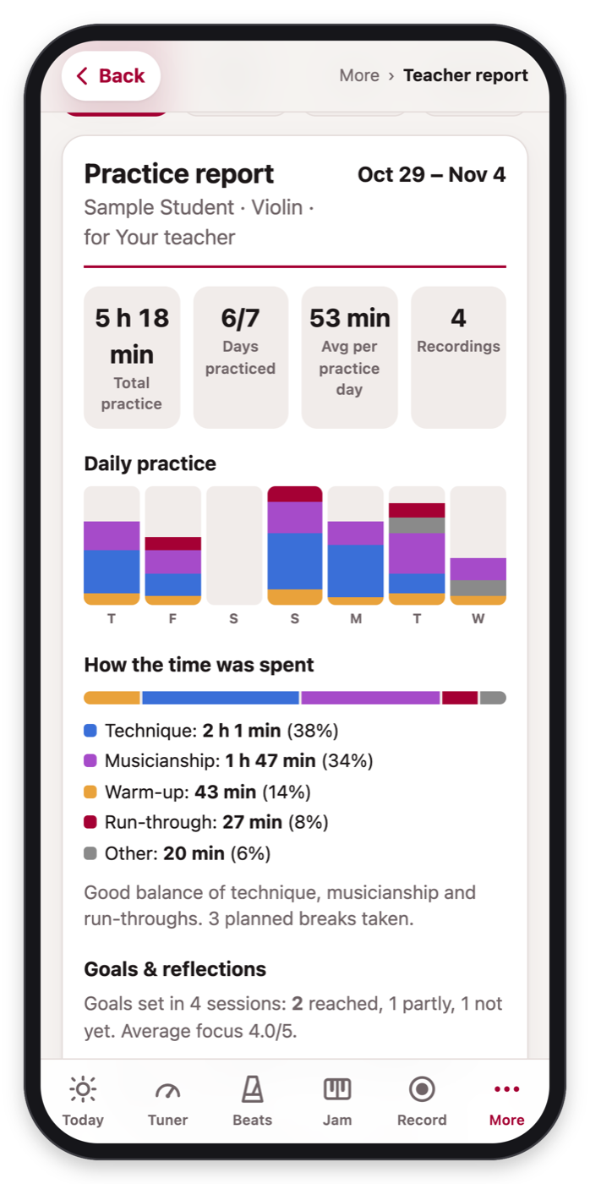  Teacher report  A one-tap summary of your week to share at your next lesson. | 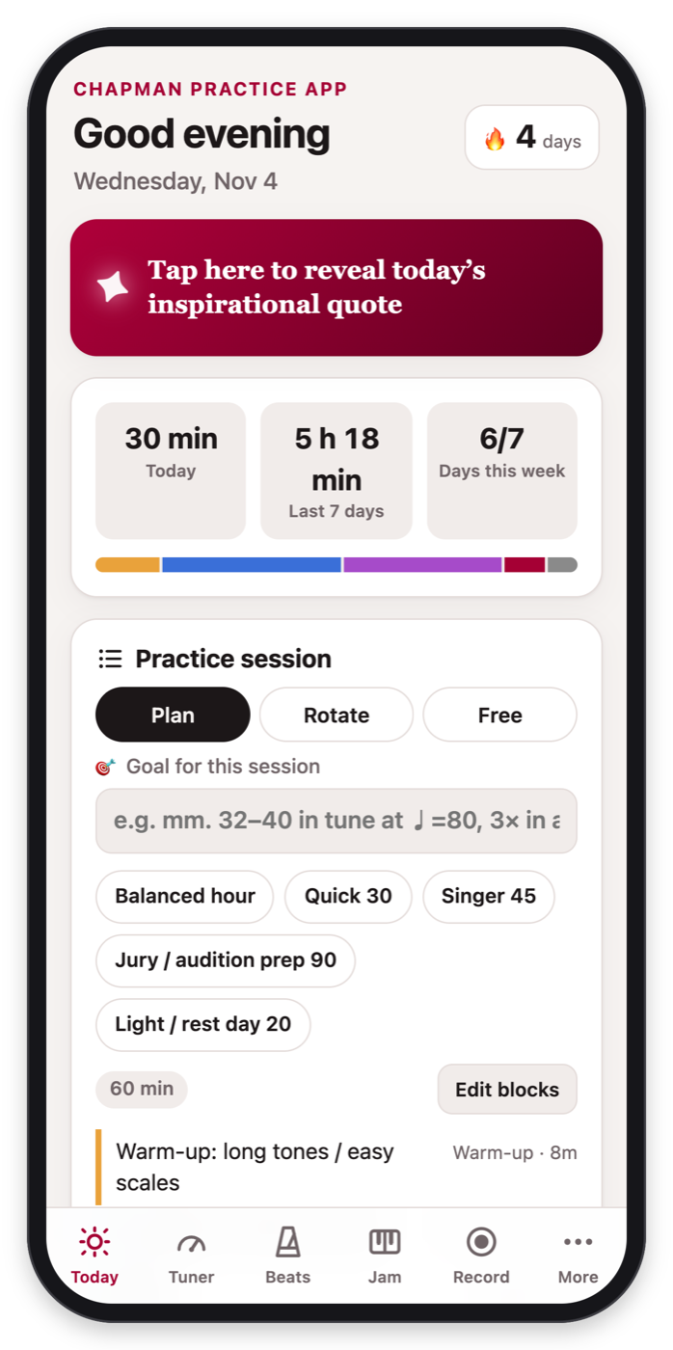  A quote for every day  374 inspirational quotes, revealed one day at a time.
Time, rhythm & pitch
A metronome, a tuner and a backing band in one place.
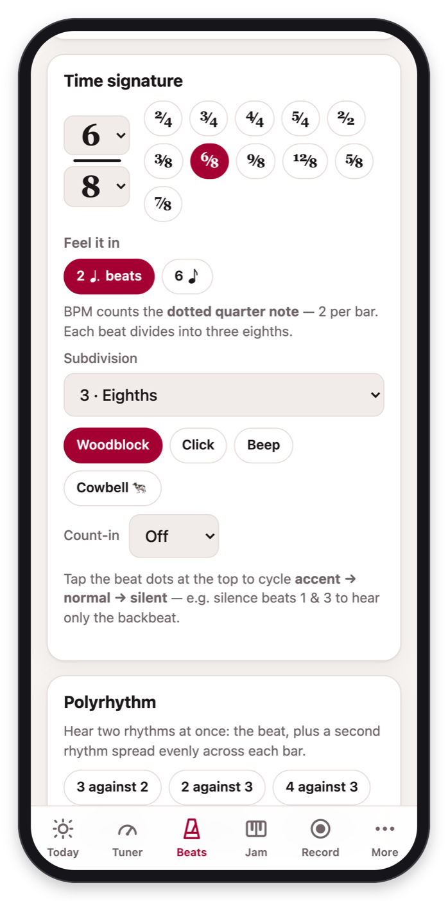  Real time signatures  6/8, 7/8, 12/8 and more, with subdivisions, swing and count-ins. | 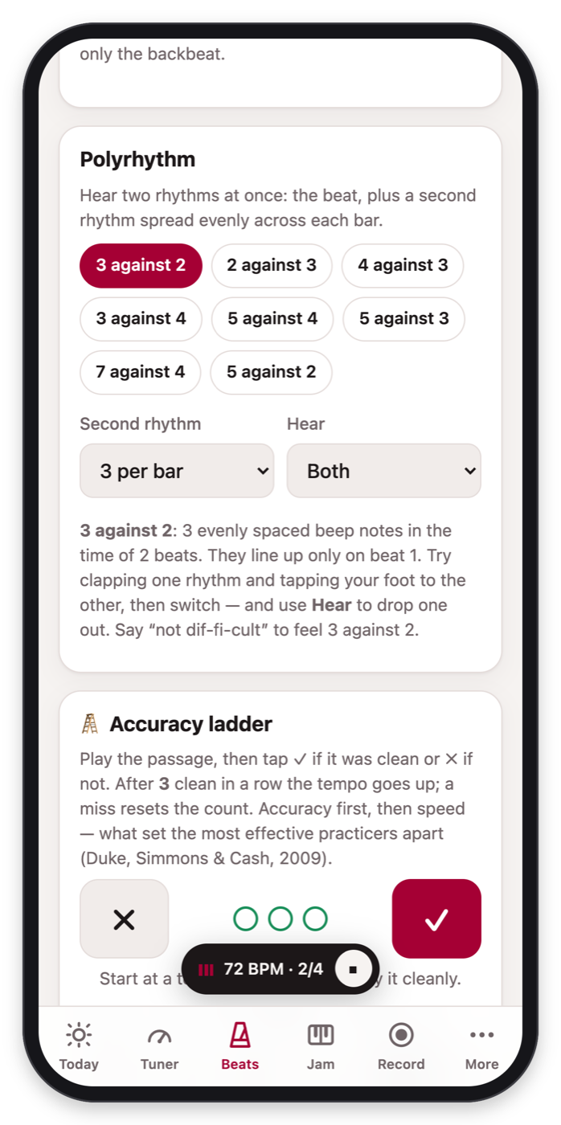  Polyrhythms  3 against 2, 4 against 3, 5 against 4… hear both, or drop one out. | 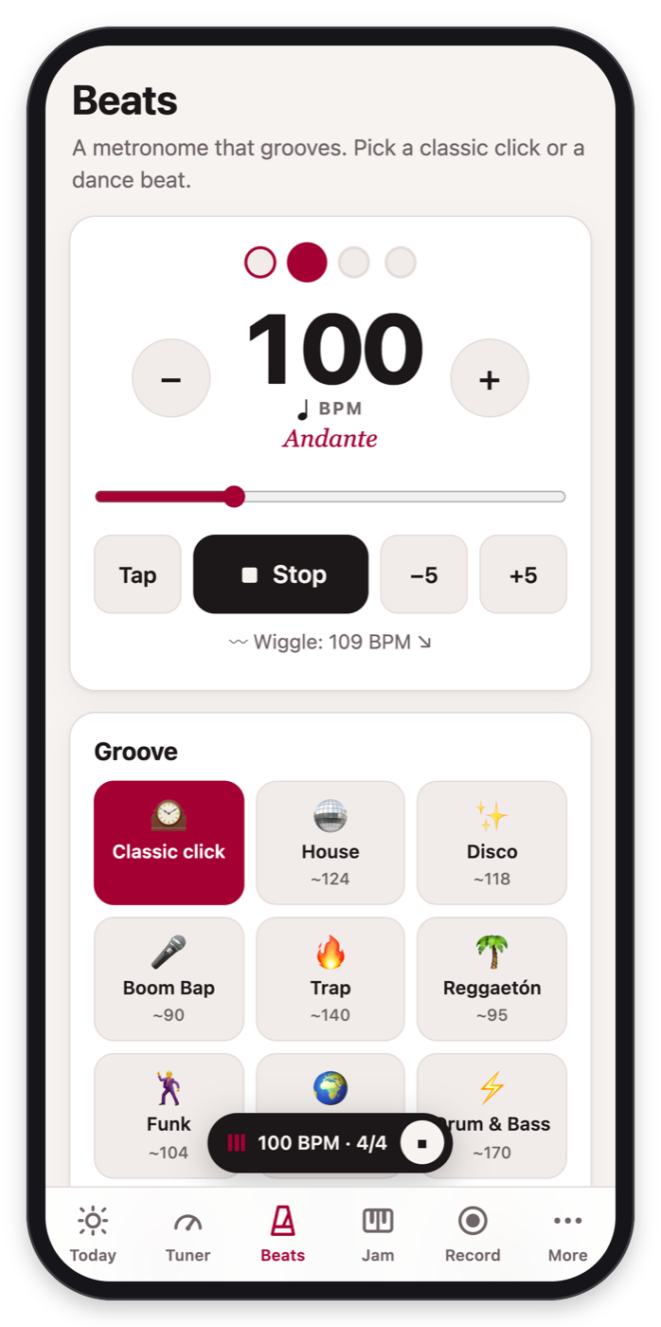  Tempo wiggle  The beat drifts faster and slower so you learn to listen and follow.
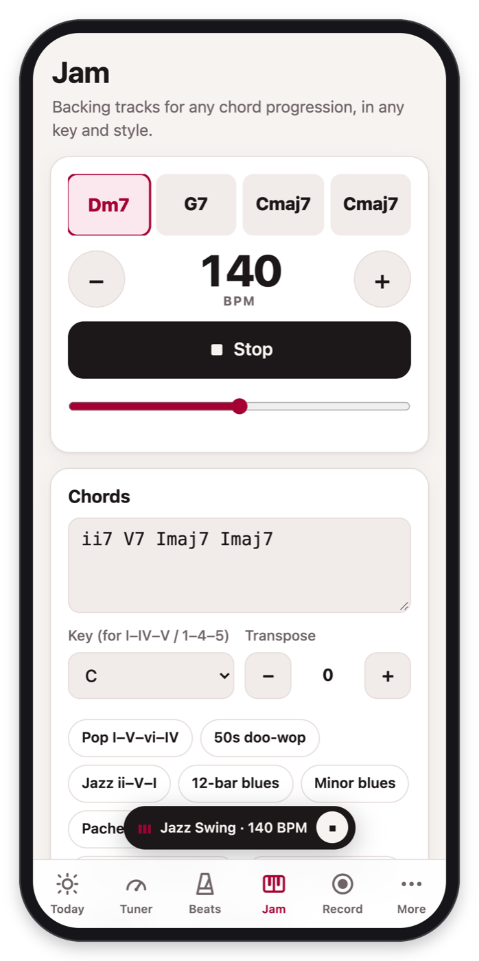  Backing tracks for any chords  Type ii–V–I, Dm7 G7 Cmaj7 or 1 5 6m 4. Any key, any style. | 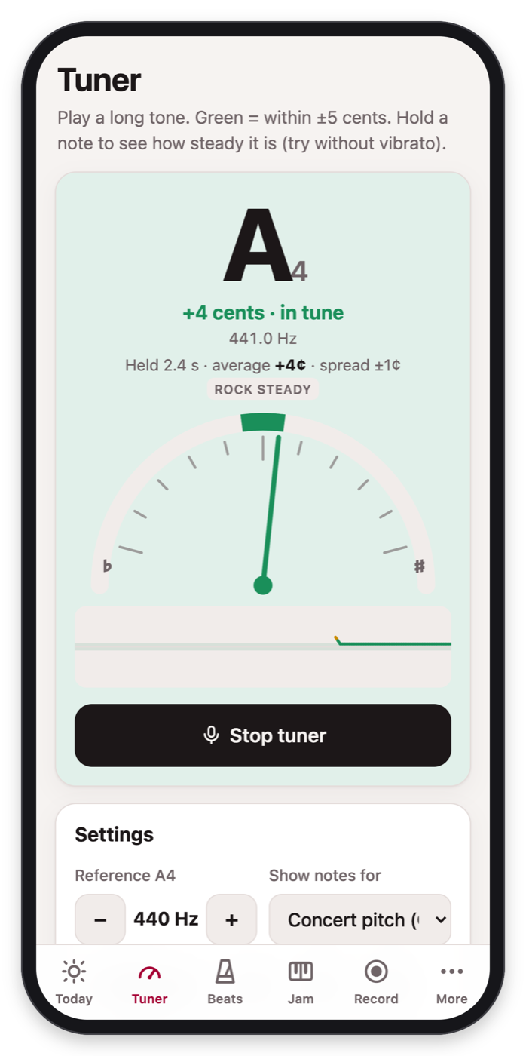  Tuner & drones  Shows how steady your note is. B♭, E♭ and F instruments too. | Also in Beats & Jam  Tap tempo and a speed trainer that creeps the tempo up  Gap trainer: the beat drops out — keep time on your own  Accents & groupings like 2+2+3, and count-ins of 1, 2 or 4 bars  12 backing-track styles: pop, rock, funk, swing, bossa nova, lo-fi, waltz, ranchera…  Mute your part in the band, and transpose to any key  Drones for intonation practice, at A=440, 442 or 415
Stay healthy. Stay connected.
Evidence-based guidance for your body, voice and ears, with the sources cited, plus what’s happening at Chapman.
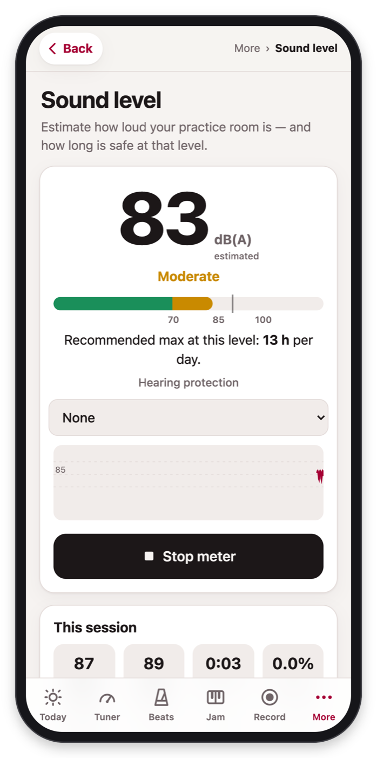  Sound level meter  Estimates dB(A) and how long is safe for your ears today. | 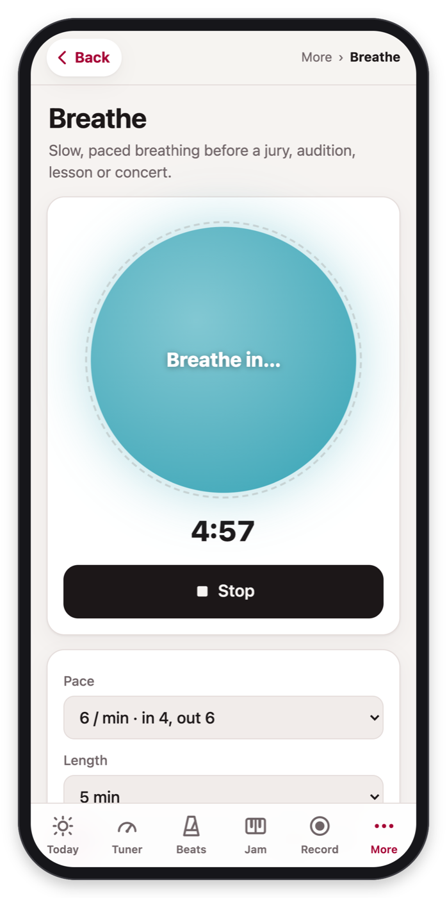  Breathe  Paced slow breathing to settle nerves before a jury. | 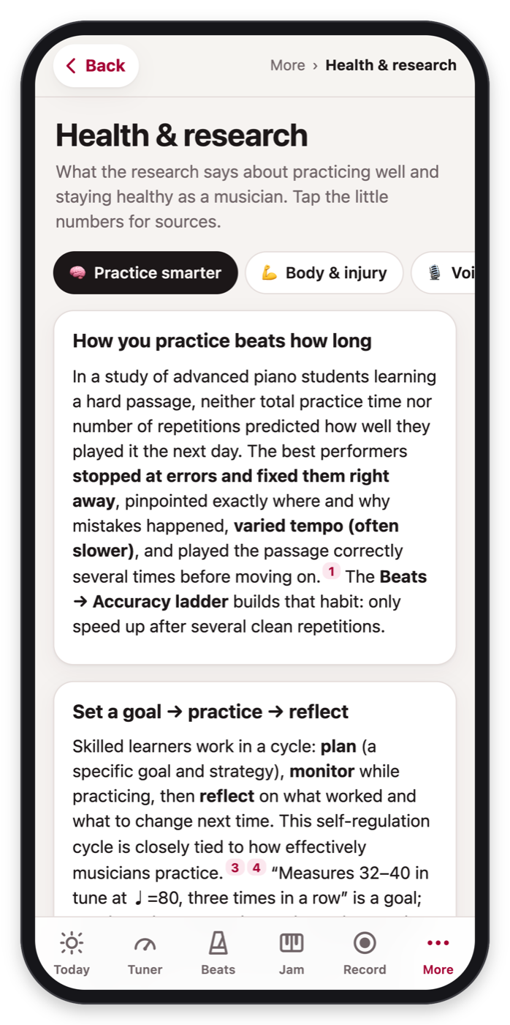  Health & research  How to practice well and avoid injury, with sources. | 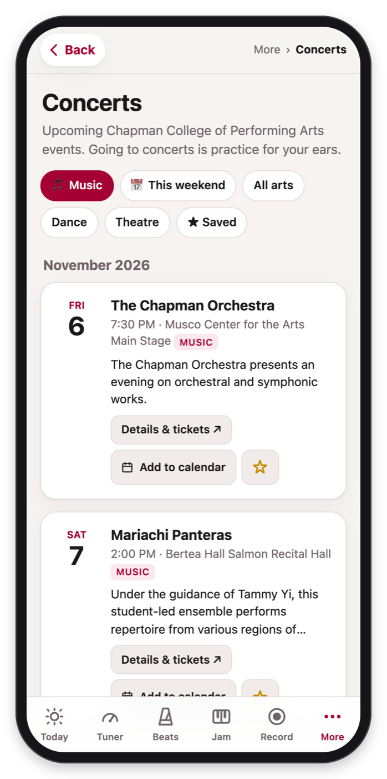  Concerts  This weekend at Chapman and the full calendar.
Good to know
Free, with no account. Add it to your home screen and it works offline in any practice room.
Private. Your practice log and recordings stay on your phone; nothing is uploaded.
Built with input from Chapman faculty, who helped shape what it does and how it teaches. Created with Claude Code.
Start in 30 seconds
1 Scan the code below with your phone’s camera (or type the link).
2 Add it to your home screen so it opens like an app and works offline.
3 Open Record → Instant replay, tap Start listening, and play a phrase.

