How to rebuild an ArcGIS Online Feature Service Spatial Index:

1. Log Into ArcGIS Online and Locate the Feature Layer Service

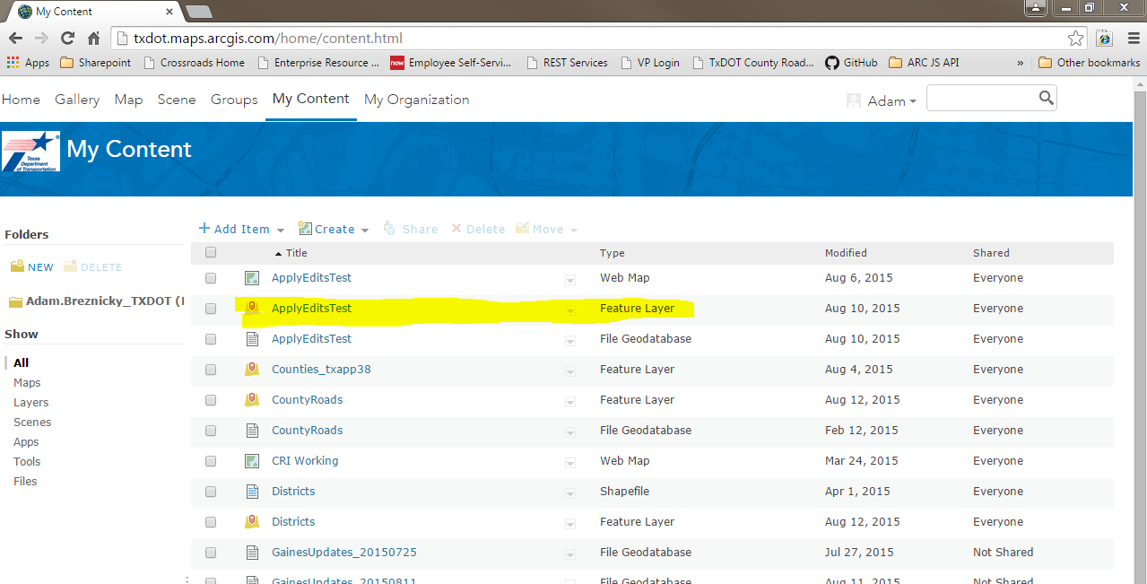

1. Open the Feature Layer Service Details

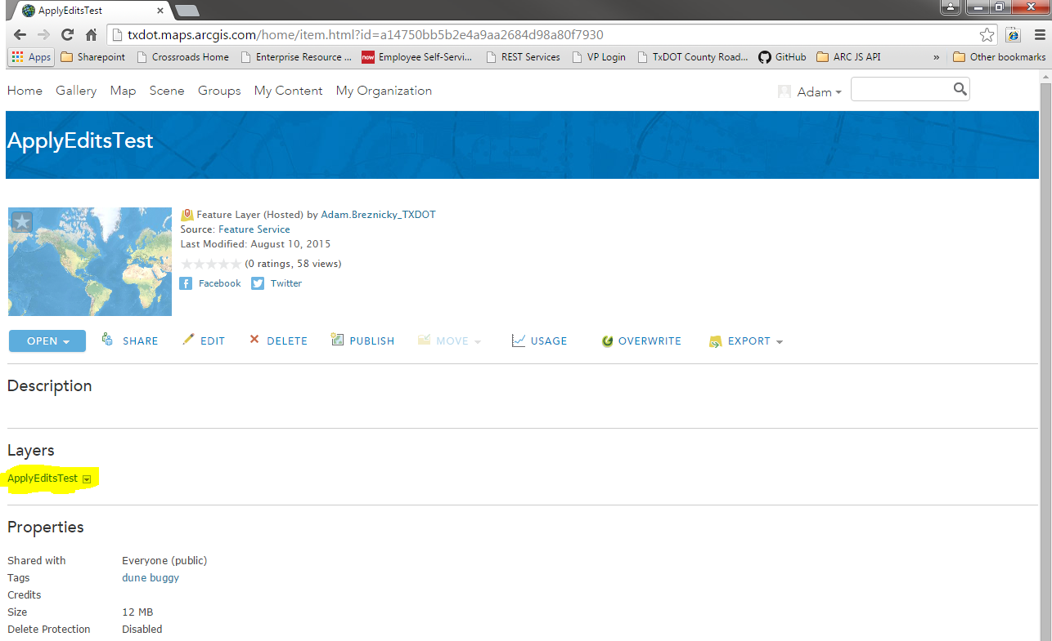

1. Access the service administrator by replacing the end of the service URL with “admin” after “/arcgis/” and press Enter

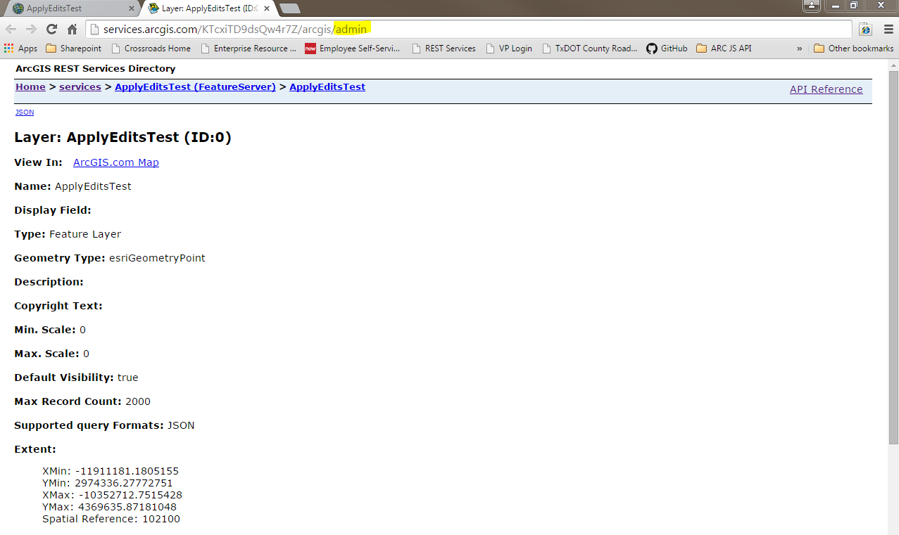

1. Choose the “Services” directory and then choose the service to be updated

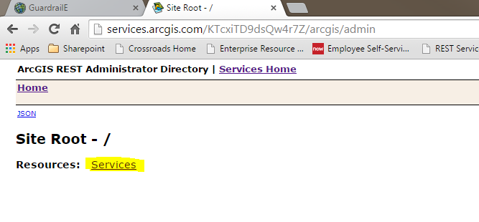

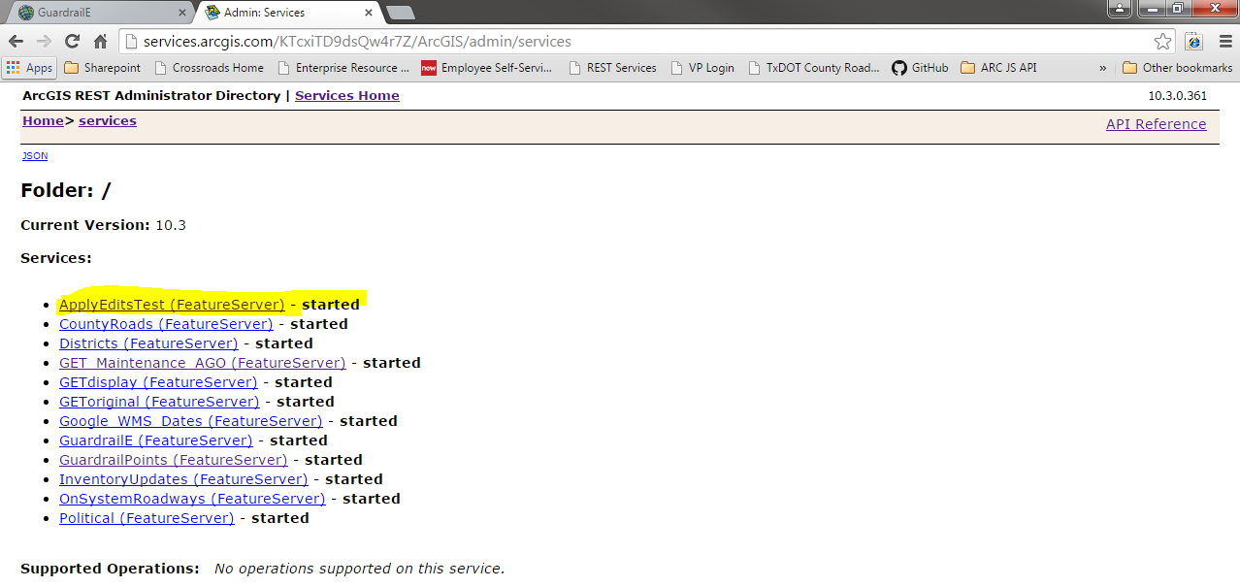

1. 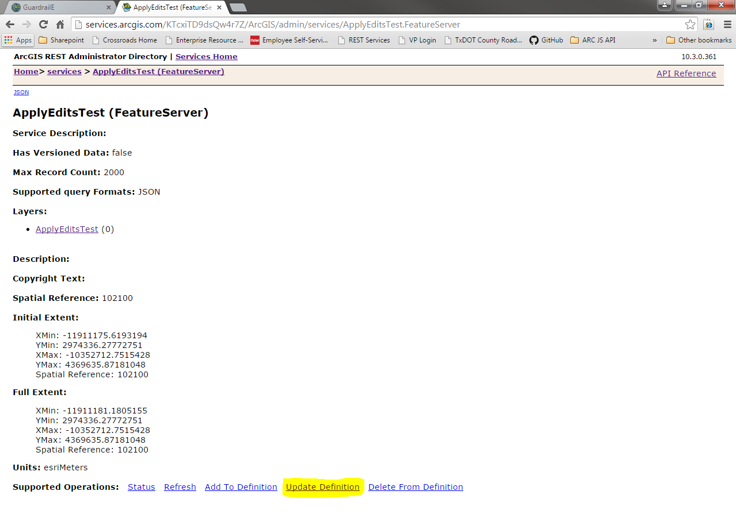Scroll to the bottom and choose “Update Definition”
2. 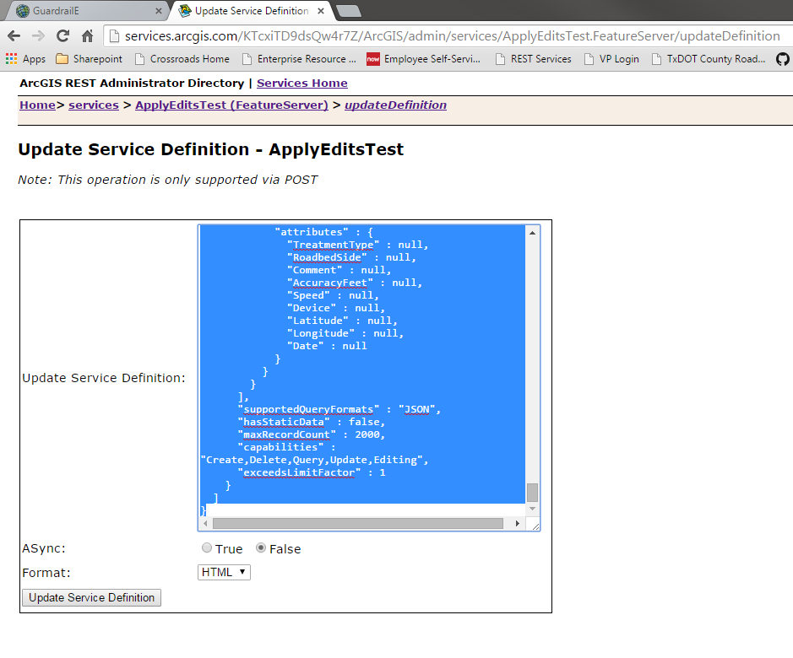Delete all text within the “Update Service Definition:” window
3. Copy the below snippet and paste into the “Update Service Definition:” window

{"indexes" : [  
 {  
      "name" : "user_231.FeatureServiceName_FeatureLayerName_Shape_sidx",   
      "fields" : "Shape"  
    }  
  ]  
}

1. 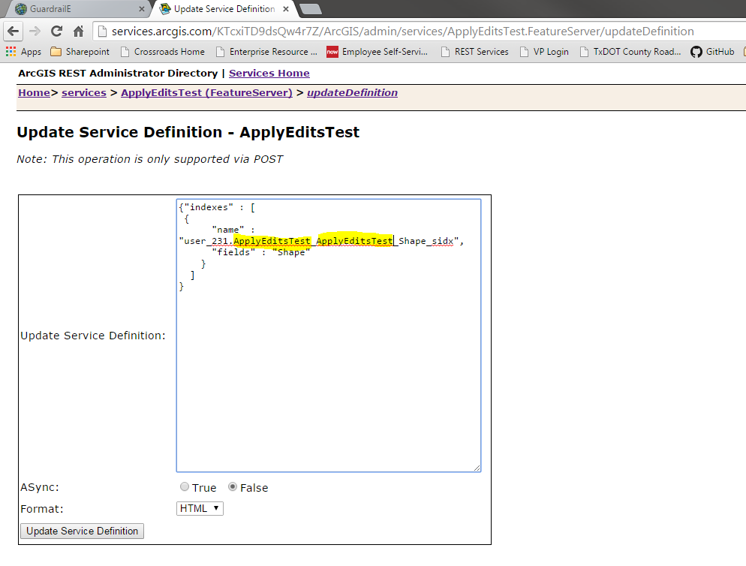Within the “Update Service Definition:” window, change the highlighted text from the snippet in #7 to be the exact name of the service
2. Choose “JSON” from the “Format” dropdown and then click the “Update Service Definition” button.

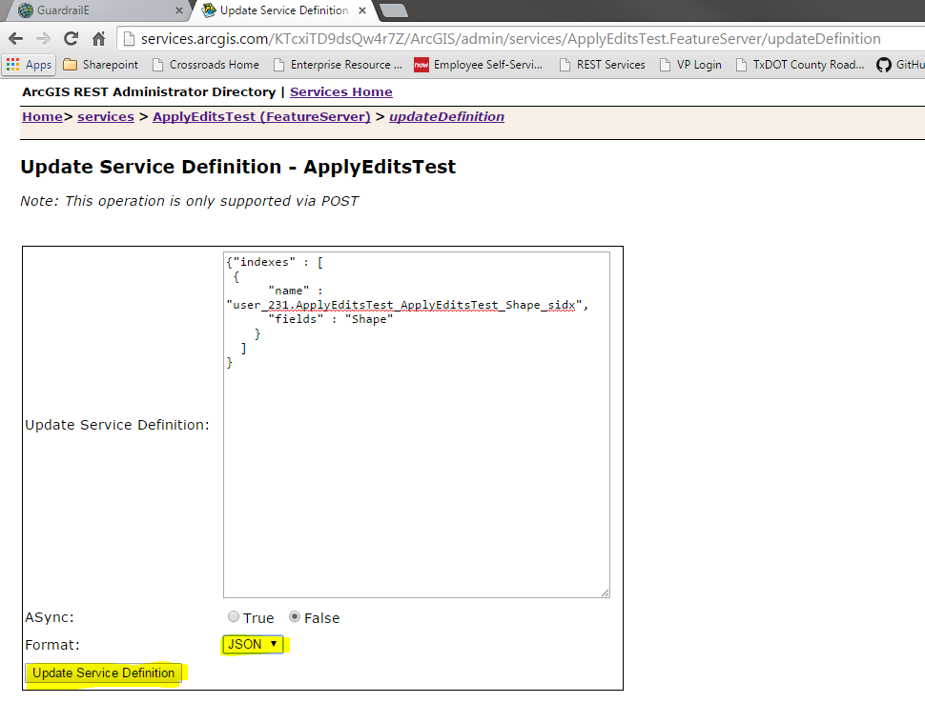

1. 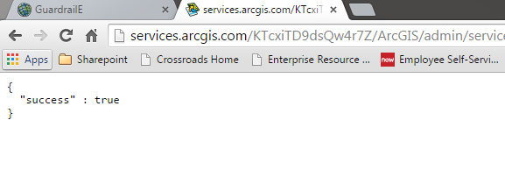 You should receive a “success” confirmation
2. Re-access the service administrator by replacing the end of the service URL with “/admin”, press Enter

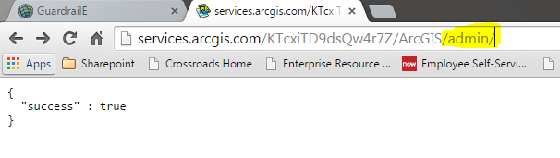

1. 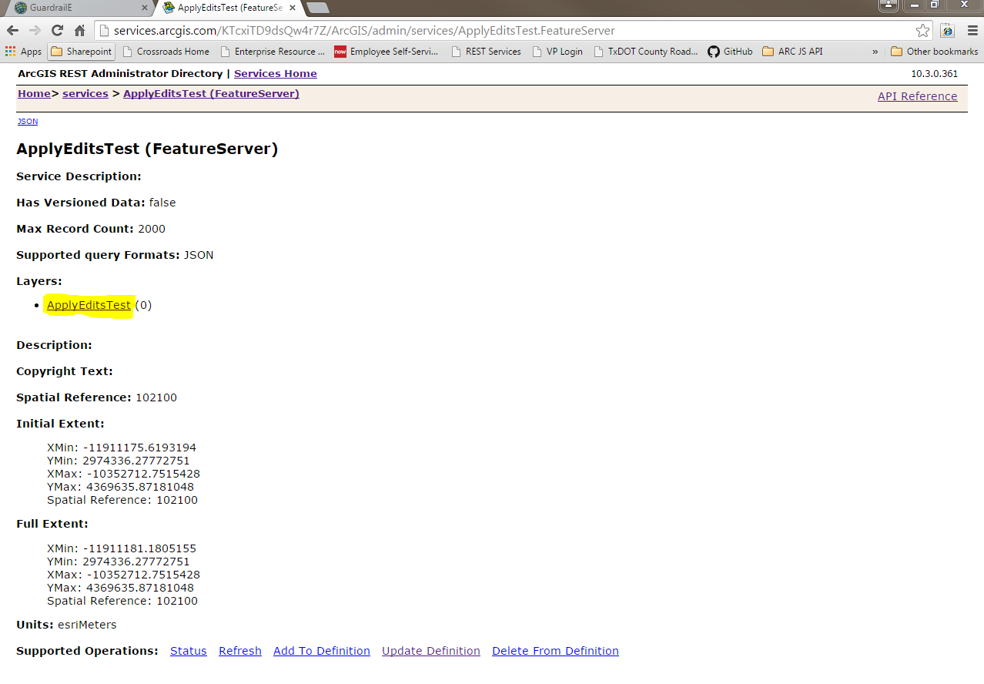Choose the “Services” directory, choose the service just updated, then choose the layer to be updated
2. Repeat steps 5-10 for the service layer
3. Cheers!