

Data Updates & Sharing Application - Download

Instruction Manual

TPP, Data Management Section

# Table of Contents

Purpose 2

Browser 2

Download Section Display 2

Progress & Results 3

Completion & Contact Info 3

# Purpose

Welcome to the Data Updates & Sharing Application – Download Section!

This document serves as a how-to guide and reference for using the Download functionality within the Data Updates & Sharing Application (DUSA) application.

# Browser Information

DUSA is accessed through an internet browser. It is highly suggested to use Google Chrome to receive the highest performance while working within a WebMap. Mozilla Firefox will also provide acceptable performance. TxDOT advises against using Internet Explorer.

# Download Section Display

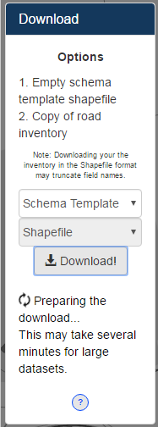The Download section of the menu offers multiple options for downloading the datasets used within the DUSA application.

Download Instructions

Status display. Display the status of the current download in progress.

Download Button. Click to begin download after all options have been selected.

Format Selector

Download Option Selector

Options display. Quick reference describing the Download Options.

“Road Inventory”: Option 2 – This option downloads ether a Shapefile or File Geodatabase with the dataset schema of TxDOT’s current road inventory as represented within DUSA. The downloaded data will contain all roads for logged in organization.

“Schema Template”: Option 1 – This option downloads a Shapefile with the dataset schema of the editable updates layer within DUSA. The Shapefile will contain no data as it should be used as a template for submitting updates in bulk within the Upload section of the menu. **Shapefile is the only available format for this option.

# Progress & Results

Begin a download by selecting the desired options from the two selector dropdowns and then pressing the ‘Download!’ button.

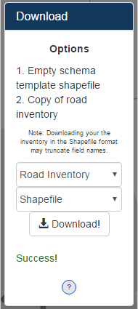The Download section of the menu has a Status display below the Download Button. This area is blank until a download begins. Once commenced, the Status display will reveal dialogue indicating the download has successfully begun.

The download process will take a couple seconds at minimum as the application queries the indicated dataset with the ‘Schema Template’ being the fastest download prepared. The ‘Road Inventory’ option may take several minutes depending on the size of the organization being downloaded.

Once the dataset has been queried and the download has been prepared, the Status display will reveal: Success! If there was any issue or error in preparing the download, the Status display will reveal the error textually in red. Please contact the TPP Data Management Section (contact address below) to inform them of your error. Please describe the error in detail and include screenshots when possible.

The prepared data will immediately being downloading as a zipfile (.zip) containing the dataset. The zipfile will be named in a manner which describes the parameters chosen within the dropdown Selectors. Software to open a zipfile can be found [here](http://www.7-zip.org/).

# Completion & Contact Info

Upon completion of the inventory review and markup, we request the user to send an email to the TPP Data Management Section (contact address below) stating your markup has been completed. At the time of completion, the updates will be reviewed and the changes which meet the inventory criteria will be implemented to update the TxDOT Road Inventory.

Thank you for using the Road Inventory Updates web application to submit changes to the TxDOT Road Inventory. If you would like to report any bugs or issues, or have any questions which need clarification of the procedures, please contact the Transportation, Programming, and Planning Division’s Data Management staff at:

[TPP-GIS@txdot.gov](mailto:TPP-GIS@txdot.gov)

(512) 486-5052