

Data Updates & Sharing Application - Upload

Instruction Manual

TPP, Data Management Section

# Table of Contents

Purpose 2

Browser 2

Download Section Display 2

Bulk Submission Requirements 3

Progress & Results 4

Completion & Contact Info 6

# Purpose

Welcome to the Data Updates & Sharing Application – Upload Section!

This document serves as a how-to guide and reference for using the Upload functionality within the Data Updates & Sharing Application (DUSA) application.

# Browser Information

DUSA is accessed through an internet browser. It is highly suggested to use Google Chrome to receive the highest performance while working within a WebMap. Mozilla Firefox will also provide acceptable performance. TxDOT advises against using Internet Explorer.

# Upload Section Display

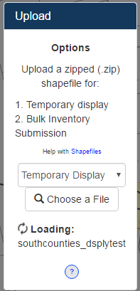The Upload section of the menu offers multiple options for uploading datasets to the DUSA application.

“Bulk Submission”: Option 2 – This option will upload all records from the ‘Template Schema’ Shapefile to the edits layer and display them on the map as if the records were created within the map using the Edit Section tools. **Requires only 1 Shapefile be present in the zipfile. Shapefile must have the same schema as the ‘Template Schema’ Shapefile acquired from the Download Section of the menu.

“Temporary Display”: Option 1 – This option will display all Shapefiles within the zipfile on the map for reference purposes when reviewing the TxDOT inventory and marking updates. Displayed Shapefiles are temporary and can be removed with the ‘Clear Display’ button. They will be cleared upon logging out of the application.

‘Choose a File’ Button. Click to browse and select the zipfile to be uploaded. When chosen, the upload will start automatically.

Status display. Display the status of the current upload in progress.

Upload Instructions

Options display. Quick reference describing the Upload Options.

Upload Option Selector

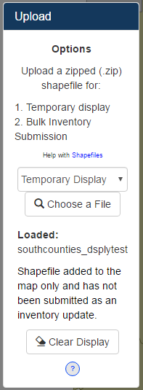

Upon a successful upload, the Status display will reveal the name of the zipfile which was uploaded.

‘Clear Display’ Button. Click to remove all the Shapefiles displayed with the ‘Temporary Display’ option.

The Status display will also reveal a dialogue confirming the Upload Option associated with the successful upload; identifying whether the data is temporary or has been submitted as changes to the inventory.

# Bulk Submission Requirements

The standard workflow to complete a ‘Bulk Submission’ is as follows: download the ‘Schema Template’ shapefile, unzip the shapefile onto your computer, complete the markup by editing the shapefile within an GIS program (ex. ArcGIS Desktop), zip up the edited shapefile, and then upload the zipfile within the ‘Upload’ section of the menu win the DUSA application.

The following requirements **must** be met to have a successful ‘Bulk Submission’ upload.

1. The schema of the submitted shapefile must be exactly the same as the ‘Schema Template’ shapefile (acquired from the ‘Download’ section of the menu).
2. Use the acceptable codes for each field when populating the attributes for each record in the markup shapefile. Reference the ‘Data Dictionary’ found within the ‘Resources’ section of the menu for the proper codes for each field in the Schema Template shapefile.
3. The uploaded zipfile must be in a ‘.zip’ format. A ‘.zipx’ format will not work and an error will display upon attempt.

# Progress & Results

Begin an upload by selecting the desired option from the selector dropdown and then press the ‘Choose a File’ button. A file explorer window will appear. Navigate to a zipfile containing the shapefile(s) to be uploaded. Select the zipfile and click ‘Open’. The upload will begin immediately.

The zipfile chosen must be of the ‘.zip’ format. A ‘.zipx’ formatted zipfile will not work and an error will display upon attempt. Software to create a zipfile can be found [here](http://www.7-zip.org/).

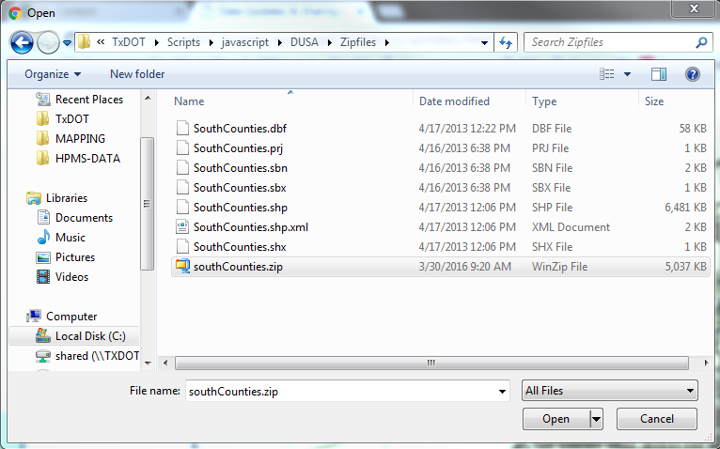

The Upload section of the menu has a Status Display below the ‘Choose a File’ Button. This area is blank until an upload begins. Once commenced, the Status display will reveal a “Loading” dialogue indicating the upload has successfully begun.

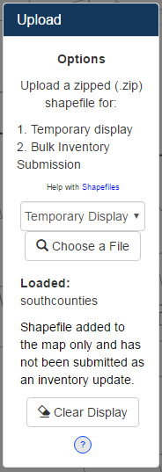The upload process will take a couple seconds at minimum as the application prepares the upload. The ‘Bulk Submission’ option may take several minutes depending on the size of the submission being uploaded.

If the ‘Temporary Display’ option has been chosen, upon a successful upload, all the shapefiles within the zipfile will display on the map with generic symbology. The Status Display will display the name of the uploaded zipfile and a dialogue will explicitly state the upload was for map display only and not part of a bulk submission.

A ‘Clear Display’ button will also appear. Click the ‘Clear Display’ button to remove the uploaded, display shapefiles from the map.

This option is for any potential reference purposes while performing a markup which may include things like the organization’s current road inventory, jurisdiction boundaries, or various structures specific to the organization performing the markup. Shapefiles on display are not interactive and their attributes cannot currently be displayed; they are for visual and overlaying purposes only.

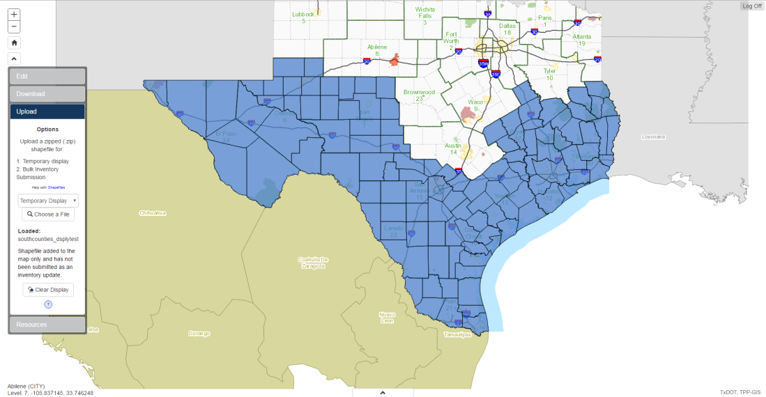

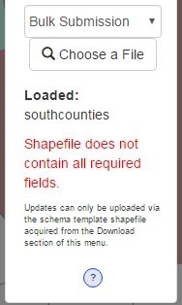If the ‘Bulk Submission’ option has been chosen, the DUSA application will verify the schema of the shapefile being submitted.

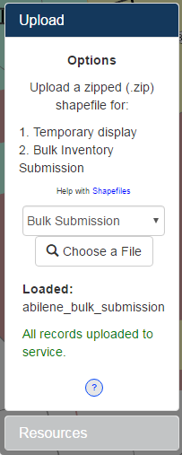**The schema of the submitted shapefile must be exactly the same as the ‘Schema Template’** (acquired from the ‘Download’ section of the menu) or the Status Display will reveal an error in red as shown in the image to the right.

Upon successful schema verification, the DUSA application will upload the records from the shapefile into the Updates Layer. The Status Display will reveal the total number of records being uploaded in green. A counter will tally as each record is added to the Updates Layer.

When all the records in the shapefile have uploaded to the Updates Layer successfully, the Status display will reveal: All records uploaded to service. The Updates Layer will then display the records submitted in the map as if they were being submitted with the tools in the ‘Edit’ section of the menu. If there was any issue or error during the upload, the Status Display will reveal the error textually in red. Please contact the TPP Data Management Section (contact address below) to inform them of your error. Please describe the error in detail and include screenshots when possible.

**\*\*Note: The records will only display in the map if the proper codes were used in the ‘CHANGE’ field of the shapefile (‘Add’, ‘Remove’, ‘Update’).** Reference the ‘Data Dictionary’ found within the ‘Resources’ section of the menu for the proper codes for each field in the Schema Template shapefile.

# Completion & Contact Info

Upon completion of the inventory review and markup, we request the user to send an email to the TPP Data Management Section (contact address below) stating your markup has been completed. At the time of completion, the updates will be reviewed and the changes which meet the inventory criteria will be implemented to update the TxDOT Road Inventory.

Thank you for using the Road Inventory Updates web application to submit changes to the TxDOT Road Inventory. If you would like to report any bugs or issues, or have any questions which need clarification of the procedures, please contact the Transportation, Programming, and Planning Division’s Data Management staff at:

[TPP-GIS@txdot.gov](mailto:TPP-GIS@txdot.gov)

(512) 486-5052