Geolocation Web-Application Testing SOP

Contents:

1.1 Purpose and Outline

1.2 Current GPS requirements and procedures

1.3 New Geolocation GPS requirements and procedures

1.4 Criteria to be tested for post-collection analysis

1.5 Safety Awareness

1.6 Accuracy Analysis

**1.1 – Purpose and Outline**

Assure the validity and integrity of the field data collected via the web application with the intent to generate authenticity and adopt next generation technology for projects requiring data collection.

* The data shall be collected simultaneously on multiple devices (as listed below) for later analysis**.** Review all procedures identified by the following bullet statements.
* Data is required to be collected on the Trimble Pathfinder Pro XH using the Current GPS methods as outlined within Section 1.2.
* Data is required to be collected on a Trimble Juno device as outlined within the Regional Data Collection project documentation:

T:\DATAMGT\MAPPING\Data Collection\Regional Data Collection\2011_RegionalDataCollection.zip

* Data is also required to be collected on a Mobile Smart Device meeting the new Geolocation GPS requirements and procedures as outlined in Section 1.3.
* Data is also preferred to be collected on multiple other Mobile Smart Devices of a different operating system than that of the first device for comparison of operating system accuracy variances.

**1.2 – Current GPS requirements and procedures**

The current standard GPS data collection method utilized by TxDOT TPP is a multi-unit hardware and custom program application requiring a laptop, power inverter for powering the laptop within an automobile, Trimble Pathfinder ProXH GPS with antenna, and the TxDOT StandAloneGPS software program. Additional software is helpful, but not required, for monitoring the GPS signal and while connected to the laptop. The collection steps are as follows:

1. Charge at least 2 Trimble Pathfinder batteries prior to collection to ensure GPS battery life for the entirety of the next day of data collection. (Battery life ~4-6 hours each)
2. Set up laptop with power supply to the power inverter inside the vehicle. Turn ‘on’ laptop.
3. Connect the Trimble Pathfinder to the laptop via a VGA to USB adaptor. Turn on the Trimble Pathfinder and wait while the unit powers up.
4. Connect the external antenna to the Trimble Pathfinder unit and mount to the exterior of the vehicle.
5. Optionally, GPS signal monitoring software can now be used to verify the status of the signal.
6. Open the StandAlongGPS software program. The interface is represented within Figure 1.2.1.

*Figure 1.2.1 – StandAloneGPS_v2 Interface*

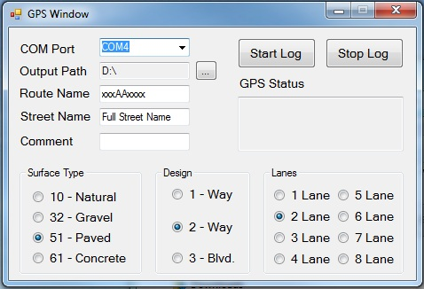

1. Choose the ‘COM Port’ which the Trimble Pathfinder is connected to the laptop in.
2. Designate the ‘Output Path’. The software will create a CSV .txt file for each data log and output it to this directory.
3. Designate the proper attributes to represent the roadway being collected. This is done by entering text and choosing the radio buttons to specify the separate attributes.
4. Choose to begin by clicking ‘Start Log’. The program will collect specific GPS points from the signal and append each to a separate line within the CSV .txt file for that data log. Each point will contain the attributes selected along with the geographic latitude and longitude coordinates. Choose to end the data log by clicking ‘Stop Log’ when you are finished.
5. During a data log the ‘GPS Status’ will display whether the signal exists and data is being logged or not. If not, an error will indicate the issue.
6. Repeat steps 9-10 for all the field data being collected.

The data is now logged and saved to the designated directory on the laptop hard drive. Upon completion of all field data collection, one would return to the office for processing the collected data into a manipulate-able ArcGIS format. Those steps are as follows:

1. Start up the laptop within the office using the Novell login tree in order to connect to the TxDOT Network.
2. Copy the collected data from the specified directory to your local machine through the network.
3. Run the countyTXTtoSHP_geodatabase.py script, designating the location of the collected data on your machine, to convert the collected CSV .txt files to a polyline feature class for copying into the TxDOT_Roadways feature class in Comanche.
4. Perform routine edits within TxDOT_Roadways, SUBFILES, and all other necessary tables to complete implementing the field data update to our inventory.

**1.3 – New Geolocation GPS requirements and procedures**

The proposed GPS tool and subject of this testing project is a HTML5 web based application which can be easily used on any modern, smart mobile device, specifically any device with GPS capabilities. This includes smart phones, tablets, laptops, etc. Based within the HTML5 setting, the application is a simple, single web page which can be accessed from any hardware supporting an internet connection. This setting dissolves any specific formatting which may be required for any single device manufacturer or operating system. The application is accessible by all. The only hardware necessary is this device and potentially a ‘car-charger’ power supply for the device which can plug into a standard 12V cigarette lighter. The collection steps are as follows:

1. Power on the device and open the internet browser.
2. Direct the webpage location of the application. For testing purposes, this address is: smudgeservices.heliohost.org
3. The interface is represented in Figure 1.3.1
4. Designate the proper attributes to represent the roadway or point being collected. This is done by entering text and choosing the radio buttons to specify the separate attributes. Each option is described within Figure 1.3.1
5. Since this application collects both point and polyline features, you begin to log data when choose to ‘Log Point’ or ‘Start Logging Line’ as the button label varies based on the data type being collected. The application will log the individual point, or the points of the polyline, to the devices’ local hard drive incognito. Each point will contain the attributes selected along with the geographic latitude and longitude coordinates. An individual point will log instantaneously while one can choose to end logging a polyline by clicking ‘Stop Logging Line’ when you are finished.
6. During a data log the ‘GPS Status’ will display whether the signal exists and data is being logged or not. If not, an error will indicate the issue.
7. Repeat steps 4-5 for all the field data being collected.
8. When data has been logged, click the ‘Upload Data’ button to upload all collected data from the local device hard drive to the database and simultaneous clear the local device hard drive for further data collection.

The data is now logged and saved to the field data database. Upon completion of all field data collection, one would return to the office for processing the collected data into a manipulate-able ArcGIS format. This can also be done in real time by any personnel within the office as the data is hosted and updated live to the field data database. That step is as follows:

1. Run Postgres_retrieve_v2.py python script. This script will retrieve the data from the field data database, reformat it into the proper point and/or polyline feature class, and upload the data to the Comanche database.

*Figure 1.3.1 – Geolocation Mobile Web Application Interface with Descriptions*

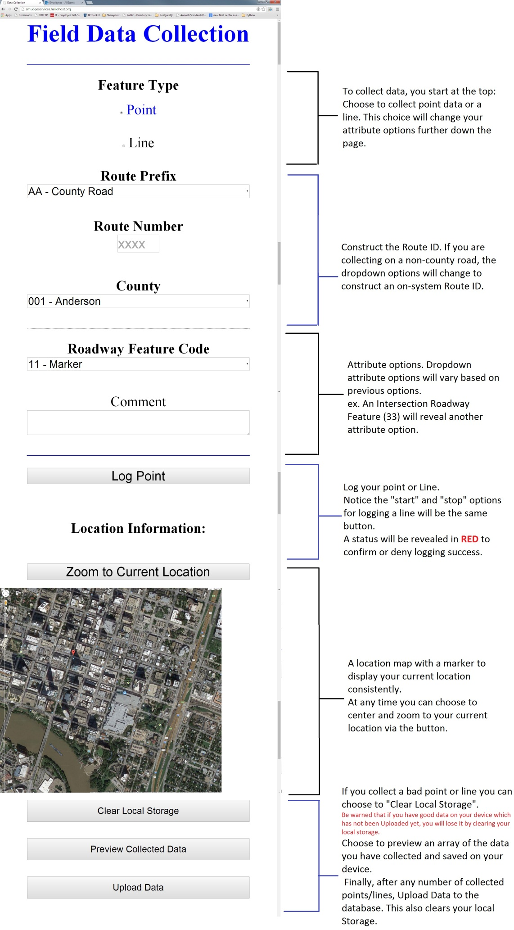

**1.4 – Criteria to be tested for post-collection analysis**

The attribute information will not be populated and utilized for these test. Any attribute information populated is not for real-world descriptive accuracy. Therefore, the road’s name, TxDOT Route ID, surface information, etc. is negligible.

Only the comment field attribute on each device is of importance; Populate the comment field attribute to specifically state the device the data is being collected on as well as the test request within the project procedure which the data is fulfilling. For example: ‘Android Mobile Device, Speed 40mph’.

Upload the data to the server after each collection.

**Speed vs. Accuracy Tests:**

* Collect linework on all devices simultaneously traveling are various speeds. Complete collection at each speed multiple times to identify unpredicted anomalies present in a specific recording session. Suggested speeds:

1. 15mph to simulate parking lot or driveway data
2. 30-40mph to simulate an overall average rate of speed
3. 60-70mph to simulate highway or high speed data collection

* Collect a point feature on all devices simultaneously to identify variances between devices. Complete collection multiple times at varying speeds to identify trends with point collection based on traveling speed. Suggested speeds:

1. 0 mph, Stopped
2. 15 mph
3. 30-40 mph
4. 60-70 mph

* Collect at least 3 point features (back-to-back) at a rapid rate while not moving (stand-still) to identify variances in location present by the GPS and satellite units themselves. Perform this on all devices simultaneously.

**Local Storage Capacity Tests:**

* Collect linework (and points if so desired) on any roadway continuously for an extended period of time in an attempt to discover a simulated maximum limit of data able to be collected and stored on a device

1.5 – Safety Awareness

* Safety is the number 1 priority. Always adhere to all TxDOT safety procedures and requirements when performing work in the field. Be aware of your surroundings and never perform any task if it risks the safety of any employee or fellow driver.
* Always be courteous of other drivers and adhere to all traffic laws.
* Utilize safety lights and warning signs when driving below the speed limit or stopping during data collection.
* Never drive above the posted speed limits, even if the project states as such. If the project requests a speed higher than what is posted then drive the maximum allowed safe speed and document it within the comments field for each device.

1.6 – Accuracy Analysis

The Accuracy Analysis will include processing all field collected data from each device and methodology. The data will be visually compared to both each other and to our current inventory for anomalies and outliers. Trends will be identified within each separate collection method as well as the separate mobile devices in order to draw general conclusions for each. All of these findings will be reported and explained within the Geolocation_Results_Analysis.docx report. The steps to complete these tasks include:

* Follow the procedures for processing collected data from the current GPS collection method utilizing the Trimble Pathfinder ProXH (outlined within Section 1.2). Add this processed data to the Geolocation_QC.mxd
* Follow the procedures outlined within Regional Data Collection project (identified within Section 1.1) to process the data collected by the Trimble Juno Handheld GPS. Add this processed data to the Geolocation_QC.mxd
* Follow the procedures for processing collected data from the Mobile Geolocation Application devices as outlined within Section 1.3. Add this processed data to the Geolocation_QC.mxd

Testing Results Review:

* Simultaneously overlay the data collected from all of the sources with the aerial photography and Comanche’s TxDOT_Roadways feature class.
* Identify any geometry which varies from TxDOT_Roadways and/or the visual aerial photographic location of the data location.
* Compare the sources of all outlying geometry and the degree of error to identify a consistency of speed, roadway, signal usage, device, and/or operating system as a component of the error.

Local Storage Capacity:

* Summarize any issues or identifiable limits when attempting to upload the maximum amount of data at one time.
* Note any uploading speed and time trends recognized during these tests.