

Guardrail End Treatment

Data Collection 2015

Adam Breznicky, Transportation, Planning, & Programming: Data Management Section

Purpose:

Obtain the total number, type, and location of the guardrail end treatments on TxDOT roadways across the State of Texas. These will support spatial and analytical statistics regarding the current status of maintenance and design efforts for guardrail safety.

Objective:

Utilize Sharepoint, ArcGIS Online Rest Services, and a custom web application to create a geospatially accurate guardrail end treatment inventory with mapping grade accuracy. The generated inventory will serve maintenance efforts and inventory cataloging into the future.

Start Date: May 19th End Date: June 30th

Statewide Type Summary

|  |  |
| --- | --- |
| ETPLUS | **43,615** |
| ET2000 | **12,722** |
| OTHER | **7,415** |
| SKT350 | **18,517** |
| SOFTSTOP | **362** |
| TURNDOWN | **50,507** |
| XLITE | **854** |
| TOTAL | **133,992** |

|  |  |
| --- | --- |
| Device | # GETs Collected |
| Android | 13,557 |
| iPad | 18,155 |
| iPhone | 102,280 |

General Statistics:

* Project duration: 30 working days
* Average Collection Speed: 35mph
* Average Accuracy Rating: 26ft
* Most common Device: iPhone
* Most GET points collected in a day: 10,801 (June 9th)

Issues & Concerns:

* 3 Counties have no GET points: Yoakum, Cochran, Waller
* Yoakum and Cochran are justifiable considering their geographic location and the context of the surrounding counties. A confirmation of their participation may be necessary (Figure 1)

*Figure 1 Figure 2*

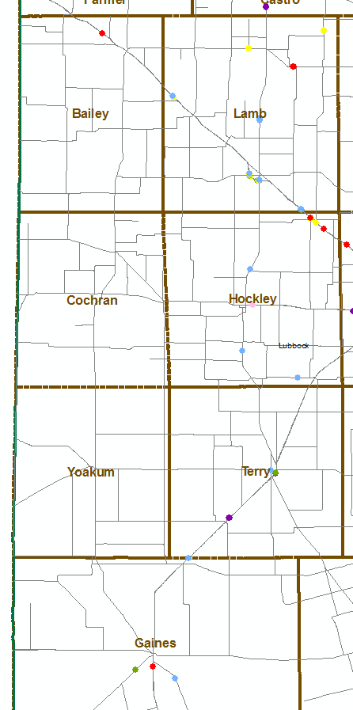 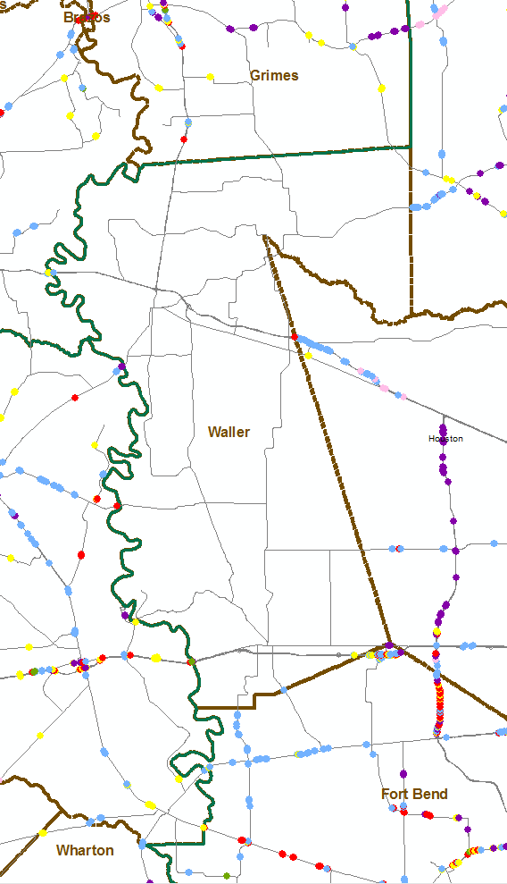

* It appears Waller County was not collected during the project considering their geographic location and the context of the surrounding counties (Figure 2)
* The north Dallas region appears to have multiple sections on major routes with no GET points collected in the triangle between Denton, Dallas, and McKinney. Although some of these sections may accurately have no GETs, most have been confirmed with Google Street View to have GETs present. These routes will need confirmation of their completion and collection of points where GETs exist (On-System frontage roads for toll roads must be collected as well). (Figure 3)

*Figure 3*

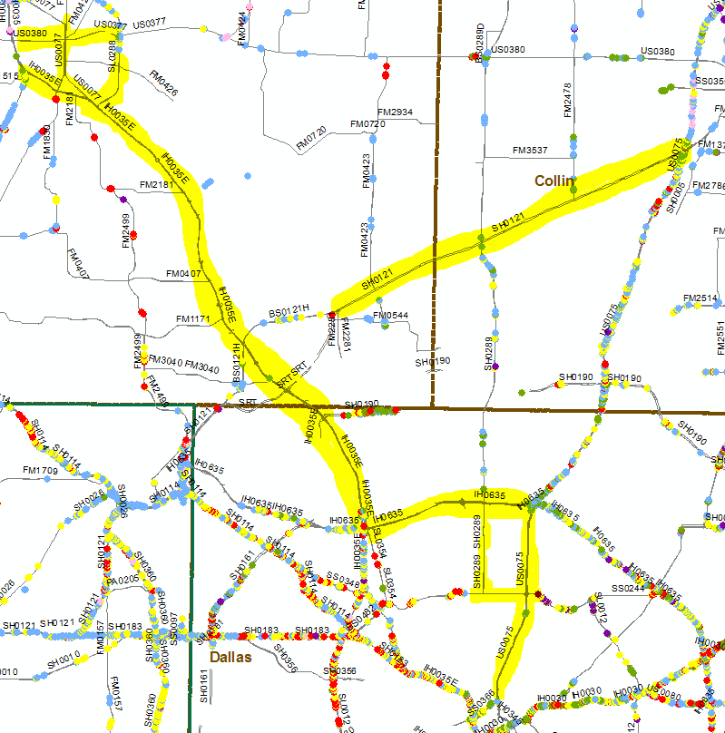

* The northern Starr and Hidalgo County region appears to have routes with no GET points or an excessive amount of ‘missing’ points reported. Large numbers of GET points were deleted from the dataset during the QC process from this region due to inaccuracies. The smart device used was attributing incorrect latitude and longitude information with an Accuracy rating beyond the threshold. The device was also duplicating most of the inaccurate points. These routes will need confirmation of their completion and re-collection of points with an alternative smart device. Special attention must be spent on this region during future QC tasks. (Figure 4)

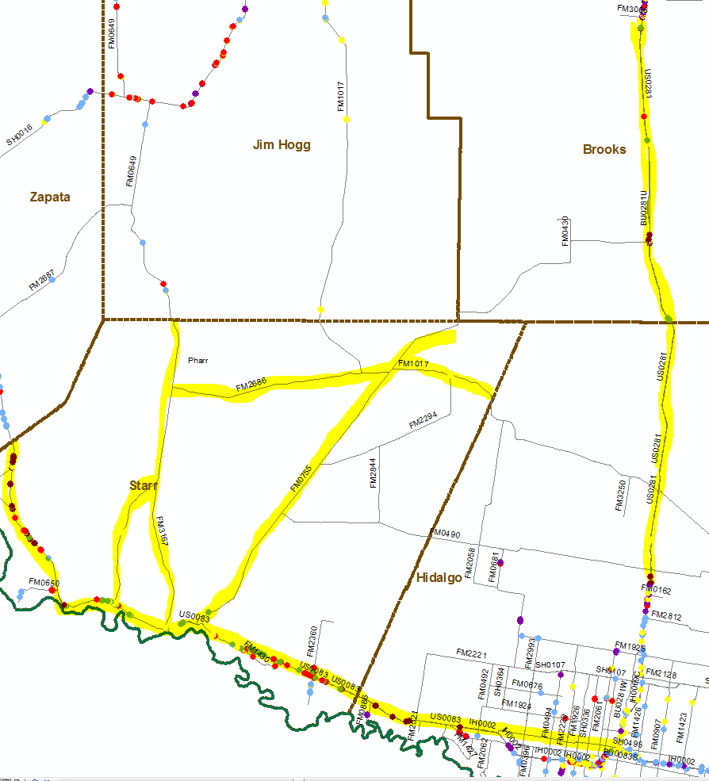

*Figure 4*

District Type Totals Summary

|  |  |  |  |  |  |  |  |  |
| --- | --- | --- | --- | --- | --- | --- | --- | --- |
| District | ETPLUS | ET2000 | OTHER | SKT350 | SOFTSTOP | TURNDOWN | XLITE | TOTAL |
| Abilene | 521 | 260 | 344 | 1,355 | 2 | 2,578 | 4 | **5,064** |
| Amarillo | 681 | 660 | 44 | 273 | 3 | 1,623 | 12 | **3,296** |
| Atlanta | 1,933 | 254 | 179 | 761 | 1 | 1,349 | 2 | **4,479** |
| Austin | 3,630 | 355 | 1,182 | 2,947 | 8 | 4,154 | 45 | **12,321** |
| Beaumont | 1,437 | 477 | 136 | 362 | 0 | 1,178 | 6 | **3,596** |
| Brownwood | 577 | 86 | 44 | 574 | 1 | 1,677 | 12 | **2,971** |
| Bryan | 1,688 | 504 | 94 | 484 | 0 | 1,985 | 57 | **4,812** |
| Childress | 531 | 203 | 386 | 267 | 0 | 659 | 0 | **2,046** |
| Corpus Christi | 1,469 | 397 | 333 | 730 | 3 | 1,551 | 2 | **4,485** |
| Dallas | 5,409 | 1,792 | 888 | 349 | 22 | 3,846 | 151 | **12,457** |
| El Paso | 1,022 | 300 | 454 | 886 | 239 | 1,650 | 26 | **4,577** |
| Fort Worth | 3,198 | 654 | 242 | 280 | 11 | 4,225 | 154 | **8,764** |
| Houston | 4,051 | 1,194 | 322 | 848 | 2 | 2,525 | 52 | **8,994** |
| Laredo | 783 | 389 | 77 | 1,118 | 2 | 1,204 | 1 | **3,574** |
| Lubbock | 320 | 590 | 151 | 538 | 0 | 723 | 30 | **2,352** |
| Lufkin | 2,331 | 75 | 118 | 346 | 36 | 982 | 57 | **3,945** |
| Odessa | 164 | 354 | 272 | 559 | 1 | 1,397 | 6 | **2,753** |
| Paris | 1,851 | 645 | 398 | 738 | 5 | 2,285 | 47 | **5,969** |
| Pharr | 1,063 | 435 | 79 | 405 | 2 | 774 | 9 | **2,767** |
| San Angelo | 922 | 278 | 57 | 693 | 2 | 1,999 | 14 | **3,965** |
| San Antonio | 2,948 | 1,157 | 428 | 1,905 | 3 | 6,119 | 17 | **12,577** |
| Tyler | 1,966 | 307 | 248 | 285 | 5 | 1,742 | 13 | **4,566** |
| Waco | 2,789 | 569 | 481 | 633 | 8 | 1,062 | 42 | **5,584** |
| Wichita Falls | 880 | 155 | 207 | 608 | 1 | 1,514 | 69 | **3,434** |
| Yoakum | 1,451 | 632 | 251 | 573 | 5 | 1,706 | 26 | **4,644** |
| **Statewide** | **43,615** | **12,722** | **7,415** | **18,517** | **362** | **50,507** | **854** | **133,992** |

