

Road Inventory Updates

Application Instruction Manual

TPP, Data Management Section

# Table of Contents

Purpose 2

Browser Information 2

Logging In 2

The Application 4

Resources Menu Section 8

Completion & Contact Info 8

# Purpose

Welcome to the Road Inventory Updates Application!

This document serves as a how-to guide and reference for reviewing and submitting changes to Texas Department of Transportation’s geospatial road inventory. The Road Inventory Updates (RIU) application serves as a communication tool for local, subject matter experts to review and acquire the GIS road network TxDOT currently has on file under their jurisdiction. The application provides multiple tools for the user to interact with the GIS inventory such as downloading a copy, uploading bulk changes to be implemented by TxDOT, or by directly marking up changes within the application to be implemented by TxDOT.

# Browser Information

RIU is accessed through an internet browser. It is highly suggested to use Google Chrome to receive the highest performance while working within a WebMap. Mozilla Firefox will also provide acceptable performance. TxDOT advises against using Internet Explorer.

# Logging In

TxDOT’s Road Inventory Updates (RIU) application can be accessed at:

**[http://www.txdot.gov/apps/statewide_mapping/riu/index.html]( http://www.txdot.gov/apps/statewide_mapping/riu/index.html)**

Upon arriving at the web application, you will be prompted to sign in. To do so,

1. Choose the road classification Inventory you are to be reviewing and marking up for updates. Choose *County Roads* for updating roads related to the biennial County Road Inventory project or *Local Streets* for updating local, city and municipality roads.
2. Choose the Organization which you are affiliated with.
3. Enter your Access Code. If you have not received an Access Code, please contact Transportation, Programming, and Planning Division’s Data Management group via [TPP-GIS@txdot.gov](mailto:TPP-GIS@txdot.gov) to request one.
4. Agree to the disclaimer by marking the checkbox stating your agreement.
5. Click ‘Sign In’

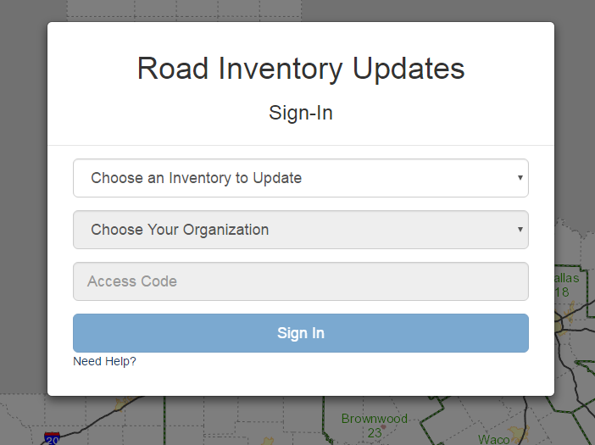

Upon successfully logging in, the ‘Sign-In’ dialogue will disappear. The web map will illuminate and automatically zoom to the location of your organization.

# The Application

The RIU Application is a large interactive map which you can navigate and has tools for completing various interactive tasks. The application is specifically oriented for reviewing and updating the TxDOT inventory. Therefore, you will only be able to view the inventory for your organization.

To ensure a quality review and mark up, you must be zoomed in for the inventory to appear (Level 11 for County Roads, Level 13 for Local Streets). If you are zoomed out too far, the inventory will disappear and your organization’s jurisdiction will appear in red.

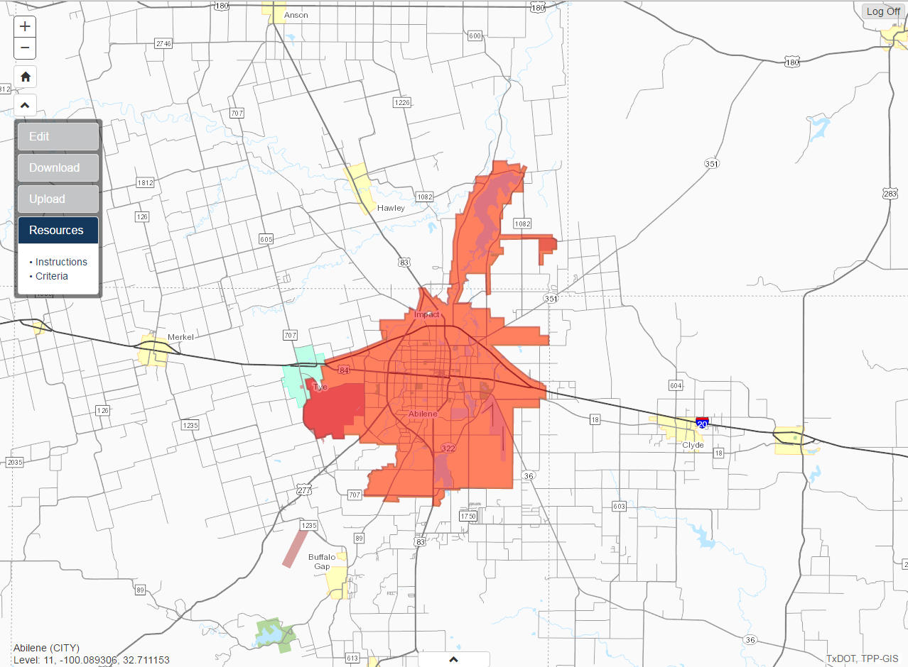

Click and drag anywhere on the map to pan around the map.

The application contains many components, each with a specific functionality.

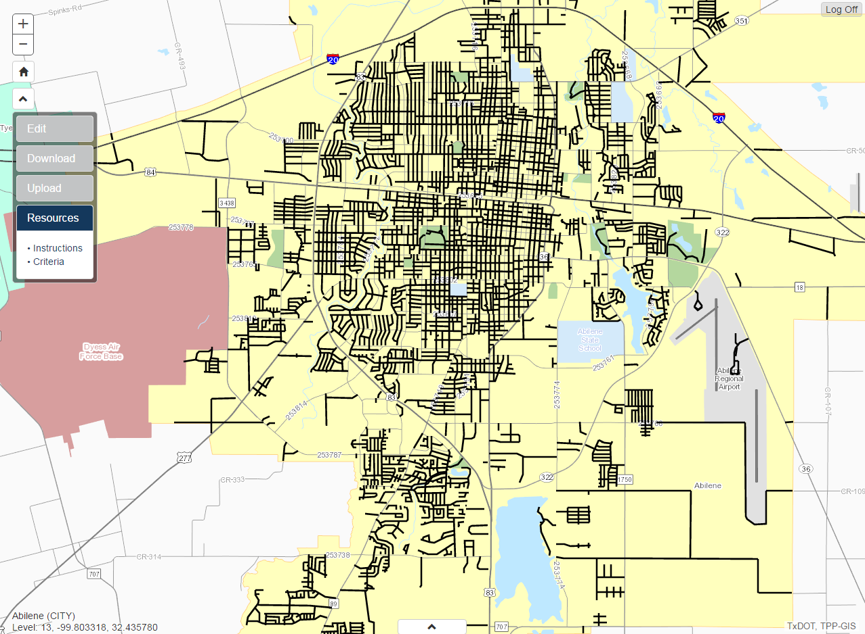

**3**

**7**

**6**

**5**

**4**

**2**

**1**

1. Zoom Buttons. Click the + (plus) button to zoom in and the – (minus) button to zoom out of the map. Alternatively, you can double click a location on the map to zoom in or use the scroll wheel on the mouse to zoom in and out.
2. Home Button. Click the Home button to return the map to the original zoom level and location as when you initially logged in. This will be the default extent for your organization.
3. Menu Button. Click the Menu button to toggle showing and hiding the menu.
4. Menu. The Menu contains 4 sections: Edit, Download, Upload, and Resources. Each section name can be clicked to open the options/tools for that section while simultaneously hiding the other sections. Detailed instructions for each section can be found through links within this document.
5. Map Information. This text displays the name of the organization you logged in with, the current zoom level of the map, and the current latitude and longitude coordinates of the mouse cursor.
6. Basemap Button. Click the basemap button to display the Basemap Menu (described below). The Basemap Menu provides options for changing the background (basemap) image on the map.
7. Log Off Button. Click the Log Off button to exit the current session and return to the Sign-In screen.

The Basemap Menu displays four options for changing the background (basemap) image of the map. With the Basemap Menu open, click any of the options to make a change. Re-click the Basemap Button to then close/hide the Basemap Menu.

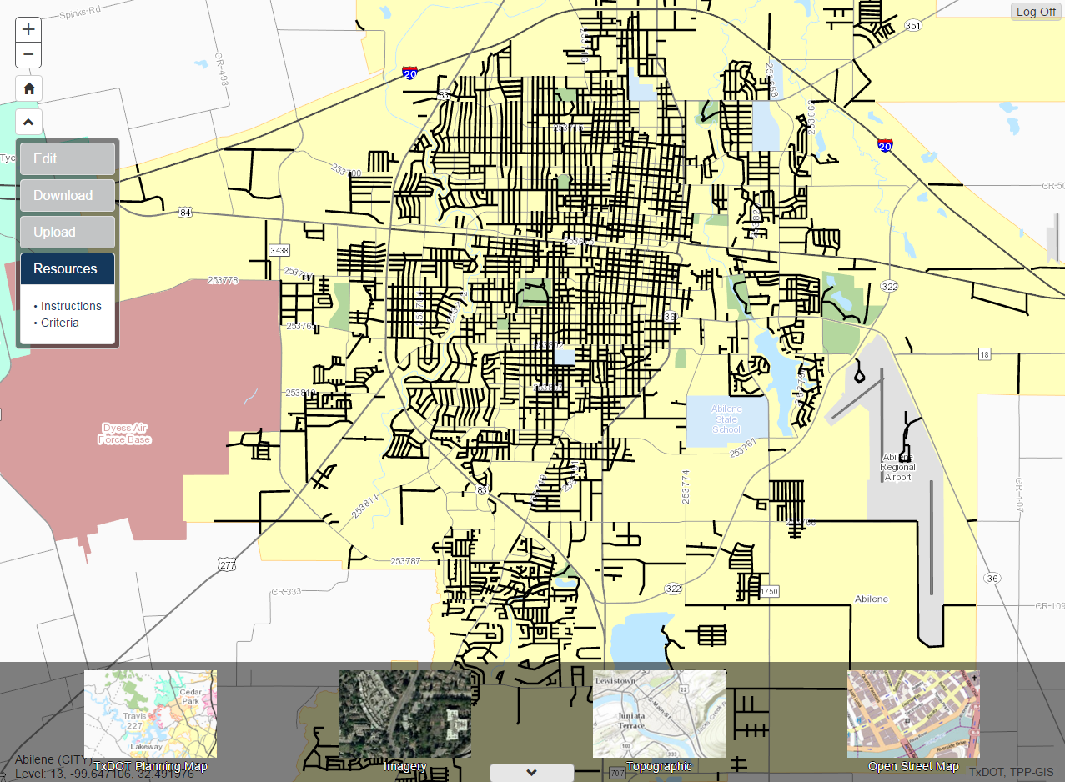

**1**

**2**

**3**

**4**

1. TxDOT Planning Map. The default basemap, this is the standard basemap for TxDOT products as it displays the full range of necessary reference information TxDOT currently has within its GIS inventory.
2. Imagery. Standard aerial photography. This basemap contains no reference information aside from the imagery itself.
3. Topographic. Similar to the TxDOT Planning Map, this basemap display a full range of reference information sourced from a variety of sources including USGS, Texas Parks & Wildlife, HERE, and more. This basemap also contains topographic contour information.
4. Open Street Map. Oriented toward the road inventory, this basemap displays the open source road inventory of the Open Street Map Foundation.

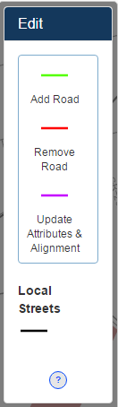The Menu is broken down into four sections. Each is of a purpose which provides an alternative method for reviewing the inventory and submitting changes.

**Edit**

The Edit section provides 3 drawing template options for you to mark up the map. Also provided is a Legend for the current inventory as it is displayed in the map. Finally, the “?” button can be clicked to open instructions specific to editing within the application.

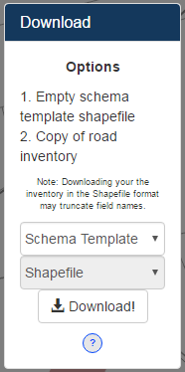 **Download**

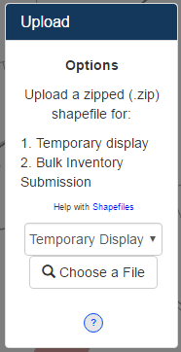The Download section offers 2 options. First is the ability to download an empty template shapfile to be used when marking up changes to the current TxDOT inventory within ArcMap on your local computer. This template shapefile is required to submit bulk updates in the Upload section. Secondly, you can download a GIS copy of the current TxDOT inventory. Choose between the option in the dropdowns and click ‘Download!’. Finally, the “?” button can be clicked to open instructions specific to downloading within the application.

**Upload**

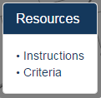The Upload section offers 2 options. First is the ability to upload a shapefile for temporarily displaying within the map. Your shapefile will draw and can be used for reference during your update. The shapefile will be cleared automatically when you log off. Secondly, if you have marked up changes within the downloaded schema template shapefile, you can submit those changes in bulk. Finally, the “?” button can be clicked to open instructions specific to uploading within the application.

**Resources**

The Resources section offers reference material for use during your update. Reference materials vary based on the road classification you are updating.

# Resources Menu Section

The Resources Menu Section contains a variety of reference materials which may serve as helpful when reviewing the current inventory and marking up changes. The listed materials change based on the road classification being updated. At minimum, available resources include:

1. Instructions. This is a link to this document with descriptions on the application and its functions and links to specific instructions for Editing, Downloading, and Uploading.
2. Criteria. A document which outlines the mandated definition of the road classification being updated. This document will list specific requirements for roads to be added to the TxDOT road inventory and reported to dependent agencies.

If you are updating the County Road classification of roads, you will see a third resource:

1. Download Packet. This is a link to the TxDOT zipfile packet specific to the County Road Inventory project. It is the same packet given to the County Judge for review and contains many materials standard to the biennial project including a county mapbook and road summary.

# Completion & Contact Info

Upon completion of the inventory review and markup, we request the user to send an email to the TPP Data Management Section (contact address below) stating your markup has been completed. At the time of completion, the updates will be reviewed and the changes which meet the inventory criteria will be implemented to update the TxDOT Road Inventory.

Thank you for using the Road Inventory Updates web application to submit changes to the TxDOT Road Inventory. If you would like to report any bugs or issues, or have any questions which need clarification of the procedures, please contact the Transportation, Programming, and Planning Division’s Data Management staff at:

[TPP-GIS@txdot.gov](mailto:TPP-GIS@txdot.gov)

(512) 486-5052