

Road Runner

Standard Operating Procedure (SOP)

TPP, MNT

# Table of Contents

Purpose 2

Quick Steps 2

Guidelines 2

Deficiency Types 3

Setup 4

Collection Application 10

FAQs 13

Office Maps 14

Summary Report 20

Ongoing Maintenance 22

Contact Info 24

# Purpose

Collect GPS located roadway deficiencies from the field for Maintenance Supervisors to review, map, summarize, and manage routine maintenance crew assignments. Create a digital deficiency inventory and historical log of types, counts, locations, and progress of issues resolved.

# Quick Steps

1. Review Safety Requirements
2. Review Deficiency Types
3. Set Up your Mobile Device
4. Familiarize Yourself with the Data Collection App
5. Collect Data in the Field
6. Review Points in the WebMap or Office App
7. Review Deficiency Statistics with a Summary Report

# Guidelines

SAFETY

Please observe the following guidelines for everyone’s safety:

* **Two-Person Teams** (Driver and Passenger): Driver must never collect data or operate a mobile device.
* **Avoid Distractions:** Driver must focus on road rather than trying to assist with the location or identification of guardrails.
* **Weather:** This is a fair weather project. No data collection is to occur in inclement weather.
* **Go Slow:** Drive a safe, comfortable speed in order to facilitate accurate collection and avoid misses that might distract driver.
* **Stay Seated:** Avoid exiting the vehicle unless absolutely necessary. Exiting the vehicle drastically increases your risk of danger.
* **Switch Drivers:** Rotate drivers periodically in order keep both participating individuals alert (we suggest an hourly basis). Stopping to upload data might also be an opportunity to switch drivers.

# Deficiency Types

The following are the deficiency types the application is enabled to collect. They are categorized based on the road asset they impact. If you are not already familiar with them, please request a descriptive explanation and examples from a maintenance supervisor.

|  |  |  |  |  |
| --- | --- | --- | --- | --- |
| ROADSIDE | Mowing/Herbicide |  | STRUCTURES | Decks |
| Trees |  | Joints |
| Litter |  | Rails |
| Guardrail |  | Debris |
| Sweeping |  | Drift |
| Illegal Sign |  | Culverts |
| Mailboxes |  | OTHER | Incident |
| Encroachments |  | Work Request |
| Erosion |  | Checked Okay |
| Driveways |  | Illumination Poles |
| Sight Visibility |  | School Zone Beacons |

|  |  |
| --- | --- |
| PAVEMENT | Pothole |
| Base Failure |
| Outside Qtr |
| Edge Drop |
| High Edges |
| Wheel Rut |
| Approach Slab |
| Pav Markers |
| TRAFFIC OPS | Striping |
| Signs |
| Delineators |
| Signal Light |
| Concrete Traffic Barrier |

# Setup

Follow these recommendations for optimizing data collection.

### Quick Steps

1. **Bring a car charger for your device:** Although the application doesn’t use an excessive amount of data or power, it will use more than usual.
2. **Allow/Enable location services:** The application will not work if this functionality is not permitted. If there are no green Latitude & Longitude coordinates in the upper left-hand corner, then the location services are not enabled.
3. **Change the timeout settings** to keep the device from going to sleep.
4. **Open Web App** on your phone before leaving the office (while you have internet connectivity).
5. **Turn off Private Browsing for iPhones:** private browsing does not allow for collection of location information
6. **Upgrade your iOS (operating system for iPhones):** older versions of the iOS inhibit the proper functionality of the data collection site.
7. Allow/Enable location services
   * For Android Devices, go to Settings>Location to enable the GPS for the phone.

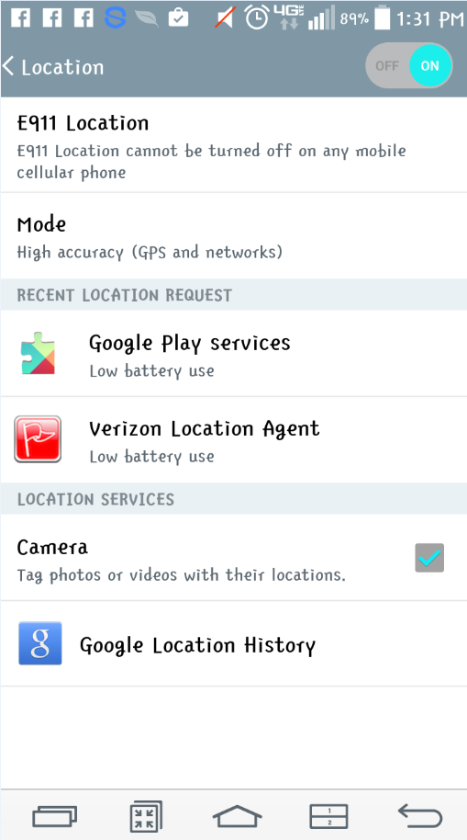

* + - Android Devices will also sometimes ask you to “Allow” location services when you go to the collection app website. Always “Allow.”

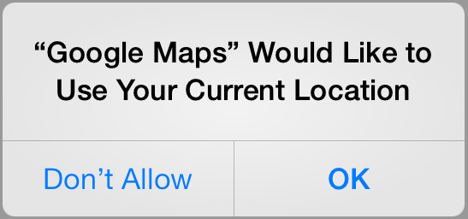

* + For Apple Devices, go to Settings>Privacy>Location Services to enable the GPS for the phone.
    - You must also change this setting for Safari.

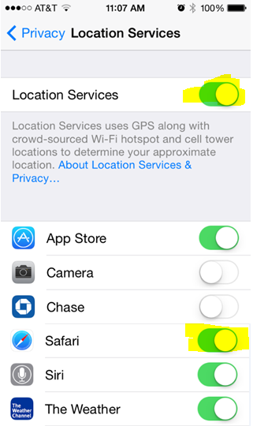

1. Change timeout settings.
   * For Android Devices, go to Settings>Display>Screen Timeout.

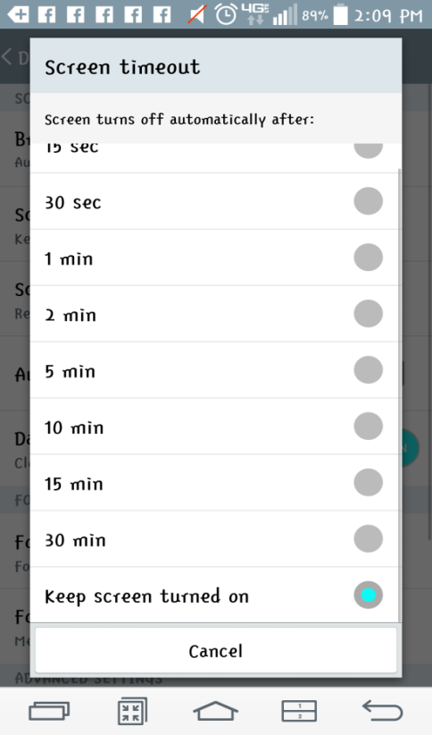

* + For Apple Devices (iPhone, iPad), go to Settings>General>Auto-Lock.

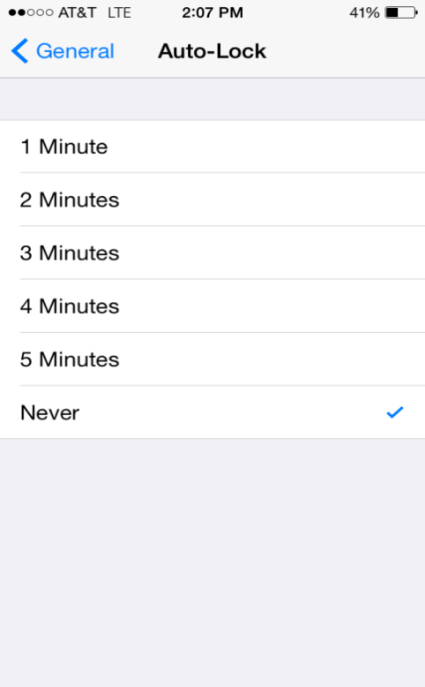

1. Turn off Private Browsing for iPhones
   1. Go to Settings>Safari and set Private Browsing to Off  
      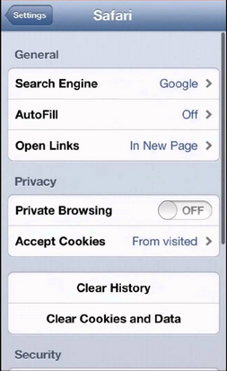
   2. Make sure that you are not still in private browsing for the webpage you are viewing
      1. With Safari (iPhone web browser) open, click the little boxes on the bottom right-hand corner. Next press the private button on the lower left-hand side.

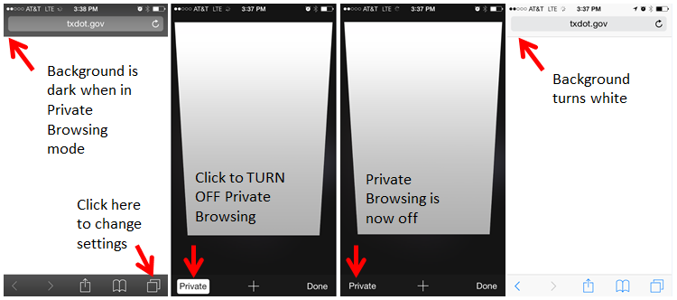

1. Update iOS (operating system for iPhones)
   1. Go to Settings>Software Update and install the most current version  
      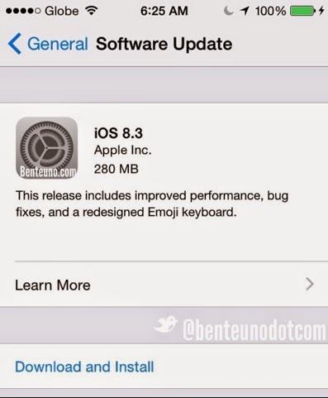

# Collection Application

A site has been created for you to collect deficiency locations. It can be accessed from any mobile device with a GPS receiver, such as smartphones, tablets, and some laptops.

<http://www.txdot.gov/apps/statewide_mapping/roadrunner/test.html>

Upon the initial load of the application, you will be prompted to log in. Choose to log in ‘USING YOUR TXDOT ACCOUNT’.

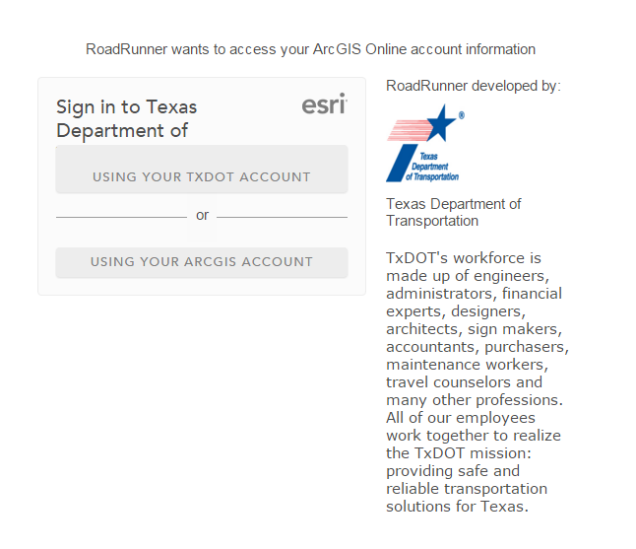

You will be redirected again to enter your credentials. In the form, enter your TxDOT Novell Network Credentials and click ‘Sign On’ to reveal the application.

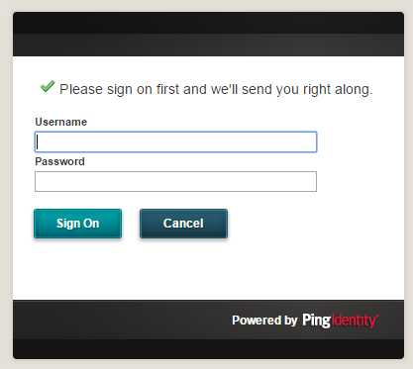

Click Sign On to verify credentials

Enter your Novell credentials. This is the same username and password used to log into any TxDOT computer.

Logged in user’s Username. Click to log out

Upload to database

If you make a mistake, Delete Last Point

Upload Successful

** may appear slightly different on various devices (Apple, etc.)

Clears All Points (Good for Training)

Enter a comment in the text box before clicking a deficiency button to apply the note to that specific point

Dots represent the 5 panels of deficiency buttons. There is 1 panel for each asset category. *Swipe* left or right to switch between panels.

# of Points Collected

Panel of deficiency buttons for collection

Current Location

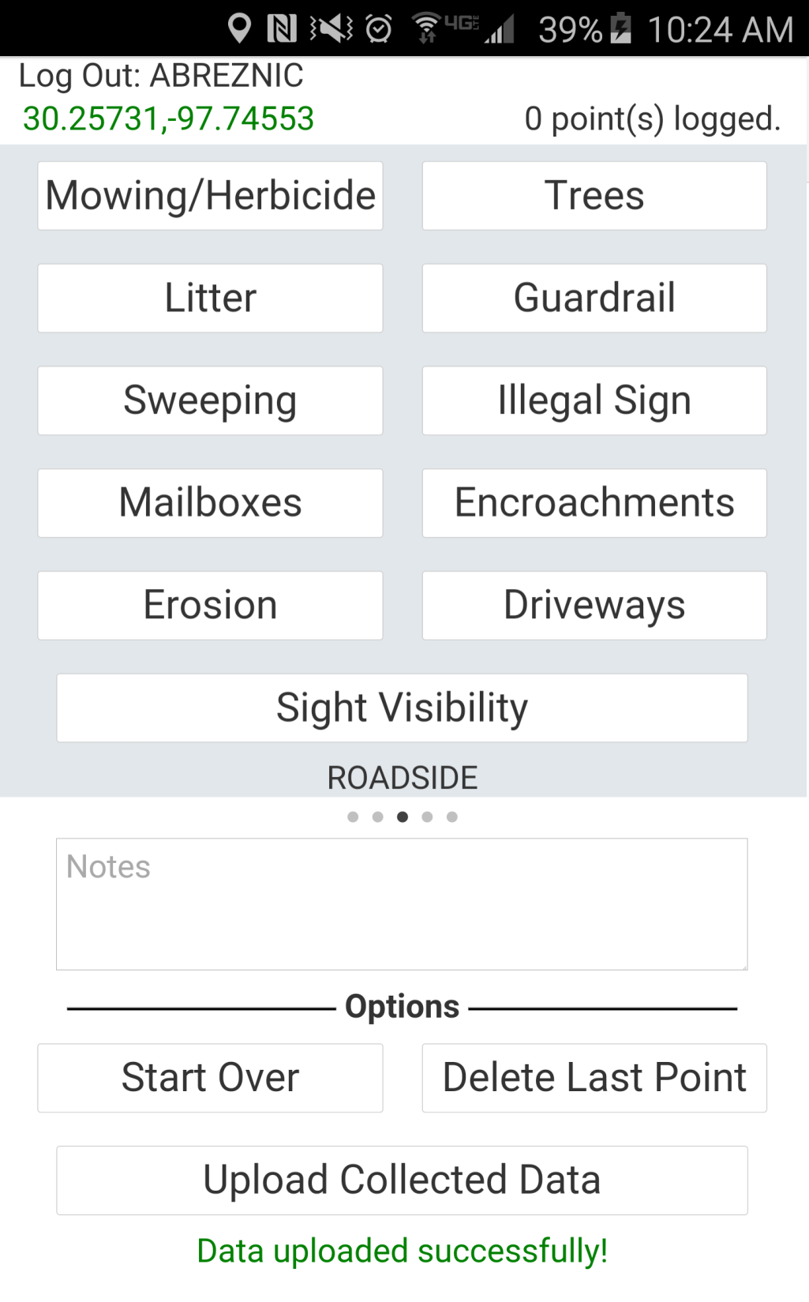

Upload Successful

Upload to Map

If you make a mistake, Delete Last Point

Clears All Points (Good for Training)

# of Points Collected

Current Location

### Quick Steps

1. **Load the Webpage** on your device before leaving the office
2. **Review Instructions**
3. **Review FAQs**

### Instructions

1. Go to <http://www.txdot.gov/apps/statewide_mapping/roadrunner/test.html>

on your mobile device to load the page before you leave the office.

1. Before getting started, press a few of the deficiency buttons to make sure you have a GPS fix and the points are logging properly. Then, be sure to press ‘Start Over’ to clear the test points from local storage.
2. In the field, the crew will drive the routine Road Runner routes to identify the locations of asset deficiencies.
3. Upon identification, the application will be used to log the deficiencies. The deficiency buttons are listed across 5 panels, grouped by asset type categories. The panels are identified by their light gray background. Press-Hold-and *Slide* the displayed panel left or right to scroll through the panels of deficiency options.
4. Point positions are logged at the physical location of the mobile device, at the exact moment when the deficiency button is pressed. Under this principle, it is best practice to collect the point when the field crew is as close to the location of the deficiency as possible. Click the button which represents the identified deficiency to log its location.

***Safety is of utmost importance, therefore, in high traffic environments be prepared to choose a deficiency while the driver maintains a safe travel speed. In rural areas, when safe to do so, the crew may choose to slow or pull off the road to log a deficiency.

1. Optionally, a comment of further descriptive detail related to a deficiency may be entered into the ‘Notes’ text box **before** clicking a deficiency button. When click a deficiency button, any text within the Notes box will be logged and attributed to the deficiency.
2. The button will flash red and emit a sound to notify you that the point was collected. Turn up the volume on your device if wish to hear the sound clearly.
3. Once you have finished collecting all deficiencies, or come to a stopping place, press the ‘Upload Collected Data’ button to upload the locations to the database. A message will appear at the bottom of your screen
   1. You can collect points without an internet/data connection, but you will need the internet to upload points.
   2. Stop to upload your data at, or before, you’ve collected 100 points. Depending on the number of points collected, it could take up to 30 seconds to upload points. Refrain from uploading points during collection, as the delay might prevent you from collecting the next point.
   3. Points are stored locally on your device until you upload them.

# FAQs

* I passed a deficiency but did not press the button in time.
  + Press the correct button as soon as you can. It is better to have a collected point with a bad location, than no point collected at all.
* I pressed the wrong button type or want to add a Note to the last logged deficiency.
  + Press the **Delete Last Point** button, enter a Note if desired, and then press the correct button.
* I don’t have a TxDOT issued phone/device for the data collection. What do I use?
  + Work with your supervisor in your district. If this application represents the desired workflow, resources should be made available accordingly

# Office Maps

When in the office, field Road Runners can review their collected points by opening the WebMap or Office Application. Both office maps offer unique interfaces and tools for reviewing and editing the collected data. They are protected by TxDOT Network Security and require the same login procedure outlined above on page 10.

WebMap: <http://arcg.is/1NdVOVu>

OfficeApp: <http://txdot.maps.arcgis.com/apps/webappviewer/index.html?id=dfa1d556f41a41f2a734ee0dd2cc9748>

**WebMap**

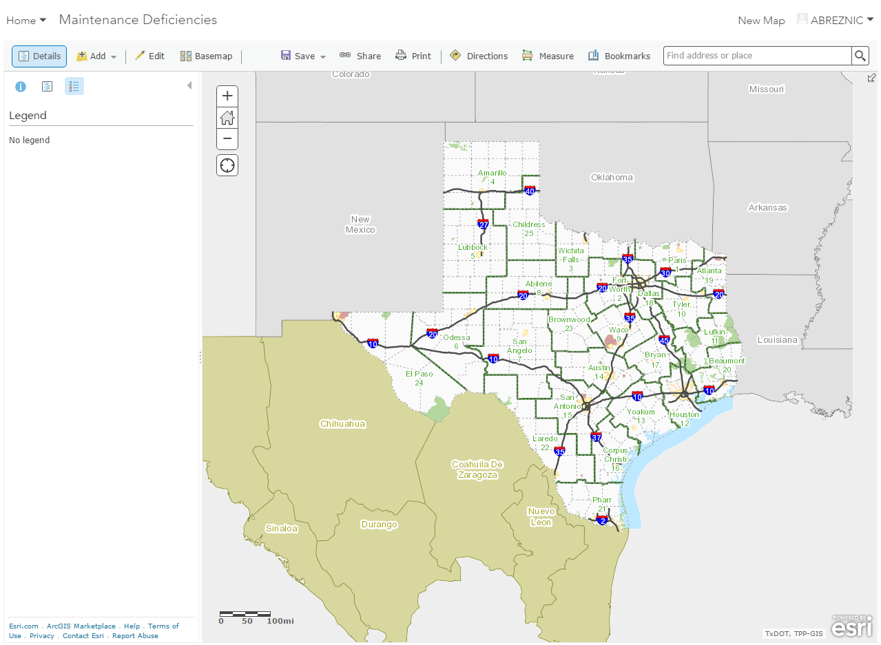

Continued on next page…

### Zoom in to a route to see the deficiency points show up on the map.

* 1. Once you have zoomed to the extent of a county, points will start to appear. **Note**: It may take a few moments for the points to load if you have a poor internet connection.
  2. The legend will also change to show Maintenance Deficiencies once you have zoomed in far enough.
  3. You can change the basemap to an aerial image if you’d like to zoom in far enough to see the surrounding surface and relevant landmarks in the image.

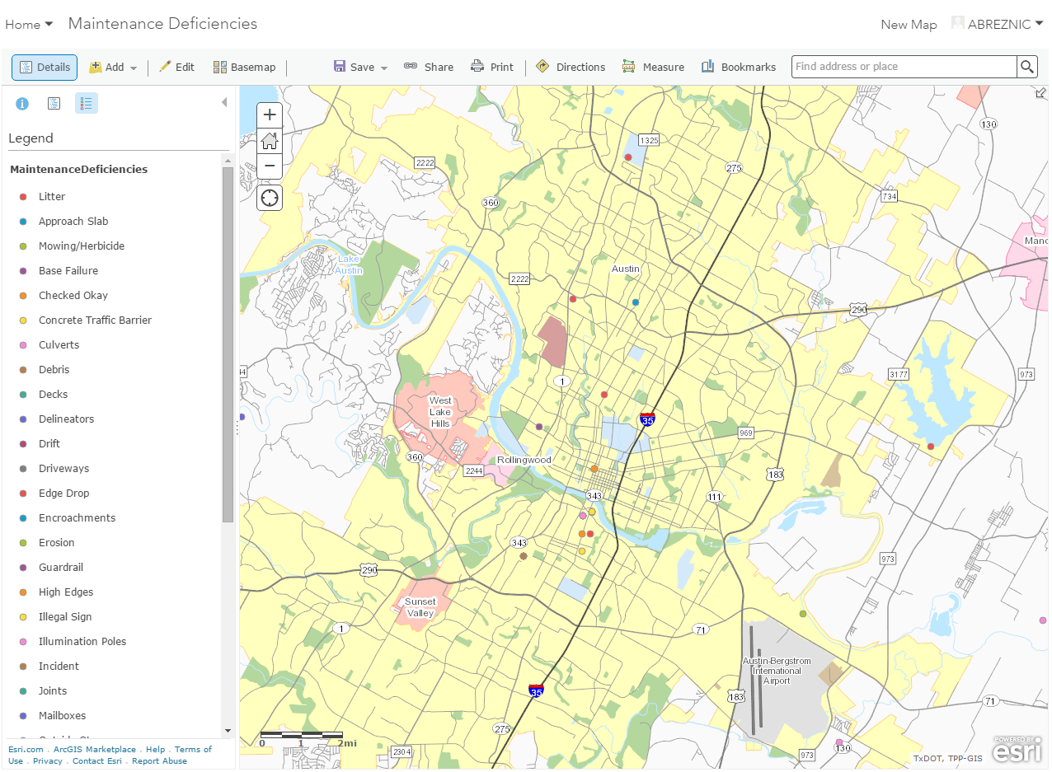

Change the background image ‘Base Map’

Maintenance Deficiencies appear in legend

### The WebMap is equipped with many tools to interact with the deficiency points.

1. Click any deficiency point to review its’ attributional details
2. Clicking the Details icon (looks like a piece of paper) above the Legend reveals several other reference layers which can be turned on and off. These will be beneficial when reviewing the data with a non-Statewide Planning Map basemap.
3. Hovering your mouse over a layer on the Details tab will reveal tools to temporarily re-symbolize the points, display a table of the points, and even provide a tool to ‘Filter’ the points. You can filter the points to view only points collected within a specific timeframe, collected within a political boundary, specific deficiency types, who collected the points, and many more.
4. Choose the ‘Edit’ button above the Legend to enable editing capabilities on the deficiency points. When editing is enabled, use the sidebar template to add new points, or click on existing ones to alter their descriptive attributes such as their resolution status.

Details tab reveals all layers available in the map and tools to alter them

### 

Filter or re-symbolize a displayed layer. Use the checkbox to turn the layer on or off

Click a deficiency point to review it. With Editing enabled, click a point to alter its’ attributes

Click the Edit button to enable editing on the deficiency points

**OfficeApp**

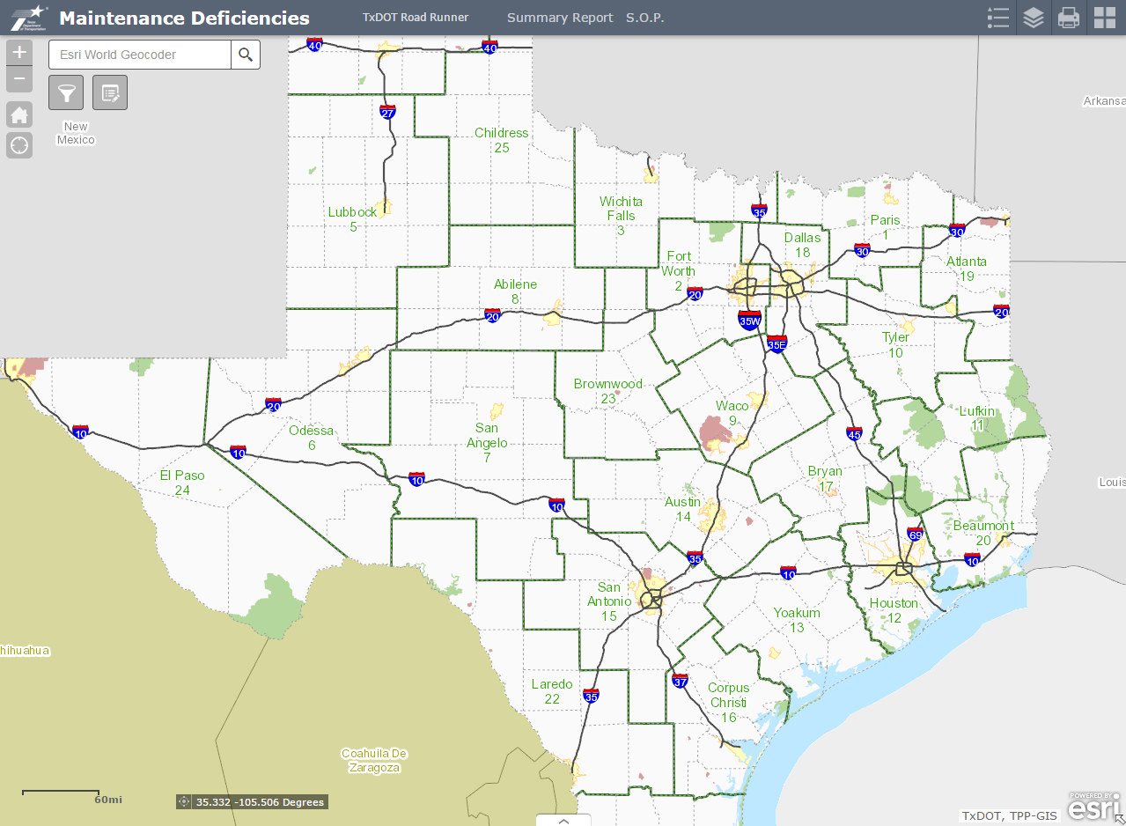

The Office App provides much of the same functionality as the WebMap but with an alternative interface which allows you to collapse or *hide* the tools. Just like the WebMap, you must zoom into the county level for the points to appear on the map.

* + - 1. Change the basemap with the gallery window represented by 4 squares in the top right corner of the app.
      2. Choose the stacked line and rhombus symbols in the top right corner of the map to view the Legend and Layer Details windows. Within the layer details window you can turn on and off layers just the same as the sidebar in the WebMap.
      3. The Edit button is located in the top left corner of the map. Clicking this button enables editing just the same as the WebMap and closing the window disables editing.

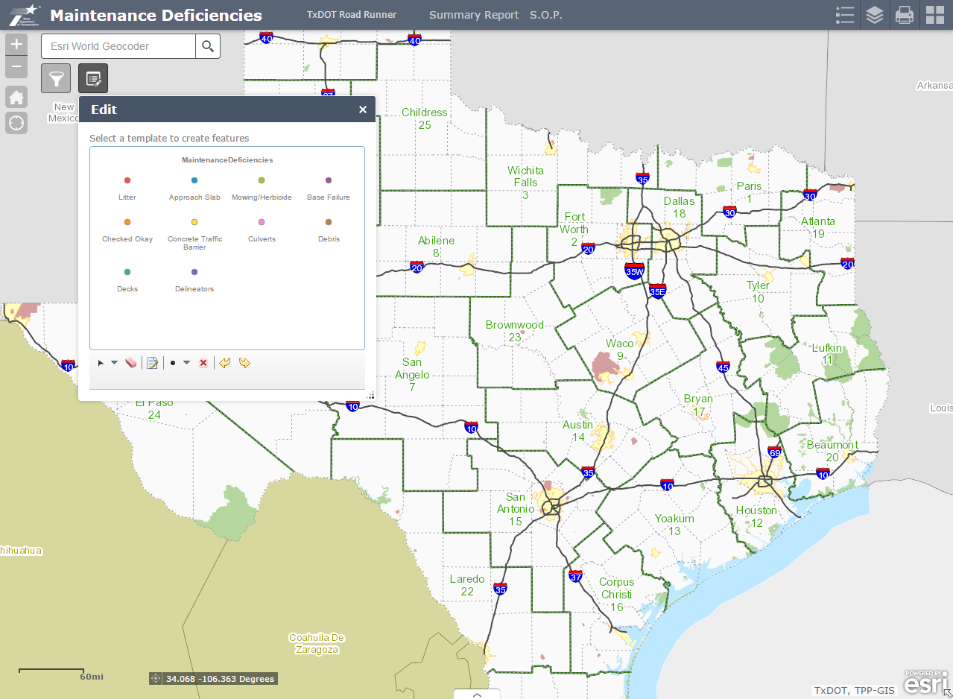

Enable Editing and access the tools

Change the basemap

Details Window

Legend Window

Links to the other Road Runner project resources are available along the top of the OfficeApp.

The Filter capabilities are available within the Query window. When the window is open, pre-defined queries are listed for each political boundary. You can enter a time frame associated with each political boundary to identify the points which satisfy your filter.

* + - Unlike the WebMap, filtering in the OfficeApp will not remove points from the map which do not satisfy the query. Applying a query will create a new layer of points which overlay those which exist on the map. This empowers you to display the queried overlay points when zoomed out further than the county level.

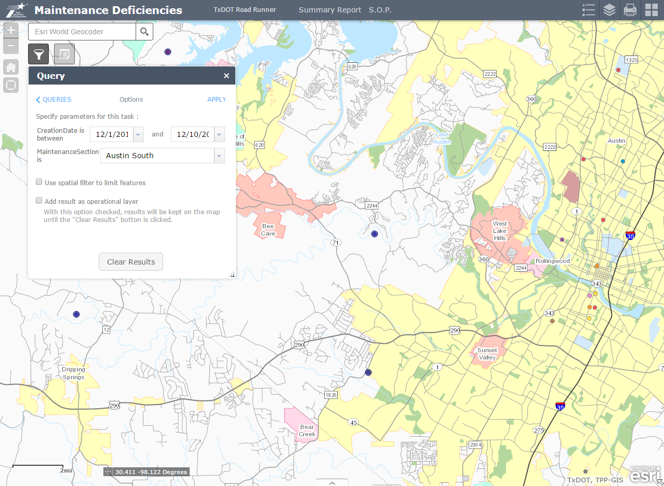

Fill out time table and political boundary details for the query

Points which do not satisfy the query remain visible

Points which satisfy the query over overlaid with a new layer

Links to associated project resources

Open the query window

# Summary Report

Access the Maintenance Deficiency Report Application to quickly generate a customized statistical Summary Report for the deficiencies collected across the state.

<http://www.txdot.gov/apps/statewide_mapping/roadrunner/report.html>

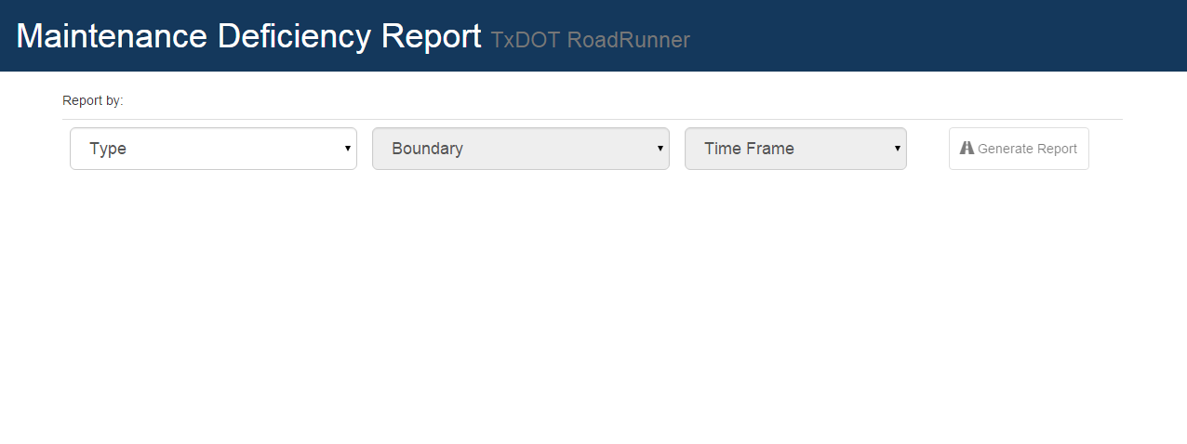

1. Choose a ‘Type’ of political boundary extent of points to summarize.
2. Choose which specific ‘Boundary’, for the chosen Type, to summarize.
3. Choose a Time Frame which to Summarize. Several quick links are listed to summarize the points collected from the beginning of the day, week, month, and year from the time the report is generated. Also available is the ‘Forever’ option to display all points ever collected. For a specific date or time frame not listed in the quick links, choose ‘Specific Dates’ and enter the desired From and To date.
4. Click ‘Generate Report’ to quickly build the report.

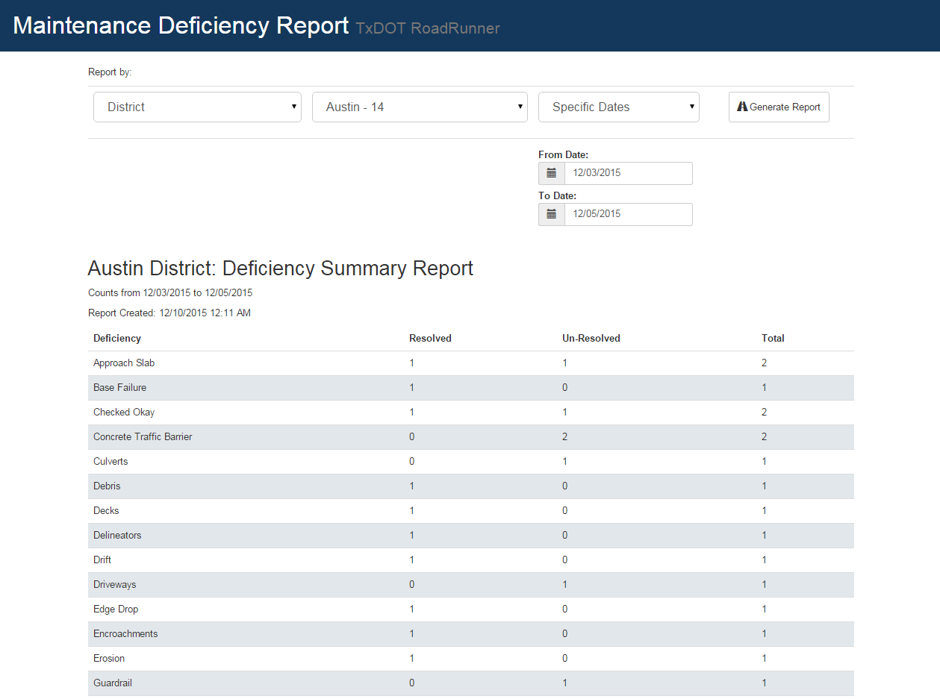

Deficiency type counts are broken down by their resolution status

Report is broken down by deficiency the Deficiency types listed alphabetically with the totals listed last

.

# Ongoing Maintenance

All of the apps and tools created for the Road Runner project have been designed to empower Maintenance Supervisors and employees with an easily accessible, digital environment to create and maintain a location-based deficiency inventory which also stands as a historical and performance log.

The field Road Runner application is designed for the collection of new deficiencies on location while the WebMap, OfficeApp, and Summary Report App are designed for in office review/manipulation of the deficiencies. The office maps are designed for Supervisors to review the data collected in the field to manage their crews for work performed to resolve the deficiencies.

The deficiency point inventory contains a data field called ‘Resolved’ to designate whether work has been performed to *fix* the identified problem. By default, when a deficiency is identified in the field and a point is created, the points’ ‘Resolved’ field is populated with a value of ‘No’ indicating the deficiency exists but has not been *fixed*. When a maintenance crew *fixes* and identified deficiency, the supervisor may choose to review their work. Upon confirmation of the works’ completion, a supervisor may edit that deficiency point within the WebMap or OfficeApp by changing the value of the ‘Resolved’ field to ‘Yes’.

Utilizing the ‘Resolved’ field to manage work completed creates an ever-running tracking system of work performed.

**Note: The ‘Resolved’ field requires the input values of ether ‘No’ or ‘Yes’. Populating any other value or case spelling will result is inaccurate report summarization.**

Collected point defaults as unresolved with the value: **No**

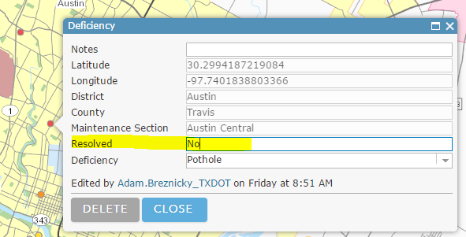

When work is completed, the deficiency issue becomes resolved and is to be populated with the value: **Yes**

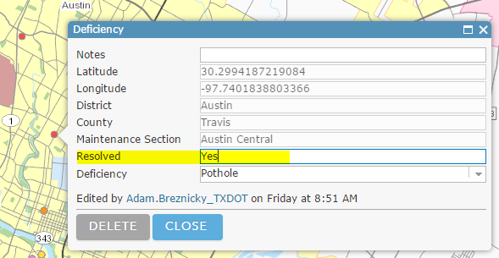

# Contact Info

For technical issues with the Road Runner field application, WebMap, OfficeApp, or Summary Report application, please contact TP&P.

[TPP-GIS@txdot.gov](mailto:TPP-GIS@txdot.gov)

(512) 486-5052

For questions about deficiency types, or difficulties acquiring a device for the data collection, contact your Supervisor.