**Objectives**

* Understand how network traffic is routed using a GUI topographical representation
* How cookies are persistent when browsing websites
* How firewalls block traffic
* How Network Address Translation changes IP addresses
  + public vs private IP address
* Understand the security difference between telnet and ssh traffic
* How the Domain Name System resolves websites names to an IP address
* See tcp handshake network traffic
* Understand the security difference between http vs https
  + Extract files from tcp stream/session

**Introduction**

Students should now have a conceptual understanding of network traffic and packet structure, but seeing is believing. Students will use networking tools on a linux machine, Ubuntu 14.04. After completing the labs, they should be able to analyze and deconstruct basic network traffic and packet captures.

**Scenario**

You’re hired by ‘teh supa 13373 h4x0r’ team, and need to learn about their new network before starting your new job. The following lab will walk you through what to do in order to become more familiar with their network, and the internet as a whole.

**Setup**

Each virtualized computer should already be pre-configured with the required programs and files. Press ‘Ctl+Alt+t’ to open a terminal and enter the following command

* cd ~/Desktop/Networking; ./check.sh

Looking at the command output, lines with a program should have a path. An example would be

* ifconfig: /sbin/ifconfig /usr/share/man/man8/ifconfig.8.gz

If a program’s directory is blank, enter the following command to install them

* sudo apt install git
* cd ~/Desktop
* git clone https://github.com/adambutac/Gencyber-Networking Networking
* cd Networking
* sudo ./install.sh
  + Note: You’ll need to enter the sudo password whenever prompted. For security reasons, you won’t be able to see it as you type. Press enter when done.

Also note that you may need to manually install the ‘Cookies Manager+’ add-on for Firefox, which can be found at the following url <https://goo.gl/5KpYTo>

This document should also be available on each computer in the ‘Networking’ folder on the ‘Desktop’ for ease of use when copying and pasting each terminal command.

**Operating System**

* Ubunter 16.06

**Programs**

* Firefox
  + With ‘Cookies Manager+’ add-on <https://goo.gl/5KpYTo>
* ifconfig
* iptables
* route
* ssh
* wget
* wireshark
* zenmap

**Section 1: Cookies and Firewalls**

1. Click on the ‘Ubuntu’ logo in the top of the launcher on the left of side the desktop
2. In the search bar, type ‘Firefox’ and click the icon to launch it
3. Open the ‘Extras’ menu in the top right of Firefox
4. Click on the ‘Cookies Manager+’ icon
5. In the ‘Cookies Manager+’ window, selected a cookie in the main window and press ‘Ctl+A’ to select all the cookies
6. Click the ‘Delete’ button
7. In the following window, click ‘Delete All’
8. With the ‘Cookies Manager+’ window open, use Firefox to visit the following websites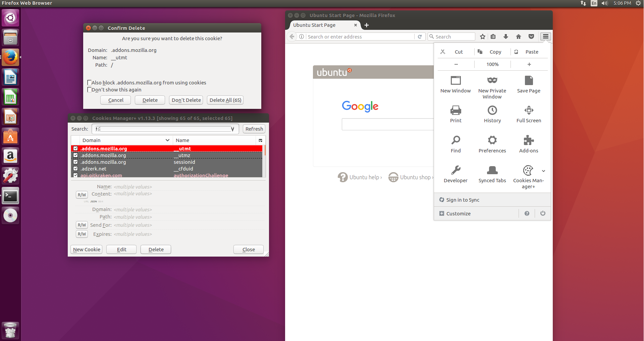
   1. https://www.facebook.com
   2. https://www.google.com
   3. https://www.imgur.com
   4. https://www.reddit.com
9. **Observe**
   1. You’re able to access the websites
   2. As you visit each website, cookies are added and are persistent
10. Click on the ‘Ubuntu’ logo in the top of the launcher on the left of the desktop
11. In the search bar, type ‘Terminal’ and click the icon to launch it
12. In the terminal prompt, enter the following commands
    1. sudo iptables -A OUTPUT -p tcp --destination-port 80 -j DROP
    2. sudo ip6tables -A OUTPUT -p tcp --destination-port 80 -j DROP
       1. Note: enter the user password when prompted for the sudo password
       2. Note: you won’t be able to see the password as it’s entered for security reasons
13. In Firefox, open a new tab and close all other tabs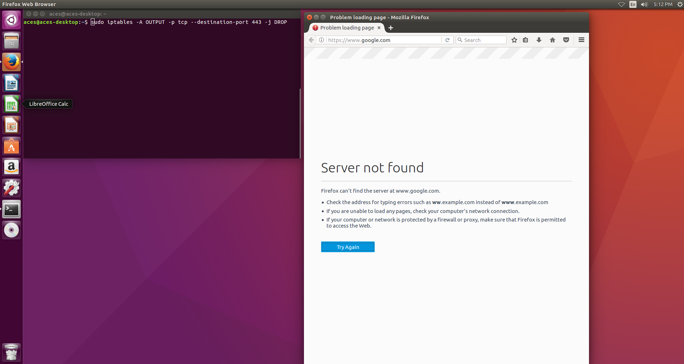
14. Using Firefox, visit the following websites
    1. https://www.facebook.com
    2. https://www.google.com
    3. http://www.imgur.com
    4. https://www.reddit.com
15. **Observe**
    1. You’re able to access only some websites
       1. Note: With the created firewall rules, you aren’t able to access websites using HTTP (port 80)
       2. Note: You’re able to access websites using HTTPS (port 443)
16. In the terminal prompt, enter the following commands
    1. sudo iptables -D OUTPUT -p tcp --destination-port 80 -j DROP
    2. sudo ip6tables -D OUTPUT -p tcp --destination-port 80 -j DROP
       1. Note: enter the user password when prompted for the sudo password
       2. Note: you won’t be able to see the password as it’s entered for security reasons
17. In Firefox, open a new tab and close all other tabs
18. Using Firefox, visit the following websites
    1. https://www.facebook.com
    2. https://www.google.com
    3. https://www.imgur.com
    4. https://www.reddit.com
19. **Observe**
    1. You’re able to access the websites
       1. Note: With the firewall rules deleted, you’re able to access all the websites again
20. Close all open programs
21. **Conclusion**
    1. Firewalls can prevent certain web traffic while allowing others based on predefined rules
    2. Cookies store user information and are kept after you leave a website

**Section 2: Routing, network address translation, and public vs private IP address**

1. Click the ‘Ubuntu’ logo on the top of the launcher on the left side of the desktop.
2. In the search bar, type ‘Terminal’ and click the icon to launch it.
3. In the terminal application, enter the following command
   1. echo private-ip; sudo ifconfig ens160 | grep -w inet; echo; echo “public-ip”; wget -qO- http://ipecho.net/plain; echo; echo
      1. Note: enter the user password when prompted for the sudo password
      2. Note: you won’t be able to see the password as it’s entered for security reasons
4. **Observe**
   1. You’re shown your ‘private’ IP address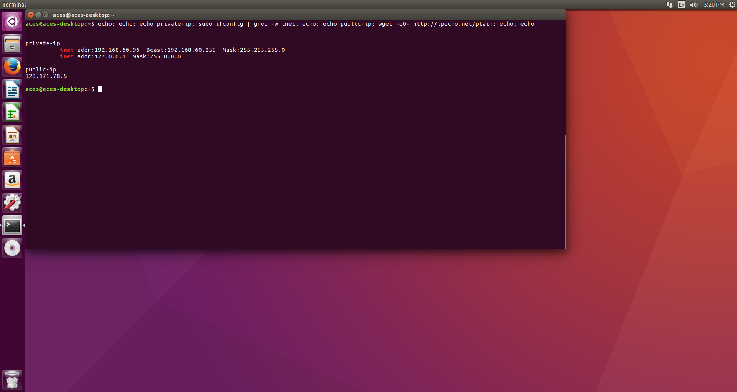
      1. Your IP address is the first decimal number in the first line
      2. You IP address is not ‘Bcast’ or ‘Mask’ or ‘127.0.0.1’
   2. You’re shown your ‘public’ IP address on the second line
   3. You public IP address is not the same as your internal IP address, this is done by Network Address Translation (NAT)
   4. Remember or write down both for reference later
5. In the terminal application, enter the following command
   1. sudo route -n | head -n 3
      1. Note: enter the user password when prompted for the sudo password
      2. Note: you won’t be able to see the password as it’s entered for security reasons
6. **Observe**
   1. The first line shows the next ‘hop’ to send traffic to
   2. A next hop is like your home router, which is connected to the wide internet
   3. In short, it the next networking device you’re connected to
   4. Remember or write down for reference later
7. Close all open programs
8. **Conclusion**
   1. You can see the difference between your public and private ip address
   2. You’re able to get basic networking information using ‘ifconfig’ and ‘route’ with the command line

**Section 3: Zenmap**

1. Click the ‘Ubuntu’ logo on the top of the launcher on the left side of the desktop.
2. In the search bar, type ‘Terminal’ and click the icon to launch it.
3. In the terminal application, enter the following command
   1. sudo zenmap
      1. Note: enter the user password when prompted for the sudo password
      2. Note: you won’t be able to see the password as it’s entered for security reasons
4. In the ‘Command Field’, enter the following
   1. nmap -T4 -F -n --traceroute scanme.nmap.org www.google.com www.facebook.com www.imgur.com
5. Click the ‘Scan’ button in the top right
6. In zenmap, click on the ‘Topology’ tab to see a graphical representation of every device between yours and the others
7. **Observe**
   1. The default gateway i.e. first hop, is closest to you, and should match what you saved from earlier
   2. There are areas where packets are directed by a central device, this is a router, routing web traffic
   3. Some are closer or farther away from you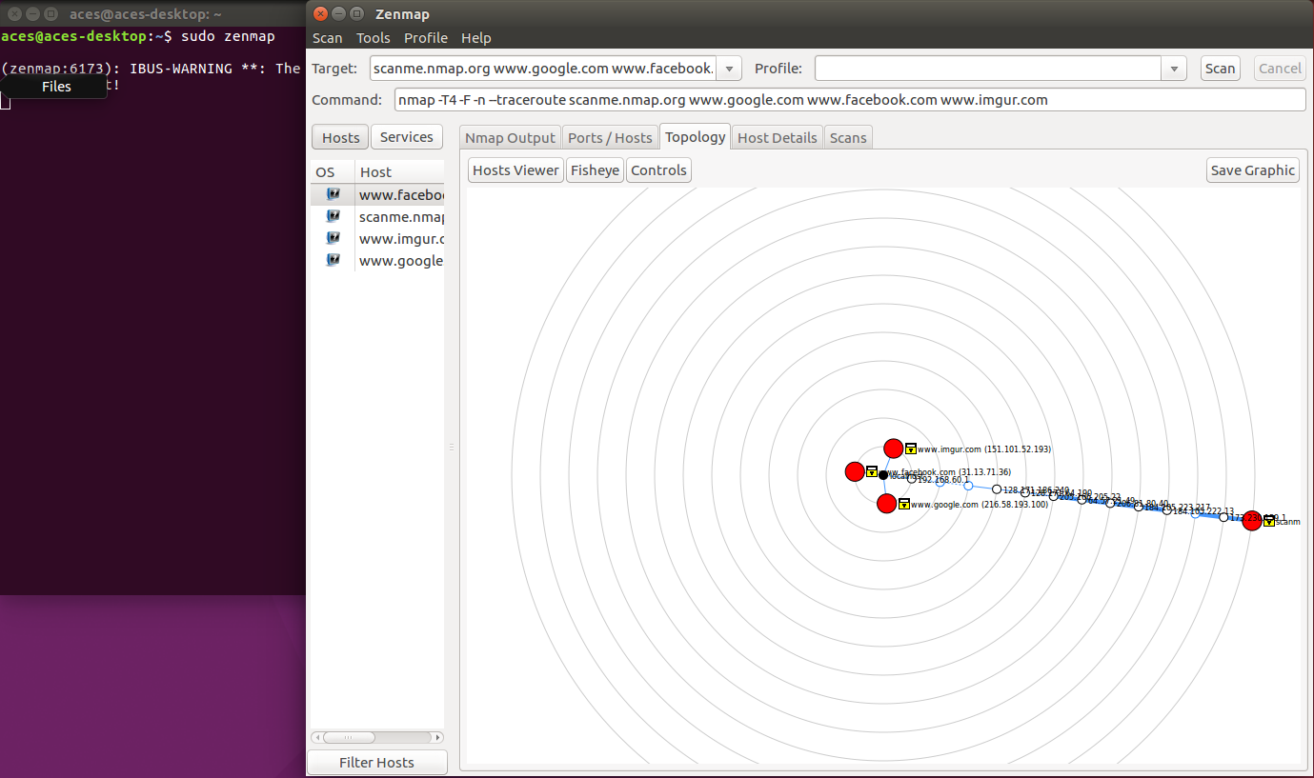
8. In zenmap, click on the ‘Ports/Services’ tab
9. Use the hosts list on the left to see what ports are open for each site
10. **Observe**
    1. How DNS resolves human readable websites to computer IP addresses in the ‘Hosts’ sidebar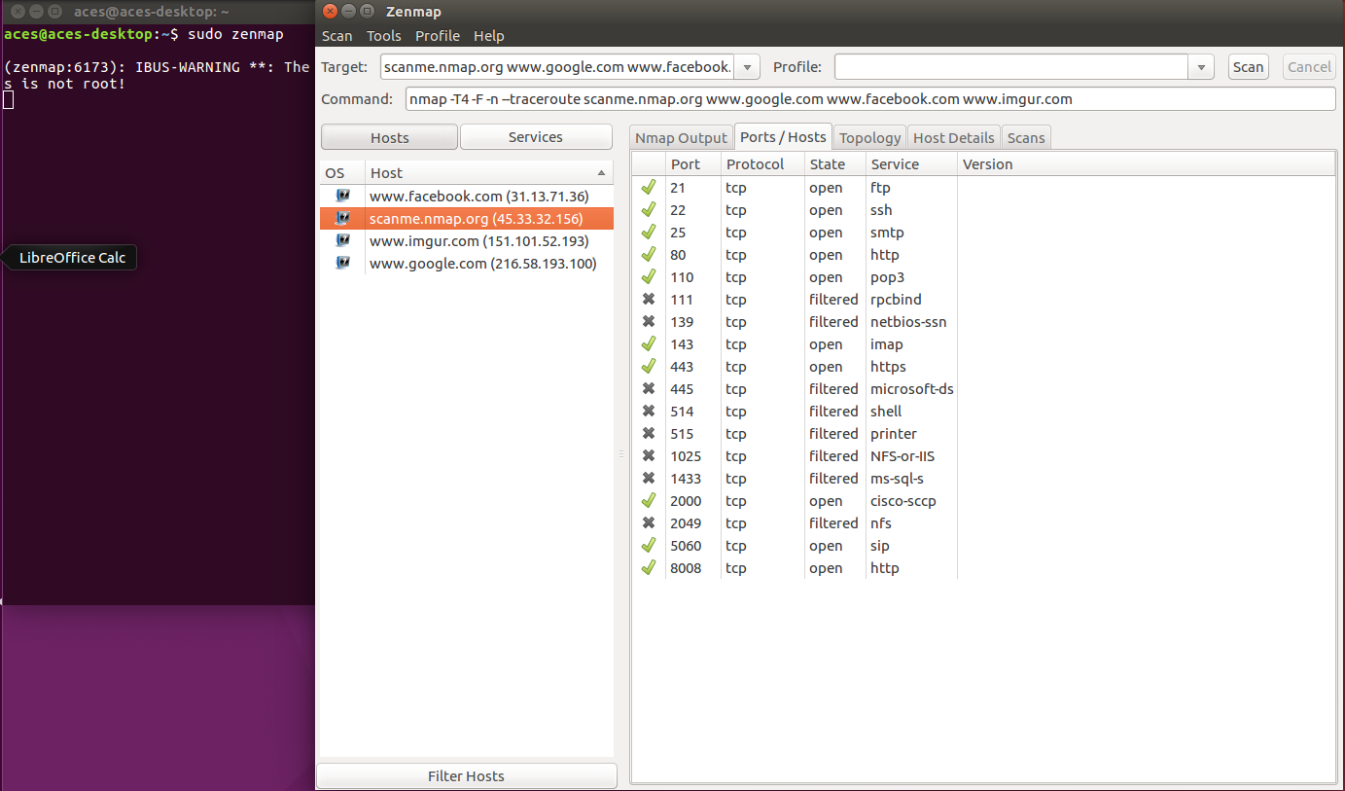
    2. Some sites have a lot of ports open, some don’t
11. Close all open programs
12. **Conclusion**
    1. You can use GUI application, like zenmap, to better visualize a network’s topology
    2. By visualizing a network, you’re better able to understand and troubleshoot any issues

**Section 4: Wireshark**

**Part 1: Telnet versus Secure Shell**

1. Click the ‘Ubuntu’ logo on the top of the launcher on the left side of the desktop.
2. In the search bar, type ‘Terminal’ and click the icon to launch it.
3. In the terminal application, enter the following command
   1. sudo wireshark
      1. Note: enter the user password when prompted for the sudo password
      2. Note: you won’t be able to see the password as it’s entered for security reasons
4. An error message may appear, click ‘OK’ to close it

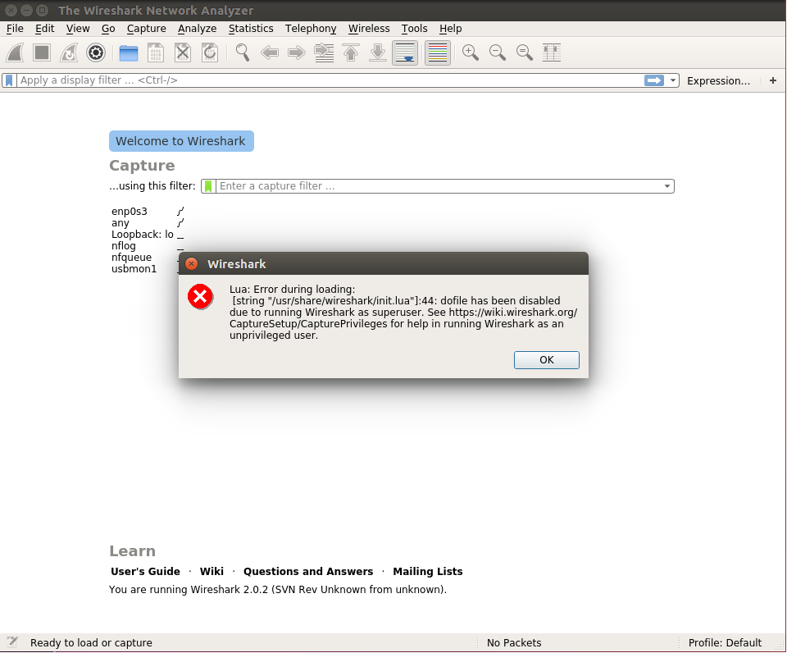

1. In the top left of wireshark, select 'File' then 'Open'
2. In the file explorer menu, navigate to the Desktop, open the ‘Networking Folder’ then 'pcap' folder and select the ‘telnet.pcap’ file, and click ‘Open’
3. In main packet list frame of wireshark, right click on any packet to open the options sub-menu
4. In the sub menu, hover over the ‘Follow’ option, and select ‘TCP Stream’
5. **Observe**
   1. The window shows the raw packet network data
   2. At the beginning, in the top, you can clearly see the username and password being entered
   3. This is bad security practice
6. Close the ‘Follow TCP Stream’ window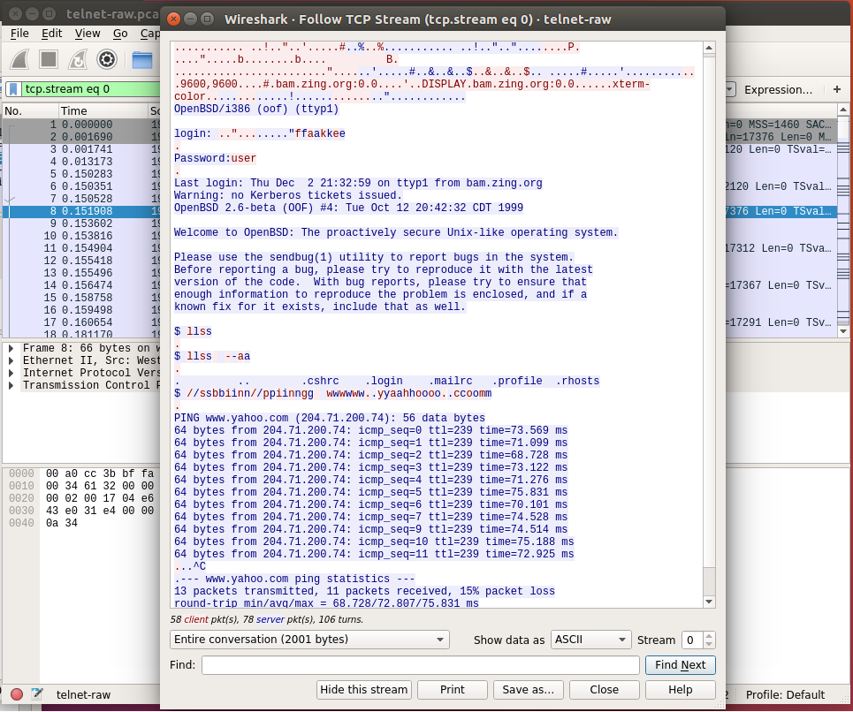
7. In the top left of wireshark, select 'File' then 'Open'
8. In the file explorer menu, navigate to the Desktop, open the ‘Networking’ folder, then 'pcap' folder, and select the ‘ssh.pcap’ file, and click ‘Open’
9. In main packet list frame of wireshark, right click on any packet to open the options sub-menu
10. In the sub menu, hover over the ‘Follow’ option, and select ‘TCP Stream’
11. **Observe**
    1. The window shows the raw packet network data
    2. At the beginning, in the top, you can see some data, but the rest is illegible
    3. This is good security practice
12. Close the ‘Follow TCP Stream’ window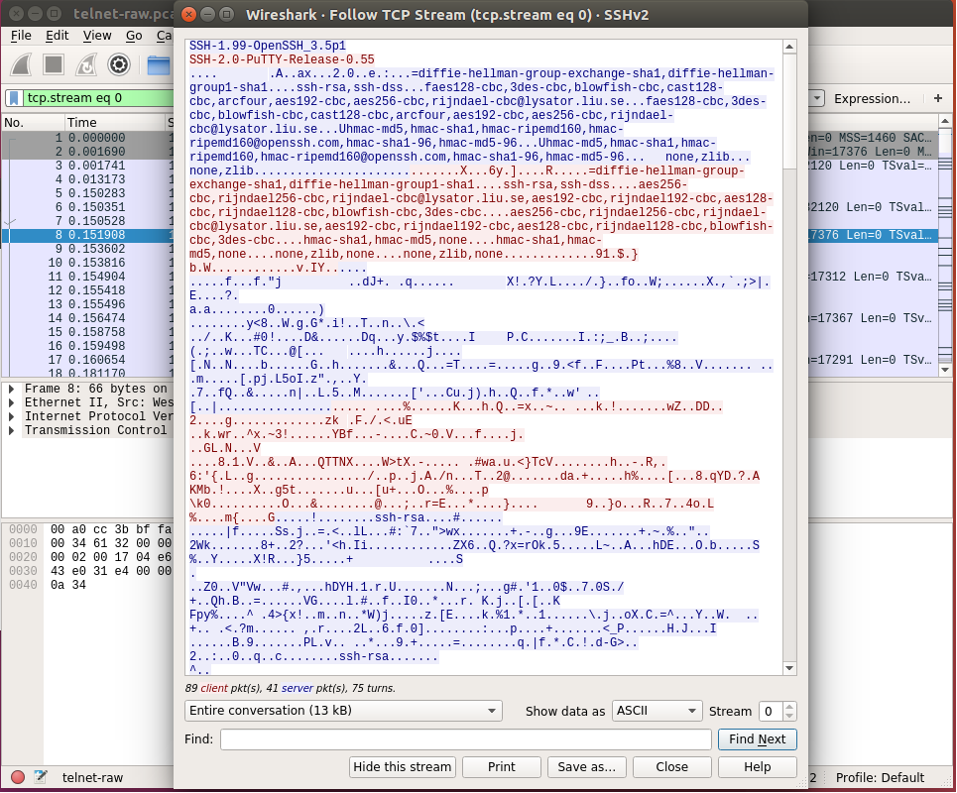
13. In the top of wireshark, click on the ‘Capture’ submenu and select ‘Options’
14. In the ‘Capture Interfaces’ window, select ‘any’ and click ‘Start’ in the bottom right

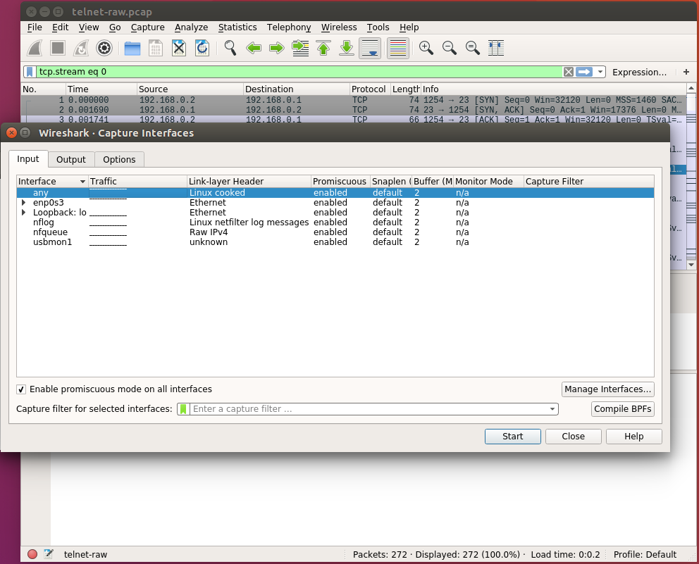

1. In the ‘Display Filter’ field, enter the following
   1. tcp.port == 22
2. Click the ‘Ubuntu’ logo on the top of the launcher on the left side of the desktop.
3. In the search bar, type ‘Terminal’ and click the icon to launch it.
4. In the terminal application, enter the following command
   1. ssh ghost@theshell.xyz
      1. Note: You’ll be asked if you’re sure you want to connect in the terminal, answer ‘yes’
5. In main packet list frame of wireshark, right click on any packet to open the options sub-menu
6. In the sub menu, hover over the ‘Follow’ option, and select ‘TCP Stream’
7. **Observe**
   1. The window shows the raw packet network data
   2. The previous command connected to a remote server
   3. At the beginning, in the top, you can see some data, but the rest is gibberish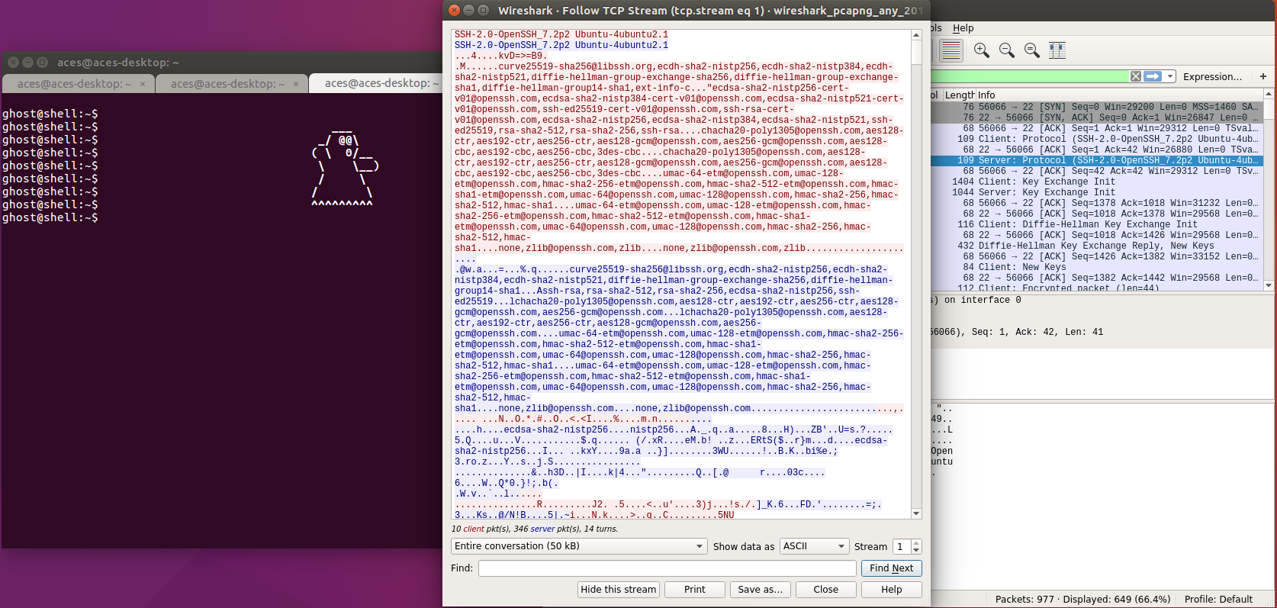
   4. This is good security practice
8. Close all open programs

**Part 2: Domain Name System**

1. Click the ‘Ubuntu’ logo on the top of the launcher on the left side of the desktop.
2. In the search bar, type ‘Terminal’ and click the icon to launch it.
3. In the terminal application, enter the following command
   1. sudo wireshark
      1. Note: enter the user password when prompted for the sudo password
      2. Note: you won’t be able to see the password as it’s entered for security reasons
4. An error message may appear, click ‘OK’ to close it
5. In the top left of wireshark, select 'File' then 'Open'
6. In the file explorer menu, navigate to the Desktop, open the ‘Networking’ folder, then 'pcap' folder, and select the ‘dns.pcap’ file, and click ‘Open’
7. In the ‘Display Filter’ field, enter the following
   1. udp.stream eq 1
8. In main packet list frame of wireshark, select the first packet, Number 16
9. In packet information frame of wireshark, expand the ‘Domain Name System’ field, then the ‘Queries’ field
10. **Observe**
    1. The information in the ‘Queries’ section shows what website the computer was trying to find
11. In main packet list frame of wireshark, select an answer packet, Number 19 and after
12. In packet information frame of wireshark, expand the ‘Domain Name System’ field, then the Answers’ field
13. **Observe**
    1. The information in the ‘Answers’ section shows the IP address of the website that was asked for after ‘addr’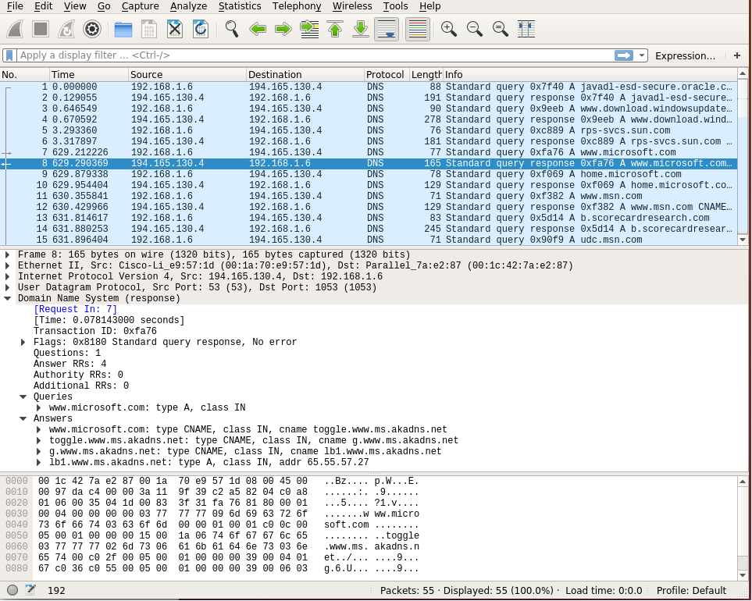
14. In the top of wireshark, click on the ‘Capture’ submenu and select ‘Options’
15. In the ‘Capture Interfaces’ window, select ‘any’ and click ‘Start’ in the bottom right
16. In the ‘Display Filter’ field, enter the following
    1. udp.port == 22
17. Click on the ‘Ubuntu’ logo in the top of the launcher on the left of side the desktop
18. In the search bar, type ‘Firefox’ and click the icon to launch it
19. Using Firefox to visit the following websites
    1. https://www.dankafmemes.gov
    2. https://www.facebook.com
    3. https://www.google.com
    4. https://www.imgur.com
    5. https://www.reddit.com
20. In wireshark, observe the ‘Queries’ and ‘Answers’ field of the packets
21. **Observe**
    1. This is actual network traffic showing how website names are turned into IP addresses
    2. Only addresses that exist are answered, while those that aren’t are ignored
22. Close all open programs

**Part 3: TCP Handshake**

1. Click the ‘Ubuntu’ logo on the top of the launcher on the left side of the desktop.
2. In the search bar, type ‘Terminal’ and click the icon to launch it.
3. In the terminal application, enter the following command
   1. sudo wireshark
      1. Note: enter the user password when prompted for the sudo password
      2. Note: you won’t be able to see the password as it’s entered for security reasons
4. An error message may appear, click ‘OK’ to close it
5. In the top left of wireshark, select 'File' then 'Open'
6. In the file explorer menu, navigate to the Desktop, open the ‘Networking Folder’ then 'pcap' folder, and select the ‘tcp-handshake.pcap’ file, and click ‘Open’
7. In main packet list frame of wireshark, select the first packet, Number 1
8. In packet information frame of wireshark, expand the ‘Transmission Control Protocol’ field
9. Go through the three packets while looking at the ‘Flags’ field
10. **Observe**
    1. You can see the SYN, SYN/ACK, and ACK handshake of TCP
11. In the top of wireshark, click on the ‘Capture’ submenu and select ‘Options’
12. In the ‘Capture Interfaces’ window, select ‘any’ and click ‘Start’ in the bottom right
13. In the ‘Display Filter’ field, enter the following
    1. udp.port == 443
14. Click on the ‘Ubuntu’ logo in the top of the launcher on the left of side the desktop
15. In the search bar, type ‘Firefox’ and click the icon to launch it
16. Using Firefox to visit the following websites
    1. https://www.facebook.com
    2. https://www.google.com
    3. https://www.imgur.com
    4. https://www.reddit.com
17. In the packet information frame of wireshark, expand the ‘Transmission Control Protocol’ field
18. Go through the three packets while looking at the ‘Flags’ field
19. **Observe**
    1. You can see the SYN, SYN/ACK, ACK handshake of TCP
    2. You can also see ‘Malformed Packets’ that show how TCP verifies packet data integrity
20. Close all open programs

**Part 5: HTTP versus HTTPS**

1. Click the ‘Ubuntu’ logo on the top of the launcher on the left side of the desktop.
2. In the search bar, type ‘Terminal’ and click the icon to launch it.
3. In the terminal application, enter the following command
   1. sudo wireshark
      1. Note: enter the user password when prompted for the sudo password
      2. Note: you won’t be able to see the password as it’s entered for security reasons
4. An error message may appear, click ‘OK’ to close it
5. In the top left of wireshark, select 'File' then 'Open'
6. In the file explorer menu, navigate to the Desktop, open the ‘Networking’ folder then 'pcap' folder, and select the ‘http.pcap’ file, and click ‘Open’
7. In the top left of wireshark, select 'File' then, ‘Export Objects’, then ‘HTTP’
8. In the file explorer menu, make sure you’re in the ‘Networking’ folder on the desktop before clicking ‘Save All’

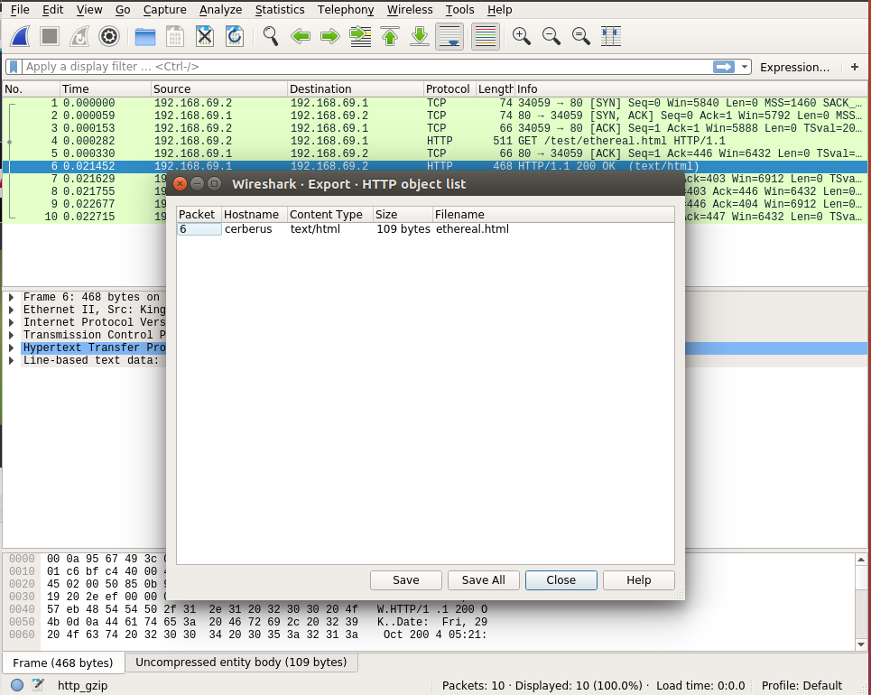

1. Click the ‘Ubuntu’ logo on the top of the launcher on the left side of the desktop.
2. In the search bar, type ‘Files’ and click the icon to launch it
3. Navigate to the ‘Networking’ folder in the ‘Desktop’ folder
4. Right click on ‘ethereal.html’ and select ‘Open with Firefox’
5. **Observe**
   1. Using wireshark, we were able to look at a web page that was sent over the network
   2. Pictures and videos on websites are also able to be extracted from network traffic
   3. This is bad security practice
6. In the top of wireshark, click on the ‘Capture’ submenu and select ‘Options’
7. In the ‘Capture Interfaces’ window, select ‘any’ and click ‘Start’ in the bottom right
8. Using Firefox to visit the following websites
   1. https://www.facebook.com
   2. https://www.google.com
   3. https://www.imgur.com
   4. https://www.reddit.com
9. In the top left of wireshark, select 'File' then, ‘Export Objects’, then ‘HTTP’
10. **Observe**
    1. Since the network traffic is secured with HTTPS, you aren’t able to extract the webpage, pictures, or videos
    2. This is good security practice
11. Close all open programs
12. **Conclusion**
    1. Using wireshark you’re able to see network traffic as it’s sent over a computer network
    2. Using wireshark, you’re able to see unsecure (in the clear, plain text) information, which is bad
    3. You’re also able to see how encryption prevents network information from being eavesdropped on bad hackerz