Topics
Hardware
Router
A networking device that forwards packets between different computer networks based on their IP address. Using information in its routing table, it directs the packet to the next network on its journey until they reach its destination The most common type is home routers that are provided by an Internet service provider (ISP). This is different from a switch, which uses hardware (MAC) addresses to process and forward data to end devices.
Simple Jack:
Much like a post office directs letters and packages, a router is a computer that specializes in directing small chunks of internet traffic which we call packets. Just like a letter has a label with a mailing address and destination address, each packet has a label with a source IP address and a destination IP address. When a post office receives a package, the postmaster must read the label in order to see where that package must be sent. It is often the case that the postmaster cannot send the package directly to its destination because it is too far away. Instead, the postmaster decides to send the package to another post office which is closer to the destination. The postmaster consults his list of reachable post offices that they can deliver to, and chooses one which is closer to the destination. This process of package forwarding continues from post office to post office until the package reaches a post office that can make the final delivery. When a router receives a packet, the router reads the destination IP address and looks in its routing table to decide which interconnecting router is closest to the destination, and forwards the packet to that router.

Firewall
A network service that controls incoming and outgoing network traffic based on defined rules. There are two types; a network firewall (home router) that protects a network, or host-based firewall that protects an end device, like windows firewall.

Switch
A networking device that connects devices on a computer network, by forwarding packets to a device. A network switch is a multiport device that uses hardware (MAC) addresses to process and forward data to end devices. This is different from a router, which uses IP packets to forward them to other computer networks.

Wireless Access Point
A networking device that allows devices to connect to a network wirelessly via radio waves. A WAP can be a independent device, like in a large business, or integrated with other devices, like a home router. A WAP is not a hot-spot in that a WAP is the device providing connectivity, and the hot-spot is the location where connectivity is available.

Network Interface Card
A networking device that allows a computer to a computer network. Originally done with expansion cards, most computers now have a network interfaces built into the motherboard. Many mobile devices also have a wireless NIC to connect to wireless networks.

Ethernet Cable
The standard way to connect computers on a network over a wired connection. A standard Ethernet cable is slightly thicker than a phone cable and has an RJ45 connector on each end. Ethernet ports look similar to telephone jacks, but are slightly wider. Common categories are Cat5, Cat5e, Cat6, and Cat7.

Protocols - Ports (add port numbers)
TCP
Transmission Control Protocol is one of the main protocols of the Internet protocol suite. Part of the initial network implementation of Internet Protocol (IP), the entire suite is commonly referred to as TCP/IP. TCP provides reliable, ordered, and error-checked delivery of packets between applications running on hosts communicating by an IP network.

UDP
User Datagram Protocol is one of the core members of the Internet protocol suite. With UDP, computer applications can send messages, in this case referred to as datagrams, to other hosts on an Internet Protocol (IP) network. Prior communications are not required to set up transmission channels or data paths like TCP. It uses a simple connectionless transmission model with a minimum data integrity checking. Time-sensitive applications often use UDP because dropping packets is preferable to waiting for delayed packets, like video games or streaming media

FTP
The File Transfer Protocol is a standard network protocol used to transfer computer files between a client and server on a computer network. It uses a client-server model, and users may authenticate themselves with a clear-text sign-in protocol, normally in the form of a username and password, but can connect anonymously if the server is configured to allow it.

SSH
Secure Shell is a cryptographic network protocol for operating network services securely. The best known example application is for remote login to computer systems by users. It provides a secure channel in a client-server architecture, connecting a client application with a server. Common applications include remote command-line login and remote command execution, but any network service can be secured with SSH.

Telnet
Telnet is protocol used on the Internet or local area networks to provide a bidirectional interactive text-oriented communication facility using a virtual terminal connection. The name stands for "teletype network". Historically, Telnet provided access to a command-line interface on a remote host. However, because of serious security concerns when using Telnet over an open network such as the Internet, its use for this purpose has waned significantly in favor of SSH.

SMTP
Simple Mail Transfer Protocol is an Internet standard for electronic mail transmission. Although electronic mail servers and other mail transfer agents use SMTP to send and receive mail messages, user-level client mail applications typically use SMTP only for sending messages to a mail server for relaying. For retrieving messages, client applications usually use either IMAP or POP3. SMTP connections secured by SSL, known as SMTPS, can be made using STARTTLS.

POP
Post Office Protocol is an application-layer Internet standard protocol used by local e-mail clients to retrieve e-mail from a remote server over a TCP/IP connection. POP has been developed through several versions, with version 3 (POP3) being the last standard in common use before largely being made obsolete by the more advanced IMAP as well as webmail.

DNS
Domain Name System is a decentralized naming system for computers, services, or any resource connected to the Internet or a private network. It associates various information with domain names assigned to each of the participating entities. It translates more readily memorized domain names to the numerical IP addresses needed for the purpose of locating and identifying computer services and devices with the underlying network protocols.

HTTP
The Hypertext Transfer Protocol is an application protocol for distributed, collaborative, hypermedia information systems.[1] HTTP is the foundation of data communication for the World Wide Web. Hypertext is structured text that uses logical links between nodes containing text. HTTP is the protocol to exchange or transfer hypertext.

Basics - Standard method of communicating, common ports/services, port independent
*What?

TCP/IP
IP address - v4, 32-bit, dotted decimal
Internet Protocol version 4 is the fourth version of the Internet Protocol. It is one of the core protocols of standards-based internetworking methods in the Internet. IPv4 is a connectionless protocol for use on packet-switched networks. It operates on a best effort delivery model, in that it does not guarantee delivery, nor does it assure proper sequencing or avoidance of duplicate delivery. These aspects, including data integrity, are addressed by an upper layer transport protocol, such as the Transmission Control Protocol.
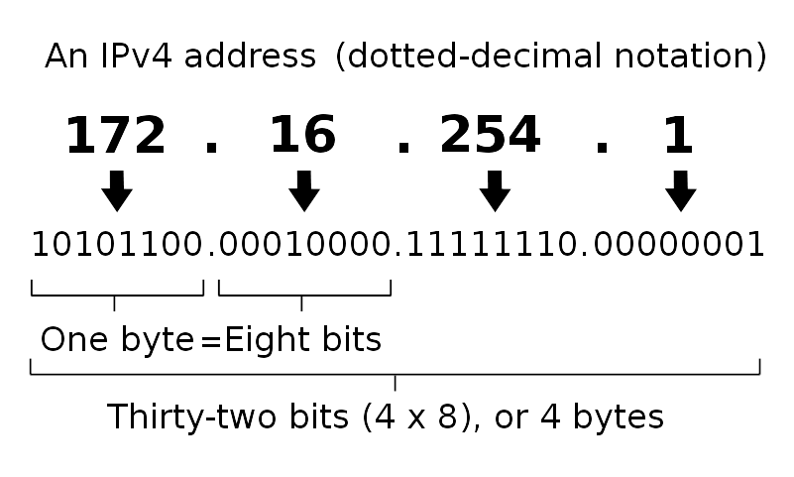

Address space exhaustion - v6, 128-bit, hex
Internet Protocol version 6 is the most recent version of the Internet Protocol (IP), the communications protocol that provides an identification and location system for computers on networks and routes traffic across the Internet. It was devloped to deal with the long-anticipated problem of IPv4 address exhaustion. Every device on the Internet is assigned a unique IP address for identification and location definition. With the rapid growth of the Internet after commercialization in the 1990s, it became evident that far more addresses would be needed to connect devices than the IPv4 address space had available. By 1998, the Internet Engineering Task Force (IETF) had formalized the successor protocol. IPv6 uses a 128-bit address allowing 3.4×1038 addresses.
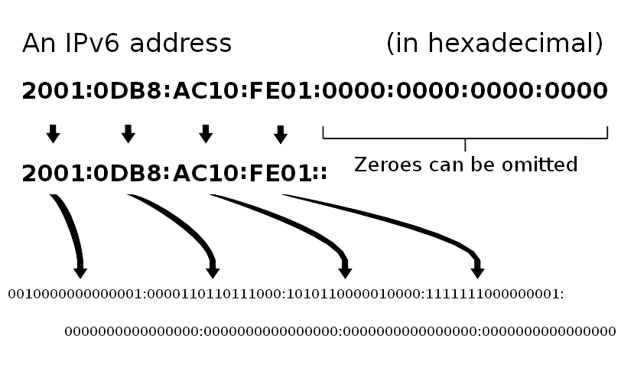

Private Networks - 10, 172.16 - 172.31, 192.168
In the Internet addressing architecture, a private network is a network that uses private IP address space. These addresses are commonly used for home, office, and enterprise local area networks. Private IP address spaces were originally defined in an effort to delay IPv4 address exhaustion, but they are also a feature of IPv6 where exhaustion is not an issue. Addresses in the private space are not allocated to any specific organization, however, IP packets addressed from them cannot be transmitted through the public Internet, and so it must do so via a network address translator (NAT) gateway, or a proxy server.

Three way handshake - syn, ack, nak, fin
A three-way handshake is the basis for all TCP communications and is used to establish a connection between two networked hosts as follows:

- Client sends a TCP packet to the server with the SYN flag set.
- Server responds to the client request with the SYN and ACK flags set.
- Client completes the connection by sending a packet with the ACK flag set.

In order for the connection to exist, each side of the connection must send a SYN (Synchronize) flag and receive an ACK (Acknowledge) flag.
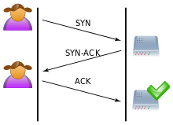

Internet
OSI layer model
The Open Systems Interconnection model is a conceptual model that characterizes and standardizes the communication functions of a telecommunication or computing system without regard to their underlying internal structure and technology. Its goal is the interoperability of diverse communication systems with standard protocols. A layer serves the layer above it and is served by the layer below it.
*packet encapsulation picture and layer model picture*

URI - Scheme, host port, query, fragment
In information technology, a Uniform Resource Identifier (URI) is a string of characters used to identify a resource. Such identification enables interaction with representations of the resource over a network, typically the World Wide Web, using specific protocols. The most common form of URI is the Uniform Resource Locator (URL), frequently referred to informally as a web address.

DNS - Recurser, TLD, domain, subdomain
*already covered?*

Website - Server, HTML
A web server is a computer system that processes requests via HTTP, the basic network protocol used to distribute information on the World Wide Web. The term can refer to the entire system, or specifically to the software that accepts and supervises the HTTP requests.

Browser - HTTP request/response, methods, header, cookies, referer, user-agent
A web browser is a software application for retrieving, presenting and traversing information resources on the World Wide Web. An information resource is identified by a Uniform Resource Identifier that may be a web page, image, video or other piece of content. Hyperlinks present in resources enable users easily to navigate their browsers to related resources.
Exercises
string plucking to show information capacity
router game, physically passing 'packets'
Pre-made wireshark packet analysis
python web/ftp server? Students can write their own homepage and visit others

Labs
TBD

Sources
Wikipedia

