DEVELOPMENT PROCESS

1. MENU AND SETTINGS

Writing the menu was very simple and not time consuming at all.
The code for the menu is shown below(You may have to zoom in):
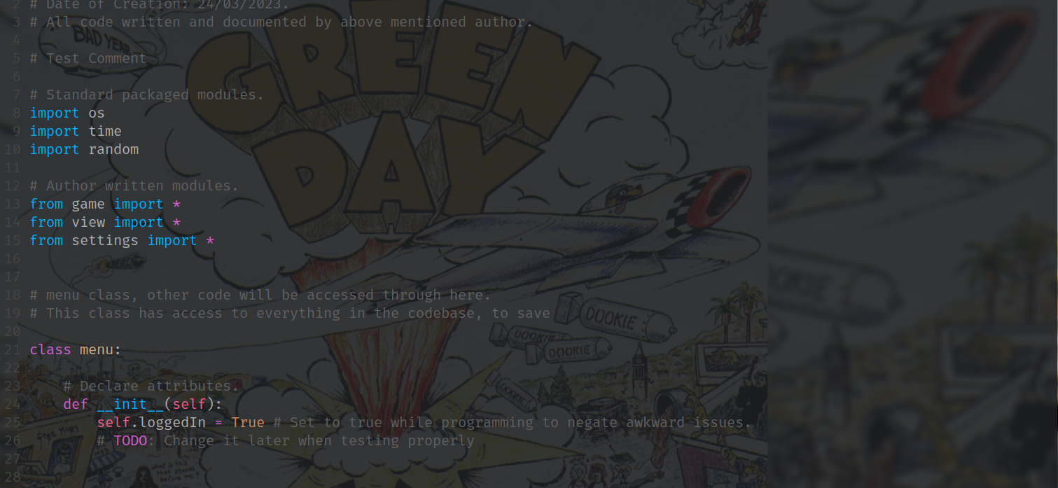
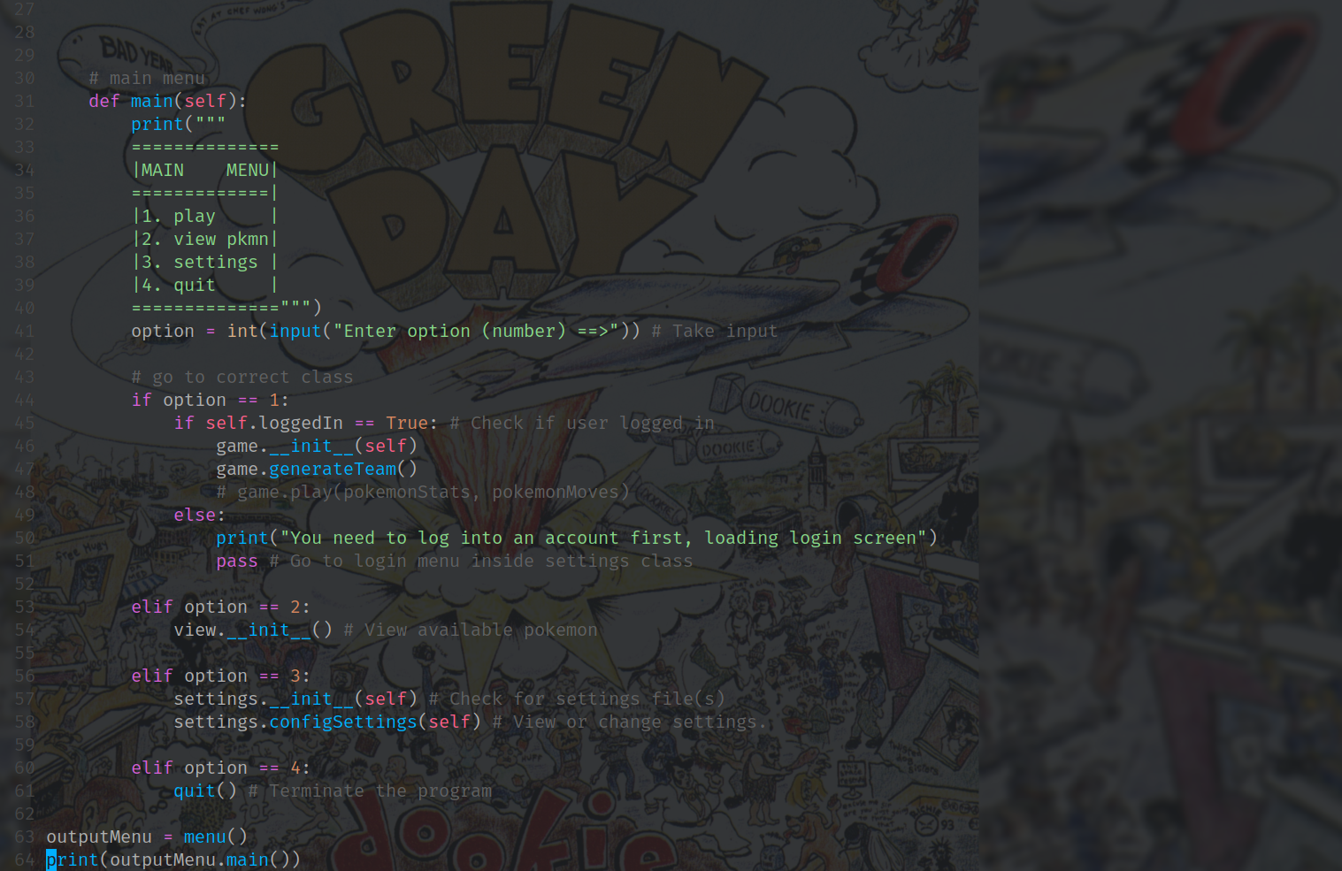
The only attribute required is loggedIn, which will be set as false by default, it is currently set to true to avoid issues, because I have no login system written.

Creating a settings menu was more difficult, as I had to decide on the best way to save settings and edit them. As most other programs/games use, I decided to use a JSON file, as it uses a format that is easily understandable, and is essentially a dictionary, this means I can import the file as a dictionary without any weird formatting, edit the dictionary as nescessary, and write changes back to the json. By using a json file, you can also simply open the file and edit settings in a text editor, rather than having to run the game.

THE GAME

Writing the main game is difficult, so far(as of 17/04/2023) I have written code to generate a random team, and some stats, however, it is all not complete, I still need to write the code and find any issues, which won’t be extremely time consuming, however, finding the right syntax will take some time, because there will be at least 200+, if not more lines to write. The main issue is working with a large JSON file containing all moves, and another JSON file containing all pokemon and their stats, this is the bulk of the problem and will take some research and reading of Python’s documentation into how I can implement them effectively.

