What the plugin is for

The main purpose of this plugin is to help in labeling edges and islands on a preferred map
and export those to a .geo file, which can be easily meshed using an algorithm. Doing so can be of
great use in fluidity as the different ids can be used to indicate inflow and outflow.

How to use this plugin

- Selecting the domain area out of a larger map '
In this example, we'll focus on the map of the United Kingdom and Ireland and try to see
how it can be exported from a larger area, labeled and, afterwards, exported to a .geo file.
The first thing we need to do is have a map in the first place in Qgis:

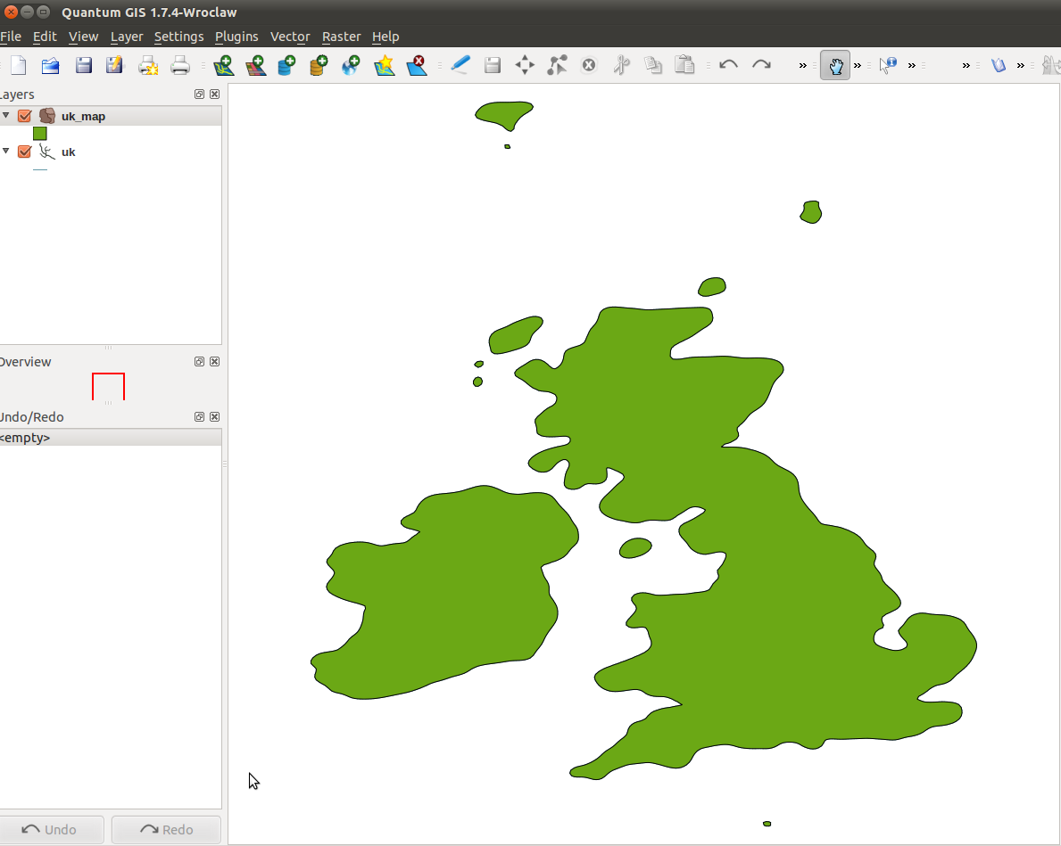
Afterwards, we need to define a selection polygon. To do that, go to Layers → New → New
Shapefile Layer...
When prompted with a new windows, select “Polygon” as a type of shape and click “Ok”.
You'll also have chose a filepath and an appropriate name for the layer. When all this is done, the new layer will appear in the layers menu on the left.
The next step is now to draw the polygon. Click on the “Toggle Editing” button (the blue
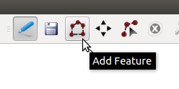
pencil) and then click on “Add Features” to begin drawing the polygon.

After drawing the polygon (by defining the points you want it to contain), right click. You will also be asked for the id of the polygon, which is not important now.

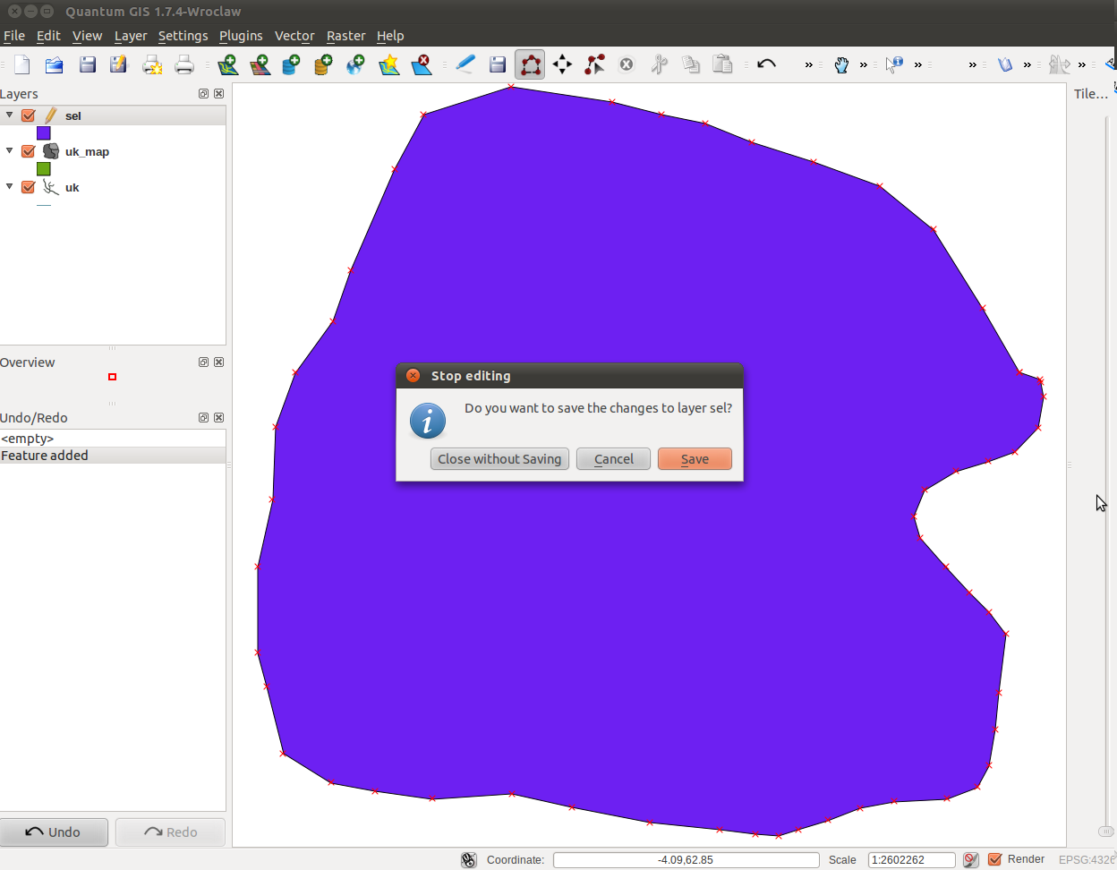
Next, all the selected area will be covered in a single color. You can modify the polygon as
you wish using the editing tools near the “Toggle Editing” button. After you're happy with the
polygon you have, just unclick “Toggle Editing” and save it.
The final step is to go to Vector → Geoprocessing Tools → Difference. The input vector
layer will be the selection and the other will be the map. Click “Browse” to select an output name
and path and click “OK”. If the processing goes without error, click “Yes” when prompted so that
the new layer can be added to the layer menu. You should now deselect the other two layers and
focus on the main one.
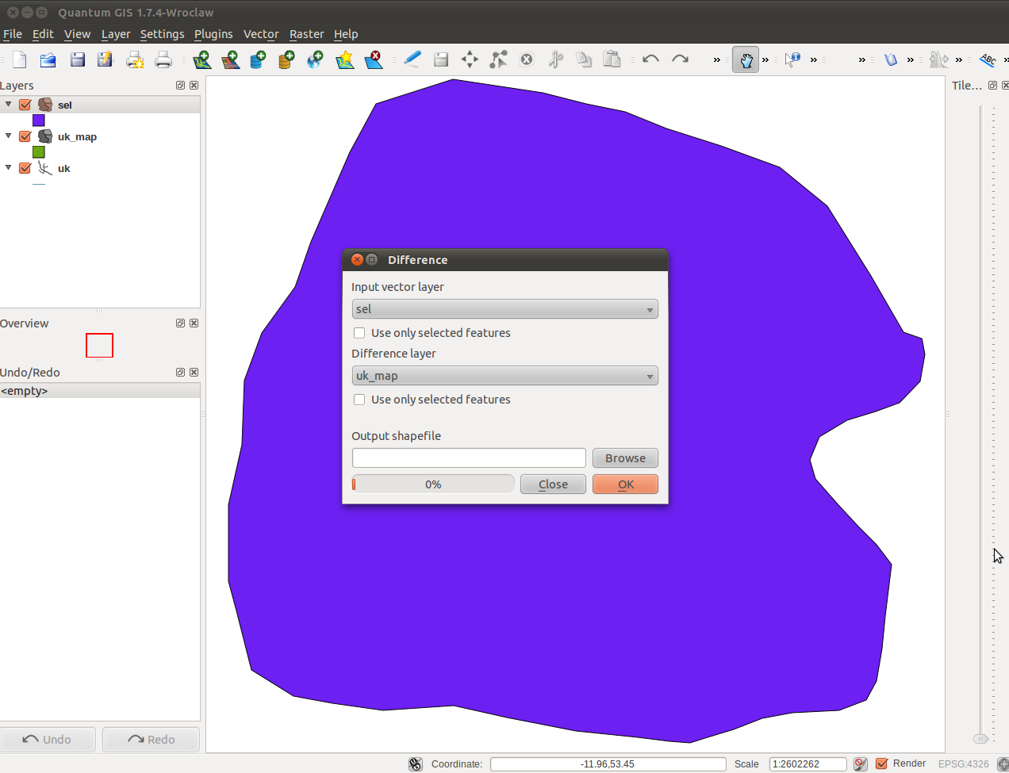
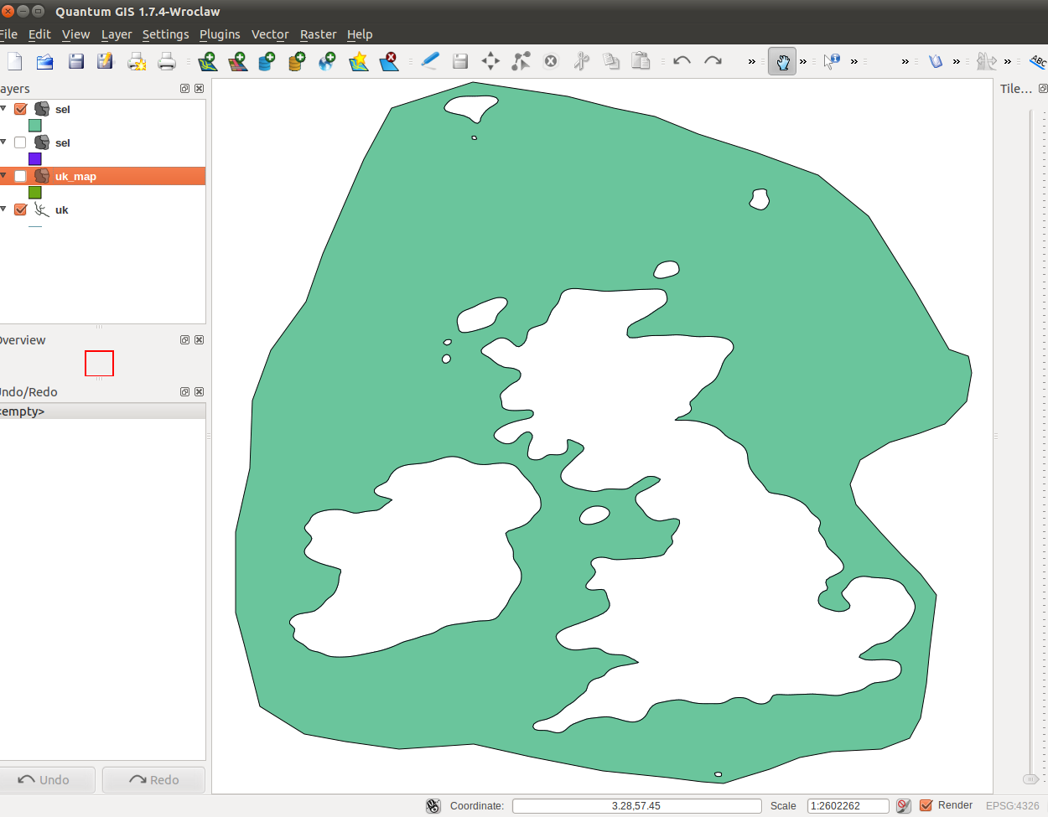
- Defining the id polygons
To begin defining id polygons, do selections as in the previous step. Create a new layer and use the “Toggle Editing” tools but only this time don't stop after selecting just one polygon.
When prompted for defining an id, chose the id you wish to assign to that specific selection.
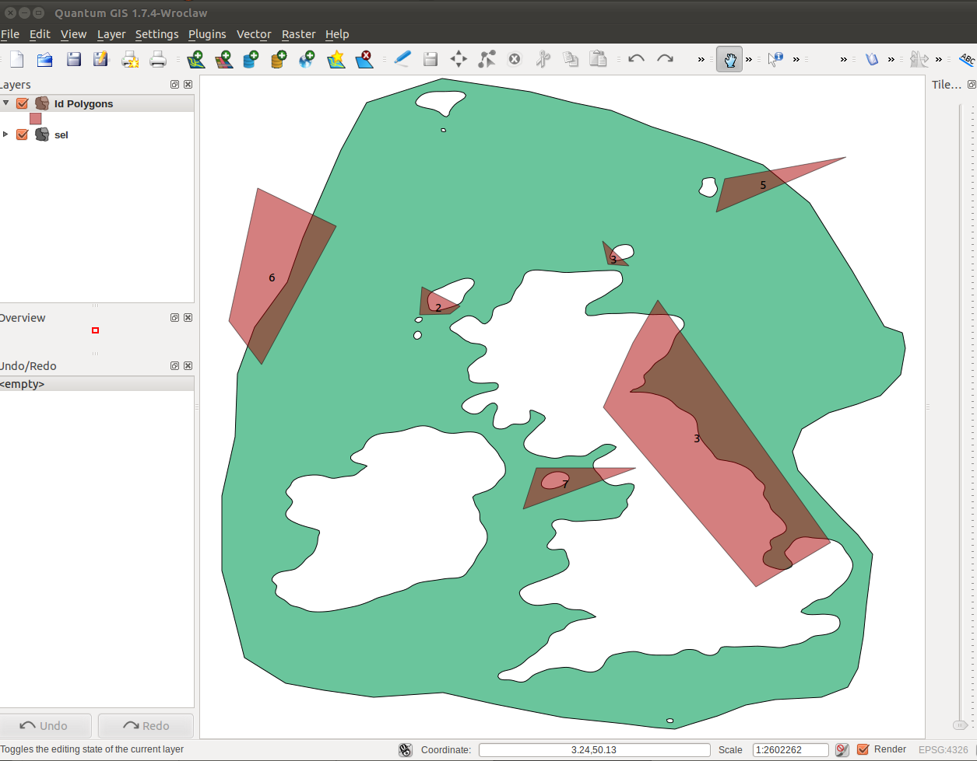
- Generating the boundary id shapefile
To do this, go to Plugins → Define Boundary Ids → Define Boundary Ids. If you want the script to completely ignore the smaller islands, you can define a threshold for how small should an island be to be ignored.
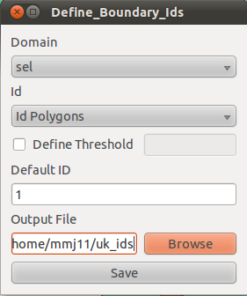

- Click “Save” and a new layer will appear containing only the lines with their specific ids. To make the layer look better, you can categorize the ids going to Properties → Style → Categorized, then click 'Classify' and 'Apply'. You might also want to display the labels by going to the Labels tab, ticking “Display Labels” and selecting 'id' from the dropdown. Next click “OK” and you should see something like this:
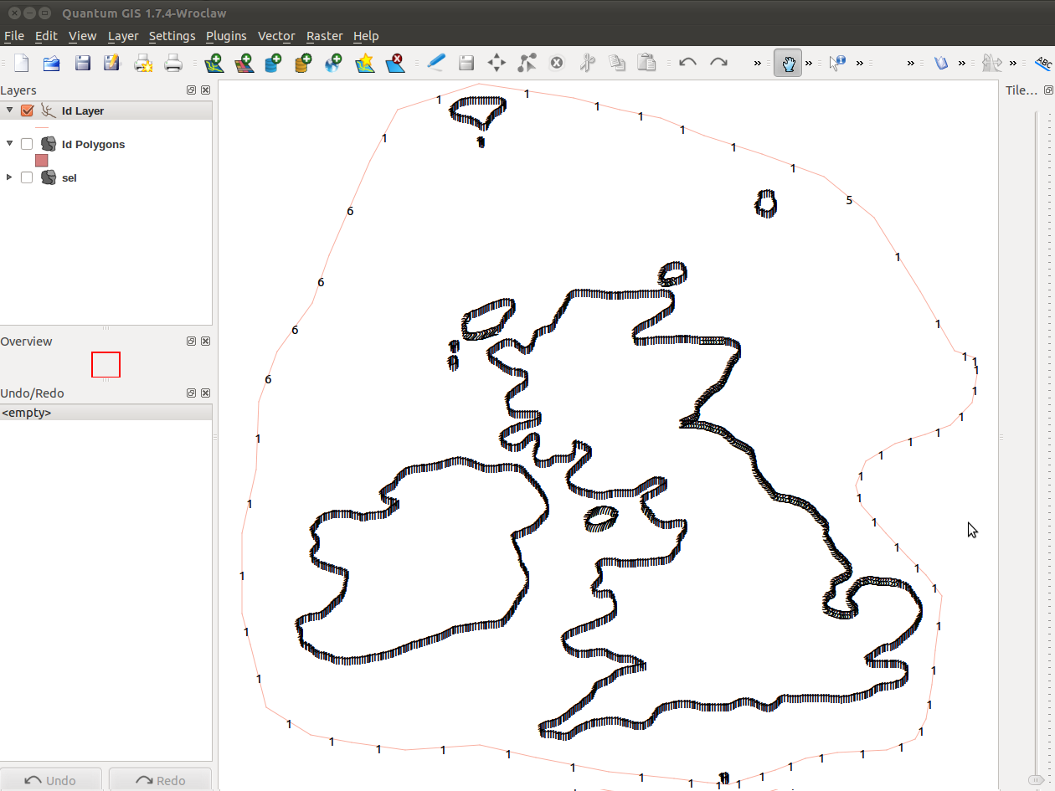
- The final step would be exporting it all to a .geo file. This is done automatically by going to Plugins → Define Boundary Ids → Export to .geo:
