Rodent Feeding Behavior
User manual
October 2026
Table of Contents

Introduction
Rodent Feeding Behavior measures how rodents feed. You record videos of an animal in an arena with a food bowl, and the tool returns feeding bouts, behavioural features, statistics and figures. SLEAP supplies the pose tracking; everything after it runs in this tool, from a browser interface or from the command line.
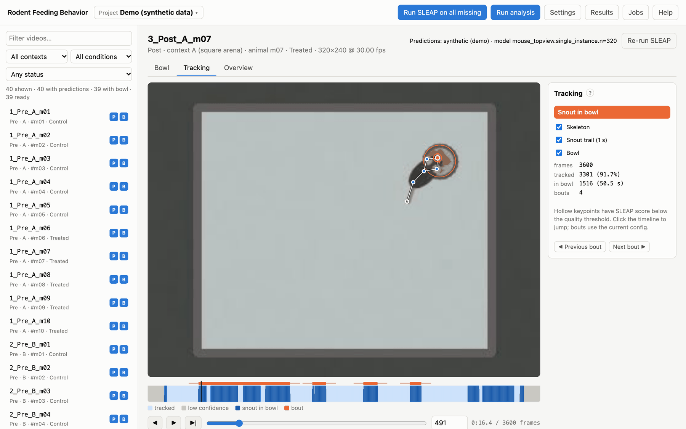
The main window: the video list on the left, a video with its tracking overlaid, and the timeline of tracked frames, contacts and bouts below it.

What it does
For every video of one animal, the tool:
- Tracks the animal’s body parts with a trained SLEAP model (or uses predictions you already have).
- Uses the bowl you mark once per video: an ellipse or a free-form polygon around the rim.
- Keeps reliably tracked frames only, using SLEAP’s confidence scores.
- Finds feeding bouts: stretches in which the snout (or another keypoint you choose) is inside the bowl rim, including brief step-backs (“returns”), with an approach before and a withdrawal after.
- Measures each bout: how directly the animal approached and left, how long it fed, how often it returned, and how fast each body part moved in each phase.
- Summarises each session: time at the bowl, latency to the first contact, bouts per minute, distance travelled, speed, time spent moving and distance kept from the bowl.
- Compares groups that you define (e.g. Control vs Treated after treatment, or Pre vs Post in the same animals). Each comparison gets the appropriate tests, effect sizes, multiple-comparison corrections, box plots and occupancy maps.
- Draws figures: per-animal heatmaps and “tornado” trajectory plots, comparison figures, PCA/UMAP projections and per-animal box plots. A run can be exported as one zip file.
Every analysis run is saved in its own folder with a manifest. The manifest records the exact settings, code version, package versions and hashes of every input, so any result can be traced back and reproduced.

The workflow at a glance
Step | Where | Chapter
Install the tool (and SLEAP, if you will run inference) | terminal | Installation
Try everything on synthetic data | Try the demo project | Quick start
Create a project from your videos | Project ▾ → New project | Projects
Assign a SLEAP model and run inference | Settings, Run SLEAP | SLEAP pose estimation
Mark the bowl in every video | Bowl tab | Annotating the bowl
Check the tracking | Tracking and Overview tabs | Reviewing the tracking
Analyse | Run analysis | Running the analysis
Read results, export | Results | Results
Compare any groups | Results → Comparisons | Comparisons

Concepts
Project. A folder with a feeding.yaml file. It names the videos, the SLEAP model(s) and all analysis settings, and it holds your annotations and results. One project usually holds one cohort or experiment. See Projects.
Video. One recording of one animal. If you film several animals at once (e.g. four arenas in one camera view), split the recording into one video per animal first (see feeding split in the command-line reference).
Animal, condition, context, session. Read from each video’s file name using a naming pattern, e.g. 3_Post_A_m12 → session 3, condition Post, context A, animal m12. Condition is the experimental state (e.g. Pre/Post, Baseline/Drug); context is usually the arena or chamber. See Naming videos.
Group. A label per animal (e.g. Control, Treated, a genotype or diet), entered in the app or in metadata/subjects.csv.
Bout. One visit to the food. It is a run of contact with the bowl, possibly with brief step-backs, plus an approach window before it and a withdrawal window after. See Contact and bouts.
Comparison (view). Two or more groups of videos defined by their metadata, and which pairs of them to test. A Standard comparison is built automatically. See Comparisons.
Run. One execution of the analysis, saved as data/results/<date-time>_<settings-hash>/. See Output files.

Requirements
- macOS, Linux or Windows, with Python 3.11 or newer (installed for you by uv).
- A recent browser (Chrome, Firefox, Safari or Edge). The app runs locally; nothing is uploaded anywhere.
- To run pose estimation: SLEAP in its own environment, plus a trained SLEAP model for your camera setup. A GPU makes inference much faster but is not required. Without SLEAP you can still import predictions made elsewhere and use everything else.

Using this manual
The manual is also built into the app: click Help in the top bar, or press ?. The ? buttons next to section titles (in Settings, the Bowl and Tracking panels, Results and the comparison editor) open the matching part. The search box finds every section that mentions all the words you type. Word version (.docx) downloads the same manual as one document for printing or offline reading.
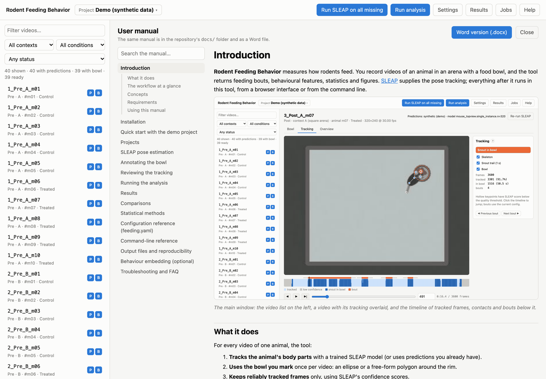
Help: chapters and sections on the left, with search; the chapter on the right.

Installation
The tool is a Python package with a browser interface. It is installed with uv, which also installs a suitable Python for you. SLEAP, which does the pose estimation, is installed separately in its own environment; you only need it to run inference yourself.

1. Install uv
macOS and Linux:
curl -LsSf https://astral.sh/uv/install.sh | sh
Windows (PowerShell):
powershell -ExecutionPolicy ByPass -c "irm https://astral.sh/uv/install.ps1 | iex"
Open a new terminal afterwards so that the uv command is found.

2. Get the tool
git clone https://github.com/adamcatto/RodentFeedingBehavior.git
cd RodentFeedingBehavior
uv sync
uv sync creates a virtual environment in .venv/ with the exact package versions pinned in uv.lock, so everyone gets the same results. Optional extras:
uv sync --extra umap # UMAP projections in the exploratory analyses
uv sync --extra embed # LSTM-VAE behaviour embedding (installs PyTorch)
uv sync --all-extras # both
Check that it works:
uv run feeding --help
uv run pytest # optional: the test suite (about 30 seconds)
Without git: download the repository as a zip from GitHub, unpack it, and run uv sync inside the folder.
With pip instead of uv: pip install "git+https://github.com/adamcatto/RodentFeedingBehavior.git" installs the feeding command into the active Python environment (versions are then not pinned by uv.lock).
In this manual, commands are written as feeding …. From a source checkout, run them as uv run feeding … inside the repository folder (or activate .venv first).

3. Start the app
uv run feeding serve
Then open http://127.0.0.1:8765 in your browser. The server keeps running in the terminal; stop it with Ctrl+C. Useful options:
uv run feeding serve path/to/project # open this project straight away
uv run feeding serve --port 9000 # another port
The server only listens on your own computer (127.0.0.1) by default. Native file dialogs (Browse…, Choose files…) open on the computer that runs the server.
After updating the code (e.g. git pull), restart feeding serve. If you don’t, the page shows a red banner saying that the server is older than the app.
To try everything without SLEAP or your own data, continue with the Quick start.

4. Install SLEAP (for running inference)
SLEAP has its own, strict dependencies, so it lives in a separate conda environment, and this tool calls its command-line programs (sleap-track, sleap-convert). Follow the SLEAP installation guide. It typically comes down to installing Miniforge or Miniconda and then:
conda create -y -n sleap -c conda-forge -c nvidia -c sleap -c anaconda sleap
The tool finds SLEAP automatically when the environment is called sleap (or starts with sleap) and lives in a usual conda location (~/miniconda3, ~/miniforge3, ~/anaconda3, ~/mambaforge, ~/opt/…; on Windows also under AppData\Local and C:\ProgramData), or when sleap-track is on your PATH. Otherwise tell it where SLEAP is in either of these ways:
- in the app: Settings → SLEAP inference → SLEAP environment, set to the environment’s bin folder (on Windows, its Scripts folder);
- from a terminal: set FEEDING_SLEAP_BIN=/path/to/envs/sleap/bin (in PowerShell: $env:FEEDING_SLEAP_BIN = "C:\Users\me\miniforge3\envs\sleap\Scripts").
The tool runs SLEAP’s programs as if its environment were activated, so you don’t need to activate it yourself.
feeding check and the app’s warning bar report when sleap-track cannot be found. The pipeline has been tested with SLEAP 1.2 and works with the same command-line options in later 1.x versions.
You also need a trained SLEAP model for your setup: a single-animal model (single_instance) or a top-down pair (centroid + centered_instance). Train it in SLEAP’s own GUI. See SLEAP pose estimation.

Windows
The tool supports Windows 10 and 11. A few notes:
- Terminal. Run the commands in PowerShell or Windows Terminal. uv run feeding … works the same as on macOS and Linux.
- git. Install it with winget install Git.Git (or from https://git-scm.com), or download the repository as a zip from GitHub instead.
- Paths. Type Windows paths as usual (D:\videos\cohort1). Paths inside a project are stored with /, so a project folder can be moved between Windows, macOS and Linux.
- Browse buttons open the Windows file and folder dialogs. The in-page folder browser (used when the server runs on another computer) has a drive selector.
- SLEAP runs on Windows with an NVIDIA GPU, or on the CPU. Install it in a conda environment as above; the tool finds sleap-track.exe in the environment’s Scripts folder.
- ffmpeg (only for feeding split): winget install Gyan.FFmpeg, then open a new terminal.

Where things are kept
What | Default location | Change with
New projects | projects/ in the repository (or ~/feeding-behavior/projects for a pip install) | FEEDING_PROJECTS_DIR
Model library (models offered in pickers) | models/ in the repository (or ~/feeding-behavior/models) | FEEDING_MODEL_LIBRARY (several folders separated by :; ; on Windows)
Recently opened projects | data/recent_projects.json in the same app folder | FEEDING_HOME moves the whole app folder
SLEAP | found automatically | FEEDING_SLEAP_BIN, or Settings
Projects can live anywhere: the projects/ folder is only where New project puts them by default. In a source checkout, projects/ and models/ are ignored by git, so your data never ends up in the code repository.

Updating
git pull
uv sync
Then restart feeding serve. Projects keep working across updates; a new run records the code version it used.

Quick start with the demo project
The demo project lets you try every step in about ten minutes, without SLEAP and without your own data. It contains synthetic videos of a simulated mouse, with SLEAP-format predictions:
- 10 animals: 5 Control (m01–m05) and 5 Treated (m06–m10).
- 4 sessions each: Pre and Post, each in a square arena (context A) and a round arena (context B).
- 40 videos of 2 minutes, named {session}_{condition}_{context}_{animal}, e.g. 3_Post_A_m07.
- Built-in effects: in Post sessions, Treated animals visit the bowl more often, feed longer, step back and return more, and move more slowly. The analysis should find these differences.

1. Create and open the demo
Start the app (uv run feeding serve) and open http://127.0.0.1:8765. On the start page, click Try the demo project. It takes about 20 seconds to render the videos.
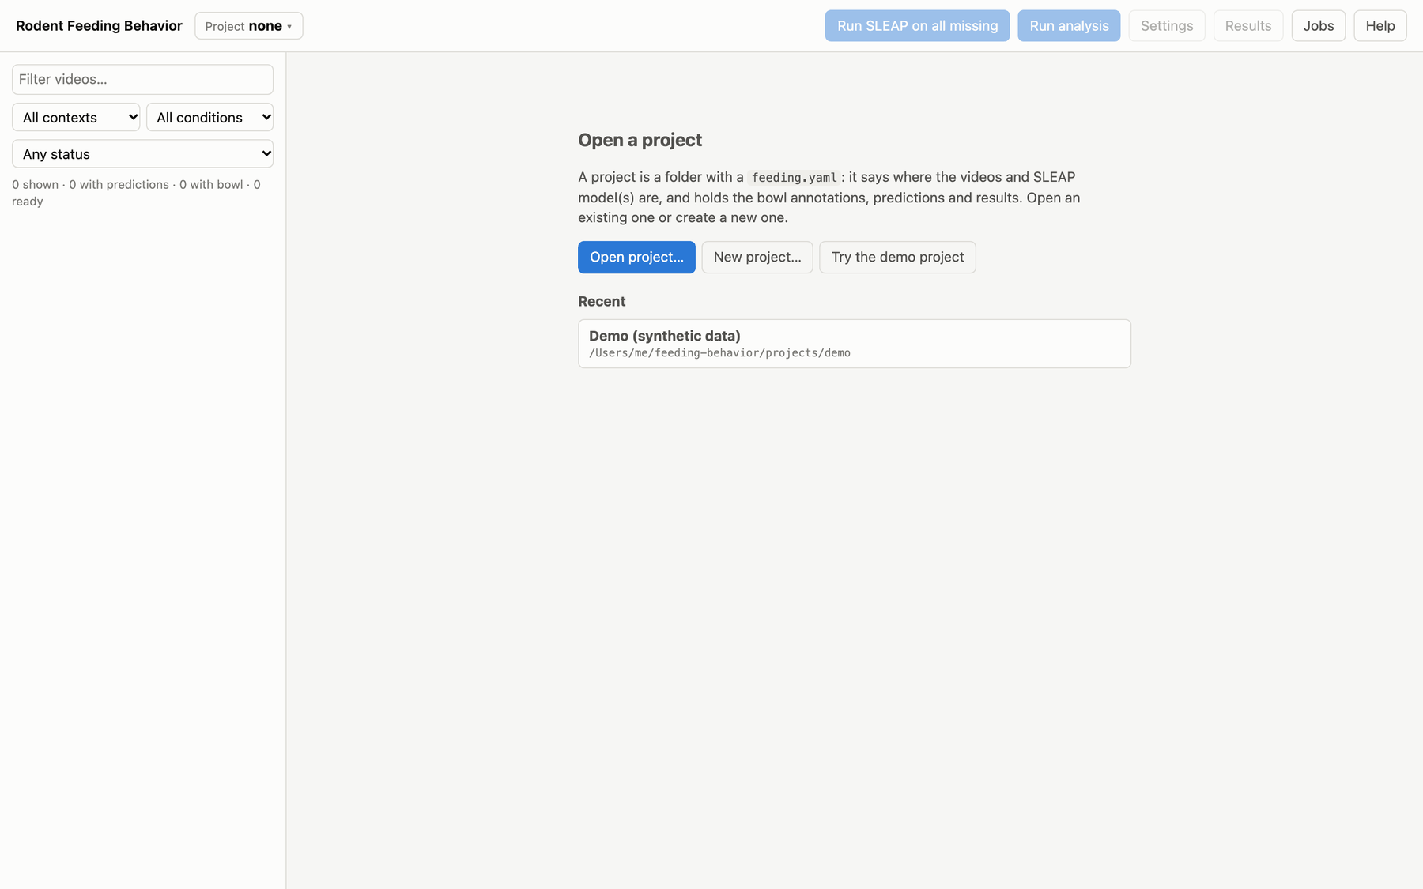
The start page, shown when no project is open: open a project, create one, or try the demo.
The same from a terminal:
uv run feeding demo # creates projects/demo
uv run feeding serve projects/demo

2. Look around
The video list on the left shows every video with two badges:
- P: SLEAP predictions exist. A video that is being processed shows a progress bar.
- B: the bowl is annotated.
Filter the list by name, context, condition or status (“needs predictions”, “needs bowl”, “ready”). The line under each name shows its condition, context, animal and group, all read from the file name and the groups table.
Click a video. It opens in the Tracking tab: the video frame with the tracked skeleton, the bowl outline and a one-second snout trail. Press Space to play; the timeline below shows tracked frames, snout-in-bowl frames and the detected bouts.
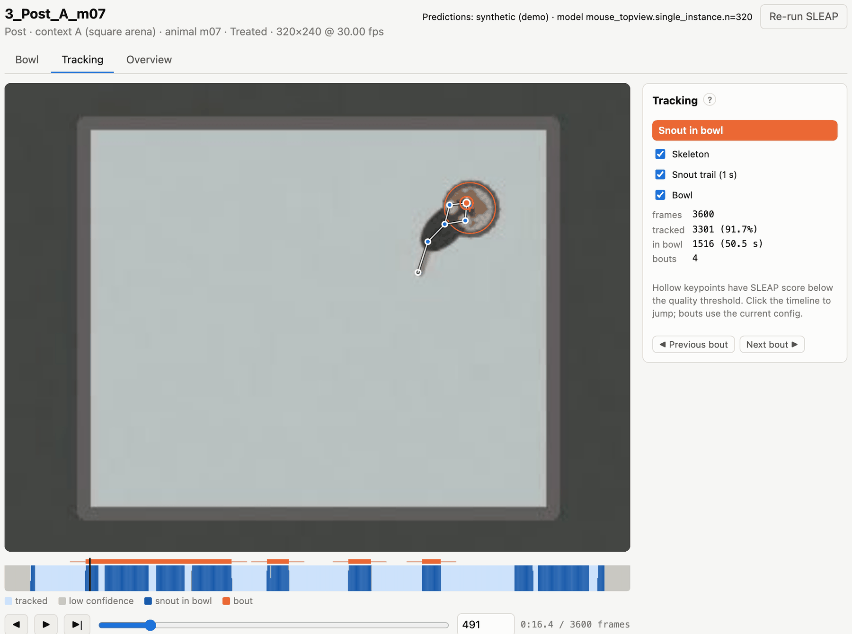
Tracking tab: skeleton, bowl rim (orange) and snout trail. On the timeline, light blue = tracked, grey = low confidence (excluded), dark blue = snout in the bowl, orange bars = bouts.

3. Annotate a bowl
The demo comes with every bowl already marked. To try annotating, open a video’s Bowl tab, click Delete, and mark it again: click the centre of the bowl, then its top, bottom, left and right edges. Then click Save bowl. See Annotating the bowl for polygons, keyboard shortcuts and copying a bowl between videos.
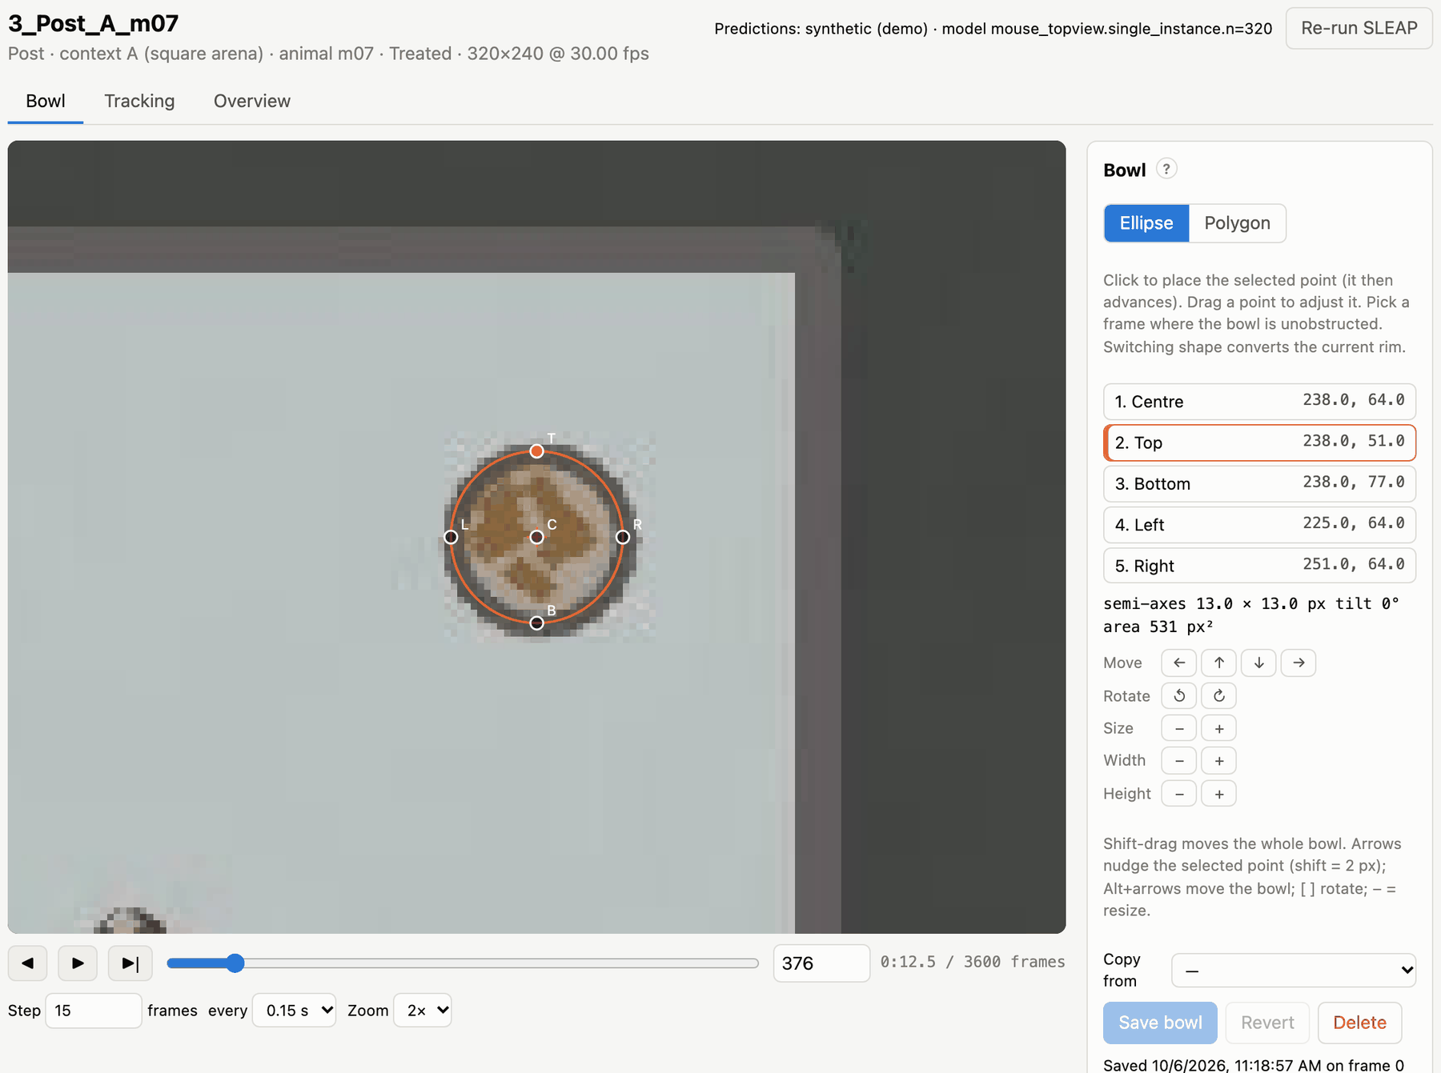
Bowl tab: the five points of an elliptical rim, with tools to move, rotate and resize it.

4. Run the analysis
Click Run analysis in the top bar. The job appears in the Jobs drawer, with its log. On the demo it takes about a minute: every video is processed, the comparisons are computed, and the figures are drawn.
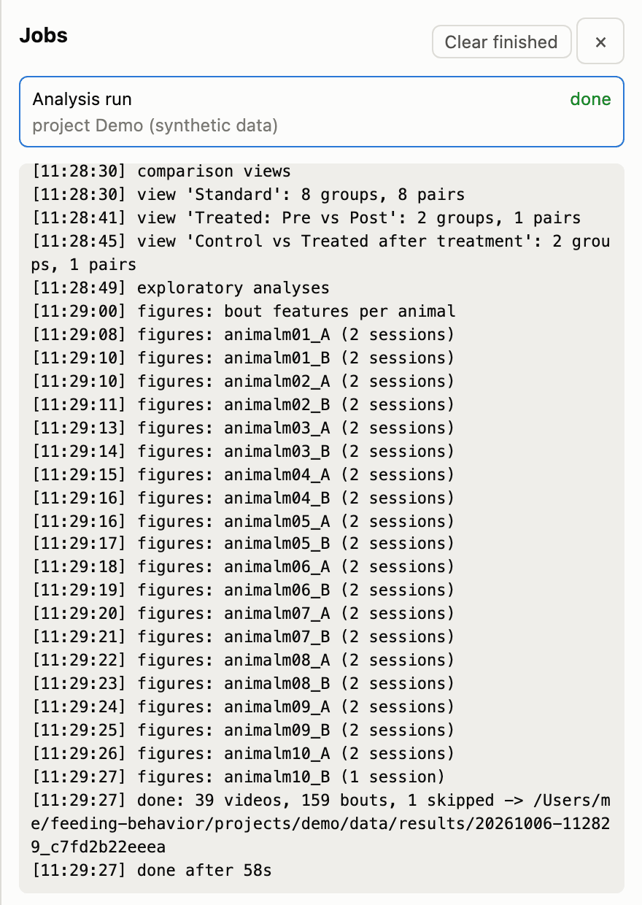
The Jobs drawer: queued, running and finished jobs, with the log of the selected one.

5. Read the results
When the job is done, click Results. The Comparisons tab opens on the Standard comparison:
- Control vs Treated within each arena and condition;
- Pre vs Post within each arena and group.
The grid lists every feature (rows) against every pair of groups (columns). Stars mark significance after correction for multiple comparisons, and the colour shows the effect size. Click a row to see its box plot and the numbers behind it.
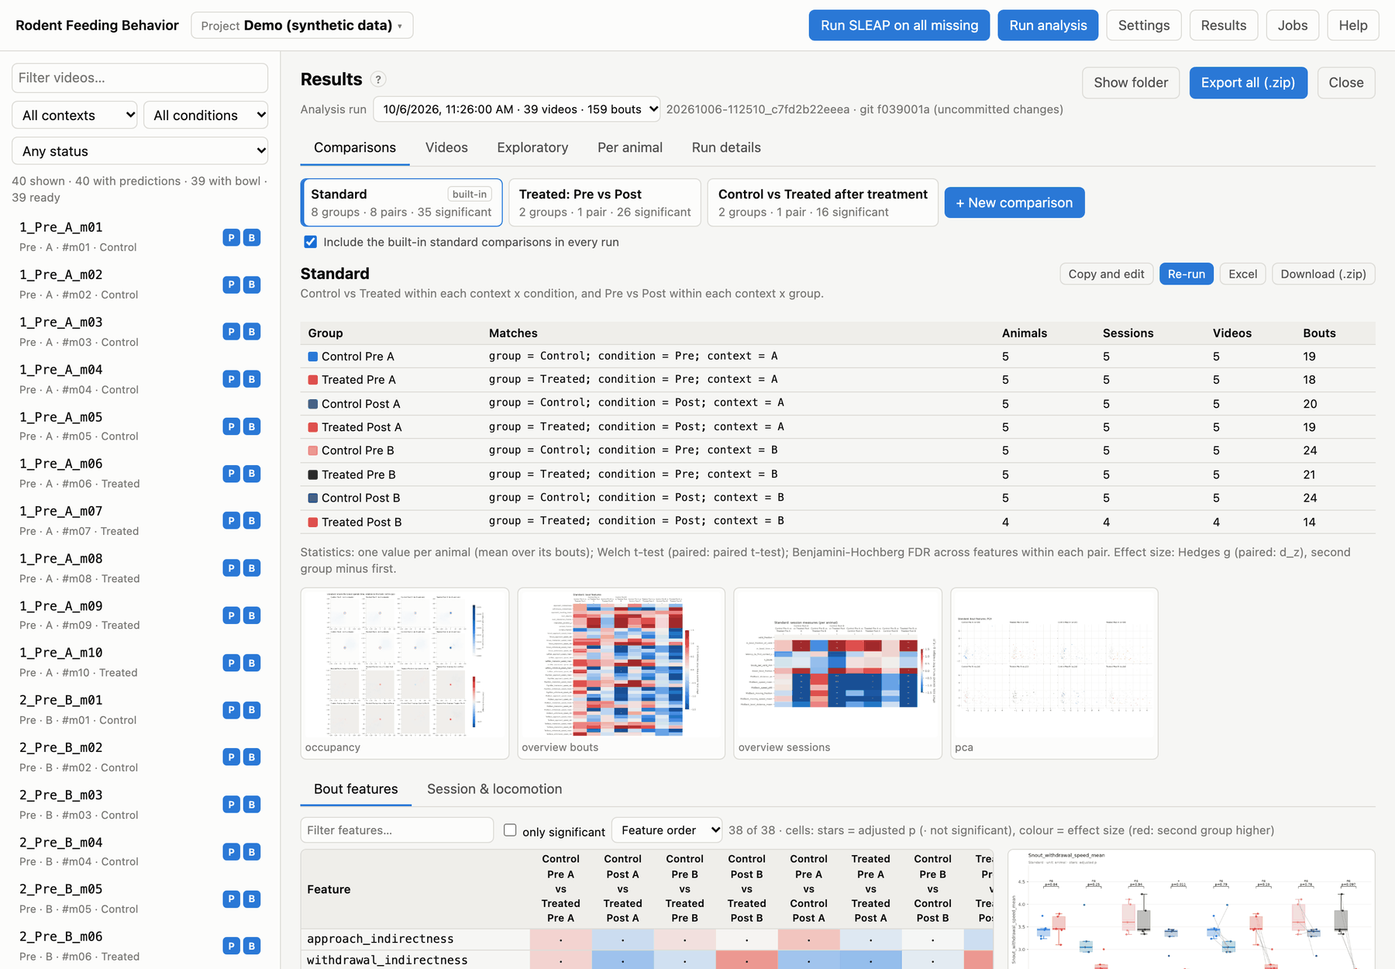
Results → Comparisons, Standard comparison: the groups it matched, figure thumbnails, and (below) the statistics grid; click any row for its box plot.
Then explore the other tabs:
- Videos: the numbers per video.
- Exploratory: per-animal box plots of every feature, PCA and UMAP projections, a local-clustering test and a random forest that tells Pre from Post.
- Per animal: heatmaps and tornado plots of each animal’s sessions.
- Run details: the exact settings and software versions.
Export all (.zip) downloads everything; Show folder opens the run folder.

6. Make your own comparison
Click + New comparison. Here is an example that compares Pre and Post in Treated animals, pooling both arenas:
- Name it Treated: Pre vs Post.
- In the first group, tick group = Treated and condition = Pre.
- In the second group, tick group = Treated and condition = Post.
- Click Save and run on this analysis. It runs in a few seconds; there is no need to re-analyse the videos.
Because both groups contain the same five animals, the tests are automatically paired. See Comparisons.
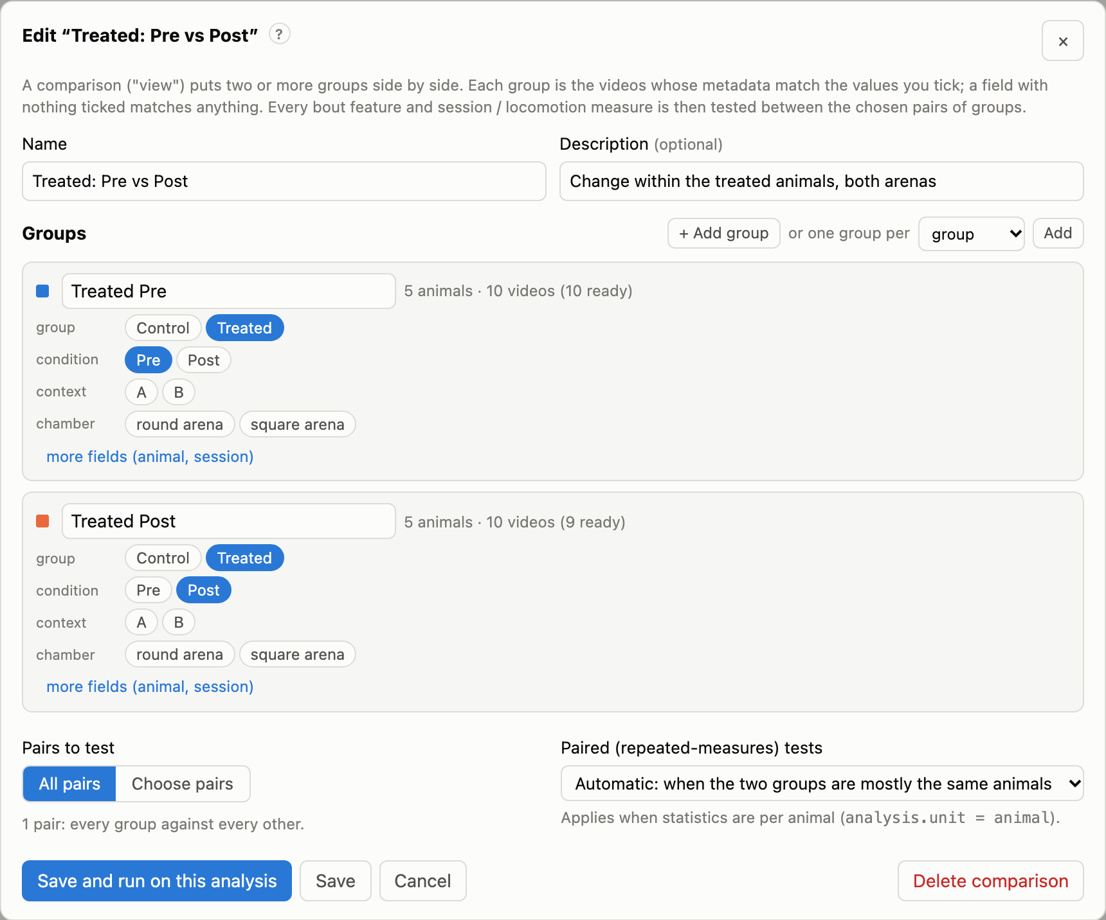
The comparison editor: each group is the set of videos whose metadata match the ticked values.

Next steps
- Set up your own project: Projects.
- Run SLEAP on your videos: SLEAP pose estimation.
- Understand exactly what is measured: Running the analysis and Statistical methods.

Projects
Everything happens inside a project: a folder with a feeding.yaml configuration file. A project knows where its videos are, which SLEAP model to use, how to read metadata from file names and which group each animal is in. It also holds your bowl annotations, the predictions and every analysis run.
A project can start with just a name and one video, and grow later: you can add videos, assign models and set groups at any time.

Creating a project
Click Project ▾ in the top bar (or New project… on the start page) and choose New project.
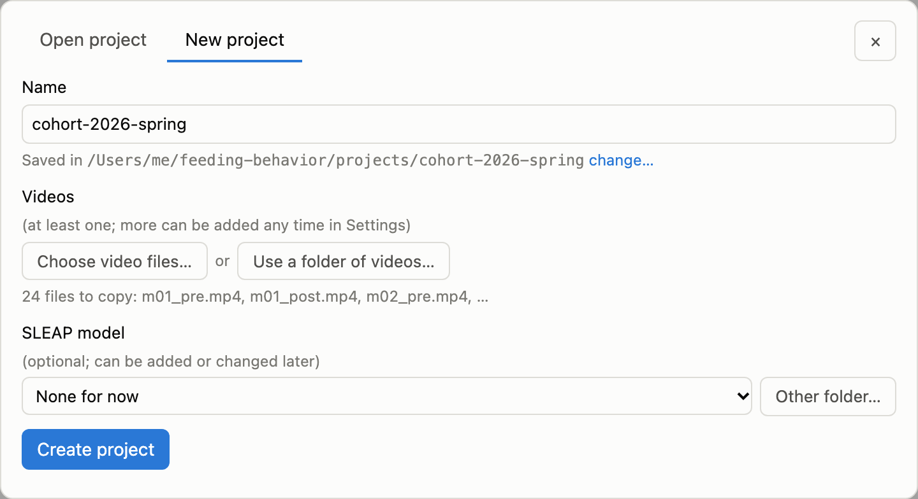
New project: a name and some videos are all that is needed.
- Name. The project folder is created under the projects folder (shown below the name; change… picks another place).
- Videos:
  - Choose video files… copies the files into the project’s videos/ folder.
  - Use a folder of videos… leaves the videos where they are and reads them in place (the folder is never written to).
- SLEAP model (optional). Pick a model from the library, or Other folder… for any model folder. You can also add it later.
- Click Create project. The naming pattern is guessed from the file names; check it in Settings → Naming.
From a terminal:
feeding init projects/my-cohort --videos /data/cohort1/videos --model /models/mouse.single_instance.n=300
feeding init projects/my-cohort # barebones; add everything later

Opening and switching projects
Project ▾ → Open project takes a project folder (type it, or Browse…) and lists recently opened projects. The current project’s name is shown in the top bar; hover over it to see its path and settings hash.
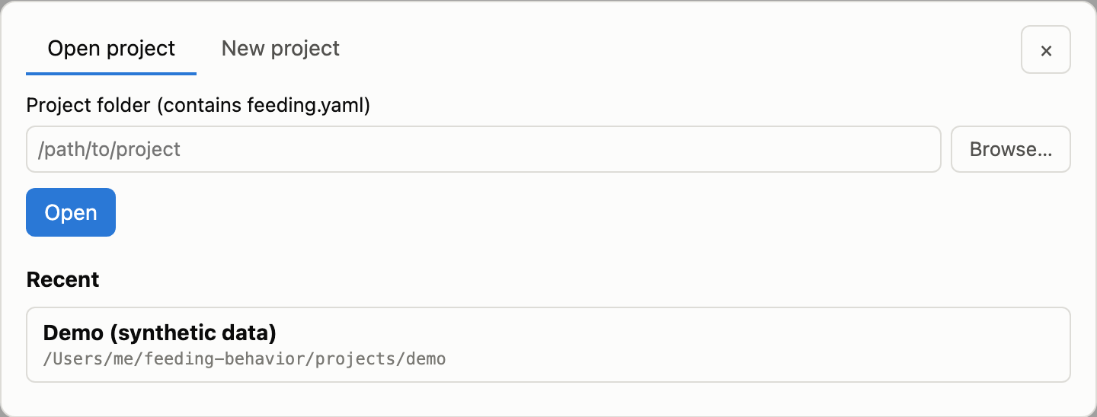
Open project, with the recent-projects list.
feeding serve PROJECT opens a project straight away. Without an argument, feeding serve opens the project in the current folder (or a parent folder) if there is one.
Problems that would stop or degrade the analysis are shown in a bar under the top bar. Examples: a missing videos folder, no model for a context, animals without a group, SLEAP not found. The same checks run with feeding check.

The project folder
my-cohort/
feeding.yaml configuration (the only required file)
videos/ videos copied into the project (more folders can be used in place)
models/ SLEAP models copied into the project (optional)
metadata/subjects.csv animal → group
annotations/bowls/ one JSON file per video, written by the Bowl tab
data/ generated: predictions, cached tracks, results, logs
Relative paths in feeding.yaml are relative to the project folder, so a project can be moved or shared as a whole. Videos referenced in place from elsewhere are stored with their absolute path.

Project settings
Settings (top bar) edits the open project. Changes are written to feeding.yaml when you click Save. Comments and formatting in the file are kept, and settings are checked before they are saved, so an invalid value is rejected with a message and the file is left unchanged.

Adding videos
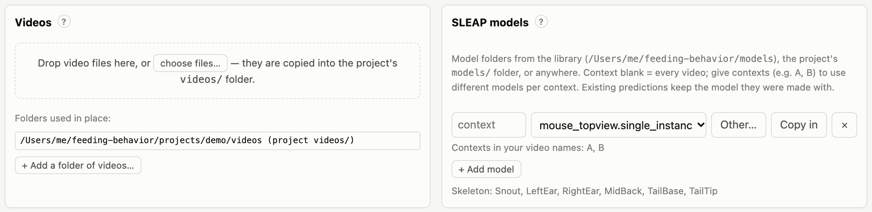
Settings → Videos and SLEAP models.
There are three ways to add videos:
- Drop video files on the drop zone, or choose files…. They are copied into the project’s videos/ folder; on the machine running the server this opens the system’s file chooser.
- + Add a folder of videos… uses a folder in place. Use this for large collections, network drives or read-only archives.
- From a terminal: feeding add-videos FILES_OR_FOLDERS… (files are copied; folders are used in place).
Supported formats are .mp4, .avi, .mov, .mpg and .mkv. Every video must show one animal. For accurate frame-by-frame review, use a codec with frequent keyframes. feeding split produces such files when it splits multi-arena recordings.

Naming videos
The tool reads each video’s metadata from its file name with a naming pattern: a regular expression with named groups.
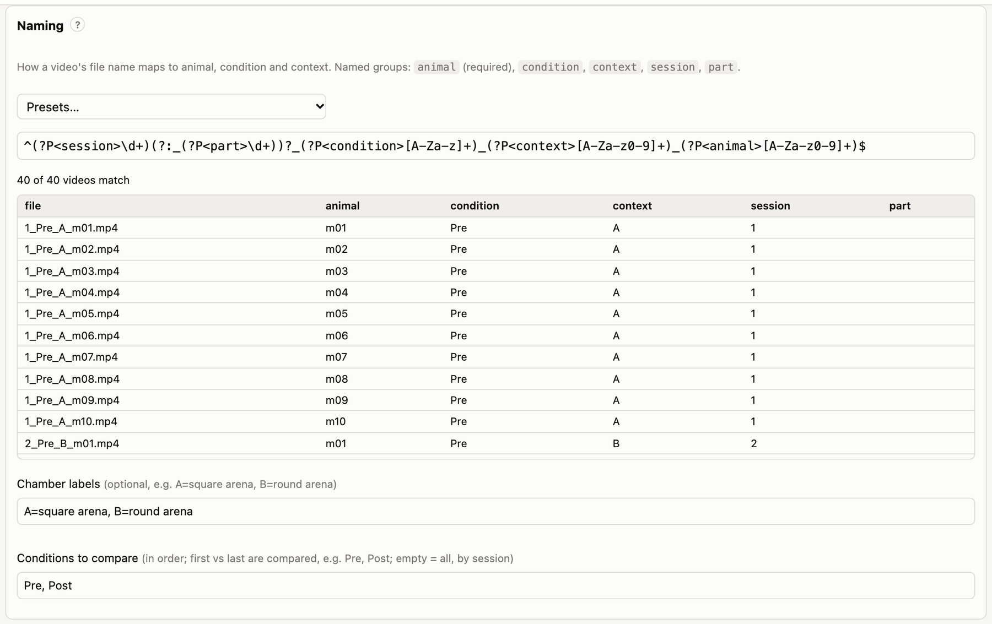
Settings → Naming: a pattern, presets, and a live preview of how every file name is read.
Named group | Meaning | Required
animal | animal ID; links videos to groups | yes
condition | experimental condition (e.g. Pre/Post, Baseline/Drug) | no
context | arena, chamber or apparatus; can select a model per context | no
session | session number; orders sessions chronologically | no
part | part number when one session was recorded in several files | no
Missing fields become NA. Files whose names don’t match are listed in the preview and ignored.
Presets:
Preset | Example file name
{session}[_{part}]_{condition}_{context}_{animal} (default) | 3_Post_A_m12.mp4, 7_2_Pre_B_m04.mp4
whole file name is the animal | mouse12.mp4
{animal}_{condition} | m12_baseline.mp4
{animal}_{condition}_{context} | m12_baseline_boxA.mp4
For other schemes, write your own pattern. For example, cohort2-m12-day3-fasted.mp4 is read by:
^cohort2-(?P<animal>m\d+)-day(?P<session>\d+)-(?P<condition>\w+)$
The preview updates as you type. Chamber labels give contexts readable names (e.g. A=square arena, B=round arena), used in the video list and in figures.
Conditions to compare sets which conditions enter the statistics, in experimental order, e.g. Pre, Post. The standard comparison contrasts the first with the last. Leave it empty to use every condition, ordered by session number.
Sessions in several parts. If a session was recorded as several files (named with a part), the parts are combined into one session for the session measures: counts and durations are added, and averages are weighted by the number of tracked frames. Each part is still annotated and processed as its own video.

Animals and groups
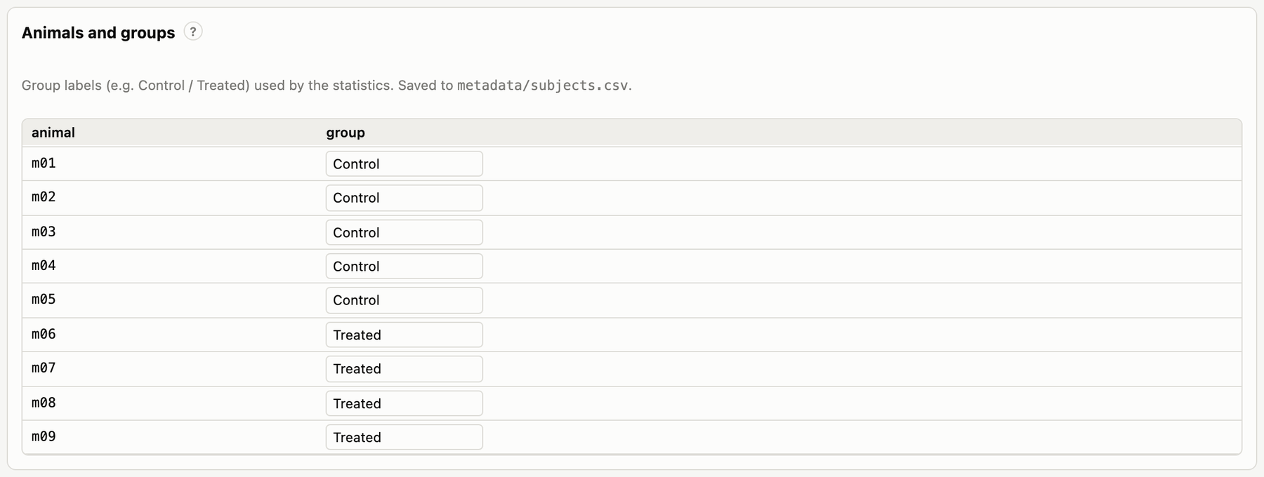
Settings → Animals and groups: one group label per animal.
Type a group for each animal (e.g. Control, Treated); labels you have used are suggested. Animals without a group are still analysed, but they are left out of group comparisons. Groups are saved in metadata/subjects.csv:
animal,group
m01,Control
m02,Treated
You can also edit this file directly, e.g. paste it from a spreadsheet. Animal IDs are compared as text, so 7 and 07 are different animals.

What to keep, share and back up
The files you create by hand are feeding.yaml, metadata/subjects.csv and annotations/bowls/*.json. Together with the videos, the predictions and the code version, they fully determine every result. Everything under data/ is generated; most of it can be recreated, but SLEAP predictions take time to recompute, so back them up.
A new project gets a .gitignore that excludes data/, so the project folder itself can be put under version control.

SLEAP pose estimation
SLEAP finds the animal’s body parts (keypoints) in every frame. This tool runs SLEAP’s sleap-track for you, converts the result to an analysis file, and records exactly how it was made. You need SLEAP installed (see Installation) and a trained model.

Models
A SLEAP model is a folder containing training_config.json and best_model.h5, produced by training in SLEAP. The pipeline analyses one animal per video, so use either:
- a single-instance model (…single_instance…), or
- a top-down pair: a centroid model plus a centered_instance model, given together.
Any skeleton works. The keypoint names are read from the model, and the analysis settings that name keypoints (which keypoint defines contact with the bowl, which are ignored, which are used for speeds) are filled in from it. The defaults suit a skeleton with a Snout; for other skeletons the first keypoint is used, and you can change it in feeding.yaml (see Configuration).

Assigning a model
In Settings → SLEAP models, choose a model in the list and click Save. The list contains:
- models in the model library: the models/ folder of the app, or the folders in FEEDING_MODEL_LIBRARY;
- models in the project’s own models/ folder;
- anything you pick with Other….
Copy in copies a model into the project, so the project stays complete when moved to another computer.
One model per context. If your contexts look different on camera (e.g. a square and a round arena), you may have trained a model for each. Add one row per context and type the context name (e.g. A, B) in the first box. A row with an empty context applies to every video without its own model. For a top-down pair, add two rows with the same context.
From a terminal:
feeding models # list the models in the library
feeding set-model /models/mouse.single_instance.n=300
feeding set-model A=/models/square.n=250 B=/models/round.n=270
feeding set-model /models/m.centroid.n=200 /models/m.centered_instance.n=200 # top-down pair
To add a model to the library, copy or link its folder into models/:
ln -s /path/to/mouse.single_instance.n=300 models/

Running inference
- One video: select it and click Run SLEAP in its header. If it already has predictions, the button says Re-run SLEAP and asks before overwriting.
- All videos without predictions: Run SLEAP on all missing in the top bar.
Jobs run one at a time in the background. Their progress shows in the video list and in the Jobs drawer, which also has each job’s full log and a Cancel button. Closing the browser does not stop them; stopping the server does. An interrupted video never leaves a half-written file behind: outputs are written under temporary names and renamed only when complete.
From a terminal:
feeding infer 3_Post_A_m12 4_Post_B_m12 # some videos
feeding infer --all # every video without predictions
feeding infer --all --force # every video, overwriting
For each video the predictions folder (data/predictions/ by default) receives:
File | Contents
<video>.slp | SLEAP’s own predictions file (open it in SLEAP to inspect or correct)
<video>.analysis.h5 | keypoint coordinates and confidence scores per frame: what the analysis reads
<video>.provenance.json | how the predictions were made (see below)

Inference parameters
Settings → SLEAP inference sets the options passed to sleap-track. They apply to inference started after you save; existing predictions keep the settings they were made with.
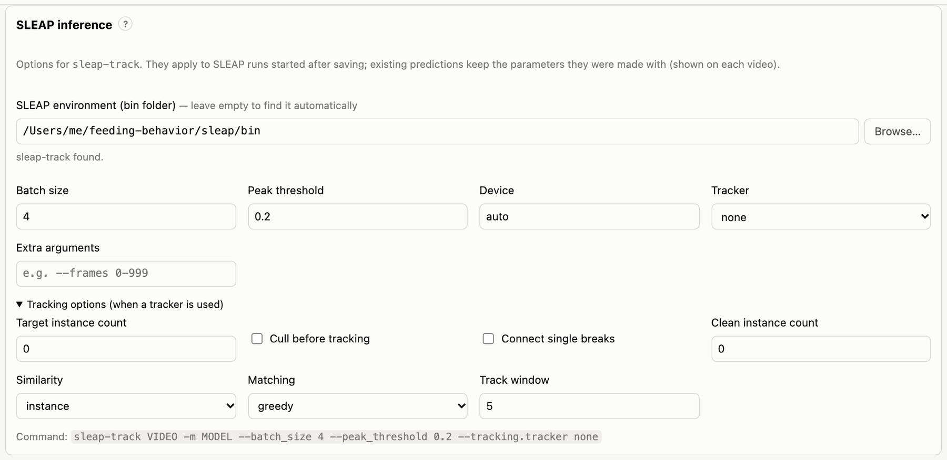
Settings → SLEAP inference: the SLEAP environment, the main options, tracking options, and a preview of the command.
Setting | sleap-track option | Default | Meaning
SLEAP environment | – | found automatically | the bin folder of the conda environment with SLEAP
Batch size | --batch_size | 4 | frames predicted at once. Larger is faster but needs more (GPU) memory; lower it after out-of-memory errors
Peak threshold | --peak_threshold | 0.2 | minimum confidence for a keypoint to be detected (0–1). Lower finds more keypoints, including more wrong ones
Device | --cpu / --first-gpu / --gpu N | auto | auto lets SLEAP choose; cpu, gpu (first GPU) or a GPU number
Tracker | --tracking.tracker | none | links detections across frames. none is right for one animal per video; simple or flow (optical flow) for several animals
Extra arguments | – | none | passed to sleap-track as written, after the options above, and override them (e.g. --frames 0-8999)
When a tracker is used, more options appear under Tracking options:
Setting | sleap-track option | Default
Target instance count | --tracking.target_instance_count | 0 (no limit)
Cull before tracking | --tracking.pre_cull_to_target | off
Connect single breaks | --tracking.post_connect_single_breaks | off
Clean instance count | --tracking.clean_instance_count | 0 (off)
Similarity | --tracking.similarity | instance (or centroid, iou)
Matching | --tracking.match | greedy (or hungarian)
Track window | --tracking.track_window | 5 frames
The bottom of the panel shows the resulting command line. In feeding.yaml the same settings are under sleap::
sleap:
bin_dir: null # null = find SLEAP automatically
models: {default: models/mouse.single_instance.n=300}
batch_size: 8
peak_threshold: 0.2
device: auto
tracker: none
extra_args: []
On the command line, feeding infer accepts the main options for one run. --save also stores them in the project:
feeding infer --all --batch-size 16 --device 0
feeding infer --all --peak-threshold 0.3 --save
feeding infer 3_Post_A_m12 --sleap-arg=--frames --sleap-arg=0-899 # any other sleap-track option
feeding config sleap # show the SLEAP settings
feeding config sleap.batch_size 16 # change one
When a video’s predictions were made with a different model or different parameters than the current settings, its header says so (e.g. made with different SLEAP settings (peak_threshold)). Re-run SLEAP on it if you want them updated.

Importing existing predictions
If you already have SLEAP analysis files (.h5, exported with File → Export Analysis HDF5 in SLEAP or with sleap-convert --format analysis), import them instead of re-running inference:
feeding import-predictions /path/to/folder/with/h5/files
A file named <video>.h5 or <video>.analysis.h5 is matched to the video with that name. Before it is copied (never moved), the import checks that its keypoint names match the project’s skeleton and that it is not longer than the video. Imported predictions are marked as such in their provenance file.

Provenance
Each <video>.provenance.json records:
- the source: a SLEAP run, an import, or the demo;
- the hash of the video file;
- the model folders, with hashes of their weights;
- the SLEAP version;
- the inference parameters and the exact commands that were run;
- start and end times.
Each analysis run copies this information into its manifest, so a result can always be traced back to the model and settings that produced its poses.

Annotating the bowl
The analysis needs to know where the food is in every video. You mark it once per video in the Bowl tab. The annotation has two parts:
- The centre is the feeding origin. Distances to the bowl and approach headings are measured to it.
- The rim decides contact: the snout (or the keypoint you chose) is in the bowl when it is inside the rim. The rim can be an ellipse or a polygon.
The camera may be tilted, so a round bowl often looks like a tilted ellipse in the image; the ellipse tool handles that. Use a polygon for bowls that are not elliptical, or that are partly hidden behind a wall or a feeder.

Marking an ellipse
Marking an elliptical rim: centre, top, bottom, left and right. The panel shows the fitted semi-axes, tilt and area.
- Pick a frame where the bowl is fully visible: drag the slider, or use the arrow buttons and the frame box. The view is zoomed in by default; change it with Zoom.
- Make sure Ellipse is selected. Then click, in this order: the centre of the bowl, and its top, bottom, left and right edges. After each click the next point is selected; the list on the right shows which point is next.
- The fitted rim is drawn as you go. Drag any point to adjust it, or select a point in the list (or press 1–5) and click again to place it.
- Click Save bowl.
The four rim points are the rim’s outermost points in the image (highest, lowest, leftmost, rightmost). They determine the ellipse exactly, including its tilt. Place them on the rim’s outer edge as it appears on screen; they don’t need to be opposite each other.

Marking a polygon
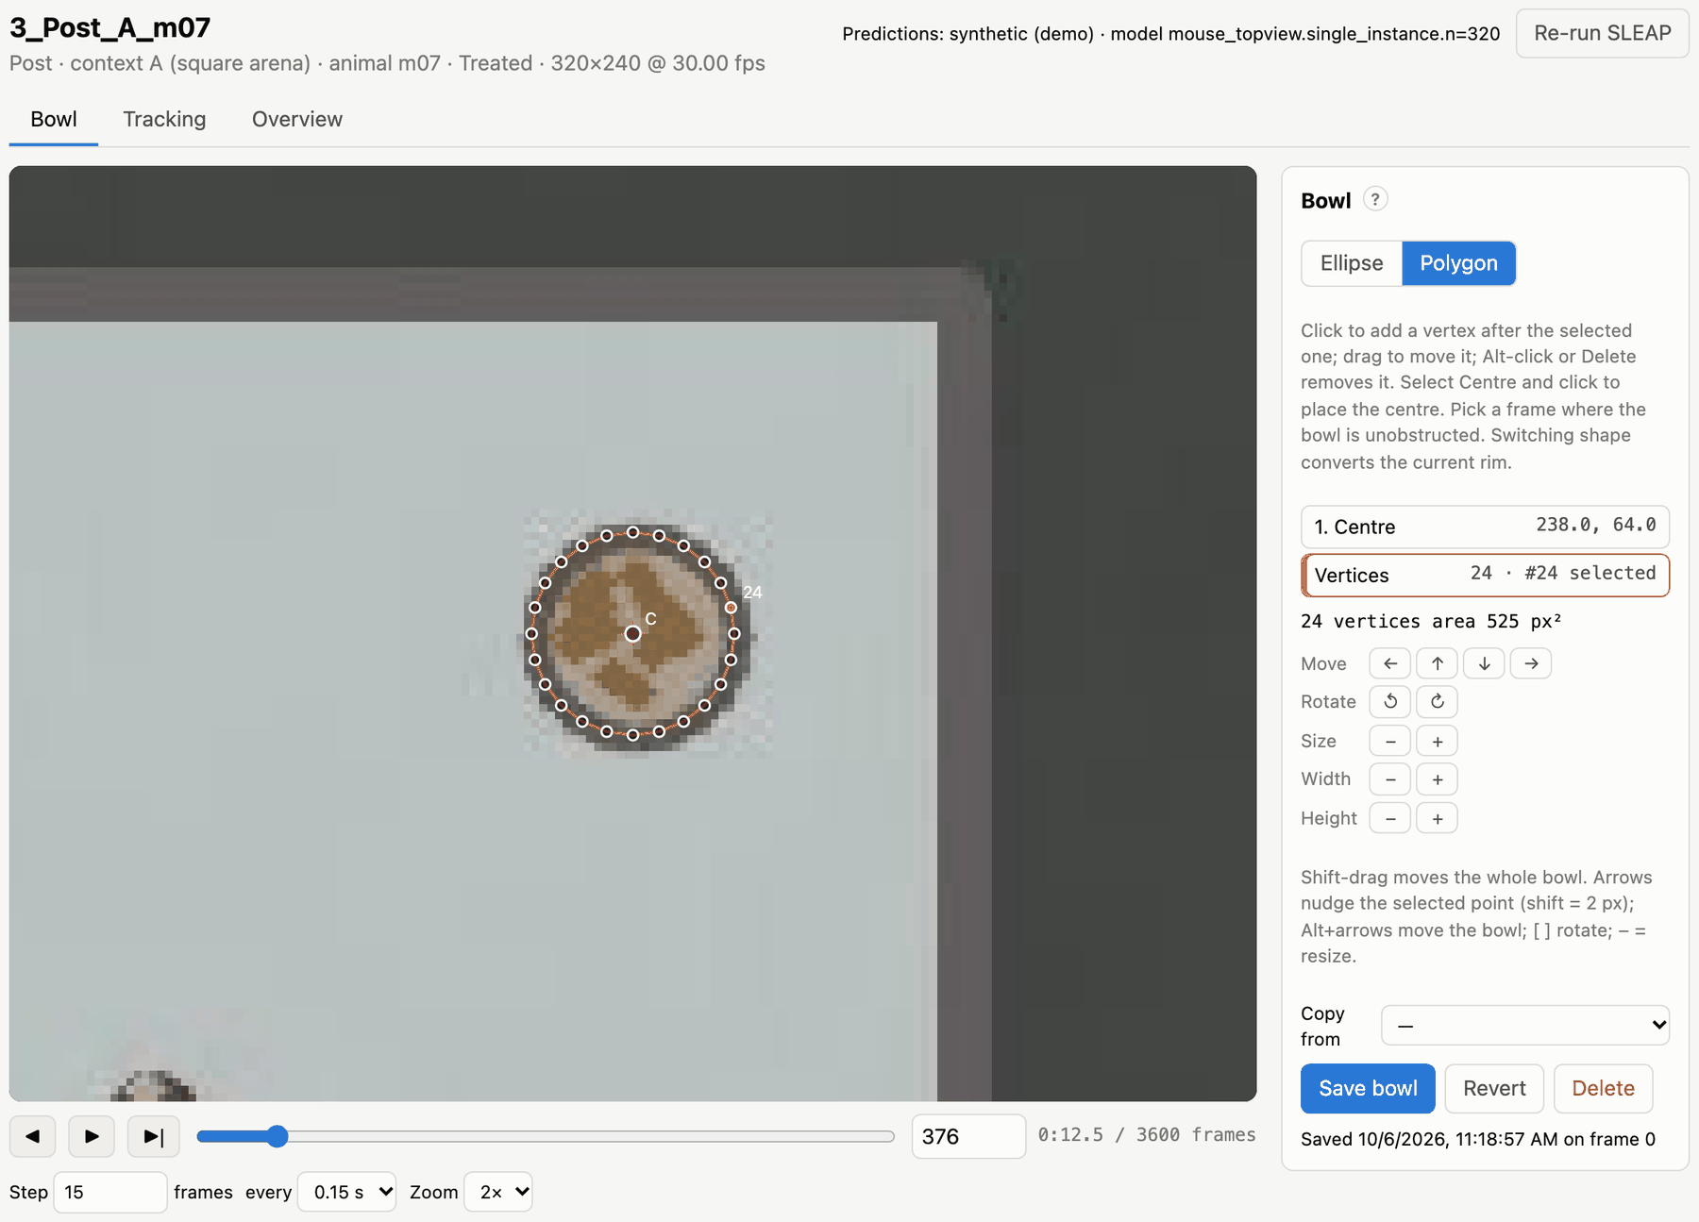
A polygon rim: click around the visible edge of the bowl.
- Click Polygon. If an ellipse was already marked, it is converted to a polygon that you can edit.
- Select Centre in the list and click to place the centre.
- Click around the rim to add corners. Each new corner is inserted after the selected one, so you can also add a corner in the middle of an edge: select the corner before it, then click.
- Drag a corner to move it. Alt-click it, or select it and press Delete, to remove it.
- Click Save bowl.
Contact with a polygon is decided the same way: the keypoint must be inside the polygon.

Moving, rotating and resizing
The tools under the point list change the whole rim:
Action | Buttons | Keys
Move the whole bowl | ← ↑ ↓ → under Move, or Shift-drag | Alt+arrows
Nudge the selected point | – | arrows (Shift = 2 px)
Rotate | ↺ ↻ | [** **] (3° steps)
Resize | − + under Size | − =
Stretch | Width and Height − + | –
Select an ellipse point | click it in the list | 1–5
Remove a polygon corner | – | Alt-click, or Delete
Revert discards unsaved changes; Delete removes the saved annotation.

Copying a bowl from another video
When the camera and bowl did not move between recordings, start from an existing annotation. In Copy from, pick another video (the same animal in the same context is listed first, then other videos of that context), check the rim against this video’s frame, adjust it if needed, and save.

Tips
- Choose a frame without the animal on the bowl, ideally a frame in which the bowl is clearly lit.
- Check one frame late in the video as well. If the bowl was pushed during the recording, the rim no longer fits. The analysis assumes the bowl doesn’t move within a video.
- Mark the rim where the animal can reach the food. Contact means “the keypoint is inside the rim”, so a rim drawn too large counts sniffing next to the bowl as feeding. You can tune this afterwards: bouts.margin_px in feeding.yaml grows (positive) or shrinks (negative) the rim for the contact test without changing the annotations.
- Use Tracking to check the result. It shows the rim with the snout and colours the timeline wherever the snout is inside. See Reviewing the tracking.

Where annotations are stored
Each bowl is saved as annotations/bowls/<video>.json in the project. The file holds the shape, the clicked points (or polygon corners), the frame it was marked on and the time it was saved. These files are small and hand-made, so keep them with the project and under version control if you can. When an annotation changes, the videos that depend on it are recomputed automatically at the next analysis.

Reviewing the tracking
Check the poses before you trust the numbers. The Tracking tab plays a video with its predictions overlaid, and shows which frames the analysis will use and where it found contacts and bouts. The Overview tab samples frames across the whole video at once.

Tracking view
Tracking: skeleton, bowl rim and snout trail on the frame; the timeline below; the summary and bout list on the right.
On the frame:
- Skeleton: keypoints joined by the skeleton’s edges. A hollow keypoint has a SLEAP score below quality.min_score for that frame.
- Bowl: the annotated rim (orange) and its centre.
- Snout trail: the last second of the contact keypoint’s positions.
Turn each overlay on or off with the checkboxes. The chip above them describes the current frame: tracked, low confidence (excluded from the analysis) or in bowl.
Playback:
Control | Effect
▶ / Space | play or pause
◀ / ▶︎| / ← → | step back or forward by Step frames
Step N frames every T s | playback speed: e.g. 15 frames every 0.15 s ≈ 3× real time at 30 fps
slider, frame box | jump to a frame (the time is shown next to it)
Zoom | 1×, 2× or 4×, centred on the bowl
The address bar keeps the video, tab and frame (e.g. #3_Post_A_m07/track/1520), so you can bookmark a frame or send the link to a colleague who has the same project.

Timeline
The bar under the video summarises the whole recording:
Colour | Meaning
light blue | tracked frames, used by the analysis
grey | low-confidence frames, excluded
dark blue | the contact keypoint is inside the bowl rim
orange bars (below) | detected bouts, from the start of the approach to the end of the withdrawal
Click the timeline to jump there. The panel on the right lists frames, tracked frames, frames in the bowl and the number of bouts. ◀ Previous bout and Next bout ▶ jump to the first contact of the previous or next bout. The bouts are detected with the project’s current settings, so after changing bouts.* in feeding.yaml you can check their effect here before running the analysis.
Before the bowl is annotated, only the tracking quality is shown; contacts and bouts need the rim.

Overview sheet
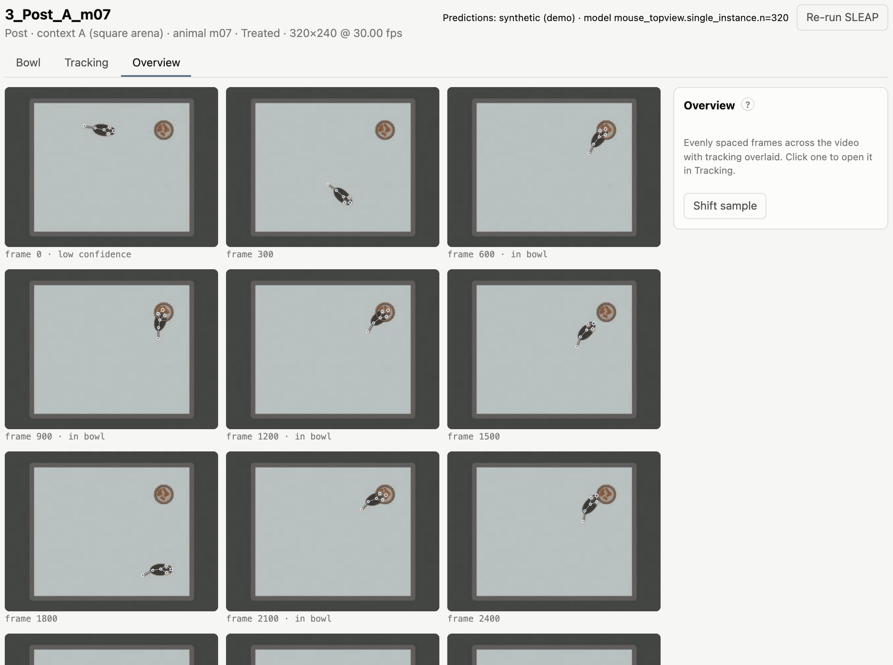
Overview: twelve frames spread over the video, with the tracking drawn on each. Captions mark frames that are in the bowl or have low confidence.
The Overview tab shows twelve evenly spaced frames with the skeleton and bowl drawn on them. It is a quick way to spot problems: a model that loses the animal in one corner, swapped body parts, or a bowl that moved during the recording. Shift sample shows a different set of frames. Click a frame to open it in the Tracking tab.

Quality filtering
Not every frame is used. A frame is tracked (used) when the SLEAP confidence of every keypoint, averaged over a centred window, is high enough. The average smooths over brief dips, while longer stretches of poor tracking are dropped:
Setting (quality.*) | Default | Meaning
drop_nodes | [] | keypoints ignored for filtering and features (e.g. an unreliable tail tip)
score_window | 300 frames | width of the centred rolling mean of each keypoint’s score
min_score | 0.5 | a frame is kept when every keypoint’s rolling mean is at least this
min_segment_frames | 90 | tracked stretches shorter than this are discarded
max_interp_gap | 0 | fill gaps of missing coordinates up to this many frames by linear interpolation (0 = off)
The first and last score_window / 2 frames of a video are never tracked, because the rolling window is incomplete there.
If too much of a video is grey on the timeline:
- Check the poses in the Tracking tab. If they look right but scores are low, lower min_score or drop a keypoint that is often hidden (drop_nodes).
- If the poses are wrong, the model needs more training data from this setup: label frames from such videos in SLEAP and retrain.
- Re-run SLEAP with a lower peak threshold (Settings → SLEAP inference) if keypoints are missing outright.
The fraction of tracked frames is reported per video (valid_fraction in the Results → Videos tab). Use it to spot videos that are tracked too poorly; re-run them, or leave them out of a comparison (see Comparisons) or of the run (feeding analyze VIDEO… analyses only the listed videos).

Running the analysis
Click Run analysis in the top bar (or run feeding analyze). Every video that has both predictions and a bowl annotation is analysed; videos missing either are skipped and listed in the run’s details. A run takes from seconds to a few minutes depending on the number and length of the videos. Figures account for most of the time: feeding analyze --no-plots skips them.

What the analysis does
For each video:
- Load the poses and apply the quality filter: only tracked frames are used.
- Find contact. A tracked frame is in the bowl when the contact keypoint (bouts.node, default Snout) is inside the annotated rim.
- Detect bouts and compute bout features (below).
- Compute session measures, including locomotion.
- Compute an occupancy map: a 2-D histogram of the contact keypoint’s position around the bowl centre, used for the group maps.
Then, for the whole run:
- Comparisons: statistics and figures for the standard comparison and for every comparison you defined (see Comparisons).
- Exploratory analyses: PCA (and UMAP, if installed), local clustering and a random-forest classifier; see Results.
- Figures per animal and per feature.
- The run folder with tables, figures, a copy of feeding.yaml and a manifest (see Output files).
Per-video results are cached (data/derived/), keyed on the predictions, the bowl annotation and the analysis settings. Unchanged videos are therefore not recomputed, and any change to their inputs is picked up automatically.

Contact and bouts
A bout on the Tracking timeline: the orange bar spans approach, contact (with a brief step-back) and withdrawal.
A bout is one visit to the food:
… away … | approach | contact ~ step back ~ contact … | withdrawal | … away …
^ window_start ^ contact_start contact_end ^ window_end ^
- Contact episodes are runs of consecutive in-bowl frames within one tracked stretch.
- Episodes separated by fewer than merge_gap_frames (default 90) non-contact frames are merged into one bout. Each extra episode counts as a return: the animal stepped back and came back to the food.
- A bout is kept only if at least one of its episodes lasts at least min_contact_frames (default 15) consecutive frames. Brief touches of the rim don’t count.
- A bout needs flank_frames (default 90) tracked, contact-free frames before and after it. They are its approach and withdrawal windows, and they make sure both are fully observed.
Setting (bouts.*) | Default | Meaning
node | Snout | keypoint whose position defines contact
margin_px | 0 | grow (positive) or shrink (negative) the rim by this many pixels for the contact test
min_contact_frames | 15 | shortest continuous contact that makes a bout
merge_gap_frames | 90 | shorter away-periods are returns within one bout
flank_frames | 90 | length of the approach and withdrawal windows
Frame counts are in video frames; at 30 fps, 90 frames are 3 seconds.

Bout features
One row per bout in bout_features.csv. Speeds are in pixels per frame. Angles are in degrees between each movement step of the contact keypoint and the direction to the bowl centre: 0° = straight at the bowl, 180° = straight away.
Feature | Meaning
approach_indirectness | standard deviation of that angle during the approach: how much the path wanders on the way in
withdrawal_indirectness | the same during the withdrawal
approach_heading_mean | mean angle during the approach: low = heads straight for the bowl
num_returns | contact episodes in the bout minus one
num_interaction_frames | frames from the first to the last contact of the bout
interaction_duration_s | the same in seconds
contact_frames | frames actually in contact (excludes step-backs)
contact_fraction | contact_frames / num_interaction_frames
{node}_{phase}_speed_mean | mean step length of a keypoint during the approach, interaction or withdrawal
{node}_{phase}_speed_std | its standard deviation
Speeds are computed for every keypoint in features.speed_nodes (default: every tracked keypoint).

Session measures
One row per video in sessions.csv. A session recorded in several parts (see Naming videos) is combined into one session before the statistics.
Measure | Meaning
valid_fraction | fraction of frames that passed the quality filter
in_bowl_time_s | time with the contact keypoint in the bowl
in_bowl_fraction_of_valid | the same as a fraction of tracked frames
latency_to_first_contact_s | time from the start of the video to the first contact
n_bouts | number of bouts
bouts_per_valid_min | bouts per minute of tracked time
mean_bout_frames | mean bout length (first to last contact)
n_frames, valid_frames, in_bowl_frames | frame counts, kept for reference (not tested)

Locomotion
Whole-session movement of one body keypoint, features.body_node. The default is a body-centre keypoint (MidBack, Centroid, Thorax, … if the skeleton has one), else the first speed keypoint. Positions are smoothed with a 5-frame moving average within each tracked stretch, so tracking jitter does not count as movement.
Measure | Meaning
{body}_distance_px | total distance travelled over tracked frames
{body}_speed_mean | mean speed (px/frame)
{body}_speed_p90 | 90th percentile of speed: how fast the animal moves when it moves
{body}_moving_fraction | fraction of tracked frames faster than features.moving_speed (default 1 px/frame)
{body}_moving_speed_mean | mean speed while moving
{body}_bowl_distance_mean | mean distance from the bowl centre
Pixels. Distances and speeds are in image pixels. They are comparable between videos recorded with the same camera geometry. If the camera distance or resolution differs between groups, compare ratios or normalised measures instead.

Figures
With figures enabled, a run draws:
- Per comparison: an overview heatmap of effect sizes, a box plot per feature, occupancy maps and a PCA (see Results).
- Per animal and context: a heatmap of where the contact keypoint was around the bowl, and two “tornado” plots (position over time, coloured by distance to the bowl or by speed), with one panel per session in recording order.
- Per feature: a box plot of every animal’s bouts by condition (and context).
- Exploratory: projections coloured by group, condition and context; local clustering; random-forest feature importances.
All figures are PNG files in the run folder, viewable in Results and included in Export all (.zip).

When something is missing
The run’s notes (shown at the top of Results) explain what could not be computed and why. Examples:
- No comparisons: the standard comparison needs animals in at least two groups and two conditions. Add groups in Settings → Animals and groups, or define your own comparison.
- No exploratory analyses: these need at least 10 bouts from the analysed conditions.
- No bouts: check the bowl annotations and the tracking (and bouts.margin_px, min_contact_frames).
Per-animal figures and session measures are produced even for a single video.

Results
Results in the top bar shows the analysis runs of the open project. Pick a run in Analysis run (the newest is selected). Runs are named <date>-<time>_<settings hash>; next to the name is the code version (git commit) that made the run. The video list stays on the left, so you can jump between results and videos.
- Export all (.zip) downloads the whole run: tables, Excel workbooks, figures and the manifest.
- Show folder opens the run folder in Finder, Explorer or your file manager.
The address bar keeps the run, tab and comparison (#results/<run>/compare/<comparison>), so a view can be bookmarked.

Comparisons
Results → Comparisons: the comparison list, the groups, figure thumbnails, the statistics grid, and the selected feature’s box plot and numbers.
The row of cards at the top lists the comparisons:
- the built-in Standard comparison;
- the comparisons you defined, each showing how many of its results are significant in this run.
+ New comparison opens the editor (see Comparisons). A comparison that is saved but has not been run on the selected analysis can be run with Run on this analysis, or all at once with Run all not yet run on this analysis. This takes seconds; the videos are not re-processed.
For the selected comparison:
- Groups table: each group’s definition, and how many animals, sessions, videos and bouts it matched in this run. Hover over the animal count to see the IDs. A group with no analysed videos is flagged, and its tests stay empty.
- Method line: the unit of analysis, the test, the correction and the effect size used.
- Figure strip: the overview heatmaps, occupancy maps and PCA. Click a figure to enlarge it; use ← → to browse.
- Bout features / Session & locomotion: the two families of measures, tested separately.
- Statistics grid: one row per feature, one column per pair of groups. A cell shows the significance stars of the adjusted p-value (· = not significant, – = not testable). Its colour shows the effect size: red when the second group is higher, blue when it is lower. Hover over a cell for the means, n, test and p-values. Comparisons with three or more groups and no explicit pairs also get an All groups column: one test across all groups.
- Filter features…, only significant, and sorting by Smallest p first narrow the grid.
- Detail: click a row to see the feature’s box plot, and a table with n, means, effect size, adjusted p and (in brackets) the unadjusted p for every pair.
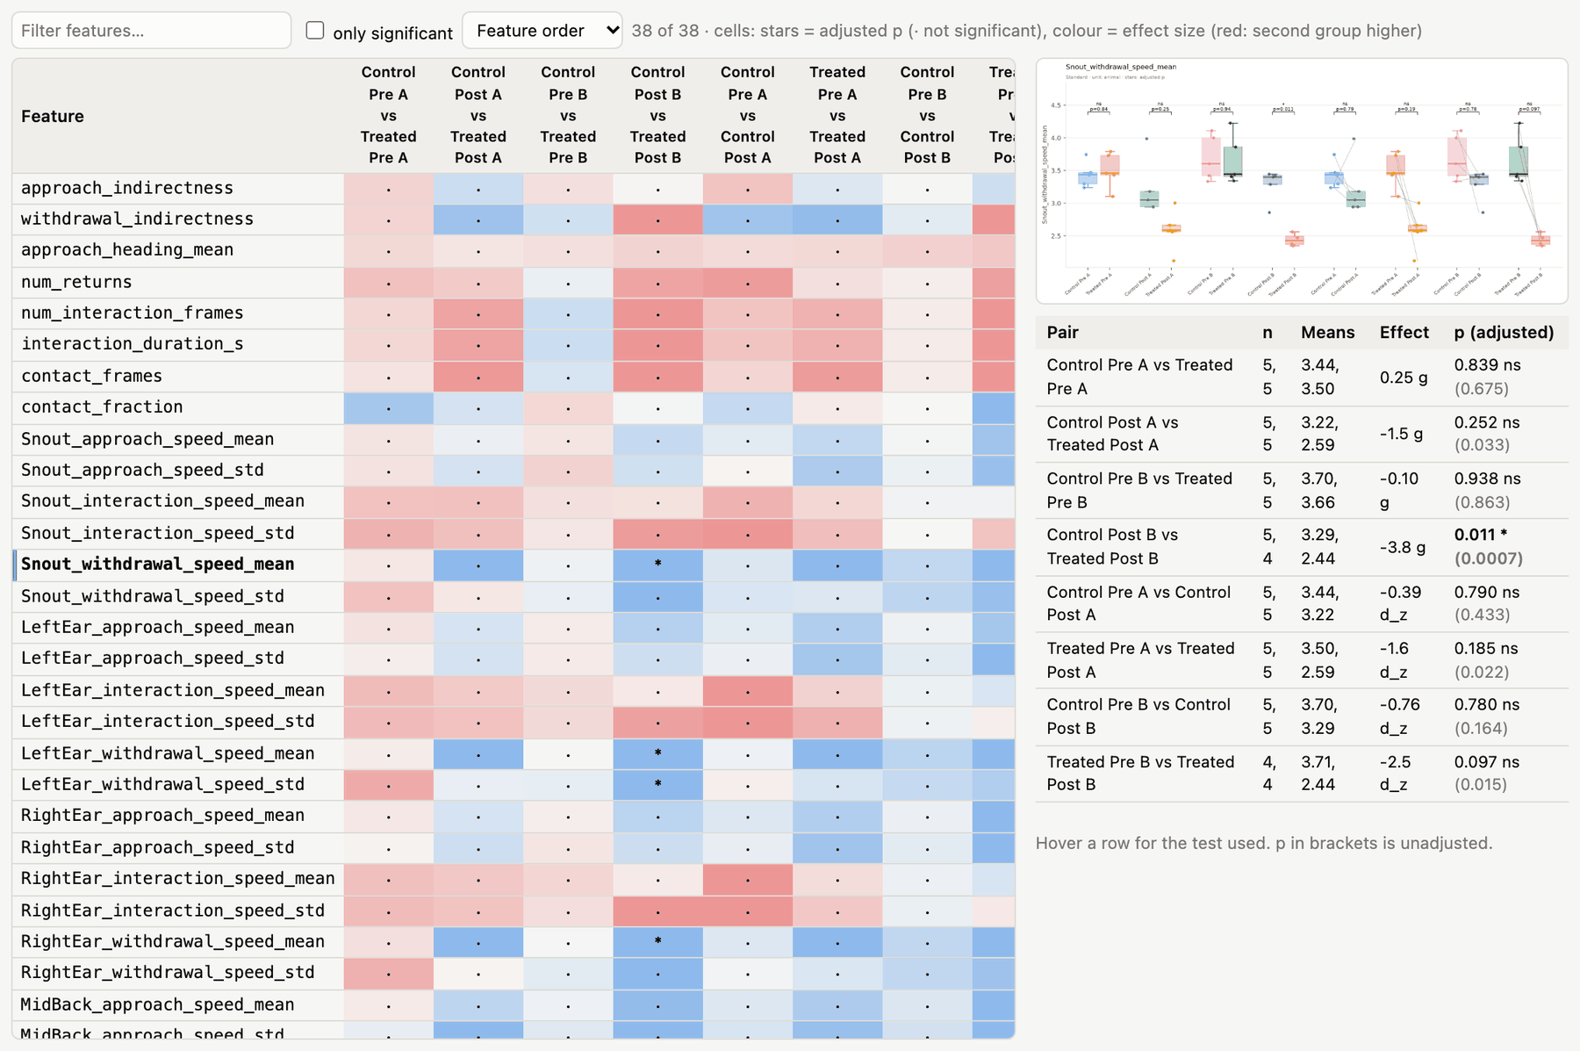
The statistics grid of the standard comparison (bout features) with one feature selected: its box plot over all pairs, and the numbers per pair.
Stars: * p < 0.05, ** p < 0.01, *** p < 0.001, **** p < 0.0001, after adjustment.
Edit changes a comparison (for the built-in one: Copy and edit); Re-run recomputes it; Excel downloads its workbook; Download (.zip) downloads its folder. If a comparison was edited after this run’s results were made, a notice offers to re-run it.

Comparison figures
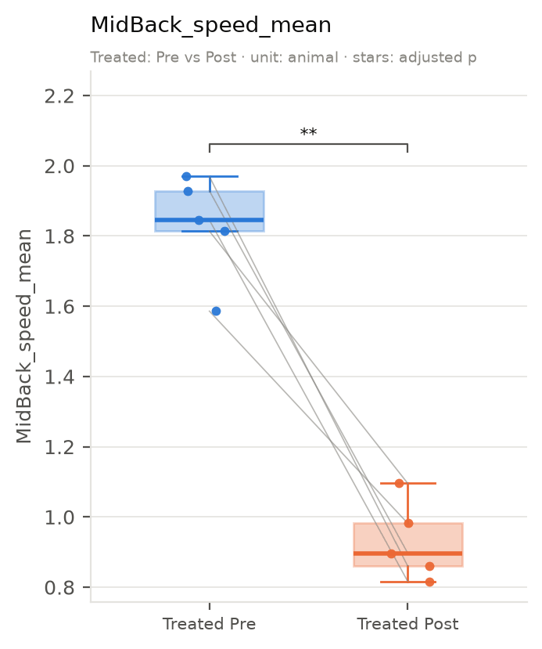
Box plot of one feature across the pairs of a comparison. Each dot is an animal (or a bout, with unit: bout); lines join the same animal in paired tests; brackets give the adjusted p.
Figure | What it shows
overview_bouts.png, overview_sessions.png | effect size of every feature (rows) for every pair (columns), with stars: the whole comparison at a glance
boxplots_bouts/<feature>.png, boxplots_sessions/<feature>.png | one box plot per feature, as above
occupancy.png | where the contact keypoint was around the bowl, per group (each animal’s map normalised, then averaged), and the difference between the groups of each pair
pca.png | the bouts of the groups on the first two principal components of the main bout features
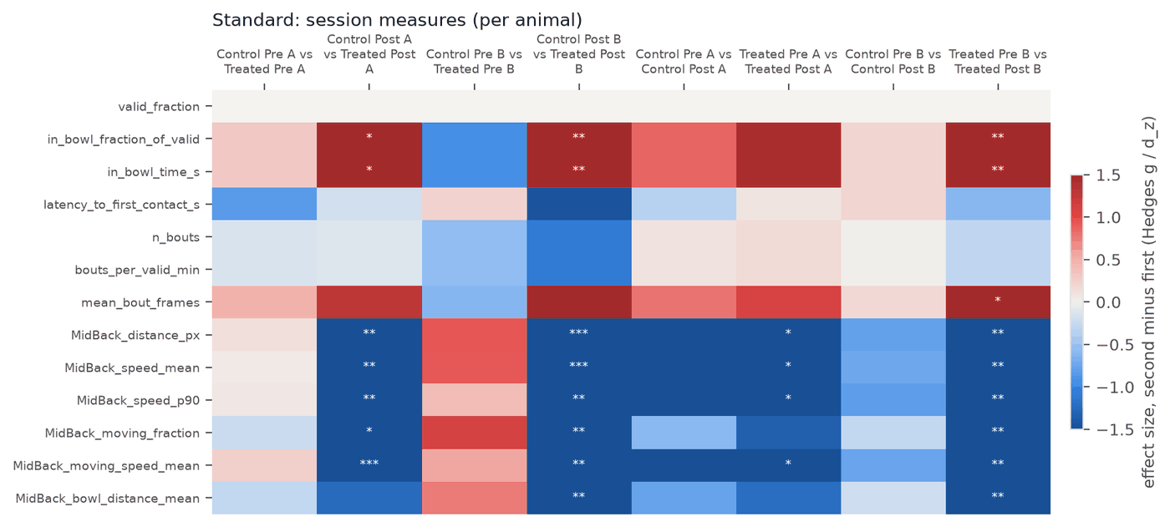
Overview heatmap: effect sizes (colour) and significance (stars) for every feature and pair.
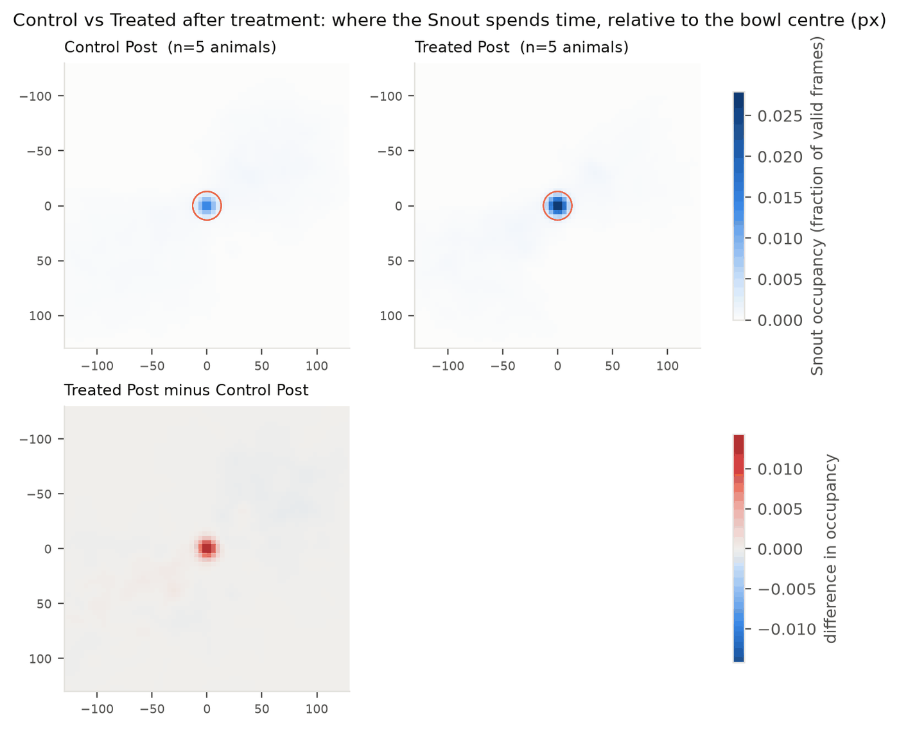
Occupancy around the bowl (centre, rim outlined) per group, and the difference between groups (red: more time in the second group).

Videos
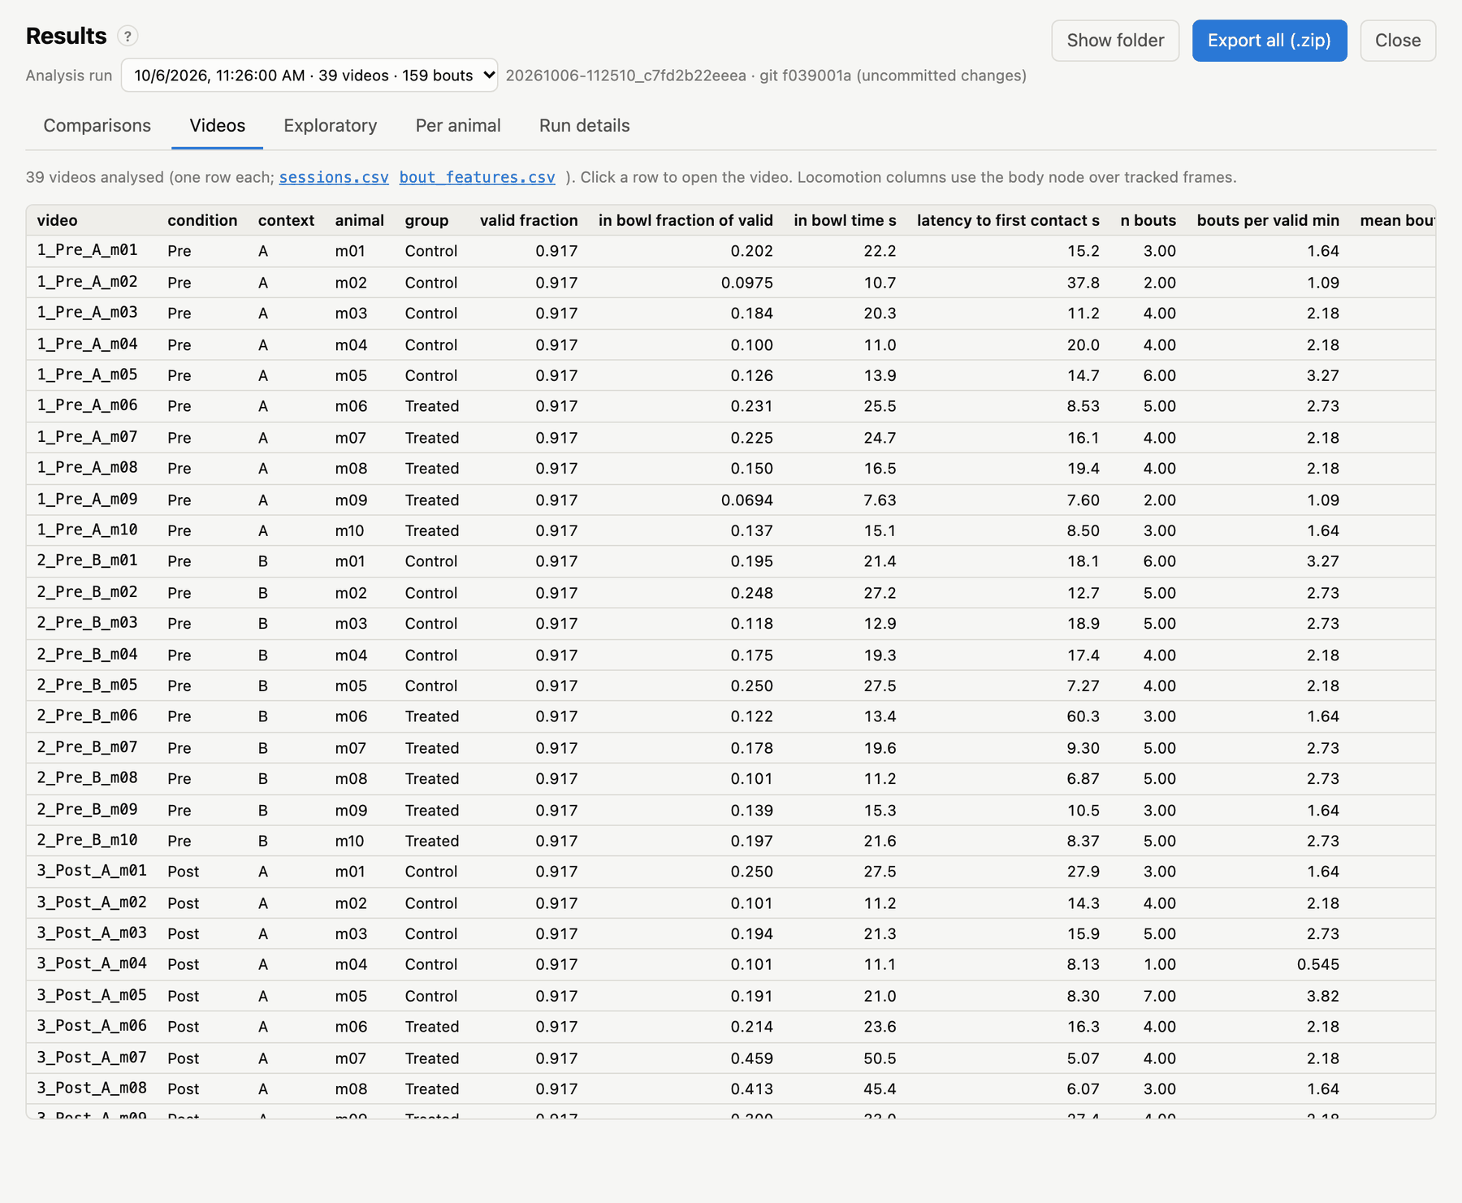
Results → Videos: one row per analysed video, with its session and locomotion measures.
The numbers per video (from sessions.csv): tracked fraction, time in the bowl, latency, bouts and locomotion. Click a row to open that video. Use it to find outliers, such as a video with little tracking or no bouts.

Exploratory
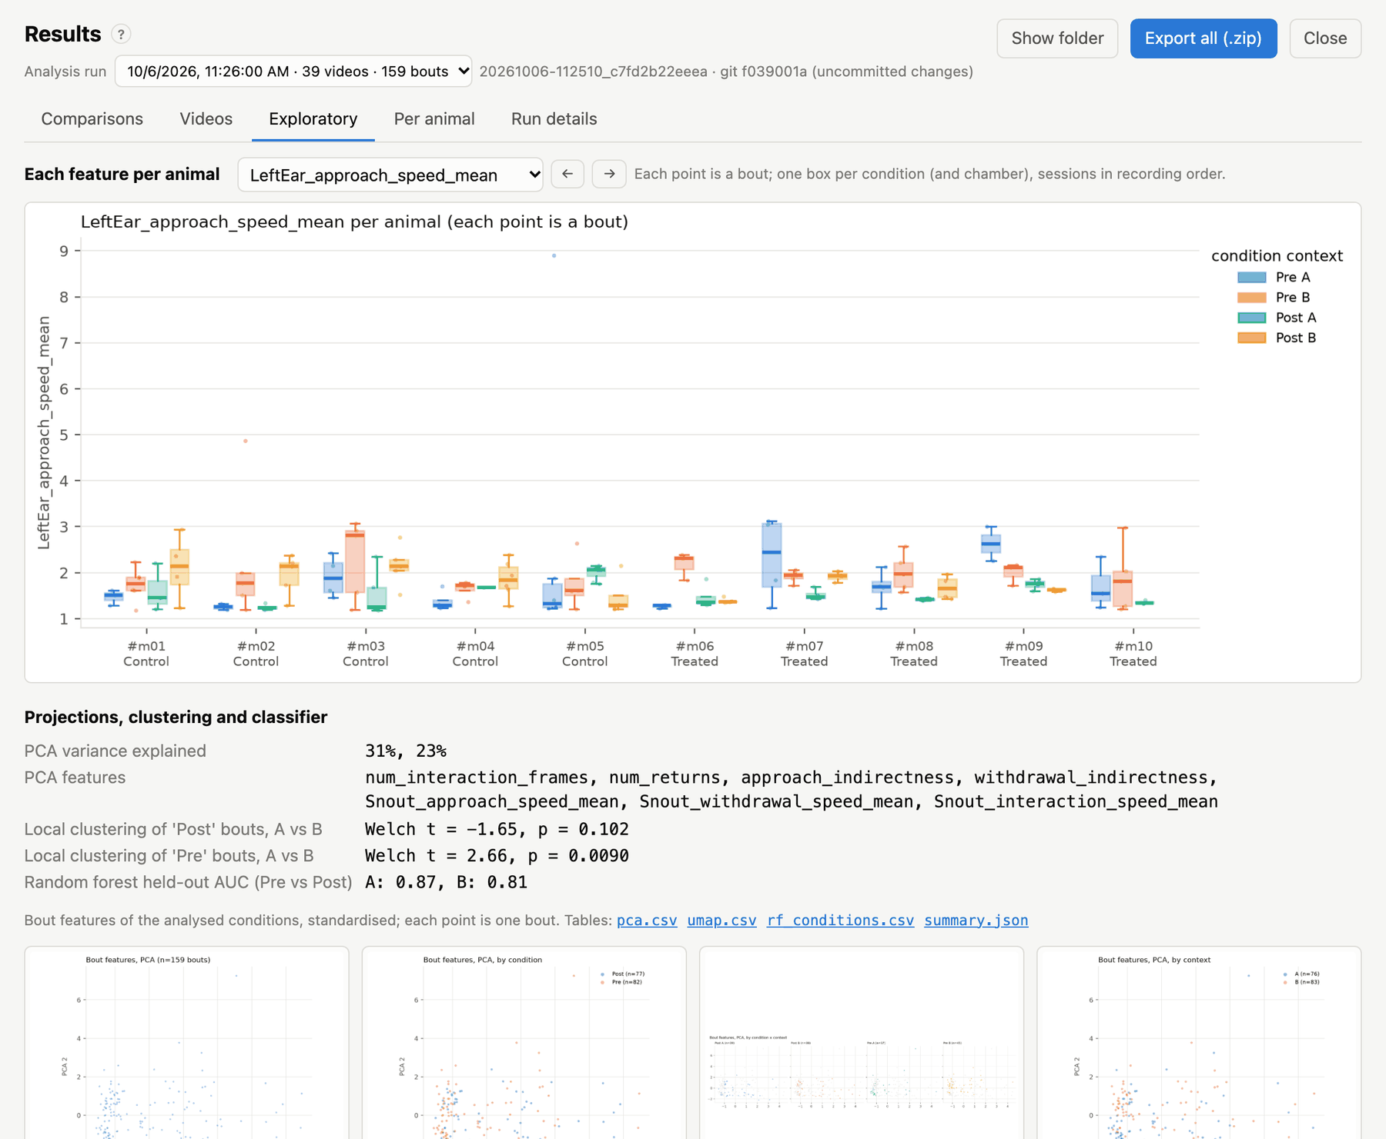
Results → Exploratory: per-animal box plots of each feature, then the multivariate analyses.
Per-animal box plots. Pick a feature (or step through them with ← →). Every animal gets one box per condition (and context), drawn from its bouts. This shows whether an effect is consistent across animals or driven by a few.
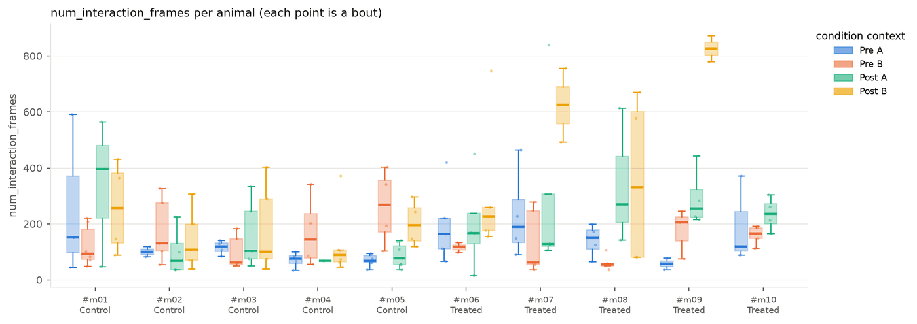
One feature for every animal, by condition and context.
The multivariate analyses use the bouts of the analysed conditions:
- PCA (and UMAP) of the main bout features: approach and withdrawal indirectness, returns, interaction length, and the contact keypoint’s speed in each phase. Each projection is drawn coloured by group, by condition, by context and by condition × context, and per context by condition.
- Local clustering: for every bout, how many of its 31 nearest neighbours in the PCA come from the same condition, relative to chance. The two contexts are then compared with a Welch t-test. This asks whether a condition’s bouts form a distinct cluster more in one context than the other.
- Random forest: classifies the first versus the last analysed condition from all bout features, per context. It reports the held-out ROC AUC (0.5 = chance) and the importance of each feature. Classes are balanced by oversampling, and everything is seeded.
The tables (pca.csv, umap.csv, rf_conditions.csv, summary.json) can be downloaded from this tab.

Per animal
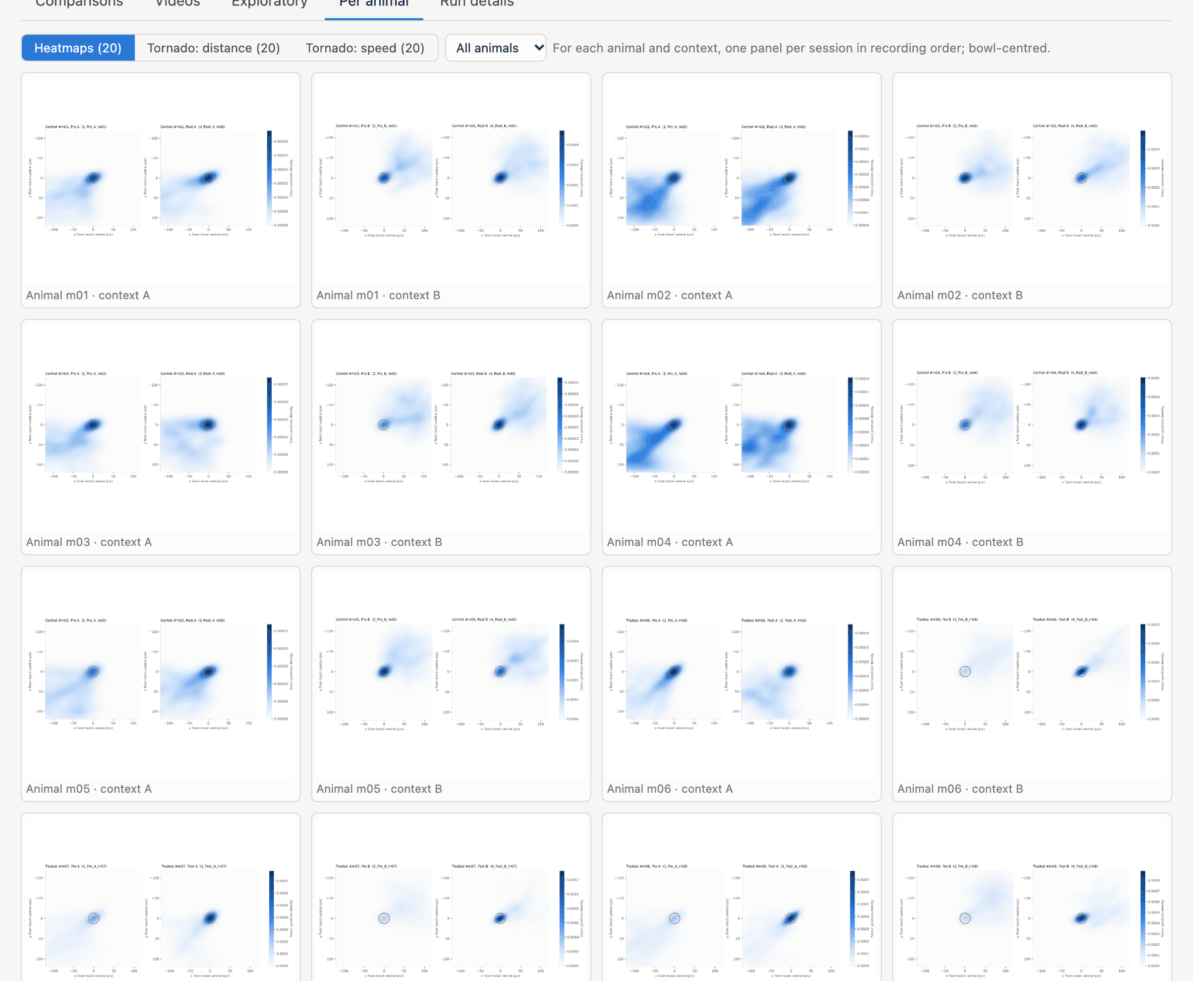
Results → Per animal: heatmaps and tornado plots for each animal and context, one panel per session.
For each animal and context, with one panel per session in recording order:
- Heatmap: the density of the contact keypoint’s positions around the bowl centre, with the rim outlined.
- Tornado plot (distance): a 3-D plot of the keypoint’s path in x and y (bowl-centred) against time (vertical axis, in frames). It is coloured by distance to the bowl centre, and the vertical line marks the bowl. Visits to the bowl show as excursions that reach the line.
- Tornado plot (speed): the same path coloured by speed.
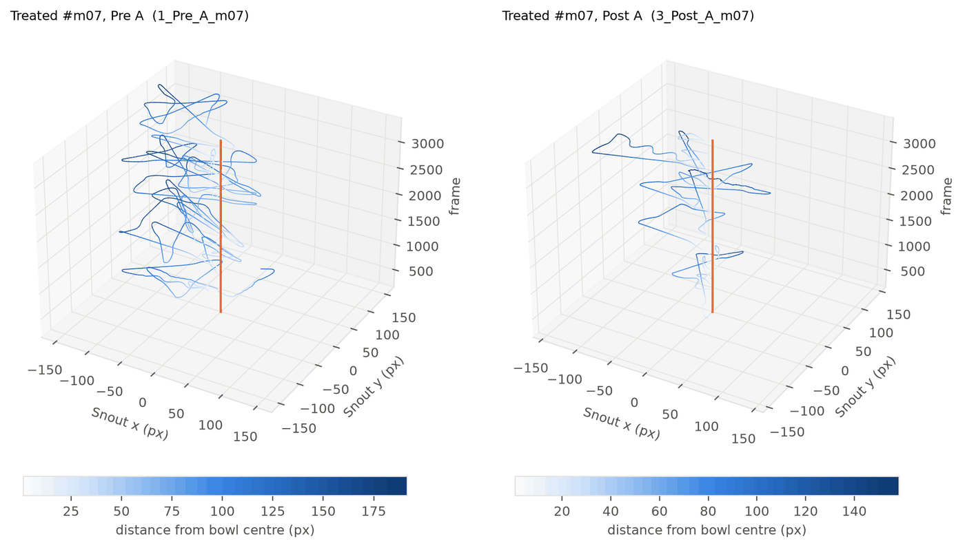
A tornado plot: position around the bowl (x, y) over time (vertical), one panel per session.

Run details
The run’s provenance:
- its folder, when it ran and how long it took;
- the number of videos and bouts;
- the settings hash and the statistics settings;
- the code version (git commit, and whether there were uncommitted changes);
- every file of the run, as links;
- videos that were skipped, and why.
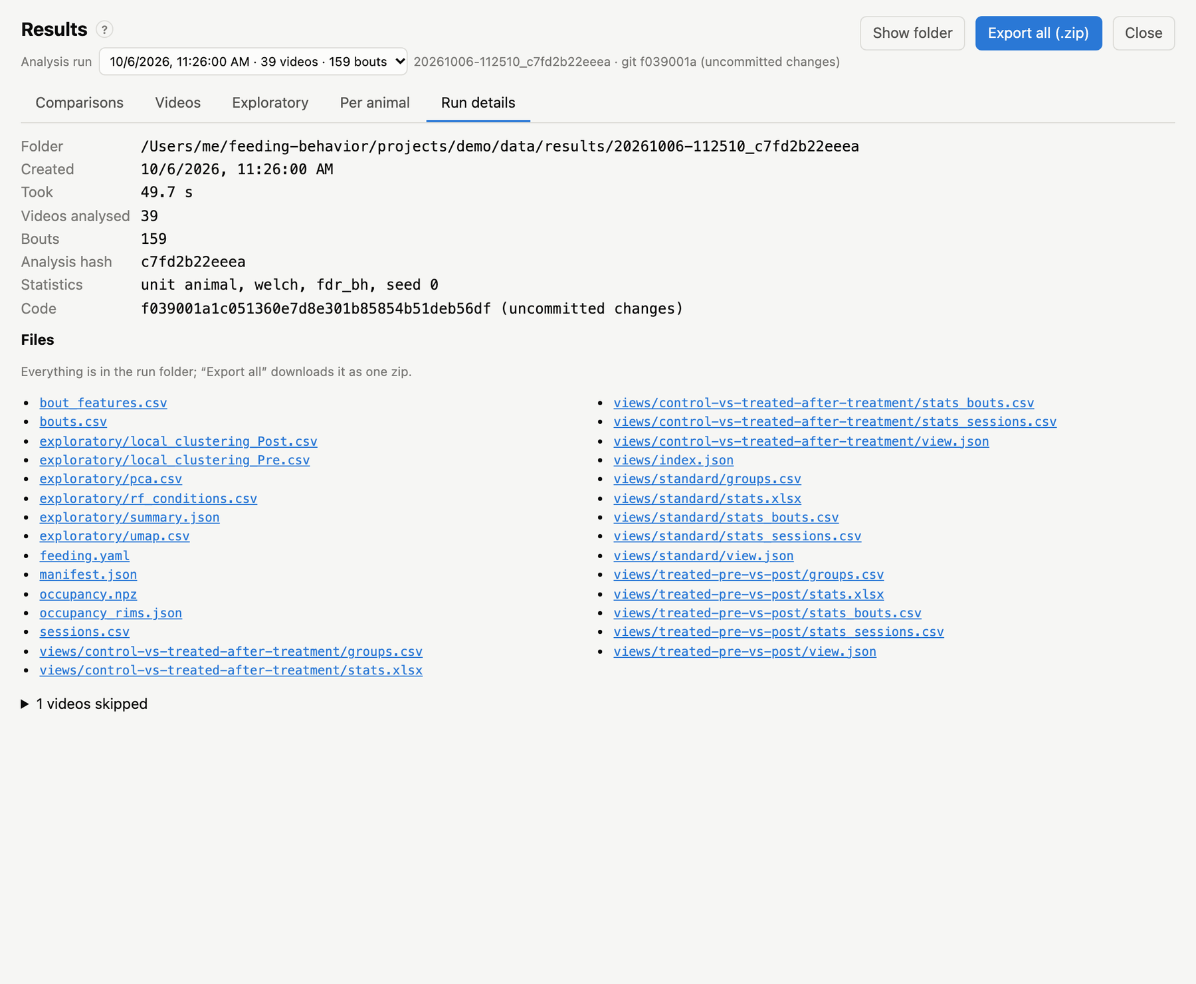
Results → Run details.
The run’s manifest.json has more, including the full settings, package versions and input hashes (see Output files).

Comparisons
A comparison (also called a view) puts two or more groups of videos side by side and tests every bout feature and every session and locomotion measure between them. A group is defined by metadata, not by a fixed list of files. For example, “group = Treated, condition = Post, context = A” matches every video with that metadata, including videos you add later.
Comparisons only read a run’s tables. Adding or editing one and running it on an existing analysis takes seconds, without re-processing any video.

The standard comparison
Every run includes a built-in Standard comparison, built from the project’s groups, conditions and contexts. Let the first and last analysed conditions be Pre and Post. It then tests:
- between groups, every pair of groups within each context × condition: Control Pre A vs Treated Pre A, Control Post A vs Treated Post A, and so on for each context;
- within groups, Pre vs Post within each context × group: Control Pre A vs Control Post A, … These tests are paired, because they compare the same animals.
The standard comparison needs at least two groups and two conditions. Turn it off for new runs with the checkbox under the comparison list, or with analysis.standard_view: false. To change it, click Copy and edit: this creates your own comparison with the same groups.

Creating a comparison
In Results → Comparisons, click + New comparison.
The comparison editor. Each group lists its matching animals and videos (and how many are ready for analysis).
- Name the comparison (it is also used for its folder) and, optionally, describe it.
- Define each group by clicking metadata values. Within one field, ticked values are alternatives (condition = Pre or Post). Across fields they must all hold (group = Treated and condition = Post). A field with nothing ticked matches anything. Under the label, the editor counts the animals and videos the group matches, and how many are ready (have predictions and a bowl). The count turns red when none are ready.
- Labels are generated from the ticked values (e.g. Treated Post). Type your own if you prefer.
- + Add group adds another group. One group per [field] → Add splits the last group into one group per value of a field. For example, tick condition = Post, then add one group per group, to get Control Post and Treated Post.
- Rarely used fields (animal, session, part) are under more fields. Use them to compare individual animals or specific sessions.
- Choose Pairs to test:
  - All pairs tests every pair of groups. With three or more groups, it also runs one omnibus test across all groups.
  - Choose pairs tests only the pairs you tick, which keeps the multiple-comparison correction small.
- Choose how pairs are paired (see below).
- Click Save and run on this analysis, or Save to run it with the next analysis.
Comparisons are stored in feeding.yaml, so they are part of the project and are re-run with every new analysis. Delete comparison removes one.
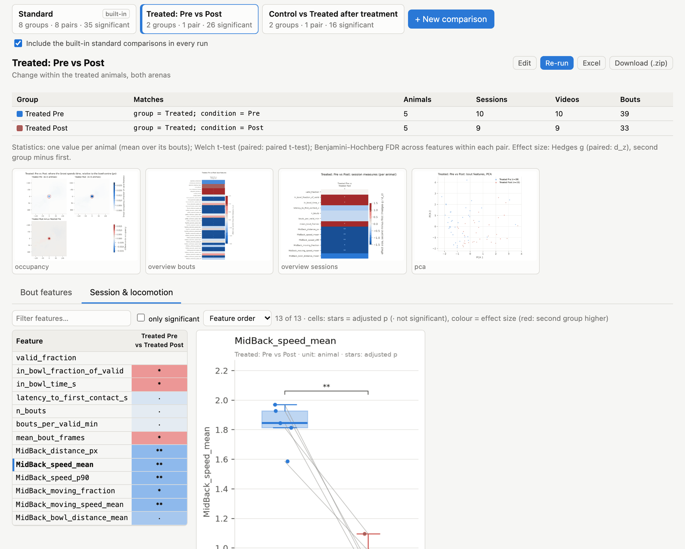
A saved comparison, Treated: Pre vs Post, on the Session & locomotion measures. The same five animals are in both groups, so the tests are paired, and the box plot joins each animal’s two values.

Paired and independent tests
When the statistics are per animal (analysis.unit: animal, the default), two groups can contain the same animals. Pre vs Post in one group is the typical case. Such groups are compared with paired tests over the animals present in both groups. These tests are more sensitive and correct for repeated measures.
Setting | Behaviour
Automatic (default) | paired when at least two animals, and at least half of the smaller group, are in both groups
Always | paired over the shared animals whenever there are at least two
Never | always independent groups
Animals that are in only one group are left out of a paired test. The n reported for each pair is the number of values actually tested. See Statistical methods for the tests themselves.

Examples
Treatment effect after treatment, both arenas pooled:
Group | group | condition
Control Post | Control | Post
Treated Post | Treated | Post
Change within the treated animals, square arena only (paired automatically):
Group | group | condition | context
Pre | Treated | Pre | A
Post | Treated | Post | A
Arena effect in every animal at baseline:
Group | condition | context
Square | Pre | A
Round | Pre | B
Three groups across days. Use one group per session, choose All pairs, and the omnibus test (All groups column) tests for any difference across days, alongside the pairwise tests.
Excluding an animal. Groups only include matching videos, so to leave one animal out, tick all the other animals under more fields → animal.

In feeding.yaml
The editor writes comparisons under views:. You can also write them by hand:
views:
- name: Treated, Pre vs Post (arena A)
description: Paired change within treated animals
groups:
- {label: Pre, where: {group: [Treated], condition: [Pre], context: [A]}}
- {label: Post, where: {group: [Treated], condition: [Post], context: [A]}}
- name: Control vs Treated after treatment
groups:
- {label: Control, where: {group: [Control], condition: [Post]}}
- {label: Treated, where: {group: [Treated], condition: [Post]}}
pairs: [[Control, Treated]] # optional; default: all pairs
paired: no # auto (default) | yes | no
where fields are group, condition, context, chamber, animal, session, part and video. Each takes a list of allowed values.

From the command line
feeding compare # run every comparison on the latest analysis run
feeding compare 20260301-101500_ab12cd # on a given run
feeding compare -v "Treated, Pre vs Post (arena A)" # only this comparison (name or folder name)
feeding compare --no-plots # statistics only
Each comparison writes a folder views/<name>/ in the run; see Output files.

Statistical methods
This chapter describes exactly how comparisons are tested. The settings are under analysis: in feeding.yaml.

Unit of analysis
Bouts from one animal are not independent: an animal that feeds slowly does so in every bout. Treating each bout as a separate sample inflates n and makes p-values too small. The default therefore treats the animal as the unit.
analysis.unit | Sample | Use
animal (default) | for each group, every animal contributes the mean of its bouts in that group | inference about animals; paired tests possible
bout | every bout is a sample | descriptive use, or to reproduce bout-level analyses; p-values are optimistic
Session and locomotion measures are always per animal. If an animal has several sessions in a group (e.g. both arenas pooled), they are averaged. Sessions recorded in several parts are first combined into one session.

Tests
analysis.test | Independent groups | Paired groups | 3+ groups (omnibus) | 3+ groups, same animals
welch (default) | Welch’s t-test (unequal variances) | paired t-test | Alexander-Govern test | Friedman test
student | Student’s t-test | paired t-test | one-way ANOVA | Friedman test
mannwhitney | Mann-Whitney U (two-sided) | Wilcoxon signed-rank | Kruskal-Wallis | Friedman test
When groups are paired is decided per pair (see Paired and independent tests). A paired test uses only the animals present in both groups.
The omnibus test runs only for comparisons with three or more groups and All pairs. It uses the Friedman test when every group contains exactly the same animals (repeated measures, unit = animal).
A test is left empty (–) when a group has fewer than two values, or when paired differences are all zero.

Effect sizes
Effect sizes are signed: positive means the second group of the pair is higher.
- Independent groups: Hedges’ g. The mean difference (second − first) divided by the pooled standard deviation, with the small-sample correction J = 1 − 3 / (4(n₁ + n₂) − 9).
- Paired groups: d_z. The mean of the paired differences divided by their standard deviation.
As a rough guide, |g| ≈ 0.2 is small, 0.5 medium and 0.8 large. With few animals, effect sizes are imprecise; read them together with n.

Multiple comparisons
Every feature is tested in every pair, so many tests are run. Two adjusted p-values are reported:
Column | Corrected across | Used for
p_adj | all features of one pair (bout features and session measures separately) | the stars in the app and figures
p_adj_view | every pair × feature of the comparison | a stricter view over the whole comparison
analysis.correction is fdr_bh (Benjamini-Hochberg false discovery rate, the default) or bonferroni. The omnibus tests are corrected across features. The unadjusted pvalue is always reported too.
Stars: * < 0.05, ** < 0.01, *** < 0.001, **** < 0.0001, from p_adj; ns otherwise.

The statistics tables
Each comparison’s stats_bouts.csv and stats_sessions.csv (and the Excel workbook) have one row per pair × feature:
Column | Meaning
view, pair, a, b | comparison, pair label, first and second group
feature, unit | measure tested; animal or bout
n_a, n_b | values tested in each group
mean_a, mean_b, sd_a, sd_b, median_a, median_b | group summaries of the tested values
diff | mean_b − mean_a
effect_size, effect_measure | Hedges g or d_z
paired, test, statistic, pvalue | the test and its result
p_adj, p_adj_view, correction, stars | adjusted p-values (see above)
omnibus_bouts.csv / omnibus_sessions.csv have one row per feature with the omnibus test, its statistic, p and adjusted p. groups.csv lists what each group matched: animals (with IDs), sessions, videos and bouts.

Exploratory analyses
The exploratory analyses (PCA/UMAP, local clustering, random forest; see Results) are descriptive and work on bouts. Their p-values are bout-level and are not corrected; use them to generate hypotheses, not to confirm them.

Reproducibility
Everything random is seeded from analysis.seed: the random forest, oversampling, subsampling for density plots, UMAP and the embedding. Running the same analysis on the same inputs gives the same numbers. Each run records its settings, and comparisons record their definition, in the run folder.

Good practice
- Decide the comparisons before looking. Define them (and their pairs) up front, and keep Choose pairs small: every extra pair or feature makes the correction stricter.
- Look at the per-animal box plots (Exploratory tab). A significant effect should be visible in most animals, not driven by one.
- Check tracking quality per group. If one group’s videos are tracked worse (valid_fraction in the Videos tab), the amount of observed behaviour differs too.
- Report n as animals. With unit: animal, the n in the tables is the number of animals.

Configuration reference (feeding.yaml)
Every project setting is in the project’s feeding.yaml. The app’s Settings page and the comparison editor edit the common ones. For everything else, edit the file in a text editor, or use feeding config KEY VALUE, which validates the change and keeps the comments.
- Every setting has a default, so a minimal file can be nearly empty.
- Relative paths are relative to the project folder.
- An invalid file is reported with the offending key, both when the app opens it and by feeding check.
feeding config # show every setting (with defaults filled in)
feeding config bouts # one section
feeding config bouts.margin_px 2 # change one value
feeding config analysis.conditions "[Pre, Post]"
feeding config sleap.bin_dir null # remove a value (back to the default)
The settings that change derived data are hashed: the hash is part of every run’s folder name. These are skeleton, quality, bouts, features and analysis. A run can therefore always be matched to its settings, and cached per-video results are recomputed when the settings change.

name
The project’s display name (default: the folder name).

paths
Key | Default | Meaning
videos | [videos] | one or more folders of videos (read-only input; may be outside the project)
predictions | data/predictions | SLEAP outputs and provenance per video
bowls | annotations/bowls | bowl annotations (one JSON per video)
subjects | metadata/subjects.csv | animal → group table
derived | data/derived | cached per-video tracks (safe to delete)
results | data/results | one folder per analysis run
logs | data/logs | logs of jobs started in the app

naming
Key | Default | Meaning
pattern | {session}[_{part}]_{condition}_{context}_{animal} (see below) | regular expression matched against each video’s file name (without extension)
chambers | {} | display label per context, e.g. {A: square arena, B: round arena}
The default pattern is ^(?P<session>\d+)(?:_(?P<part>\d+))?_(?P<condition>[A-Za-z]+)_(?P<context>[A-Za-z0-9]+)_(?P<animal>[A-Za-z0-9]+)$. See Naming videos.

sleap
Key | Default | Meaning
bin_dir | null (find automatically) | bin folder of the SLEAP conda environment
models | {} | model folder per context, or default; a list for a top-down pair
batch_size | 4 | frames per batch
peak_threshold | 0.2 | minimum keypoint confidence (0–1)
device | auto | auto, cpu, gpu or a GPU index
tracker | none | none, simple or flow
target_instance_count | 0 | tracker: animals per frame (0 = no limit)
pre_cull_to_target | false | tracker: drop extra instances before tracking
post_connect_single_breaks | false | tracker: join single track breaks
clean_instance_count | 0 | tracker: instances kept after tracking (0 = off)
similarity | instance | tracker: instance, centroid or iou
match | greedy | tracker: greedy or hungarian
track_window | 5 | tracker: frames to look back
extra_args | [] | further sleap-track arguments, passed verbatim (they override the options above)
sleap:
models:
A: models/square.single_instance.n=250
B: models/round.single_instance.n=270
# top-down pair for every context instead:
# models: {default: [models/m.centroid.n=200, models/m.centered_instance.n=200]}
See SLEAP pose estimation.

skeleton
Key | Default | Meaning
nodes | read from the model, or from existing predictions | keypoint names, in SLEAP’s order
edges | read from the model | pairs of keypoints joined when drawing
The skeleton must match the predictions. Every keypoint named in other settings must be one of nodes.

quality
Key | Default | Meaning
drop_nodes | [] | keypoints ignored for filtering and features
score_window | 300 | frames in the centred rolling mean of each keypoint’s score
min_score | 0.5 | a frame is tracked when every keypoint’s rolling-mean score is at least this
min_segment_frames | 90 | shortest tracked stretch that is kept
max_interp_gap | 0 | linearly fill gaps of missing coordinates up to this many frames
See Quality filtering.

bouts
Key | Default | Meaning
node | Snout (else the first keypoint) | keypoint that defines contact with the bowl
margin_px | 0 | grow (+) or shrink (−) the rim for the contact test
min_contact_frames | 15 | shortest continuous contact that makes a bout
merge_gap_frames | 90 | shorter away-periods are returns within one bout
flank_frames | 90 | approach and withdrawal window length
See Contact and bouts.

features
Key | Default | Meaning
speed_nodes | every tracked keypoint | keypoints whose speeds are bout features
body_node | a body-centre keypoint (MidBack, Centroid, Center, Body, Thorax, Spine, …), else the first speed keypoint | keypoint used for whole-session locomotion
moving_speed | 1.0 | px/frame (after 5-frame smoothing) above which the animal counts as moving

analysis
Key | Default | Meaning
conditions | [] (every condition, in session order) | conditions included in statistics, in experimental order; the standard comparison contrasts the first and the last
unit | animal | animal (mean per animal) or bout (every bout a sample)
test | welch | welch, student or mannwhitney
correction | fdr_bh | fdr_bh or bonferroni
seed | 0 | seed for everything random
standard_view | true | include the standard comparison in every run
See Statistical methods.

views
A list of comparisons; see Comparisons.
Key | Meaning
name | unique name (also the folder name, simplified)
description | optional text
groups | list of {label, where}; where maps fields (group, condition, context, chamber, animal, session, part, video) to lists of allowed values
pairs | optional list of [label, label] pairs to test (default: all pairs)
paired | auto (default), yes or no

split
Settings for feeding split, which splits recordings of four arenas into one video per animal (optional).
Key | Default | Meaning
raw_videos | null | folder of recordings named {prefix}_{TL}_{TR}_{BL}_{BR}
output | data/split_videos | where the per-animal videos are written
crf | 18 | H.264 quality (lower = better, larger files)
gop | 30 | keyframe interval; small values make frame seeking fast and exact

embedding
Settings for the optional behaviour embedding; see Behaviour embedding.
Key | Default | Meaning
checkpoint | null | trained model to use (model.pt from feeding embed --train)
featurization | bowl_centred | bowl_centred or legacy (for checkpoints trained on absolute coordinates)
window | 90 | frames per window
stride | 6 | embed every stride-th window
k_range | [8, 10] | k-means k in [first, last); the best silhouette is kept

A complete example
name: Feeding after treatment, cohort 2
paths:
videos: [videos, /mnt/archive/cohort2/videos]
naming:
pattern: '^(?P<session>\d+)_(?P<condition>[A-Za-z]+)_(?P<context>[AB])_(?P<animal>m\d+)$'
chambers: {A: square arena, B: round arena}
sleap:
models: {default: models/mouse.single_instance.n=300}
batch_size: 8
quality:
drop_nodes: [TailTip]
bouts:
node: Snout
margin_px: 2
analysis:
conditions: [Pre, Post]
unit: animal
test: welch
views:
- name: Control vs Treated after treatment
groups:
- {label: Control, where: {group: [Control], condition: [Post]}}
- {label: Treated, where: {group: [Treated], condition: [Post]}}

Command-line reference
Everything the app does can also be done with the feeding command, e.g. to process many videos on a server without a browser, or in scripts. From a source checkout, run it as uv run feeding … in the repository folder.
Choosing the project. Commands act on one project, chosen in this order:
- --project DIR (or -p DIR), a project folder or its feeding.yaml;
- the FEEDING_PROJECT environment variable;
- the current folder, or the nearest parent folder that contains a feeding.yaml (like git).
For example, both of these work:
uv run feeding status -p projects/my-cohort
cd projects/my-cohort && uv run --project ../.. feeding status
feeding COMMAND --help describes every option of a command.

Overview
Command | Purpose
feeding serve [PROJECT] | start the browser app
feeding demo [DIR] | create the synthetic demo project
feeding init DIR | create a project
feeding add-videos FILES_OR_FOLDERS… | add videos (files are copied, folders used in place)
feeding models | list the SLEAP models in the model library
feeding set-model MODEL… | assign SLEAP model(s)
feeding config [KEY [VALUE]] | show or change settings
feeding check | check the project for problems
feeding status | list videos with their prediction and bowl status
feeding infer VIDEO… / --all | run SLEAP inference
feeding import-predictions DIR… | import existing SLEAP analysis files
feeding split | split four-arena recordings into one video per animal
feeding analyze [VIDEO…] | run the analysis
feeding compare [RUN] | (re-)run comparisons on an existing run
feeding embed | optional behaviour embedding and clustering

serve
feeding serve [PROJECT] [--host 127.0.0.1] [--port 8765]
Starts the app at http://HOST:PORT. With PROJECT, that project is opened; otherwise the project in the current folder, if any. --host 0.0.0.0 makes the app reachable from other computers. It has no login, so do this only on a trusted network.

demo
feeding demo [DIR] [--animals 5] [--seconds 120] [--seed 0] [--no-bowls] [--force]
Creates the synthetic demo project (default projects/demo): two groups of --animals animals, four sessions each, with videos, predictions and (unless --no-bowls) bowl annotations. See Quick start.

init
feeding init DIR [--videos FOLDER]… [--model PATH | --model CONTEXT=PATH]… [--pattern REGEX]
[--chamber CONTEXT=LABEL]… [--name NAME] [--sleap-bin PATH] [--force]
Creates a project folder with feeding.yaml, metadata/subjects.csv (one row per animal found, groups blank) and the standard subfolders. Everything except DIR is optional:
- the naming pattern is guessed from the video names;
- the skeleton is read from the model;
- --force overwrites an existing feeding.yaml.

add-videos
feeding add-videos FILE_OR_FOLDER… [--move] [-p PROJECT]
Video files are copied into <project>/videos (moved with --move). Folders are added to paths.videos and read in place.

models, set-model
feeding models
feeding set-model PATH # one model for every video
feeding set-model A=PATH_A B=PATH_B # one per context
feeding set-model CENTROID CENTERED # a top-down pair
set-model replaces the current assignment and updates the skeleton and the keypoint settings to match the model.

config
feeding config # every setting
feeding config SECTION # e.g. sleap, bouts, analysis
feeding config KEY VALUE # e.g. bouts.margin_px 2; VALUE is YAML: 8, true, [a, b], null
Changes are validated and written with comments preserved. See Configuration.

check, status
feeding check reports problems (exit code 1 if there are errors), e.g.:
- missing folders or models;
- contexts without a model;
- animals without a group;
- SLEAP not found.
feeding status lists every video with its metadata and whether it has predictions and a bowl.

infer
feeding infer VIDEO… | --all [--force]
[--batch-size N] [--peak-threshold X] [--device auto|cpu|gpu|N] [--tracker none|simple|flow]
[--target-instance-count N] [--sleap-arg ARG]… [--save]
Runs SLEAP on the given videos (by name, without extension), or on every video without predictions (--all). --force re-runs videos that already have predictions. The options override the project’s sleap: settings for this run; --save stores them in feeding.yaml. The resulting sleap-track options are printed first. See SLEAP pose estimation.

import-predictions
feeding import-predictions DIR… [--overwrite]
Copies SLEAP analysis files named <video>.h5 or <video>.analysis.h5 from the given folders, after checking their skeleton and length.

split
feeding split [--overwrite]
Splits recordings of four arenas in a 2×2 grid, found in split.raw_videos, into one video per animal in split.output. A recording <prefix>_<TL>_<TR>_<BL>_<BR>.<ext> gives <prefix>_<animal>.mp4 for each of the four animal IDs (top-left, top-right, bottom-left, bottom-right). The split keeps the source frame rate and uses frequent keyframes for exact seeking (split.crf, split.gop). It needs ffmpeg on the PATH. Then add split.output to the project’s videos.

analyze
feeding analyze [VIDEO…] [--no-plots]
Analyses every ready video (or only the listed ones) and writes a new run folder. See Running the analysis.

compare
feeding compare [RUN] [-v NAME]… [--no-plots]
Runs the standard comparison and the project’s comparisons on the latest run (or RUN, a run folder name). This is fast: only the run’s tables are read. -v limits it to the named comparisons. See Comparisons.

embed
feeding embed [--train] [--epochs 50]
Optional; needs uv sync --extra embed. See Behaviour embedding.

Environment variables
Variable | Meaning
FEEDING_PROJECT | project to use when --project is not given (and to open in serve)
FEEDING_HOME | app folder (default: the repository, or ~/feeding-behavior for a pip install)
FEEDING_PROJECTS_DIR | where New project and feeding demo create projects
FEEDING_MODEL_LIBRARY | model library folders (separated by :, or ; on Windows)
FEEDING_SLEAP_BIN | the SLEAP environment’s bin folder
FEEDING_RECENT_FILE | file listing recently opened projects
FEEDING_NATIVE_DIALOGS=0 | disable the native file dialogs (use the in-page folder browser)

Output files and reproducibility
All generated files are under the project’s data/ folder (the locations can be changed under paths).
data/
predictions/ <video>.slp, <video>.analysis.h5, <video>.provenance.json
derived/ cached per-video tracks (parquet); safe to delete, recomputed when needed
results/ one folder per analysis run (and per embedding run)
logs/ logs of jobs started in the app

An analysis run
Each run creates data/results/<YYYYMMDD-HHMMSS>_<settings hash>/:
manifest.json what was run, on what, with which settings and code (below)
feeding.yaml a copy of the project configuration used
bouts.csv one row per bout: frame indices of the windows and contacts
bout_features.csv one row per bout: metadata + bout features
sessions.csv one row per video: metadata + session and locomotion measures
occupancy.npz per-video 2-D histogram of the contact keypoint around the bowl
occupancy_rims.json each video's rim, centred on the bowl, for drawing the maps
views/ one folder per comparison (below), and index.json summarising them
exploratory/ pca.csv, umap.csv, local_clustering_*.csv, rf_conditions.csv, summary.json, figures
exploratory/per_animal/<feature>.png per-animal box plots
figures/heatmaps/animal<ID>_<context>.png
figures/tornado_distance/animal<ID>_<context>.png
figures/tornado_speed/animal<ID>_<context>.png

Tables
Every table carries each video’s metadata: video, session, part, condition, context, animal, chamber and group. Feature definitions are in Running the analysis. bouts.csv has, per bout:
Column | Meaning
window_start | first frame of the approach
contact_start | first contact frame
contact_end | frame after the last contact
window_end | frame after the end of the withdrawal
n_episodes | contact episodes in the bout
contact_frames | frames in contact
longest_episode | longest continuous contact
segment | the tracked stretch the bout lies in
Frame indices are 0-based.

Comparison folders
views/<comparison>/:
File | Contents
view.json | the comparison’s definition, the statistics settings, group sizes and when it ran
groups.csv | what each group matched: animals (and IDs), sessions, videos, bouts
stats_bouts.csv | every pair × bout feature (see The statistics tables)
stats_sessions.csv | every pair × session/locomotion measure
omnibus_bouts.csv, omnibus_sessions.csv | the all-groups test (three or more groups, all pairs)
stats.xlsx | all of the above as sheets, plus one sheet per pair sorted by p
figures/ | overview_*.png, boxplots_bouts/, boxplots_sessions/, occupancy.png, pca.png

manifest.json
Key | Contents
created_at, elapsed_s | when the run happened and how long it took
project | name and folder
analysis_hash, config | the settings hash and the full settings
subjects_sha256 | hash of the groups table
git | commit of the code and whether it had uncommitted changes
packages | versions of the Python packages
inputs | per video: predictions hash and source, model, SLEAP version, bowl annotation and rim
skipped | videos not analysed, and why
notes | analyses that could not be done, and why
n_videos_analysed, n_bouts, outputs | summary

Reproducing a result
A run is determined by:
- the code (git in the manifest; uv.lock pins every package);
- the settings (feeding.yaml copied into the run);
- the groups (subjects_sha256);
- the bowl annotations (copied into the manifest);
- the predictions (hashed in the manifest, and traced to model and SLEAP version by their provenance files).
To reproduce a run:
- Check out the commit recorded in the manifest and run uv sync.
- Use the run’s feeding.yaml, the same groups table, bowl annotations and predictions.
- Run feeding analyze.
Everything random is seeded, so the numbers are identical. Prediction files are matched by hash, so you can verify that the poses are the same ones.
SLEAP inference itself is reproducible from the provenance files, which record the model weights’ hashes, the SLEAP version and the exact command. Results can differ slightly between GPU and CPU, or between GPU models, which is why the predictions themselves are hashed.

Sharing results
- Export all (.zip) (Results page) or the run folder itself contains everything about one run.
- Download (.zip) on a comparison contains just that comparison.
- The Excel workbook of a comparison is convenient for supplementary tables.
- Figures are PNG files at 200 dpi. Fonts and colours are consistent across figures, and the colour palette was chosen to stay distinguishable for colour-blind readers. For a journal’s exact style, redraw from the CSV tables.

Behaviour embedding (optional)
feeding embed is an unsupervised analysis of posture and movement. It learns a compact representation of short windows of tracking, then clusters them into behaviour types and counts transitions between types. It needs PyTorch:
uv sync --extra embed

How it works
- Windows. Every tracked stretch of every video is cut into windows of embedding.window frames (default 90), taking every embedding.stride-th window (default 6).
- Features. With bowl_centred featurization (the default), each window holds the x and y of every tracked keypoint relative to the bowl centre, plus its confidence, z-scored over all videos. This needs bowl annotations.
- Model. An LSTM variational autoencoder encodes each window into a 30-dimensional latent vector. feeding embed --train trains a new model on the project’s videos. The trained model is saved as model.pt in the output folder.
- Clusters. The latent means are clustered with k-means for each k in embedding.k_range. The k with the best silhouette score is kept.
- Transitions. For every video, the matrix of transition probabilities between clusters of consecutive windows is computed.
GPU (CUDA) or Apple-silicon (MPS) acceleration is used when available.
feeding embed --train --epochs 50 # train a model and cluster
feeding embed # reuse the model in embedding.checkpoint
To reuse a trained model, e.g. to embed a new cohort with the same model, set embedding.checkpoint to its model.pt. The legacy featurization (absolute coordinates, min-max scaled per video) exists for models trained with an earlier version of this pipeline; use it only with such a checkpoint.

Outputs
data/results/embedding_<date-time>_<trained|pretrained>/:
File | Contents
embeddings.parquet | video, frame, cluster and the latent vector of every window
cluster_labels.csv | video, frame, cluster
silhouette.csv | silhouette score per k
transition_matrices/<video>.npy | cluster-to-cluster transition probabilities
training_history.csv, model.pt | with --train: losses per epoch and the trained model
manifest.json | settings, model, features, best k, code and package versions

Interpreting clusters
Clusters are found without supervision. Before giving one a name such as “grooming” or “rearing”, watch windows from it: the frames are listed in cluster_labels.csv, and the app’s address bar takes #<video>/track/<frame>. Clusters can differ between models and data sets, so compare cluster use between groups only within one embedding run.

Troubleshooting and FAQ

The app
The page shows a red banner: “The app was updated after this server started”. The code changed (e.g. after git pull) while feeding serve was running. Stop the server with Ctrl+C, start it again, and reload the page.
The page doesn’t load, or shows “address already in use”. Another program uses the port. Start on another one: feeding serve --port 8800.
“Browse…” or “Choose files…” opens an in-page folder browser instead of the system dialog. Native dialogs only open on the computer running the server, and need a desktop session (on Linux, zenity, kdialog or Tk; on Windows, Tk or PowerShell). Type or browse to the path in the page instead, or drag and drop files onto the Videos drop zone.
On Windows, the dialog doesn’t appear. It may have opened behind the browser: look for it in the taskbar. The page waits until it is closed.
A video is missing from the list. Its file name doesn’t match the naming pattern. Settings → Naming shows which files match and how they are read. Adjust the pattern, or rename the file.
Changing a setting has no effect on old results. Results are never changed after the fact: run the analysis again. Comparisons can be re-run on an existing run (Re-run, or feeding compare), because they only read the run’s tables.

SLEAP
“sleap-track not found”. Set Settings → SLEAP inference → SLEAP environment to the environment’s bin folder (…/envs/sleap/bin; on Windows …\envs\sleap\Scripts). Alternatively, set FEEDING_SLEAP_BIN. Check from a terminal that …/bin/sleap-track --help works.
On Windows, SLEAP fails with “DLL load failed” or doesn’t use the GPU. Check that SLEAP works in its own environment first: conda activate sleap, then sleap-track --help and python -c "import sleap; sleap.system_summary()". If it only fails when started from this tool, set SLEAP environment to the environment’s Scripts folder explicitly. A missing GPU is usually an NVIDIA driver too old for SLEAP’s CUDA version.
Inference fails with an out-of-memory error. Lower the batch size (Settings → SLEAP inference, or feeding infer --batch-size 2). Or run on the CPU (--device cpu), which is slower.
Inference is very slow. Without a GPU, SLEAP runs on the CPU; expect minutes per minute of video. Check that SLEAP sees the GPU. Its log (in the Jobs drawer) reports the device it uses. Larger batches help on a GPU.
“model … has nodes […] but skeleton.nodes is […]”. The model’s keypoints differ from those of the project’s predictions or other models. Use models trained on the same skeleton, or re-run SLEAP on all videos after changing the model.
The tracking is poor in some videos. Label frames from those videos in SLEAP (it has a suggestions feature for this), retrain, and re-run the affected videos. Lighting changes, a different camera angle or a new arena usually need new training frames.

Analysis
A video is skipped (“missing predictions” or “missing bowl”). Each video needs both. The video list’s P and B badges, and the Status filter, show which videos are missing what.
No bouts are found. Check in the Tracking tab:
- whether the dark-blue “in bowl” marks appear when the animal feeds. If not, the rim may be too small, or bouts.node is the wrong keypoint.
- whether the frames around the bowl are tracked (light blue). Feeding often hides keypoints; if those frames are grey, lower quality.min_score or drop the hidden keypoint (quality.drop_nodes).
- whether visits are long enough (bouts.min_contact_frames), and whether the approach and withdrawal are tracked for bouts.flank_frames frames.
Too many short bouts, or bouts merged together. Tune bouts.merge_gap_frames: smaller values split visits more readily. Tune bouts.min_contact_frames: larger values ignore brief touches.
“No comparisons” in the run notes. The standard comparison needs at least two groups (Settings → Animals and groups) and two conditions. Or define your own comparison in Results → Comparisons.
A comparison’s group shows 0 animals. No analysed video matches the group’s values. Check the ticked values, and whether the videos are ready (predictions and bowl).
Paired tests where I expected independent ones (or the reverse). Set the comparison’s Paired option explicitly (Always or Never). See Paired and independent tests.

Data and projects
Can I move a project to another computer? Yes, also between Windows, macOS and Linux. Copy the project folder. Paths inside it are relative. Videos used in place from elsewhere must be at the same path, or be re-added in Settings → Videos. Models outside the project must be re-assigned (or copied in with Copy in beforehand).
Can several people annotate the same project? Bowl annotations are one small file per video, so people can split the videos, then combine their annotations/bowls/ files (e.g. with git).
Where are my projects? By default in projects/ inside the app folder; the start page lists recent projects. The top bar shows the open project’s name; hover over it for the path.
How do I cite the tool and its methods? Cite the software using CITATION.cff in the repository (on GitHub: Cite this repository), and cite SLEAP for the pose estimation. The Statistical methods and Running the analysis chapters give the definitions. Report the code version (commit) and the settings from the run’s manifest.json and feeding.yaml.
Under what license is the tool distributed? BSD 3-Clause (see LICENSE): you may use, modify and redistribute it, in academic or any other work, provided the copyright notice is kept.

Getting help
Open an issue on the repository with:
- what you did and what happened;
- the output of feeding check;
- for failed jobs, the log from the Jobs drawer (also saved in data/logs/);
- for unexpected results, the run’s manifest.json.

