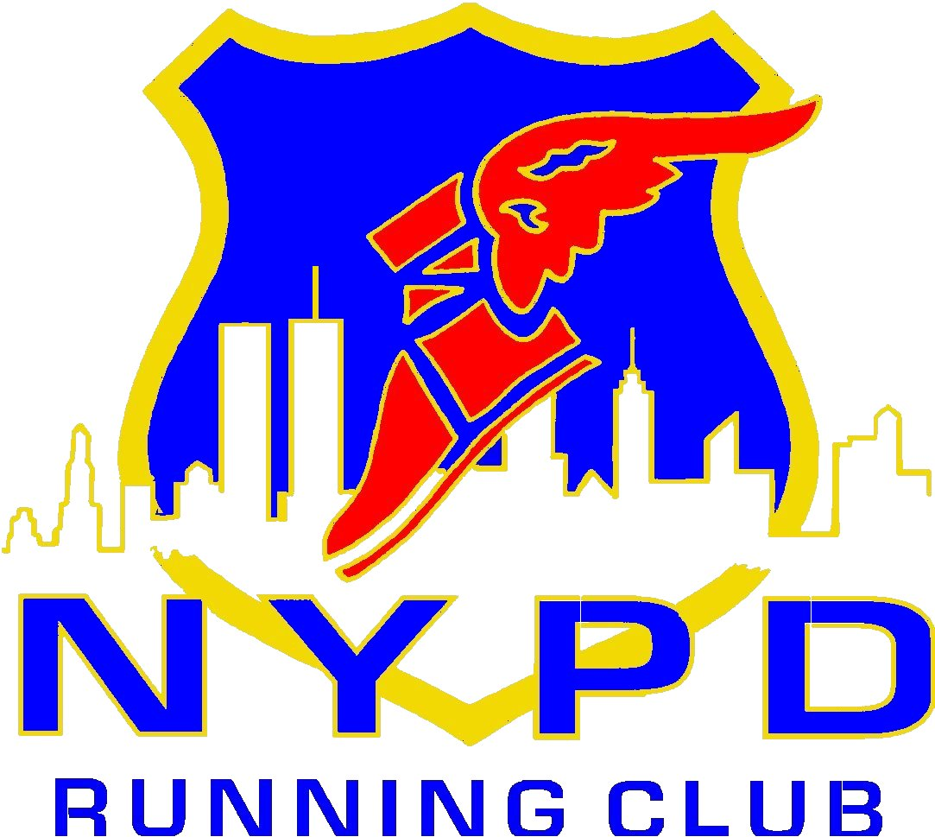

2014 MEMBERSHIP
(Expires December 31, 2014)

Last Name First ____

Address ________________

City State ____ Zip Code ___ DOB __________

E-mail Address __________ Phone# _______________________

Type of Applicant:

NYPD Active Retired (If retired list last command)

Rank ____ Tax # _______________ Cmd _______________________________________

Other Law Enforcement Officer (List your title and Agency) _ ______________________

Non-Law Enforcement Guest (List your sponsoring officers Name, Rank, and Agency below.)

__________________________________________________________________________________

Membership Waiver: I know that running and participating in club races and other related events are potentially hazardous activities. I should not enter and run in club activities unless I am medically able and properly trained. I agree to abide by any decision of a race official relative to my ability to safely compete in any event. I assume all risks associated with running and participating in club activities including, but not limited to, falls, contact with other participants, the effects of the weather, including high heat and/or humidity, the conditions of the roads and traffic on the course, all such risks being known and appreciated by me. Having read this waiver and knowing these facts, and in consideration of your acceptance of my application, I, for myself and anyone entitled to act on my behalf, waive and release the NYPD Running Club, its Officers and/or Members, the City of New York, the New York City Police Department, and all sponsors, their representatives and successors from all claims or liabilities of any kind arising out of my participation in these club activities, even though that liability may arise out of negligence or carelessness on the part of the persons named in this waiver. I know that membership in the NYPD Running Club does not guarantee me entry into the New York City Marathon, or any other race. I am also aware that the NYPD Running Club has no official affiliation with the New York Police Department.

Signature Date

Make Check Payable to NYPDRC Send check or money order Payable to NYPDRC:
99 East 2nd Street, Suite #55
Mineola, N.Y. 11501

Join online at www.NYPDRunningClub.COM Entry Fee $20.00

