Sentiment Analysis: Process and Methodology
Reddit Comments Corpus — r/LosAngeles
LA Reddit Community Analysis | GBA 6410 – Group 7
Process documentation. Describes how the analysis was built, the decisions taken at each stage, and the reasoning behind them. Results and findings are documented separately.

1. Purpose and Scope
This document records how the sentiment analysis component was developed. It covers the sequence of work, the decisions made at each stage, and the justification for each.
The component had three required deliverables:
- Use TextBlob, VADER, and a transformer-based model (e.g., BERT). Compare the distribution of their positive, neutral, and negative results.
- Compare the performance of each method to a few human-coded examples to estimate accuracy. Choose and explain which model works best.
- Use the best model to summarize sentiment trends by topic selected by the best topic modeling technique.
All four sentiment methods were applied to the complete corpus of 498,147 comments, so every figure reported is directly comparable across methods with no difference in coverage.
The work was structured as seven phases, each producing a saved output that the next phase consumed.

1.1 Why the work was phased
The phase structure was chosen for three reasons. Each phase writes its output to disk, so a failure or interruption never costs more than one stage of work. Each phase has a single responsibility, which makes it possible to revise one part of the analysis without re-running the rest. And the phases divide cleanly by computational requirement — most run on a standard processor, while only the transformer scoring needs a graphics processor — so expensive resources are held for the shortest possible time.
All handoffs between phases are files keyed on the comment identifier. No phase depends on another phase's row ordering. This was a deliberate safeguard: a single accidental sort would otherwise attach every sentiment score to the wrong comment, and nothing in the output would look wrong.

2. Data and Corpus Decisions
The input was the final cleaned comments dataset produced by the project's two-stage preprocessing pipeline: 498,147 Reddit comments from r/LosAngeles, collected between August 2025 and June 2026, with a median length of roughly 23 words.

2.1 Comments were analyzed; posts were excluded
The project collected both posts and comments. Inspection of the posts dataset showed that the majority were link posts whose text content reduced to a headline, with roughly three quarters carrying no body text at all.
Scoring a news headline measures the tone of media coverage, not the attitude of a community member. Pooling those records with genuine text posts would have silently changed what the resulting figures represented. Comments are unmediated community voice, are available in far greater volume, and have a length well suited to both families of method. Posts were therefore excluded entirely rather than filtered or handled separately.

2.2 Engagement scores were not used as weights
Each comment carries a score reflecting net upvotes. This was reported descriptively but never used to weight sentiment aggregates. A comment's score measures how many readers agreed with it, which is a different quantity from how strongly it expresses sentiment. Weighting by score would have conflated community endorsement with sentiment intensity and allowed a small number of highly upvoted comments to dominate a topic's average.

3. Phase 1 — Preparing Text for Sentiment Scoring
Objective: produce a text representation suited to sentiment methods, without disturbing any earlier preprocessing decision.

3.1 The problem with the existing cleaned text
Preprocessing had produced two cleaned columns: one retaining stopwords, intended for sentiment and embedding work, and one with stopwords removed and words lemmatized, intended for topic modelling. Both were lowercased and had emoji stripped.
Those two steps are appropriate for term-frequency methods but remove information sentiment methods use directly. VADER treats capitalization and punctuation as intensity modifiers, scoring an emphatic capitalized word higher than the same word in lower case, and its dictionary contains emoji entries. Transformer tokenizers represent both capitalization and emoji as meaningful parts of the input.
The preprocessing documentation had anticipated this, deferring emoji-based sentiment to the sentiment stage on the grounds that the models used there handle emoji directly. That reasoning was sound but the signal was unavailable in practice, because the column reaching this stage had already had emoji removed.

3.2 What was done
A third text column was derived from the original unmodified comment text. It applies every cleaning step from the original pipeline — Unicode normalization, apostrophe normalization, markdown and quote-marker removal, URL removal, HTML entity decoding, control-character removal, whitespace normalization — and omits only lowercasing and emoji removal.
Two properties of this step were treated as requirements. First, the operations were ordered so that markdown links are unwrapped before URLs are stripped; reversing them leaves orphaned bracket text. Second, and more importantly, the step adds a column and removes no rows.
Why no rows were dropped: All structural filtering, deduplication, length filtering, and language filtering during preprocessing was decided against the cleaned column. The 498,147 records are the survivors of that process. Re-deriving the corpus from raw text and re-filtering would have produced a different record set, and the preprocessing documentation would no longer have described the data in use. Adding a column preserves row alignment with every existing column and keeps the audit trail intact.

3.3 The effect was measured, not assumed
Rather than asserting that the change mattered, its magnitude was measured directly. The proportion of records containing emoji, capitalized words, and exclamation marks was compared between the new and existing columns. This confirmed that punctuation had never been stripped, so the difference was confined to capitalization and emoji.
The consequence of the change was then measured on each method by scoring identical records both ways, holding the method and its thresholds constant so that any difference is attributable to the text representation alone. The results are reported in section 5.4.

4. Phase 2 — Lexicon-Based Methods
Objective: score the corpus with TextBlob and VADER and characterize how each behaves on this data.

4.1 Why lexicons were run first
Lexicon methods require no specialized hardware and complete in well under an hour on the full corpus. Running them first validated the text pipeline end to end at negligible cost and established a baseline before any expensive computation was committed.

4.2 Converting continuous scores to classes
Both lexicon methods return a continuous score rather than a class. Converting to three classes requires choosing cutoff points, and that choice is a methodological decision rather than an implementation detail.
A symmetric threshold of plus or minus 0.05 was used for both methods. For VADER this is the value its authors recommend and the standard convention in published work. For TextBlob no such convention exists, so the value is arbitrary; the same figure was adopted so that the two methods remain directly comparable rather than differing on both scoring and cutoff point.
Because the TextBlob threshold has no principled basis, a sensitivity analysis was run at wider cutoff points. This was not a formality — it revealed that TextBlob's neutral share nearly doubles across the range tested while VADER's moves far less, which materially affects how much weight TextBlob's distribution can bear. The finding is reported rather than buried.
Lexicon model scores and label distributions
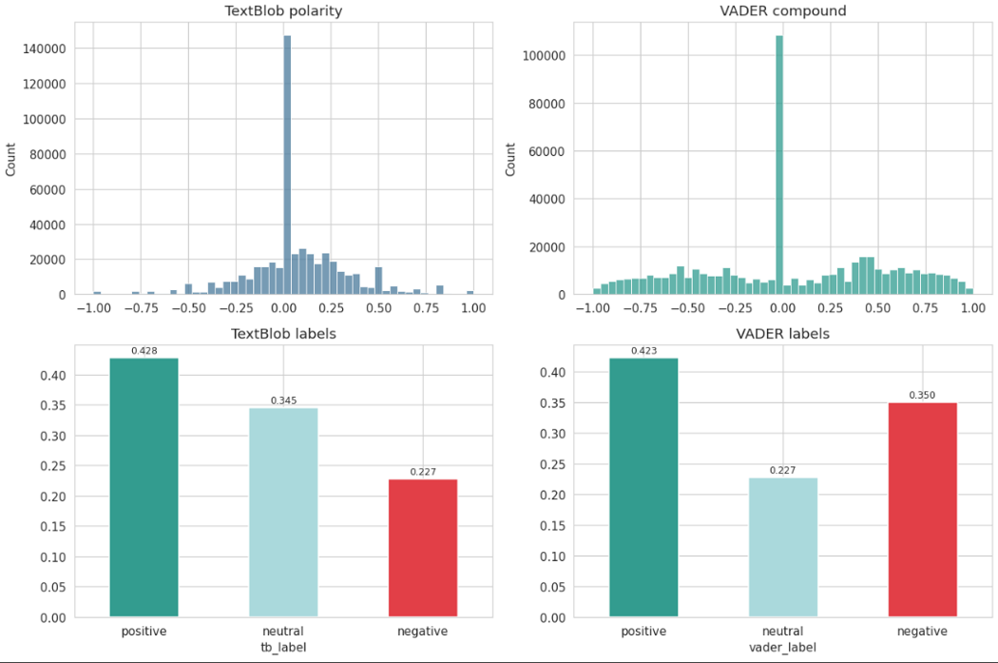
Figure 1. Polarity and compound score histograms with the resulting three-class label shares. The pronounced spike at exactly zero in both histograms is the abstention mass discussed in section 4.3.

4.3 Tracking abstentions separately
Both methods return a score of exactly zero when no word in the text matches their dictionary. That outcome is an abstention, not a judgment of neutrality, but both land in the neutral class and are indistinguishable in the output.
Exact-zero counts were therefore recorded as a separate flag alongside the label. This was included as a precaution against inflated neutral shares and turned out to be one of the more consequential measurements in the analysis: it showed that the large majority of both methods' neutral classes are abstentions rather than judgments.
Method | Labelled neutral | Of those, exactly zero | Genuine neutral
TextBlob | 34.5% | 75.4% | 8.5% of corpus
VADER | 22.7% | 92.6% | 1.7% of corpus

4.4 Qualitative stress testing
A small set of hand-written test cases was scored to document failure modes concretely: negation, capitalized emphasis, slang, sarcasm, genuine neutrality, and emoji-carried sentiment. Cases were written around local subject matter so that the documented failure modes reflect the domain under study rather than generic examples.
This is diagnostic rather than statistical evidence and is presented as such. Its value is in demonstrating a mechanism rather than estimating a rate.

5. Phase 3 — Transformer-Based Methods
Objective: score the corpus with two transformer models chosen to contrast meaningfully with each other.

5.1 Model selection
Binary sentiment classifiers were considered first, since several widely used checkpoints fall into that category, and were rejected. The first deliverable is a three-class distribution comparison, and a binary model contributes a structurally empty neutral share rather than an empirically measured one: its neutral count would be zero because the model cannot produce the label, not because no neutral content exists.
Two models were selected instead, chosen so that the comparison tests something rather than duplicating a result:
Model | Role | Native output
cardiffnlp/twitter-roberta-base-sentiment-latest | Domain-matched — trained on social media text | Three classes
nlptown/bert-base-multilingual-uncased-sentiment | General-purpose contrast | Five-point star scale

The pairing allows the human-coded benchmark to answer whether domain matching actually improves accuracy on Reddit comments, rather than simply demonstrating that transformers differ from lexicons. Running two models from the same family that behave alike would have added cost without adding evidence.

5.2 Converting the five-star output
The general-purpose model rates comments from one to five stars, which required conversion to three classes. Two conversions were evaluated.
The first takes the single most likely star rating and maps it, with one and two stars becoming negative, three becoming neutral, and four and five becoming positive. The second sums the probabilities belonging to each class — the probability that a comment is negative being the probability of one star plus the probability of two stars — and takes the largest total.
The second is correct, because the star ratings form an ordinal scale rather than a set of unrelated categories. Taking the most likely single star allows three stars to win on a plurality while negative or positive support sits divided across two adjacent ratings that are never added together. The effect is systematic and always favors neutral.
Conversion | Positive | Neutral | Negative
Most likely star | 25.9% | 19.8% | 54.3%
Summed probabilities (adopted) | 29.3% | 8.1% | 62.6%

The two conversions disagree on 11.9 percent of comments, and the neutral share more than halves under the correct one. This is a structural property of the label scheme: negative draws on two source ratings and positive draws on two, but neutral draws on only one, so it must outweigh the combined mass on either side to win.
Both sets of labels were retained so that the impact of this decision could be reported as a sensitivity comparison, in the same way the lexicon threshold sensitivity is reported. The summed conversion also makes the model's confidence values comparable with the other transformer's, since both then represent a maximum over three classes rather than over five.

5.3 Scoring the full corpus
Both models were run over all 498,147 records. Scoring was implemented in resumable chunks, saving after each block of 25,000 records.
This was necessary because cloud notebook sessions disconnect: without chunked saving, an interruption late in a run would discard the entire run. With it, an interruption costs at most one block, and re-running the same step resumes from where it stopped. Requesting the full probability distribution from the five-star model also returns five values per record, so memory pressure is a genuine consideration at this scale.
Two efficiency measures were applied. Records were sorted by length before batching, because transformers pad every sequence in a batch to the length of the longest one present; grouping similar lengths keeps batches tight rather than filling them with padding. Results were then written back through the original ordering so that every score attaches to its own record.

5.4 The text-representation decision revisited
The controlled comparison described in section 3.3 was repeated for the selected transformer, scoring the same records under both text representations. Each comparison was measured over a subset of the corpus,
Method | Labels changed by preserving capitalization and emoji
TextBlob | 0.04%
VADER | 0.80%
Twitter-RoBERTa | 5.08%

The pattern follows the mechanism. TextBlob has no rules for capitalization or emoji and barely responds. VADER has such rules and shifts twenty times as much. The transformer shifts six times more again, because it tokenizes capitalization and emoji as meaningful units rather than checking them against a rule set.
For the model ultimately selected, one label in twenty depends on this choice, which is why the text-representation decision is documented as a substantive methodological point rather than a routine cleaning preference. Inspection of the changed cases confirmed the mechanism: comments where an emoji carries the sentiment, and comments where capitalization marks emphasis. Some portion of the 5.08 percent is attributable to other differences between the two text versions, so the finding is described as the effect of the richer text representation overall rather than of capitalization and emoji exclusively.

6. Phase 4 — Comparing the Four Methods
Objective: characterize how far the methods diverge and in what pattern.
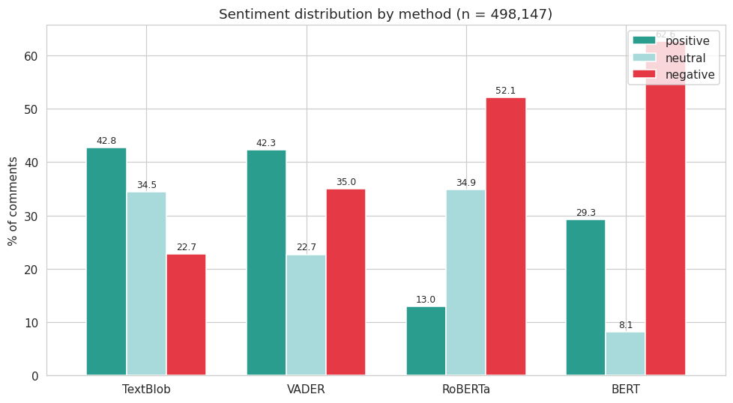
Sentiment distribution by method

Figure 2. Positive, neutral, and negative shares for all four methods over the full corpus. The negative class spans 39.9 percentage points across methods scoring identical text.

6.1 Raw agreement was insufficient
Pairwise agreement was first computed as the proportion of comments receiving the same label. This measure is intuitive but has a floor problem: two methods that both predict negative frequently will match often through coincidence alone, with no real correspondence between their judgments.
Cohen's kappa was therefore computed alongside it, adjusting for the agreement expected by chance given each method's class proportions. The adjustment changed the conclusion. The two transformers had the highest raw agreement of any pair, but after correction the two lexicons corresponded more closely; the transformers only appeared close because both lean heavily negative, inflating coincidental matches.
Both measures are reported, with kappa used for any comparison between pairs. Standard kappa treats all disagreements as equal, so a positive-to-negative reversal counts the same as a positive-to-neutral shift. A weighted variant would penalize reversals more heavily; it was not used because the unweighted figures were already conclusive.

Chance-corrected agreement between methods
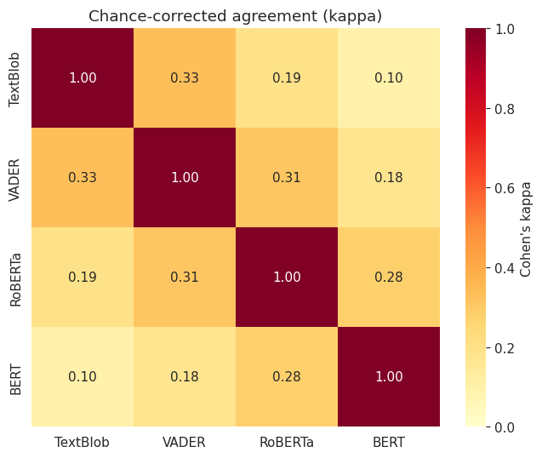
Source: Notebook 03, kappa cell (heatmap)
Figure 3. Cohen's kappa for all six method pairs. No pair reaches moderate agreement on the standard interpretation; values range from 0.10 to 0.33.

6.2 Identifying the underlying structure
Ordering the four methods by how frequently each assigns a negative label revealed that agreement declines monotonically with distance along that ordering. Adjacent pairs agree most, pairs at opposite ends agree least.
This reframed the comparison. The organizing variable is not model family but how readily a method reaches for a negative label — one lexicon and one transformer agree more with each other than the two transformers do. This is a stronger and more specific finding than the family-level contrast the raw figures suggested, and it was found by looking for structure in the agreement matrix rather than by reporting the matrix alone.

7. Phase 5 — Human-Coded Benchmark
Objective: establish an external reference against which the four methods can be scored and select a model on that evidence.

7.1 Why a benchmark was necessary
The four methods contradicted each other on the basic character of the corpus, with the negative share ranging across forty percentage points. Nothing in the model outputs can resolve which is closest to correct, because the outputs are the thing being evaluated. An external reference was required, and hand-labelling is the only available source of one.

7.2 Benchmark design
Two sets were drawn, serving different purposes and treated differently.
Set | Size | Selection | Use
A | 100 | Drawn at random from the corpus | Sole source of every accuracy figure reported
B | 25 | Comments where the four methods produced all three labels | Qualitative error analysis only; excluded from all metrics

The separation is essential. Disagreement cases are the most informative to read but the least representative to measure on: an accuracy estimate computed on them would be concentrated on difficult examples and would understate performance across the corpus. Keeping the sets apart captures the diagnostic value of disagreement without contaminating the estimate.
Set A is drawn at random and without reference to any model output, which is what allows its accuracy estimate to generalize to the corpus as a whole. At 100 records, accuracy figures carry a margin of roughly plus or minus nine to ten percentage points. This was judged acceptable because the methods proved to be separated by twenty points rather than by two; precision was not required to establish the ranking, only to establish which differences are real, and that question is answered by significance testing rather than by interval width.

7.3 Two design choices that protect the estimate
The two sets were shuffled together into a single annotation file, with set membership recorded in a separate key file not visible to the annotator. Annotating a batch known to consist of hard cases would invite different levels of care than annotating a random batch; mixing them means all records were labelled under identical conditions, with the split reapplied afterwards.
The annotation file contained only a row number, the comment identifier, and the comment text. No model predictions were included. Seeing that three methods had labelled a comment negative would anchor the judgment, and an anchored benchmark measures agreement with the models rather than agreement with the truth.

7.4 Coding rules fixed in advance
A written set of coding rules was agreed before any annotation began and distributed with the annotation file. Fixing them in advance is what makes the resulting labels defensible; deciding edge cases while annotating invites unconscious adjustment toward whatever the models produced.
Situation | Rule
General principle | Label the attitude the commenter expresses, not whether the subject matter is pleasant.
Negative subject, neutral delivery | Neutral. A factual statement about an unwelcome event carries no expressed attitude.
Mixed sentiment | Assign the dominant sentiment; if genuinely balanced, neutral.
Sarcasm and irony | Label the intended meaning, not the literal wording.
Profanity | Not negative by default. Profanity functions as intensification in this register.
Reply aimed at another user | Label the sentiment expressed, regardless of its target.
Questions and requests | Neutral unless evaluative language is present.
Insufficient context | Unclear. Excluded from metrics and reported separately.

The first rule is the one the analysis turns on. It is precisely the distinction the four methods were spread along — the lexicon methods reading positive vocabulary as positive attitude, the transformer methods reading unpleasant subject matter as unpleasant attitude — so consistent application of it directly determines the outcome.
A fourth label value, unclear, was made available for comments that cannot be judged without the surrounding thread. The alternative of defaulting such comments to neutral was rejected: it would have padded the neutral class with unreadable comments and penalized any model that correctly identified their sentiment. In the event the annotator did not use the value, so no records were excluded on this basis.

7.5 Metrics
Macro-averaged F1 was specified in advance as the primary selection metric, reported alongside overall accuracy, per-class precision and recall, and a confusion matrix for each method.
The reasoning was that sentiment classes were expected to be imbalanced, and under imbalance overall accuracy rewards a method that over-predicts the majority class. Macro-F1 weights each class equally and therefore exposes performance on the neutral class, where the two families were expected to diverge most.
The metric choice was load-bearing: Two methods finished with identical overall accuracy and would have appeared equivalent on that measure alone. Macro-F1 separated them clearly, entirely because one of them almost never identifies neutral content. Specifying the metric before seeing results is what makes this a design decision rather than a post-hoc selection.

Confusion matrices for all four methods
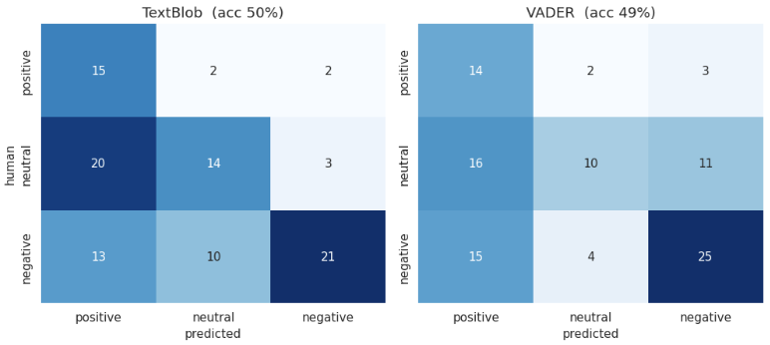
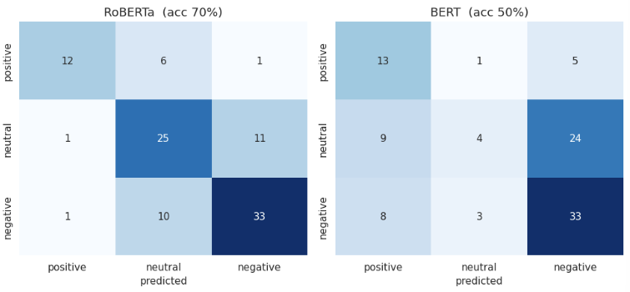
Figure 4. Human labels against predicted labels for each method. Every method's dominant error involves neutral comments, but the lexicon methods misclassify them as positive while the transformer methods misclassify them as negative.

7.6 Testing whether differences are real
Ranking methods by score is not sufficient at this benchmark size. Each pair of methods was therefore compared on only the records where they disagreed, testing whether the split of those disagreements departs from chance.
This produced a more honest conclusion than the raw ranking: one method is significantly better than all three alternatives, and those three are statistically indistinguishable from one another. Reporting the four-way ranking without this test would have implied differences between the lower three that the evidence does not support.

8. Phase 6 — Topic Assignments
Objective: obtain a topic label for every comment, suitable for aggregating sentiment.

8.1 Topics were sourced from the project's topic modelling workstream
Topic modelling for the wider project was carried out in a separate workstream, and its results are adopted here as the topic source. Three techniques were compared by that workstream on coherence and topic diversity, and Latent Dirichlet Allocation (LDA) with five topics (K=5) was selected. That comparison is not repeated in this document; it is cited as the basis for the topic source.
The aggregation stage reads a fixed four-column interface — comment identifier, topic identifier, topic label, and assignment probability — rather than depending on how the topics were produced. This decouples the sentiment analysis from the topic method, so that any conforming source can be substituted without rewriting the aggregation.
One qualification was identified on review and is carried forward into the results. The candidate grid ran from five topics upward, and both coherence and held-out perplexity were best at the lowest value tested. Five therefore outperformed every larger value examined but was never compared against smaller values, so it is the best of the candidates rather than a demonstrated optimum. Findings are described accordingly.

8.2 The assignments were reproduced rather than imported
Rather than accepting an exported file of topic assignments, the selected model configuration was re-executed from the source data within this component. Two reasons:
- Key alignment. The external notebook applied a train-test split, so row ordering could not be assumed to match the source file. Re-executing locally guaranteed that every topic label attaches to the correct comment identifier, which is the single point where a silent error would corrupt the entire topic analysis.
- Verification. Reproducing the result independently tests whether it is reproducible at all.
Topic sizes matched the original run to within 0.06 percent, with totals agreeing exactly, consistent with minor numerical differences between library versions. The reproduction output was used throughout so that a single internally consistent source underlies every figure.

8.3 Assignment confidence was characterized before use
Because the topic model produces a probability distribution rather than a hard label, the probability attached to each assignment was examined before the assignments were relied upon.
Assignments proved diffuse: the median comment is only around 2.4 times more likely to belong to its assigned topic than to a topic chosen at random. Examination of the probability values showed them concentrated at simple fractions, indicating that many assignments rest on a small number of informative words.
A contributing cause was identified in the source implementation, where prior parameters were defined but not passed to the estimator, leaving it on library defaults. A lower document-topic prior would have produced sharper assignments, so part of the diffuseness reflects an unused configuration rather than a property of the corpus.
Two decisions followed. Sentiment by topic is reported under two views — all assigned comments, and the subset assigned with at least 0.50 probability — so that the influence of weak assignments is visible. And individual comment-level topic assignments are not quoted as evidence, because inspection confirmed that high assignment probability does not guarantee semantic correctness.

8.4 Topic labels were validated against content
Supplied topic labels were checked against each topic's characteristic terms and against representative documents rather than adopted directly. A mislabeled topic would misdirect the interpretation of its sentiment score, so this step is a prerequisite for the aggregation rather than a presentational detail.
Representative documents were drawn across the full range of assignment probabilities rather than from the highest-probability records alone.
Method note: Reading only the highest-probability documents in a topic is misleading, because those documents are selected for being extreme rather than typical. Sampling across low, middle, and high probability bands gives an accurate picture of what a topic actually contains.

One topic, supplied with a label describing community and local events, did not match its content: across all probability bands it contains reactive commentary on public affairs, figures, and events. It was relabeled News Reactions and Opinion Commentary. Its assignment confidence is also the weakest of the five, consistent with a topic the model is least certain about.
The validation also established that two of the five topics are residual groupings without a coherent subject. Their sentiment figures reflect heterogeneous content rather than attitude toward any particular thing, and they are reported separately from the three interpretable topics. A further topic carries evaluative vocabulary among its characteristic terms, which makes its sentiment result partially circular; this is qualified where reported.

9. Phase 7 — Sentiment by Topic
Objective: combine the selected model's labels with topic assignments and test whether the resulting pattern is robust.

9.1 Aggregation
Sentiment labels from the selected model were joined to topic assignments on the comment identifier, and class shares computed per topic. Topics were ranked on net sentiment — the positive share minus the negative share, in percentage points.
Net sentiment was chosen over a mean of coded values because it disregards the neutral class entirely. Neutral accounts for roughly a third of the selected model's output and varies substantially between topics, so a measure that folds it in would conflate two different things: how critical a topic is, and how much of it is informational.

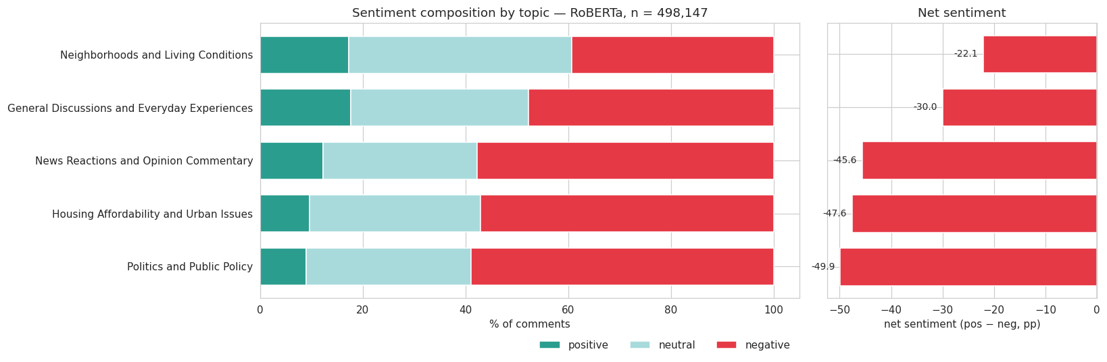
Sentiment composition and net sentiment by topic

Figure 5. Left: class composition per topic. Right: net sentiment, positive share minus negative share. The three interpretable topics span 27.8 percentage points.

9.2 Three independent robustness checks
A ranking derived from a single aggregation is weak evidence. Three separate checks were applied, each testing a different way the result could be an artifact:
Check | What it tests | Outcome
Confidence filter | Whether weakly assigned comments drive the ranking | Ranking identical; all topics shift in the same direction
Thread position | Whether reply dynamics rather than topic drive the result | Replies uniformly more negative; ranking unaffected
Monthly series | Whether the ranking is an artifact of averaging over time | No topic overtakes another in any month

All three agree. The reply check is worth noting specifically: roughly two thirds of the corpus are replies to other comments, and a reply's sentiment may be aimed at another commenter rather than at the topic. The check could not remove that effect, but it established that the effect is a constant offset across topics rather than a confound that distorts the comparison between them.

Net sentiment over time by topic
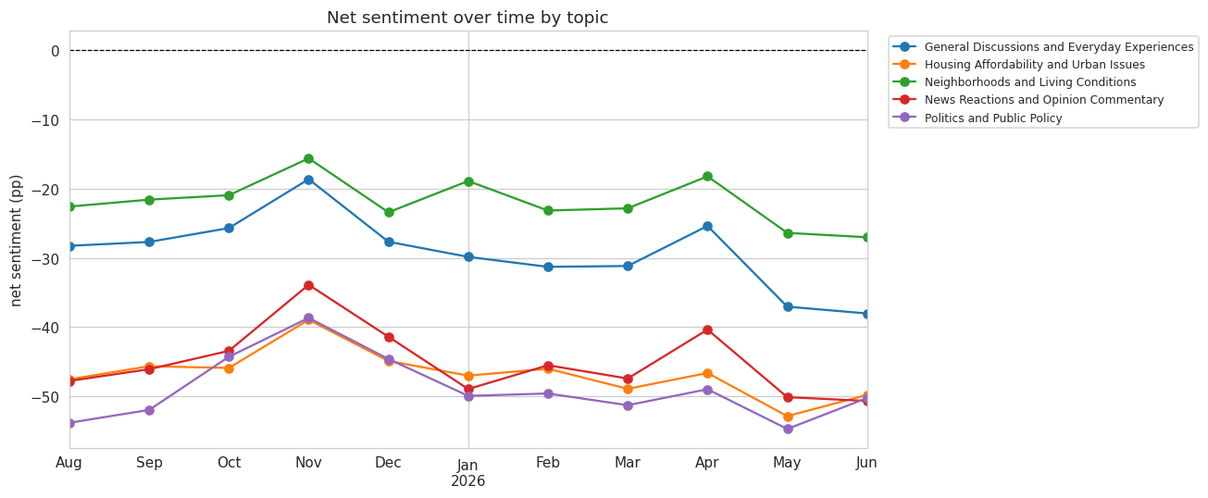

Figure 6. Monthly net sentiment across the eleven months of the corpus. No topic overtakes another at any point, and a corpus-wide improvement is visible in November 2025 affecting all five topics simultaneously.

9.3 Model bias and how it is reported
The selected model's most common error on the human-coded benchmark is labelling genuinely neutral comments as negative. Measured sentiment levels therefore run more negative than the underlying reality, and absolute figures are read accordingly.

No numerical correction is applied. Estimating the size of the bias would require comparing the model's net sentiment against the benchmark's on the same records, and at 100 records that estimate carries an uncertainty interval wider than the estimate itself. Publishing an adjusted figure would give it a precision it does not have. The measured values are reported as the results, with the direction of the bias described alongside them.

10. Decisions and Justifications
Consolidated record of every substantive decision.
Decision | Choice | Justification
Corpus | Comments only | Posts are predominantly headlines; scoring them measures media tone, not community attitude
Coverage | All four methods over the full corpus | Every figure directly comparable across methods with no difference in coverage
Engagement score | Not used as a weight | Measures agreement, not sentiment intensity
Text representation | Derived column preserving capitalization and emoji | Both are signals the methods use; measured to change 5.08% of labels for the selected model
Row handling | Add a column, drop no rows | Preserves the preprocessing audit trail and row alignment
Lexicon thresholds | Plus or minus 0.05, both methods | VADER's published convention, applied to both so the methods stay comparable
Threshold sensitivity | Reported at three cutoff points | The TextBlob value is arbitrary, so its influence must be visible
Lexicon abstentions | Counted separately from neutral | An exact-zero score is a non-answer, not a judgment of neutrality
Binary transformer | Rejected | Cannot contribute a neutral share to a three-class comparison
Transformer pairing | Domain-matched and general-purpose | Allows the benchmark to test whether domain matching helps
Star conversion | Sum of star probabilities | Ratings are ordinal; taking the top rating biases toward neutral on 11.9% of comments
Full-corpus scoring | Resumable chunked processing | A session interruption costs one block rather than an entire run
Agreement measure | Cohen's kappa alongside raw agreement | Raw agreement is inflated when methods share a skewed class distribution
Benchmark structure | Random Set A (100) and disagreement Set B (25) | Random selection keeps the accuracy estimate unbiased
Annotation conditions | Sets shuffled together, no model output shown | Prevents differential care between sets and anchoring to model predictions
Coding rules | Fixed and written before annotation | Prevents unconscious adjustment toward model output
Unclear label | Available but unused | Defaulting unreadable comments to neutral would penalize correct predictions
Primary metric | Macro-F1 | Robust to class imbalance; exposes neutral-class performance
Significance testing | Pairwise, on discordant records | Score ranking alone overstates differences at this benchmark size
Topic source | External selection, reproduced locally | Avoids duplicated work while guaranteeing key alignment
Topic interface | Fixed four-column schema | Decouples aggregation from the topic method
Topic labels | Validated against terms and documents sampled across probability bands | One supplied label did not match its topic's content
Topic reporting | Two views, at all and at 0.50 confidence | Median assignment probability is only 0.480 against a 0.200 baseline
Aggregation measure | Net sentiment | Excludes the neutral class, which varies independently between topics
Model bias | Described, not applied to the figures | Direction is established; magnitude cannot be reliably estimated at this benchmark size

