Sentiment Analysis: Results and Findings
Reddit Comments Corpus — r/LosAngeles
LA Reddit Community Analysis | GBA 6410 – Group 7
Results document. Covers what the four sentiment methods found, how accurate each one is, and what the sentiment looks like across topics. The methods and design decisions behind these numbers are documented separately.

1. Summary of Findings
Four sentiment methods were applied to all 498,147 Reddit comments from r/LosAngeles, covering August 2025 through June 2026. Two are lexicon-based (TextBlob and VADER) and two are transformer-based (Twitter-RoBERTa and multilingual BERT). Five findings stand out.
First, the four methods disagree far more than expected. Depending on which method is used, the share of negative comments in the corpus is anywhere from 23% to 63%. All four methods assign the same label to only 19.5% of comments.
Second, the lexicon methods have a specific and measurable weakness: most of what they label neutral is not a judgment of neutrality at all, but a failure to recognize any of the words in the comment.
Third, tested against 100 hand-labelled comments, Twitter-RoBERTa is clearly the most accurate at 70% accuracy. The other three methods sit at 49-50% and are statistically indistinguishable from each other.
Fourth, the corpus is negative overall. Hand-labelling puts it at roughly 44% negative, 37% neutral, and 19% positive.
Fifth, sentiment varies substantially by topic. Politics and housing draw the most criticism; discussion of neighborhoods and getting around the city is far less negative. That ordering holds under every robustness check applied to it.
Bottom line: Twitter-RoBERTa is the method to use. It is the only one that reliably tells the difference between a comment about an unpleasant subject and a comment expressing an unpleasant attitude — which is the distinction the whole analysis depends on.

2. How the Four Methods Compare
Every method was run over the full corpus of 498,147 comments, so these figures are directly comparable.

2.1 The methods produce very different pictures
Sentiment | TextBlob | VADER | RoBERTa | BERT | Range
Positive | 42.8% | 42.3% | 13.0% | 29.3% | 29.8 pts
Neutral | 34.5% | 22.7% | 34.9% | 8.1% | 26.8 pts
Negative | 22.7% | 35.0% | 52.1% | 62.6% | 39.9 pts

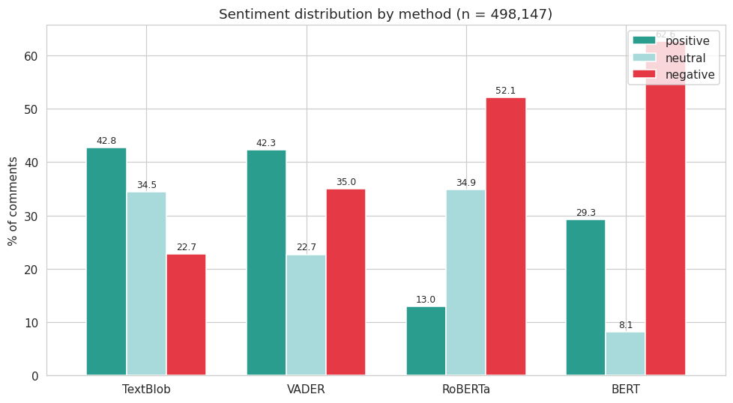
Sentiment distribution by method

Figure 1. The same 498,147 comments scored four ways. The negative class spans nearly forty percentage points across methods
These are the same 498,147 comments scored four ways. TextBlob reads the corpus as mostly positive and only 23% negative. BERT reads it as 63% negative. That is not a small methodological difference — the two methods disagree about the basic character of the community being studied.
The two lexicon methods agree closely on how much positive sentiment there is (42.8% and 42.3%) but disagree sharply on the split between neutral and negative. The two transformer methods both see a majority-negative corpus but disagree on how much neutral content exists (34.9% versus 8.1%).

2.2 Agreement between methods is poor
Counting how often two methods assign the same label gives the following:
Method pair | Same label | Cohen's kappa
TextBlob and VADER | 55.9% | 0.33
RoBERTa and BERT | 56.2% | 0.28
VADER and RoBERTa | 52.9% | 0.31
VADER and BERT | 47.6% | 0.18
TextBlob and RoBERTa | 43.0% | 0.19
TextBlob and BERT | 36.6% | 0.10

The second column is the raw match rate. The third is Cohen's kappa, which adjusts for the fact that two methods will sometimes agree purely by coincidence — a method that labels most things negative will match another negative-leaning method fairly often without any real correspondence between their judgments.
On the standard interpretation of kappa, values below 0.20 are slight agreement and 0.21 to 0.40 is fair. Every pair here falls in one of those two bands. No pair reaches moderate agreement.
The adjustment matters. RoBERTa and BERT have a higher raw match rate than TextBlob and VADER (56.2% versus 55.9%), which makes them look like the closer pair. After correcting for chance, the two lexicons actually correspond better (0.33 versus 0.28). The two transformers only appeared close because both lean heavily negative, which inflates coincidental matches.

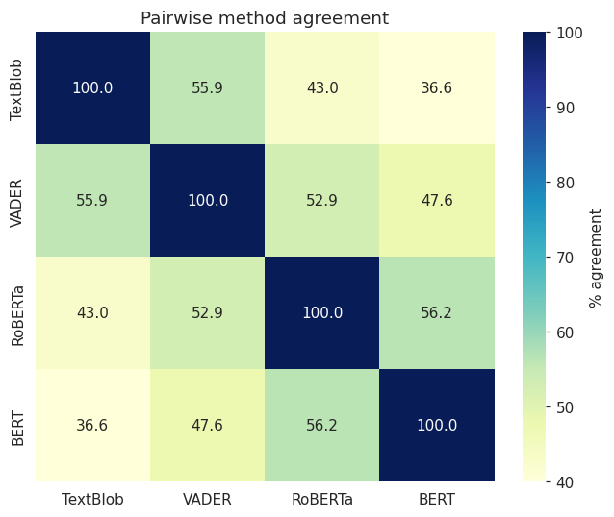
Raw pairwise agreement between methods

Figure 2. The proportion of comments on which each pair of methods assigns the same label. Values range from 36.6% to 56.2%.

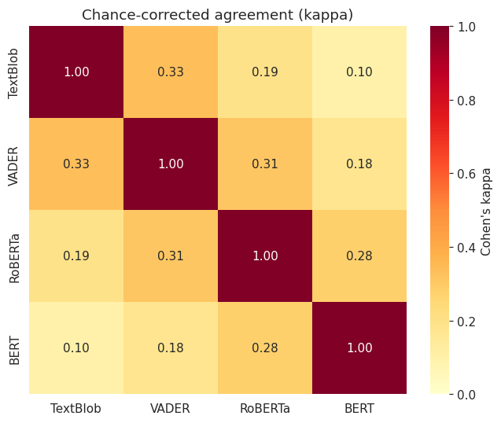
Chance-corrected agreement between methods

Figure 3. Cohen's kappa for the same six pairs. No pair reaches moderate agreement; values range from 0.10 to 0.33.
Comparing the two figures shows why the chance-corrected values are the ones the conclusions rest on. Raw agreement makes every pair look moderately similar, clustered between 37% and 56%, and it puts the two transformers at the top. Kappa spreads the same pairs across a much wider range and reorders them, because it discounts the matches each pair would have produced by coincidence. Raw agreement is reported here for transparency, but any statement in this document about which methods are closer to each other uses kappa.

2.3 Agreement follows negativity, not model type
Ordering the methods by how negative they are produces a clean pattern:
Ordering by negativity | Adjacent pairs (kappa) | Two apart | Opposite ends
TextBlob 22.7% → VADER 35.0% → RoBERTa 52.1% → BERT 62.6% | 0.33, 0.31, 0.28 | 0.19, 0.18 | 0.10

Agreement declines steadily with distance along that line. This means the useful way to think about the four methods is not lexicon versus transformer, but how readily each one reaches for a negative label. VADER and RoBERTa — one lexicon, one transformer — agree more with each other (0.31) than the two transformers do (0.28), because they sit closer together on that scale.

2.4 Full agreement is rare
Level of agreement across all four methods | Comments | Share
All four assign the same label | 97,088 | 19.5%
Two different labels appear | 283,984 | 57.0%
All three labels appear | 117,075 | 23.5%

For nearly a quarter of the corpus, the four methods collectively produce every possible answer. Fewer than one comment in five gets unanimous treatment.

3. Why the Methods Disagree
Four specific mechanisms account for most of the divergence. Each was measured directly.

3.1 Most lexicon neutrals are non-answers
TextBlob and VADER both return a score of exactly zero when no word in a comment appears in their dictionary. That zero is not a judgment that the comment is balanced — it means the method found nothing it recognized. Both outcomes end up labelled neutral, and they are indistinguishable in the output.
 | Labelled neutral | Of those, score exactly zero | Genuine neutral judgments
TextBlob | 34.5% | 75.4% | 8.5% of corpus
VADER | 22.7% | 92.6% | 1.7% of corpus

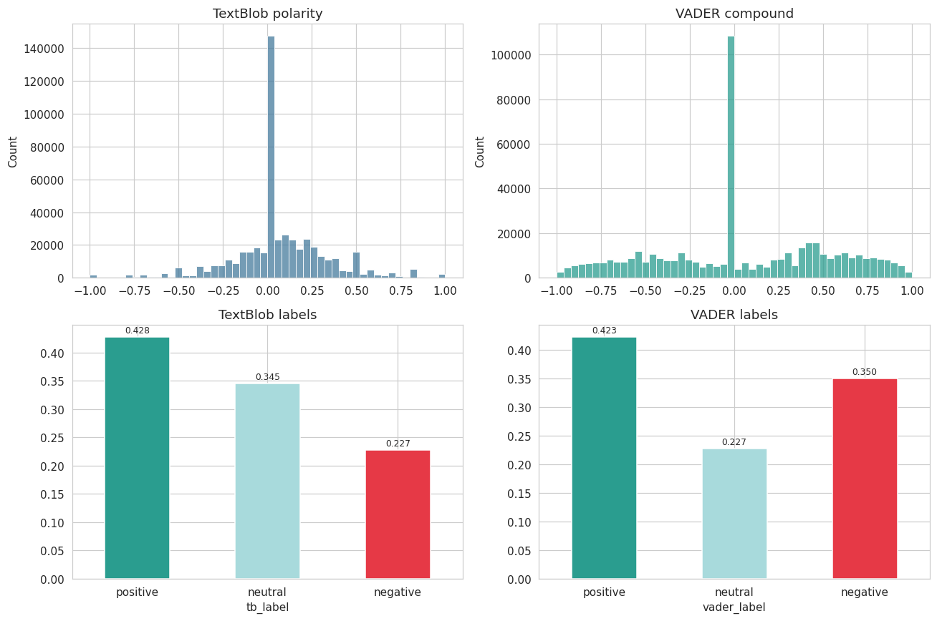
Lexicon score distributions

Figure 4. Polarity and compound score histograms. The tall spike at exactly zero in both is the abstention mass — comments the method could not read, which are then labelled neutral.
VADER's neutral class is almost entirely made up of comments it could not read. Once those are removed, VADER identifies genuine neutral sentiment in under 2% of nearly half a million comments. It is effectively a two-class method with a large bin of unprocessed text attached.
Neither lexicon method identifies them reliably: TextBlob recovers 37.8% of genuinely neutral comments and VADER 27%.

3.2 TextBlob's results depend heavily on an arbitrary cutoff
Both lexicon methods produce a continuous score that has to be cut into three classes. The cutoff used throughout was plus or minus 0.05, which is the value the VADER authors recommend. For TextBlob no standard value exists, so the same number was used for consistency. Testing alternatives shows the two methods respond very differently:
Cutoff | TextBlob pos / neu / neg | VADER pos / neu / neg
± 0.05 | 42.8 / 34.5 / 22.7 | 42.3 / 22.7 / 35.0
± 0.10 | 37.0 / 44.5 / 18.5 | 40.8 / 25.6 / 33.6
± 0.20 | 25.4 / 63.1 / 11.5 | 37.9 / 31.6 / 30.5

TextBlob's neutral share nearly doubles as the cutoff widens, from 34.5% to 63.1%. VADER's moves by nine points. TextBlob's scores cluster tightly around zero, so a large amount of the corpus sits inside any moderately wide neutral band; VADER's scores spread further toward the extremes.
The practical consequence is that TextBlob's distribution is substantially an artifact of a cutoff that has no principled basis. VADER's is not, and its cutoff is the one with published support. One conclusion does survive at every cutoff for both methods: positive exceeds negative. That much is robust; the size of the neutral class is not.

3.3 Preserving capitalization and emoji changes transformer results
The project's standard cleaned text is lowercased and has emoji removed, which suits topic modelling but discards signals sentiment methods use. A second version of the text was prepared that keeps capitalization and emoji while applying every other cleaning step. Scoring the same comments both ways, over a subset of the corpus, shows how much difference it makes:
Method | Labels that changed
TextBlob | 0.04%
VADER | 0.80%
RoBERTa | 5.08%

TextBlob barely notices, which is expected — it has no rules for capitalization or emoji. VADER does have such rules and shifts twenty times as much. RoBERTa shifts six times more than VADER again, because it treats capitalization and emoji as meaningful parts of the text rather than as flags to check.
For the method ultimately selected, one label in twenty depends on this choice. Examples of comments whose label changed once the richer text was used:
- “Unless it's winning like Charlie Sheen 🙁” — neutral on the words alone; the emoji carries the sentiment.
- “Have you heard of......... the homeless? 😬” — same pattern, the emoji supplies the tone.
- “Ah shit I should posted the link—THANK YOU” — capitalization marks genuine gratitude, and the profanity is not hostile.

3.4 How BERT's five-star output is converted matters
The BERT model rates comments from one to five stars, which has to be converted into three classes. Two conversions were evaluated. The first takes the single most likely star rating and maps it: one and two stars become negative, three becomes neutral, four and five become positive. The second adds up the probabilities — the chance a comment is negative is the chance of one star plus the chance of two stars — and takes the largest total.
The second is correct, because the star ratings are a scale rather than unrelated categories. The first lets three stars win on a plurality while negative or positive support sits split across two neighboring ratings that never get added together.
Conversion method | Positive | Neutral | Negative
Most likely star | 25.9% | 19.8% | 54.3%
Summed probabilities (used) | 29.3% | 8.1% | 62.6%

The two approaches disagree on 11.9% of comments, and the neutral share more than halves under the correct one. This is a structural feature of the label scheme: negative draws on two source ratings and positive draws on two, but neutral draws on only one, so it has to outweigh the combined mass on either side to win. Under the correct conversion, BERT is a very poor detector of neutral content — which the accuracy testing confirms.

4. Accuracy Against Human Coding
Because the four methods contradict each other, nothing in their output can settle which is right. One hundred comments were drawn at random from the corpus and labelled by hand, without reference to any model output, using a written set of coding rules fixed in advance. A further 25 comments were drawn from cases where the four methods produced all three labels; those are used only for examining failure patterns and are excluded from every accuracy figure below.

4.1 What the corpus actually looks like
Sentiment | Hand-labelled (n=100) | TextBlob | VADER | RoBERTa | BERT
Positive | 19% | 42.8% | 42.3% | 13.0% | 29.3%
Neutral | 37% | 34.5% | 22.7% | 34.9% | 8.1%
Negative | 44% | 22.7% | 35.0% | 52.1% | 62.6%

The hand-labelled column covers 100 comments; the four method columns cover all 498,147. Differences between them therefore reflect both model behavior and the difference between those 100 comments and the corpus.
Reading down the columns, before any per-comment scoring: both lexicon methods call more than twice as many comments positive as actually are. BERT finds 8% neutral where 37% exists. RoBERTa is closest on all three classes. Scored on the same 100 comments, it produces 14 positive, 41 neutral, and 45 negative against the human 19 / 37 / 44 — understating positive by five points and shifting the difference into neutral. Its full-corpus figures run more negative than this, which reflects the corpus being more negative than these 100 comments rather than a further model effect.
Matching the overall proportions is not the same as being right about individual comments, however. A method could have perfect proportions and still assign every single comment incorrectly. The next section measures the per-comment match.

4.2 Per-comment accuracy
Method | Accuracy | Macro-F1 | F1 positive | F1 neutral | F1 negative
RoBERTa | 70.0% | 70.3 | 72.7 | 64.1 | 74.2
TextBlob | 50.0% | 49.7 | 44.8 | 44.4 | 60.0
VADER | 49.0% | 47.2 | 43.8 | 37.7 | 60.2
BERT | 50.0% | 44.4 | 53.1 | 17.8 | 62.3

Macro-F1 averages performance across the three classes equally, rather than letting the largest class dominate. It was chosen in advance for exactly the situation that arose here: TextBlob and BERT both score 50% accuracy and look equivalent, but their macro-F1 differs by five points because BERT almost never identifies neutral content. Its neutral F1 of 17.8 reflects catching 4 of the 37 neutral comments in the benchmark.
With 100 comments, accuracy figures carry a margin of roughly plus or minus 9 to 10 points:
Method | Accuracy | 95% confidence interval
RoBERTa | 70.0% | 61.0% to 79.0%
TextBlob | 50.0% | 40.2% to 59.8%
BERT | 50.0% | 40.2% to 59.8%
VADER | 49.0% | 39.2% to 58.8%

RoBERTa's interval does not overlap any other method's. The other three overlap almost completely, so the one-point differences between them mean nothing.

4.3 Is the difference real?
Testing each pair of methods on only the comments where they disagreed confirms the picture:
Comparison | Split of disagreements | p-value | Conclusion
RoBERTa vs VADER | 27 to 6 | 0.000 | RoBERTa better
RoBERTa vs TextBlob | 30 to 10 | 0.002 | RoBERTa better
RoBERTa vs BERT | 31 to 11 | 0.003 | RoBERTa better
TextBlob vs VADER | 17 to 16 | 1.000 | No difference
TextBlob vs BERT | 19 to 19 | 1.000 | No difference
VADER vs BERT | 16 to 15 | 1.000 | No difference

The honest summary of the ranking is RoBERTa first, then a three-way tie. TextBlob did not beat VADER by one point in any meaningful sense; those differences are noise.

4.4 Each method fails in a characteristic way
Every method's most common error involves neutral comments, but the two families fail in opposite directions:
Method | Most common error | Count (of 100)
TextBlob | Neutral comment labelled positive | 20
VADER | Neutral comment labelled positive | 16
BERT | Neutral comment labelled negative | 24
RoBERTa | Neutral comment labelled negative | 11

Confusion matrices for all four methods
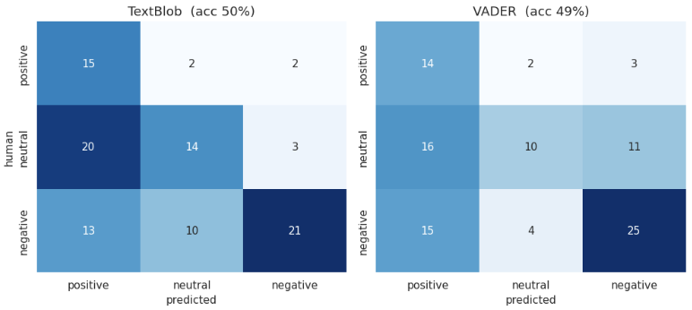
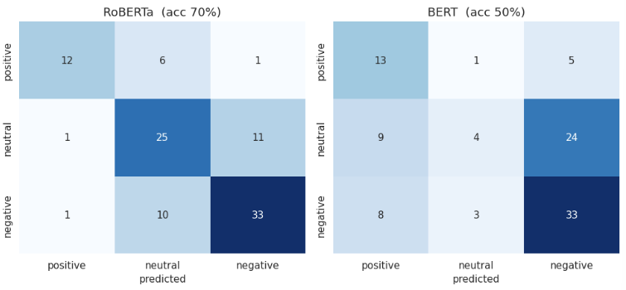
Figure 5. Human labels (rows) against predicted labels (columns). The lexicon methods push neutral comments toward positive; the transformer methods push them toward negative.
The lexicon methods find words like good, love, or nice inside an otherwise factual comment and conclude it is positive. The transformer methods read the subject matter — traffic, rent, policing — and conclude the writer is upset about it. RoBERTa makes the same kind of mistake as BERT but less than half as often.
A more serious error shows up in the lexicon results. TextBlob labelled 13 genuinely negative comments as positive, and VADER labelled 15 that way. RoBERTa did this once. These are outright reversals, and they are the direct consequence of scoring word by word without regard to negation, sarcasm, or context.

4.5 What RoBERTa gets that the others miss
Among the 25 hard cases where the methods produced all three labels, RoBERTa was the only method correct on 8 of the 13 comments that just one method got right. Five of those eight share a pattern: factual or explanatory writing about a charged subject.
- A verbatim summary of California Assembly Bill 253 on residential building permits. Every other method assigned a sentiment; the comment is a neutral description of legislation.
- An account of the Clinton impeachment investigation, written as history rather than opinion.
- Arithmetic about the price of soda, framed around cost but making no evaluative claim.
The other three are short negatives that contain no negative words at all, such as “This whole country is the Wild West now” and the quoted line “You are an unfit mother.” Neither can be scored correctly by looking up individual words; both require reading the phrase as a whole.
Note: These 25 comments were deliberately selected as hard cases and are not a second accuracy estimate. They illustrate how each method fails; the figures in section 4.2 are the ones that describe general performance.

4.6 Model selected
Twitter-RoBERTa (cardiffnlp/twitter-roberta-base-sentiment-latest) is the method used for the topic analysis. It is 20 points more accurate than any alternative, the difference is statistically significant against all three, it is the only method that identifies neutral content reliably, and it makes reversal errors at a fraction of the rate the lexicon methods do. It was also trained on social media text, which is a closer match to Reddit comments than the general-purpose training behind the alternatives.
Two limitations of the selected model should be carried into any reading of the results. It labels roughly 30% of individual comments incorrectly, so it is reliable in aggregate but not for any single comment. And its most common error is labelling genuinely neutral comments as negative, so absolute sentiment levels likely overstate negativity — though comparisons between groups remain valid, since the effect applies evenly.

5. Sentiment by Topic
Topics come from an LDA model with five topics, fitted over the full corpus by the project's topic modelling workstream and independently reproduced for this analysis. Net sentiment below is the share of positive comments minus the share of negative comments, in percentage points. A more negative number means a more critical topic.

5.1 Results across all comments
Topic | Positive | Neutral | Negative | Net | Comments
Politics and Public Policy | 9.0% | 32.1% | 58.9% | -49.9 | 94,345
Housing Affordability and Urban Issues | 9.6% | 33.3% | 57.2% | -47.6 | 126,908
News Reactions and Opinion Commentary | 12.2% | 30.0% | 57.8% | -45.6 | 81,009
General Discussions and Everyday Experiences | 17.7% | 34.6% | 47.7% | -30.0 | 91,442
Neighborhoods and Living Conditions | 17.2% | 43.5% | 39.3% | -22.1 | 104,443

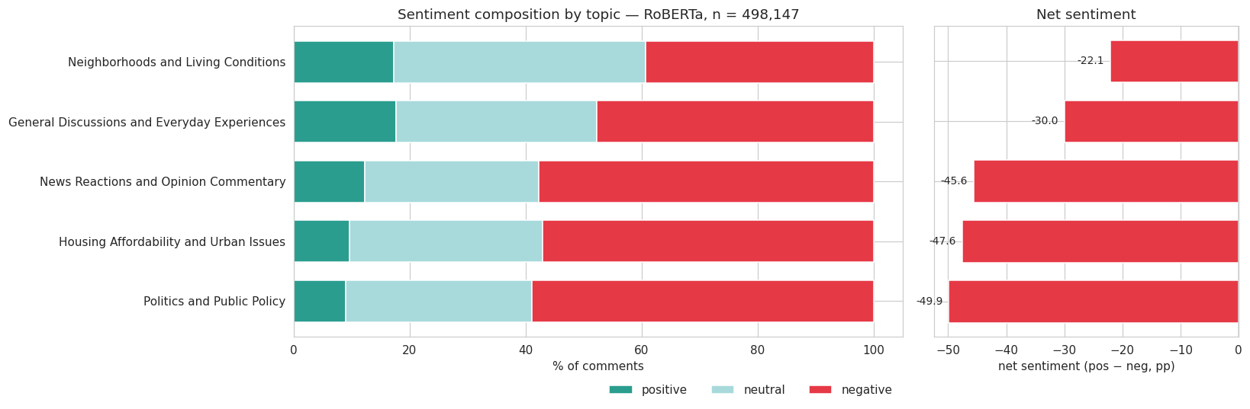
Sentiment composition and net sentiment by topic

Figure 6. Left: class composition per topic. Right: net sentiment, positive share minus negative share.
Two of these five topics are residual groupings rather than coherent subjects. General Discussions covers unrelated everyday material — groceries, television, parenting, driving — and News Reactions collects commentary on public affairs, figures, and events without a single unifying subject. Sentiment figures for both reflect a mixture of content and should not be read as the community's attitude toward any particular thing. The three remaining topics are interpretable.

5.2 The main finding
Interpretable topic | Net sentiment
Politics and Public Policy | -49.9
Housing Affordability and Urban Issues | -47.6
Neighborhoods and Living Conditions | -22.1

The gap between the most and least critical topic is 27.8 points. Discussion of politics and of housing policy is sharply negative; discussion of neighborhoods, transit, and getting around the city is far less so. Criticism in this community is directed at institutions and policy rather than at the place itself.
Housing sitting alongside politics rather than alongside neighborhoods is worth noting. Housing could plausibly be discussed as a feature of daily life, but the sentiment pattern suggests it is discussed mainly as a policy failure.
Part of the mechanism is visible in the neutral column of the previous table. Neighborhoods carries 43.5% neutral against Politics' 32.1%, because much of that topic is informational — which route to take, where to park, and how the airport terminals are numbered. Politics offers fewer opportunities for a comment to be neutral.
With between 81,000 and 127,000 comments per topic, every gap in these tables is far larger than sampling variation. All differences reported here are real.

5.3 How to read the absolute levels
RoBERTa's most common error on the human-coded benchmark is labelling genuinely neutral comments as negative, which it did 11 times out of 100. Measured sentiment levels therefore run more negative than the underlying reality. The size of that effect cannot be reliably estimated from a benchmark of this size, so no numerical correction is applied, and the measured figures are reported as they stand.
The headline is therefore not that every topic is negative, but that there is a wide gap between how residents discuss institutions and how they discuss the places they live. Because the bias applies evenly across topics, that comparison is unaffected.

6. Robustness Checks
The topic ranking was tested three separate ways. It survives all of them unchanged.

6.1 Weakly assigned comments are not driving the result
LDA assigns every comment a probability of belonging to its topic. Many assignments are weak — the median is 0.480 against 0.200 for a comment assigned at random. Restricting to comments assigned with at least 0.50 probability retains 228,023 comments, 45.8% of the corpus:
Topic | Net (all) | Net (confident only) | Change
Politics and Public Policy | -49.9 | -47.5 | +2.4
Housing Affordability and Urban Issues | -47.6 | -44.6 | +3.0
News Reactions and Opinion Commentary | -45.6 | -42.0 | +3.6
General Discussions and Everyday Experiences | -30.0 | -24.7 | +5.3
Neighborhoods and Living Conditions | -22.1 | -14.4 | +7.7

The ranking is identical under both views. Every topic shifts in the same direction, so weakly assigned comments were making the whole corpus look slightly more negative without changing which topics rank where.

6.2 Replies are more negative, but uniformly so
Two thirds of the corpus (65.7%) are replies to other comments rather than to the original post. A reply's sentiment may be aimed at another commenter rather than at the topic, which could distort topic-level figures.
Topic | Top-level | Replies | Difference
Politics and Public Policy | -47.5 | -51.0 | -3.5
Housing Affordability and Urban Issues | -45.6 | -48.3 | -2.7
News Reactions and Opinion Commentary | -42.7 | -47.4 | -4.7
General Discussions and Everyday Experiences | -27.0 | -32.0 | -5.0
Neighborhoods and Living Conditions | -19.3 | -23.8 | -4.5

Replies are more negative in every topic, by between 2.7 and 5.0 points. Because the effect is consistent across topics, it shifts the overall level rather than changing the comparison between topics. The ranking is unaffected.

6.3 The ordering holds every month
Plotting net sentiment by month across the eleven months of the corpus shows no topic ever overtaking another. Politics and housing remain the most critical in every single month; neighborhoods remains the least critical in every single month.
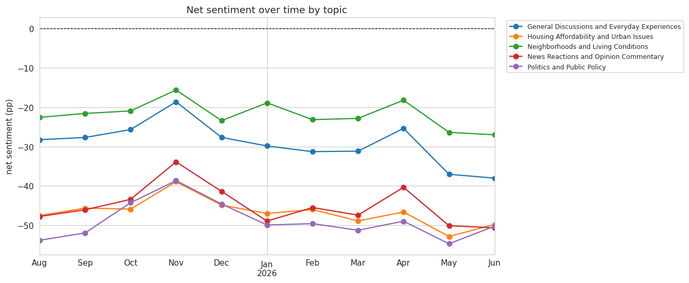
Net sentiment over time by topic

Figure 7. Monthly net sentiment across the eleven months of the corpus. No topic overtakes another at any point. The November 2025 improvement affects all five topics at once.
One corpus-wide movement is visible: November 2025 is the least negative month for all five topics simultaneously, with the largest shift in News Reactions (a 15-point improvement from October). A change affecting every topic at once points to a corpus-level event rather than a topic-level one, and the timing coincides with the Los Angeles municipal election, which appears throughout the political content of the corpus. Sentiment returns to prior levels by December.
A second movement appears at the end of the series, where Neighborhoods and General Discussions both decline noticeably from April to June while the policy topics stay flat. This has not been attributed to a specific cause.

7. What These Results Cannot Show
The following constraints should be read alongside every figure in this document.
- The benchmark is small and single-coded. One hundred comments give accuracy figures with a margin of roughly plus or minus 9 points, and all labels were assigned by one person, so no agreement between coders can be reported. The ranking of methods is clear enough to survive this, but the exact accuracy percentages should not be treated as precise.
- The selected model is wrong about 30% of the time on individual comments. Aggregate figures over tens of thousands of comments are dependable; no single comment's label should be quoted as evidence.
- Absolute sentiment levels likely overstate negativity. The selected model's most common error is labelling genuinely neutral comments as negative, so measured sentiment runs more negative than the underlying reality. The size of that effect cannot be reliably estimated from a 100-comment benchmark. Comparisons between topics, time periods, and comment types remain valid because the effect applies evenly.
- Two of five topics have no coherent subject. Sentiment for General Discussions and for News Reactions reflects mixed content rather than attitude toward a subject.
- Five topics is coarse for a corpus this size. Five was the best of the topic counts tested, but smaller counts were never tried, and the two residual groupings suggest the model may be under-fitting. Finer topics would allow more specific conclusions.
- Topic assignments are often weak. The median comment is only about 2.4 times more likely to belong to its assigned topic than to a topic picked at random, and individual assignments were found to be wrong even when confidently made.
- Sentiment is scored one label per comment. A comment praising one thing and criticising another is reduced to whichever dominates.
- Replies may be aimed at people, not topics. Two thirds of comments are replies, and hostility directed at another commenter is counted as negative sentiment within whatever topic the comment was assigned to.
- The findings describe one community over one period. Results cover r/LosAngeles between August 2025 and June 2026 and should not be generalised to other platforms, places, or times.

8. Reference Figures
All figures below are over the full corpus of 498,147 comments unless stated otherwise.
Measure | Value
Comments analysed | 498,147
Period covered | August 2025 to June 2026
Source | r/LosAngeles
Methods applied | TextBlob, VADER, Twitter-RoBERTa, multilingual BERT
Method selected | Twitter-RoBERTa (70.0% accuracy, 70.3 macro-F1)
Hand-labelled benchmark | 100 random comments, plus 25 hard cases for error analysis
Corpus sentiment (hand-labelled) | 44% negative, 37% neutral, 19% positive
Full agreement across all four methods | 19.5% of comments
Highest agreement between any two methods | Cohen's kappa 0.33 (TextBlob and VADER)
Most critical topic | Politics and Public Policy (net -49.9)
Least critical topic | Neighborhoods and Living Conditions (net -22.1)
Topics | 5, from LDA; 3 interpretable and 2 residual

