Adam Chung, Rutvik Marakana, Liam Hardage, Zachary Okwuosa

Group 5

LARZ Pizza Company

Project Plan

Contents

Scope: 2

Schedule: 3

Team Organization: 5

Resumes: 6

Technical Description: 10

Data Management Plan: 12

Test Plan: 14

# Scope:

1. Customer Record
   * Customer Name
   * Customer Address
   * Customer Phone
   * Customer Charge Account

1. Payment
   * Check
   * Cash
   * Credit Cards
   * Amount Paid

1. Database
   * Customer Database showing customer transactions
2. Payment Receipt
   * Place to sign the receipt if the payment is done by credit card
   * Customer information
   * Items ordered
   * Delivery or pickup
   * Amount due
3. Restaurant Menu
   * Pizza sizes
   * Typical toppings
   * Crust options
   * Beverages
   * Extras

# Schedule:

|  |  |  |  |  |  |  |
| --- | --- | --- | --- | --- | --- | --- |
| ***Task ID*** | ***Work Breakdown Structure*** | ***Planned Start*** | ***Planned Finish*** | ***Workload-planned*** | ***Workload- actual*** | ***Progress***  ***(% Complete)*** |
| 1_1 | Customer Name | 3/4/2020 | 3/11/2020 | 3 person hours |  |  |
| 1_2 | Customer Address | 3/4/2020 | 3/11/2020 | 3 person hours |  |  |
| 1_3 | Customer Phone | 3/5/2020 | 3/12/2020 | 4 person hours |  |  |
| 1_4 | Customer Charge Amount | 3/5/2020 | 3/12/2020 | 4 person hours |  |  |
| 2_1 | Check | 3/15/2020 | 3/22/2020 | 3 person hours |  |  |
| 2_2 | Cash | 3/15/2020 | 3/22/2020 | 3 person hours |  |  |
| 2_3 | Credit Cards | 3/15/2020 | 3/22/2020 | 3 person hours |  |  |
| 2_4 | Amount Paid | 3/15/2020 | 3/22/2020 | 3 person hours |  |  |
| 3_1 | Customer Database | 3/12/2020 | 3/18/2020 | 9 person hours |  |  |
| 4_1 | Receipt signature place | 3/22/2020 | 3/31/2020 | 3 person hours |  |  |
| 4_2 | Customer information | 3/22/2020 | 3/31/2020 | 3 person hours |  |  |
| 4_3 | Items ordered | 3/22/2020 | 3/31/2020 | 3 person hours |  |  |
| 4_4 | Delivery or Pickup | 3/22/2020 | 3/31/2020 | 3 person hours |  |  |
| 4_5 | Amount Due | 3/22/2020 | 3/31/2020 | 3 person hours |  |  |
| 5_1 | Pizza Sizes | 4/1/2020 | 4/13/2020 | 4 person hours |  |  |
| 5_2 | Typical Topings | 4/1/2020 | 4/13/2020 | 4 person hours |  |  |
| 5_3 | Crust Topings | 4/1/2020 | 4/13/2020 | 4 person hours |  |  |
| 5_4 | Bevarages | 4/1/2020 | 4/13/2020 | 3 person hours |  |  |
| 5_5 | Extras | 4/1/2020 | 4/13/2020 | 3 person hours |  |  |

# Team Organization:

|  |  |  |
| --- | --- | --- |
| Roles | Identity | Responsibilities |
| • Technical and Graph Provider • Organizer | Adam Chung | Provides graphs to from existing data to visualize the data. Organize the layout of the project. |
| • Database Administrator • File manager | Rutvik Marakana | Manage the customer database. Arrange all the documents in a file so that it is easy to access. |
| • Lead Designer • Project Manager | Zachary Okwuosa | Design the GUI of the software Leads the project planning to achieve all of the desired goals |
| • Creativity Analyst • Programmer | Liam Hardage | Organizes and expresses ideas that will be implemented into the program. Will program said ideas into working code. |

# Resumes:

Chung, Adam P

Sandy Springs, GA 30350 | https://www.linkedin.com/in/chungadam/ | 404-492-3368 | achung12@students.kennesaw.edu

Objectives

To secure a programing internship that would utilize my knowledge in programming, organizational, and mathematical skills

Education

Kennesaw State University, Marietta, GA

Bachelor of Science in Computer Science Expected: June 2022

Current GPA: 3.55 / 4.0

Coursework: CSE 1321, CSE1322

Georgia State University, Atlanta, GA

Dual-Enrollment May 2017- May 2018

Professional Experience

Publix Super Market | Sandy Springs, GA August 2017 - August 2019

Cashier/Front Service Clerk

● Provided premier customer service to over 150 customers a day, including greeting customers and responding to their questions

● Maintained clean cases, shelves, floors, stock room, and dairy coolers

● Retrieved shopping carts from the parking lot

● Adhered to Publix customer satisfaction standards

Stratix Corporation | Norcross, GA June 2018 - August 2018

Intern

● Restored mobile devices and prepare for refurbishing and customer specifications

● Categorized inventory by designing pallet layout and completed inventory checks

● Configured and programmed mobile devices to ship out

Community Service

Community Assistance Center | Sandy Springs, GA June 2017 - July 2017

● Distributed food to hundreds of people in need of groceries

● Unloaded grocery items from local grocery stores

● Categorized and price toys for customers to purchase

Skills

● Proficient in Microsoft Office

● Programming Languages: Python, Java

● Critical Thinking

● Customers Service Experienc

● Organization Skills

|  |
| --- |
| RUTVIK MARAKANA  MARIETTA, GA 30060 | 551-246-2667 | [marakanarutvik@gmail.com](mailto:marakanarutvik@gmail.com) |

# Experience

|  |
| --- |
| no previous work expereince |

# Education

|  |
| --- |
| RYAN INTERNATIONAL SCHOOL | 2014 – 2016• Graduated with 3.94 gpA• GRADUATED IN TOP 10% OF CLASS• COURSEWORK IN MATHEMATICS, SCIENCE, ENGLISH, HINDI, SOCIAL STUDIES |
| DON BOSCO SENIOR SECONDARY SCHOOL | 2016 - 2018  * GRADUATED WITH 3.95 GPA * GRADUATED IN TOP 10% OF CLASS * COURSEWORK IN MATHEMATICS, CHEMISTRY, PHYSICS, ENGLISH, PHYSICAL EDUCATION |

# Skills

|  |  |
| --- | --- |
| * Familiar with Java and SSMS * Database Management Skills * Fluency in English, Hindi and Gujarati languages | * Active listening * Research skills * Interactive and Supportive |

# PROJECTS

# DATABASE PROJECT| AUGUST 2019 – DECEMBER 2019

# • CREATED a database project that keeps up with the data required in A construction company under the supervision of a computer science professor.

# • USED SQL CODE TO CREATE THE DATABASE.

# MATHEMATICS PROJECT | JANUARY 2020 – PRESENT

# • CREATING A PROJECT THAT DEMONSTRATES THE USE OF LU DECOMPOSITION (LINEAR ALGEBRA TOPIC) UNDER THE SUPERVISION OF A MATHEMATICS PROFESSOR.

# • CREATING A JAVA PROGRAM TO DEMONSTRATE THE THEME OF THE PROJECT.

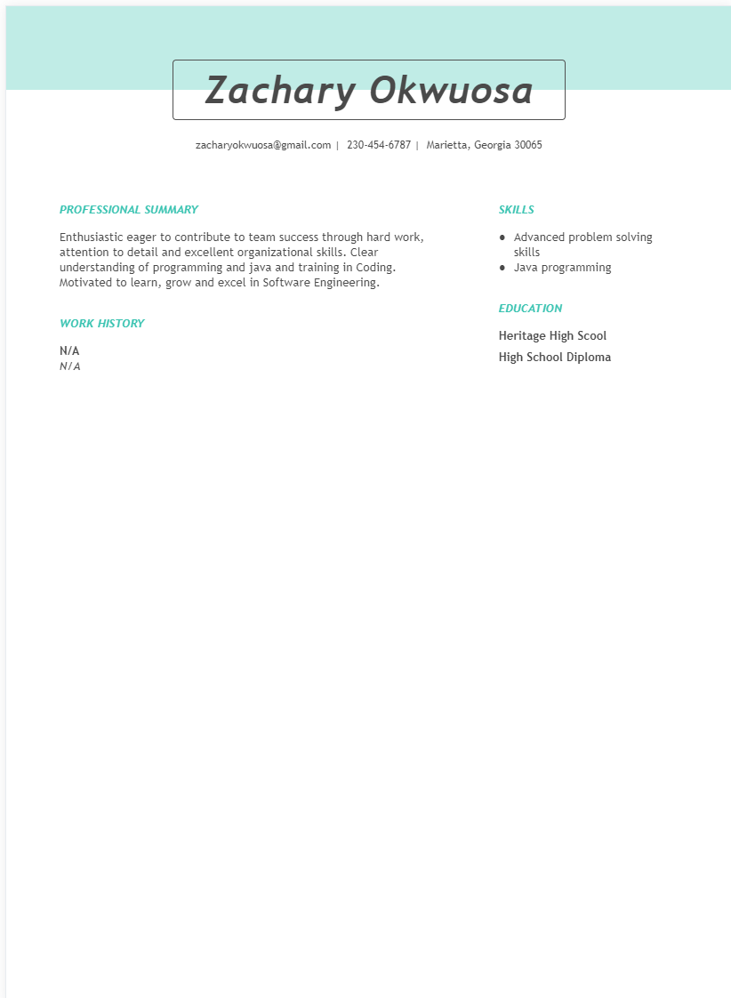

Hardage, Liam K

Savannah, GA 31419 | 912-414-1984 | [lhardag3@students.kennesaw.edu](mailto:lhardag3@students.kennesaw.edu)

-Professional Experience-

None yet...Shape

Shape

-Education-

Kennesaw State University, Marietta, GA

Bachelor's in software engineering

Anticipated Completetion: June 2022

Current GPA: 3.5

Shape

-Current Goals-

To achieve an internship or job with the intent of utilizing my knowledge in programming and/or other computing skills.

-Skills-

Certified in Microsoft Office 2010, Excel 2013, & Powerpoint 2013

Experienced with the programming languages: C#, Java, and Python

# Technical Description:

Our mom and pop pizza venue is a venture that requires our website to have subtlety, mom and pop operations don’t need the flair and grand looks big corporations have since they are small in nature and operation. Our website landing page is divided into 4 sections, the first section being for the pizzas, it has our specialties/deals then under is the normal pizzas and create a custom-made pizza. Next section is the appetizers, featuring options like breadsticks, cheesy bread, chicken wings, brownies, cookies, etc. Next to it is our is our beverages, we have an array of options from coca cola products to minute maid and fruit juices. By the side next to the drink the user can select the size of the beverage. The user adds it to their cart within these sections

The next area is the checkout of our operation, it has a log in/sign up for membership and usage of awards and points, if not the user can check out as a guest, followed by that it has a bar for the user to insert their address to determine proximity and if we are able to deliver to location. Then it displays the total and list of items added to cart. Our website then under has a location to put card information and gift cards to pay for their items if using the delivery option.

Finally, we also have the carryout option for the user to come pick up the pizzas at the store by themselves.

A few more components we need to address are the requirements needed to run the program, the minimum requirement to run this software is intel i3, it is not an intensive so most users wouldn’t have any problem accessing this. The user hardware requirements include nothing too grand, a simple computer that utilizes the operating system of windows and Macintosh. The user should be fine with these options. Building this application comes with a few hurdles before it can actually be completed, we as a team cannot perform these certain actions.

***Development restrictions***:

* + Translate our text for other users. So, customers who are unfamiliar with English can’t place an order with us because they will be unable to understand our text.
  + Not having an easy access, and it is not convenient for other users. Our software does not run on mobile phones or on televisions even though they have internet access. So, customers who don’t have access to laptops or computers cannot place an order with us.
  + We’re not able to incorporate tracking mechanism for our hungry customers. Tracking mechanisms allow customers to know when their order is prepared, when its packed and when it's out for delivery.

***Coding methods:***

* + We will be utilizing and using eclipse with JavaFX, and within JavaFX we will incorporate the use of event handlers, buttons, and text boxes for the entering of information.
  + Modular code to increase efficiency to re-use elements of existing code, instead of not coding again and to make the program fully functioning.
  + We will be utilizing and using SQL Server Management Studio (SSMS) to create the database that holds the information of the customer.
  + We will incorporate security requirements to ensure that our data files are not leaked to the ones who don’t have access to it.

# Data Management Plan:

The pizza company customers have access to their personal information (Name, Address and phone Number) they entered while creating an account on the pizza company website. We have provided the opportunity to change personal information to the customers because some customers move to a different address and want the order to be delivered to the new address and so they need to update their existing address. Further, some customers might change their phone number, so they need to update their number. This feature is of great use because some customers might enter incorrect information and want to change their information. They can also change the type of charge account and add or delete credit card information.

Our pizza company customers will be able to access the points they would have earned by ordering from our store. By accessing the points, the customers can check how far they are from earning great and exciting reward. Further, customers have access to coupons our store will generate. By using these coupons customers can save some money on their orders.

The store manager is given the access to the customer database. By looking at the customer database, manager can check each customer’s name, address, phone, type of charge account, delivery information, the date of the customers first order and the total orders placed by that customer. The manager is also given access to the coupons generated by our store. By accessing the customer database, the manager can count the number of customers the store has. Further, by giving access to the coupons, manager can generate information about the increase in customer flow and the number of new customers after the coupons were given to customers. By getting this information, manager can come up with some new and innovative offers which would increase the customer flow and thus the profits of the store.

# Test Plan:

Our test plan will go through the basic procedures in order to check whether there are bugs in the program. Ideally, we will test the smaller parts as we create them to find minute issues such as syntactical errors or possible logic flaws. As the project grows, we will shift our focus into the larger connections between files and programs. This means we will test if the information inputted into an account stays with that account then once that works, we will make sure it’s properly saved for later use. Finally, we will have some test runs where we try to order pizza normally and abnormally to aid in locating bugs.

This, of course, is a minor summary of what we will do in order to make sure the program is running efficiently. After our own testing phase for possible issues in the program, we will attempt to run through it in the mindset of a new customer. This step could also involve inviting a random participant to use our program to figure out what parts are difficult to understand. Once we have enough information, we can rework minor details, debug, and test once more. The importance of this loop is crucial as the program should be inviting and easy to use for new and returning customers of the restaurant.

As for the storage of data and access for both employees and management. There will be a log in page that will confirm the users position in the pizza shop once the user logs in. This info will be pulled from the data structure we will have created that will store the information of each person who has signed up to the website. Less important information will be temporarily saved in memory such as individual orders. Once an order is complete or printed out it can be deleted from the employee side of the program. This can be handled when we investigate paging issues as is deals with the same memory problem.