# Capabilities

This module is created to expose Salesforce campaigns as Sitecore roles. Salesforce campaigns appear in Sitecore as roles. This enables the following:

• Salesforce campaigns can be created using the Sitecore API

• Salesforce campaigns can be managed using the Sitecore Role Manager

• Salesforce contacts can be associated with campaigns via Sitecore User/Role Management.

• Developer can use source of this module as an example of how to customize Sitecore Salesforce.

# Installation

Note: You should have Sitecore 7.5 or greater with Sitecore Salesforce Connect package installed, although you should have your SalesForce user configured to work properly with Sitecore Salesforce Connect package. If you don’t – please see [Sitecore-Salesforce-Connect docs on GitHub](https://github.com/adamconn/sitecore-salesforce-connect/tree/5085c4c072de3559d21f8b92bd9b88d68b58ea3a/docs) to make all required configuration.

## Salesforce configuration

In addition to all rights, that should have your user, it should be a [Marketing user](https://success.salesforce.com/answers?id=90630000000h1bpAAA) to create campaigns.

So go to User Edit Screen and turn on the “Marketing User” checkbox

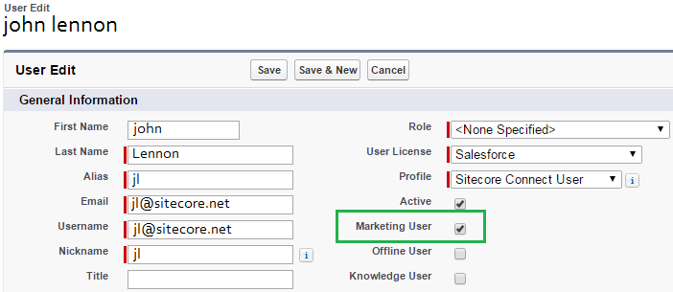

Although this user should have “Create” permissions on Salesforce Campaigns:

* 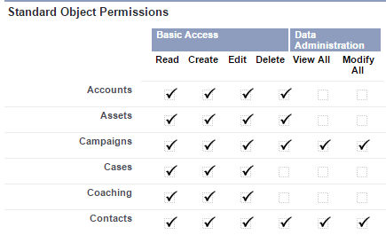Open “Sitecore Connect User” Profile, which was created for Sitecore Salesforce Connect
* Scroll down to Standard Object Permissions
* Set all permissions for Campaigns: Read, Edit, Delete, View All, Modify All

## Sitecore Installation

To deploy this feature to your site just install provided package to your sitecore via package installation wizard.

Or you can do it manually – just put

Sitecore.Salesforce.CampaignExtension.dll to website\bin directory

Sitecore.Salesforce.RoleCampaign.config to website\App_Config\Include directory

**If you are developer** – extract solution to your sitecore root directory (level up from website), copy Sitecore.Salesforce.RoleCampaign.config to website\App_Config\Include directory and use Sitecore.Salesforce.CampaignExtension.sln

If you have multiple Salesforce Connect configurations – just go to Sitecore.Salesforce.RoleCampaign.config, find section <configurations> and enable your Campaign provider for all of them.

# Expected result

After all the steps are done – you should be able to see and manage salesforce Campaigns as Sitecore roles under Salesforce domain.

And You should be able to see and manage Sitecore “salesforse” domain roles as Campaigns in salesforce.

