Goel-Okumoto NHPP Software Reliability Growth Analysis & Modeler

Using GO Modeler…
Click the “Load Data…” button
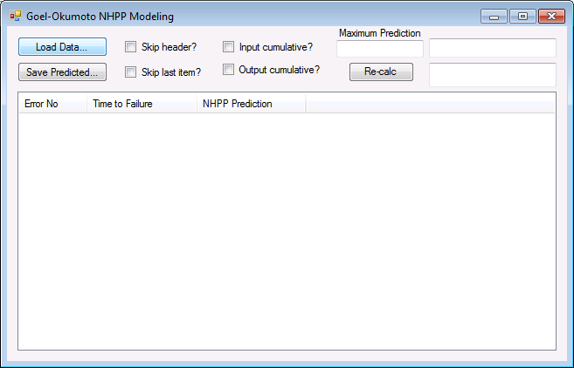

Choose an input file (three examples were provided: input1.csv, input2.csv, and input3.csv)

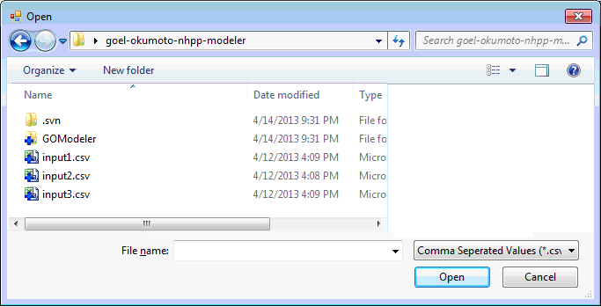

The file will be loaded and the model will be fitted to the input data.

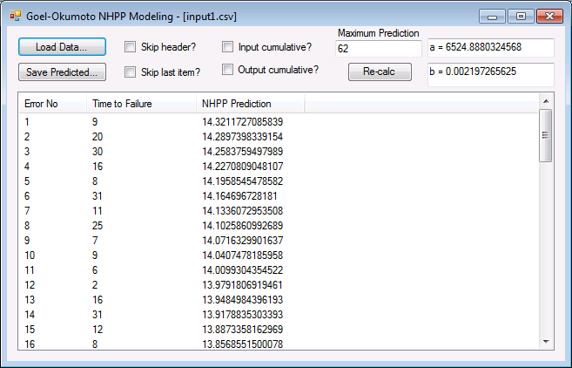

To predict future values beyond your data using Goel-Okumoto NHPP, change the Maximum Prediction to your desired end value and press the “Re-calc button”.

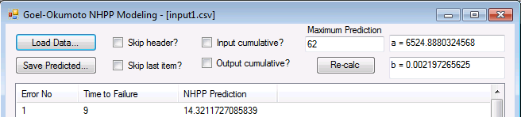

To save your prediction in CSV format click the “Save Predicted” button and choose the name of the output file.

Now, open the CSV file in your favorite Data Analysis tool (MATLAB, Mathmatica, Excel) and plot the results. Here are some example plots from Excel…

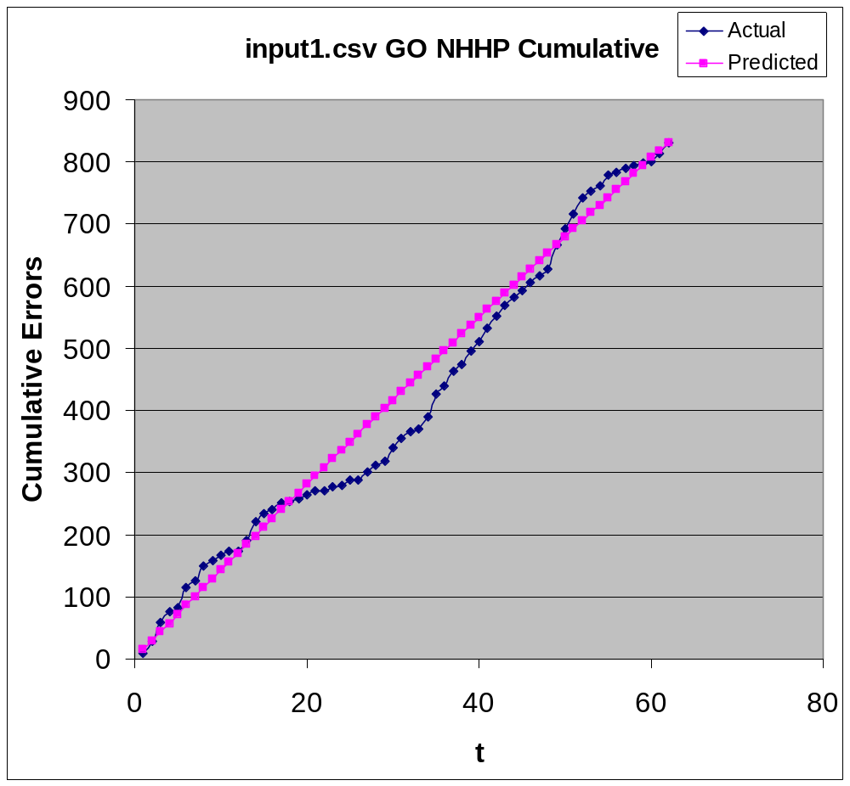

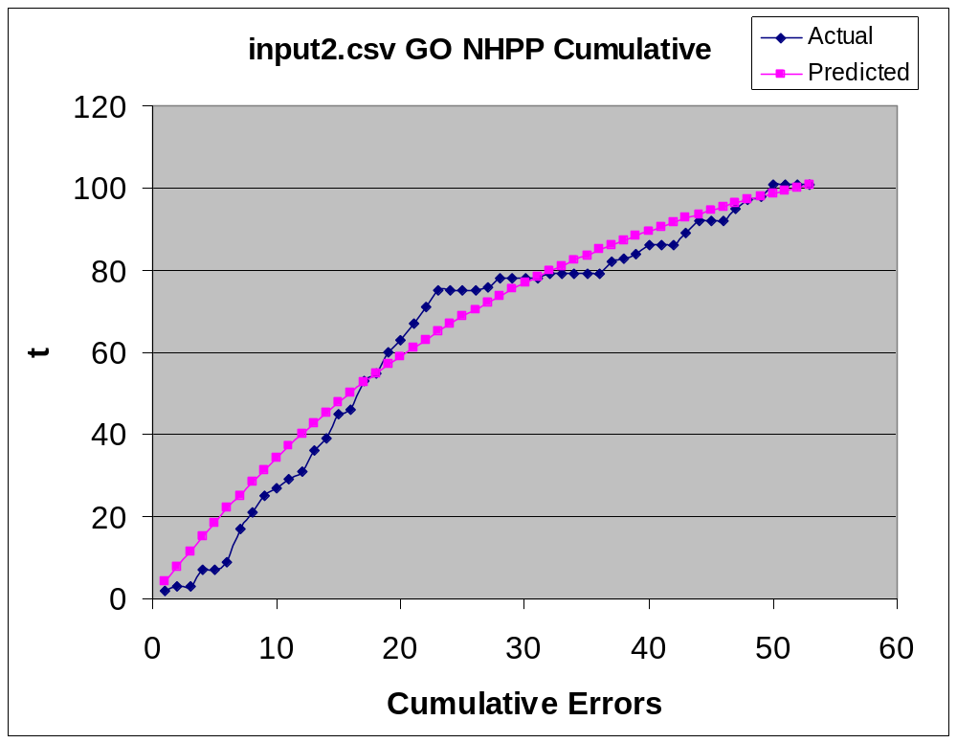

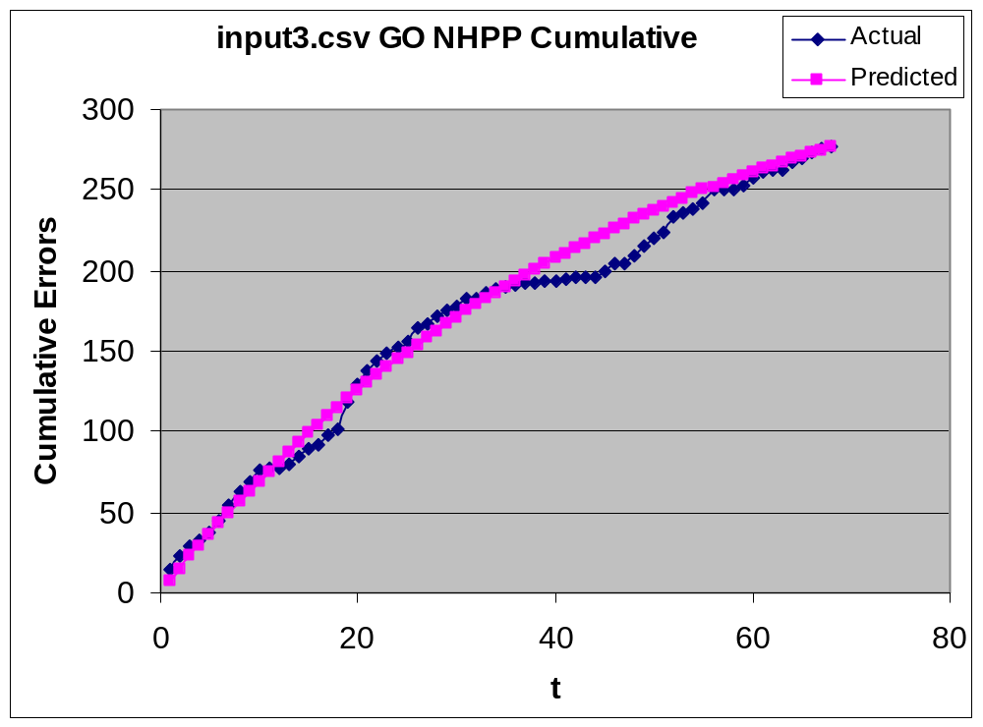
Have fun!

