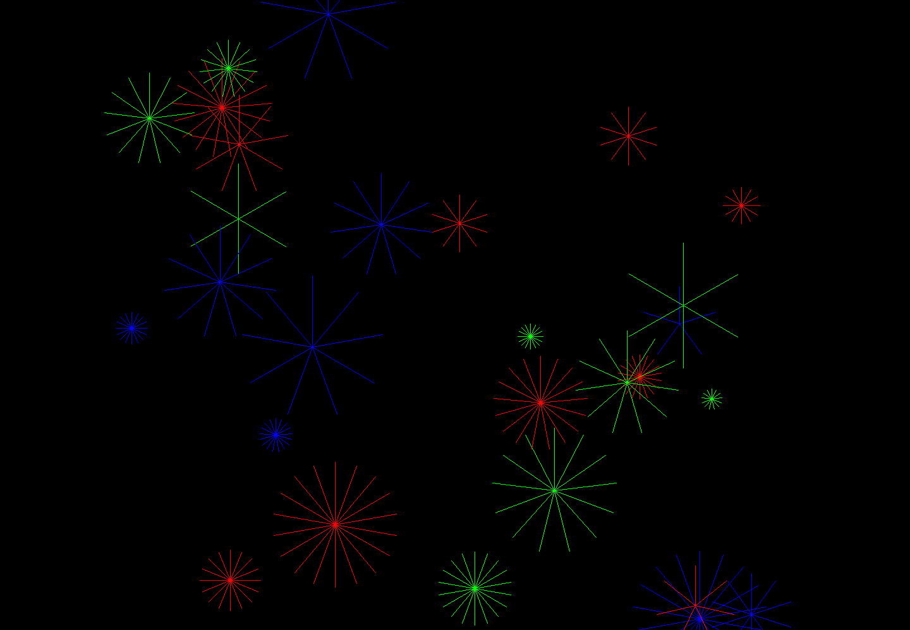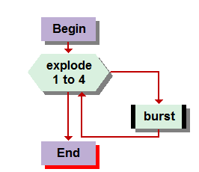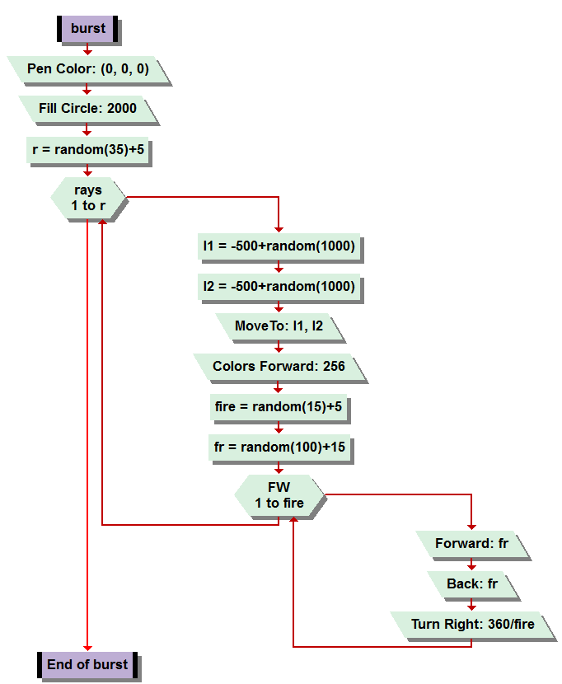

Okay so for the first time I really feel like a genius. Disappointed though I am, however, that so many people on the discussion board simply are dismissing this as, “very difficult” in a matter of other phrases, such to the point that I feel they are not even reading the ample amount of problem solving hints and solutions I wrote out in plain English all over the board. They sound like they are giving up when if they could just take a second to read and compute the information I have shared anybody could write this program, and its frustrating, until I see my post referenced on another post and, yes, it was not wasted, at least I know ONE person out there read and could use the information I provided for them.   
  
SO it was not that hard. I read the chapter two times through and some key parts over more thoroughly. I examined the chart early in the chapter with layout of all the commands and their explanations for what felt like an eternity. I really only was on the computer for maybe a half hour working on this before I got it. Now I did get lucky, I thought of something totally genius, if you haven’t noticed I have a slight favoritism towards that word… lol My stroke of genius was, the way I found a way to position and reposition the bursts all over the screen. But that’s later in the process, lets start from the beginning.

First we fill a circle with a value of 2000 to black, to create the perfect night sky. Then we generate a random number, variable “r.” Variable r will ultimately represent the number of fireworks that are created. I used a random(35)+5 value for this, but found that I had to run the entire procedure through a for loop 4 times to satisfy my pyromania. I could have easily changed the random value to 120+20 but I was lazy and already satisfied with the coding I had laid in order to solve it as quick as I did, so I took a lazy fix.   
  
A for loop is then generated to start at one, increase by one, until it reaches the random value of variable r. Whatever the value may be, each time until it is reached, it creates a fire work. And it does so, at a random location, with a random color, which I intend on playing with more in the future to make a much more magical “finale” if you will. The random location, which I had posted so many times on the message boards, was found with a plotted location of -500+random(1000). This allows the point plotted to exists anywhere between -500 on one end of the graph, depending on x or y coordinate, or positive 500, and everywhere between. Then we create the spectacle. ( I wonder if this is easier or harder than real fireworks… LOL)  
  
We generate another random number “Fire”, which will depict the number of lines generated in the explosion. Fire is a random value (15)+5 so there will be at least 5 lines and no more than 15, or twenty? Not sure about that lol. Anyway Another random variable, “FR” will determine the length of the line. SO the loop runs however many times “Fire” decides. Then moves “forward” “FR” the random amount, then back, then rotates 360/fire degrees to complete the image.   
It was simple. It was awesome. It was, exhilarating. I am proud.