Lab06

- Hybrid students submit the entire lab (parts 1 & 2) via Blackboard.
- Face to face class:
  - print Part 1 and hand in
  - Learn Part 2 for quizzes

Part 1: Hands on.
- Add an additional drive to your PC. (20 points)

Use (My) Computer and right clicking on the drive to find: (20 points)
Your PC’s drive capacity before the new drive was added
Snip before the drive was added
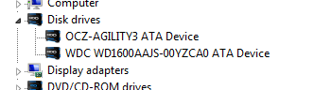

Your drive capacity after the new drive was added
Snip after the drive was added
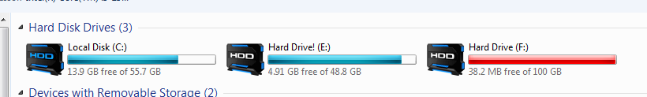

Part 2
Vocabulary:
- What is the relationship among tracks, sectors, and clusters that reside on disks formatted with a FAT system? (10 points)

A type of firm ware that allows the mother board to communicate with the clusters of magnetized data on the sectors of tracks
- What is contained in the boot sector and why do we need one? (10 points)
The operating system or firmware used to instruct the mother board how to communicate with that particular piece of equipment the boot sectors are found upon.
- What are the chief differences between the parallel ATA and serial ATA interface standards? (10 points)
Serial data paths allow for only one device per data cable and are much faster than parallel ata’s which allow for two.
- What are the chief differences between the IDE and SSD drives? (10 points)
IDE’s or PAta use ribbon cables that can accomidate one or two drives and the hardware is always a magnetic hard drive with moving parts. A solid state drive is like a very large flash drive which does not contain moving pieces within and is much faster than any magnetic hard drive and IDE.
- Why would someone partition a hard drive? (10 points)
A partitioned hard drive is a good idea for single hard drive computers so you can keep your operating system and essential operating functions on one partition and all your data on another so that even if you are presented with a virus or mal ware in your data your system will still be usable because your operating system is on another drive.
- What does Defrag mean? Why is it necessary?(10 points)
Defragmentation is when you clean up all the little bits and pieces of un-erased data that is left behind when a drive writes to a disk and then writes over it when it is deleted. It greatly improves performance because it makes finding the necessary information on a drive that much easier when there are not misplaced bits and pieces left over.

