LAB EXERCISE REPORT FOR WEEK 4

BITP 3123 Sem 2 2020/2021

MOHAMAD ADAM DANIEAL BIN SLUHUDIN HAMDAN

B031910495

**Table of Contents**

Document Information 1

Solution for Exercise 3 1

Solution for Exercise 5 4

# Document Information

### This document described the solutions and outcomes for Lab 4.

# Solution for Exercise 3

## Client.java

package Exe3Method1;

import java.io.IOException; import java.io.PrintStream; import java.net.Socket;

import java.net.UnknownHostException; import java.util.Scanner;

import java.io.DataInputStream; import java.io.DataOutputStream; import java.net.InetAddress;

public class Client

{

public static void main(String args[])throws UnknownHostException, IOException

{

//define variable String text;

//create object, syntax for input Scanner sc= new Scanner(System.***in***);

Socket s = new Socket("127.0.0.1",4646);

//create output stream, utk send ke server

DataOutputStream outputStream = new DataOutputStream(s.getOutputStream());

//output

System.***out***.println("Enter Any Words: ");

//input syntax text=sc.nextLine();

//send data to server, send text yg client tulis outputStream.writeUTF(text); outputStream.flush();

//create input stream, utk baca dari server

DataInputStream dataIn = new DataInputStream(s.getInputStream());

//read from server

int textword = dataIn.readInt();

//kt sini print number of word sent dri server System.***out***.print("Number of Words: "); System.***out***.println(textword);

}

}

## Server.java

package Exe3Method1;

import java.io.IOException; import java.io.PrintStream; import java.net.ServerSocket; import java.net.Socket; import java.util.Scanner; import java.io.BufferedReader;

import java.io.DataInputStream; import java.io.DataOutputStream; import java.io.InputStreamReader;

public class Server

{

private static final String ***String*** = null;

public static void main(String args[]) throws IOException

{

String words; int count=0;

ServerSocket s1=new ServerSocket(4646);

//accept client request Socket exe3=s1.accept();

//create input stream, utk baca dari client

DataInputStream dataIn = new DataInputStream(exe3.getInputStream());

//read data from client, pakai readUTF sebab String words=dataIn.readUTF();

//call method count=*countWord*(words);

//Create output stream to send back to client DataOutputStream dataOut = new

DataOutputStream(exe3.getOutputStream());

//send data kt client, pakai writeInt sebab integer dataOut.writeInt(count);

dataOut.flush();

//Close everything s1.close();

exe3.close(); dataIn.close(); dataOut.close();

}

public static int countWord(String words)

{

if(words.isBlank())

{

return 0;

}

int count = 0;

for(int index = 0;index<words.length() -1 ;index++)

{

if(words.charAt(index) == ' ' && words.charAt(index +1) != ' ')

{

count += 1;

}

}

return count + 1;

}

}

## Output

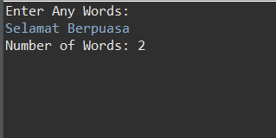

# Solution for Exercise 5

## ClientSide.java

package Exe5;

import java.io.DataInputStream; import java.io.DataOutputStream; import java.io.IOException; import java.net.InetAddress; import java.net.Socket;

import java.util.Scanner;

public class ClientSide {

public static void main(String[] args) { try {

//Connect to the server at localhost for port 4646

Socket socket = new Socket(InetAddress.*getLocalHost*(),4646);

//Create input object

Scanner sc = new Scanner(System.***in***);

//create output stream, utk send ke server DataOutputStream outputStream = new

DataOutputStream(socket.getOutputStream());

//Display

System.***out***.println(" "); System.***out***.println("\t Client Side");

System.***out***.println(" "); System.***out***.println(" ");

//Input From User

System.***out***.print("Enter Words In English: "); String text =(sc.nextLine());

//send data to server, send text yg client tulis outputStream.writeUTF(text); outputStream.flush();

//create input stream, utk baca dari server

DataInputStream dataIn = new DataInputStream(socket.getInputStream());

//assign object to read data from server String translatedText = dataIn.readUTF();

System.***out***.println("\nTranslated text: " ); System.***out***.println("\nMalay Arabic Korean");

//print translated text sent from server System.***out***.println(translatedText);

//Close everything outputStream.close(); sc.close(); socket.close(); dataIn.close();

} catch (IOException e) {

// **TODO** Auto-generated catch block e.printStackTrace();

}

}

}

## ServerSide.java

package Exe5;

import java.io.BufferedReader; import java.io.DataInputStream; import java.io.DataOutputStream; import java.io.IOException; import java.io.InputStreamReader; import java.net.ServerSocket; import java.net.Socket;

public class ServerSide {

public static void main(String[] args) throws Exception {

ServerSocket serverSocket = null; try {

//Bind Serversocket to a port int portNo = 4646;

serverSocket = new ServerSocket(portNo);

System.***out***.println(" "); System.***out***.println("\t Server Side"); System.***out***.println("\t...Waiting for request..."); System.***out***.println("\t ...Running...");

System.***out***.println(" "); System.***out***.println(" ");

while(true) {

//Accept client request for connection Socket clientSocket = serverSocket.accept();

//Create stream to read data from client DataInputStream dataIn = new

DataInputStream(clientSocket.getInputStream());

//create new object for translator Translator message = new Translator();

//assign text read from client message.setText(dataIn.readUTF());

//Object to store text

String text = message.getText();

//Translate the text

Translator textToTranslate = new Translator(text);

//Create stream to write data to the network DataOutputStream dataOut = new

DataOutputStream(clientSocket.getOutputStream());

//Send data to the client dataOut.writeUTF(textToTranslate.getTranslatedText()); dataOut.flush();

//close the socket clientSocket.close(); dataIn.close(); dataOut.close();

}

}catch(IOException ioe) {

if(serverSocket != null)

serverSocket.close(); ioe.printStackTrace();

}

}

}

## Translator.java

package Exe5;

public class Translator {

private String text;

public Translator(String text) { this.text=text;

//this.language=language;

}

public Translator() {

}

public void setText(String text) { this.text=text;

}

public String getText() {

return text;

}

public String getTranslatedText() { String translatedText = "";

if(text.contentEquals("Good Morning")||text.contentEquals("Good morning")||text.contentEquals("good morning")) {

translatedText="Selamat Pagi الخير 좋은 아침";

}

else if (text.contentEquals("Good Night")||text.contentEquals("Good night")||text.contentEquals("good night")) {

translatedText="Selamat malam

مساء الخير

안녕히 주무세요";

}

else if (text.contentEquals("How are you?")||text.contentEquals("how are you?")) {

지내세요?";

translatedText="Apa khabar?

كيف حالكم؟

어떻게

}

else if (text.contentEquals("Thank you")||text.contentEquals("thank you")) {

translatedText="Terima kasih

شكرا جزيال

감사합니다";

}

else if (text.contentEquals("Goodbye")||text.contentEquals("goodbye")) {

translatedText="Selamat Tinggal

مع السالمة

안녕";

}

else if (text.contentEquals("What's up?")||text.contentEquals("what's up?")) {

translatedText="Ada apa?

ما أخبارك؟

뭐야?";

}

return translatedText;

}

}

## Output

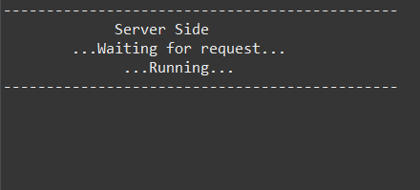

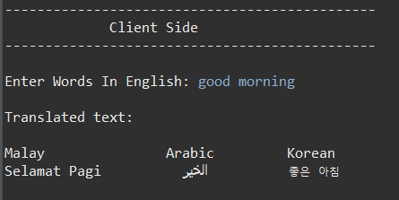

## <https://github.com/adamdanieal/DAD-Lab4>