Accessible Digital Office Document Project:  
Authoring Techniques for Accessible Office Documents:  
Microsoft Word 2010

Version

Date of Current Version: 04 Feb 2011

Latest Version (HTML): <http://inclusivedesign.ca/accessible-office-documents/word2010>

Quick Reference

[Usage Notes 2](#_Toc284509797)

[Technique 1. Use Accessible Templates 3](#_Toc284509798)

[Technique 2. Specify Document Language 5](#_Toc284509799)

[Technique 3. Provide Text Alternatives for Images and Graphical Objects 7](#_Toc284509800)

[Technique 4. Avoid “Floating” Elements 9](#_Toc284509801)

[Technique 5. Use Headings 9](#_Toc284509802)

[Technique 6. Use Named Styles 10](#_Toc284509803)

[Technique 7. Use Built-In Document Structuring Features 10](#_Toc284509804)

[Technique 8. Create Accessible Charts 13](#_Toc284509805)

[Technique 9. Make Content Easier to See 15](#_Toc284509806)

[Technique 10. Make Content Easier to Understand 16](#_Toc284509807)

[Technique 11. Check Accessibility 17](#_Toc284509808)

[Technique 12. Use Accessibility Features when Saving/Exporting to Other Formats 20](#_Toc284509809)

[Other Application Features 21](#_Toc284509810)

[Accessibility Help 22](#_Toc284509811)

[References and Resources 22](#_Toc284509812)

[Acknowledgments 22](#_Toc284509813)

# Usage Notes

## ****Overview****

At the time of testing (September 30, 2010), Word 2010 provides a set of accessibility features that is sufficient to enable the production of accessible digital office documents. In addition, Word 2010 includes an accessibility checking feature.

## What’s an “Office Document”?

You should use these techniques when you are using Word 2010 to create documents that are:

* **Intended to be used by people** (i.e., not computer code),
* **Text-based** (i.e., not simply images, although they may contain images),
* **Fully printable** (i.e., where dynamic features are limited to automatic page numbering, table of contents, etc. and do not include audio, video, or embedded interactivity)**,**
* **Self-contained** (i.e., without hyperlinks to other documents, unlike web content), and
* **Typical of office-style workflows** (Reports, letters, memos, budgets, presentations, etc.).

**If you are creating forms, web pages, applications, or other dynamic and/or interactive content, these techniques will still be useful to you, but you should also consult the** [**W3C-WAI Web Content Accessibility Guidelines (WCAG 2.0)**](http://www.w3.org/WAI/intro/wcag.php) **because these are specifically designed to provide guidance for highly dynamic and/or interactive content.**

## File Formats

The default file format for Word 2010 is **Office Open XML (DOCX)**.

In addition, Word 2010 offers many other word processor and web format saving options. Most of these have not been checked for accessibility, but some information and/or instructions are available for the following formats in Technique 12 (below):

* MS Word
* PDF
* HTML

## ****Document Conventions****

We have tried to formulate these techniques so that they are useful to all authors, regardless of whether they use a mouse. However, for clarity there are several instances where mouse-only language is used. Below are the mouse-only terms and their keyboard alternatives:

**\*Right-click:** To right-click with the keyboard, select the object using the Shift+Arrow keys and then press either (1) the “Right-Click” key (some keyboard have this to the right of the spacebar) or Shift+F10.

## ****Disclaimer and Testing Details:****

**Following these techniques will increase the accessibility of your documents, but it does not guarantee accessibility to any specific disability groups**. In cases where more certainty is required, it is recommended that you test the office documents with end users with disabilities, including screen reader users.

The application-specific steps and screenshots in this document were created using Microsoft Word 2010 (ver.14.0.4762.1000, Windows XP, Aug. 2010) while creating a DOCX document. Files are also easily saved as other file formats (see Technique 12, below).

# Technique 1. Use Accessible Templates

All office documents start with a template, which can be as simple as a blank standard-sized page or as complex as a nearly complete document with text, graphics and other content. For example, a “Meeting Minutes” template might include headings for information relevant to a business meeting, such as “Actions” above a table with rows to denote time and columns for actions of the meeting.

Because templates provide the starting-point for so many documents, accessibility is critical. If you are unsure whether a template is accessible, you should check a sample document produced when the template is used (see Technique 11, below).

Word 2010’s default template for new documents is a blank page. The basic installation also includes blank business card, blank label templates, and other blank office-related documents. These are all accessible by virtue of being blank.

It is possible to create your own accessible templates from scratch in Word 2010. As well, you can edit and modify the existing prepackaged templates, ensuring their accessibility as you do so and saving them as a new template.

## To create an accessible template

1. Create a new document (from the default blank template or from one of the prepackaged templates)
2. Ensure that you follow the techniques in this document
3. When you are finished you should also check the accessibility of the document (see Technique 11, below)
4. Go to menu item: **File > Save As**
5. Select **Templates**
6. In the **Save as type** list, select **Word Template**
7. In the **File name** box, type a name for the template. Using a descriptive **File name** (e.g., “Accessible Memo Template”) may increase the prominence of the accessibility status. As well, filling in the text box labeled Tags with the term “accessibility” may improve its searchability as an accessible file.
8. Select **Save**

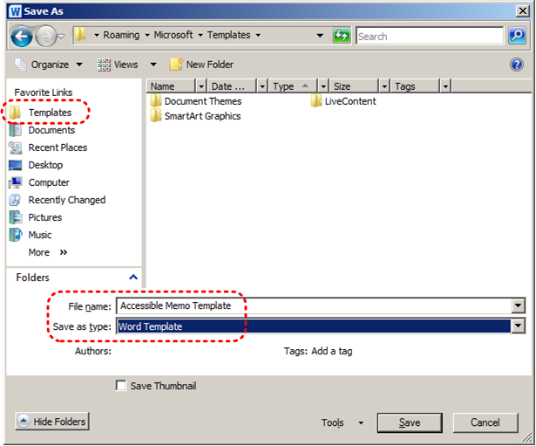

## To select an accessible template

1. Go to menu item: **File > New**
2. Under **Available Templates**, select **My Templates**

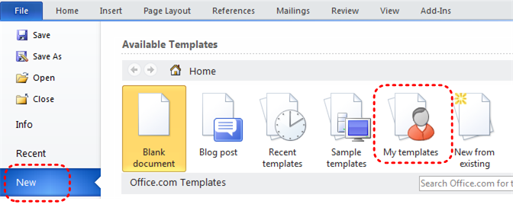

1. In the **New** document dialog, select your accessible template from the list
2. Select **OK**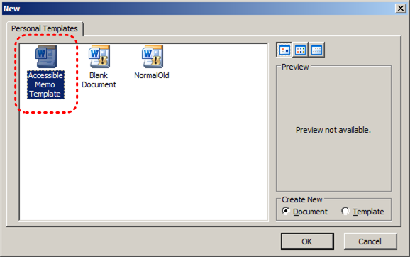
3. A new document based on the template will be displayed. If you have chosen an accessible template, the document will be accessible at this point. **As you add your content (e.g., text, images, etc.), ensure that you consult the sections that follow to preserve accessibility.**

# Technique 2. Specify Document Language

In order for assistive technologies (e.g., screen readers) to be able to present your document accurately, it is important to indicate the natural language of the document. If a different natural language is used for a paragraph or selected text, this also needs to be clearly indicated.

## To change the default language

1. Go to menu item: **File**
2. Select **Options** from the list in the left window pane
3. Select **Language** from the list in the left of the **Options** dialog
4. Under **Choose Editing Languages**, select the editing language you want to use

Note: to add an editing language, select the language from the drop down list labeled **[Add additional editing languages]**

1. Select **Set as Default**
2. Close all Office 2010 programs and open them again for the changes to take effect  
   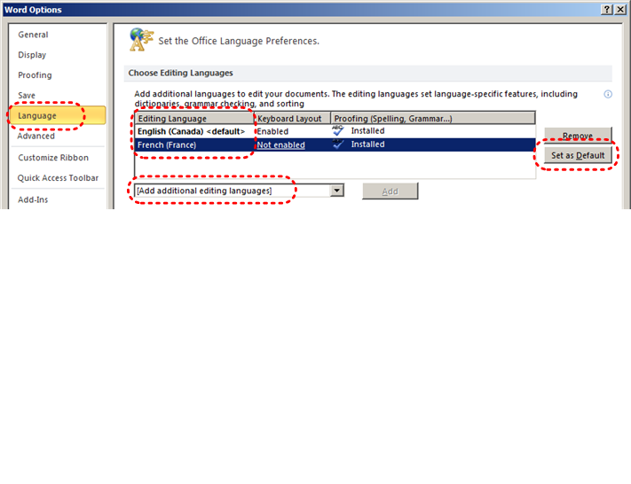

Word 2010 has an automatic language detection mechanism, which can automatically detect the language of your text. If you type a section of text in a different language than the rest of your document, Word 2010 will programmatically mark the language of that section of text appropriately.

## To turn on automatic language detection

1. Go to menu item: **Review**
2. In the **Language** section, select the **Language** button
3. Select **Set Proofing Language**
4. In the **Language** dialog, select the **Detect language automatically** check box

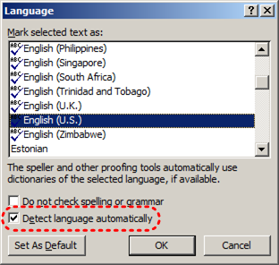

## To apply a language directly to selected text

1. Select the text
2. Go to menu item: **Review**
3. In the **Language** section, select the **Language** button
4. Select **Set Proofing Language**
5. In the **Mark selected text as** box, select the language from the list
6. Select **OK**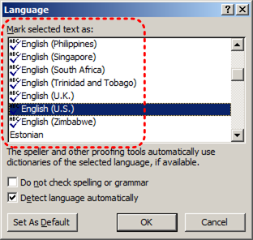

# Technique 3. Provide Text Alternatives for Images and Graphical Objects

When using images or other graphical objects, such as charts and graphs, it is important to ensure that the information you intend to convey by the image is also conveyed to people who cannot see the image. This can be accomplished by adding concise alternative text to of each image. If an image is too complicated to concisely describe in the alternative text alone (artwork, flowcharts, etc.), provide a short text alternative and a longer description as well.

## Tips for writing alternative text (“Title” in Word 2010)

* Try to answer the question "what information is the image conveying?"
* If the image does not convey any useful information, leave the alternative text blank
* If the image contains meaningful text, ensure all of the text is replicated
* Alternative text should be fairly short, usually a sentence or less and rarely more than two sentences
* If more description is required (e.g., for a chart or graph), provide a short description in the alternative text (e.g., a summary of the trend) and more detail in the long description, see below
* Test by having others review the document with the images replaced by the alternative text

## Tips for writing longer descriptions (“Description” in Word 2010)

* Long descriptions should be used when text alternatives (see above) are insufficient to answer the question "what information is the image conveying?"
* In some situations, the information being conveyed will be how an image looks (e.g., an artwork, architectural detail, etc.). In these cases, try to describe the image without making too many of your own assumptions.
* One approach is to imagine you are describing the image to a person over the phone
* Ensure that you still provide concise alternative text to help readers decide if they are interested in the longer description

Alternatively, you can include the same information conveyed by the image within the body of the document, providing the images as an alternate to the text. In that case, you do not have to provide alternate text within the image.

## To add alternative text to images and graphical objects

1. Right-click\* the object
2. Select **Format Picture…**
3. Select the **Alt Text** option from the list
4. Fill in the **Title**. If more description is required (e.g., for a chart or graph), provide a short description in the **Title** (e.g., a summary of the trend) and more detail in the **Description**.

**** At this time, if a Word 2010 document is ever saved to HTML, the **Title** and **Description** fields are combined into a single entry within the HTML <alt> tag. **[Tested: September 30th, 2010]**

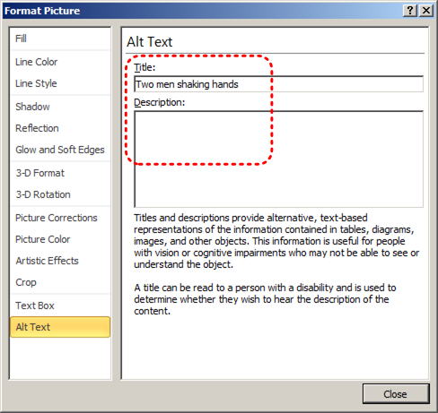

**Caution** When inserting a very small image, or resizing a larger image to be much smaller, Word 2007 assumes that the image is intended to be a bullet-point for a bulleted list. Once Word 2007 defines the image as a bullet, the option to add alternative text disappears. Select **Undo**, to redefine the bullet as an image. When you right-click\* the image, select **Format Picture…** and select the **Alt Text** tab in the **Format Picture** dialog. Alternative text can be found, or can be entered, into the **Alternative text** box.

# Technique 4. Avoid “Floating” Elements

When images and objects are inserted into Word 2010 documents they default to being an “inline object”. Inline objects keep their position on the page relative to a portion of the text.

A “floating” object keeps its position relative to the page, while text flows around it. As content moves up or down on the page, the object stays where it was placed. To ensure that images and objects remain with the text that references it, always position it as an inline object.

Similarly, avoid placing drawing objects directly into the document (e.g., as borders, to create a diagram). Instead, create borders with page layout tools and insert complete graphical objects.

## To prevent an image or object from “floating”

1. Select the object
2. Go to menu item: **Page Layout**
3. Select **Position** from the **Arrange** section
4. Select **In Line with Text**

# Technique 5. Use Headings

Any documents that are longer than a few paragraphs require structuring to make them more straightforward for readers to understand. **One of the easiest ways to do this is to use “True Headings” to** create logical divisions between paragraphs. True headings are more than just bolded, enlarged, or centered text; they are structural elements that order and levels provide a meaningful sequence to users of assistive technologies.

## Tips for headings

* Use the default headings styles provided (“Heading “, “Heading 2”, etc.)
* Nest headings properly (e.g., the sub-headings of a “Heading 1” are “Heading 2”, etc.)
* Do not skip heading levels

## To apply headings to selected text

1. Select text
2. Right-click\* and select **Styles**
3. Select the heading style from the list

## To apply headings using the Styles toolbar

1. Select text
2. Go to menu item: **Home**
3. In the **Styles** section, select the heading you wish to apply

Note: You can scroll through the multiple heading styles using the arrows on the right side of the **Styles** section. You can also change the **Style** design by selecting the **Change Styles** button on the right.

## To modify heading styles

1. Go to menu item: **Home**
2. In the **Styles** section, right-click\* the style you wish to use from the **Styles Gallery**
3. Select **Modify**
4. In the **Modify Style** dialog, make the appropriate changes to style characteristics
5. Select **OK**

## To return to the default heading styles

1. Go to menu item: **Home**
2. In the **Styles** section, select **Change Styles**
3. Select **Style Set**
4. Select **Word 2010** from the list

# Technique 6. Use Named Styles

As with “True Headings” (see Technique 5), you should attempt to make use of the named styles that are included with the office application (e.g., “emphasis”, “caption”, etc.) before creating your own styles or using the character formatting tools directly. Named styles help your readers understand why something was formatted in a given way, which is especially helpful when there are multiple reasons for the same formatting (e.g., it is common to use italics for emphasis, Latin terms and species names).

For more information on formatting using named styles, see Technique 9.

Note: While office application suites support headings in much the same way, the named styles often differ.

## To use default named styles

1. Default named styles can be applied the same way as headings (see Technique 5).

# Technique 7. Use Built-In Document Structuring Features

## 7.1 Tables

When using tables, it is important to ensure that they are clear and appropriately structured. This helps all users to better understand the information in the table and allows assistive technologies (e.g., screen readers) to provide context so that the information within the table can be conveyed in a meaningful way.

### Tips for tables

* Only use tables for tabular information, not for formatting, such as to position columns.
* Use “real tables” rather than text formatted to look like tables using the TAB key or space bar. These will not be recognized by assistive technology.
* Keep tables simple by avoiding merged cells and dividing complex data sets into separate smaller tables, where possible.
* If tables split across pages, set the header to show at the top of each page. Also set the table to break between rows instead of in the middle of rows.
* Create a text summary of the essential table contents. Any abbreviations used should be explained in the summary.
* Table captions or descriptions should answer the question "what is the table's purpose and how is it organized?" (e.g., "A sample order form with separate columns for the item name, price and quantity").
* Table cells should be marked as table headers when they serve as labels to help interpret the other cells in the table.
* Table header cell labels should be concise and clear.
* Ensure the table is not “floating” on the page (see Technique 4).

## To add a table with headings

1. Go to menu item: **Insert**
2. In the **Tables** section, select the **Tables** icon
3. Select the number of rows and columns you would like your table to have
4. Select the table and a **Table Tools** menu item should appear
5. Go to menu item: **Table Tools > Design**
6. In the **Table Style Options** section, select the **Header Row** check box  
   Note: Whenever possible, keep tables simple with just 1 row of headings.

**** At this time, Word 2010 does not properly communicate the location of header rows to assistive technologies. The following work-around may be used with some versions of JAWS:

**Work-around: To specify for JAWS that a table row is a header row**

1. Place the cursor in any cell within the row containing headings
2. Go to menu item: **Insert**
3. In the **Links** section, select **Bookmark**
4. Type “ColumnTitle” and press **Enter**Note: Only mark one cell in the row.

## 7.2. Lists

When you create lists, it is important to format them as “real lists”. Otherwise, assistive technologies will interpret your list as a series of short separate paragraphs instead of a coherent list of related items.

### To create an ordered or unordered list

1. Go to menu item: **Home**
2. In the **Paragraph** section, select the **Bullets** icon for unordered lists or select the **Numbering** icon for ordered lists
3. To choose a different list format, select the arrow beside the icon
4. Select a format from the format **Library** that appears in the drop-down menu

### To modify list styles

1. Go to menu item: **Home**
2. In the **Paragraph** section, select the arrow beside the **Bullets** icon for unordered lists or select the arrow beside the **Numbering** icon for ordered lists
3. Select **Define New Bullet…** to create a new unordered list format
4. Select **Define New Number Format…** to create a new ordered list format
5. In the **New Bullet** dialog or the **New Number Format** dialog, select the list characteristics
6. Select **OK**

## 7.3 Columns

Use **Columns** feature for placing text in columns.   
Note: Because columns can be a challenge for users of some assistive technologies, consider whether a column layout is really necessary.

## 7.4 Page Breaks

Start a new page by inserting a page break instead of repeated hard returns.

## 7.5 Use a Table of Contents

Creating an index or table of contents to outline office document content can provide a means of navigating the meaningful sequence of content.

The best way to generate a table of contents is after applying the predefined heading styles, such as "Heading 1" as described above, to the headings that you want to include in your table of contents. After you apply these styles, you can then create a table of contents.

### To insert a Table of Contents

1. Place the cursor in your document where you want to create the table of contents
2. Go to menu item: **References**
3. In the **Table of Contents** section, select **Table of Contents**
4. Select the style that you want to use

### To update a Table of Contents

1. Select the table
2. Go to menu item: **References**
3. In the **Table of Contents** section, select the **Update Table** button

## 7.6 Use Page Numbering

Numbering the pages of your document helps those reading and editing your document effectively navigate and reference its content. For users of assistive technologies, it provides a valuable point of reference within the document.

### To Insert Page Numbers

1. Go to menu item: **Insert**
2. In the **Header & Footer** section, select **Page Number**
3. Select where you would like to insert your page numbers
4. Select the style of page number you would like to use

### To Format Page Numbers

1. Go to menu item: **Insert**
2. In the **Header & Footer** section, select Page Number
3. Select **Format Page Numbers…**
4. In the **Page Number Format** dialog, select the page format characteristics you would like to use

Note: These changes are applied to the predefined page format styles. It does not create a new page format style.

## 7.7 Document Title

In case the document is ever converted into HTML, it should be given a descriptive and meaningful title.

### To change the title of the current document

1. Go to menu item: **File**
2. Select **Info** from the list in the left window pane
3. In the right window pane, select on the **Title** text box
4. Enter the **Title**Note: The **Title** defined in the properties is different than the file name. It is also unrelated to the template name, discussed above.

# Technique 8. Create Accessible Charts

Charts can be used to make data more understandable for some audiences.  However, it is important to ensure that your chart is as accessible as possible to all members of your audience.  All basic accessibility considerations that are applied to the rest of your document must also be applied to your charts and the elements within your charts.  For example, use shape and color, rather than color alone, to convey information.  As well, some further steps should be taken to ensure that the contents are your chart are appropriate labeled to give users reference points that will help them to correctly interpret the information.

## To create a chart

1. Go to menu item: **Insert**
2. In the **Illustrations** section, select **Chart**
3. Select a **Chart Type** from the **Chart Gallery**
4. Select **OK**
5. **Update the datasheet with the data you would like to include in your chart**
6. **Close the datasheet**

Note: **This will open the Excel document titled “Chart in Microsoft Office PowerPoint”, where you can input the data you would like to include in the chart. When you have done this, simply close the Excel window and the data will appear on the chart in the PowerPoint presentation.**

## To add titles and labels

1. In the **Chart Tools** menu section, go to menu item: **Layout**
2. In the **Labels** section, select the type of title or label you would like to define (e.g., **Chart Title, Axis Titles, Data Labels**)

## To apply a predefined Chart Layout

1. In the **Chart Tools** menu section, go to menu item: **Design**
2. In the **Chart Layouts** section, select a **Quick Layout** from the scrolling **Chart Layouts** gallery

## To change to a different predefined Chart Type

1. In the **Chart Tools** menu section, go to menu item: **Design**
2. In the **Type** section, select the **Change Chart Type** icon
3. In the **Change Chart Type** dialog, select a chart type from the left pane
4. Select a **Chart Design** from the right pane
5. Select **OK**

## Other Chart Considerations

* When creating line charts, use the formatting options to create different types of dotted lines to facilitate legibility for users who are color blind
* When creating bar charts, go to menu item: **Chart Tools > Format** and in the **Shape Styles** section select **Shape Fill** to apply a texture to help distinguish the bars
* Change the default colors to a color safe or gray-scale palette
* Use the formatting options to change predefined colors, ensuring that they align with sufficient contrast requirements (see Technique 9.2, below)

# Technique 9. Make Content Easier to See

Here are some other things to keep in mind:

## 9.1 Format of Text

When formatting text, especially when the text is likely to printed, try to:

* Use font sizes between 12 and 18 points for body text.
* Use fonts of normal weight, rather than bold or light weight fonts. If you do choose to use bold fonts for emphasis, use them sparingly.
* Use standard fonts with clear spacing and easily recognized upper and lower case characters. Sans serif fonts (e.g., Arial, Verdana) may sometimes be easier to read than serif fonts (e.g., Times New Roman, Garamond).
* Avoid large amounts of text set all in caps, italic or underlined.
* Use normal or expanded character spacing, rather than condensed spacing.
* Avoid animated or scrolling text.

**But can’t users just zoom in?**Office applications do typically include accessibility features such as the ability to magnify documents and support for high contrast modes. However, because printing is an important aspect of many workflows and changing font sizes directly will change documents details such the pagination, the layout of tables, etc., it is best practice to always format text for a reasonable degree of accessibility.

### To change the text size for a default named style

1. Go to menu item: **Home**
2. In the **Styles** section, right-click\* the **Style** you wish to modify
3. Select **Modify Style**
4. Under **Formatting** in the **Modify** dialog box, select the appropriate font size
5. Exit with **OK**

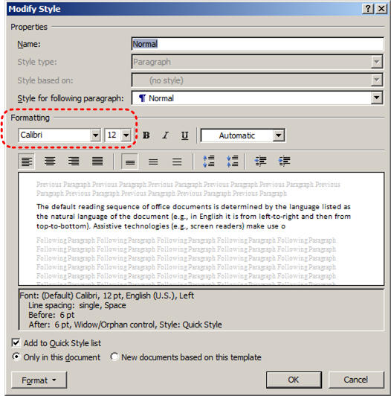

## 9.2 Use Sufficient Contrast

The visual presentation of text and images of text should have a contrast ration of at least 4.5:1. To help you determine the contrast, here are some examples on a white background:

* Very good contrast (Foreground=black, Background=white, Ratio=21:1)
* Acceptable contrast (Foreground=#767676, Background=white, Ratio=4.54:1)
* Unacceptable contrast (Foreground=#AAAAAA, Background=white, Ratio=2.32:1)

Also, always use a single solid color for a text background rather than a pattern.

In order to determine whether the colors in your document have sufficient contrast, you can consult an online contrast checker, such as:

* [Juicy Studio: Luminosity Color Contrast Ratio Analyzer](http://juicystudio.com/services/luminositycontrastratio.php)
* [Joe Dolson Color Contrast Spectrum Tester](http://www.joedolson.com/color-contrast-tester.php)
* [Joe Dolson Color Contrast Comparison](http://www.joedolson.com/color-contrast-compare.php)

## 9.3 Avoid Using Color Alone

Color should not be used as the only visual means of conveying information, indicating an action, prompting a response, or distinguishing a visual element. In order to spot where color might be the only visual means of conveying information, you can create a screenshot of the document and then view it with online gray-scale converting tools, such as:

* [GrayBit v2.0: Grayscale Conversion Contrast Accessibility Tool](http://graybit.com/main.php)

## 9.4 Avoid Relying on Sensory Characteristics

The instructions provided for understanding and operating content should not rely solely on sensory characteristics such as the color or shape of content elements. Here are two examples:

* Do not track changes by simply changing the color of text you have edited and noting the color. Instead use Word 2010’s “Track Changes” feature to track changes.
* Do not distinguish between images by referring to their appearance (e.g. “the bigger one”). Instead, label each image with a figure number and use that for references.

## 9.5 Avoid Using Images of Text

Before you use an image to control the presentation of text (e.g., to ensure a certain font or color combination), consider whether you can achieve the same result by styling “real text”. If this is not possible, as with logos containing stylized text, make sure to provide alternative text for the image following the techniques noted above.

# Technique 10. Make Content Easier to Understand

## 10.1 Write Clearly

By taking the time to design your content in a consistent way, it will be easier to access, navigate and interpret for all users:

* Whenever possible, write clearly with short sentences.
* Introduce acronyms and spell out abbreviations.
* Avoid making the document too “busy” by using lots of whitespace and by avoiding too many different colors, fonts and images.
* If content is repeated on multiple pages within a document or within a set of documents (e.g., headings, footings, etc.), it should occur consistently each time it is repeated.

## 10.2 Provide Context for Hyperlinks

Hyperlinks are more effective navigation aids when the user understands the likely result of following the link. Otherwise, users may have to use trial-and-error to find what they need.

To help the user understand the result of selecting a hyperlink, ensure that the link makes sense when read in the context of the text around it. For example, while it would be confusing to use “more information” as a link by itself on a page, it would be fine to use “more information” as a link in the following sentence: “The airport can be reached by taxi or bus (more information).”

To make the address of hyperlink clear when printing, you may wish to include the address in brackets following the descriptive text of the hyperlink.

## To add hyperlinks with meaningful text

1. Type (or paste in) a web address and press spacebar or “Enter” to convert into a hyperlink
2. Select the link and right-click\*
3. Select **Edit Hyperlink** (Ctrl + K)
4. Edit the text in the **Text to display** box

# Technique 11. Check Accessibility

If you wish to check the accessibility of your document or template (see Technique 1, above), Word 2010 offers an “Accessibility Checker” to review your document against a set of possible issues that users with disabilities may experience in your file.

### The “Accessibility Checker” classifies issues as

* **Error** – content that makes a file very difficult or impossible for people with disabilities to understand
* **Warning** – content that in most, but not all, cases makes a file difficult for people with disabilities to understand
* **Tip** – content that people with disabilities can understand, but that might be better organized or presented in a way that would maximize their experience

To learn more about the Accessibility Checker and the rules it uses to identify and classify accessibility issues in your document, visit the Word 2010 help section (see Accessibility Help, below). Use the search term “accessibility checker rules” in the help search box.

### To use the “Accessibility Checker”

1. Go to menu item: **File**
2. Select **Info** in the left window pane
3. Under **Prepare for Sharing**, an alert will appear if a potential accessibility issue has been detected  
   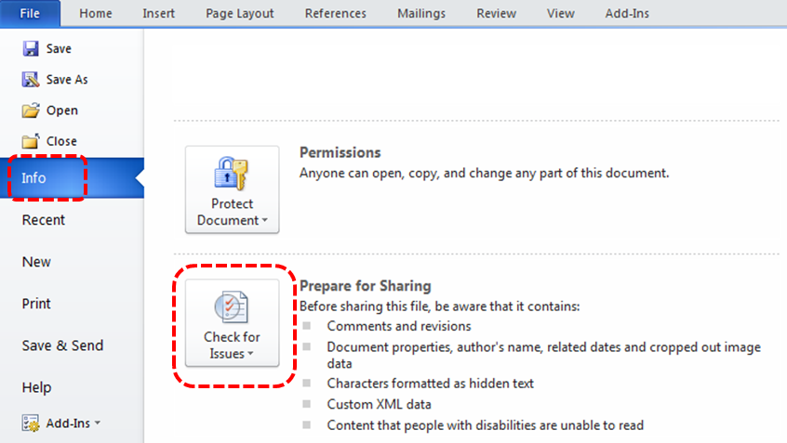
4. To view and repair the issues, select **Check for Issues** and then **Check Accessibility**

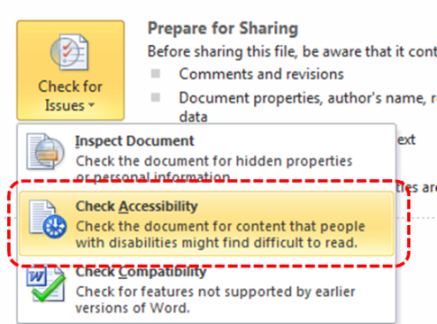

1. An **Accessibility Checker** task pane will open, showing the inspection results

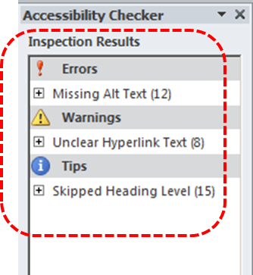

1. Select a specific issue to see **Additional Information**
2. Follow the steps provided to fix or revise the content  
   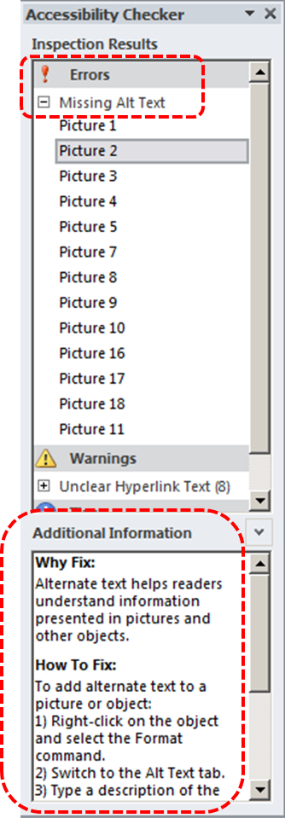

In order to get some indication of the accessibility of your document or template (see Technique 1), then you may consider saving the file into HTML or PDF in order to perform an accessibility check in one of those formats, as described below.

### To evaluate HTML accessibility

Another option is to save the document into HTML format and use one of the web accessibility checkers available online. Such as:

* [AChecker](http://achecker.ca/checker/index.php)
* [WebAIM Wave Web Accessibility Evaluation Tool](http://wave.webaim.org/)

### To evaluate PDF accessibility

If you saved your document in tagged PDF format, you can use the following tools and steps to evaluate the accessibility of the PDF document:

* Adobe Acrobat Professional
* [PDF Accessibility Checker (PAC)](http://www.access-for-all.ch/en/pdf-lab/pac-pdf-accessibility-checker.html) – a free alternative provided by “Access for all”

### To evaluate PDF accessibility in Adobe Acrobat Professional

1. Go to menu item: **Advanced > Accessibility > Full Check…**
2. In the **Full Check** dialog, select all the checking option
3. Select the **Start Checking** button

# Technique 12. Use Accessibility Features when Saving/Exporting to Other Formats

In some cases, additional steps must be taken in order to ensure accessibility information is preserved when saving/exporting to formats other than the default.

## PDF

**** PDF documents are not always accessible. Accessible PDF documents are often called “Tagged PDF” because they include “tags” that encode structural information required for accessibility. To evaluate the accessibility of your PDF document, see Technique 11 (above).

1. Go to menu item: **File**
2. Select **Save As**
3. In the **File name** box, type a name for the file
4. In the **Save as type** list, select **PDF or XPS Document**
5. Select the **Options** button
6. Under **Include non-printing information** in the **Options** dialog, ensure that the **Document structure tags for accessibility** check box is selected
7. Select **OK** and **Save**

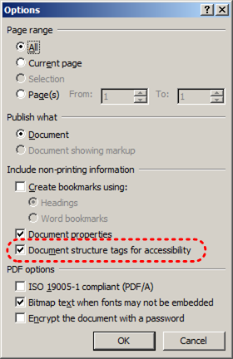

## HTML

1. Go to menu item: **File**
2. Select **Save As**
3. In the **File name** box, type a name for the file
4. In the **Save as type** box, select **Web Page**
5. Select **Save**
6. Check the HTML file for accessibility (see Technique 11, above)

## To clean up your HTML file

1. Remove unnecessary styles, line breaks, etc.
2. Remove unnecessary id, class, and attributes
3. Remove font tags
4. Remove styles in the <head> tag
5. Ensure the <th> tags have a scope attribute
6. Remove <p> tags nested inside <th> and <td> tags
7. Check for accessibility (see Technique 11, above)

Note: you may wish to use HTML editors or utilities to help with this process.

# Technique 13. Consider Using Accessibility Support Applications/Plugins

Disclaimer: This list is provided for information purposes only. It is not exhaustive and inclusion of an application or plug-in on the list does not constitute a recommendation or guarantee of results.

* [Microsoft Accessibility Page](http://www.microsoft.com/enable/)
* [Office 2010 Accessibility Tutorials](http://www.microsoft.com/enable/training/office2010/default.aspx)
* [Keyboard shortcuts for Word 2010](http://office2010.microsoft.com/en-us/word-help/keyboard-shortcuts-for-microsoft-word-HP010370109.aspx)
* [Customize keyboard shortcuts for Word 2010](http://office2010.microsoft.com/en-us/word-help/customize-keyboard-shortcuts-HA010370106.aspx)
* [Accessibility features in Word 2010](http://office2010.microsoft.com/en-us/word-help/accessibility-features-in-word-HP010370103.aspx)

# Other Application Features

## Word 2010’s “Navigation” Feature

After you have populated your document with content and true headings have been applied, you may wish to rearrange the content. In order to maintain the integrity and accessibility of the altered sequence, you will need to ensure that structural information (e.g., heading levels) is adjusted accordingly.

Word 2010 provides a “Navigation” mechanism which displays all parts of the document, such as headings, paragraphs, objects, etc. in sequential order. It helps you navigate, access, and manipulate the content. You can move headings or subordinate text up or down, rearranging their sequence in a way that can be programmatically determined and therefore accessible to assistive technologies.

### To use the “Navigation” feature

1. Go to menu item: **View**
2. In the **Show** section, select the **Navigation Pane** check box
3. The **Navigation** pane will open to the left of your document

### To jump to a location in a document

1. Select one of three navigation options:
   1. Select the **Browse headings** icon (Note: select the heading to view hierarchical headings and content below it)
   2. Select the **Browse pages** icon
   3. Select the **Search text**

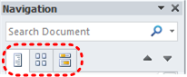

1. Scroll through the sequential list and double-click\* on the location you would like to jump to

### To move content up or down in a document

1. Select and drag the content to a new location in the list

# Accessibility Help

If you are interested in what features are provided to make using Word 2010 more accessible to users, documentation is provided in the Help system:

1. Go to menu item: **File**
2. Select **Help** from the list on the left
3. Under the **Support** section, select the **Help** icon
4. Enter “Accessibility” as your search term in the **Help** dialog box

# References and Resources

1. Microsoft Word 2010 Help
2. GAWDS Writing Better Alt Text [<http://www.gawds.org/show.php?contentid=28>]
3. Microsoft Word 2010 Online Accessibility Center
4. Andrew Godwin, [http://www.mail-archive.com/jaws-users-list@googlegroups.com/msg01713.html](http://www.mail-archive.com/jaws-users-list@googlegroups.com/msg01713.html" \t "_blank)

# Acknowledgments

This document was produced as part of the Accessible Digital Office Document (ADOD) Project (<http://inclusivedesign.ca/accessible-office-documents>).

This project has been developed by the Inclusive Design Research Centre, OCAD University as part of an EnAbling Change Partnership project with the Government of Ontario and UNESCO (United Nations Educational, Scientific and Cultural Organization).



Copyright © 2011 Inclusive Design Research Centre, OCAD University

This material may be reproduced and distributed in print or electronic format only as long as: (a) the reproduction is offered at no cost to the recipients; and

(b) the reproduction must preserve the "Version" section; and

(c) the reproduction must preserve the "Acknowledgments" section; and

(d) the reproduction must preserve this copyright notice.