**Problem of the Month - Polly Gone**

(adapted from Problem of the Month, Noyce Foundation, 2007)

Level A

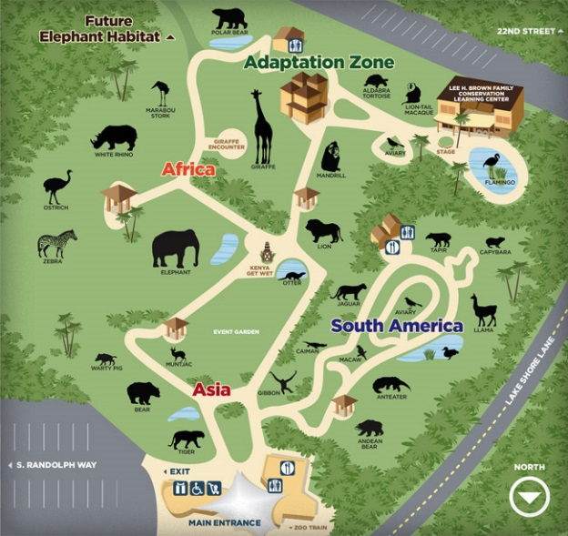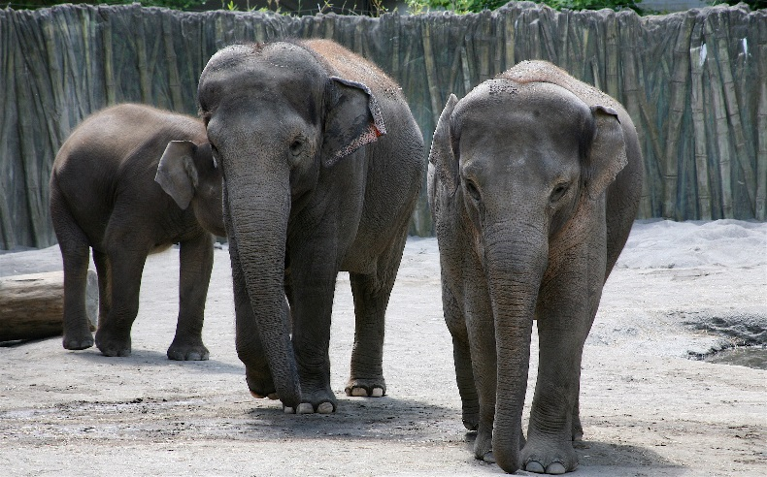

Polly works in a zoo and needs to build pens where animals can live and be safe. The walls of the pens are made out of cubes that are connected together. Polly has 40 cubes and wants to make the largest pen possible, so the animals can move around freely but not get loose. **Build the largest area using all 40 cubes**. Your walls must:

* Be fully enclosed, no doors or windows so Polly’s animals can’t get out.
* Have a height of one cube.
* Each cube must be joined.

Help Polly by making several shaped pens and determine which pen provides the largest area for the animals.

Build the pen on the grid paper first and **trace each one**. Find the **perimeter** and **area** for each pen. After you have determined which pen provides the largest area, **explain** to Polly why you believe your pen has the largest area that can be made using 40 cubes.

3.MD.B.5; 3.MD.B.6; 3.MD.C.7a; 3.MD.C.7b; 3.MD.D.8