Mock-up of jupyterLab interface

Step 1-Select a reference image and an analysis image.

For this mockup using:

Set1-reference and set1-250a.jpg. Both images are 1920 by 1080 and top left is 0,0

Step 2 inputs for coordinates of area of interest. These have defaults but can be changed if required.

The hole in the card is at:

topLeft (453, 309) width 442 height 405

Unless otherwise changed from defaults. Mark area of interest on the image and display

Area of interest

topLeft (503,339) width 342 height 345

Display both images with the area of interest marked

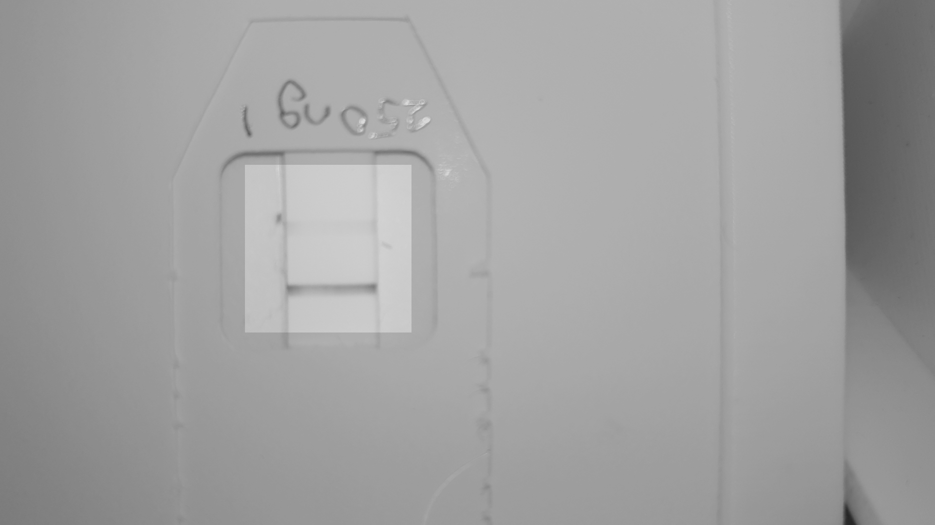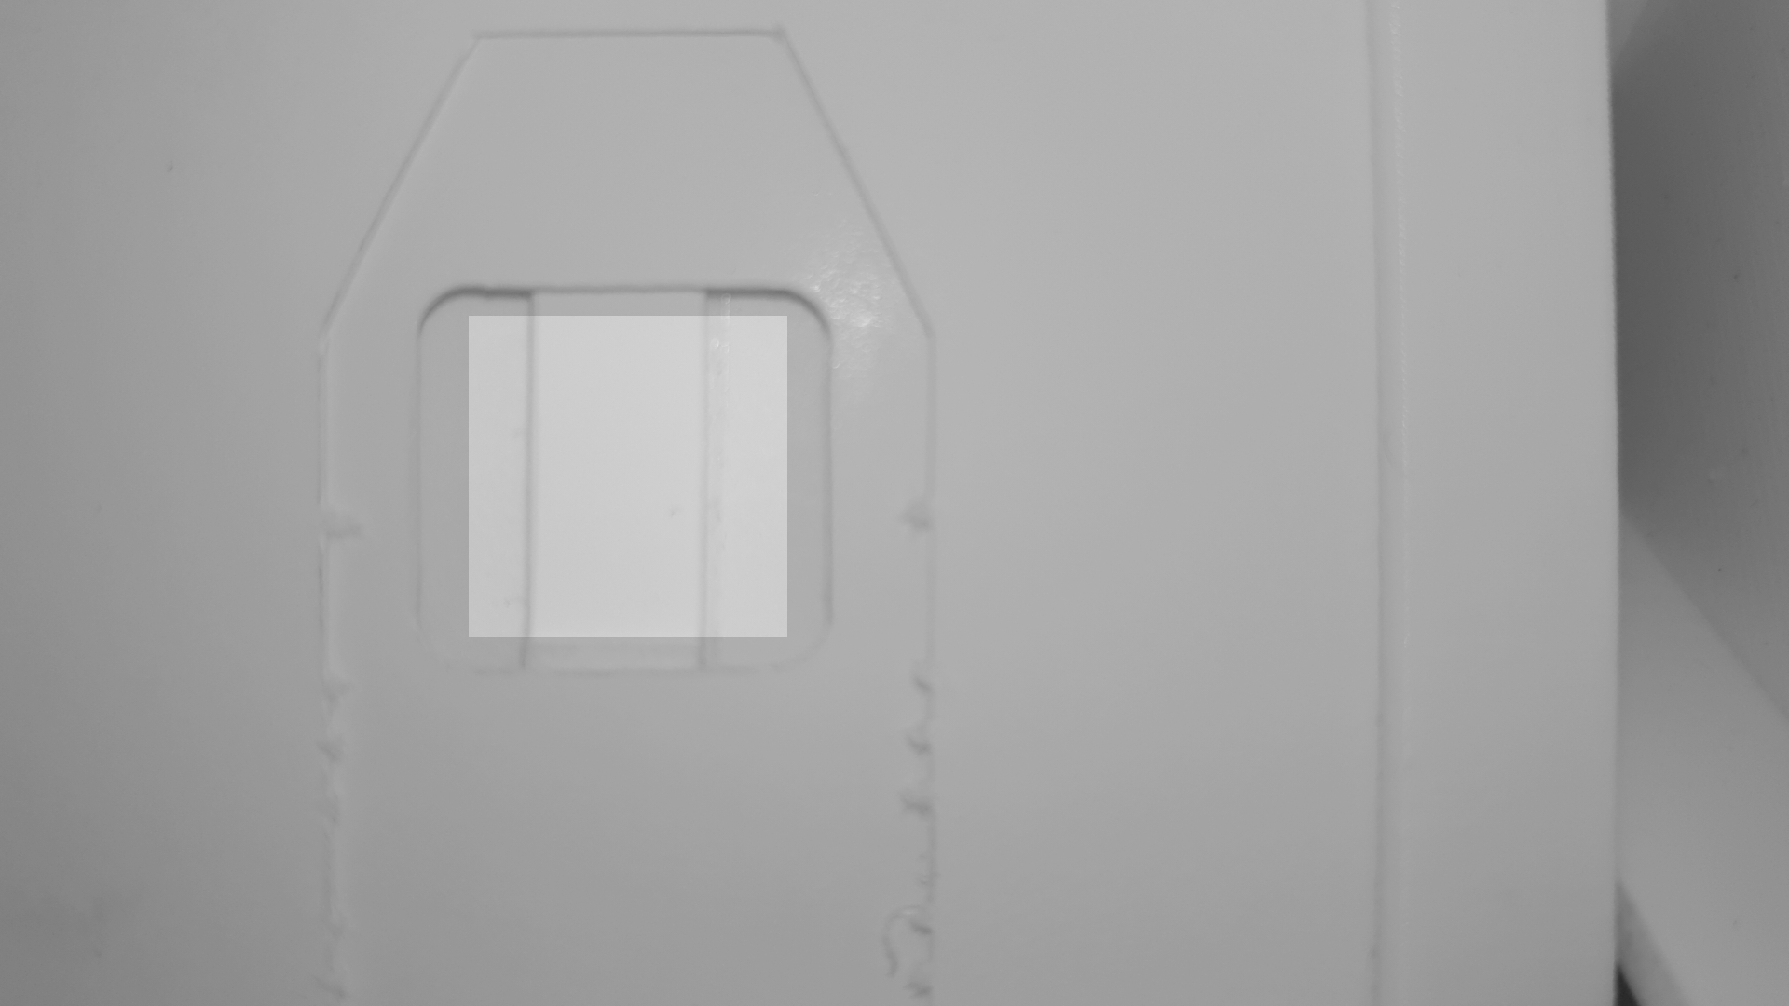

Step 3 Find the centre line of the test strip by identifying both edges of the strip at the top and bottom of the area of interest.

On the test card, search along the centreline from the bottom to find the maximum value corresponding to the control line.

Rotate image around point of intersection of centre line and control line.

Straighten the reference image

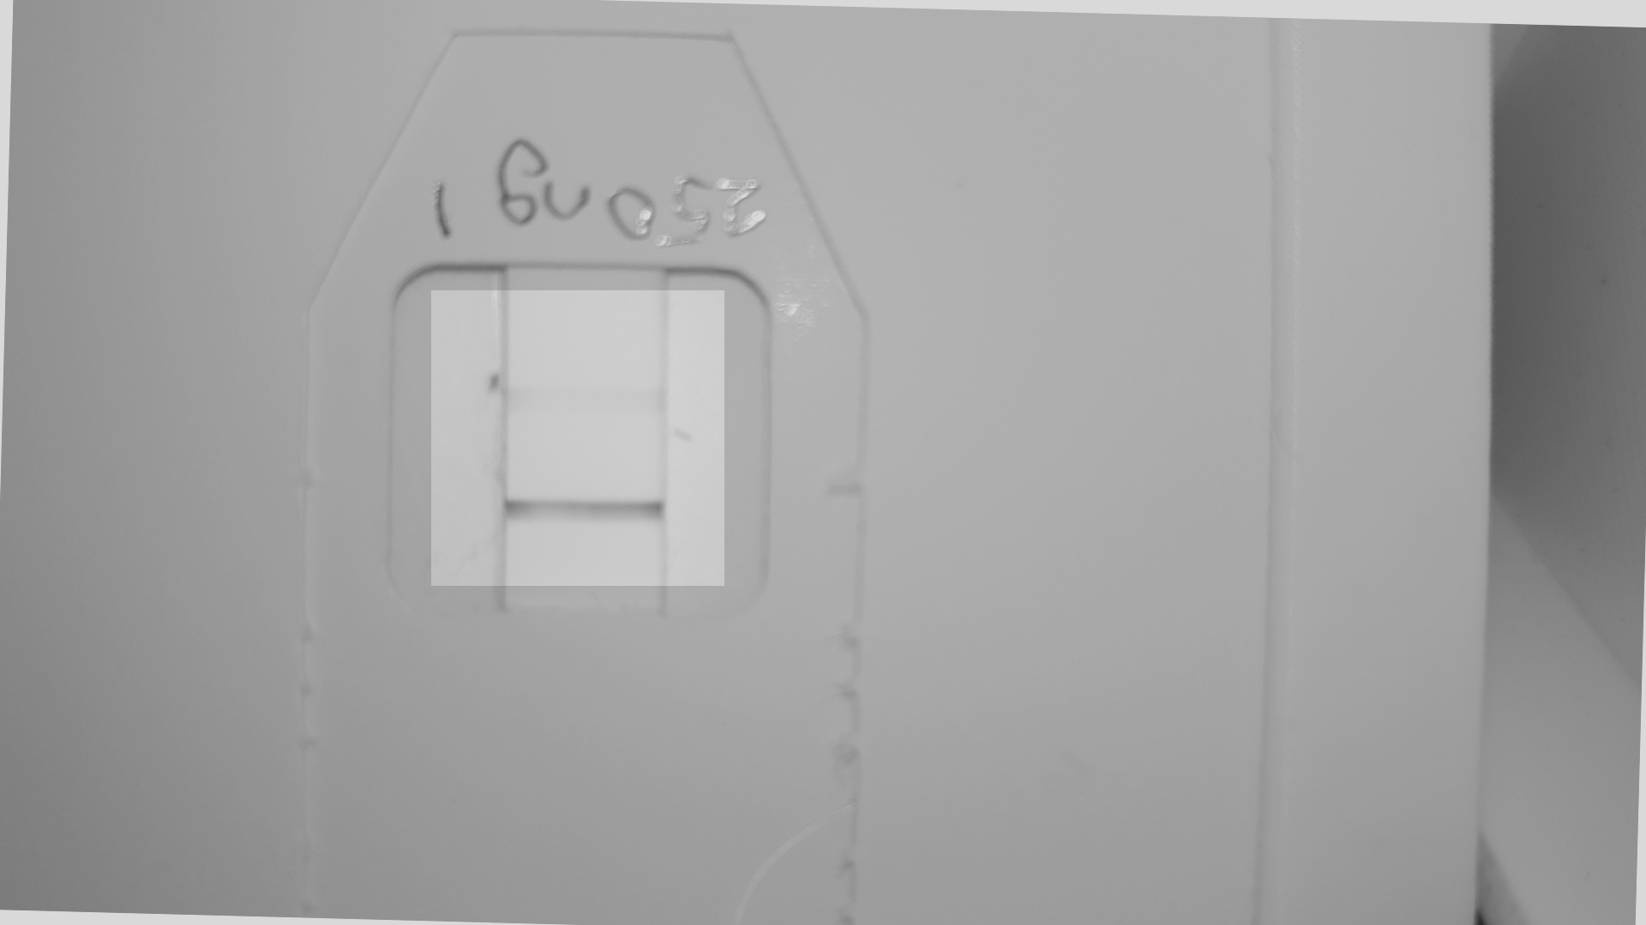

Now we can extract a matrix from both images either side of the centre line 130 pixels wide

