How to Pull the Right Lever: School Attainment, Open Data Analytics and Local Education Policy in England
  - Lessons from Brighton and Hove
Adam Dennett
Dan Campbell-Meiklejohn
Beatrice Taylor
2026-05-08
Abstract
In its 2026 White Paper, the UK government has set a worthwhile and ambitious target to halve the disadvantage attainment gap in education. Achieving improvements in disadvantaged student attainment requires local education authorities to understand their local situations and the specific drivers in their areas. But it is all too easy to pull the wrong policy lever when the research is complex and local intelligence is incomplete. Recent experiences in Brighton and Hove have highlighted the gap between open data and actionable information for Policy Makers, Schools and anyone wanting to actively contribute to statutory public consultations. Using multilevel linear mixed effects models fitted to all state-funded secondary schools in England over four years (2021–22 to 2024–25), we show that school-level Attainment 8 is highly predictable from a small number of readily available variables, but non-linearities mean understanding local context is key. We apply these models to a case study of Brighton and Hove, where admissions policy proposals in 2024 were designed around the premise that attainment is reduced by lower socio-economic mixing across schools. Our analysis suggests these proposals are unlikely to deliver the targeted gains in disadvantaged attainment, and that the wider literature on long school commutes points to social and educational costs that the proposals did not consider. By contrast, Brighton and Hove has the second worst absence rate in England, and our modelling indicates that improving attendance in the city would be the most impactful single lever available for raising attainment — particularly for disadvantaged pupils. We also introduce a school-level value-added view that allows parents and policy makers to assess how a school is performing over and above the structural intake characteristics it inherits, helping support better-informed local decisions. We introduce a new policy simulator tool to help bridge the gap between the Department for Education’s open data and accessible, contextualised intelligence.

1. Introduction
Pupil outcomes, including attainment, are a recurrent policy theme given the established links to individual life outcomes (Farquharson et al. 2024) and our collective national success through measures such as economic productivity (Grant 2017). The UK Government’s 2026 schools white paper (DfE 2026) sets ambitious targets including halving the disadvantage attainment gap, improving attendance, reforming admissions and tackling place-based disadvantage. These ambitions will require local education authorities (LEAs) to understand the specific drivers of attainment in their areas and choose interventions accordingly.
This paper argues that the Department for Education’s (DfE) open data provides most of the raw materials needed for such nuanced localised understanding, but a crucial gap exists between data availability and accessible, contextualised intelligence for decision makers. We demonstrate this through an analysis of school-level attainment across England, combined with a case study of Brighton and Hove where a policy direction would be predicted by our model, to potentially do more harm than good.
Brighton and Hove provides a particularly instructive case. The city already has a distinctive admissions landscape featuring catchment areas with a lottery tie-break for oversubscribed schools, introduced following a secondary school closure in 2005 (Allen et al. 2013), and an admissions priority for FSM-eligible pupils across its community schools. In 2024, the council launched proposals to reduce Published Admission Numbers at popular central-catchment schools, reserve places for out-of-catchment children in those catchments ahead of in-catchment children, and redraw catchment boundaries. The proposals were promoted on the premise that attainment in the city was ‘driven by economic advantage’ and that redistributing pupils would narrow the attainment gap. The response was overwhelmingly negative, yet parents and schools lacked the tools to challenge the proposals effectively and the core policy direction persisted, albeit slightly watered down.
Raw data on the attainment gap, without context, was presented to the city alongside statements correlating concentrations of disadvantage with lower attainment. The gap was framed as a unique failure requiring urgent action; the second-order impacts of the proposed interventions — longer school journeys, displacement from local communities, effects on well-being — were not scrutinised in depth. What we (the citizens of Brighton and Hove, including the councillors developing policy) did not know at the time was that, prior to the proposals, Brighton and Hove was one of the best performing LEAs in the country for both disadvantaged (7th out of 152) and non-disadvantaged (5th out of 152) GCSE attainment once the factors known to influence attainment are accounted for. With this knowledge, the approach to improving outcomes for disadvantaged pupils could have been more effective: “what can we learn from what the city is doing right?” and “would asking pupils to travel out of their communities to schools jeopardise this success?” Some rapidly-produced analysis was put into the public domain by some of the authors of this paper, but as a response to, not a contribution to, policy formation.
The discussions that led to this paper took place over an 18-month period spanning the 2024 and 2025 admissions consultations and involved a diverse group of parents, academics, policy practitioners, school governors and council staff. We do not claim our model is optimal or novel — the variables and effects are very similar to those reported by Macleod et al. (2015) over a decade ago. Our intention is to show that with freely available open data and a small set of well-chosen variables, it is possible to build a model explaining over 80% of the variation in school-level Attainment 8, and then to use it to answer locally targeted questions such as: ‘is changing the social mix in schools likely to improve disadvantaged pupil attainment?’, ‘what is the most important factor affecting attainment in a particular LEA?’, and ‘which schools are doing better or worse than expected?’. We report effects in GCSE-point units rather than standard deviations so that they have more direct meaning for policy makers.
The paper proceeds as follows. We briefly review the literature on secondary school attainment drivers, then outline our modelling approach using DfE open data. We present results showing which factors matter most and how they interact, before applying these findings to Brighton and Hove. We conclude with implications for local and national education policy.

2. Literature review: factors affecting pupil attainment

2.1 Socio-economic background and disadvantage
The Education Policy Institute’s annual reports document that by the time pupils sit their GCSEs (the General Certificate of Secondary Education - the exam most students in England sit at age 16), disadvantaged pupils are on average around 18 months of learning behind their more affluent peers, a gap that narrowed modestly after 2011 but partially reversed following the COVID-19 pandemic (Tuckett et al. 2023). It is this ‘attainment-gap’ which has remained stubbornly persistent for many years and that the recent government white paper has resolved to try and tackle. The size of the gap and the reasons behind it are complex and vary from place to place, but its existence has spawned large volumes of literature delving into disadvantage and attainment.
Free School Meal (FSM) eligibility serves as the standard proxy for disadvantage, though its limitations are well established. For example, Stopforth and Gayle (2025) demonstrate that finer-grained measures of parental social class reveal persistent attainment gaps that FSM-based analyses tend to understate, with the thresholds for FSM eligibility low enough that many students who might otherwise be classed as disadvantaged, are not included in these statistics. Despite this, because eligibility for Free School Meals is regularly recorded at pupil and school levels, it is frequently used as a proxy.
Inequalities in GCSE outcomes are substantially mediated by prior attainment at National Curriculum Key Stage 2 (KS2 — the latter stages of primary school from ages 7 to 11), reflecting accumulated inequalities from before secondary school (Stopforth and Gayle 2025). Gorard and Siddiqui (2019) show that the duration of disadvantage is a stronger predictor than disadvantage at any single point, and propose that pupils do worse in schools with higher concentrations of disadvantage, estimating improvements of 0.05–0.15 standard deviations (approximately one GCSE grade in one subject) from greater social mixing. They argue this can be achieved at ‘almost no cost’ — a conjecture that overlooks real-world consequences for communities, particularly where local social geographies mean de-concentration requires children travelling long distances.

2.2 Attendance
School attendance is among the strongest predictors of attainment and this comes through strongly in the literature. DfE analysis of 2018/19 data (DfE 2022) documents a stark gradient: among persistently absent pupils, only 35.6% achieved a standard pass in English and Maths, compared with 83.7% among those with no recorded absences. It is also cited as one of the main factors in pushing down attainment for disadvantaged pupils by Macleod et al. (2015). More recent analysis finds that pupils with near-perfect attendance were 1.9 times as likely to achieve a grade 5 pass compared with otherwise similar pupils attending 90–95% of the time (DfE 2025a). Dräger et al. (2024), using the 1970 British Cohort Study, find that absences at age 10 are associated with lower educational attainment in adulthood. The Social Mobility Commission (Riordan et al. 2021) conclude that the correlation between attendance and progress is ‘most likely to be causal’.
Post-pandemic persistent absence has risen sharply, from around 10.5% pre-pandemic to approximately 21.9% in secondary schools by 2023/24, with rates for FSM-eligible pupils around 32% (DfE 2025b). This compounds the challenge of disentangling school-level from pupil-level effects.

2.3 Other factors
Ethnic inequalities are persistent (Gillborn et al. 2017), though Gorard et al. (2025) show these are substantially reduced when controlling for pupil-level characteristics. The under-performance of disadvantaged White British pupils, particularly boys, has attracted policy attention, with causes contested between place-based deprivation and cultural factors (Strand 2021; Commons Education Committee 2021).
School-level selectivity inflates raw performance metrics. Anders et al. (2024) find that the private school premium effectively disappears once socio-economic background is controlled for. Simon Burgess et al. (2018) show grammar schools reinforce socio-economic stratification without overall attainment benefits.
Workforce factors including effective leadership (Zuccollo et al. 2023), teaching quality (Simon Burgess et al. 2023; S. Burgess et al. 2022), and teacher retention (Gibbons et al. 2018; Menzies 2023) contribute to variation in attainment, with effects felt most acutely by disadvantaged students (Allen et al. 2018). The ‘London Effect’ (the apparent boost to attainment for disadvantaged pupils who live in the Capital) (Ross et al. 2020) reflects a localised concentration of agency factors — parental expectations, homework hours, lower unauthorised absence — rather than a purely geographic phenomenon.
The factors affecting attainment are multifaceted and interrelated, and many drivers are well-established. With so many concurrently relevant predictors, however, it is difficult to judge their relative importance in any specific context. What is required is an analysis combining as many drivers as possible, so that their relative influences, interactions, and mediation pathways can be assessed concurrently — which is where we now turn.

3. Data and methods

3.1 Data
The DfE publishes extensive open data on schools via its statistical services. We assembled a panel dataset covering the four post-COVID academic years (2021–22 to 2024–25), linking school performance, absence, pupil population, workforce and Ofsted data. Data pre-processing details are available in the supplementary material. The full panel comprises 13,419 school-year observations from 3,523 academies and maintained schools across 152 LEAs. Independent schools, colleges and ‘special schools’ (those catering more for pupils with special educational needs and disabilities) are excluded. After the exclusion of cases with missing predictor values or imputation of those values required for the log-linear specification (principally missing workforce or Ofsted data in 2024-25[^missing]), the analysis sample used in the models is approximately 12,200 observations. All data are school-level aggregates; interpretations relate to this level of aggregation.
[^missing] missing data and imputation: https://adamdennett.github.io/school_attainment_tool/data_overview.html#missing-data

3.2 Model specification
We fit multilevel linear mixed effects models (LMEs) with schools nested within LEAs within regions (Snijders 2012). The outcome is log-transformed Attainment 8 (for all, disadvantaged and non-disadvantaged pupils), the measure of interest cited in the DfE (2026) white paper. We have selected Attainment 8 over Progress 8 as we want to assess the influence and interaction variables like prior attainment on other predictor variables, not just as a partial outcome. Because the outcome is on the log scale, coefficients for log-transformed predictors represent elasticities.
The model specification is:
$$log\left({\text{ATT8}}_{ij}\right)=β_{0}+\sum_{k=1}^{9}{β_{k}} x_{kij}+u_{\text{year}}+u_{\text{Ofsted}}+u_{\text{region}}+u_{\text{LA|region}}+ε_{ij}$$
where $i$ indexes schools, $j$ indexes year-observations, the $β_{k}$ are fixed-effect coefficients, and the $u$ terms are random-effect intercepts for year, Ofsted rating, region, and LEA nested within region.
Fixed-effect predictors comprise: log(% KS4 pupils who are disadvantaged - % FSM), log(% overall absence - % Absence), log(% pupils with English as an additional language - % EAL), % low prior attainment at KS2, selective admissions (dummy), Gorard Segregation Index (LA-level), teacher retention rate, leadership pay proportion, and log(teacher sickness days). Variable selection was informed by the literature review and by the policy narrative in Brighton and Hove, where segregation featured prominently in the council justification. Full details of the variables and the full analysis panel can be found in the supplementary material .
We fit separate models for overall Attainment 8, disadvantaged-pupil Attainment 8, and non-disadvantaged-pupil Attainment 8, as both panel models (all four years) and individual year models. Models were estimated using the lme4 package in R with Restricted Maximum Likelihood estimation.

4. Results

4.1 Model fit
The models explain a substantial proportion of variance in school-level Attainment 8. In order that these fits are more intuitive for those used to interpreting OLS regression models, we use the method described by Nakagawa and Schielzeth (2013) and Nakagawa et al. (2017) to general to calculate indicative $R^{2}$ values. For all pupils, the conditional $R^{2}$ (fixed plus random effects) is 0.77, with marginal $R^{2}$ (fixed effects alone) of 0.63. For disadvantaged pupils the conditional $R^{2}$ is 0.73; for non-disadvantaged pupils, 0.79. School-level attainment is remarkably predictable from these structural factors, which makes them very useful for exploring the effectiveness of local policy levers.

4.2 Stepwise decomposition
Table 1: Stepwise progression to the full multilevel model for overall Attainment 8.
Variable | Est. | t | Est. | t | Est. | t | Est. | t | Est. | t
(Intercept) | 4.473*** | 621.25 | 5.006*** | 579.97 | 4.833*** | 547.18 | 4.628*** | 319.11 | 4.633*** | 125.61
log(% FSM) | -0.201*** | -88.94 | -0.122*** | -59.66 | -0.073*** | -33.46 | -0.071*** | -28.60 | -0.067*** | -24.90
log(% Absence) |  |  | -0.364*** | -82.87 | -0.287*** | -65.28 | -0.242*** | -51.65 | -0.213*** | -46.03
log(% EAL) |  |  |  |  |  |  | 0.014*** | 13.69 | 0.006*** | 4.92
% Low Prior Attainment |  |  |  |  | -0.006*** | -45.75 | -0.005*** | -37.59 | -0.006*** | -41.35
Admissions: Other non-selective |  |  |  |  |  |  | 0.051*** | 11.01 | 0.001 | 0.08
Admissions: Selective |  |  |  |  |  |  | 0.140*** | 19.96 | 0.108*** | 16.20
Gorard Segregation |  |  |  |  |  |  | 0.052 | 1.92 | -0.033 | -0.69
Teacher Retention |  |  |  |  |  |  | 0.001*** | 12.92 | 0.000*** | 10.20
Leadership Pay % |  |  |  |  |  |  | -0.001*** | -6.10 | -0.001*** | -5.39
log(Teacher Sickness) |  |  |  |  |  |  | -0.016*** | -6.08 | -0.015*** | -6.17
Random effects
Year |  |  |  |  |  |  |  |  | 0.030 | (SD)
Ofsted rating |  |  |  |  |  |  |  |  | 0.017 | (SD)
Region |  |  |  |  |  |  |  |  | 0.047 | (SD)
LA (nested in region) |  |  |  |  |  |  |  |  | 0.044 | (SD)
Residual |  |  |  |  |  |  |  |  | 0.094 | (SD)
R² | 0.393 |  | 0.612 |  | 0.669 |  | 0.693 |  | 0.632 | (marginal)
R² (conditional) |  |  |  |  |  |  |  |  | 0.771 | (fixed + random)
N | 12,210 |  | 12,210 |  | 12,210 |  | 12,210 |  | 12,210

The stepwise progression in Table 1 reveals the mediating structure among the key predictors. In Model 1, we start with the % KS4 pupils who are disadvantaged (%FSM for short) as the only predictor - mainly as this was the variable that has dominated the policy discussion in Brighton and Hove in recent years, leading to the 2023 FSM priority policy and the 2024 mixing policy. the FSM coefficient is –0.201 and statistically significant, on its own accounting for almost 40% of the variation in Attainment 8 across schools in England. However, adding absence in Model 2 halves it to –0.122. Absence absorbs much of the explanatory power previously attributed to deprivation, although together they now account for over 60% of the variation in Attainment 8 scores. Adding prior attainment in Model 3 reduces both FSM and absence coefficients further. By Model 3, with just three variables, approximately two-thirds of attainment variation is explained, with the t-values (in some respects a standardised version of the coefficients allowing for a degree of relative comparison) showing that % absence (t = -65.28) is the most important variable, % of pupils with low prior attainment (t = -45.75) the next most important and % FSM the least influential (t = -33.46).
Model 4 adds additional fixed effects including EAL proportions, selective admissions, workforce variables and the Gorard Segregation Index. Model 5 adds random effects for year, Ofsted rating, region and LEA nested within region, lifting the conditional $R^{2}$ from 0.63 (marginal) to approximately 0.77, indicating that 14% of attainment variance is tied to these grouping factors — capturing unmeasured factors such as school culture, leadership quality, local authority support services, and community characteristics.
The Gorard Segregation Index is not statistically significant in Models 4 or 5. Once a school’s own FSM levels, attendance, prior attainment and geographic location are accounted for, the distribution of disadvantaged students across schools within an LEA adds no predictive power. Any harm that segregation causes is fully mediated by the variables already in the model. We include it because segregation arguments formed much of the justification for the Brighton and Hove admissions proposals.
A crucial feature of these models is that the log-transformed variables encode non-linear relationships. The same percentage-point change produces different effects depending on where a school starts. For concentrations of disadvantage, the relationship between FSM and attainment flattens above about 20% FSM — further increases in disadvantage do not correlate with noticeable further declines. Most of the strong effect appears below 15%, where further reductions are correlated with much steeper attainment increases. This non-linearity has direct policy consequences: individual LEAs need to consider carefully where each school sits on the distribution to appreciate what changes might realistically achieve.

4.3 Relative variable importance
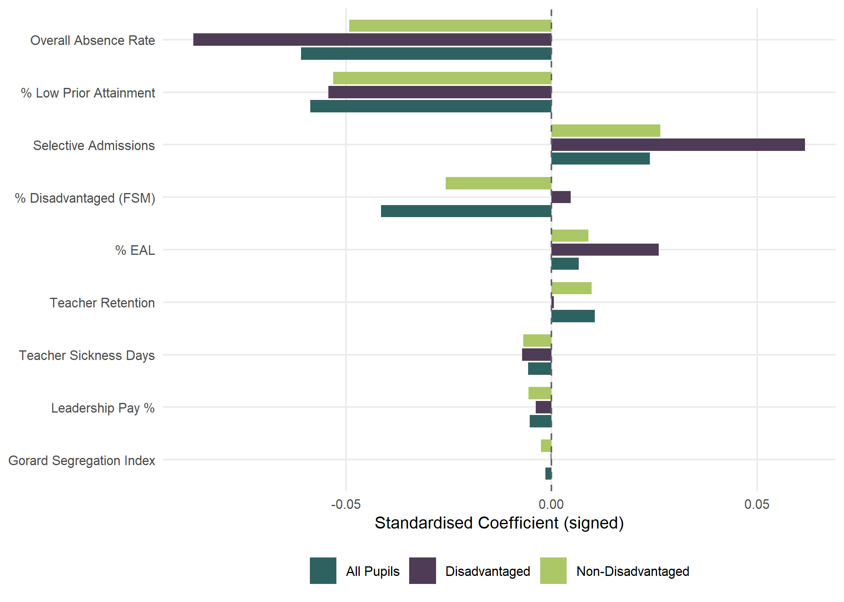
Figure 1: Standardised coefficients showing relative variable importance across pupil groups. Bars show the change in log(ATT8) associated with a one-SD shift in each predictor.
Figure 1 compares the standardised coefficients across all three pupil groups (all pupils, disadvantaged pupils and non-disadvantaged pupils - full model outputs available in the supplementary materials). Absence is the dominant predictor across all groups, but it is even more important for disadvantaged pupils — nearly half of the variation in school-level performance for this group is explained by attendance alone.
The most contentious finding in our analysis concerns concentrations of disadvantage (contentious in Brighton and Hove - although the findings echo the analysis of Macleod et al. (2015) a decade ago). For non-disadvantaged pupils, higher FSM proportions are associated with lower attainment. But for disadvantaged pupils, the coefficient is positive — after controlling for absence and low prior attainment, disadvantaged pupils perform slightly better in schools with higher concentrations of other disadvantaged pupils. This finding is robust across individual year models and alternative specifications of disadvantaged attainment and disadvantage measures. In the full multilevel model, this positive coefficient shrinks substantially, suggesting the effect operates through LEA-level and Ofsted-level factors rather than concentration per se — schools with higher FSM proportions in certain LEAs appear to have developed effective support systems, possibly through targeted use of Pupil Premium funding and other specialisations.
For non-disadvantaged pupils, the effect of higher disadvantage concentrations is more clearly negative — being in a higher-disadvantage school depresses Attainment 8 for this group, possibly through peer effects or curriculum-resourcing dynamics. Both findings challenge the ‘no cost’ conjecture and, in the Brighton and Hove context, suggest that further mixing of an already comparatively well-integrated set of schools could be counter-productive for disadvantaged attainment.
Absence is the biggest predictor across all groups and is even more important for disadvantaged pupils, for whom nearly half of the school-level variation in performance is explained by attendance alone. Disadvantaged pupils may lack the safety net of engaged parents, private tutors or revision resources that some peers have, making classroom instruction more critical. Attendance, in this sense, is the ultimate equity lever. We do not advocate concentrating disadvantaged pupils, but the evidence does not support deconcentration policies premised on the assumption that disadvantaged pupils inevitably fare worse in higher-disadvantage schools. Where such policies require longer journeys that risk increasing absence (Thomson 2023), they could be actively counter-productive.

5. Brighton and Hove case study

5.1 Local context
Brighton and Hove has ten secondary schools: six community schools run by the LEA, two academies (Brighton Aldridge Community Academy — BACA — and Portslade Aldridge Community Academy — PACA) and two church schools (King’s and Cardinal Newman) that set their own admissions. Following the closure of CoMArt in the east of the city in 2005, large catchment areas were introduced (Figure 2) with a lottery tie-break for oversubscribed schools — making admissions very different to most other places in England where distance typically determines priority (Allen et al. 2013).
In October 2024, the council launched proposals to amend the secondary school admissions process. The cabinet papers set out three stated objectives: ‘a school system where all pupils get access to a great education’, improving ‘the education offer for disadvantaged pupils by reducing some schools’ barriers to success’, and ‘better equality of outcomes — results not driven by economic advantage’. Alongside ran a School Organisation Strategy commitment to ‘schools which are sustainable and able to thrive’ against falling pupil numbers. The specific proposals were to reduce Published Admission Numbers (PANs) at Longhill, Blatchington Mill and Dorothy Stringer by a combined 120 places, redraw the Longhill/Dorothy Stringer/Varndean boundary, and reserve up to 20% of places in single-school catchment areas for out-of-catchment children. Underpinning the case was a reading of Gorard and Siddiqui (2019) in which more mixed intakes produce better outcomes for disadvantaged pupils, plus a premise that attainment in the city was ‘driven by economic advantage’ — a characterisation challenged in this context by Tan and Dennett (2025). This built on a 2023 policy giving FSM-eligible pupils priority at schools below the city-average (30%) FSM share, which was already producing flows from peripheral to central catchments.
The public response was overwhelmingly negative, with the council’s pre-consultation feedback summary noting ‘a strong preference for improving existing schools rather than redistributing students, alongside deep concerns about potential impacts on community cohesion and student wellbeing’. The proposals would, by the council’s own calculations, force significant numbers of children from central catchments to schools at the city’s periphery, potentially requiring over two hours of daily commuting. The council’s transport-implications appendix reports approximately £606,000 already spent each year on supported bus routes and bus passes, with further travel-assistance spending likely to support new pupil flows generated by the admissions changes. Notably, the previous administration’s comprehensive strategy for tackling educational disadvantage — which included sections on attendance, leadership, governance and targeted support — was not referenced in the 2024 consultation materials.
Whether better evidence would have changed the political outcome is unknowable, but accessible evidence would have enabled earlier and more constructive engagement. The compressed consultation timeline left inadequate time to assemble and present counter-evidence for the complexity of the issues at stake. What follows demonstrates what that evidence looks like and how it could inform future debates in Brighton and Hove and beyond.
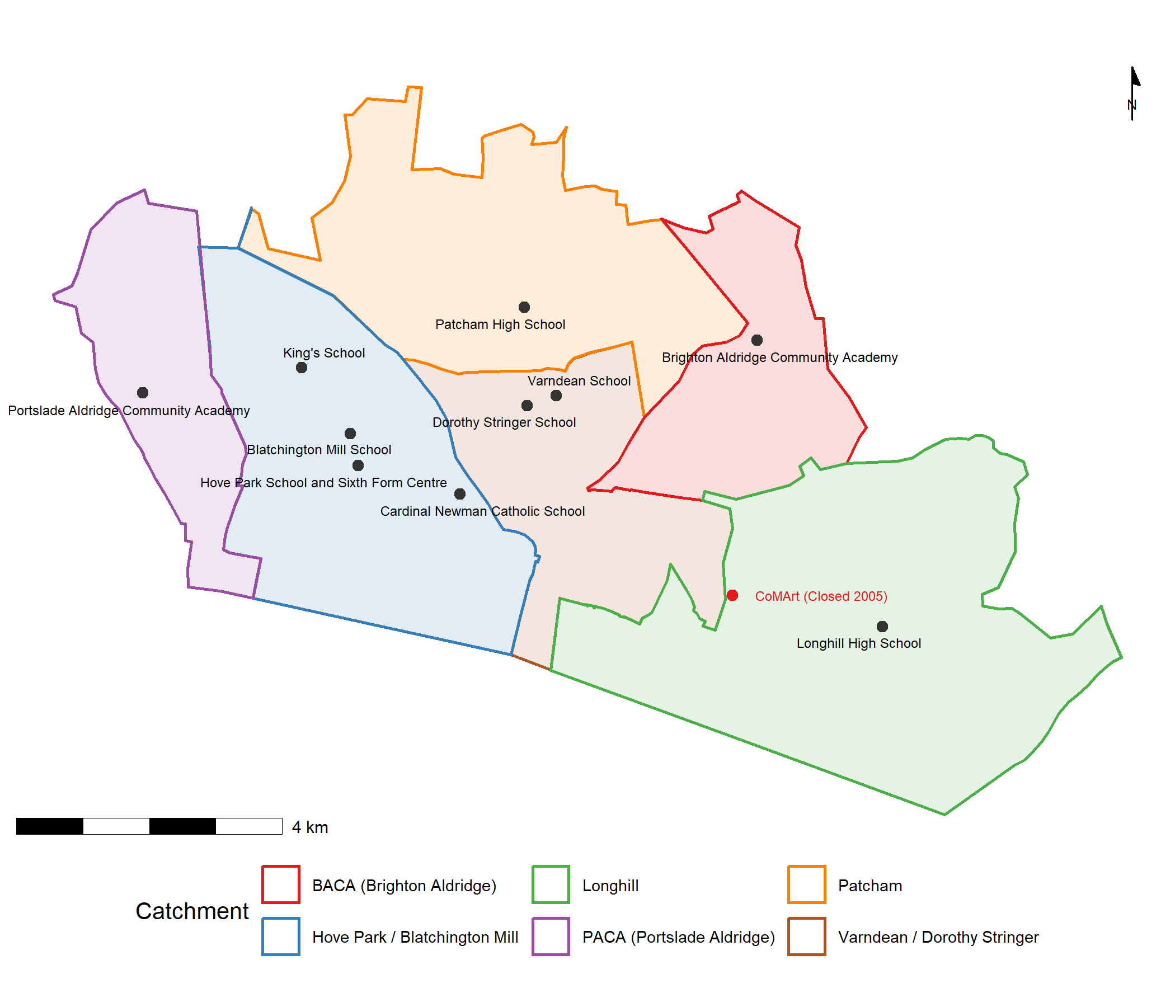
Figure 2: Brighton and Hove secondary schools with 2025/26 catchment boundaries.

5.2 Local authority effects
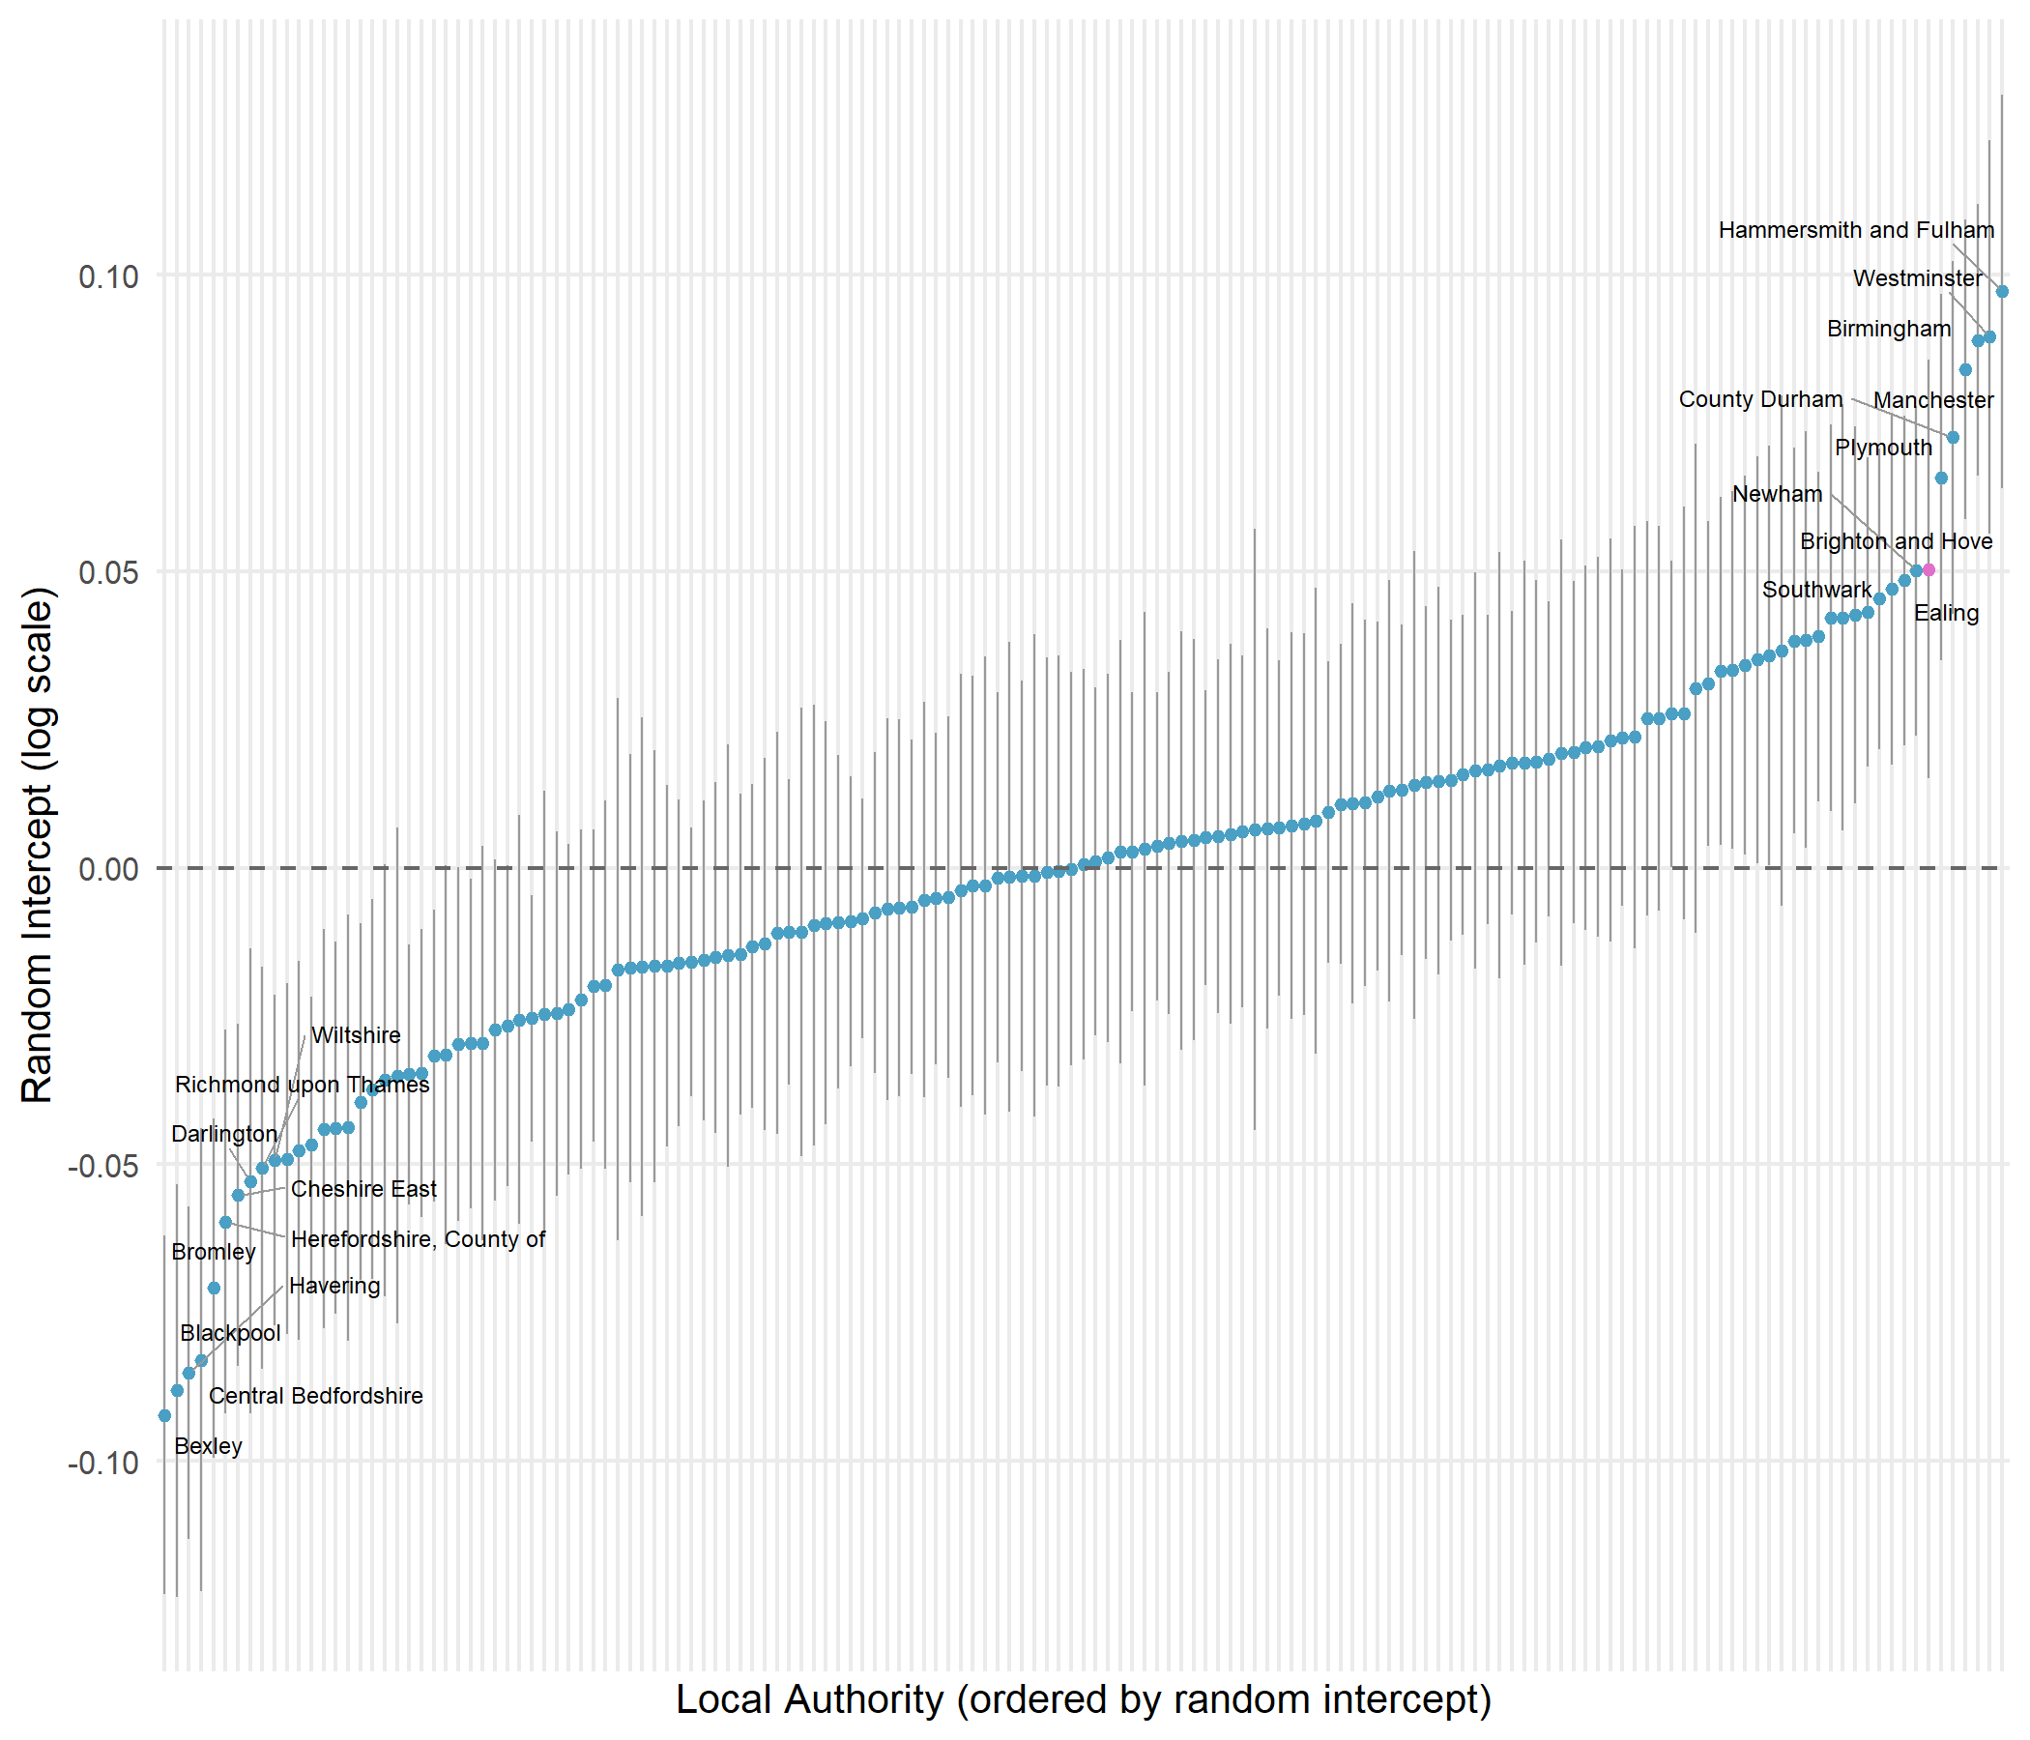
Figure 3: LA random intercepts for disadvantaged-pupil attainment (imputed full panel model). Top and bottom 10 LAs labelled; Brighton and Hove highlighted.
Figure 3 shows that Brighton and Hove ranks 7th out of 152 LEAs for disadvantaged attainment once structural factors are accounted for in the multilevel model presented earlier. For non-disadvantaged pupils it ranks 5th; for all pupils, 4th. The positive random intercept of approximately +0.06 translates to around a 6% uplift in Attainment 8 — roughly 2 GCSE points above what structural factors would predict. This was unknown at the time of the 2024 consultation and entirely absent from the public narrative, which was framed around a premise of failure, based on the raw attainment gap only.

5.3 Comparing policy levers: absence versus disadvantage
Because the model uses log-transformed variables, the same percentage-point change produces different effects depending on where a school starts — returns accelerate as values improve. Figure 4 places both the absence and FSM levers on a common y-axis.
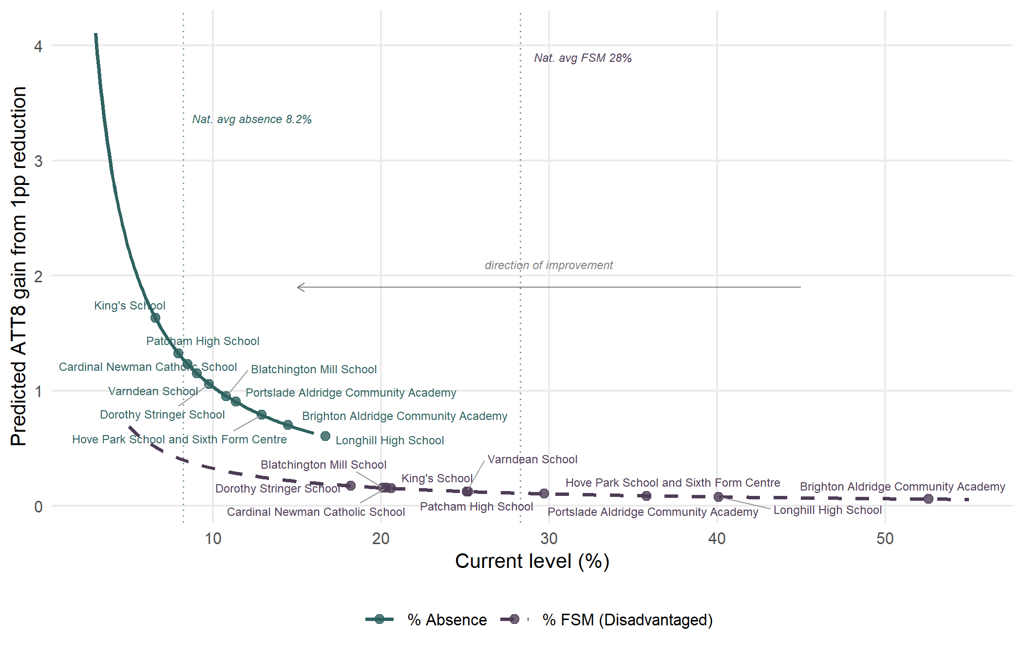
Figure 4: Accelerating returns: each percentage-point reduction buys a progressively larger ATT8 gain (reading right to left). Absence delivers substantially larger gains than FSM at every level. Brighton and Hove schools marked on each curve.
Three features are immediately visible. First, the absence curve sits above the FSM curve at every starting level. Second, the gap widens as values improve. Third, Brighton and Hove schools cluster in the flatter right-hand portion for both variables, but the city’s position is far more extreme for absence.
Brighton and Hove’s mean school FSM rate (28.8%) is close to the national average (28.3%). But the city’s mean absence rate (10.8%) against a national average of 8.2% places it at the 99th percentile — among the very worst in England. When standardised by the city’s spread, the absence coefficient is 2.6 times as important as FSM for predicting attainment.
Bringing schools above the national average for absence down to it would produce predicted gains averaging +2.9 Attainment 8 points per school, with gains for disadvantaged pupils averaging +3.3 points. Even dramatic FSM reductions would yield gains closer to 1 point. On the evidence, attendance is the single most consequential lever the city has available, and admissions changes of the kind proposed in 2024 are very unlikely to produce equivalent gains in disadvantaged attainment.

5.4 Contextualised school performance
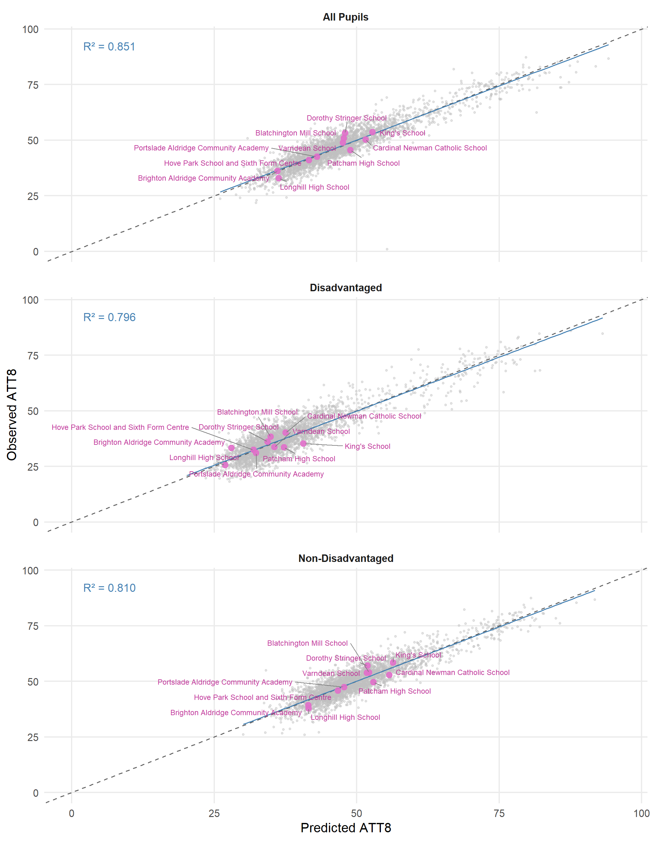
Figure 5: Observed versus predicted Attainment 8 for Brighton and Hove schools (highlighted) against all schools nationally, 2024–25.
Figure 5 shows observed versus predicted Attainment 8 for the latest year across all schools in England (grey) with Brighton and Hove schools highlighted (pink). The close clustering of the points around the diagonal line is a visual representation of the $R^{2}$ values show on the plot and in the tabular model outputs shown earlier - observed values for most schools are close to the model predictions. The model residuals — the vertical distance from the diagonal — show whether a school is doing better (above) or worse (below) than the model predicts and provides what we might think of as contextualised ‘value-added’ measures - more nuanced than Progress 8 - as this model-based value added accounts for far more than just prior attainment in its representation.

5.5 Decomposing absence: structural intake versus school management
The contextualised value-added reading above hides a complication. Our headline model treats school-level absence as a single regressor on the same footing as other intake variables, but absence is different to FSM or EAL. Part of it is exogenous to the school — driven by family circumstances, area-level health, deprivation, and SEND profile — while part is produced by the school via pastoral systems, attendance officers, parental engagement and the broader ethos around getting children into class. Controlling for raw absence absorbs both components together, so the residual we have called ‘value-added’ reflects what the school does given its attendance, not what it does to its attendance.
A two-stage decomposition separates these elements. First, we model school-level absence on the variables we treat as exogenous (FSM, EAL, low prior attainment, segregation, plus place and year random effects), producing for every school-year an expected absence (intake-predicted) and a residual absence (school-controllable). Second, we refit the attainment model with intake-predicted absence in place of raw absence, dropping the workforce predictors. The school-level residual from this refitted model is a more honest value-added measure: attendance management is now counted as part of the school’s contribution rather than stripped away as a control.
The national picture is informative. Most of the school-year variation in absence is explained by the intake-only first stage; the school-controllable residual is the smaller share, and its marginal contribution to attainment is modest once intake-driven absence is accounted for. The headline raw-absence coefficient therefore borrows much of its statistical force from the structural component: the lever is real, but the school-only portion is smaller than the single coefficient implies. For LEAs this means closing a city’s absence problem requires both school-level attention and cross-departmental work — public health, children’s services, area-level deprivation policy — because much of what schools deal with on attendance is inherited rather than generated.
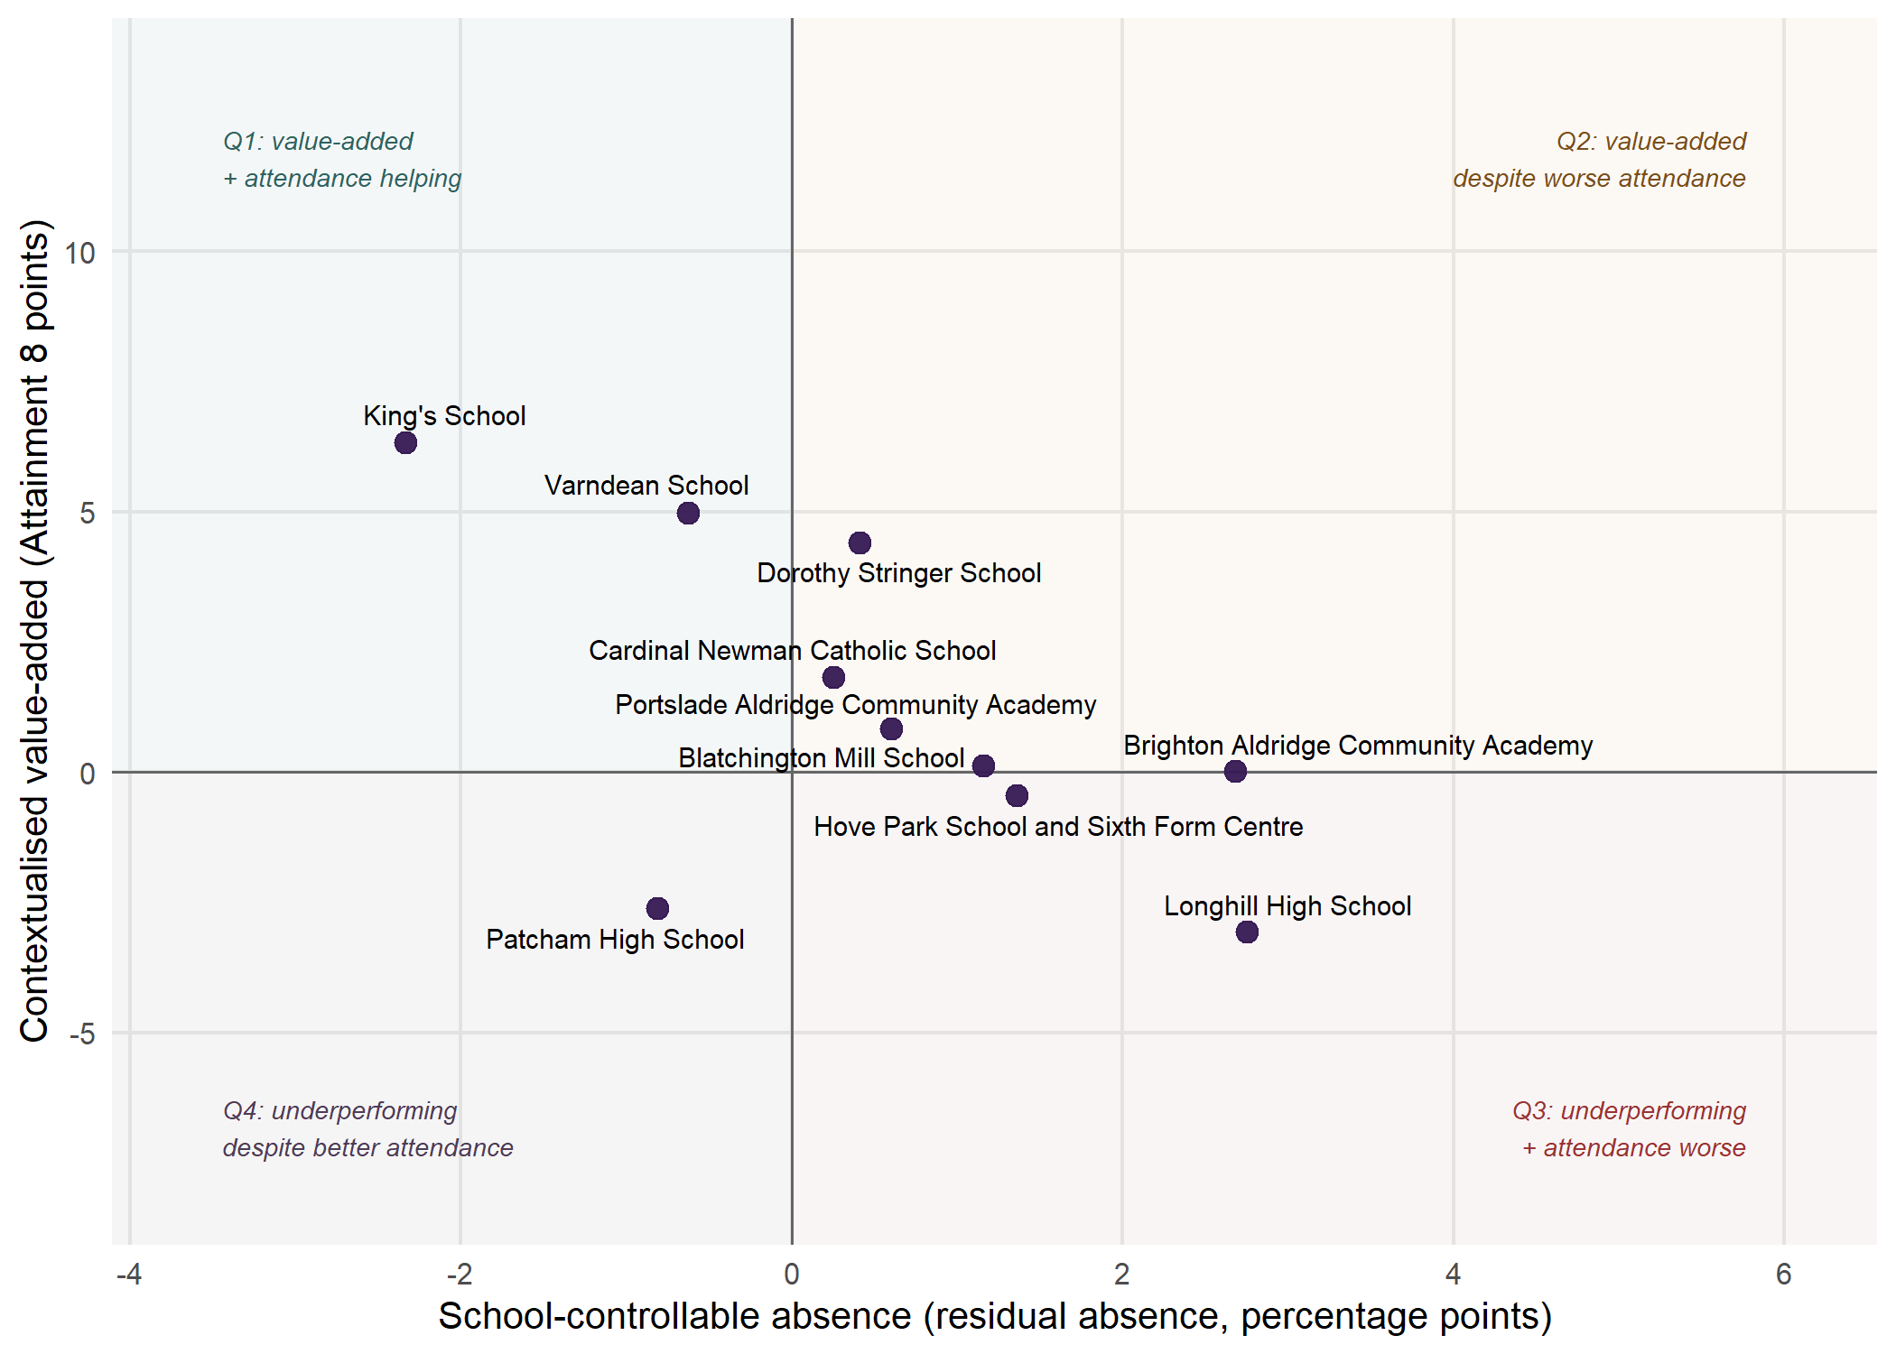
Figure 6: Brighton and Hove secondaries on the joint-signal plane: contextualised value-added (vertical, in Attainment 8 points) versus the school-controllable absence component (horizontal, in percentage points). The reference lines at zero on each axis split the plane into four narrative quadrants discussed in the text. The full national version with a local-authority filter is available interactively in the project’s HTML report.
For local school-level diagnostics the decomposition becomes considerably more informative. Two signals can now be read side by side: the school’s contextualised value-added, and its residual absence (positive when the school runs more absence than its intake would predict, negative when less). Sorted on these two axes (Figure 6), schools fall into four meaningful policy stories: schools adding value with attendance management helping (Q1, top-left); schools adding value despite worse-than-predicted attendance (Q2, top-right); schools underperforming with attendance the cleanest single lever (Q3, bottom-right); and schools underperforming despite unusually good attendance management (Q4, bottom-left).
For Brighton and Hove the joint-signal view sharpens the case-study reading. Most of the city’s schools sit in Q2 in the top-right: they are delivering attainment above what their intake would predict and is doing so while running more absence than their intake-driven absence model expects. In these schools, the pedagogical work happening is the more impressive for it; closing any of these school’s residual-absence gap would compound directly onto an already-strong value-added signal. Any schools in Q4 provide a challenge: their attendance management is genuinely strong, but once intake is properly accounted for their attainment outcomes fall short of what their profile predicts, so the simple “fix attendance” improvement story is not available. Schools in Q3 are the most natural targets for council-led attendance interventions, and Q1 schools are where the city should look for practice worth sharing. Reporting value-added alongside residual absence, with explicit uncertainty intervals, is a more honest framing than the single number that conventional benchmarking produces, and would help align local policy conversation with what the data can support.

6. Discussion

6.1 The danger of single-lever policy thinking
The Brighton and Hove experience illustrates the risks of building a policy around a single causal narrative. The council’s 2024 admissions proposals were built around the premise that redistributing disadvantaged pupils would narrow the attainment gap. In the consultation papers released to the public, it was stated:
“We also know that children from disadvantaged homes are less likely to do well at school and that can be made worse when more disadvantaged children all go to school together. We are looking at options for how we can help the city manage that issue better, including through our school admissions arrangements.”
This premise sits awkwardly with the existing evidence base. Macleod et al. (2015)’s earlier analysis for the DfE found that, controlling for intake characteristics, schools with higher concentrations of disadvantage tend to do better for their disadvantaged pupils, not worse. Our more up-to-date modelling on four years of national data reaches the same conclusion. Concentrations of disadvantage are one of the weaker available levers, and for disadvantaged pupils specifically the direction of the effect runs in the opposite direction to the policy assumption. The implication is that admissions changes of the kind proposed in Brighton and Hove are unlikely to deliver the targeted gains in disadvantaged attainment and could produce the opposite outcome.
The chosen lever also carries risks that the proposals did not engage with. Redistribution generates longer journeys to school, and the wider literature is clear that long commutes are associated with reduced sleep and its psychosocial (Fredriksen et al. 2004; Yeo et al. 2019), physical (Voulgaris et al. 2019; Pradhan and Sinha 2017; Pereira et al. 2014; Faulkner et al. 2013) and mental health (Nakajima et al. 2024; Chairassamee et al. 2024; Guan et al. 2025) consequences, including stress (Karan et al. 2021), lower wellbeing (Ding et al. 2023), and higher absence across multiple national settings (Otsuka et al. 2025; Cordes et al. 2022; Blagg et al. 2018), including England (Thomson 2023). Absence is the largest predictor of attainment in our modelling and the city’s most acute structural problem; a policy that even marginally increases it could be counterproductive. There is also a qualitative dimension: schools serve as community anchors, supporting after-school participation, friendship groups, parental engagement and active travel (Faulkner et al. 2013). A Chicago case study (Shah 2023) argues that the burden of long commutes falls disproportionately on pupils already experiencing other forms of marginalisation, and long-distance transit predicts early high school transfer (Stein et al. 2021), itself a risk factor for poor attainment. These are not peripheral concerns; they are part of the cost-benefit calculus any redistribution policy needs to engage with, and were largely missing from the 2024 deliberation. The claim that social mixing can be achieved at ‘almost no cost’ (Gorard and Siddiqui 2019) sits awkwardly with this second-order literature.

6.2 Attendance as the most impactful single lever
A policy conversation about Brighton and Hove’s disadvantage attainment gap that wants to make the largest predictable difference should put attendance at its centre. This sits squarely within the council’s own framing: the December 2024 cabinet report named ‘reducing some schools’ barriers to success’ for disadvantaged pupils as one of its three core objectives for the 2026/27 admissions changes . Of the school-level barriers our modelling is able to quantify — intake composition, prior attainment, workforce stability, segregation, and absence — none has a larger or better-evidenced effect on disadvantaged attainment than absence. On the council’s own framing, in other words, the most direct route to ‘reducing barriers to success’ for the city’s disadvantaged pupils points at attendance rather than at admissions arrangements. The city has the second-worst absence rate in England, and the wider evidence indicates that closing this gap would yield attainment gains for disadvantaged pupils that comfortably exceed anything achievable through changes to admissions arrangements — and would do so without the social, health and travel costs that a redistribution-led approach implies.
Brighton and Hove’s absence rates are not a necessary consequence of its intake. The city has near-average FSM eligibility but near-worst absence, suggesting the problem reflects local factors — attendance culture, enforcement practices, transport friction or community dynamics — rather than being an unavoidable correlate of disadvantage. If the city is not already running a substantial cross-departmental attendance programme alongside its school-level work, the case for one is strong. There is a budget question too: the £606,000 already spent annually on supported bus routes and passes , plus any further travel-assistance spending generated by the admissions changes, would arguably have a stronger evidence base for raising disadvantaged attainment if invested directly in attendance support, family liaison and pastoral capacity in the city’s most affected schools.

6.3 A new value-added view to support better local decisions
Another contribution of this work is methodological. The multilevel model lets us look beyond a school’s raw attainment outcomes and ask how much it is adding over and above the structural intake characteristics it inherits — characteristics that the school cannot itself choose. The school-level random intercept, plus the school-level residual from the fitted model, gives us a contextualised value-added view that is fairer than the headline attainment number and more informative than a single (or multi)-word Ofsted rating, both for parents making school choices and for policy makers assessing where local effort is best directed. Brighton and Hove provides a particularly sharp illustration of why this matters: the local school for one of the city’s most disadvantaged catchments is, on this view, doing materially better for its disadvantaged pupils than the schools to which a number of those pupils’ families have been opting to travel.
Table 2: Value-added rankings for Brighton and Hove schools (panel model residuals by year, in Attainment 8 points).
Rank | School | 2021-22 | 2022-23 | 2023-24 | 2024-25 | Mean
1 | Dorothy Stringer School | +3.5 | +3.8 | +2.8 | +5.2 | +3.8
2 | Varndean School | +4.0 | +3.3 | +6.0 | +1.2 | +3.6
3 | King’s School | +4.8 | +0.1 | +5.9 | +0.8 | +2.9
4 | Portslade Aldridge Community Academy | +2.9 | -0.4 | +3.1 | -0.5 | +1.3
5 | Brighton Aldridge Community Academy | +2.0 | +1.2 | +0.4 | -0.0 | +0.9
6 | Blatchington Mill School | -2.2 | -0.8 | +2.5 | +3.1 | +0.6
7 | Hove Park School and Sixth Form Centre | +0.6 | +2.0 | +0.4 | -0.6 | +0.6
8 | Cardinal Newman Catholic School | +0.4 | -1.7 | +1.2 | -1.3 | -0.3
9 | Longhill High School | +0.4 | -2.2 | -2.2 | -3.4 | -1.8
10 | Patcham High School | -3.2 | -2.7 | -4.9 | -3.4 | -3.6
1 | Brighton Aldridge Community Academy | +3.2 | -1.3 | +4.1 | +5.2 | +2.8
2 | Varndean School | +3.2 | +3.6 | +4.5 | -1.9 | +2.3
3 | Dorothy Stringer School | +2.9 | +3.2 | +0.3 | +1.7 | +2.0
4 | Cardinal Newman Catholic School | +2.4 | -5.0 | +6.5 | +2.5 | +1.6
5 | King’s School | +5.8 | +0.9 | +4.4 | -5.4 | +1.5
6 | Blatchington Mill School | -5.4 | +1.3 | +5.2 | +3.4 | +1.1
7 | Hove Park School and Sixth Form Centre | +2.4 | -1.7 | +1.3 | +0.5 | +0.6
8 | Portslade Aldridge Community Academy | +2.6 | -4.0 | +4.7 | -1.3 | +0.5
9 | Patcham High School | +3.8 | +1.6 | -11.9 | -3.7 | -2.6
10 | Longhill High School | -4.6 | -6.2 | +0.8 | -1.4 | -2.9

During the 2024 consultation, the public debate shifted from how the council’s proposals would improve disadvantaged attainment to how they would facilitate parental choice. An activist group (Equity in Education — supported by Class Divide) emerged from within the BACA catchment advocating for alternatives to that school, which then had a ‘requires improvement’ Ofsted rating and some of the city’s lowest raw attainment scores. A considerable number of BACA-catchment parents subsequently opted for Patcham School — ‘Good’ rated, mid-table on raw attainment, in a more prosperous neighbouring catchment.
The contextualised picture differs sharply. BACA sits in one of the most deprived parts of the city, runs absence well above the high city average, has around 50% FSM and 30% low prior attainment; Patcham has below-national-average absence, around 25% FSM and 16% low prior attainment. Once these cohort differences are accounted for, the league tables in Table 2 (derived from Figure 5) show that in 2024-25 a disadvantaged pupil at BACA left, on average, with GCSE results around 5 points higher than a comparable pupil at a similar school elsewhere in England, with a four-year average around 3 points higher — substantially above the fraction of a point that might be expected from altering schools’ disadvantage mix. BACA out-performs every other school in the city for disadvantaged pupils, including those popularly viewed as the ‘best’. Its April 2025 Ofsted upgrade to ‘Good’ in all five areas is unsurprising in the context of this analysis, but would have been surprising to anyone looking only at prior raw attainment and Ofsted ratings. Patcham, by contrast, sits ~2.6 GCSE points below expectation for disadvantaged pupils on a four-year average, with the gap reaching double figures in 2023-24 — differences hidden by its comfortable mid-table raw position. What other schools could learn from Patcham, however, is its attendance: it is one of only two city schools with absence below the national average, and exploring how it achieves this is a constructive city-level policy focus.

6.4 Viability versus attainment
The cabinet papers set out the financial-sustainability rationale plainly. Schools in England are funded almost entirely on a per-pupil basis, so falling pupil numbers across the city would, in time, leave some schools struggling to operate efficiently or ‘offer a wide and balanced curriculum’. The proposed PAN reductions of 120 places in total were framed by the council as a way of distributing that impact across the city’s most over-supplied schools rather than concentrating it on individual under-subscribed ones. The council also noted, importantly for the framing of the policy, that ‘the largest percentage of [disadvantaged] pupils attend the schools with the lowest pupil numbers’ — making the viability concern and the disadvantage objective explicitly interlinked in the council’s argument. Financial viability is therefore a legitimate concern, particularly given the historical context of an earlier school closure in a deprived part of the city that left some pupils already travelling long distances to peripheral provision. There is, however, an inherent tension between optimising for financial sustainability and optimising for educational outcomes — and the two cases need to be weighed transparently. The contextualised value-added view introduced above suggests that the city’s pattern of school-level effectiveness does not map cleanly onto raw attainment or popularity: if redistribution moves children from schools adding more value to schools adding less, the aggregate impact on city-wide attainment could be negative even if the financial case for the receiving schools improves.
Following widespread opposition and appeals to the Schools Adjudicator, the proposed PAN reductions were rejected. Parental objections meant that the 20% out-of-catchment priority was reduced to 5%. While displacement was minimised, the policy reverberations continued through choices expressed by parents already influenced by the preceding debate.

6.5 What is driving Brighton and Hove’s over-achievement? And what we don’t yet know
The LEA random effect for Brighton and Hove is large and statistically significant across all three attainment groups. After accounting for the structural (disadvantage, absence, prior attainment) or school management and governance (workforce characteristics, staff retention) factors in the model - schools in the city consistently outperform what the national picture would predict. For disadvantaged pupils, the city ranks 7th; for non-disadvantaged pupils, 5th; for all pupils, 4th in England.
This is a genuinely important finding that should re-frame the policy conversation. The starting point for the 2024 consultation was a narrative of failure — the city was presented as uniquely failing its disadvantaged students, sitting on a vast attainment gap, with radical structural reform required to address the problem. The evidence suggests the opposite: Brighton and Hove is one of the highest-performing LEAs in the country once we account for the factors that we know drive attainment. Rather than asking what the city is doing wrong, the more productive question is what it is doing right — and how that can be protected and extended?
The honest answer is that we do not yet know what produces this LEA effect. The random effect, by definition, captures variance that the fixed-effect predictors do not explain. It could reflect high levels of parental engagement and aspiration — Brighton and Hove has a well-educated population with a strong civic culture. It could relate to the quality of school leadership and governance across the city, or to effective local authority support services and school improvement programmes. It could be something about the collaborative relationships between schools, or community factors that are difficult to quantify. Identifying the sources of this over-performance is an important research question in its own right, and one that could require additional qualitative investigation or access to pupil-level data that goes beyond what is publicly available. What is clear, however, is that policy interventions which risk disrupting a well-functioning system without understanding what makes it function well carry substantial downside risk.

6.6 Implications for national policy
The DfE (2026) white paper’s ambitions will founder if pursued at the local level without adequate analytical infrastructure. Every LEA occupies different positions along the non-linear curves that relate predictors to outcomes. What works in one context may be counterproductive in another. The DfE’s open data provides most of the raw materials, but there is a crucial gap between raw data availability and the accessible, contextualised intelligence that decision makers need.
We have developed an interactive Policy Simulator tool, underpinned by the models in this paper, to begin bridging that gap. The tool allows users to explore any school in England, compare against contextual expectations, and model the indicative impact of changes to key variables.

6.7 Limitations
These are school-level models built from aggregate published data, not pupil-level analyses. The associations identified are not experimental causal estimates but the best approximations available from observational data. The models cannot capture unmeasured factors such as school culture, parental engagement, or individual pupil resilience. The Policy Simulator translates associations into indicative, not definitive, projections. We do not claim that reducing absence by a given amount will mechanically produce the predicted gain — the real world is more complex than any model captures. What we do claim is that these models are accurate enough, and the patterns consistent enough across years and specifications, to substantially improve the quality of the conversation around what matters most.

7. Conclusion
This paper has demonstrated that the DfE’s open data is a substantially underutilised resource for understanding school attainment and informing local policy, at least in the context of our case study LEA. School-level Attainment 8 is remarkably predictable from a small number of variables, and that predictability creates opportunities for better-informed local policy. The Brighton and Hove case study yields three positions we feel are well-supported by the evidence presented here.
First, the city’s 2024 admissions proposals were built on a premise — that concentrations of disadvantage are a primary driver of low disadvantaged attainment — that does not hold in the context of four years of national data analysed here, nor with the earlier DfE-commissioned analysis (Macleod et al. 2015). Combined with the wider literature on the consequences of long school commutes for sleep, health, well-being, attendance, school transfer and the loss of community-anchored schooling, the proposals are unlikely to deliver the targeted gains in disadvantaged attainment and carry a set of social and educational costs that the consultation did not engage with.
Second, the single most consequential lever available to Brighton and Hove for raising disadvantaged attainment is attendance. The city has the second-worst absence rate in England, and the modelling suggests that moving the city’s worst-affected schools toward the national absence average would yield gains for disadvantaged pupils that comfortably exceed anything achievable through admissions reform. The two-stage decomposition we develop here also shows that this lever has two parts to it: a structural component of school-level absence inherited from intake, area health, deprivation and family circumstances — which schools cannot themselves change — and a smaller school-controllable residual that pastoral systems, attendance officers, family liaison and persistent-absentee follow-up can act on directly. Closing the city’s absence problem therefore needs both school-level effort and cross-departmental action; treating it as a single school-level lever would over-state what individual schools can deliver alone. If the city is not already running a substantial cross-departmental attendance programme, the case for one is strong; resources of the scale required to bus children between catchments would, on the evidence, deliver more for disadvantaged pupils if invested directly in attendance and pastoral support in the city’s most affected schools.
Third, the modelling provides a contextualised, value-added view of school performance that is fairer than raw league tables and more informative than a single-word Ofsted rating. For parents this matters directly: in Brighton and Hove, the local school of one of the city’s most disadvantaged catchments is, on this view, doing materially better for its disadvantaged pupils than the schools families have been opting to travel to instead. A wider understanding of this view would help families make decisions that work for their children and preserve the benefits of local schooling.
Our recommendations follow. For the DfE: invest in analytical infrastructure at the local level and consider how contextualised benchmarking tools might be developed at scale. For LEAs: contextualised benchmarking and a focus on the most impactful levers should be at the centre of local policy on attainment. The factors affecting attainment are multiple, interacting, non-linear and context-dependent, and a single-narrative approach risks pulling the wrong lever. For schools, governors and parents: a contextualised value-added view offers a fairer basis for understanding school quality than raw scores or Ofsted ratings, and can support better choices that do not come at the cost of community-anchored schooling, while helping point to where improvement efforts might be most usefully targeted.

CRediT authorship contribution statement
Adam Dennett: Conceptualisation, Methodology, Software, Formal analysis, Data curation, Writing – original draft, Writing – review & editing, Visualisation, Project administration. Dan Campbell-Meiklejohn: Methodology – refining and review; Writing – review & editing. Beatrice Taylor: Methodology – refining and review; Writing – review & editing.

Declaration of generative AI use
The authors used Anthropic’s Claude Code (Claude Opus 4.6) to assist with the development of R data-processing pipelines, the implementation of multilevel model fitting and visualisation code, the formatting of tables and bibliography entries, and the rendering and deployment of Quarto outputs. Any analytical decisions and interpretations during the iterative analytical process were reviewed, verified and approved by the authors, who take full responsibility for the work.

Acknowledgements
Development of the Policy Simulator tool was substantially accelerated by large language model assistance (Anthropic’s Claude) as part of work supported by the UKRI National AI Research Hub for Collective Intelligence (AI4CI). All of this work has been co-designed through many hours of conversations over the last 18 months or so with a group of parents in Brighton and Hove who have come together under the banner of the ‘Parent Support Group’. The range of perspectives and breadth of expertise within this group has been inspirational.

Declaration of interest
The authors are residents of Brighton and Hove with lived experience of the effects of the admissions policy process described. Some authors are involved in local school governance. No financial conflicts of interest exist.

References
Allen, Rebecca, Simon Burgess, and Jennifer Mayo. 2018. “The Teacher Labour Market, Teacher Turnover and Disadvantaged Schools: New Evidence for England.” Education Economics 26 (1): 4–23. https://doi.org/10.1080/09645292.2017.1366425.
Allen, Rebecca, Simon Burgess, and Leigh McKenna. 2013. “The Short-Run Impact of Using Lotteries for School Admissions: Early Results from Brighton and Hove’s Reforms.” Transactions of the Institute of British Geographers 38 (1): 149–66. https://doi.org/10.1111/j.1475-5661.2012.00511.x.
Anders, Jake, Francis Green, Morag Henderson, and Golo Henseke. 2024. “Private School Pupils’ Performance in GCSEs (and IGCSEs).” Cambridge Journal of Education 54 (6): 795–813. https://doi.org/10.1080/0305764X.2024.2420611.
Blagg, Kristin, Victoria Rosenboom, and Matthew M. Chingos. 2018. The Extra Mile: Time to School and Student Outcomes in Washington, DC. Urban Institute. https://www.urban.org/sites/default/files/publication/99027/time_to_school_and_student_outcomes_in_dc_1.pdf.
Burgess, Simon, Claire Crawford, and Lindsey Macmillan. 2018. “Access to Grammar Schools by Socio-Economic Status.” Environment and Planning A: Economy and Space 50 (7): 1381–85. https://doi.org/10.1177/0308518X18787820.
Burgess, Simon, Shenila Rawal, and Eric S. Taylor. 2023. “Teachers’ Use of Class Time and Student Achievement.” Economics of Education Review 94 (June): 102405. https://doi.org/10.1016/j.econedurev.2023.102405.
Burgess, S., S. Rawal, and E. Taylor. 2022. Characterising Effective Teaching. Nuffield Foundation. https://www.nuffieldfoundation.org/project/characterising-effective-teaching-2.
Chairassamee, Nattanicha, Kanokwan Chancharoenchai, and Wuthiya Saraithong. 2024. “Getting There: How Commuting Time and Distance Impact Students’ Health.” PLoS One 19 (12): e0314687. https://doi.org/10.1371/journal.pone.0314687.
Commons Education Committee, House of. 2021. “Forgotten” White Working-Class Pupils Let down by Decades of Neglect, MPs Say - Committees - UK Parliament. UK Parliament. https://committees.parliament.uk/committee/203/education-committee/news/156024/forgotten-white-workingclass-pupils-let-down-by-decades-of-neglect-mps-say/.
Cordes, Sarah A., Christopher Rick, and Amy Ellen Schwartz. 2022. “Do Long Bus Rides Drive down Academic Outcomes?” Educational Evaluation and Policy Analysis 44 (4): 689–716. https://doi.org/10.3102/01623737221092450.
DfE. 2022. The Link Between Absence and Attainment at KS2 and KS4, Academic Year 2018/19. https://explore-education-statistics.service.gov.uk/find-statistics/the-link-between-absence-and-attainment-at-ks2-and-ks4/2018-19.
DfE. 2025a. Link Between Attendance and Attainment. Department for Education. https://www.gov.uk/government/publications/link-between-attendance-and-attainment.
DfE. 2025b. Pupil Absence in Schools in England, Autumn and Spring Term 2024/25. Department for Education. https://explore-education-statistics.service.gov.uk/find-statistics/pupil-absence-in-schools-in-england/2024-25-autumn-and-spring-term.
DfE. 2026. Every Child Achieving and Thriving. Policy {Paper}. Department for Education. https://www.gov.uk/government/publications/every-child-achieving-and-thriving/every-child-achieving-and-thriving-html-version.
Ding, Peng, Yan Li, Suwei Feng, and Dorina Pojani. 2023. “Do Long School Commutes Undermine Teenagers’ Wellbeing? Evidence from a Nation-Wide Survey in China.” Journal of Transport & Health 30: 101605. https://doi.org/10.1016/j.jth.2023.101605.
Dräger, Jascha, Markus Klein, and Edward Sosu. 2024. “The Long-Term Consequences of Early School Absences for Educational Attainment and Labour Market Outcomes.” British Educational Research Journal 50 (4): 1636–54. https://doi.org/10.1002/berj.3992.
Farquharson, Christine, Sandra McNally, and Imran Tahir. 2024. “Education Inequalities.” Oxford Open Economics 3 (Supplement_1): i760–820. https://doi.org/10.1093/ooec/odad029.
Faulkner, Guy, Michelle Stone, Ron Buliung, Bonny Wong, and Raktim Mitra. 2013. “School Travel and Children’s Physical Activity: A Cross-Sectional Study Examining the Influence of Distance.” BMC Public Health 13 (1): 1166. https://doi.org/10.1186/1471-2458-13-1166.
Fredriksen, Katia, Jean Rhodes, Ranjini Reddy, and Niobe Way. 2004. “Sleepless in Chicago: Tracking the Effects of Adolescent Sleep Loss During the Middle School Years.” Child Development 75 (1): 84–95. https://doi.org/https://doi.org/10.1111/j.1467-8624.2004.00655.x.
Gibbons, Stephen, Vincenzo Scrutinio, and Shqiponja Telhaj. 2018. Teacher Turnover: Does It Matter for Pupil Achievement? CEPDP1530. Centre for Economic Performance, LSE. https://cep.lse.ac.uk/_new/publications/abstract.asp?index=5752.
Gillborn, David, Sean Demack, Nicola Rollock, and Paul Warmington. 2017. “Moving the Goalposts: Education Policy and 25 Years of the Black/White Achievement Gap.” British Educational Research Journal 43 (5): 848–74. https://doi.org/10.1002/berj.3297.
Gorard, Stephen, and Nadia Siddiqui. 2019. “How Trajectories of Disadvantage Help Explain School Attainment.” Sage Open 9 (1): 2158244018825171. https://doi.org/10.1177/2158244018825171.
Gorard, Stephen, Nadia Siddiqui, Beng Huat See, and Yiyang Gao. 2025. “Do School Exclusions and Attainment Outcomes Disproportionately Impact Minority Ethnic Pupils? Analysis of Pupil Characteristics, Segregation, and Outcomes in England.” Education Sciences 15 (1): 6. https://doi.org/10.3390/educsci15010006.
Grant, Catherine. 2017. The Contribution of Education to Economic Growth. Report. The Institute of Development Studies; Partner Organisations. https://opendocs.ids.ac.uk/articles/report/The_Contribution_of_Education_to_Economic_Growth/26453986/1.
Guan, Hongwei, Jingjing Xue, Yaqi Zhang, Fang Chang, and Wei Liu. 2025. “Examining the Relationship Between Commuting Time, Academic Achievement, and Mental Health in Rural China: A Cross-Sectional Analysis.” BMC Public Health 25 (1): 1616. https://doi.org/10.1186/s12889-025-22861-7.
Karan, Maira, Danny Rahal, David M. Almeida, et al. 2021. “School Commute Time, Chronotype, and Altered HPA Axis Functioning During Adolescence.” Psychoneuroendocrinology 133: 105371. https://doi.org/10.1016/j.psyneuen.2021.105371.
Macleod, S., C. Sharp, D. Bernardinelli, A. Skipp, and S. Higgins. 2015. Supporting the Attainment of Disadvantaged Pupils: Articulating Success and Good Practice. Department for Education. https://www.nfer.ac.uk/publications/supporting-the-attainment-of-disadvantaged-pupils-articulating-success-and-good-practice/.
Menzies, Loic. 2023. “Continuity and Churn: Understanding and Responding to the Impact of Teacher Turnover.” London Review of Education 21 (1). https://doi.org/10.14324/LRE.21.1.20.
Nakagawa, Shinichi, Paul C. D. Johnson, and Holger Schielzeth. 2017. “The Coefficient of Determination R2 and Intra-Class Correlation Coefficient from Generalized Linear Mixed-Effects Models Revisited and Expanded.” Journal of The Royal Society Interface 14 (134): 20170213. https://doi.org/10.1098/rsif.2017.0213.
Nakagawa, Shinichi, and Holger Schielzeth. 2013. “A General and Simple Method for Obtaining R2 from Generalized Linear Mixed-Effects Models.” Methods in Ecology and Evolution 4 (2): 133–42. https://doi.org/10.1111/j.2041-210x.2012.00261.x.
Nakajima, Sakurako, Yuichiro Otsuka, Osamu Itani, Yoshifumi Kaneko, Masato Suzuki, and Yoshitaka Kaneita. 2024. “Association Between Commuting and Mental Health Among Japanese Adolescents.” Psychiatry and Clinical Neurosciences 78 (10): 588–94. https://doi.org/10.1111/pcn.13714.
Otsuka, Yuichiro, Mikiko Tokiya, Issei Saitoh, Osamu Itani, and Yoshitaka Kaneita. 2025. “Factors Associated with School Absenteeism Due to Difficulty Awakening: A Two-Year Prospective Cohort Study of Japanese Adolescents.” Environmental Health and Preventive Medicine 30: 89–89. https://doi.org/10.1265/ehpm.25-00290.
Pereira, Erico F., Claudia Moreno, and Fernando M. Louzada. 2014. “Increased Commuting to School Time Reduces Sleep Duration in Adolescents.” Chronobiology International 31 (1): 87–94. https://doi.org/10.3109/07420528.2013.826238.
Pradhan, Rajesh Kumar, and Nandita Sinha. 2017. “Impact of Commuting Distance and School Timing on Sleep of School Students.” Sleep and Biological Rhythms 15 (2): 153–58. https://doi.org/10.1007/s41105-017-0091-0.
Riordan, S., M. Jopling, and S. Starr. 2021. Against the Odds: Achieving Greater Progress for Secondary Students Facing Socio-Economic Disadvantage. Social Mobility Commission. https://www.gov.uk/government/publications/against-the-odds.
Ross, A., C. Lessof, R. Brind-Kantar, R. Khandker, and D. Aitken. 2020. Examining the London Advantage in Attainment: Evidence from LSYPE. Department for Education. https://www.gov.uk/government/publications/examining-the-london-advantage-in-attainment-evidence-from-lsype.
Shah, Kajal B. 2023. “Traversing the City: Examining the Impacts of Extended Commute on Student Wellbeing & High School Experience in Chicago.” Master’s thesis, University of Chicago. https://knowledge.uchicago.edu/record/7216.
Snijders, T. A. B. 2012. Multilevel Analysis: An Introduction to Basic and Advanced Multilevel Modeling. 2nd ed. SAGE.
Stein, Marc L., Julia Burdick-Will, and Jeffrey Grigg. 2021. “A Choice Too Far: Transit Difficulty and Early High School Transfer.” Educational Researcher 50 (3): 137–44. https://doi.org/10.3102/0013189X20949504.
Stopforth, Sarah, and Vernon Gayle. 2025. “Parental Social Class and School Examinations: A Longitudinal Investigation Using Linked Administrative and Survey Data.” British Journal of Sociology of Education 46 (4): 434–53. https://doi.org/10.1080/01425692.2025.2474040.
Strand, S. 2021. Ethnic, Socio-Economic and Sex Inequalities in Educational Achievement at Age 16, by Professor Steve Strand. Commission on Ethnic; Racial Disparities. https://www.gov.uk/government/publications/the-report-of-the-commission-on-race-and-ethnic-disparities-supporting-research/ethnic-socio-economic-and-sex-inequalities-in-educational-achievement-at-age-16-by-professor-steve-strand.
Tan, Josiah, and Adam Dennett. 2025. “Do Good Schools Influence Property Prices? Disentangling School and Neighbourhood Effects with Empirical Evidence from Brighton.” In Digital-Era Urban Transformations, edited by Robert Goodspeed, Esra Suel, Huanfa Chen, Joana Barros, and Christopher Pettit. Springer Nature Switzerland. https://doi.org/10.1007/978-3-031-98300-9_17.
Thomson, Dave. 2023. “Are Pupils Who Live Further Away from Their School Absent More Often?” In FFT Education Datalab. https://ffteducationdatalab.org.uk/2023/11/are-pupils-who-live-further-away-from-their-school-absent-more-often/.
Tuckett, S., E. Hunt, D. Robinson, and N. Babbini. 2023. EPI Annual Report 2023. Education Policy Institute. https://epi.org.uk/annual-report-2023/.
Voulgaris, Carole Turley, Michael J. Smart, and Brian D. Taylor. 2019. “Tired of Commuting? Relationships Among Journeys to School, Sleep, and Exercise Among American Teenagers.” Journal of Planning Education and Research 39 (2): 142–54. https://doi.org/10.1177/0739456X17725148.
Yeo, Sing Chen, Anna Mini Jos, Christina Erwin, et al. 2019. “Associations of Sleep Duration on School Nights with Self-Rated Health, Overweight, and Depression Symptoms in Adolescents: Problems and Possible Solutions.” Sleep Medicine 60: 96–108. https://doi.org/10.1016/j.sleep.2018.10.041.
Zuccollo, J., J. Cardim Dias, E. Jimenez, and N. Braakmann. 2023. The Influence of Headteachers on Their Schools. Education Policy Institute. https://epi.org.uk/publications-and-research/the-influence-of-headteachers-on-their-schools/.

https://adamdennett.github.io/BH_Schools_Consultation/about.html
Details of English National Curriculum Key Stages https://www.gov.uk/national-curriculum
Supplementary material: https://adamdennett.github.io/school_attainment_tool/ - with links through to the source code on Github.
See data overview for details https://adamdennett.github.io/school_attainment_tool/data_overview.html
Standardised coefficients are computed as $β_{k}^{*}={\hat{β}}_{k}×\text{SD}\left(x_{k}\right)/\text{SD}\left(log\text{ATT8}\right)$, where $\text{SD}\left(x_{k}\right)$ is the sample standard deviation of the predictor (log-transformed where applicable). This rescales each coefficient to represent the change in outcome, in standard-deviation units, associated with a one-standard-deviation change in the predictor.
Stepwise Models for all pupil groups https://adamdennett.github.io/school_attainment_tool/model_results.html#stepwise-model-building
See supplementary material for robustness checks: https://adamdennett.github.io/school_attainment_tool/model_experiments.html
Gorard Segregation was calculated for all LEAs in 2022-23 and shown visually in this piece https://adamdennett.github.io/BH_Schools_Consultation/absence.html#trick-or-treatment
Brighton and Hove City Council (2024) School Admission Arrangements 2026/27 — Cabinet Report, 5 December 2024 (decision to consult): https://democracy.brighton-hove.gov.uk/documents/s204040/School%20Admission%20Arrangements%202026-27.pdf. Brighton and Hove City Council (2025) School Admission Arrangements 2026/27 — Full Council Report, 27 February 2025 (determination): https://democracy.brighton-hove.gov.uk/documents/s205834/School%20Admission%20Arrangements%202026-27.pdf.
Brighton and Hove City Council (2024) School Admission Arrangements 2026/27 — Appendix 9: Transport Implications and Considerations. Cabinet papers accompanying the secondary school admissions consultation, available via the consultation portal: https://yourvoice.brighton-hove.gov.uk/en-GB/projects/school-admission-arrangements-public-consultation/1.
https://www.brighton-hove.gov.uk/schools-and-learning/school-policies-reports-strategies-and-other-documents/better-outcomes-better-lives-brighton-hoves-strategy-tackling-educational-disadvantage
Full technical details, model fits, sensitivity checks and a 50-replicate clustered bootstrap of school rank uncertainty are in the supplementary material: https://adamdennett.github.io/school_attainment_tool/model_experiments.html#sec-two-stage-absence
Brighton and Hove Council 2024 Consultation Papers: https://yourvoice.brighton-hove.gov.uk/en-GB/projects/school-admission-arrangements-public-consultation/1
Brighton and Hove City Council (2024) School Admission Arrangements 2026/27 — Cabinet Report, 5 December 2024 (decision to consult): https://democracy.brighton-hove.gov.uk/documents/s204040/School%20Admission%20Arrangements%202026-27.pdf. Brighton and Hove City Council (2025) School Admission Arrangements 2026/27 — Full Council Report, 27 February 2025 (determination): https://democracy.brighton-hove.gov.uk/documents/s205834/School%20Admission%20Arrangements%202026-27.pdf.
Brighton and Hove City Council (2024) School Admission Arrangements 2026/27 — Appendix 9: Transport Implications and Considerations. Cabinet papers accompanying the secondary school admissions consultation, available via the consultation portal: https://yourvoice.brighton-hove.gov.uk/en-GB/projects/school-admission-arrangements-public-consultation/1.
https://educationequity.kit.com/
https://www.classdivide.co.uk/
https://reports.ofsted.gov.uk/provider/23/136164
Brighton and Hove City Council (2024) School Admission Arrangements 2026/27 — Cabinet Report, 5 December 2024 (decision to consult): https://democracy.brighton-hove.gov.uk/documents/s204040/School%20Admission%20Arrangements%202026-27.pdf. Brighton and Hove City Council (2025) School Admission Arrangements 2026/27 — Full Council Report, 27 February 2025 (determination): https://democracy.brighton-hove.gov.uk/documents/s205834/School%20Admission%20Arrangements%202026-27.pdf.
School Attainment Policy Simulator: https://adam-dennett.shinyapps.io/School_Attainment_Policy_Simulator/

