How to Pull the Right Lever: School Attainment, Open Data Analytics and Local Education Policy in England
  - Lessons from Brighton and Hove
Adam Dennett
Beatrice Taylor
Dan Campbell-Meiklejohn
2026-05-08
Abstract
In its 2026 White Paper, the UK government has set a worthwhile and ambitious target to halve the disadvantage attainment gap in education. Achieving improvements in disadvantaged student attainment requires local education authorities to understand their local situations and the specific drivers in their areas. But it is all too easy to pull the wrong policy lever when the research is complex and local intelligence is incomplete. Recent experiences in Brighton and Hove have highlighted the gap between open data and actionable information for Policy Makers, Schools and anyone wanting to actively contribute to statutory public consultations. Using multilevel linear mixed effects models fitted to all state-funded secondary schools in England over four years (2021–22 to 2024–25), we show that school-level Attainment 8 is highly predictable from a small number of readily available variables, but non-linearities mean understanding local context is key. We apply these models to a case study of Brighton and Hove, where admissions policy proposals in 2024 were designed around the premise that attainment is reduced by lower socio-economic mixing across schools. Our analysis suggests these proposals are unlikely to deliver the targeted gains in disadvantaged attainment, and that the wider literature on long school commutes points to social and educational costs that the proposals did not consider. By contrast, Brighton and Hove has the second worst absence rate in England, and our modelling indicates that improving attendance in the city would be the most impactful single lever available for raising attainment — particularly for disadvantaged pupils. We also introduce a school-level value-added view that allows parents and policy makers to assess how a school is performing over and above the structural intake characteristics it inherits, helping support better-informed local decisions. We introduce a new policy simulator tool to help bridge the gap between the Department for Education’s open data and accessible, contextualised intelligence.

1. Introduction
Pupil outcomes, including attainment, are a recurrent policy theme given the established links to individual life outcomes (Farquharson et al. 2024) and our collective national success through measures such as economic productivity (Grant 2017). The UK Government’s 2026 schools white paper (DfE 2026) sets ambitious targets including halving the disadvantage attainment gap, improving attendance, reforming admissions and tackling place-based disadvantage. These ambitions will require local education authorities (LEAs) to understand the specific drivers of attainment in their areas and choose interventions accordingly.
This paper argues that the Department for Education’s (DfE) open data provides most of the raw materials needed for such nuanced localised understanding, but a crucial gap exists between data availability and accessible, contextualised intelligence for decision makers. We demonstrate this through an analysis of school-level attainment across England, combined with a case study of Brighton and Hove where a policy direction would be predicted by our model, to potentially do more harm than good.
Brighton and Hove provides a particularly instructive case. The city already has a distinctive and progressive admissions landscape featuring catchment areas with a lottery tie-break for oversubscribed schools, introduced following a secondary school closure in 2005 (Allen et al. 2013) and an admissions priority for those on Free School Meals in all of its community schools. In 2024, the council launched proposals to shake things up even further by reducing Published Admission Numbers at popular central-catchment schools (and keeping them higher at less popular under-subscribed schools), reserving a number of places for out-of-catchment children in central catchments, ahead of in-catchment children and altering the catchment areas in the city. These new policy proposals were promoted to the public as premised on the assumption that attainment in the city was ‘driven by economic advantage’ and that redistributing pupils around the city would narrow the attainment gap. The response to the consultation was overwhelmingly negative from parents and schools alike, yet many did not have the tools to effectively challenge the proposal and the core policy direction persisted - albeit eventually slightly watered down from the initial proposals.
Raw data on the attainment gap, without context, was presented to the city along with statements about the correlation between concentrations of disadvantage in schools and lower attainment. The attainment gap was painted by the policy makers as a unique failure in need of urgent action to counter the assumed impact of economic advantage on school attainment. Such was the dominance of the narrative around economic advantage, the second-order impacts of the policy interventions, for example longer school journeys to schools outside of local communities affecting safety, attainment, environment and the well-being of affected children, were not scrutinised in depth. It is our proposal that detailed data and analytics about the local situation would have led to a different framing of the city’s situation. Some rapidly produced analysis was put into the public domain by some of the authors of this paper, but this was produced as a response to, rather than contributing to, the creation of the policy. Consistent with the national picture, there is an attainment gap in Brighton and Hove. However, what we (the citizens of Brighton and Hove, including the local councillors developing policy) didn’t know at the time, was prior to the policy proposals, Brighton and Hove was one of the best performing Local Education Authorities in the Country for both disadvantaged (7th out of 152) and non-disadvantaged (5th out of 152) GCSE attainment, once you account for the factors we know influence that attainment. With this knowledge, the approach to improving outcomes for disadvantaged pupils could have been more effective by asking, for example, “what can we learn from what the city is doing right?” and “would asking pupils to travel out of their communities to schools jeopardise this success?” While we can’t know if open, accessible, location-specific analysis would have resulted in a change of policy direction, it would have facilitated far more informed policy debate.
The discussions that led to this paper took place over an 18 month period spanning the 2024 and 2025 secondary school admissions consultation in the city with a wide group of parents and stakeholders. Some were academics, some experienced in national policy making, some involved in school governance and teaching, others worked for the council in different capacities and others would simply identify as concerned parents. This diverse positionality motivates the analysis: we argue that better analytical tools, applied to readily available open data, could have substantially improved the quality of the policy debate and may have resulted in better policy formation.
We are not claiming that the model outlined in this paper is the best possible or that our variable selection is optimal, or indeed novel (the variables and effects are very similar to those reported by Macleod et al. (2015) over 10 years ago). Our intention is to show that with open, freely available data and variables that are along the right lines, it is possible to build a model explaining over 80% of the variation in school-level attainment with just a handful of predictors. Then, when we know the vast majority of influences on attainment and how they interact in different local contexts, we can answer locally targeted questions such as: ‘is changing the social mix in schools likely to improve disadvantaged pupil attainment?’, ‘what is the most important factor affecting attainment in a particular LEA?’, and ‘which schools are doing better or worse than expected?’.
We are also acutely aware that statistical analysis does not always translate effectively into accessible policy relevant intelligence. While the reporting of standard deviation improvements is more statistically sound, trying to translate such an effect into a tangible outcome would be a challenge for most. Therefore in this paper we try to present the effects we observe in more readily understandable GCSE points so that they have more real-world meaning and potentially more resonance with policy makers.
Before examining the Brighton and Hove proposals specifically later in the paper, we wish to be explicit about the scope of our argument. Our models measure attainment outcomes only; they cannot speak to the broader social, civic and developmental value of diverse school communities, which we do not dispute. We are also aware that our findings regarding concentrations of disadvantaged students could be read selectively to justify resistance to integration efforts in general — that is not our argument. Our claim is specific: in this city, at this time, with this evidence base, the proposed mixing intervention was not the most impactful lever available for disadvantaged student attainment, and carried costs the consultation did not adequately weigh.
The paper proceeds as follows. We briefly review the literature on secondary school attainment drivers, then outline our modelling approach using DfE open data. We present results showing which factors matter most and how they interact, before applying these findings to Brighton and Hove. We conclude with implications for local and national education policy.

2. Literature review: factors affecting pupil attainment

2.1 Socio-economic background and disadvantage
The Education Policy Institute’s annual reports document that by the time pupils sit their GCSEs (the General Certificate of Secondary Education - the exam most students in England sit at age 16), disadvantaged pupils are on average around 18 months of learning behind their more affluent peers, a gap that narrowed modestly after 2011 but partially reversed following the COVID-19 pandemic (Tuckett et al. 2023). It is this ‘attainment-gap’ which has remained stubbornly persistent for many years and that the recent government white paper has resolved to try and tackle. The size of the gap and the reasons behind it are complex and vary from place to place, but its existence has spawned large volumes of literature delving into disadvantage and attainment.
Free School Meal (FSM) eligibility serves as the standard proxy for disadvantage, though its limitations are well established. For example, Stopforth and Gayle (2025) demonstrate that finer-grained measures of parental social class reveal persistent attainment gaps that FSM-based analyses tend to understate, with the thresholds for FSM eligibility low enough that many students who might otherwise be classed as disadvantaged, are not included in these statistics. Despite this, because eligibility for Free School Meals is regularly recorded at pupil and school levels, it is frequently used as a proxy.
A crucial dimension is that inequalities in outcomes between disadvantaged and non-disadvantaged students at GCSE level are substantially mediated by prior attainment at National Curriculum Key Stage 2 (KS2 - the latter stages of Primary School from ages 7 to 11). Prior attainment at KS2 reflects accumulated inequalities from before secondary school (Stopforth and Gayle 2025), and Gorard and Siddiqui (2019) show that the duration of disadvantage is a stronger predictor than disadvantage at any single point. We will return to this later in the paper, however Gorard and Siddiqui (2019) take their focus on disadvantage further and also propose that pupils do worse in schools with higher concentrations of disadvantage, estimating improvements in grades of 0.05–0.15 standard deviations from greater social mixing. While they don’t translate this effect, it works out at approximately one GCSE grade in one subject (most students take around 8-10 GCSE subjects in total). One seductive policy point they make in their paper is that additional mixing can be achieved at ‘almost no cost’. However this is a conjecture that overlooks the real-world consequences for communities, particularly where local social geographies might mean that de-concentration might require children travelling long distances, either by choice or because they are no longer able to attend their most local school.

2.2 Attendance
School attendance is among the strongest predictors of attainment and this comes through strongly in the literature. DfE analysis of 2018/19 data (DfE 2022) documents a stark gradient: among persistently absent pupils, only 35.6% achieved a standard pass in English and Maths, compared with 83.7% among those with no recorded absences. It is also cited as one of the main factors in pushing down attainment for disadvantaged pupils by Macleod et al. (2015). More recent analysis finds that pupils with near-perfect attendance were 1.9 times as likely to achieve a grade 5 pass compared with otherwise similar pupils attending 90–95% of the time (DfE 2025a). Dräger et al. (2024), using the 1970 British Cohort Study, find that absences at age 10 are associated with lower educational attainment in adulthood. The Social Mobility Commission (Riordan et al. 2021) conclude that the correlation between attendance and progress is ‘most likely to be causal’.
Post-pandemic persistent absence has risen sharply, from around 10.5% pre-pandemic to approximately 21.9% in secondary schools by 2023/24, with rates for FSM-eligible pupils around 32% (DfE 2025b). This compounds the challenge of disentangling school-level from pupil-level effects.

2.3 Other factors
Ethnic inequalities are persistent (Gillborn et al. 2017), though Gorard et al. (2025) show these are substantially reduced when controlling for pupil-level characteristics. The under-performance of disadvantaged White British pupils, particularly boys, has attracted policy attention, with causes contested between place-based deprivation and cultural factors (Strand 2021; Commons Education Committee 2021).
School-level selectivity inflates raw performance metrics. Anders et al. (2024) find that the private school premium effectively disappears once socio-economic background is controlled for. Simon Burgess et al. (2018) show grammar schools reinforce socio-economic stratification without overall attainment benefits.
Workforce factors including effective leadership (Zuccollo et al. 2023), teaching quality (Simon Burgess et al. 2023; S. Burgess et al. 2022), and teacher retention (Gibbons et al. 2018; Menzies 2023) contribute to variation in attainment, with effects felt most acutely by disadvantaged students (Allen et al. 2018). The ‘London Effect’ (the apparent boost to attainment for disadvantaged pupils who live in the Capital) (Ross et al. 2020) reflects a localised concentration of agency factors — parental expectations, homework hours, lower unauthorised absence — rather than a purely geographic phenomenon.
It’s clear from the review above that the factors affecting attainment are multifaceted, complex and interrelated. The research is extensive and many of the drivers well-established and evidenced through high-quality studies on thousands of pupils over long periods of time. As such, with so much evidence on the various different drivers of attainment it can be challenging for anyone comparing different studies to make a judgement on which driver(s) might be most relevant or important in a particular context. It is also the case that many of the factors affecting attainment are associated with each other, so unpicking issues of mediation (where a variable sits on the causal pathway between another and an outcome) and confounding (where another variable is a common cause of both explanatory and predictor variables) needs to occur. To do this, what is required is an analysis which is able to combine as many of these drivers at the same time so that their relative influences and interactions can be assessed concurrently — which is where we now turn.

3. Data and methods

3.1 Data
The DfE publishes extensive open data on schools via its statistical services. We assembled a panel dataset covering the four post-COVID academic years (2021–22 to 2024–25), linking school performance, absence, pupil population, workforce and Ofsted data. Data pre-processing details are available in the supplementary material. The full panel comprises 13,419 school-year observations from 3,523 academies and maintained schools across 152 LEAs. Independent schools, colleges and ‘special schools’ (those catering more for pupils with special educational needs and disabilities) are excluded. After the exclusion of cases with missing predictor values or imputation of those values required for the log-linear specification (principally missing workforce or Ofsted data in 2024-25[^missing]), the analysis sample used in the models is approximately 12,200 observations. All data are school-level aggregates; interpretations relate to this level of aggregation.
[^missing] missing data and imputation: https://adamdennett.github.io/school_attainment_tool/data_overview.html#missing-data

3.2 Model specification
We fit multilevel linear mixed effects models (LMEs) with schools nested within LEAs within regions (Snijders 2012). The outcome is log-transformed Attainment 8 (for all, disadvantaged and non-disadvantaged pupils), the measure of interest cited in the DfE (2026) white paper. We have selected Attainment 8 over Progress 8 as we want to assess the influence and interaction variables like prior attainment on other predictor variables, not just as a partial outcome. Because the outcome is on the log scale, coefficients for log-transformed predictors represent elasticities.
The model specification is:
$$log\left({\text{ATT8}}_{ij}\right)=β_{0}+\sum_{k=1}^{9}{β_{k}} x_{kij}+u_{\text{year}}+u_{\text{Ofsted}}+u_{\text{region}}+u_{\text{LA|region}}+ε_{ij}$$
where $i$ indexes schools, $j$ indexes year-observations, the $β_{k}$ are fixed-effect coefficients, and the $u$ terms are random-effect intercepts for year, Ofsted rating, region, and LEA nested within region.
Fixed-effect predictors comprise: log(% KS4 pupils who are disadvantaged - % FSM), log(% overall absence - % Absence), log(% pupils with English as an additional language - % EAL), % low prior attainment at KS2, selective admissions (dummy), Gorard Segregation Index (LA-level), teacher retention rate, leadership pay proportion, and log(teacher sickness days). Variable selection was informed by the literature review and by the policy narrative in Brighton and Hove, where segregation featured prominently in the council justification. Full details of the variables and the full analysis panel can be found in the supplementary material .
We fit separate models for overall Attainment 8, disadvantaged-pupil Attainment 8, and non-disadvantaged-pupil Attainment 8, as both panel models (all four years) and individual year models. Models were estimated using the lme4 package in R with Restricted Maximum Likelihood estimation.

4. Results

4.1 Model fit
The models explain a substantial proportion of variance in school-level Attainment 8. In order that these fits are more intuitive for those used to interpreting OLS regression models, we use the method described by Nakagawa and Schielzeth (2013) and Nakagawa et al. (2017) to general to calculate indicative $R^{2}$ values. For all pupils, the conditional $R^{2}$ (fixed plus random effects) is 0.77, with marginal $R^{2}$ (fixed effects alone) of 0.63. For disadvantaged pupils the conditional $R^{2}$ is 0.73; for non-disadvantaged pupils, 0.79. School-level attainment is remarkably predictable from these structural factors, which makes them very useful for exploring the effectiveness of local policy levers.

4.2 Stepwise decomposition
Table 1: Stepwise progression to the full multilevel model for overall Attainment 8.
Variable | Est. | t | Est. | t | Est. | t | Est. | t | Est. | t
(Intercept) | 4.473*** | 621.25 | 5.006*** | 579.97 | 4.833*** | 547.18 | 4.628*** | 319.11 | 4.633*** | 125.61
log(% FSM) | -0.201*** | -88.94 | -0.122*** | -59.66 | -0.073*** | -33.46 | -0.071*** | -28.60 | -0.067*** | -24.90
log(% Absence) |  |  | -0.364*** | -82.87 | -0.287*** | -65.28 | -0.242*** | -51.65 | -0.213*** | -46.03
log(% EAL) |  |  |  |  |  |  | 0.014*** | 13.69 | 0.006*** | 4.92
% Low Prior Attainment |  |  |  |  | -0.006*** | -45.75 | -0.005*** | -37.59 | -0.006*** | -41.35
Admissions: Other non-selective |  |  |  |  |  |  | 0.051*** | 11.01 | 0.001 | 0.08
Admissions: Selective |  |  |  |  |  |  | 0.140*** | 19.96 | 0.108*** | 16.20
Gorard Segregation |  |  |  |  |  |  | 0.052 | 1.92 | -0.033 | -0.69
Teacher Retention |  |  |  |  |  |  | 0.001*** | 12.92 | 0.000*** | 10.20
Leadership Pay % |  |  |  |  |  |  | -0.001*** | -6.10 | -0.001*** | -5.39
log(Teacher Sickness) |  |  |  |  |  |  | -0.016*** | -6.08 | -0.015*** | -6.17
Random effects
Year |  |  |  |  |  |  |  |  | 0.030 | (SD)
Ofsted rating |  |  |  |  |  |  |  |  | 0.017 | (SD)
Region |  |  |  |  |  |  |  |  | 0.047 | (SD)
LA (nested in region) |  |  |  |  |  |  |  |  | 0.044 | (SD)
Residual |  |  |  |  |  |  |  |  | 0.094 | (SD)
R² | 0.393 |  | 0.612 |  | 0.669 |  | 0.693 |  | 0.632 | (marginal)
R² (conditional) |  |  |  |  |  |  |  |  | 0.771 | (fixed + random)
N | 12,210 |  | 12,210 |  | 12,210 |  | 12,210 |  | 12,210

The stepwise progression in Table 1 reveals the mediating structure among the key predictors. In Model 1, we start with the % KS4 pupils who are disadvantaged (%FSM for short) as the only predictor - mainly as this was the variable that has dominated the policy discussion in Brighton and Hove in recent years, leading to the 2023 FSM priority policy and the 2024 mixing policy. the FSM coefficient is –0.201 and statistically significant, on its own accounting for almost 40% of the variation in Attainment 8 across schools in England. However, adding absence in Model 2 halves it to –0.122. Absence absorbs much of the explanatory power previously attributed to deprivation, although together they now account for over 60% of the variation in Attainment 8 scores. Adding prior attainment in Model 3 reduces both FSM and absence coefficients further. By Model 3, with just three variables, approximately two-thirds of attainment variation is explained, with the t-values (in some respects a standardised version of the coefficients allowing for a degree of relative comparison) showing that % absence (t = -65.28) is the most important variable, % of pupils with low prior attainment (t = -45.75) the next most important and % FSM the least influential (t = -33.46).
Model 4 adds additional fixed effects including EAL proportions, selective admissions, workforce variables and the Gorard Segregation Index. Model 5 adds random effects for year, Ofsted rating, region and LEA nested within region, lifting the conditional $R^{2}$ from 0.63 (marginal) to approximately 0.77, indicating that 14% of attainment variance is tied to these grouping factors — capturing unmeasured factors such as school culture, leadership quality, local authority support services, and community characteristics.
The Gorard Segregation Index is not statistically significant in Models 4 or 5. Once a school’s own FSM levels, attendance, prior attainment and geographic location are accounted for, the distribution of disadvantaged students across schools within an LEA adds no predictive power. Any harm that segregation causes is fully mediated by the variables already in the model. We include it because segregation arguments formed much of the justification for the Brighton and Hove admissions proposals.
A crucial feature of these models is that the log-transformed variables encode non-linear relationships. The same percentage-point change produces different effects depending on where a school starts. For concentrations of disadvantage, the relationship between FSM and attainment flattens above about 20% FSM — further increases in disadvantage do not correlate with noticeable further declines. Most of the strong effect appears below 15%, where further reductions are correlated with much steeper attainment increases. This non-linearity has direct policy consequences: individual LEAs need to consider carefully where each school sits on the distribution to appreciate what changes might realistically achieve.

4.3 Relative variable importance
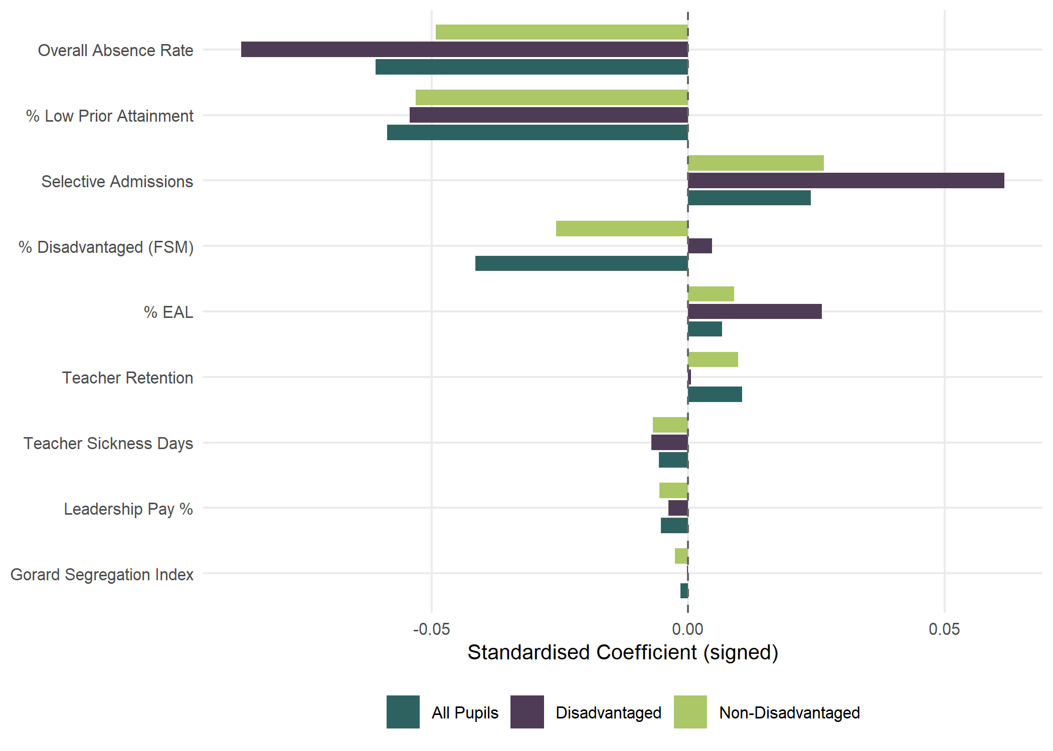
Figure 1: Standardised coefficients showing relative variable importance across pupil groups. Bars show the change in log(ATT8) associated with a one-SD shift in each predictor.
Figure 1 compares the standardised coefficients across all three pupil groups (all pupils, disadvantaged pupils and non-disadvantaged pupils - full model outputs available in the supplementary materials). Absence is the dominant predictor across all groups, but it is even more important for disadvantaged pupils — nearly half of the variation in school-level performance for this group is explained by attendance alone.
The most contentious finding in our analysis concerns concentrations of disadvantage (contentious in Brighton and Hove - although the findings echo the analysis of Macleod et al. (2015) a decade ago). For non-disadvantaged pupils, higher FSM proportions are associated with lower attainment. But for disadvantaged pupils, the coefficient is positive — after controlling for absence and low prior attainment, disadvantaged pupils perform slightly better in schools with higher concentrations of other disadvantaged pupils. This finding is robust across individual year models and alternative specifications of disadvantaged attainment and disadvantage measures. In the full multilevel model, this positive coefficient shrinks substantially, suggesting the effect operates through LEA-level and Ofsted-level factors rather than concentration per se — schools with higher FSM proportions in certain LEAs appear to have developed effective support systems, possibly through targeted use of Pupil Premium funding and other specialisations.
For non-disadvantaged pupils, the effects of higher disadvantage concentrations are more clearly negative. Even after controlling for attendance and prior scores, being in a higher-disadvantage school depresses Attainment 8 for this group — possibly due to a peer effect or curriculum-resourcing dynamic. Both of these findings are contentious in the Brighton and Hove context as they challenge the ‘no cost’ conjecture, but perhaps most importantly suggest that policy efforts to make the schools in the city more mixed than they already are (Brighton and Hove’s schools are already in the top third for integration of disadvantaged and non-disadvantaged students when using the Gorard Segregation index – a fact that emerged during the 2024 consultation, but not one that on its own moved the dial) might actually be counter productive as a policy to improve disadvantaged attainment.
Absence remains consistently the biggest predictor across all groups and is even more important for disadvantaged pupils. Nearly half of the difference in school-level performance for disadvantaged pupils is explained simply by whether they regularly attend. Disadvantaged pupils may lack the safety net of engaged parents, private tutors or revision resources that some less disadvantaged students have, which could be a factor in making classroom instruction more important for them. In this sense, attendance is the ultimate equity lever.
These outcomes do not advocate for concentrating disadvantaged pupils. We do not. However, where the social and spatial composition of LEAs means that disadvantaged and non-disadvantaged students are not evenly spread across schools, deconcentration policies premised on the assumption that disadvantaged pupils inevitably fare worse in schools with lower concentrations of disadvantage are not supported by this evidence. And where remediating policies require longer journeys that risk increasing absence (Thomson 2023), they could be actively counter-productive given how much more negatively impactful absence is.

5. Brighton and Hove case study

5.1 Local context
Brighton and Hove has ten secondary schools: six community schools run by the LEA, two academies (Brighton Aldridge Community Academy — BACA — and Portslade Aldridge Community Academy — PACA) and two church schools (King’s and Cardinal Newman) that set their own admissions. Following the closure of CoMArt in the east of the city in 2005, large catchment areas were introduced (Figure 2) with a lottery tie-break for oversubscribed schools — making admissions very different to most other places in England where distance typically determines priority (Allen et al. 2013).
In October 2024, the council launched proposals to amend the secondary school admissions process. The cabinet papers set out three stated objectives for the proposals: ‘a school system where all pupils get access to a great education’, improving ‘the education offer for disadvantaged pupils by reducing some schools’ barriers to success’, and using ‘all available options to maintain a broad curriculum and holistic school experience for all pupils’. The intended design principles included delivering ‘better equality of outcomes — results not driven by economic advantage’ and a ‘comprehensive offer from our city schools as a more mixed pupil intake creates better outcomes for disadvantaged pupils’, while ‘maintaining the geographic spread of secondary schools in the city’. Sitting alongside these attainment-focused objectives was the council’s broader School Organisation Strategy commitment to ‘schools which are sustainable and able to thrive’ against a backdrop of falling pupil numbers across the city. The specific proposals were to reduce Published Admission Numbers (PANs) at Longhill, Blatchington Mill and Dorothy Stringer by a combined 120 places, redraw the boundary between Longhill and Dorothy Stringer/Varndean catchment areas, and reserve up to 20% of places in single-school catchment areas for out-of-catchment children, thus increasing cross-city travel and mixing of children from different communities in different schools. Underpinning the case for these proposals was a reading of the evidence on school segregation (Gorard and Siddiqui 2019) in which more mixed pupil intakes produce better outcomes for disadvantaged pupils, and a related premise that attainment in the city was ‘driven by economic advantage’ — a framing that implied that those who could afford to do so paid a housing premium to be near better schools in the city. A characteristation that, in the Brighton and Hove context specifically, has been empirically challenged by Tan and Dennett (2025). This built on a 2023 policy giving FSM-eligible pupils priority in admissions at schools with below the city-average (30%) FSM share, which was already producing flows from peripheral to more popular central catchments.
The public response was overwhelmingly negative, with the council’s feedback summary from the pre-consultation engagement exercise noting ‘a strong preference for improving existing schools rather than redistributing students, alongside deep concerns about potential impacts on community cohesion and student wellbeing’. The proposals would, by the council’s own calculations, force significant numbers of children from central catchments to attend schools at the periphery of the city, potentially requiring over two hours of daily school commuting for many pupils. To support these increased flows, the council’s own transport-implications appendix to the consultation papers sets out that the council already spends approximately £339,000 per year on supported bus routes and a further £267,000 per year on around 600 bus passes for qualifying pupils, with provision likely to be re-prioritised — and in some cases extended — to support new pupil flows generated by the admissions changes. It’s worth noting that prior to the new administration taking control in 2023, the city council had in place a comprehensive strategy for tacking educational disadvantage which included a section on attendance, alongside leadership and governance and targeted support. This was not referenced in the materials produced for the 2024 consultation.
Whether the availability of better evidence would have changed the political outcome is unknowable. But with lived experience of responding to the council’s proposals, we can say that accessible evidence would have enabled earlier and more constructive engagement. Without ease of data access, the compressed consultation timeline left inadequate time to assemble and present counter-evidence for the complexity of the issues at stake. What follows is an attempt to demonstrate what that evidence looks like and how it could inform future debates in Brighton and Hove and beyond.
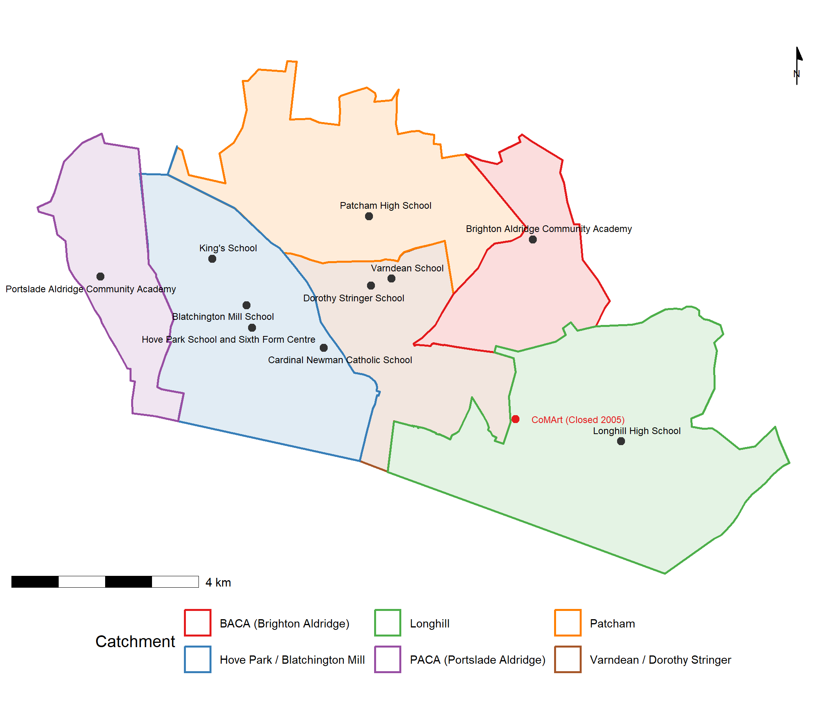
Figure 2: Brighton and Hove secondary schools with 2025/26 catchment boundaries.

5.2 Local authority effects
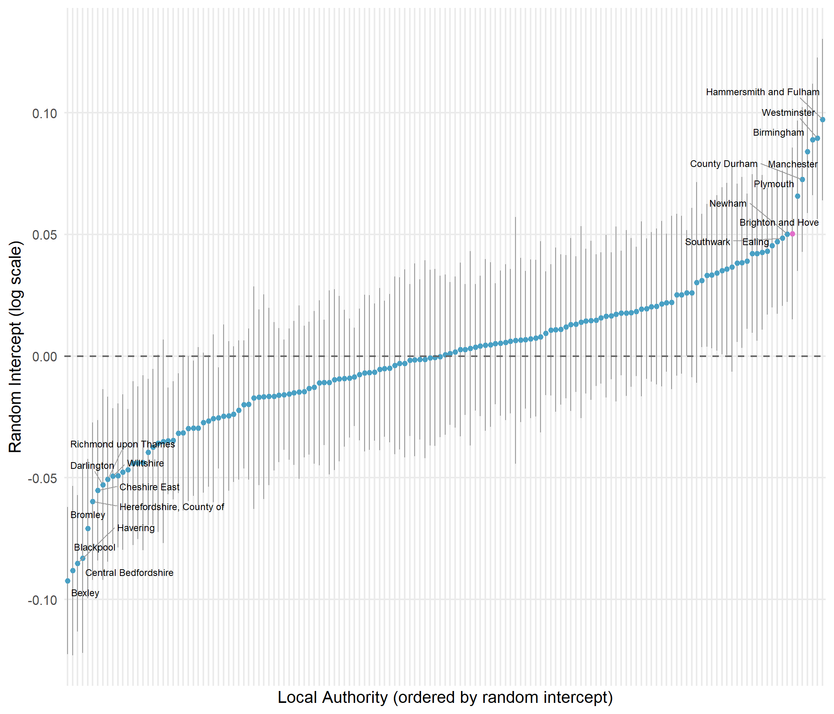
Figure 3: LA random intercepts for disadvantaged-pupil attainment (imputed full panel model). Top and bottom 10 LAs labelled; Brighton and Hove highlighted.
Figure 3 shows that Brighton and Hove ranks 7th out of 152 LEAs for disadvantaged attainment once structural factors are accounted for in the multilevel model presented earlier. For non-disadvantaged pupils it ranks 5th; for all pupils, 4th. The positive random intercept of approximately +0.06 translates to around a 6% uplift in Attainment 8 — roughly 2 GCSE points above what structural factors would predict. This was unknown at the time of the 2024 consultation and entirely absent from the public narrative, which was framed around a premise of failure, based on the raw attainment gap only.

5.3 Comparing policy levers: absence versus disadvantage
Because the model uses log-transformed variables, the same percentage-point change produces different effects depending on where a school starts — returns accelerate as values improve. Figure 4 places both the absence and FSM levers on a common y-axis.
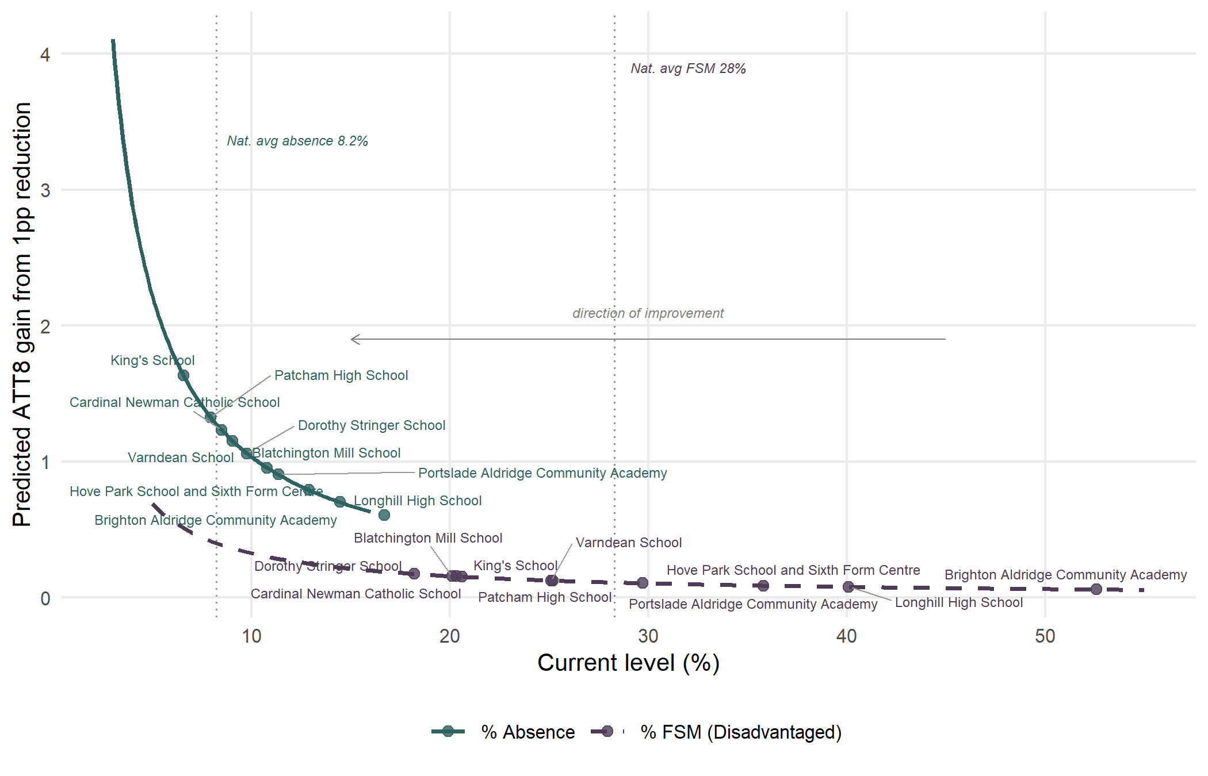
Figure 4: Accelerating returns: each percentage-point reduction buys a progressively larger ATT8 gain (reading right to left). Absence delivers substantially larger gains than FSM at every level. Brighton and Hove schools marked on each curve.
Three features are immediately visible. First, the absence curve sits above the FSM curve at every starting level. Second, the gap widens as values improve. Third, Brighton and Hove schools cluster in the flatter right-hand portion for both variables, but the city’s position is far more extreme for absence.
Brighton and Hove’s mean school FSM rate (28.8%) is close to the national average (28.3%). But the city’s mean absence rate (10.8%) against a national average of 8.2% places it at the 99th percentile — among the very worst in England. When standardised by the city’s spread, the absence coefficient is 2.6 times as important as FSM for predicting attainment.
Bringing schools above the national average for absence down to it would produce predicted gains averaging +2.9 Attainment 8 points per school, with gains for disadvantaged pupils averaging +3.3 points. Even dramatic FSM reductions would yield gains closer to 1 point. On the evidence, attendance is the single most consequential lever the city has available, and admissions changes of the kind proposed in 2024 are very unlikely to produce equivalent gains in disadvantaged attainment.

5.4 Contextualised school performance
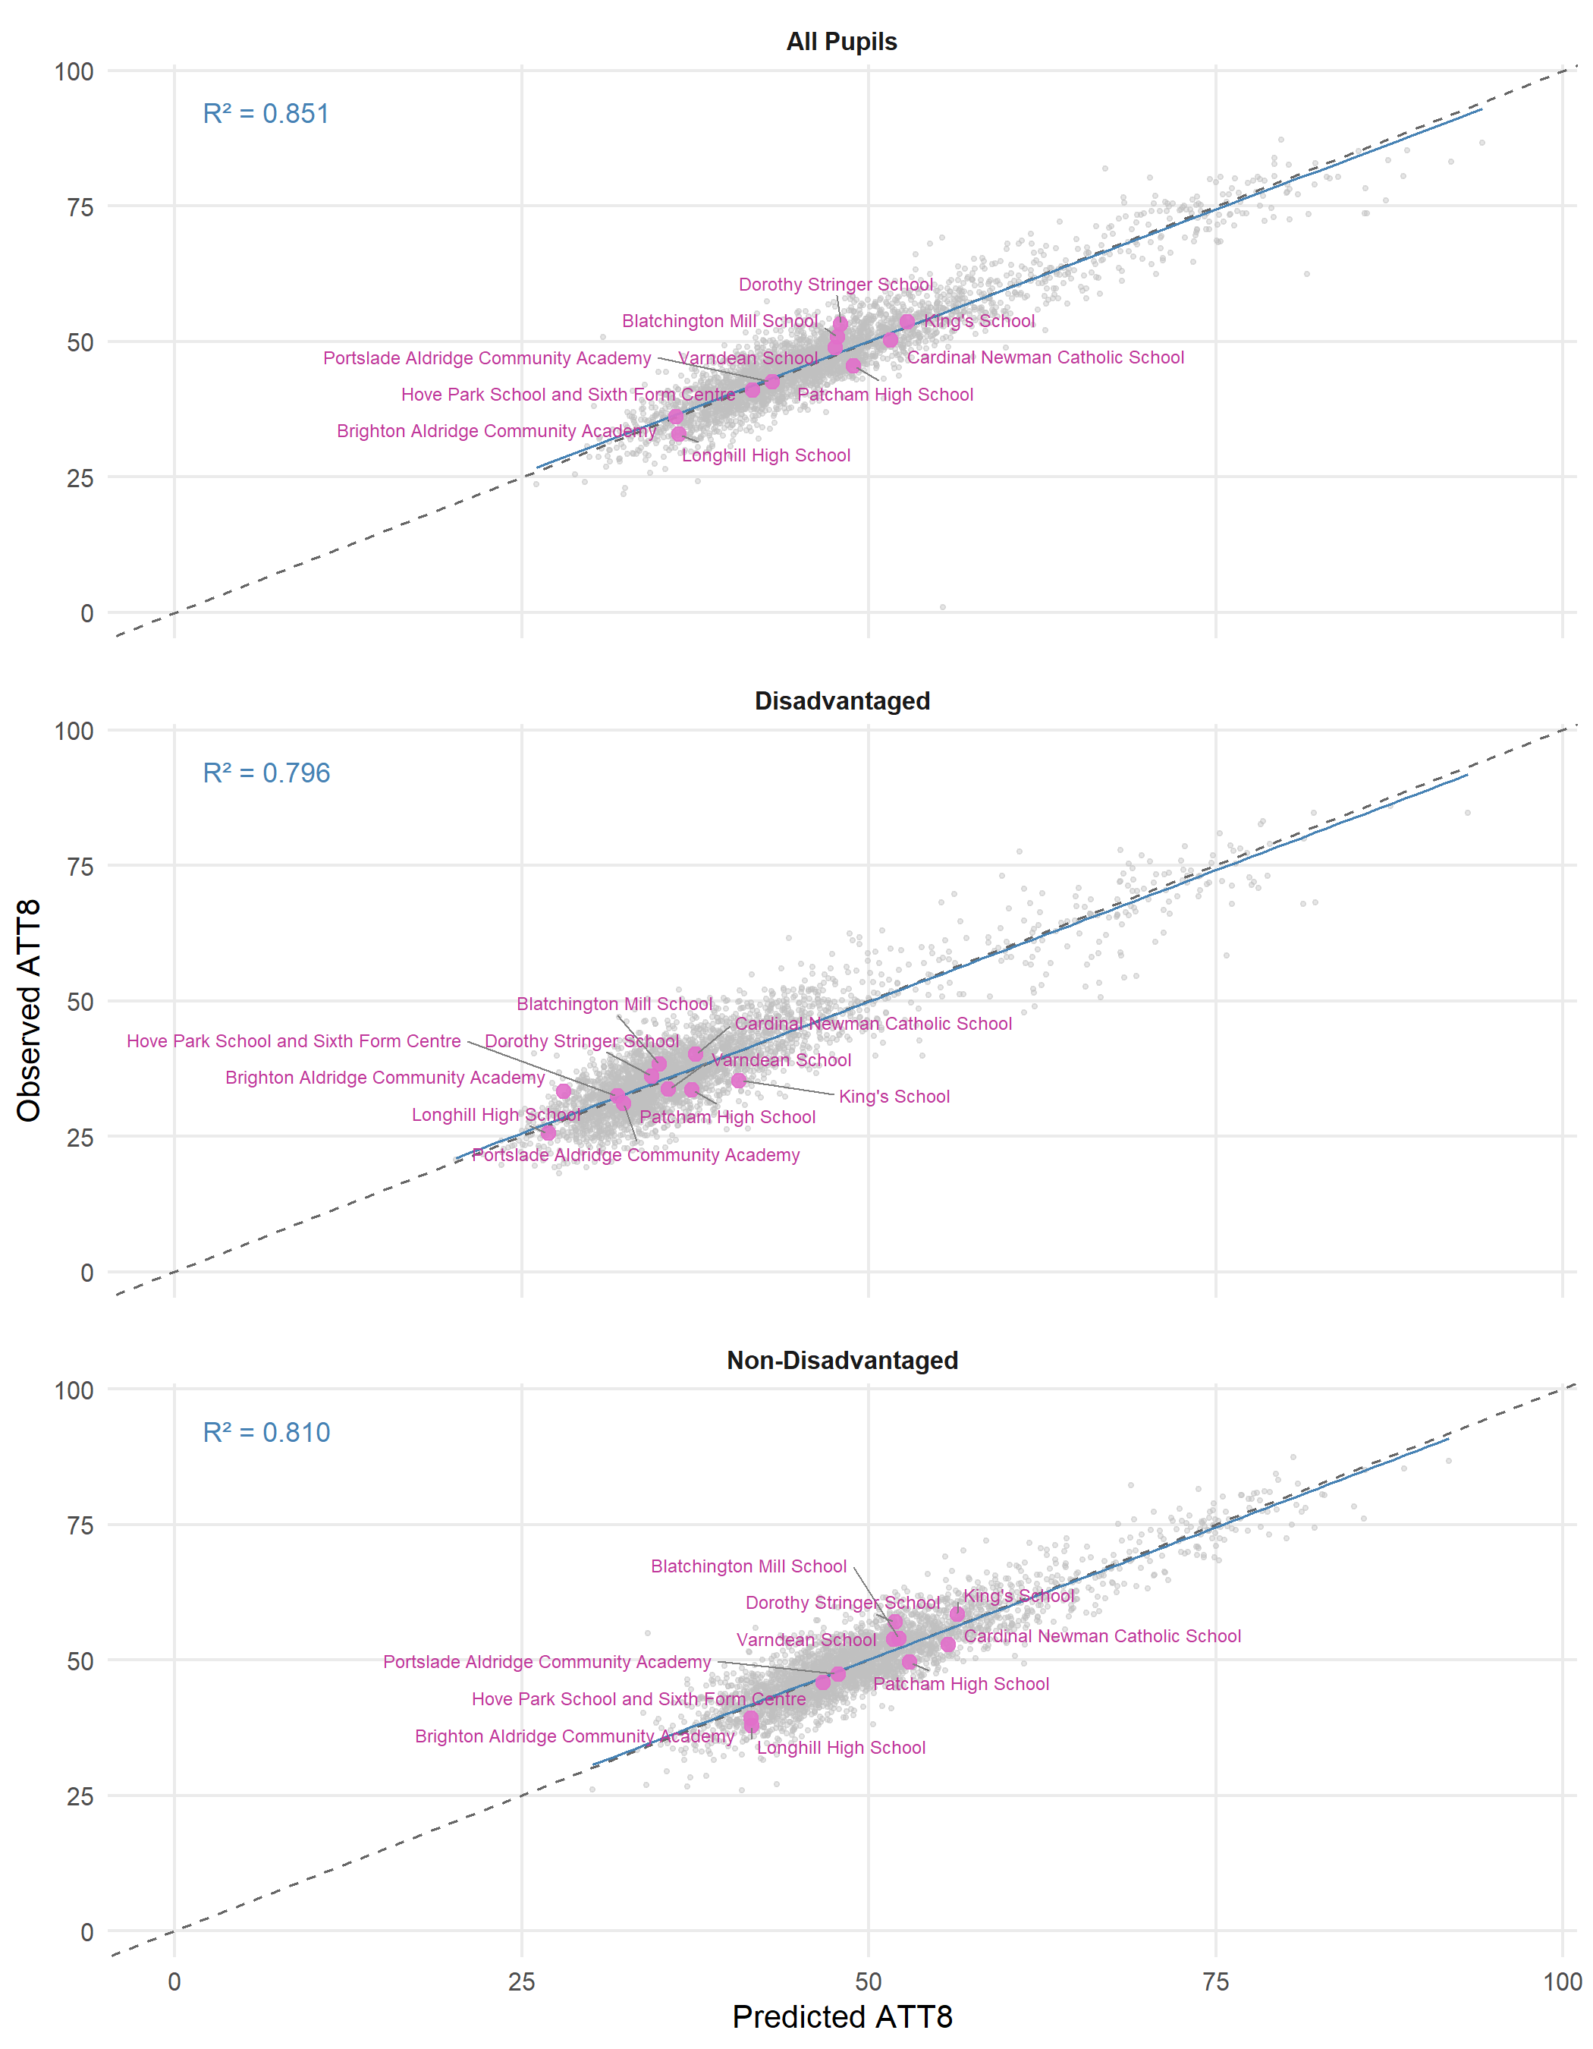
Figure 5: Observed versus predicted Attainment 8 for Brighton and Hove schools (highlighted) against all schools nationally, 2024–25.
Figure 5 shows observed versus predicted Attainment 8 for the latest year across all schools in England (grey) with Brighton and Hove schools highlighted (pink). The close clustering of the points around the diagonal line is a visual representation of the $R^{2}$ values show on the plot and in the tabular model outputs shown earlier - observed values for most schools are close to the model predictions. The model residuals — the vertical distance from the diagonal — show whether a school is doing better (above) or worse (below) than the model predicts and provides what we might think of as contextualised ‘value-added’ measures - more nuanced than Progress 8 - as this model-based value added accounts for far more than just prior attainment in its representation.

5.5 Decomposing absence: structural intake versus school management
The contextualised value-added reading above hides a complication we should make explicit. Our headline model treats school-level absence as a single regressor on the same footing as the school’s other intake variables, but absence is a little different to deprivation or English as and additional language. Some of school-level absence is exogenous to the school: driven by family circumstances, area-level health trends, deprivation patterns, the SEND profile of the catchment and other features of the intake the school inherits but cannot directly choose. However some of it is produced by the school: through pastoral systems, attendance officers, parental engagement and the broader ethos around getting children into class. When we control for raw absence in our headline model, both components are absorbed together — the school-level residual we have just been calling ‘value-added’ reflects what the school does given its attendance, not what it does to its attendance.
However, it is possible to separate these endogenous and exogenous elements of absence via A two-stage decomposition. Firstly, we fit a new absence model in which school-level absence is modelled only on the variables we treat as exogenous to the school (FSM, EAL, low prior attainment, segregation, plus place and year random effects). This produces two derived quantities for every school-year: an expected absence (the part the intake predicts) and a residual absence (what is left over — broadly, the school-controllable component). Secondly, we refit the attainment model with the intake-predicted absence in place of raw absence, and we drop the workforce predictors. The school-level residual from this refitted attainment model is a more honest value-added measure: it gives credit for what the school adds to attainment over and above its intake, with attendance management already counted as part of the school’s contribution rather than stripped away as a control.
The national-level picture this paints is informative. Most of the school-year variation in absence is explained by the intake-only first stage — absence at school level is dominated by intake and place-level structural factors. The school-controllable residual is the smaller share, and a model that fits expected absence and residual absence as separate predictors confirms that the marginal contribution of residual absence to attainment is modest at England school level once intake-driven absence is already accounted for. This does not mean attendance management is unimportant. It means the headline raw-absence coefficient borrows much of its statistical force from the structural component. The lever is real, but the school-only portion of it is smaller than the single coefficient implies. For local education authorities this has direct policy consequences: closing a city’s absence problem requires both school-level attention and cross-departmental work — public health, children’s services, area-level deprivation policy — because much of what schools are dealing with on attendance is inherited from within the LEA, rather than generated.
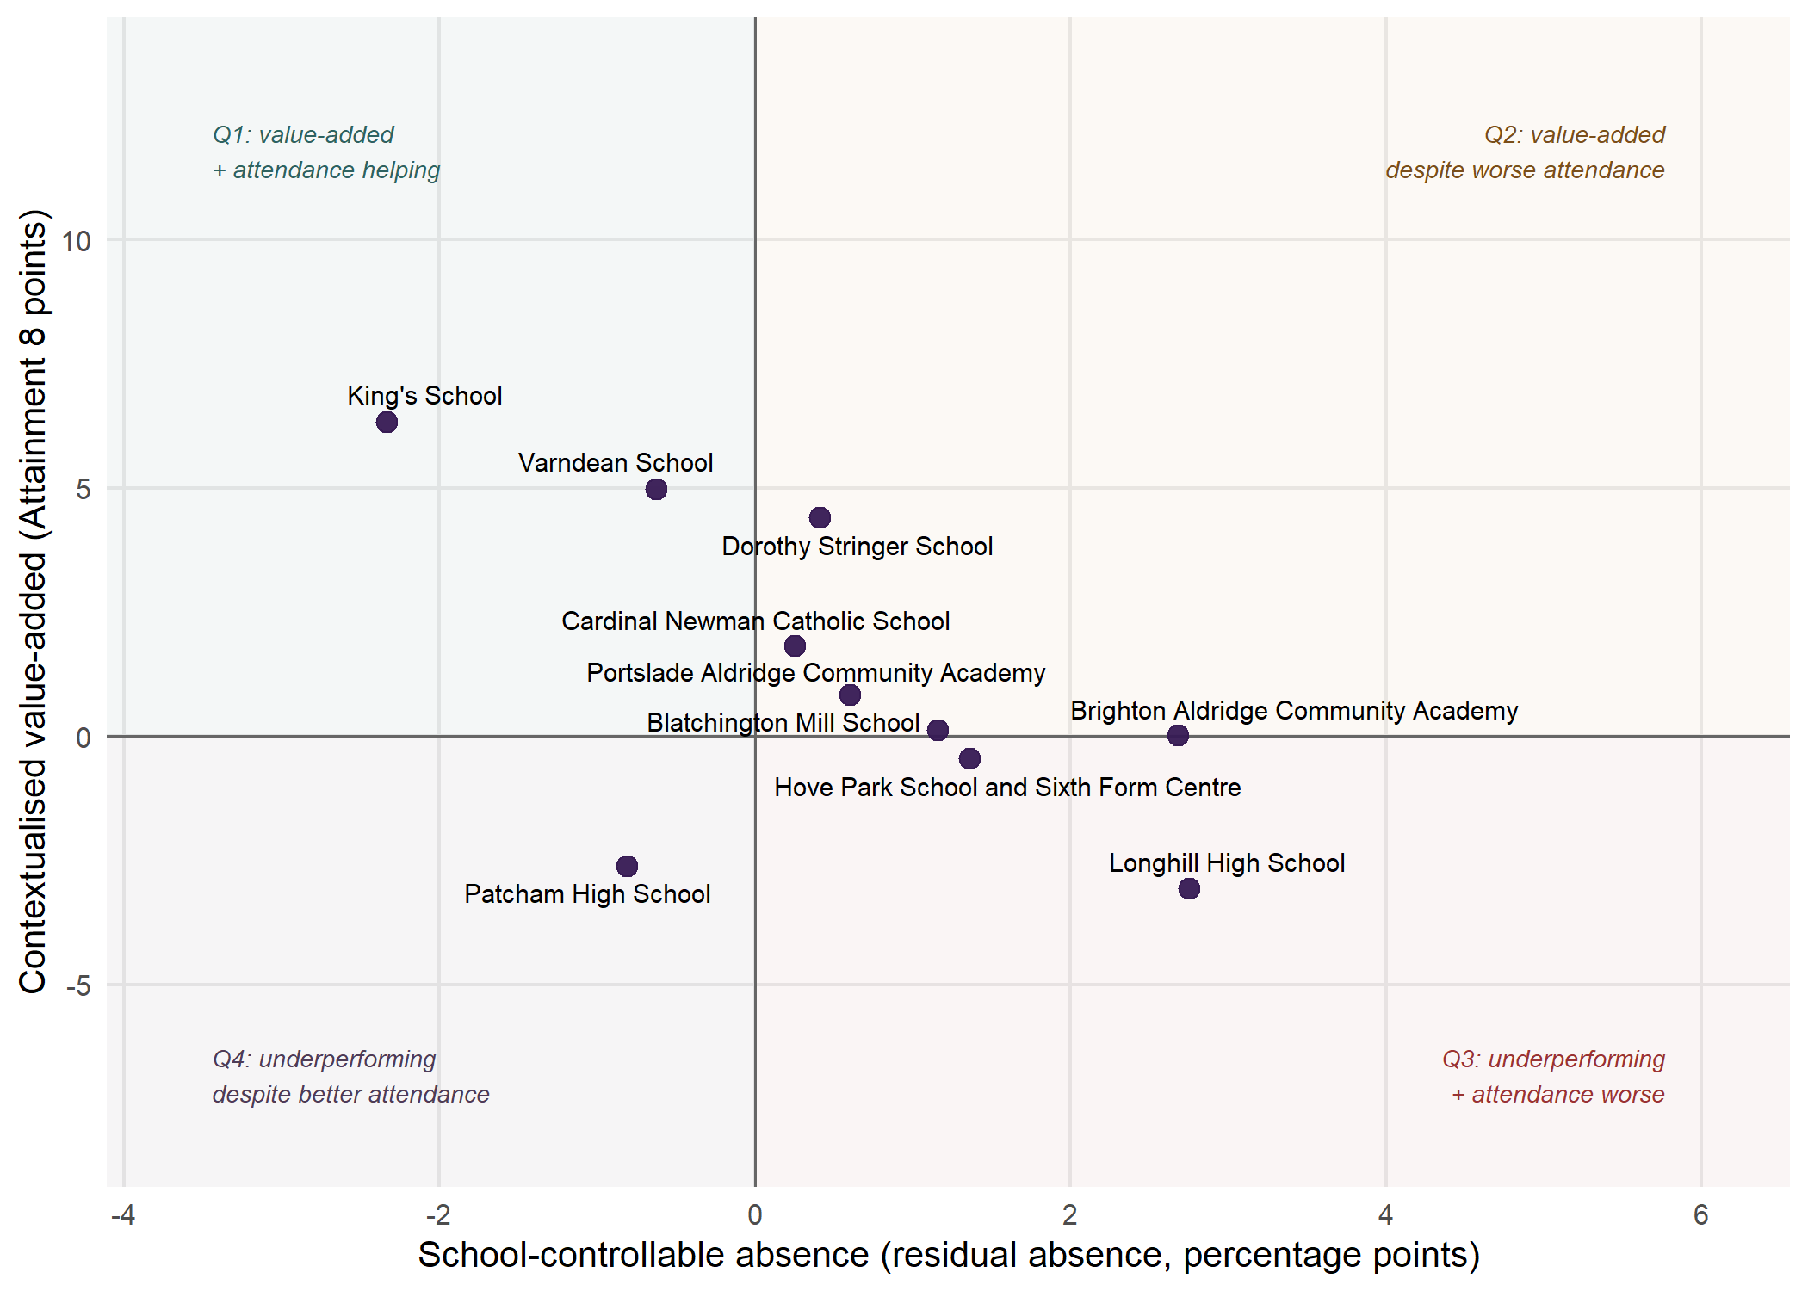
Figure 6: Brighton and Hove secondaries on the joint-signal plane: contextualised value-added (vertical, in Attainment 8 points) versus the school-controllable absence component (horizontal, in percentage points). The reference lines at zero on each axis split the plane into four narrative quadrants discussed in the text. The full national version with a local-authority filter is available interactively in the project’s HTML report.
For local school-level diagnostics the decomposition becomes considerably more informative. Two signals can now be read side by side: the school’s contextualised value-added, and its residual absence (positive when the school runs more absence than its intake would predict, negative when less). Sorted on these two axes (Figure 6), schools fall into four meaningful policy stories: schools adding value with attendance management helping (Q1, top-left); schools adding value despite worse-than-predicted attendance (Q2, top-right); schools underperforming with attendance the cleanest single lever (Q3, bottom-right); and schools underperforming despite unusually good attendance management (Q4, bottom-left).
For Brighton and Hove the joint-signal view sharpens the case-study reading. Most of the city’s schools sit in Q2 in the top-right: they are delivering attainment above what their intake would predict and is doing so while running more absence than their intake-driven absence model expects. In these schools, the pedagogical work happening is the more impressive for it; closing any of these school’s residual-absence gap would compound directly onto an already-strong value-added signal. Any schools in Q4 provide a challenge: their attendance management is genuinely strong, but once intake is properly accounted for their attainment outcomes fall short of what their profile predicts, so the simple “fix attendance” improvement story is not available. Schools in Q3 are the most natural targets for council-led attendance interventions, and Q1 schools are where the city should look for practice worth sharing. Reporting value-added alongside residual absence, with explicit uncertainty intervals, is a more honest framing than the single number that conventional benchmarking produces, and would help align local policy conversation with what the data can support.

6. Discussion

6.1 The danger of single-lever policy thinking
The Brighton and Hove experience illustrates the risks of building a policy around a single causal narrative. The council’s 2024 admissions proposals were built around the premise that redistributing disadvantaged pupils would narrow the attainment gap. In the consultation papers released to the public, it was stated:
“We also know that children from disadvantaged homes are less likely to do well at school and that can be made worse when more disadvantaged children all go to school together. We are looking at options for how we can help the city manage that issue better, including through our school admissions arrangements.”
This premise sits awkwardly with the existing evidence base. Macleod et al. (2015)’s earlier analysis for the DfE found that, controlling for intake characteristics, schools with higher concentrations of disadvantage tend to do better for their disadvantaged pupils, not worse. Our more up-to-date modelling on four years of national data reaches the same conclusion. Concentrations of disadvantage are one of the weaker available levers, and for disadvantaged pupils specifically the direction of the effect runs in the opposite direction to the policy assumption. The implication is that admissions changes of the kind proposed in Brighton and Hove are unlikely to deliver the targeted gains in disadvantaged attainment and could produce the opposite outcome.
The chosen lever also carries its own risks that the proposals did not engage with. Redistribution policies necessarily generate longer journeys to school for many pupils, and the wider literature is clear that long commutes are associated with reduced sleep and its psychosocial (Fredriksen et al. 2004; Yeo et al. 2019), physical (Voulgaris et al. 2019; Pradhan and Sinha 2017; Pereira et al. 2014; Faulkner et al. 2013) and mental health (Nakajima et al. 2024; Chairassamee et al. 2024; Guan et al. 2025) consequences, including stress (Karan et al. 2021) and general wellbeing (Ding et al. 2023), and crucially with higher absence across multiple national settings (Otsuka et al. 2025; Cordes et al. 2022; Blagg et al. 2018), including England (Thomson 2023). Absence is the single largest predictor of attainment in our modelling and the city’s most acute structural problem; a policy that even marginally increases it could be counterproductive in attainment terms. With the claim that social mixing can be achieved at ‘almost no cost’ (Gorard and Siddiqui 2019) , ‘almost’ is doing a lot of heavy lifting in the presence of this second-order literature.
There is a further, more qualitative dimension to displacing pupils from their local schools. Schools serve as community anchors for the families and neighbourhoods around them: walked-to schools and the ability to easily attend after-school activities, friendship groups that map onto local catchments, parental engagement that depends on geographic proximity, and active travel that supports physical and mental health (Faulkner et al. 2013). A masters-level case study of extended commutes in Chicago (Shah 2023) argues that the burden of long commutes falls disproportionately on pupils already experiencing other forms of marginalisation. Long-distance transit also predicts early high school transfer (Stein et al. 2021), itself a known risk factor for poor attainment. These are not peripheral concerns; they are part of the cost-benefit calculus that any redistribution policy needs to take seriously, and they were largely missing from the 2024 deliberation.

6.2 Attendance as the most impactful single lever
A policy conversation about Brighton and Hove’s disadvantage attainment gap that wants to make the largest predictable difference should put attendance at its centre. This sits squarely within the council’s own framing: the December 2024 cabinet report named ‘reducing some schools’ barriers to success’ for disadvantaged pupils as one of its three core objectives for the 2026/27 admissions changes . Of the school-level barriers our modelling is able to quantify — intake composition, prior attainment, workforce stability, segregation, and absence — none has a larger or better-evidenced effect on disadvantaged attainment than absence. On the council’s own framing, in other words, the most direct route to ‘reducing barriers to success’ for the city’s disadvantaged pupils points at attendance rather than at admissions arrangements. The city has the second-worst absence rate in England, and the wider evidence indicates that closing this gap would yield attainment gains for disadvantaged pupils that comfortably exceed anything achievable through changes to admissions arrangements — and would do so without the social, health and travel costs that a redistribution-led approach implies.
Brighton and Hove’s absence rates are not a necessary consequence of its intake composition. The city has near-average FSM eligibility levels but near-worst absence, suggesting the problem reflects local factors — attendance culture, enforcement practices, transport friction or community dynamics — rather than being an unavoidable correlate of disadvantage. If the city is not already running a substantial cross-departmental attendance programme alongside its school-level work, the case for one is strong. There is also a budget question here that policy makers may want to weigh transparently: the council’s own transport-implications appendix which was part of the 2024 consultation reports that approximately £606,000 is already being spent each year on supported bus routes and bus passes to facilitate pupils getting to school, with the prospect of further travel-assistance spending to accommodate pupil flows generated by the admissions changes. Resources of that scale invested directly in attendance support, family liaison and pastoral capacity in the city’s most affected schools would have a stronger evidence base for raising disadvantaged attainment than the equivalent spend on lengthening some children’s daily commutes.

6.3 A new value-added view to support better local decisions
Another contribution of this work is methodological. The multilevel model lets us look beyond a school’s raw attainment outcomes and ask how much it is adding over and above the structural intake characteristics it inherits — characteristics that the school cannot itself choose. The school-level random intercept, plus the school-level residual from the fitted model, gives us a contextualised value-added view that is fairer than the headline attainment number and more informative than a single (or multi)-word Ofsted rating, both for parents making school choices and for policy makers assessing where local effort is best directed. Brighton and Hove provides a particularly sharp illustration of why this matters: the local school for one of the city’s most disadvantaged catchments is, on this view, doing materially better for its disadvantaged pupils than the schools to which a number of those pupils’ families have been opting to travel.
Table 2: Value-added rankings for Brighton and Hove schools (panel model residuals by year, in Attainment 8 points).
Rank | School | 2021-22 | 2022-23 | 2023-24 | 2024-25 | Mean
1 | Dorothy Stringer School | +3.5 | +3.8 | +2.8 | +5.2 | +3.8
2 | Varndean School | +4.0 | +3.3 | +6.0 | +1.2 | +3.6
3 | King’s School | +4.8 | +0.1 | +5.9 | +0.8 | +2.9
4 | Portslade Aldridge Community Academy | +2.9 | -0.4 | +3.1 | -0.5 | +1.3
5 | Brighton Aldridge Community Academy | +2.0 | +1.2 | +0.4 | -0.0 | +0.9
6 | Blatchington Mill School | -2.2 | -0.8 | +2.5 | +3.1 | +0.6
7 | Hove Park School and Sixth Form Centre | +0.6 | +2.0 | +0.4 | -0.6 | +0.6
8 | Cardinal Newman Catholic School | +0.4 | -1.7 | +1.2 | -1.3 | -0.3
9 | Longhill High School | +0.4 | -2.2 | -2.2 | -3.4 | -1.8
10 | Patcham High School | -3.2 | -2.7 | -4.9 | -3.4 | -3.6
1 | Brighton Aldridge Community Academy | +3.2 | -1.3 | +4.1 | +5.2 | +2.8
2 | Varndean School | +3.2 | +3.6 | +4.5 | -1.9 | +2.3
3 | Dorothy Stringer School | +2.9 | +3.2 | +0.3 | +1.7 | +2.0
4 | Cardinal Newman Catholic School | +2.4 | -5.0 | +6.5 | +2.5 | +1.6
5 | King’s School | +5.8 | +0.9 | +4.4 | -5.4 | +1.5
6 | Blatchington Mill School | -5.4 | +1.3 | +5.2 | +3.4 | +1.1
7 | Hove Park School and Sixth Form Centre | +2.4 | -1.7 | +1.3 | +0.5 | +0.6
8 | Portslade Aldridge Community Academy | +2.6 | -4.0 | +4.7 | -1.3 | +0.5
9 | Patcham High School | +3.8 | +1.6 | -11.9 | -3.7 | -2.6
10 | Longhill High School | -4.6 | -6.2 | +0.8 | -1.4 | -2.9

In the period of the 2024 consultation the public debate in the city shifted slightly, away from how the council’s proposals were going to improve disadvantaged attainment to how they were facilitating parental choice. Choice in this instance was largely to do with parents perceiving their local options to be poor and wanting access to alternatives. An activist group (Equity in Education — supported by another more established activist group — Class Divide) emerged from within the BACA catchment advocating for parents to have more options available to not send their children to that school. At the time BACA’s Ofsted rating was ‘requires improvement’ and its raw attainment scores were some of the lowest in the city — creating an impression of that school being a poor option.
As a family deciding on where to send their child, they can decide based on how the school performs overall, or where a school increases attainment beyond the structural disadvantage faced by their pupils (over which they have little control). These do not always lead to the same answer. In Brighton and Hove, one of the outcomes that emerged from the vocal public debate, was a considerable number of parents from the BACA catchment opting to send their children to Patcham School (in the neighbouring catchment — see Figure 2) for entry in 2025 and 2026 — a school rated ‘Good’ by Ofsted and with raw attainment scores placing somewhere mid-table in the city. However, if we move beyond the raw attainment scores and blunt single-word Ofsted ratings, a very different picture of the two schools emerges. BACA is situated in one of the most economically deprived parts of Brighton and Hove, Patcham, is more economically prosperous. BACA’s absence rates have been in excess of the very high city average. Patcham is one of two schools in the City with absence rates below the national average. The number of pupils entitled to Free School Meals attending BACA is around 50%, at Patcham it is around 25%. Around 30% of the pupils attending BACA have low prior attainment, at Patcham it is around 16%. When we account for these stark cohort differences in our model, a very different picture of school effectiveness occurs.
These are, of course, school-level observations and difficult to translate into predictions about whether any individual Pupil A will be better-off attending school X or school Y, but they do correspond to an average expected situation. As the league tables in Table 2, derived from Figure 5 in above reveal, in 2024-25, a disadvantaged pupil attending BACA and taking their GSCEs would have, on average, left that school with GCSEs 5-points higher than if they’d attended a similar school with a similar profile elsewhere in England. Over the last 4 years, this would have averaged around 3 points higher. This is a boost way in excess of the fraction of a point differences that might be expected from altering the disadvantage mix in schools. BACA is doing incredibly well for its disadvantaged students and indeed out-performs every other school in the city by some margin — even those which in the popular imagination are viewed as the ‘best’ or most desirable schools in the city, e.g. Varndean, Cardinal Newman. BACA in some ways is the case study that illuminates the findings in the national data earlier in this paper which showed that disadvantaged attainment is higher in schools with bigger concentrations of disadvantaged students and in direct contradiction to the statement in Brighton and Hove City Council’s consultation materials. In April 2025, BACA received a new Ofsted report which rated it ‘Good’ in all 5 areas of provision — a result unsurprising in the context of this data analysis, but probably more surprising to anyone just looking at raw prior attainment and previous Ofsted report.
If we contrast BACA — the school popular narrative discouraged parents from sending their children to — with Patcham — the school many from BACA catchment in the end opted for, the differences on this alternative league table are stark. Disadvantaged pupils attending Patcham on average over the last 4 years and compared to other disadvantaged pupils attending schools with similar profiles elsewhere in England, would leave with around 2.6 GCSE points fewer than they might be expected to compared to similar schools elsewhere in England. In 2023-24, the difference was in double figures. These differences have been hidden from view amongst the comfortable mid-table position, in raw attainment terms, the school has enjoyed. There might be many reasons why parents would want to opt for Patcham High School over BACA - some may reasonably ask why it would be better to send a child to a school doing well “considering” vs doing well in raw terms? The answer is that at the school-level, those statistics reflect ALL children (including all of those who, for example, missed a lot of school and consequently did poorly in their exams). The “considering” element of this analysis and the nuance nuance it affords to the effectiveness of these schools by showing the value added in the face of (in our example) high levels of absence, reveals the underlying positive features of the school that will benefit all pupils. The modelling in this paper helps provide this alternative view that might have made some of parents from BACA catchment who opted to send their children to Patcham, make a different decision.
One thing other schools in the city certainly could learn from Patcham High School is in how to improve attendance rates. The school is one of only two in the city with attendance better than the national average. This is an actionable policy lever at the school-level. Without a deeper dive into attendance issues at the different schools in the city, it’s impossible to know what the drivers of this issue are. But given we now know where the real problems in Brighton and Hove lie at the LEA level, one useful policy focus at the city level could well be exploring how schools like Patcham are able to keep attendance relatively high, while then allowing more school-level investigations into where under-performance might be occurring given our new knowledge of interacting structural drivers within the city.

6.4 Viability versus attainment
The cabinet papers set out the financial-sustainability rationale plainly. Schools in England are funded almost entirely on a per-pupil basis, so falling pupil numbers across the city would, in time, leave some schools struggling to operate efficiently or ‘offer a wide and balanced curriculum’. The proposed PAN reductions of 120 places in total were framed by the council as a way of distributing that impact across the city’s most over-supplied schools rather than concentrating it on individual under-subscribed ones. The council also noted, importantly for the framing of the policy, that ‘the largest percentage of [disadvantaged] pupils attend the schools with the lowest pupil numbers’ — making the viability concern and the disadvantage objective explicitly interlinked in the council’s argument. Financial viability is therefore a legitimate concern, particularly given the historical context of an earlier school closure in a deprived part of the city that left some pupils already travelling long distances to peripheral provision. There is, however, an inherent tension between optimising for financial sustainability and optimising for educational outcomes — and the two cases need to be weighed transparently. The contextualised value-added view introduced above suggests that the city’s pattern of school-level effectiveness does not map cleanly onto raw attainment or popularity: if redistribution moves children from schools adding more value to schools adding less, the aggregate impact on city-wide attainment could be negative even if the financial case for the receiving schools improves.
Following widespread opposition and appeals to the Schools Adjudicator, the proposed PAN reductions were rejected. Parental objections meant that the 20% out-of-catchment priority was reduced to 5%. While displacement was minimised, the policy reverberations continued through choices expressed by parents already influenced by the preceding debate.

6.5 What is driving Brighton and Hove’s over-achievement? And what we don’t yet know
The LEA random effect for Brighton and Hove is large and statistically significant across all three attainment groups. After accounting for the structural (disadvantage, absence, prior attainment) or school management and governance (workforce characteristics, staff retention) factors in the model - schools in the city consistently outperform what the national picture would predict. For disadvantaged pupils, the city ranks 7th; for non-disadvantaged pupils, 5th; for all pupils, 4th in England.
This is a genuinely important finding that should re-frame the policy conversation. The starting point for the 2024 consultation was a narrative of failure — the city was presented as uniquely failing its disadvantaged students, sitting on a vast attainment gap, with radical structural reform required to address the problem. The evidence suggests the opposite: Brighton and Hove is one of the highest-performing LEAs in the country once we account for the factors that we know drive attainment. Rather than asking what the city is doing wrong, the more productive question is what it is doing right — and how that can be protected and extended?
The honest answer is that we do not yet know what produces this LEA effect. The random effect, by definition, captures variance that the fixed-effect predictors do not explain. It could reflect high levels of parental engagement and aspiration — Brighton and Hove has a well-educated population with a strong civic culture. It could relate to the quality of school leadership and governance across the city, or to effective local authority support services and school improvement programmes. It could be something about the collaborative relationships between schools, or community factors that are difficult to quantify. Identifying the sources of this over-performance is an important research question in its own right, and one that could require additional qualitative investigation or access to pupil-level data that goes beyond what is publicly available. What is clear, however, is that policy interventions which risk disrupting a well-functioning system without understanding what makes it function well carry substantial downside risk.

6.6 Implications for national policy
The DfE (2026) white paper’s ambitions will founder if pursued at the local level without adequate analytical infrastructure. Every LEA occupies different positions along the non-linear curves that relate predictors to outcomes. What works in one context may be counterproductive in another. The DfE’s open data provides most of the raw materials, but there is a crucial gap between raw data availability and the accessible, contextualised intelligence that decision makers need.
We have developed an interactive Policy Simulator tool, underpinned by the models in this paper, to begin bridging that gap. The tool allows users to explore any school in England, compare against contextual expectations, and model the indicative impact of changes to key variables.

6.7 Limitations
These are school-level models built from aggregate published data, not pupil-level analyses. The associations identified are not experimental causal estimates but the best approximations available from observational data. The models cannot capture unmeasured factors such as school culture, parental engagement, or individual pupil resilience. The Policy Simulator translates associations into indicative, not definitive, projections. We do not claim that reducing absence by a given amount will mechanically produce the predicted gain — the real world is more complex than any model captures. What we do claim is that these models are accurate enough, and the patterns consistent enough across years and specifications, to substantially improve the quality of the conversation around what matters most.

7. Conclusion
This paper has demonstrated that the DfE’s open data is a substantially underutilised resource for understanding school attainment and informing local policy, at least in the context of our case study LEA. School-level Attainment 8 is remarkably predictable from a small number of variables, and that predictability creates opportunities for better-informed local policy. The Brighton and Hove case study yields three positions we feel are well-supported by the evidence presented here.
First, the city’s 2024 admissions proposals were built on a premise — that concentrations of disadvantage are a primary driver of low disadvantaged attainment — that does not hold in the context of four years of national data analysed here, nor with the earlier DfE-commissioned analysis (Macleod et al. 2015). Combined with the wider literature on the consequences of long school commutes for sleep, health, well-being, attendance, school transfer and the loss of community-anchored schooling, the proposals are unlikely to deliver the targeted gains in disadvantaged attainment and carry a set of social and educational costs that the consultation did not engage with.
Second, the single most consequential lever available to Brighton and Hove for raising disadvantaged attainment is attendance. The city has the second-worst absence rate in England, and the modelling suggests that moving the city’s worst-affected schools toward the national absence average would yield gains for disadvantaged pupils that comfortably exceed anything achievable through admissions reform. The two-stage decomposition we develop here also shows that this lever has two parts to it: a structural component of school-level absence inherited from intake, area health, deprivation and family circumstances — which schools cannot themselves change — and a smaller school-controllable residual that pastoral systems, attendance officers, family liaison and persistent-absentee follow-up can act on directly. Closing the city’s absence problem therefore needs both school-level effort and cross-departmental action; treating it as a single school-level lever would over-state what individual schools can deliver alone. If the city is not already running a substantial cross-departmental attendance programme, the case for one is strong; resources of the scale required to bus children between catchments would, on the evidence, deliver more for disadvantaged pupils if invested directly in attendance and pastoral support in the city’s most affected schools.
Third, the modelling provides a contextualised, value-added view of school performance that is fairer than raw league tables and more informative than a single-word Ofsted rating. For parents this matters directly: in Brighton and Hove, the local school of one of the city’s most disadvantaged catchments is, on this view, doing materially better for its disadvantaged pupils than the schools families have been opting to travel to instead. A wider understanding of this view would help families make decisions that work for their children and preserve the benefits of local schooling.
Our recommendations follow. For the DfE: invest in analytical infrastructure at the local level and consider how contextualised benchmarking tools might be developed at scale. For LEAs: contextualised benchmarking and a focus on the most impactful levers should be at the centre of local policy on attainment. The factors affecting attainment are multiple, interacting, non-linear and context-dependent, and a single-narrative approach risks pulling the wrong lever. For schools, governors and parents: a contextualised value-added view offers a fairer basis for understanding school quality than raw scores or Ofsted ratings, and can support better choices that do not come at the cost of community-anchored schooling, while helping point to where improvement efforts might be most usefully targeted.

CRediT authorship contribution statement
Adam Dennett: Conceptualisation, Methodology, Software, Formal analysis, Data curation, Writing – original draft, Writing – review & editing, Visualisation, Project administration. Dan Campbell-Meiklejohn: Methodology – refining and review; Writing – review & editing. Beatrice Taylor: Methodology – refining and review; Writing – review & editing.

Declaration of generative AI use
The authors used Anthropic’s Claude Code (Claude Opus 4.6) to assist with the development of R data-processing pipelines, the implementation of multilevel model fitting and visualisation code, the formatting of tables and bibliography entries, and the rendering and deployment of Quarto outputs. Any analytical decisions and interpretations during the iterative analytical process were reviewed, verified and approved by the authors, who take full responsibility for the work.

Acknowledgements
Development of the Policy Simulator tool was substantially accelerated by large language model assistance (Anthropic’s Claude) as part of work supported by the UKRI National AI Research Hub for Collective Intelligence (AI4CI). All of this work has been co-designed through many hours of conversations over the last 18 months or so with a group of parents in Brighton and Hove who have come together under the banner of the ‘Parent Support Group’. The range of perspectives and breadth of expertise within this group has been inspirational.

Declaration of interest
Some of the authors are residents of Brighton and Hove with school aged children and lived experience of the effects of the admissions policy process described. No financial conflicts of interest exist.

References
Allen, Rebecca, Simon Burgess, and Jennifer Mayo. 2018. “The Teacher Labour Market, Teacher Turnover and Disadvantaged Schools: New Evidence for England.” Education Economics 26 (1): 4–23. https://doi.org/10.1080/09645292.2017.1366425.
Allen, Rebecca, Simon Burgess, and Leigh McKenna. 2013. “The Short-Run Impact of Using Lotteries for School Admissions: Early Results from Brighton and Hove’s Reforms.” Transactions of the Institute of British Geographers 38 (1): 149–66. https://doi.org/10.1111/j.1475-5661.2012.00511.x.
Anders, Jake, Francis Green, Morag Henderson, and Golo Henseke. 2024. “Private School Pupils’ Performance in GCSEs (and IGCSEs).” Cambridge Journal of Education 54 (6): 795–813. https://doi.org/10.1080/0305764X.2024.2420611.
Blagg, Kristin, Victoria Rosenboom, and Matthew M. Chingos. 2018. The Extra Mile: Time to School and Student Outcomes in Washington, DC. Urban Institute. https://www.urban.org/sites/default/files/publication/99027/time_to_school_and_student_outcomes_in_dc_1.pdf.
Burgess, Simon, Claire Crawford, and Lindsey Macmillan. 2018. “Access to Grammar Schools by Socio-Economic Status.” Environment and Planning A: Economy and Space 50 (7): 1381–85. https://doi.org/10.1177/0308518X18787820.
Burgess, Simon, Shenila Rawal, and Eric S. Taylor. 2023. “Teachers’ Use of Class Time and Student Achievement.” Economics of Education Review 94 (June): 102405. https://doi.org/10.1016/j.econedurev.2023.102405.
Burgess, S., S. Rawal, and E. Taylor. 2022. Characterising Effective Teaching. Nuffield Foundation. https://www.nuffieldfoundation.org/project/characterising-effective-teaching-2.
Chairassamee, Nattanicha, Kanokwan Chancharoenchai, and Wuthiya Saraithong. 2024. “Getting There: How Commuting Time and Distance Impact Students’ Health.” PLoS One 19 (12): e0314687. https://doi.org/10.1371/journal.pone.0314687.
Commons Education Committee, House of. 2021. “Forgotten” White Working-Class Pupils Let down by Decades of Neglect, MPs Say - Committees - UK Parliament. UK Parliament. https://committees.parliament.uk/committee/203/education-committee/news/156024/forgotten-white-workingclass-pupils-let-down-by-decades-of-neglect-mps-say/.
Cordes, Sarah A., Christopher Rick, and Amy Ellen Schwartz. 2022. “Do Long Bus Rides Drive down Academic Outcomes?” Educational Evaluation and Policy Analysis 44 (4): 689–716. https://doi.org/10.3102/01623737221092450.
DfE. 2022. The Link Between Absence and Attainment at KS2 and KS4, Academic Year 2018/19. https://explore-education-statistics.service.gov.uk/find-statistics/the-link-between-absence-and-attainment-at-ks2-and-ks4/2018-19.
DfE. 2025a. Link Between Attendance and Attainment. Department for Education. https://www.gov.uk/government/publications/link-between-attendance-and-attainment.
DfE. 2025b. Pupil Absence in Schools in England, Autumn and Spring Term 2024/25. Department for Education. https://explore-education-statistics.service.gov.uk/find-statistics/pupil-absence-in-schools-in-england/2024-25-autumn-and-spring-term.
DfE. 2026. Every Child Achieving and Thriving. Policy {Paper}. Department for Education. https://www.gov.uk/government/publications/every-child-achieving-and-thriving/every-child-achieving-and-thriving-html-version.
Ding, Peng, Yan Li, Suwei Feng, and Dorina Pojani. 2023. “Do Long School Commutes Undermine Teenagers’ Wellbeing? Evidence from a Nation-Wide Survey in China.” Journal of Transport & Health 30: 101605. https://doi.org/10.1016/j.jth.2023.101605.
Dräger, Jascha, Markus Klein, and Edward Sosu. 2024. “The Long-Term Consequences of Early School Absences for Educational Attainment and Labour Market Outcomes.” British Educational Research Journal 50 (4): 1636–54. https://doi.org/10.1002/berj.3992.
Farquharson, Christine, Sandra McNally, and Imran Tahir. 2024. “Education Inequalities.” Oxford Open Economics 3 (Supplement_1): i760–820. https://doi.org/10.1093/ooec/odad029.
Faulkner, Guy, Michelle Stone, Ron Buliung, Bonny Wong, and Raktim Mitra. 2013. “School Travel and Children’s Physical Activity: A Cross-Sectional Study Examining the Influence of Distance.” BMC Public Health 13 (1): 1166. https://doi.org/10.1186/1471-2458-13-1166.
Fredriksen, Katia, Jean Rhodes, Ranjini Reddy, and Niobe Way. 2004. “Sleepless in Chicago: Tracking the Effects of Adolescent Sleep Loss During the Middle School Years.” Child Development 75 (1): 84–95. https://doi.org/https://doi.org/10.1111/j.1467-8624.2004.00655.x.
Gibbons, Stephen, Vincenzo Scrutinio, and Shqiponja Telhaj. 2018. Teacher Turnover: Does It Matter for Pupil Achievement? CEPDP1530. Centre for Economic Performance, LSE. https://cep.lse.ac.uk/_new/publications/abstract.asp?index=5752.
Gillborn, David, Sean Demack, Nicola Rollock, and Paul Warmington. 2017. “Moving the Goalposts: Education Policy and 25 Years of the Black/White Achievement Gap.” British Educational Research Journal 43 (5): 848–74. https://doi.org/10.1002/berj.3297.
Gorard, Stephen, and Nadia Siddiqui. 2019. “How Trajectories of Disadvantage Help Explain School Attainment.” Sage Open 9 (1): 2158244018825171. https://doi.org/10.1177/2158244018825171.
Gorard, Stephen, Nadia Siddiqui, Beng Huat See, and Yiyang Gao. 2025. “Do School Exclusions and Attainment Outcomes Disproportionately Impact Minority Ethnic Pupils? Analysis of Pupil Characteristics, Segregation, and Outcomes in England.” Education Sciences 15 (1): 6. https://doi.org/10.3390/educsci15010006.
Grant, Catherine. 2017. The Contribution of Education to Economic Growth. Report. The Institute of Development Studies; Partner Organisations. https://opendocs.ids.ac.uk/articles/report/The_Contribution_of_Education_to_Economic_Growth/26453986/1.
Guan, Hongwei, Jingjing Xue, Yaqi Zhang, Fang Chang, and Wei Liu. 2025. “Examining the Relationship Between Commuting Time, Academic Achievement, and Mental Health in Rural China: A Cross-Sectional Analysis.” BMC Public Health 25 (1): 1616. https://doi.org/10.1186/s12889-025-22861-7.
Karan, Maira, Danny Rahal, David M. Almeida, et al. 2021. “School Commute Time, Chronotype, and Altered HPA Axis Functioning During Adolescence.” Psychoneuroendocrinology 133: 105371. https://doi.org/10.1016/j.psyneuen.2021.105371.
Macleod, S., C. Sharp, D. Bernardinelli, A. Skipp, and S. Higgins. 2015. Supporting the Attainment of Disadvantaged Pupils: Articulating Success and Good Practice. Department for Education. https://www.nfer.ac.uk/publications/supporting-the-attainment-of-disadvantaged-pupils-articulating-success-and-good-practice/.
Menzies, Loic. 2023. “Continuity and Churn: Understanding and Responding to the Impact of Teacher Turnover.” London Review of Education 21 (1). https://doi.org/10.14324/LRE.21.1.20.
Nakagawa, Shinichi, Paul C. D. Johnson, and Holger Schielzeth. 2017. “The Coefficient of Determination R2 and Intra-Class Correlation Coefficient from Generalized Linear Mixed-Effects Models Revisited and Expanded.” Journal of The Royal Society Interface 14 (134): 20170213. https://doi.org/10.1098/rsif.2017.0213.
Nakagawa, Shinichi, and Holger Schielzeth. 2013. “A General and Simple Method for Obtaining R2 from Generalized Linear Mixed-Effects Models.” Methods in Ecology and Evolution 4 (2): 133–42. https://doi.org/10.1111/j.2041-210x.2012.00261.x.
Nakajima, Sakurako, Yuichiro Otsuka, Osamu Itani, Yoshifumi Kaneko, Masato Suzuki, and Yoshitaka Kaneita. 2024. “Association Between Commuting and Mental Health Among Japanese Adolescents.” Psychiatry and Clinical Neurosciences 78 (10): 588–94. https://doi.org/10.1111/pcn.13714.
Otsuka, Yuichiro, Mikiko Tokiya, Issei Saitoh, Osamu Itani, and Yoshitaka Kaneita. 2025. “Factors Associated with School Absenteeism Due to Difficulty Awakening: A Two-Year Prospective Cohort Study of Japanese Adolescents.” Environmental Health and Preventive Medicine 30: 89–89. https://doi.org/10.1265/ehpm.25-00290.
Pereira, Erico F., Claudia Moreno, and Fernando M. Louzada. 2014. “Increased Commuting to School Time Reduces Sleep Duration in Adolescents.” Chronobiology International 31 (1): 87–94. https://doi.org/10.3109/07420528.2013.826238.
Pradhan, Rajesh Kumar, and Nandita Sinha. 2017. “Impact of Commuting Distance and School Timing on Sleep of School Students.” Sleep and Biological Rhythms 15 (2): 153–58. https://doi.org/10.1007/s41105-017-0091-0.
Riordan, S., M. Jopling, and S. Starr. 2021. Against the Odds: Achieving Greater Progress for Secondary Students Facing Socio-Economic Disadvantage. Social Mobility Commission. https://www.gov.uk/government/publications/against-the-odds.
Ross, A., C. Lessof, R. Brind-Kantar, R. Khandker, and D. Aitken. 2020. Examining the London Advantage in Attainment: Evidence from LSYPE. Department for Education. https://www.gov.uk/government/publications/examining-the-london-advantage-in-attainment-evidence-from-lsype.
Shah, Kajal B. 2023. “Traversing the City: Examining the Impacts of Extended Commute on Student Wellbeing & High School Experience in Chicago.” Master’s thesis, University of Chicago. https://knowledge.uchicago.edu/record/7216.
Snijders, T. A. B. 2012. Multilevel Analysis: An Introduction to Basic and Advanced Multilevel Modeling. 2nd ed. SAGE.
Stein, Marc L., Julia Burdick-Will, and Jeffrey Grigg. 2021. “A Choice Too Far: Transit Difficulty and Early High School Transfer.” Educational Researcher 50 (3): 137–44. https://doi.org/10.3102/0013189X20949504.
Stopforth, Sarah, and Vernon Gayle. 2025. “Parental Social Class and School Examinations: A Longitudinal Investigation Using Linked Administrative and Survey Data.” British Journal of Sociology of Education 46 (4): 434–53. https://doi.org/10.1080/01425692.2025.2474040.
Strand, S. 2021. Ethnic, Socio-Economic and Sex Inequalities in Educational Achievement at Age 16, by Professor Steve Strand. Commission on Ethnic; Racial Disparities. https://www.gov.uk/government/publications/the-report-of-the-commission-on-race-and-ethnic-disparities-supporting-research/ethnic-socio-economic-and-sex-inequalities-in-educational-achievement-at-age-16-by-professor-steve-strand.
Tan, Josiah, and Adam Dennett. 2025. “Do Good Schools Influence Property Prices? Disentangling School and Neighbourhood Effects with Empirical Evidence from Brighton.” In Digital-Era Urban Transformations, edited by Robert Goodspeed, Esra Suel, Huanfa Chen, Joana Barros, and Christopher Pettit. Springer Nature Switzerland. https://doi.org/10.1007/978-3-031-98300-9_17.
Thomson, Dave. 2023. “Are Pupils Who Live Further Away from Their School Absent More Often?” In FFT Education Datalab. https://ffteducationdatalab.org.uk/2023/11/are-pupils-who-live-further-away-from-their-school-absent-more-often/.
Tuckett, S., E. Hunt, D. Robinson, and N. Babbini. 2023. EPI Annual Report 2023. Education Policy Institute. https://epi.org.uk/annual-report-2023/.
Voulgaris, Carole Turley, Michael J. Smart, and Brian D. Taylor. 2019. “Tired of Commuting? Relationships Among Journeys to School, Sleep, and Exercise Among American Teenagers.” Journal of Planning Education and Research 39 (2): 142–54. https://doi.org/10.1177/0739456X17725148.
Yeo, Sing Chen, Anna Mini Jos, Christina Erwin, et al. 2019. “Associations of Sleep Duration on School Nights with Self-Rated Health, Overweight, and Depression Symptoms in Adolescents: Problems and Possible Solutions.” Sleep Medicine 60: 96–108. https://doi.org/10.1016/j.sleep.2018.10.041.
Zuccollo, J., J. Cardim Dias, E. Jimenez, and N. Braakmann. 2023. The Influence of Headteachers on Their Schools. Education Policy Institute. https://epi.org.uk/publications-and-research/the-influence-of-headteachers-on-their-schools/.

https://adamdennett.github.io/BH_Schools_Consultation/about.html
Details of English National Curriculum Key Stages https://www.gov.uk/national-curriculum
Supplementary material: https://adamdennett.github.io/school_attainment_tool/ - with links through to the source code on Github.
See data overview for details https://adamdennett.github.io/school_attainment_tool/data_overview.html
Standardised coefficients are computed as $β_{k}^{*}={\hat{β}}_{k}×\text{SD}\left(x_{k}\right)/\text{SD}\left(log\text{ATT8}\right)$, where $\text{SD}\left(x_{k}\right)$ is the sample standard deviation of the predictor (log-transformed where applicable). This rescales each coefficient to represent the change in outcome, in standard-deviation units, associated with a one-standard-deviation change in the predictor.
Stepwise Models for all pupil groups https://adamdennett.github.io/school_attainment_tool/model_results.html#stepwise-model-building
See supplementary material for robustness checks: https://adamdennett.github.io/school_attainment_tool/model_experiments.html
Gorard Segregation was calculated for all LEAs in 2022-23 and shown visually in this piece https://adamdennett.github.io/BH_Schools_Consultation/absence.html#trick-or-treatment
Brighton and Hove City Council (2024) School Admission Arrangements 2026/27 — Cabinet Report, 5 December 2024 (decision to consult): https://democracy.brighton-hove.gov.uk/documents/s204040/School%20Admission%20Arrangements%202026-27.pdf. Brighton and Hove City Council (2025) School Admission Arrangements 2026/27 — Full Council Report, 27 February 2025 (determination): https://democracy.brighton-hove.gov.uk/documents/s205834/School%20Admission%20Arrangements%202026-27.pdf.
Brighton and Hove City Council (2024) School Admission Arrangements 2026/27 — Appendix 9: Transport Implications and Considerations. Cabinet papers accompanying the secondary school admissions consultation, available via the consultation portal: https://yourvoice.brighton-hove.gov.uk/en-GB/projects/school-admission-arrangements-public-consultation/1.
https://www.brighton-hove.gov.uk/schools-and-learning/school-policies-reports-strategies-and-other-documents/better-outcomes-better-lives-brighton-hoves-strategy-tackling-educational-disadvantage
Full technical details, model fits, sensitivity checks and a 50-replicate clustered bootstrap of school rank uncertainty are in the supplementary material: https://adamdennett.github.io/school_attainment_tool/model_experiments.html#sec-two-stage-absence
Brighton and Hove Council 2024 Consultation Papers: https://yourvoice.brighton-hove.gov.uk/en-GB/projects/school-admission-arrangements-public-consultation/1
Brighton and Hove City Council (2024) School Admission Arrangements 2026/27 — Cabinet Report, 5 December 2024 (decision to consult): https://democracy.brighton-hove.gov.uk/documents/s204040/School%20Admission%20Arrangements%202026-27.pdf. Brighton and Hove City Council (2025) School Admission Arrangements 2026/27 — Full Council Report, 27 February 2025 (determination): https://democracy.brighton-hove.gov.uk/documents/s205834/School%20Admission%20Arrangements%202026-27.pdf.
Brighton and Hove City Council (2024) School Admission Arrangements 2026/27 — Appendix 9: Transport Implications and Considerations. Cabinet papers accompanying the secondary school admissions consultation, available via the consultation portal: https://yourvoice.brighton-hove.gov.uk/en-GB/projects/school-admission-arrangements-public-consultation/1.
https://educationequity.kit.com/
https://www.classdivide.co.uk/
https://reports.ofsted.gov.uk/provider/23/136164
Brighton and Hove City Council (2024) School Admission Arrangements 2026/27 — Cabinet Report, 5 December 2024 (decision to consult): https://democracy.brighton-hove.gov.uk/documents/s204040/School%20Admission%20Arrangements%202026-27.pdf. Brighton and Hove City Council (2025) School Admission Arrangements 2026/27 — Full Council Report, 27 February 2025 (determination): https://democracy.brighton-hove.gov.uk/documents/s205834/School%20Admission%20Arrangements%202026-27.pdf.
School Attainment Policy Simulator: https://adam-dennett.shinyapps.io/School_Attainment_Policy_Simulator/

