Niches
A niche is a local tissue, a kind of microenvironments, where stem cells are maintained and fed but also regulated and, when needed, differentiated.
Page 50 traduction
Les ISC's sont multipotente
base mésanchymateuse
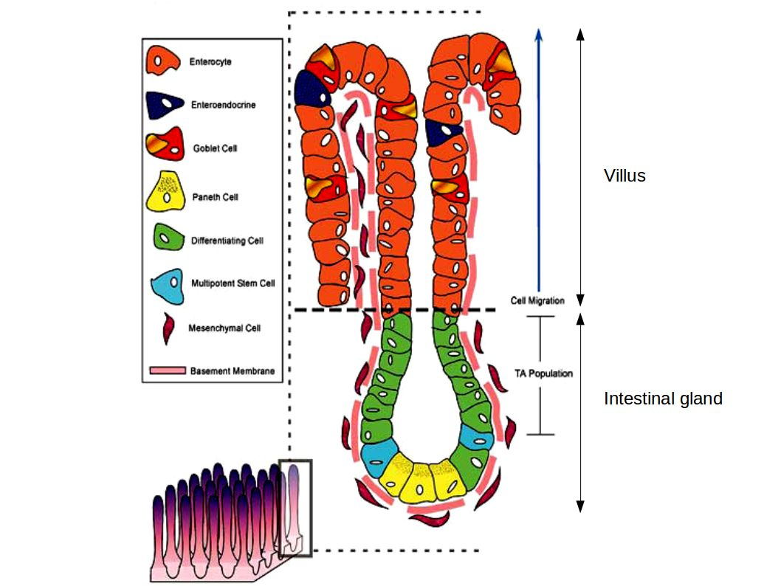

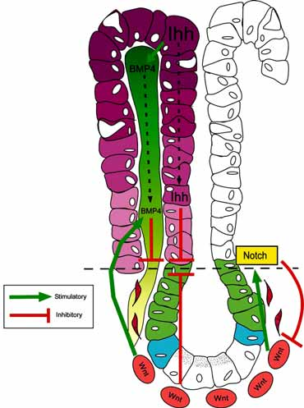

maintain of stem cells
In the basis of the intestinal gland, there is expression of Wnt in order to make proliferate multipotent stem cells and diffrenciation. But BMP-4 is also expressed, in order to regulate the differenciation because cells there are not supposed to differentiate to much.

Differentiation
The low expression of WNT in the middle and high region allow NOTCH to differentiate stem cells into differentiated cells.

