Telomerase

Actually at each division, there is a lose of a small part at the end of the chromosome, it is called the telomere. And stem cells replicates many times in their all life, indeed they need an enzyme that rebulid this telomere, this one is named telomerase. (évite fusion avec d'autres)

1) Avant la réplication
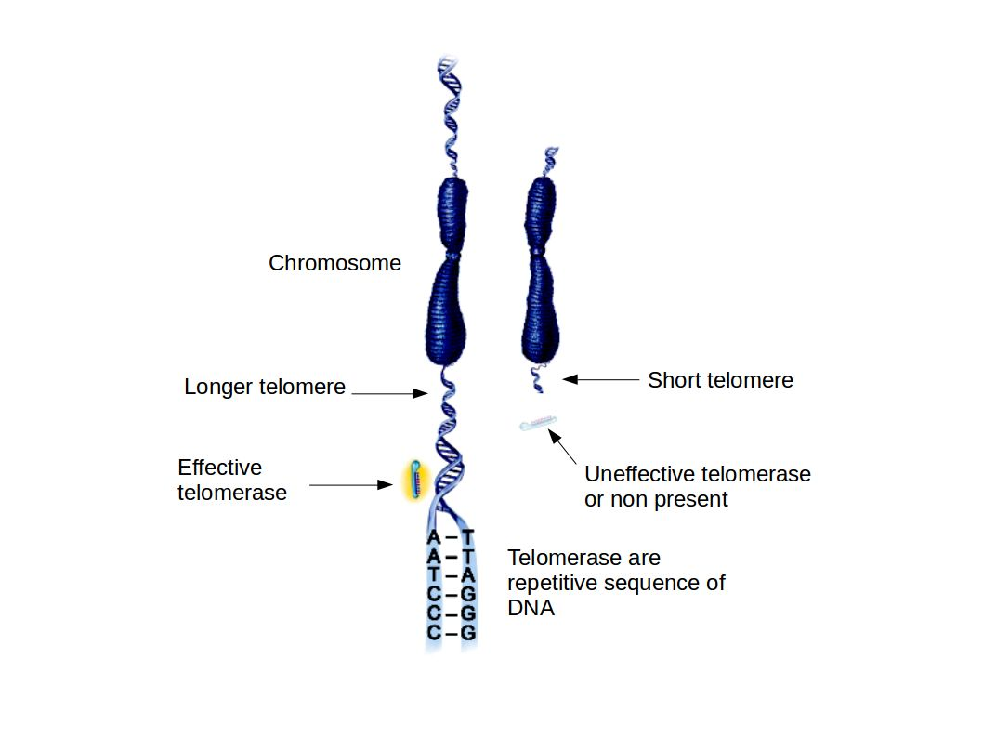

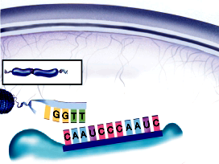
2) Positionnement de la télomérase

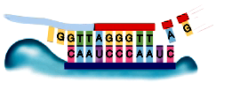
3) Complémentation

4) Adn polymérase
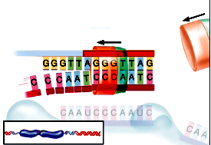

http://www.salk.edu/news-release/scientists-discover-an-onoff-switch-for-aging-cells/
http://www.universalis-edu.com.docelec.u-bordeaux.fr/encyclopedie/telomerase/

gène codant pour cette protéine :
télomère :

