RERM Officer Quickstart Guide
https://www.reshiftmanager.com/rerm/
Current Version: ______________ Effective: ______________
RERM tracks every member of the RE committee against four requirements, and gives each officer a view of just the people they are responsible for chasing.
This site is best used on desktop for data entry but can also be loaded on your phone to make your committee member contact easier — the Call, Text and Email buttons hand straight off to your phone.
Upon login you will land at the “My Roster Status” page. You can navigate to the main menu by clicking “Menu” at the top of any screen.

Signing in
Sign in with your member number — not your email address. Email is not used as a login: some members share an address and at least one has none at all, so the member number is the one identifier that is yours alone. It is the same number shown under every member’s name on the roster screens.
The first time you sign in, your password is 1234, and RERM will make you change it before it lets you do anything else. Pick something only you know — your account can see real contact details for real people.
“Keep me signed in” holds your session on that device for 90 days. Leave it off on a shared or borrowed computer.
If you forget your password, use “Forgot your password?” on the sign-in screen. A reset link goes to the email address the roster has on file for your member number. If the roster has no email for you, the screen will tell you so — ask an Admin, who can get you back in.

What you can see
RERM shows you your team and nothing else. If you help with more than one team, an Admin can widen you to cover both, and a team filter then appears on View My Roster. Menu tiles also vary by access level, so a screenshot in this guide may show a tile you do not have — or leave out one you do.
If a member you expect is missing, they are most likely on a team outside your scope, or the last roster load did not list them. See Dropped Members below.

The four requirements, and what the status words mean
Four requirements are scored for every member:
- Rodeo Dues
- Committee Dues
- Indemnity
- Background Check
Harassment prevention training is also shown, but it is not scored and never counts against anybody. Most members arrive with it blank, which is not the same as “no” — blank shows as Not reported.
Two separate things are tracked for each requirement, and the difference between them explains almost everything you will see on screen:
- What the Rodeo’s roster says. Met or unmet, from the last roster load. Nobody can type this in; it changes only when a new roster arrives.
- What you have learned. What the member told you when you reached them. This part is yours, and you set it when you log a contact.
The status on screen combines the two:

Status | What it means
Complete  green | The official Rodeo roster shows this requirement met. Nothing left to do.
Reported Complete  blue | The roster still shows this unmet, but the member told an officer it is done. Waiting for the next roster load to confirm.
Member Handling  amber | The roster shows this unmet; the member told an officer they are taking care of it.
Contacted  amber outline | The roster shows this unmet. An officer has reached the member this show year, but the member has not committed to anything yet.
Open/No Contact  red | The roster shows this unmet and nobody has contacted the member this show year. These are the next calls to make.
Not reported  grey | No roster load has covered this member for this item. Unknown, never a failure.

The most common question
A member who paid you in person this morning still shows Open/No Contact until you log the contact or the next roster arrives. That is the system working, not a fault: it is showing you the Rodeo’s official position, not disputing yours.
Log what they told you and the status moves to Reported Complete — the blue “we are waiting on the paperwork” state — and it turns green on its own at the next roster load.

My Roster Status
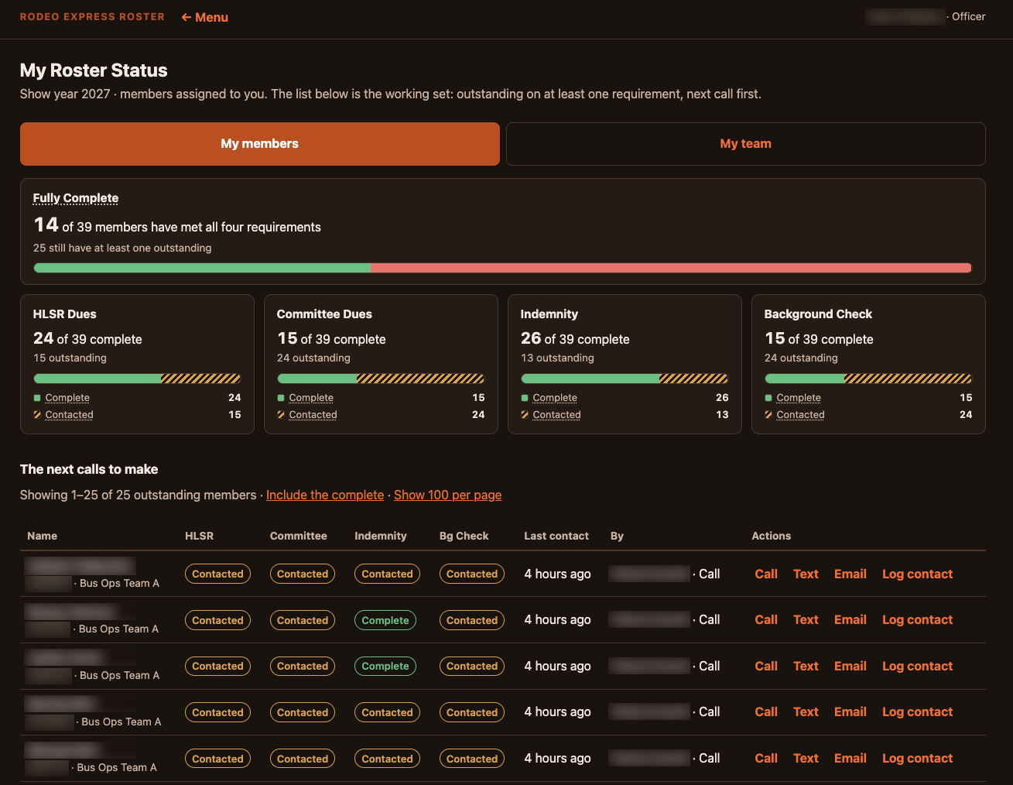
My Roster Status — member names and numbers blurred
This is where you work. It opens on one of two views:
- My members — the people assigned to you.
- My team — everybody on any team you can see, whether or not they are assigned to you.
It defaults to My members as soon as somebody has assigned you members. Until then it opens on My team.
The “Fully Complete” card counts the members who have met all four requirements; the four cards below it break out each requirement on its own. All of these counts follow whichever view you are in — switching to My team changes every number on the page.

The list is a work queue, not an alphabetical roster
“The next calls to make” is sorted by who most needs the call: never contacted first, then the ones contacted longest ago. Working from the top down is the intended way to use the screen.
By default it shows only members with something still outstanding. “Include the complete” adds the finished ones back in, and “Show 100 per page” lengthens the page.

Call, Text and Email
These appear for each member as the roster’s contact details allow, and on a phone they hand off to your dialler, messaging app and mail app. If a member has no Text button, the number on file is a home or business line rather than a cell, and a text to it would silently fail — so RERM does not offer one. No Email button means the roster has no address for them.

Log contact
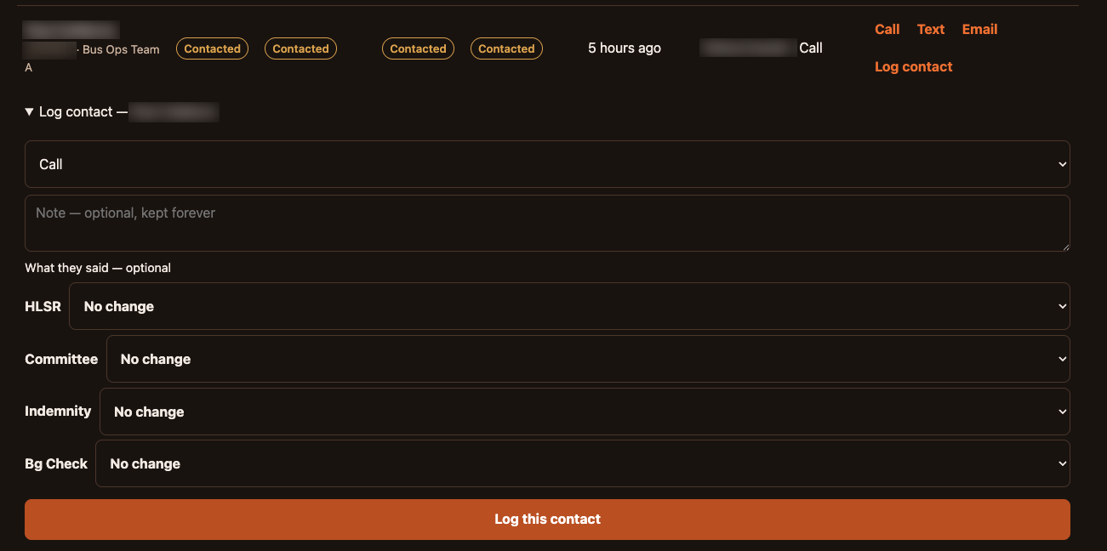
Log contact — member and officer names blurred
Choose how the contact happened, add a note if there is anything worth remembering, and then, for each requirement not already Complete, say what they told you:
- Member Handling — they are taking care of it.
- Reported Complete — they say it is done.
- Not started — clears a status you set by mistake.
Requirements already showing Complete are not offered, because there is nothing left to chase on them.

Notes are permanent, and leadership can read them
A contact record is never edited or deleted. It is what answers “why did this member’s dues flip back” years from now, so it is kept for good.
Notes are also visible to committee leadership. Write them as though the Division Chairman will read them, because they can. If you get something wrong, log a new contact with the correction rather than trying to take the old one back.

When a new roster arrives
Rosters are loaded periodically by an Admin. A load refreshes what the Rodeo knows, and never overwrites what you know:
- If a requirement flips to met, that item’s tracking clears — the thing you were chasing has happened.
- If it is still unmet, your status stays exactly where you left it. A roster refresh does not erase your work.
- Your contact history is never touched. Not by a roster load, not by anything.
Titles, teams, names, addresses and phone numbers all come from the Rodeo and are replaced on every load. That is deliberate, and it is why those details cannot be corrected inside RERM — a Roster Change Form is how they get fixed.

View My Roster
Search and browse everybody in your scope, whether or not they are assigned to you. This is the screen to use when somebody rings you and you need them in front of you quickly.
Search runs on name or member number and starts working at three characters. If you can see more than one team, a team filter appears — leave it empty for all of them. The columns are sortable.
Each row expands to a Details panel holding the member’s full contact information and their contact history for this show year: who reached them, when, how, and what was noted. Contacts loaded in bulk from before RERM existed are marked “loaded from history”.

Assign Officers
Assigning members to officers is what fills each officer’s My members list. Without it everybody sees the whole team, and nobody is specifically responsible for anyone.
- Up to three officers can share one member — for example an assistant captain, a captain and a vice chairman.
- Assignment is same-team only. An officer can only be given members of a team they are on. Widening somebody’s visibility to a second team does not make them assignable there.
- Members nobody has been given surface in their own unassigned group, so they cannot quietly go unchased.
- If an officer is demoted or moves teams, the members they held show as “officer no longer eligible” and need reassigning. Those assignments are never silently deleted — an emptied assignment is how twenty people stop being called without anyone noticing.

Dropped Members
A cumulative list of members in your scope that the last roster load did not list. They are hidden from every other screen, which is why they get one of their own.

Dropped is not removed
A drop means one file did not mention somebody — not that they have left. A team-mode load lists one team, and anyone who reappears in a later roster is picked back up automatically.
Nothing of theirs is gone: contact history, statuses and assignments are all still there. If you know somebody has genuinely left the committee, tell an Admin — only an Admin can purge, and that is a separate, confirmed step.

Export Roster
Exports the members you can see as a spreadsheet, for one show year, optionally narrowed to a single team. It contains the same people every other screen shows you.
Treat the file as what it is: real names, addresses, phone numbers and email addresses for real people. Every export is recorded with your name, the scope and the row count. Keep it off shared drives, and delete it when you are finished with it.

Change Password
Changes your password. Use it straight away if you think anybody else has it.

Complete Forms — Roster Change Form
This section will be built out further. For now it lets you fill in a Roster Change Form and export it to your computer for submission to Leadership.
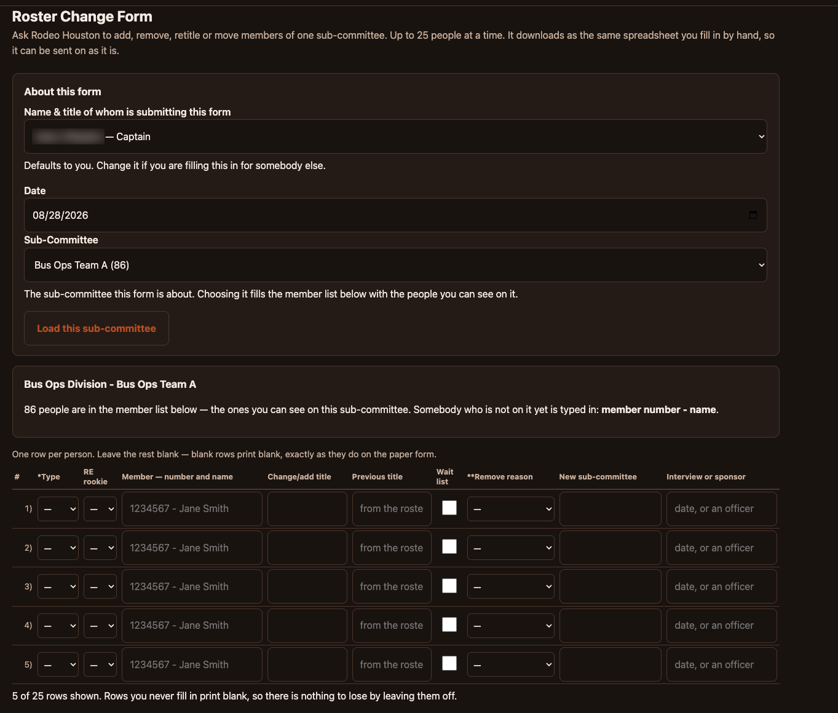
Roster Change Form — submitting officer’s name blurred
The form asks the Rodeo to add, remove, retitle or move members of one sub-committee, up to 25 people at a time. It downloads as the same spreadsheet you would otherwise fill in by hand, so it can be sent on as it is.
Fill in the top of the form first — who is submitting it (it defaults to you; change it if you are filling it in for somebody else), the date, and the sub-committee it concerns — then click Load this sub-committee to populate the member list with the people you can see on it.
One row per person, and leave the rest blank: blank rows print blank, exactly as they do on the paper form. Somebody not on the sub-committee yet is typed in as member number - name.

Submitting the form does not change RERM
The form is a request to the Rodeo. The change appears in RERM only after the Rodeo issues a new roster and an Admin loads it, which is why somebody you asked to have moved keeps showing on their old team for a while.

If something looks wrong
- A member I know has paid still shows Open/No Contact. Log the contact and set that requirement to Reported Complete. It turns green on its own at the next roster load.
- Somebody I expect is missing. Check Dropped Members. If they are not there either, they are on a team outside your scope — ask an Admin.
- A member has no Text button. The number on file is a home or business line, not a cell. Call or email them instead.
- I logged the wrong thing. Log a new contact with the correction. Contact records are permanent by design.
- The numbers on the cards changed when I clicked something. The cards follow the My members / My team toggle, so they count a different set of people in each view.
- I cannot log a contact at all. The show year has probably been closed. A closed year is frozen — an Admin will tell you when the next one opens.

