I can confirm I have studied the lecture notes

# Task1:

Const modifier is not reflected in the type string

Rerunning the code results in the same variables stored in different places

Float size is the same as long/int

# Task2:

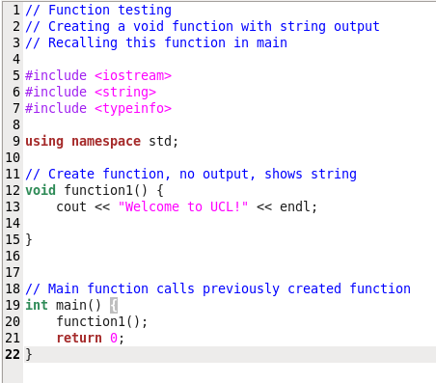2.1

2.2

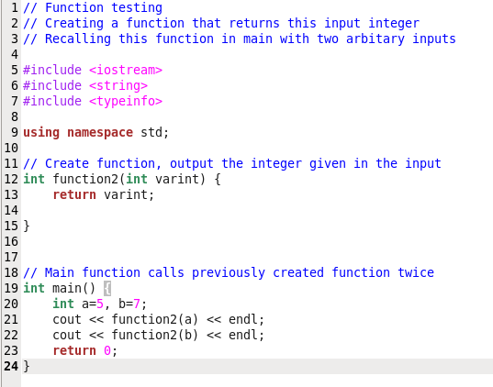

2.3 The input variable to the function is stored in the same place, however this place is different than either of the two variables defined in main, used as the input variable to the function

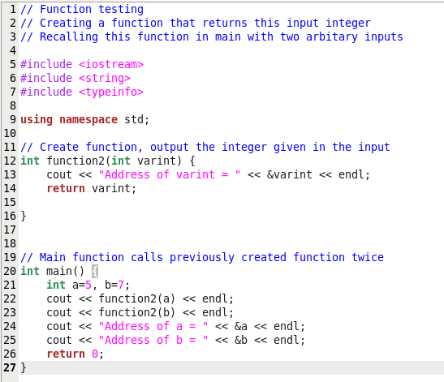

2.4

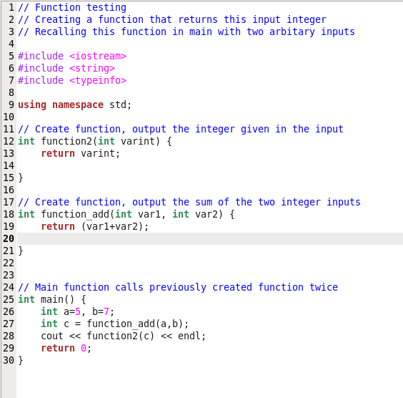

2.5

How to define new variables using int. Operations are possible as arguments of return.