The following is applied to a large pork shoulder (whole or a portion of your choosing)
Rub – Applied the night before you plan on cooking
Generous helpings of: kosher Salt, paprika, dry mustard (regular mustard will work in a pinch), brown sugar, chili powder
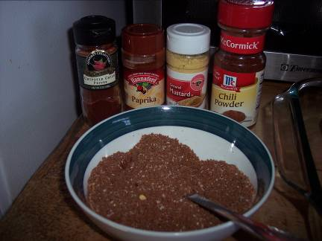
The Rub (Brown Sugar not Pictured)
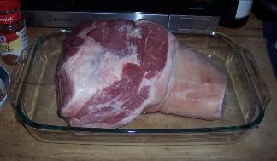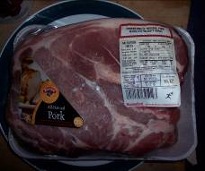
Your Meat Choices (Picnic Roast on the left, Boston Butt on the right)
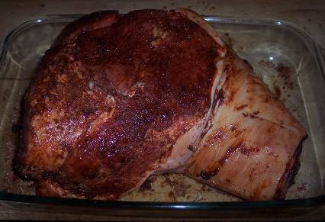
Rubbed Roast

Place rubbed meat in croc-pot or pot on the stove-top filled with:
1 C apple cider vinegar
¾-1 C Water
1/3 C ketchup
1/3 C of your favorite BBQ sauce (I like Stubbs or Sweet Baby Rays myself)
½ C Brown Sugar
5 tsp kosher salt
3-4 tsp red pepper flakes
1 tsp black pepper
1 tsp white pepper
1 tsp Worcestshire sauce
Touch of Liquid Smoke
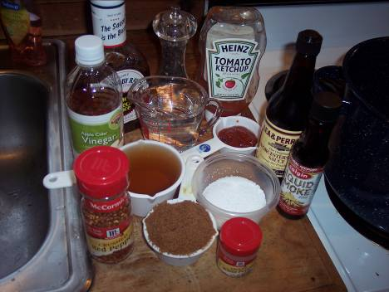
Croc Pot Ingredients
Cook 6-10 hours and then shred:
Stove Top:
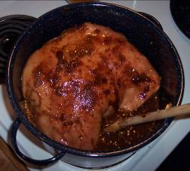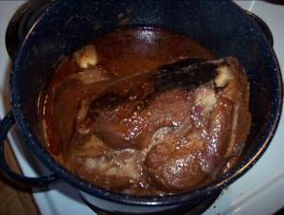
I didn’t cove the meat in the big pot, I just turned it a few times throughout the day ~every two hours.
Croc Pot:
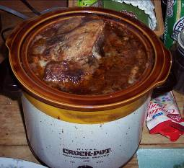
Cover and forget about it for 10 hours!
Shredding:
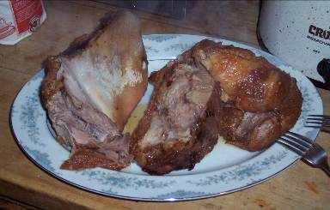
This should rip apart easily with two forks into shreds as big as you want. On the left there is the hunk of shoulder bone, if cooked right, not an ounce of meat should stick to that bone.
I almost always make this with my cole-slaw that I pile on top of the pork on a burger bun and eat sandwich style.
Cole Slaw:
1 Cabbage, chopped
Some scallions
1 Jalepeno, minced
1 red onion, chopped

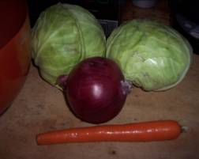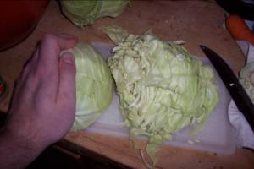
Dressing:
1.5 C Mayo
Couple Tbsp Mustard
Splash of apple cider vinegar
Pinch of sugar
Pinch of celery seed/salt
Squeeze of lemon
Salt/pepper to taste

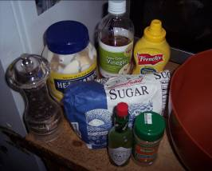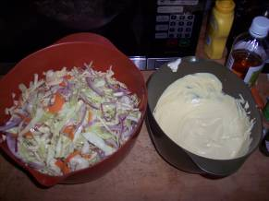
Mix it all up!
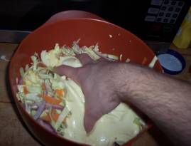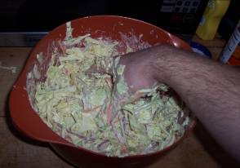
If I don’t have a jalepeno around I’ll just shake in some jalepeno Tabasco, which I always have handy, love that stuff!
Make into a sandwich, or just eat it shredded, it’s up to you. Either way it’s best with a cold beer!
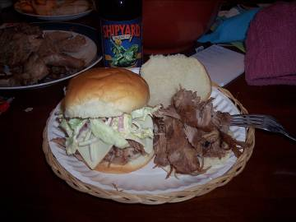
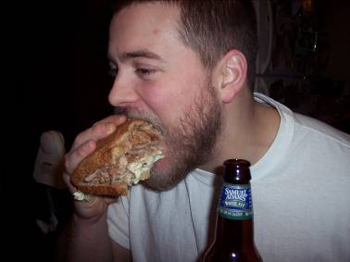
Enjoy, and squat heavy!

