Modeling the spatiotemporal abundance of wintering sea ducks in Nantucket Sound, USA: implications for marine spatial planning
Adam D. Smith,^{1,5}, Benjamin Hofner,², Jason E. Osenkowski,³, Taber Allison,⁴, Giancarlo Sadoti,⁴, Scott R. McWilliams,¹, and Peter W. C. Paton,¹
¹ Department of Natural Resources Science, University of Rhode Island, Kingston, Rhode Island 02881 USA
² Department of Medical Informatics, Biometry and Epidemiology, Friedrich-Alexander-University Erlangen-Nuremberg, Waldstraße 6, 91054 Erlangen, Germany
³ 277 Great Neck Road, Rhode Island Department of Environmental Management, West Kingston, Rhode Island 02892 USA
⁴ American Wind Wildlife Institute, 1110 Vermont Avenue, NW, Suite 950, Washington, D.C. 20005 USA
⁵ Present address: United States Fish and Wildlife Service, National Wildlife Refuge System, Inventory and Monitoring Branch, 135 Phoenix Rd., Athens, GA 30605 USA

Abstract. Ecosystem-based marine spatial plans (MSP) require estimates of species’ distribution and associated uncertainty in order to effectively evaluate where to allow development including proposed offshore wind energy developments (OWED). However, for most species of marine birds there is a paucity of such information collected at spatial scales relevant to localized planning efforts. We used 30 aerial surveys conducted from 2003-05 to assess the distribution and abundance of five species of sea ducks in Nantucket Sound, Massachusetts (Common Eider (Somateria mollissima), Black Scoter (Melanitta. americana), Surf Scoter (M. perspicillata), White-winged Scoter (M. deglandi), and Long-tailed Duck (Clangula hyemalis). We related spatiotemporal variation in sea duck occupancy (i.e., probability of presence) and conditional abundance to potentially relevant biophysical and spatiotemporal covariates. We applied a negative binomial hurdle model that first modeled occupancy using a generalized additive model (GAM ), and second used generalized additive models for location, scale, and shape (GAMLSS) to estimate the count models. The covariates associated with occupancy were relatively consistent among sea duck species (List these key covariates?), whereas spatial effects were the dominant explanatory feature of conditional abundance estimates for scoters and Long-tailed Duck. Models suggest that a planned OWED in Nantucket Sound could impact sea ducks in this area, but key habitats used by the largest concentrations of sea ducks are less likely to be affected. This utility of this modelling approach …..
Introduction
Marine spatial plans (MSP) can provide a rigorous framework to protect marine ecosystems from a variety of anthropogenic stressors including coastal development (Polasky et al. 2008, Foley et al. 2010). A key element of MSPs is accurate spatially-explicit estimates of the abundance and distribution of biological resources, as well as information on the spatial distribution of potential human uses (Douvere 2008, Punt et al. 2009). Along the northwest Atlantic Coast, there are numerous proposals to construct offshore wind energy developments (OWED; Breton et al. 2009, Musial and Ram 2010), including the first in U.S. waters, the 5-turbine 30 MW facility in Rhode Island Sound to be operational by fall 2016. Therefore there is a pressing need to develop spatially-explicit models of key biological resources that can assist marine spatial planners in siting of OWEDs while minimizing impacts to marine ecosystem integrity.
Understanding the distribution and abundance of wintering marine birds including sea ducks (Tribe: Mergini) represents a particular challenge to marine spatial planners because the environmental factors associated with their distribution and abundance remain notably understudied (Zipkin et al. 2010, Bowman et al. 2015, Flanders et al. 2015). Sea ducks are important to consider in the context of marine spatial planning because populations of most North American species are below historic levels, there is considerable uncertainty in population trajectories (Bowman et al. 2015), effective harvest regulations for sea ducks and other waterfowl require reasonably accurate estimates of abundance, and evidence from Europe's numerous offshore wind facilities suggest that offshore wind energy developments could have negative consequences for sea duck populations (Larsen and Guillemette 2007, Langston 2013). The majority of North American sea ducks migrate from high-latitude arctic and sub-arctic breeding areas to mid-latitude temperate wintering areas where they reside for most of the year (Silverman et al. 2013, Bowman et al. 2015, Flanders et al. 2015). At large spatial scales, the distribution and abundance of sea ducks during winter may be affected by large-scale ocean characteristics (e.g., Flint 2013), climatic conditions (e.g., Zipkin et al. 2010), and static or persistent habitat features (e.g., bathymetry, substrate, current and frontal systems; Hyrenbach et al. 2000 Nur et al. 2011, Flanders et al. 2015). At regional and local scales, however, most species of sea ducks congregate in large flocks (e.g., up to tens of thousands of birds) at sites where prey are abundant and accessible (Loring et al. 2013, Flint 2013) although the abundance and distribution of these prey, and thus predators can be extremely ephemeral and dynamic (Hyrenbach et al. 2000, Ortega Cisneros et al. 2011). Thus, sea duck distribution and abundance is spatially and temporally dynamic yet expected to be driven by biophysical covariates (Oppel et al. 2009, Zipkin et al. 2010, Flanders et al. 2015).
Model-based approaches are a useful framework to generate spatially-explicit estimates of animal abundance and changes in animal distribution independent of abundance (Borchers et al. 2002, see, e.g., Certain and Bretagnolle 2008, Nur et al. 2011, Kinlan et al. 2012, Winiarski et al. 2014). However, modelling the spatial ecology of marine organisms such as sea ducks presents a variety of analytical challenges. First, the spatiotemporal distribution of marine organisms can be highly irregular, thus surveys often produce zero-inflated (Martin et al. 2005, Cunningham and Lindenmayer 2005), overdispersed (Richards 2008) count data that may vary with biophysical features in complex, non-linear ways (Austin 2007). Second, an adequate modeling approach usually must identify a small suite of important covariates among many potentially correlated covariates (i.e., high dimensionality; multicollinearity) while avoiding overfitting models, a process that often is complicated by data from repeated surveys that regularly exhibit spatial and temporal autocorrelation (Hoeting 2009).
We demonstrate a model-based approach to predict animal distribution and abundance using aerial transect survey data of sea ducks in Nantucket Sound, Massachusetts, USA. We implemented generalized additive models (GAMs; Hastie and Tibshirani 1990, Wood 2006) and their recent extension (GAMLSS - GAMs for location, scale, and shape; Rigby and Stasinopoulos 2005) in a gradient descent boosting framework (Hothorn et al. 2010, Mayr et al. 2012, Hofner et al. 2015b). GAMLSS methods extend GAMs to allow all parameters of the conditional response distribution to be modeled as a function of relevant covariates (Rigby and Stasinopoulos 2005). This approach provides spatially-explicit insights into the covariates associated with sea duck abundance and its variability. The boosting algorithm accommodates the inclusion of various effect types (e.g., linear, smooth, spatial, spatiotemporal, and random effects; Hofner et al. 2014a) and correlated covariates (i.e., parameter estimates are regularized), identifies the most relevant subset among potentially many covariates (i.e., variable selection), and evaluates competing representations of continuous covariates (e.g., linear vs. nonlinear effects of covariates; Kneib et al. 2009, Maloney et al. 2012). Our specific objectives were to demonstrate a flexible, model-based approach that (1) provides spatially- and temporally-explicit estimates of sea duck abundance and distribution while accommodating many of the challenges inherent in animal survey data; and (2) describes the associations between biophysical features and sea duck distribution and abundance in one of the most important migrating and wintering areas in the western Atlantic.

Methods
Study area and species.---We conducted fieldwork throughout Nantucket Sound in Massachusetts, USA (Figure 1). Our study area encompassed ca. 1,500 km² of Nantucket Sound, was relatively shallow (generally < 20 m deep), and included some of the most important sea duck wintering habitat in the western Atlantic (White et al. 2009, Silverman et al. 2013). The primary species of sea ducks found in Nantucket Sound were Common Eider (Somateria mollissima; hereafter eider), Black Scoter (Melanitta. americana), Surf Scoter (M. perspicillata), and White-winged Scoter (M. deglandi), and Long-tailed Duck (Clangula hyemalis). Additionally, approximately 62 km² of Horseshoe Shoal in northwestern Nantucket Sound is fully permitted for wind energy (Figure 1), which could affect sea duck use of this important wintering area (Drewitt and Langston 2006, Langston 2013, Winiarski et al. 2014).
Aerial strip transect surveys.---During the winters (late October to mid-April) of 2003-2005, we conducted 30 (2003/2004: 13, 2004/2005: 10, 2005/2006: 7) standardized aerial strip-transect surveys (Flanders et al. 2015) throughout an 1,100 km² study area in Nantucket Sound (Figure 1). Surveys occurred primarily from November - March (n = 27), with occasional October (n = 1) or April (n = 2) surveys. During each survey, we flew along 15 parallel (ca. 2.5 km apart), roughly north-south transects (Figure 1) at an average altitude of 152 m and speed of 167 kmh-1 (90 kts) using a high-wing, twin-engine aircraft (Cessna Skymaster 337). This altitude allowed us to identify most birds at the sea surface and reduced sea disturbance (i.e., flushing birds to another part of the study area and, thus, potential double counting). The airspeed was the slowest at which the aircraft could safely fly. Surveys occurred only on days with wind speeds ≤ 15 kts and good visibility (>15 km). Surveys occurred between 0900 to 1600 h (average duration of ~ 2.5 h) to ensure that birds had completed any post-dawn movements (e.g., Davis 1997) but had yet to initiate pre-sunset movements from feeding to roosting areas; this time window also reduced glares due to low sun angles.
On each survey flight, two observers used their unaided eyes to continuously detect individuals or flocks, identifying sea ducks to species with the aid of binoculars as needed. Observers monitored the sea surface on their side of the plane in a ca. 91 m wide transect between ca. 56 - 147 m from the plane; observers could not see beneath the plane out to 56 m on each side. The narrow strip width ensured birds were detectable and identifiable with the naked eye and allowed us to avoid situations in which ducks were too abundant or spread over too wide an area to count accurately. This last point was especially relevant because sea ducks occasionally congregated in extremely large aggregations of 1000s of individuals. We thus assumed inconsequential perception bias (i.e., we missed few individuals present to be counted; Marsh and Sinclair 1989) given our flight altitude and narrow transect width (e.g., Certain and Bretagnolle 2008) within the strip transect (Buckland et al. 2012). Our transect dimensions resulted in the sampling of approximately 6% (median; 68.4 km²) of the study area during a survey.
Observers verbally communicated duck sightings to a recorder, who entered the number of ducks, species, and behavior (i.e., on the water or flying) into a laptop computer linked to the plane's onboard GPS; we report results only from ducks observed sitting on the water. Due to difficulties associated with identifying to species the three species of scoters, we pooled all scoter observations. We subsequently consolidated counts for each species (eider and Long-tailed Duck) or species group (scoter) into 2.25km² segments (Figure 1); this resolution (1.5 km x 1.5 km) corresponded approximately to the coarsest level of resolution of biophysical covariates (see below).
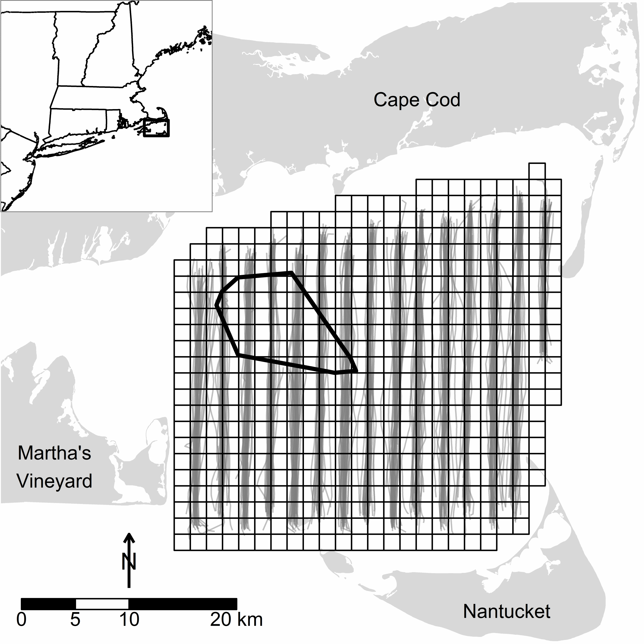
Figure 1. Actual aerial strip transect tracks (gray lines) during winter (October - April, 2003 - 2005) sea duck surveys (n = 30) in Nantucket Sound, Massachusetts, US. The grid indicates the extent of the 1100 km² study area and its division into 504 2.25km² segments. The polygon in northwest Nantucket Sound indicates the 62 km² area of permitted wind energy development on Horseshoe Shoal.
Modeling approach.---We related spatiotemporal variation in sea duck occupancy (i.e., probability of presence) and abundance to potentially relevant biophysical and spatiotemporal covariates. We applied a negative binomial hurdle model that first modeled (1) the probability of occurrence of at least one individual (hereafter, the occupancy model) in a given segment using a logistic regression model and then (2) the abundance of sea ducks in that segment conditional on their presence (hereafter, the count model) using a truncated negative binomial model. The prevalence of zero counts (e.g., 75% of eider segment observations) and the expected low incidence of false zeros (sea ducks present but not observed) in study segments prompted the use of a hurdle model. Specifically, occupancy and abundance values correspond to the probability of sea duck presence (occupancy) or sea duck abundance in an 1.5 km x ca. 180 m transect through a given segment. We generated separate hurdle models for each sea duck group (i.e., eider, scoters, and Long-tailed Duck; Zipkin et al. 2010).
To model sea duck occupancy, we used a generalized additive model (GAM; Hastie and Tibshirani 1990, Wood 2006) that flexibly accommodated potential nonlinearities between covariates and sea duck occupancy. We used generalized additive models for location, scale, and shape (GAMLSS; Rigby and Stasinopoulos 2005) to fit the count models; these models accommodated potential nonlinearities between covariates and the conditional mean and overdispersion of sea duck abundance.
We implemented GAMs and GAMLSS in a gradient descent boosting framework (Mayr et al. 2012, Hofner et al. 2015b). More specifically, we used component-wise functional gradient descent boosting to fit the models. We first computed the negative gradient of a user-specified loss function (typically the negative log-likelihood of the underlying model); the negative gradient can be viewed as a proxy for residuals. We used the negative binomial log-likelihood as the loss function for occupancy models and the (negative) truncated negative binomial log-likelihood as the loss function for count models.
In the next step, all modeling alternatives (i.e., functional forms of the covariates relative to the response, called base-learners; Hofner et al. 2014b) were fitted separately to the negative gradient and a fraction of the single best fitting base-learner was added to the current model fit. The negative gradient was then reevaluated at the current model fit and the procedure iterated for a fixed number of iterations, 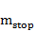, specified by the user (see Bühlmann and Hothorn 2007 for additional details). We fit boosted GAMLSS models similarly, although in each iteration the negative gradient was computed separately with respect to each GAMLSS parameter (e.g., mean and overdispersion) while holding other parameters as fixed constants. We then fit base-learners to the resulting parameter-specific negative gradient vector and model updates were computed separately for each GAMLSS parameter as for boosted GAMs (see Mayr et al. 2012 for additional details).
As only the single best-fitting base-learner was selected in each iteration, the algorithm thus integrated intrinsic selection of the most relevant covariates and their functional form (i.e., some base-learners may never be selected). Variable selection was further fostered by stopping the algorithm prior to convergence to maximum likelihood estimates (early stopping; Mayr et al. 2012, Maloney et al. 2012). Furthermore, early stopping aims at maximizing predictive accuracy while avoiding model overfitting.
We used 25-fold subsampling to determine the optimal stopping iteration for each model. Specifically, we randomly drew (without replacement) 25 samples of size from the original data set. We used the selected sample to estimate the model and the balance of the data in each sample to determine the out-of-bag prediction accuracy (empirical risk) measured by the negative log-likelihood of each model; the optimal stopping iteration (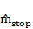) is the iteration with the lowest average empirical risk. In boosted GAMLSS models we used multi-dimensional subsampling to determine the stopping iteration for each of the GAMLSS parameters while allowing for potentially different model complexities in the parameters; a detailed explanation of this cross-validation (subsampling) scheme is given in Hofner et al. (2014a).
Despite these agreeable features, boosting methods typically produce "rich" models relying to some extent on many base-learners (Hofner et al. 2015a). Thus, we additionally applied stability selection (Meinshausen and Bühlmann 2010, Shah and Samworth 2013) to identify those base-learners, and thus covariates, most commonly selected in each model while preserving an upper bound of ~ 0.05 for the per-comparison error rate (see Appendix 1 and Hofner et al. (2015b) for more details).
Covariates.---We evaluated biophysical covariates expected to influence the distribution, abundance, and movements of sea ducks or, more likely, the distribution and availability of their benthic prey (e.g., mollusks and crustaceans; see Appendix 2); we did not have information related directly to the distribution of preferred prey. Biophysical covariates could be characterized as strictly spatial or temporal effects (i.e., varying only among segments or within or among winters, respectively) or as spatiotemporal effects (i.e., varying among segments and within or among winters; see Appendix 2). Additionally, we included interactions that allowed the effects of two covariates (water depth and relative sea surface temperature; see Appendix 2) to vary over time within a given winter. We standardized (i.e., mean centered and scaled) all continuous covariates. Appendix 3 describes a custom R function to visualize the spatial and temporal distribution of covariates in Nantucket Sound.
For each continuous covariate, we specified two base-learners: a linear base-learner and a penalized nonlinear base-learner (i.e., P-splines; Eilers and Marx 1996, Schmid and Hothorn 2008). We dummy-coded categorical covariates, resulting in K - 1 linear base-learners for a K-level covariate. To address potential spatial autocorrelation, we included a smooth surface function of the spatial coordinates of segment centers (Kneib et al. 2008); this surface comprised four base-learners -- linear base-learners for the easting and northing, their linear interaction, and a penalized nonlinear tensor product P-spline (Kneib et al. 2008, 2009, Maloney et al. 2012). We also allowed this surface to vary over time within a winter (via an interaction). Hofner et al. (2014b) describe base-learners in detail.
The decomposition of continuous covariates into centered linear and penalized orthogonal nonlinear base-learners allowed us to weight base-learners equally and thus allowed unbiased model choice (i.e., prevented the preferential selection of smooth base-learners; Kneib et al. 2009, Hofner et al. 2011). Specifically, we restricted each base-learner to a single degree of freedom and omitted the intercept term from each base-learner (Kneib et al. 2009, Hofner et al. 2011). Consequently, we added an explicit linear base-learner for the model intercept. The occupancy and count models had the following structure (see Appendix 2 for descriptions of abbreviated covariates):
g(·) =int + time + f(time) + SSTw + f(SSTw) + SSTm + f(SSTm) + SSTrel+ f(SSTrel) + SSTrel · time + f(SSTrel, time) + SBT + f(SBT) + NAOw+ depth + f(depth) + depth · time + f(depth, time) + d2land + f(d2land)+ chla + f(chla) + cdom + f(cdom) + f(cdom, chla) + meanphi + f(meanphi)+ SAR + f(SAR) + tidebmean + f(tidebmean) + tidesd + f(tidesd) + strat+ f(strat) + ferry + y2004 + y2005 + xkm + ykm + xkm · ykm+ f(xkm, ykm) + xkm · time + ykm · time + xkm · ykm · time+ f(xkm, ykm) · time + obs_window + f(obs_window).
In our occupancy models, is , the occupancy probability of a given duck species in a segment and is the logit link. In our count models, took two forms within the GAMLSS framework -- the (conditional) mean count of sea ducks, , and the (conditional) overdispersion in sea duck counts, ; is the log link in both cases. Base-learners denoted as indicate the penalized nonlinear deviations from the corresponding linear base-learner (e.g., ). The explicit intercept (int) was a necessary byproduct of our decomposition of base-learners (see above; Kneib et al. 2009, Hofner et al. 2011). Small values of obs_window, our measure of survey effort (see Appendix 2), in some segments impaired the estimability of models including obs_window as an offset; we thus included it as a covariate.
Subsequent to their independent fitting, we consolidated occupancy and conditional count models (see, e.g., Equation 6 in Zeileis et al. 2008) to generate spatially-explicit estimates of unconditional sea duck abundance. These estimates were used to evaluate the approximate explanatory power of our final models using a pseudo R² measure of the explained variation (Nagelkerke 1991, Maloney et al. 2012).
All analyses were conducted in R (Version 3.1.3; R Core Team 2014) with the add-on packages gamboostLSS (Hofner et al. 2015b), mboost (Hothorn et al. 2015), and stabs (Hofner and Hothorn 2015). The data and code for reproducing this manuscript and analyses are provided freely at http://github.com/adamdsmith/NanSound_paper.

Results
We fit two models per each species because sea duck occupancy and conditional count were modelled independently. Bootstrapped empirical risk suggested that occupancy models for all species converged on the maximum likelihood estimates (i.e., occupancy models failed to stop early; see Appendix 4). Conversely, bootstrapped empirical risks prescribed early stopping for both the conditional mean and overdispersion parameter in all count models (see Appendix 4). Final occupancy and count (conditional mean) models included only a subset (12% to 38%) of the 48 base-learners initially specified for selection (see equation 1). Occupancy models generally contained more covariates and their interactions (8-10 of 23) than did count models (3-6), particularly among stably selected covariates and their interactions (Figure 2, see also Appendices 5 - 7).
Sea duck occupancy---The covariates associated with occupancy were relatively consistent among sea duck species (Figure 2). The influence of univariate effects on the response is reflected in the range of the effect over the Y-axis and, due to standardization, can be compared among species and covariates within a model (i.e., lines in Figure 2). For example, monthly sea surface temperature (SST_{m}) associated more strongly with eider occupancy than did distance to land (d2land) because it spanned a larger range of the Y-axis (Figure 2). In contrast, monthly sea surface temperature (SST_{m}) associated much more strongly with occupancy of Long-tailed Duck than eider for the same reason (Figure 2). Covariate interactions, illustrated with bivariate plots, are similarly comparable within a model. Only the general association (i.e., positive or negative) with the additive predictor is given for factor variables. Comparing univariate, bivariate, and categorical effects is accomplished using the detailed covariate plots for eider, scoters, and Long-tailed Duck (Appendices 5 - 7, respectively); these plots are in descending order of effect size within a model, and provide values for the partial contribution to the additive predictor for covariates and their interactions.
Spatiotemporal effects (i.e., occupancy associated with the xkm-ykm location of segments and the change over time within winter) were the dominant explanatory feature in occupancy models, although these patterns varied considerably among species (Figure 2). Occupancy increased, but at a decreasing rate, with survey effort (obs_window) in a given segment (Figure 2). Occupancy estimates increased at intermediate monthly sea surface temperature (SST_{m}), greater distances from land (d2land), and in areas with coarser sediments (i.e., smaller meanphi). Eider occupancy was associated negatively with chromomorphic dissolved organic material (cdom) and positively with sea floor surface:planimetric area (SAR; our measure of the topographic variability of the sea floor)(Figure 2), whereas scoter occupancy likewise related to SAR and cdom, but in the opposite direction in both cases (Figure 2). Scoter occupancy was modestly greater in deeper waters (depth), whereas Long-tailed Duck occupancy was greatest in shallow waters early in the winter but in deeper waters later in the winter (Figure 2). Other effects were relatively minor and inconsistent among species.
Strictly spatial (i.e., segment xkm-ykm location) factors had a dominant influence on spatially-explicit estimates of median occupancy (Figure 3, top row). Therefore, we documented distinct spatial patterns of occupancy among species (Figure 3) despite the relative similarity of occupancy associations with biophysical covariates (Figure 2). Occupancy was typically highest for eider in northwest and southwest Nantucket Sound, in interior Nantucket Sound for scoter, and in northeast and south Nantucket Sound for Long-tailed Duck (Figure 3, top row). All species tended to avoid the western edge of the Sound northeast of Martha's Vineyard (see Figure 1). Generally, the areas of highest occupancy exhibited the lowest relative variability (Figure 3, bottom row), defined as the median absolute deviation (MAD) of occupancy relative to median occupancy within a segment (a measure analogous to the coefficient of variation).
Sea duck conditional abundance and overdispersion.--- Spatial effects (xkm-ykm) were the dominant explanatory feature of conditional abundance estimates for scoters and Long-tailed Duck, but they were not selected in the eider model (Figure 2). For a given species, biophysical covariates selected in occupancy and count models exhibited broad agreement with the exception of sediment grain size (meanphi) in scoter and more complex relationships between eider conditional abundance and dissolved organic material (cdom) and sea floor topography (SAR; Figure 2). The conditional abundance of eider and scoter was also associated with relatively warm or cool sea surface temperatures (SST_{rel}; Figure 2).
Spatially-explicit patterns of median conditional abundance (Figure 4, top row) did not necessarily reflect patterns of occupancy (cf. Figure 3, top row). Some areas of Nantucket Sound exhibited mutually high conditional abundance and occupancy for a given species (e.g., eider in the southwest, scoter in the interior, and Long-tailed Duck in parts of the northeast). However, conditional abundance was low despite relatively high occupancy in some instances (e.g., eider in the northeast and Horseshoe Shoal, scoter in the northeast and southeast, and Long-tailed Duck along the northern margin). Conversely, other areas of Nantucket Sound exhibited lower occupancy but sea ducks, when present, were more abundant (e.g., eider along the eastern margin, and scoter and Long-tailed Duck in the southwest). As in occupancy models, sea ducks were relatively absent from the middle-western margin of Nantucket Sound (i.e., northeast of Martha's Vineyard; see Figure 1). In contrast to sea duck occupancy, however, areas of highest conditional sea duck abundance typically exhibited the highest relative variability over time (Figure 4, bottom row).
Overdispersion in conditional sea duck abundance also varied with biophysical covariates, although there was less consistency in the associated covariates among species (Figure 2; see also Appendices 5 - 7). Variability (i.e., overdispersion) in sea duck counts was heterogeneous in space (Appendix 8; Figure 8.1, top row) and time (Appendix 8; Figure 8.2, bottom row) in Nantucket Sound, particularly for eider and scoter (as indicated by the magnitude of the overdispersion parameter values).
Expected sea duck abundance.---Consolidated occupancy and conditional count models provided estimates of unconditional sea duck abundance in the study area over the survey period (Figure 5, top row). Final models of expected sea duck abundance explained moderate amounts of variation in observed counts of eider, scoter, and Long-tailed Duck (pseudo R² = 0.31, 0.48, and 0.32, respectively). Conditional abundance (Figure 4) strongly influenced the spatially-explicit patterns of expected abundance. Sea duck species exhibited relatively distinct patterns of abundance in Nantucket Sound. Eider were consistently most abundant in southwestern Nantucket Sound (Figure 5); eider were also relatively abundant in northeastern part of the study area but less consistently so as evidenced by the relatively high MAD/median abundance over time (Figure 5, bottom row). Scoter were also most abundant, with occasional extreme flocks, in southwestern Nantucket Sound, although this was also the area of highest relative variation in scoter abundance (Figure 5); relatively high abundances of scoter also occurred in interior Nantucket Sound (Figure 5). Long-tailed Ducks were consistently most abundant in northeastern Nantucket Sound, as well as along its southern margin (Figure 5). No species' highest abundances occurred in the permitted Nantucket Shoal area, although expected eider and scoter abundances were consistently elevated in some parts of the Shoal (west and southeast, respectively; Figure 5).
Summing the spatially explicit estimates of unconditional sea duck abundance (i.e., Figure 5) provides an estimate of total abundance in a 1.5 km x 180 m transect through all segments in the study area. We compared the total count (summed across all segments) of each sea duck species observed in aerial strip transects with the corresponding estimated total abundance in surveyed segments for each of the 30 aerial surveys (Figure 6). Our models tended to overestimate sea duck abundance when the actual numbers of sea ducks were relatively low, although overestimation was typically less than an order of magnitude. Additionally, scoter abundance was occasionally extreme relative to typical counts and somewhat prone to underestimation during these extreme counts. Nonetheless, the general adherence of observed and predicted abundance to a line of unit slope indicated that it may be reasonable to estimate sea duck abundance for the entire study area based on observed sea duck densities in transects (Figure 6).
Temporal dynamics in wintering sea ducks.---The MAD/median estimates (bottom rows of Figures 3-5; Appendix 8) show that our spatially-explicit estimates of occupancy, abundance, and overdispersion invariably change over time, either explicitly via the selection of a within- or among-winter temporal effect (time and y2004/y2005, respectively) or implicitly via the selection of biophysical covariates that change within or among winters. The temporal dynamics of the wintering sea duck system in Nantucket Sound was one of its most striking attributes (see animated scoter example for winter 2005 in Appendix 9).

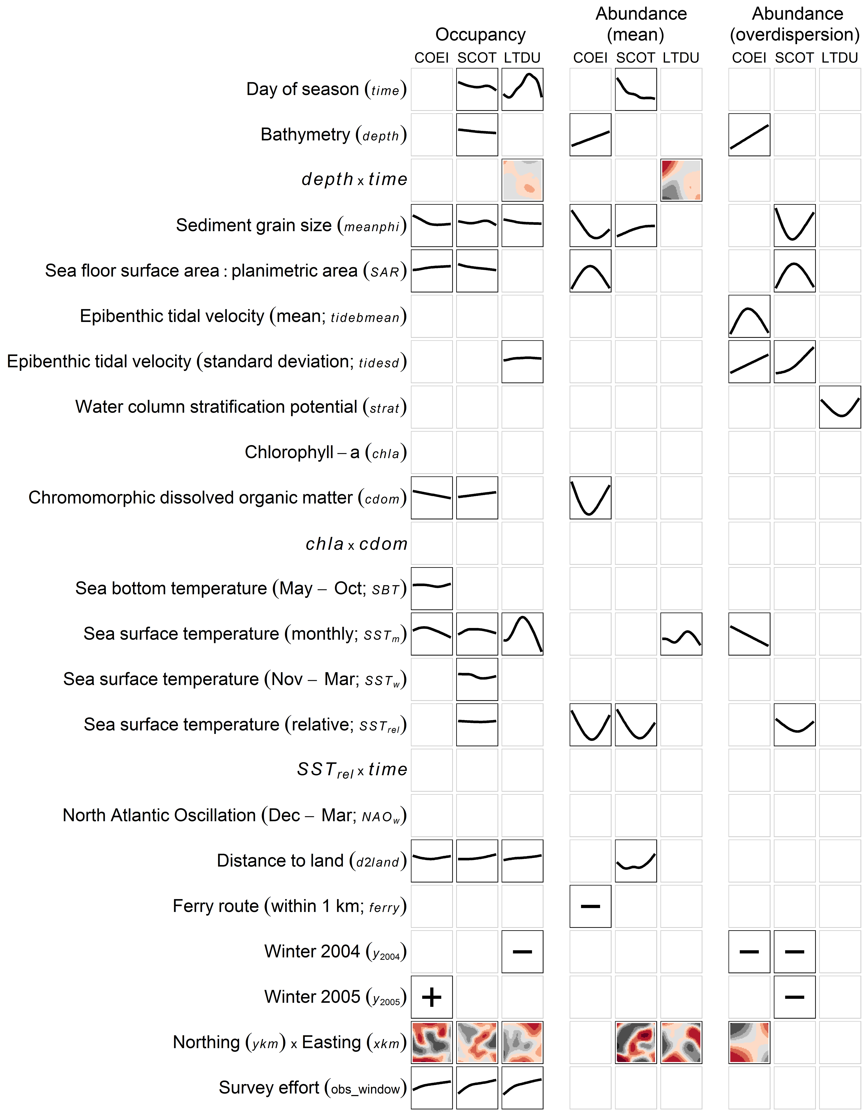
Figure 2. Marginal functional plots for stably selected covariates in the occupancy (probability of presence) and conditional abundance (mean and overdispersion of count model) of Common Eider (COEI), scoter (SCOT), and Long-tailed Duck (LTDU) in Nantucket Sound during winters 2003 - 2005. Plots illustrate the partial contribution to the additive predictor of a covariate holding all other covariates at their mean. Within a model, univariate plots (i.e., lines) share a Y-axis scale, enabling direct comparisons of effect sizes among covariates and species. For bivariate plots, the Y-axis and X-axis reflect the first and second variables listed in the interaction, respectively; colors indicate the direction and magnitude of the partial contribution (blacks = negative, reds = positive; darker colors = larger effect) and are likewise comparable within a model. Northing by easting effects are given only at 31 December. For factor variables, only the general association (i.e., positive or negative) with the additive predictor is given. Covariate abbreviations correspond to Equation 1.

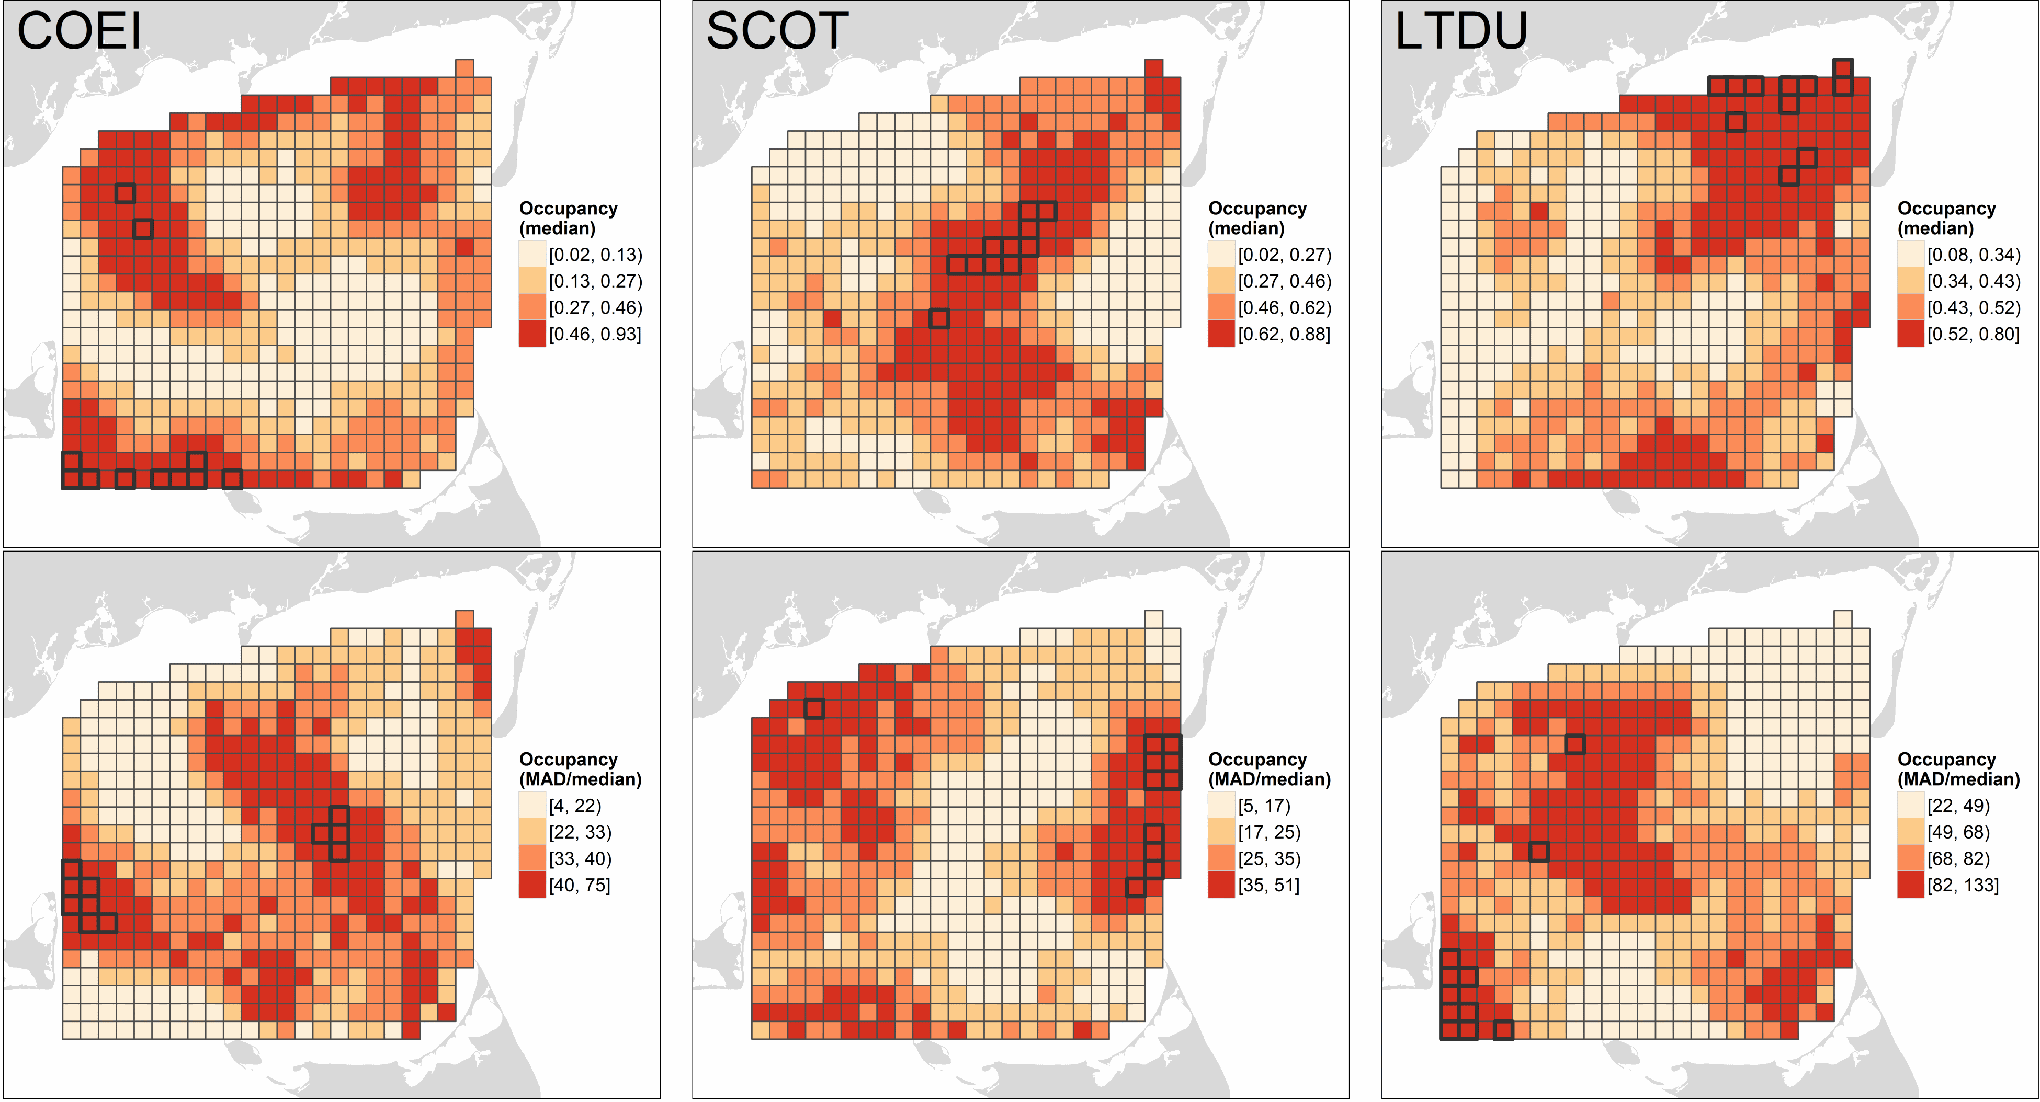
Figure 3. Occupancy estimates for sea ducks in Nantucket Sound: Common Eider (COEI), scoter (SCOT), and Long-tailed Duck (LTDU). Predictions (median [top row] and median absolute deviation, MAD, relative to median [%; bottom row]) were based on 10 dates evenly-spaced from 15 November through 1 April in three winters (2003 - 2005). Predicted values are categorized based on their quartiles; segments with predictions 98th percentile are outlined in black. Occupancy values indicate the expected probability of sea duck presence in a 1.5 km x ca. 180 m transect through a given segment.
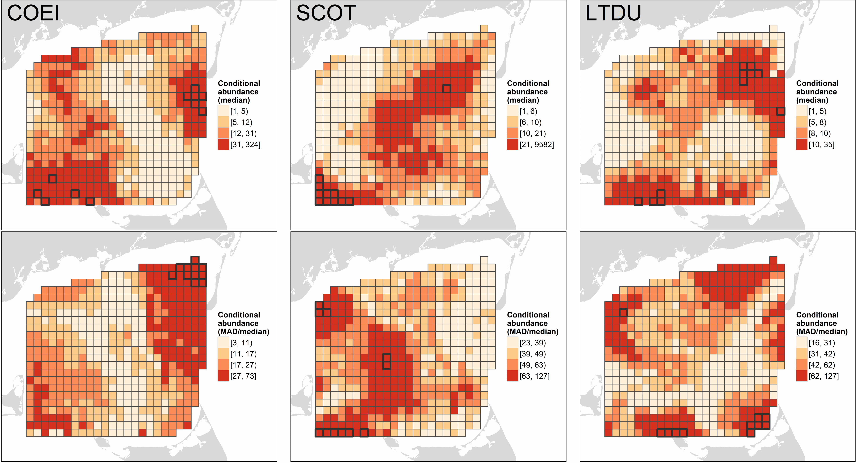
Figure 4. Conditional abundance estimates for sea ducks in Nantucket Sound: Common Eider (COEI), scoter (SCOT), and Long-tailed Duck (LTDU). Predictions (median [top row] and median absolute deviation, MAD, relative to median [%; bottom row]) were based on 10 dates evenly-spaced from 15 November through 1 April in three winters (2003 - 2005). Predicted values are categorized based on their quartiles; segments with predictions 98th percentile are outlined in black. Conditional abundance values indicate the expected number of sea ducks, assuming their presence, in a 1.5 km x ca. 180 m transect through a given segment.

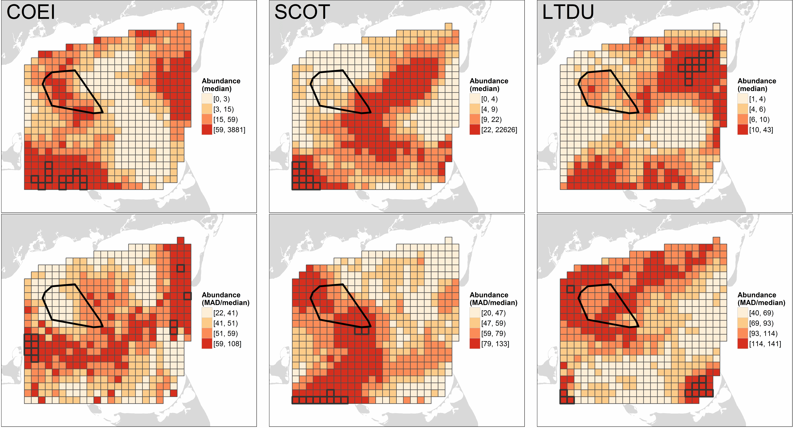
Figure 5. Unconditional abundance estimates for sea ducks in Nantucket Sound: Common Eider (COEI), scoter (SCOT), and Long-tailed Duck (LTDU). Predictions (median [top row] and median absolute deviation, MAD, relative to median [%; bottom row]) were based on 10 dates evenly-spaced from 15 November through 1 April in three winters (2003 - 2005). Predicted values are categorized based on their quartiles; segments with predictions 98th percentile are outlined in black. Abundance values indicate the expected number of sea ducks in a 1.5 km x ca. 180 m transect through a given segment. The polygon in the northwest corner of Nantucket Sound indicates the location of permitted wind energy development on Horseshoe Shoal.

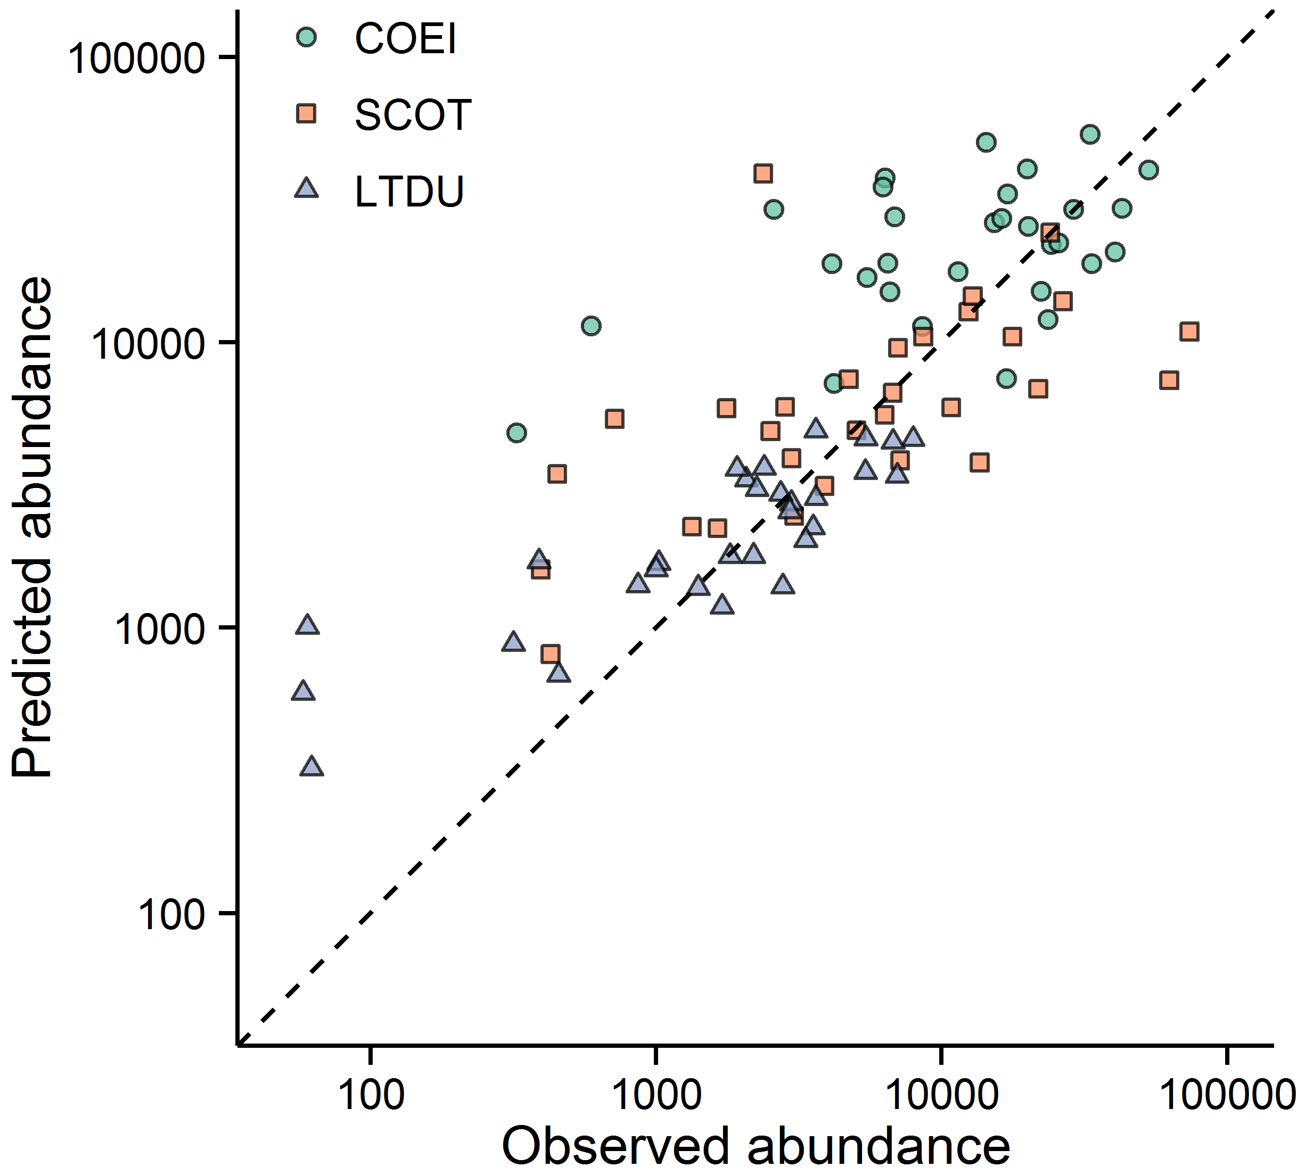
Figure 6. Relationship between observed and predicted total abundance of Common Eider (COEI), scoter (SCOT), and Long-tailed Duck (LTDU) during 30 aerial surveys of Nantucket Sound. The dashed line indicates a 1:1 relationship between predicted and observed abundances in surveyed segments; points below and above this line indicate underestimates and overestimates of predicted abundances, respectively.

Literature cited
Andrewartha, H. G., and L. C. Birch. 1986. The ecological web: More on the distribution and abundance of animals. University of Chicago Press, Chicago, Illinois, USA.
Austin, M. 2007. Species distribution models and ecological theory: A critical assessment and some possible new approaches. Ecological Modelling 200:1–19.
Benoit-Bird, K. J., B. C. Battaile, S. A. Heppell, B. Hoover, D. Irons, N. Jones, K. J. Kuletz, C. A. Nordstrom, R. Paredes, R. M. Suryan, C. M. Waluk, and A. W. Trites. 2013. Prey patch patterns predict habitat use by top marine predators with diverse foraging strategies. PLoS ONE 8:e53348.
Bertrand, S., R. Joo, C. Arbulu Smet, Y. Tremblay, C. Barbraud, and H. Weimerskirch. 2012. Local depletion by a fishery can affect seabird foraging. Journal of Applied Ecology 49:1168–1177.
Borchers, D. L., S. T. Buckland, and W. Zucchini. 2002. Estimating animal abundance: Closed populations. Springer, London.
Bowman, T. D., E. D. Silverman, S. G. Gilliland, and J. B. Leirness. 2015. Status and trends of North American sea ducks: Reinforcing the need for better monitoring. Pages 1–27 in J.-P. L. Savard, D. V. Derksen, D. Esler, and J. M. Eadie, editors. Ecology and Conservation of North American Sea Ducks. Studies in Avian Biology. CRC Press, New York, NY, USA.
Boyd, C., R. Castillo, G. L. Hunt, A. E. Punt, G. R. VanBlaricom, H. Weimerskirch, and S. Bertrand. 2015. Predictive modelling of habitat selection by marine predators with respect to the abundance and depth distribution of pelagic prey. Journal of Animal Ecology. XXX
Breton, S.-P. and G. Moe. 2009. Status, plans, and technology for offshore wind turbine in Europe and North America. Renewable Energy 34:646-654.
Buckland, S. T., M. L. Burt, E. A. Rexstad, M. Mellor, A. E. Williams, and R. Woodward. 2012. Aerial surveys of seabirds: The advent of digital methods. Journal of Applied Ecology 49:960–967.
Bühlmann, P., and T. Hothorn. 2007. Boosting algorithms: Regularization, prediction and model fitting. Statistical Science 22:477–505.
Certain, G., and V. Bretagnolle. 2008. Monitoring seabirds population in marine ecosystem: The use of strip-transect aerial surveys. Remote Sensing of Environment 112:3314–3322.
Cervencl, A., and S. Alvarez Fernandez. 2012. Winter distribution of Greater Scaup aythya marila in relation to available food resources. Journal of Sea Research 73:41–48.
Cervencl, A., K. Troost, E. Dijkman, M. de Jong, C. J. Smit, M. F. Leopold, and B. J. Ens. 2014. Distribution of wintering Common Eider somateria mollissima in the Dutch Wadden Sea in relation to available food stocks. Marine Biology 162:153–168.
Cunningham, R. B., and D. B. Lindenmayer. 2005. Modeling count data of rare species: Some statistical issues. Ecology 86:1135–1142.
Davis, J., W.E. 1997. He Nantucket oldsquaw flight: New England’s greatest bird show? Bird Observer 25:16–22.
Drewitt, A. L., and R. H. W. Langston. 2006. Assessing the impacts of wind farms on birds. Ibis 148:29–42.
Douvere, F. 2008. The importance of marine spatial planning in advancing ecosystem-based sea use management. Marine Policy 32:762-771.
Eilers, P. H. C., and B. D. Marx. 1996. Flexible smoothing with B-splines and penalties (with discussion). Statistical Science 11:89–121.
Flanders, N. P., B. Gardner, K. J. Winiarski, P. W. C. Paton, T. Allison, and A. O’Connell. 2015. Using a community occupancy model to identify key seabird areas in southern New England. Marine Ecology Progress Series 533: 277-290.
Flint, P. L. 2013. Changes in size and trends of North American sea duck populations associated with North Pacific oceanic regime shifts. Marine Biology 160:59–65.
Garthe, S., N. Markones, O. Hppop, and S. Adler. 2009. Effects of hydrographic and meteorological factors on seasonal seabird abundance in the southern North Sea. Marine Ecology Progress Series 391:243–255.
Grémillet, D., S. Lewis, L. Drapeau, C. D. Van Der Lingen, J. A. Huggett, J. C. Coetzee, H. M. Verheye, F. Daunt, S. Wanless, and P. G. Ryan. 2008. Spatial match–mismatch in the Benguela upwelling zone: Should we expect chlorophyll and sea-surface temperature to predict marine predator distributions? Journal of Applied Ecology 45:610–621.
Halpern, B. S., S. Walbridge, K. A. Selkoe, C. V. Kappel, F. Micheli, C. D’Agrosa, J. F. Bruno, K. S. Casey, C. Ebert, H. E. Fox, R. Fujita, D. Heinemann, H. S. Lenihan, E. M. P. Madin, M. T. Perry, E. R. Selig, M. Spalding, R. Steneck, and R. Watson. 2008. A global map of human impact on marine ecosystems. Science 319:948–952.
Hastie, T. J., and R. J. Tibshirani. 1990. Generalized additive models. CRC Press, Boca Raton, FL, USA.
Hofner, B., and T. Hothorn. 2015. Stabs: Stability selection with error control, R package version 0.5-1.
Hofner, B., L. Boccuto, and M. Göker. 2015a. Controlling false discoveries in high-dimensional situations: Boosting with stability selection. BMC Bioinformatics in press.
Hofner, B., T. Hothorn, T. Kneib, and M. Schmid. 2011. A framework for unbiased model selection based on boosting. Journal of Computational and Graphical Statistics 20:956–971.
Hofner, B., A. Mayr, and M. Schmid. 2014a. gamboostLSS: An R package for model building and variable selection in the GAMLSS framework.
Hofner, B., A. Mayr, N. Fenske, and M. Schmid. 2015b. gamboostLSS: Boosting methods for GAMLSS models, R package version 1.1-3.
Hofner, B., A. Mayr, N. Robinzonov, and M. Schmid. 2014b. Model-based boosting in R: A hands-on tutorial using the R package mboost. Computational Statistics 29:3–35.
Hothorn, T., P. Buehlmann, T. Kneib, M. Schmid, and B. Hofner. 2015. Mboost: Model-based boosting, R package version 2.4-2.
Hothorn, T., P. Bühlmann, T. Kneib, M. Schmid, and B. Hofner. 2010. Model-based boosting 2.0. Journal of Machine Learning Research 11:2109–2113.
Hyrenbach, K. D., K. A. Forney, and P. K. Dayton. 2000. Marine protected areas and ocean basin management. Aquatic Conservation: Marine and Freshwater Ecosystems 10:437–458.
Kaiser, M. J., M. Galanidi, D. A. Showler, A. J. Elliott, R. W. G. Caldow, E. I. S. Rees, R. A. Stillman, and W. J. Sutherland. 2006. Distribution and behaviour of Common Scoter melanitta nigra relative to prey resources and environmental parameters. Ibis 148:110–128.
Katz, R. W., G. S. Brush, and M. B. Parlange. 2005. Statistics of extremes: Modeling ecological disturbances. Ecology 86:1124–1134.
Kearney, M., and W. Porter. 2009. Mechanistic niche modelling: Combining physiological and spatial data to predict species’ ranges. Ecology Letters 12:334–350.
Kinlan, B., C. Menza, and F. Huettmann. 2012. Chapter 6: Predictive modeling of seabird distribution patterns in the New York Bight. Pages 87–224 in C. Menza, B. Kinlan, D. Dorfman, M. Poti, and C. Caldow, editors. A biogeographic assessment of seabirds, deep sea corals and ocean habitats of the New York Bight: Science to support offshore spatial planning. NOAA Technical Memorandum NOS NCCOS 141. NOAA, Silver Spring, MD.
Kirk, M., D. Esler, S. A. Iverson, and W. S. Boyd. 2008. Movements of wintering Surf Scoters: Predator responses to different prey landscapes. Oecologia 155:859–867.
Kneib, T., T. Hothorn, and G. Tutz. 2009. Variable selection and model choice in geoadditive regression models. Biometrics 65:626–634.
Kneib, T., J. Müller, and T. Hothorn. 2008. Spatial smoothing techniques for the assessment of habitat suitability. Environmental and Ecological Statistics 15:343–364.
Langston, R. H. W. 2013. Birds and wind projects across the pond: A UK perspective. Wildlife Society Bulletin 37:5–18.
Larsen, J. K., and M. Guillemette. 2000. Influence of annual variation in food supply on abundance of wintering common eiders Somateria mollissima. Marine Ecology Progress Series 201:301-309.
Larsen, J. K., and M. Guillemette. 2007. Effects of wind turbines on flight behaviour of wintering common eiders: Implications for habitat use and collision risk. Journal of Applied Ecology 44:516–522.
Logerwell, E. A., and N. B. Hargreaves. 1996. The distribution of sea birds relative to their fish prey off Vancouver Island: Opposing results at large and small spatial scales. Fisheries Oceanography 5:163–175.
Lovvorn, J. R., J. M. Grebmeier, L. W. Cooper, J. K. Bump, and S. E. Richman. 2009. Modeling marine protected areas for threatened eiders in a climatically changing Bering Sea. Ecological Applications 19: 1596-1613.
Loring, P. H., P. W. C. Paton, S. R. McWilliams, R. A. McKinney, and C. A. Oviatt. 2013. Densities of wintering scoters in relation to benthic prey assemblages in a North Atlantic estuary. Waterbirds 36:144–155.
Lotze, H. K., H. S. Lenihan, B. J. Bourque, R. H. Bradbury, R. G. Cooke, M. C. Kay, S. M. Kidwell, M. X. Kirby, C. H. Peterson, and J. B. C. Jackson. 2006. Depletion, degradation, and recovery potential of estuaries and coastal seas. Science 312:1806–1809.
MacArthur, R. H. 1972. Geographical ecology: Patterns in the distribution of species. Joanna Cotler Books, New York, NY, USA.
Maloney, K. O., M. Schmid, and D. E. Weller. 2012. Applying additive modelling and gradient boosting to assess the effects of watershed and reach characteristics on riverine assemblages. Methods in Ecology and Evolution 3:116–128.
Marsh, H., and D. F. Sinclair. 1989. Correcting for visibility bias in strip transect aerial surveys of aquatic fauna. The Journal of Wildlife Management 53:1017–1024.
Martin, T. G., B. A. Wintle, J. R. Rhodes, P. M. Kuhnert, S. A. Field, S. J. Low-Choy, A. J. Tyre, and H. P. Possingham. 2005. Zero tolerance ecology: Improving ecological inference by modelling the source of zero observations. Ecology Letters 8:1235–1246.
Maurer, B. A. 1999. Untangling ecological complexity: The macroscopic perspective. University Of Chicago Press, Chicago, Illinois, USA.
Mayr, A., N. Fenske, B. Hofner, T. Kneib, and M. Schmid. 2012. Generalized additive models for location, scale and shape for high-dimensional data - a flexible approach based on boosting. Journal of the Royal Statistical Society: Series C (Applied Statistics) 61:403–427.
Megrey, B. A., K. A. Rose, R. A. Klumb, D. E. Hay, F. E. Werner, D. L. Eslinger, and S. L. Smith. 2007. A bioenergetics-based population dynamics model of Pacific herring (clupea harengus pallasi) coupled to a lower trophic level nutrient–phytoplankton–zooplankton model: Description, calibration, and sensitivity analysis. Ecological Modelling 202:144–164.
Meinshausen, N., and P. Bühlmann. 2010. Stability selection (with discussion). Journal of the Royal Statistical Society: Series B (Statistical Methodology) 72:417–473.
Musial, W. and R. Ram. 2010. Large-scale offshore wind power in the United States: assessment of opportunities and barriers. NREL/LP-500-40745. National Renewable Energy Laboratory, Golden, Colorado.
Nagelkerke, N. J. D. 1991. A note on a general definition of the coefficient of determination. Biometrika 78:691–692.
Nur, N., J. Jahncke, M. P. Herzog, J. Howar, K. D. Hyrenbach, J. E. Zamon, D. G. Ainley, J. A. Wiens, K. Morgan, L. T. Ballance, and D. Stralberg. 2011. Where the wild things are: Predicting hotspots of seabird aggregations in the California Current System. Ecological Applications 21:2241–2257.
Oppel, S., A. N. Powell, and D. L. Dickson. 2009. Using an algorithmic model to reveal individually variable movement decisions in a wintering sea duck. Journal of Animal Ecology 78:524–531.
Ortega Cisneros, K., A. J. Smit, J. Laudien, and D. S. Schoeman. 2011. Complex, dynamic combination of physical, chemical and nutritional variables controls spatio-temporal variation of sandy beach community structure. PLoS ONE 6:e23724.
Pollock, K. H., H. D. Marsh, I. R. Lawler, and M. W. Alldredge. 2006. Estimating animal abundance in heterogeneous environments: An application to aerial surveys for dugongs. Journal of Wildlife Management 70:255–262.
Punt, M. J., R. A. Groeneveld, E. C. van Ierland, and J. H. Stel. 2009. Spatial planning of offshore wind farms: a windfall to marine environmental protection? Ecological Economics 69:93-103.
R Core Team. 2014. R: A language and environment for statistical computing. R Foundation for Statistical Computing, Vienna, Austria.
Richards, S. A. 2008. Dealing with overdispersed count data in applied ecology. Journal of Applied Ecology 45:218–227.
Rigby, R. A., and D. M. Stasinopoulos. 2005. Generalized additive models for location, scale and shape (with discussion). Journal of the Royal Statistical Society: Series C (Applied Statistics) 54:507–554.
Robinson, L. M., J. Elith, A. J. Hobday, R. G. Pearson, B. E. Kendall, H. P. Possingham, and A. J. Richardson. 2011. Pushing the limits in marine species distribution modelling: Lessons from the land present challenges and opportunities. Global Ecology and Biogeography 20:789–802.
Rose, G. A., and W. C. Leggett. 1990. The importance of scale to predator-prey spatial correlations: An example of Atlantic fishes. Ecology 71:33–43.
Schmid, M., and T. Hothorn. 2008. Boosting additive models using component-wise P-splines. Computational Statistics & Data Analysis 53:298–311.
Scott-Hayward, L. a. S., M. L. Mackenzie, C. R. Donovan, C. G. Walker, and E. Ashe. 2013. Complex region spatial smoother (CReSS). Journal of Computational and Graphical Statistics 23:340–360.
Shah, R. D., and R. J. Samworth. 2013. Variable selection with error control: Another look at stability selection. Journal of the Royal Statistical Society: Series B (Statistical Methodology) 75:55–80.
Silverman, E. D., D. T. Saalfeld, J. B. Leirness, and M. D. Koneff. 2013. Wintering sea duck distribution along the Atlantic Coast of the United States. Journal of Fish and Wildlife Management 4:178–198.
Smolik, M., S. Dullinger, F. Essl, I. Kleinbauer, M. Leitner, J. Peterseil, L.-M. Stadler, and G. Vogl. 2010. Integrating species distribution models and interacting particle systems to predict the spread of an invasive alien plant. Journal of Biogeography 37:411–422.
Torres, L. G., A. J. Read, and P. Halpin. 2008. Fine-scale habitat modeling of a top marine predator: Do prey data improve predictive capacity. Ecological Applications 18:1702–1717.
Vaitkus, G., and A. Bubinas. 2001. Modelling of sea duck spatial distribution in relation to food resources in Lithuanian offshore waters under the gradient of winter climatic conditions. Acta Zoologica Lituanica 11:288–302.
White, T. P., R. R. Veit, and M. C. Perry. 2009. Feeding ecology of Long-Tailed Ducks clangula hyemalis wintering on the Nantucket Shoals. Waterbirds 32:293–299.
Winiarski, K. J., D. L. Miller, P. W. Paton, and S. R. McWilliams. 2014. A spatial conservation prioritization approach for protecting marine birds given proposed offshore wind energy development. Biological Conservation 169:79–88.
Wood, S. N. 2006. Generalized additive models: An introduction with R. Chapman; Hall/CRC, Boca Raton, FL, USA.
Zeileis, A., C. Kleiber, and S. Jackman. 2008. Regression models for count data in R. Journal of Statistical Software 27:1–25.
Zipkin, E. F., B. Gardner, A. T. Gilbert, A. F. O. Jr, J. A. Royle, and E. D. Silverman. 2010. Distribution patterns of wintering sea ducks in relation to the North Atlantic Oscillation and local environmental characteristics. Oecologia 163:893–902.
Žydelis, R., D. Esler, M. Kirk, and W. Sean Boyd. 2009. Effects of off-bottom shellfish aquaculture on winter habitat use by molluscivorous sea ducks. Aquatic Conservation: Marine and Freshwater Ecosystems 19:34–42.

