Laboratory Report - Image Recognition

Course: SGN-26006 Advanced Signal Processing

Assignment no. 6: Image Recognition

Authors: Adam Ligocki, Amir Salah

Measured: 10th of December, 2018

# Task

Get familiar with modern convolutional neural network techniques and create simple video-based application that will be able to classify the smiling and non-smiling faces.

Implementation should be done in python and neural network should be implemented using Keras framework on TensorFlow backend.

As a training set the MPLab GENKI dataset should be used. This dataset contains 4000 labeled face images divided proximately half by half to smiling and non-smiling classes.

# Solution

## Architecture

We have designed the 7-layer neural network. It contains six 2Dconvolutional layers, each layer is batch-normalized and the with the Relu activation function on the output. Every second layer is ended by max pooling with pooling size 2.

The final layer is fully connected one with softmax output into one-hot-end encoding two class output.

Conv 2D  
64x64x16

Conv 2D  
62x62x32

Batch Norm

Max Pool - DropOut

Batch Norm

Conv 2D  
30x30x32

Conv 2D  
28x28x64

Batch Norm

Max Pool - DropOut

Batch Norm

Conv 2D  
13x13x64

Conv 2D  
11x11x128

Batch Norm

Max Pool - DropOut

Batch Norm

FC layer - 128

FC layer - 2

Figure 1 - Used neural network architecture

The dropout rate was used 0.5 and all convolutional kernels was of size 3x3 pixels.

## Dataset

As a learning data the MPLab GENKI dataset has been used. It contains 2162 smiling images and 1838 non-smiling ones. Also, the data are sorted by classes in the dataset, so before the learning it needs to be randomly shuffled.

For better results the images has been normalized in range of <0,1> and also the Keras's build in data generator has been used to create wide range of different image augmentations which helps reach better learning results.

Figure 2 - Example of images from MPLab GENK dataset



As and augmentation the random rotation of 45deg has been used as well as wide and height shift of 20% of image size, the horizontal image flip and brightness adjustment in range <0.5, 1.2>.

The required output classifying has been mapped into one-hot-encoding format.

## Learning

The learning process has been realized by Keras's inbuilt fit function for sequential model.

For scoring the binominal classification problem we have used binary cross entropy loss function and learning has been driven by Adadelta optimizer with initial parameters of learning rate = 1, rho = 0.95 and decay = 0.

The learning parameters has been chosen 32 batch size and 50 epochs.

Also, the terminating condition has been set to end up learning after reaching 90% accuracy.

The dataset has been spitted during the learning into learning and validation subsets by ratio 3000:500. Last 500 images have been used for testing.

Figure 3 - Learning process. 50 epochs

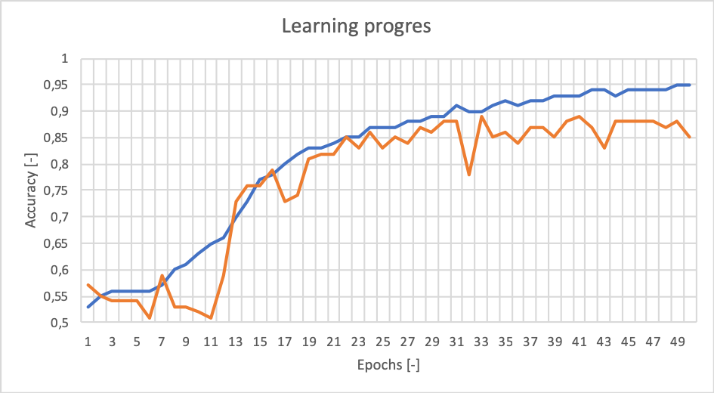

# Results and Video processing

First testing has been done on 500 test images. Every image has been putted into neural network and the output has been compared with image label. As a result, we get following confusion matrix.

|  |  |  |
| --- | --- | --- |
| Pred. / Ground True | Smiling | Non-Smiling |
| Smiling | 200 | 29 |
| Non-Smiling | 25 | 246 |

Table - Confusion matrix of learned neural network testing

The final validation of the trained neural network has been done on short video sequence taken by mobile phone.

This video has been loaded by opencv's VideoCapture API. The region of interest which contains the face has been cutted out from the video and results image has been slightly blurred and resized into 64x64px format.

Finally, 24 pre-labeled randomly selected images from video sequence has been putted into neural network with final accuracy of 83%.

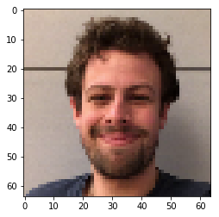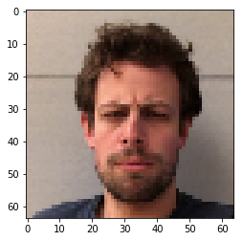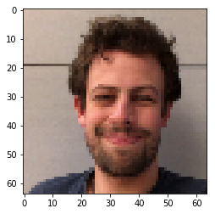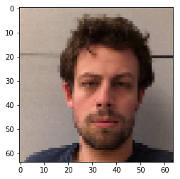

Figure 4 - Example of different reslts of NN "SMILE" calssification. From left folows: True Positive, True Negative, False Positive and False Negative

# Conclusion

For this assignment we have successfully designed and trained convolutional neural network for classifying smiling and non-smiling faces. Our network consists 6 convolutional layers combined with batch normalization, dropout and max pooling layers. The output is finalized with two fully connected layers. Output is in one-hot-encoding format.

We have trained this network on 3000 labeled images, validation was done on 500 images and for final testing the 500 images have been used.

The test results give us 89.2% accuracy.

Finally, network has been tested on our own video sequence with 83% accuracy.