AI notes: UMJ Weekly Meeting on Jul 2, 2026
Participants: Mind Suthinee, Adam Foo (Second PIC, PD – PM), Adeline Hiew (Main PIC, PD – PM ), Merlin Tsai (PD – PM), Steason Tee Qi Shern (PD – PM)
Summary
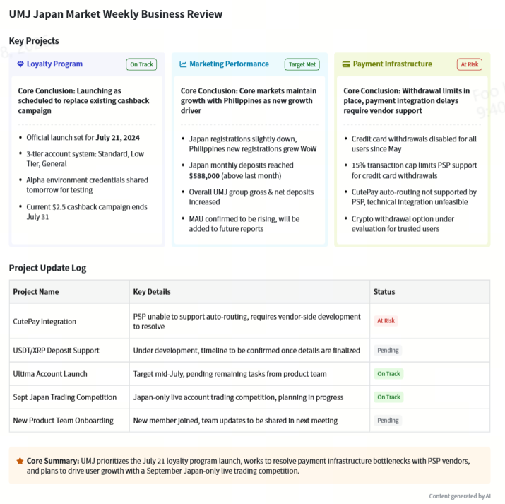
• Loyalty Program Plans​
◦ Launch Details: Terry confirmed a likely July 21 launch with possible amendments notified by the next day. Credentials will be sent for system checks.​
◦ Account Tiers: It will have three tiers standard low tier and general with regional differences visible.​
• Bit Team Progress​
◦ Key Tasks: Japanese language support will cover the entire Ultima platform. Self rebate on IV’s own trading account will be restricted for UMJ regions. The Ultima account landing page is in progress with a mid July target pending product team tasks. US ETH and XRP deposit development is ongoing with no set timeline.​
◦ QPay Issue: PSP cannot support auto routing and bit team cannot integrate all providers. Kevin will ask the target partner to allocate members to assist with integrations.​
• Product Team Status​
◦ New Member Update: New product team member Foo has no updates yet but will clarify with the team later.​
◦ Ultima Account IB Rebate: Mind is coordinating with Adeline and Derek for the launch which is expected on time.​
• CS Updates​
◦ June Metrics: Main contact reasons were deposits and local bank transfers.​
◦ Withdrawal Issue: Credit card withdrawal is unavailable for all users due to a 15 percent transaction cap. Clients are told it is default instead of under maintenance. Crypto withdrawal is being considered for users unable to use bank transfers but carries money laundering risks.​
• Other Updates​
◦ IB Activation: Shoto noted slight deposit growth from a new middle level IB.​
◦ Future Plan: Kevin proposed a Japan focused live trading competition in September.

Action items​
- Add MAU data: Replace DAU with MAU in the marketing data presentation materials, include the MAU data that is inferred to have increased along with the growth deposit, and present it in the next marketing data update.
- Inform about program amendments: Send everyone the credential to access the system for checking the loyalty program's features and design, and inform everyone of any loyalty program launch amendments by tomorrow.​
- Send program credentials: Send the loyalty program system credentials to all meeting participants by tomorrow, enabling them to check the program's features and design; inform everyone promptly if there are any amendments to the planned 21st of July launch date.​
- provide alpha environment: Deliver the alpha environment by tomorrow to all relevant team members so they can check and test the 3 - tier loyalty program that is scheduled to launch around July 21.​
- confirm development timeline: Confirm the development timeline for the US ETH deposit and XRP deposit requirements raised by UM2 and Jimmy, and share the confirmed information with the relevant team members in a timely manner.
- Request PSP auto-routing enhancement: Ask the target partner's PSP to enhance auto-routing for QPay integration, connect nicely to their providers first to reduce heavy integration workload, and support the launch without unstable user experience issues. ​​
- Create cashback campaign notifications: Prepare email notifications and update the t and seats for the current cashback campaign’s end by the end of July, since the royalty program will launch on July 24 and the cashback campaign needs to conclude then.​
- share product feedback: Collect specific feedback about trading slippage and trading city page from Allen, then share the collected feedback with the entire team to keep the team informed of relevant product service situations. ​​
- Plan live trading competition: Organize a UMJ Japan live trading account competition in September, with a one-month duration. The competition is proposed due to the loyalty program launching at the end of July and user acquisition in August, and coordinate with Bobo Tsang to confirm the schedule feasibility.
- clarify product update: Get clarification on product updates from the product team, then get back to Mind Suthinee with the relevant information since no product updates were available due to recent company joining.​
- Update crypto withdrawal whitelist progress: Share the latest progress of the crypto withdrawal whitelist initiative with all meeting attendees, including related discussions with the bid team and Terry Lim’s upcoming ETL update.

