**Knowledge and Theory: SQL**

**Part 1 – Basic Select Statements:**

|  |
| --- |
| SELECT <one or more attributes or columns>  FROM <one or more relations or tables>  SELECT <one or more attributes or columns>  FROM <one or more relations or tables>  WHERE <conditions>  **Note:** You can use * to specify all columns.  **Condition Example:** If you have an attribute called ‘age’, a condition could be “age >= 18”. |

**Part 2 – Order Results:**

Get all the veteran (age over 30) players on the USA team roster, who are starters.

Of these players, get their name, number and team and order these results on age and then salary for those with the same age.

SELECT name, number, team

FROM TeamUsaRoster

WHERE role =‘starter’ AND age > 30

ORDER BY age, name

The way to interpret this information and be ready to write your query is;

1. Figure out what the table is. Which table is this information being searched from.
2. What records (rows) in this table are we retrieving? What is the condition?
3. Now that we retreived the correct row, which attributes of this row? A

**Part 3 – Insert and Delete:**

INSERT INTO USATeam

SELECT name

FROM NBARoster

WHERE (ppg >= 25) Product)

DELETE FROM Cavaliers

WHERE firstname = ‘Kyrie’ AND

lastname = ‘Irving’

**Part 4 – Joins**

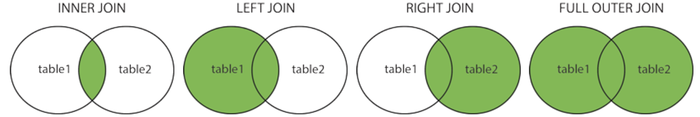

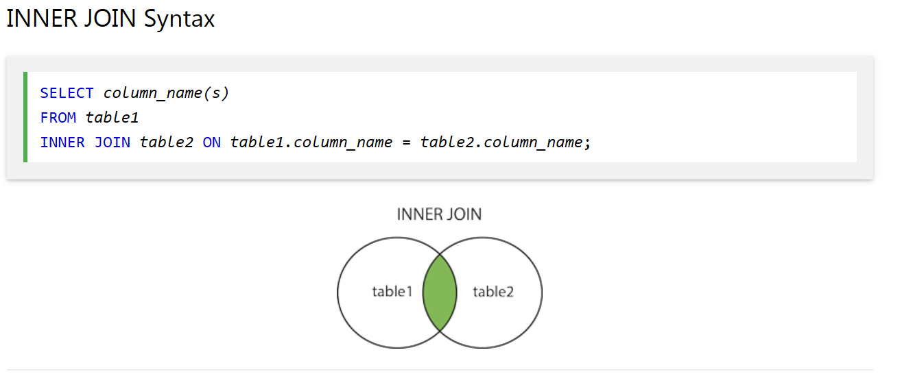

|  |
| --- |
| **SELECT** firstname, lastname  **FROM** USATeamPlayers  **INNER JOIN** CavaliersPlayers **ON** CavalierPlayers.playerId = CavalierPlayers.playerId  This would get the players on with the same player id on the USA team and the Cavs. Left Join would be any player on the (USA team but not cavaliers) or (Cavaliers and USA team). Right join would be any player on the (Cavaliers but not USA) or (Cavaliers and USA). Full Outer join would do players on cavaliers or usa but avoids duplicates for players on both. |