Supplementary Table. Correlation, OLS regression, and MLM results for primary analyses (Analyses 01-05).
p-values are one-tailed for directional hypotheses (Analyses 01-05) and two-tailed otherwise. * p < .05, ** p < .01, *** p < .001.
Analysis | Predictor | Outcome | N | r | r p | OLS t | OLS p | MLM z | MLM p
Analysis 01: Age -> Daily Affect | Age (Project 2) | Positive affect (diary) | 1174 | 0.145 | 0.000*** | 4.79 | 0.000*** | 4.91 | 0.000***
Analysis 01: Age -> Daily Affect | Age (Project 2) | Negative affect (diary) | 1174 | -0.111 | 0.000*** | -4.24 | 0.000*** | -4.07 | 0.000***
Analysis 01: Age -> Daily Affect | Age (Project 2) | Negative affect, log (diary) | 1174 | -0.147 | 0.000*** | -5.33 | 0.000*** | -5.28 | 0.000***
Analysis 02: Persistence -> Daily Affect | Neg. persistence, left amygdala | Positive affect (diary) | 80 | -0.276 | 0.007** | -2.37 | 0.010* | -1.75 | 0.040*
Analysis 02: Persistence -> Daily Affect | Neg. persistence, left amygdala | Negative affect (diary) | 80 | 0.234 | 0.019* | 2.77 | 0.004** | 2.29 | 0.011*
Analysis 02: Persistence -> Daily Affect | Neg. persistence, left amygdala | Negative affect, log (diary) | 80 | 0.134 | 0.118 | 1.71 | 0.046* | 1.36 | 0.088
Analysis 03: Age -> Persistence | Age (Project 5) | Neg. persistence, left amygdala | 128 | -0.114 | 0.100 | -0.37 | 0.357 | -1.23 | 0.110
Analysis 04: FC -> Daily Affect | Left amygdala-ant. vmPFC FC | Positive affect (diary) | 80 | 0.157 | 0.083 | 2.17 | 0.017* | 1.51 | 0.066
Analysis 04: FC -> Daily Affect | Left amygdala-ant. vmPFC FC | Negative affect (diary) | 80 | -0.186 | 0.050* | -1.68 | 0.049* | -2.89 | 0.002**
Analysis 04: FC -> Daily Affect | Left amygdala-ant. vmPFC FC | Negative affect, log (diary) | 80 | -0.204 | 0.034* | -1.73 | 0.045* | -1.94 | 0.026*
Analysis 04: FC -> Daily Affect | Left amygdala-post. vmPFC FC | Positive affect (diary) | 80 | 0.112 | 0.162 | 0.79 | 0.215 | -0.79 | 0.784
Analysis 04: FC -> Daily Affect | Left amygdala-post. vmPFC FC | Negative affect (diary) | 80 | -0.164 | 0.073 | -0.82 | 0.206 | -1.18 | 0.119
Analysis 04: FC -> Daily Affect | Left amygdala-post. vmPFC FC | Negative affect, log (diary) | 80 | -0.207 | 0.033* | -1.11 | 0.137 | -1.53 | 0.063
Analysis 05: FC -> Persistence | Left amygdala-ant. vmPFC FC | Neg. persistence, left amygdala | 128 | 0.103 | 0.876 | 0.93 | 0.823 | 1.19 | 0.882
Analysis 05: FC -> Persistence | Left amygdala-post. vmPFC FC | Neg. persistence, left amygdala | 128 | 0.011 | 0.551 | 0.21 | 0.582 | 0.24 | 0.595

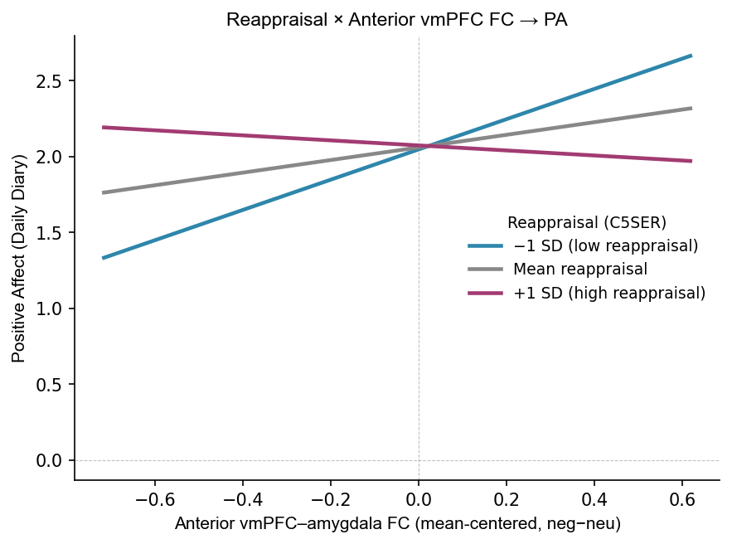
Supplementary Figure 1. Simple slopes suggest the relationship between vmPFC-amygdala task connectivity in response to negative images (compared to neutral) is attenuated in individuals that are high in reappraisal use.

