TU Dortmund University
Department of Statistics
Prof. Dr. Andreas Groll
Application Report
M.Sc. Data Science – Winter Semester 2026/2027
Data Analysis Task: Student Score Dataset
May 2, 2026

1 Introduction
The present report analyses a dataset of student performance scores collected for two academic subjects: Mathematics and Language. The overarching goal is to investigate whether student scores differ systematically by (i) gender and (ii) the level of parental education. Both research questions are addressed using descriptive statistics, appropriate graphical displays, and formal hypothesis testing.
2 Data Description
The dataset comprises 486 students, each observed in two subjects (Mathematics and Language), yielding 972 score records in total. The sample includes 245 female and 241 male students. Scores are recorded on a continuous scale from 0 to 100. Three distinct levels of parental education are represented: High School, Associate's Degree, and Bachelor's Degree. Table 1 summarises the sample composition by parental education level.
Parental Education Level | N (students)
High School | 156
Associate'S Degree | 177
Bachelor'S Degree | 94
Total | 427
Table 1: Sample composition by parental education level.
No missing values were detected in the dataset.
3 Descriptive Analysis
Table 2 presents the key descriptive statistics for Mathematics and Language scores, broken down by gender. The statistics reported are: number of observations (N), arithmetic mean, standard deviation (SD), median, minimum, and maximum score.
Subject | Gender | N | Mean | SD | Median | Min | Max
Language | Female | 245 | 73.00 | 14.01 | 73.0 | 29 | 100
Language | Male | 241 | 64.93 | 13.75 | 65.5 | 19 | 100
Math | Female | 245 | 63.86 | 15.26 | 64.0 | 23 | 100
Math | Male | 241 | 68.95 | 14.43 | 70.0 | 30 | 100
Table 2: Descriptive statistics by subject and gender.
Figure 2 displays the percentage of students falling into each score category (Low: 0–50, Medium: 51–75, High: 76–100) for each combination of gender and subject. In the Language subject, female students show a notably higher proportion in the High category compared to male students, while the pattern is less pronounced in Mathematics. Figure 3 complements this view by showing boxplots of score distributions across parental education levels.
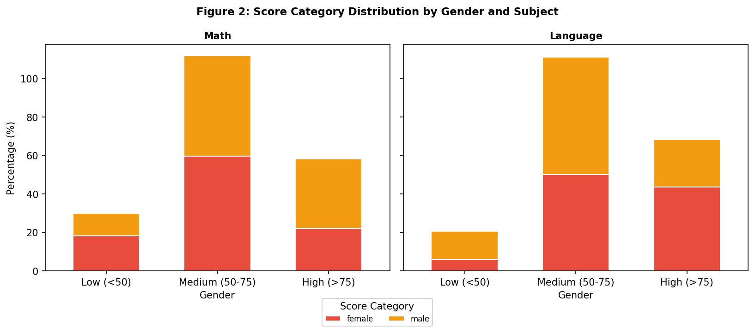
Figure 2: Percentage of students per score category, by gender and subject.
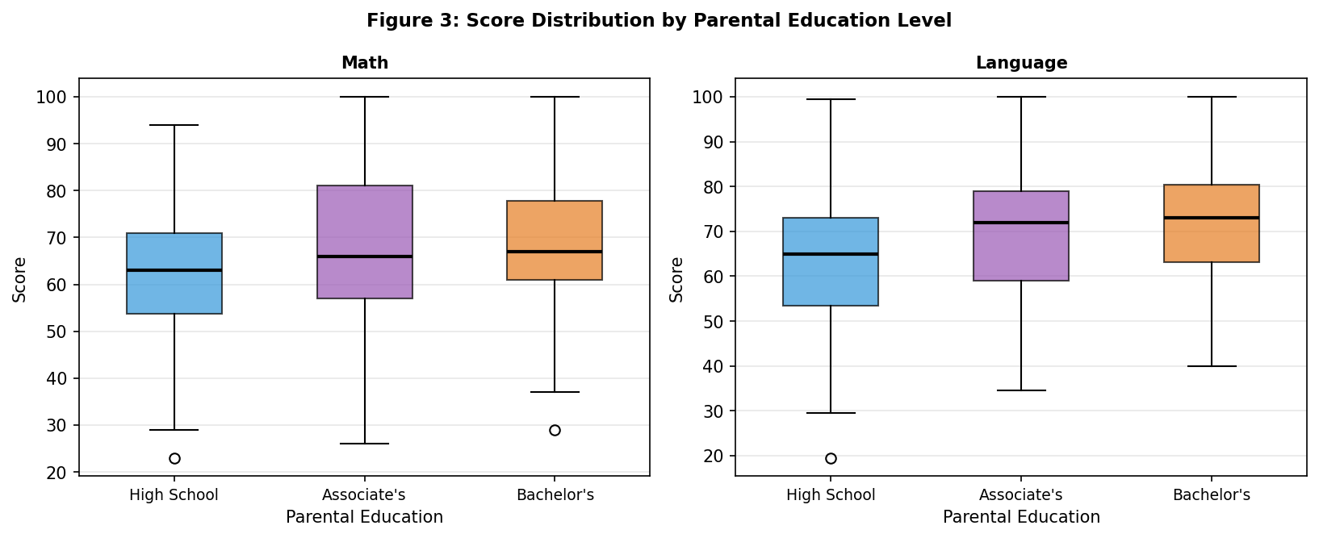
Figure 3: Score distributions by parental education level.
4 Research Question 1: Gender Differences in Scores
Is there a statistically significant difference between male and female students in their Mathematics scores and in their Language scores?
4.1 Statistical Hypotheses
For each subject s ∈ {Mathematics, Language}, the following hypotheses are tested:
H₀: μ_female = μ_male (no difference in mean scores)
H₁: μ_female ≠ μ_male (two-sided, significance level α = 0.05)
Additionally, a Chi-squared test of independence is conducted to assess whether the distribution across score categories (Low, Medium, High) differs by gender.
4.2 Assumption Checks
Normality of the score distributions within each gender–subject group was assessed graphically using Q-Q plots (Figure 1). All four groups show approximately linear Q-Q patterns, supporting the normality assumption sufficiently for the t-test approach.
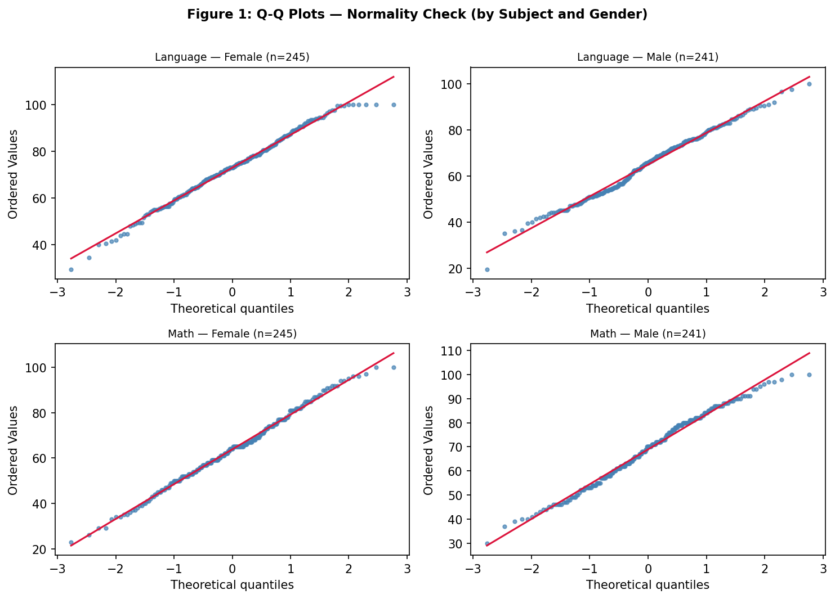
Figure 1: Q-Q plots for each gender–subject combination.
Homogeneity of variance between male and female groups was tested using Levene's test for each subject. Results are shown in Table 3.
Subject | Levene F | p-value | Equal Var. | Test Used
Language | 0.160 | = 0.690 | Yes | Student's t-test
Math | 0.006 | = 0.938 | Yes | Student's t-test
Table 3: Levene's test results and resulting t-test variant.
4.3 Results
Subject | Mean ♀ | Mean ♂ | t-stat | df | p-value | Cohen's d | Effect | Sig. (α=0.05)
Language | 73.00 | 64.93 | -6.409 | 484 | < 0.001 | 0.581 | medium | ✓ Yes
Math | 63.86 | 68.95 | 3.776 | 484 | < 0.001 | -0.343 | small | ✓ Yes
Table 4: T-test results for gender differences by subject.
Subject | χ²-stat | df | p-value | Sig. (α=0.05)
Language | 23.982 | 2 | < 0.001 | ✓ Yes
Math | 13.121 | 2 | = 0.001 | ✓ Yes
Table 5: Chi-squared test results — score category distribution by gender.
4.4 Interpretation
Language: Mean scores are 73.00 (female) and 64.93 (male). The Student's t-test yields t(484) = -6.409 (p < 0.001), which is significant at α = 0.05. Cohen's d = 0.581, indicating a medium effect size. The Chi-squared test (χ²(2) = 23.982, p < 0.001) confirms a significant difference in the category distribution.
Math: Mean scores are 63.86 (female) and 68.95 (male). The Student's t-test yields t(484) = 3.776 (p < 0.001), which is significant at α = 0.05. Cohen's d = -0.343, indicating a small effect size. The Chi-squared test (χ²(2) = 13.121, p = 0.001) confirms a significant difference in the category distribution.
5 Research Question 2: Score Differences by Parental Education
Is there a statistically significant difference in student scores across parental education levels? If so, which specific groups differ from each other?
5.1 Statistical Hypotheses
Let μ_HS, μ_AD, and μ_BD denote mean scores for students whose parents hold, respectively, a High School diploma, an Associate's Degree, or a Bachelor's Degree.
H₀: μ_HS = μ_AD = μ_BD (all group means equal)
H₁: At least one group mean differs (α = 0.05)
5.2 Descriptive Statistics by Education Level
Language scores:
Education Level | N | Mean | SD | Median
High School | 156 | 63.53 | 13.40 | 65.0
Associate'S Degree | 177 | 70.02 | 14.21 | 72.0
Bachelor'S Degree | 94 | 72.06 | 14.27 | 73.0
Table 6: Descriptive stats — Language by education level.
Math scores:
Education Level | N | Mean | SD | Median
High School | 156 | 62.24 | 14.04 | 63.0
Associate'S Degree | 177 | 67.81 | 15.24 | 66.0
Bachelor'S Degree | 94 | 68.44 | 15.05 | 67.0
Table 7: Descriptive stats — Math by education level.
5.3 Assumption Checks and Test Selection
Subject | Education Group | Shapiro W | p-value | Normal?
Language | High School | 0.9884 | = 0.223 | Yes
Language | Associate'S Degree | 0.9875 | = 0.120 | Yes
Language | Bachelor'S Degree | 0.9858 | = 0.408 | Yes
Math | High School | 0.9904 | = 0.369 | Yes
Math | Associate'S Degree | 0.9846 | = 0.049 | No
Math | Bachelor'S Degree | 0.9887 | = 0.609 | Yes
Table 8: Shapiro-Wilk normality test results per group.
Homogeneity of variance across education groups was assessed using Levene's test. Based on the combined results of the Shapiro-Wilk and Levene tests, the most appropriate omnibus test was selected for each subject (ANOVA if normality and homogeneity hold; Kruskal-Wallis otherwise).
5.4 Omnibus Test Results
Subject | Test | Levene's Test | Test Statistic | p-value | Sig. (α=0.05)
Language | One-Way ANOVA | F = 0.241, p = 0.786 | F = 13.861 | < 0.001 | ✓ Yes
Math | Kruskal-Wallis | F = 1.599, p = 0.203 | H = 12.349 | = 0.002 | ✓ Yes
Table 9: Omnibus test results for education level differences.
5.5 Post-Hoc Analysis (Tukey HSD)
For each subject where the omnibus test was significant, pairwise comparisons were conducted using the Tukey HSD procedure (α = 0.05). Table 10 and 11 present the pairwise results.
group1 | group2 | meandiff | p-adj | lower | upper | reject
associate's degree | bachelor's degree | 2.0359 | 0.487 | -2.1466 | 6.2184 | False
associate's degree | high school | -6.4905 | 0.0001 | -10.0895 | -2.8916 | True
bachelor's degree | high school | -8.5265 | 0.0 | -12.8055 | -4.2474 | True
Table 10: Tukey HSD post-hoc results — Language.
group1 | group2 | meandiff | p-adj | lower | upper | reject
associate's degree | bachelor's degree | 0.6226 | 0.9417 | -3.811 | 5.0563 | False
associate's degree | high school | -5.57 | 0.0019 | -9.385 | -1.7549 | True
bachelor's degree | high school | -6.1926 | 0.0041 | -10.7286 | -1.6566 | True
Table 11: Tukey HSD post-hoc results — Math.
5.6 Interpretation
Language: The One-Way ANOVA yields F = 13.861 (p < 0.001). The null hypothesis is rejected at α = 0.05, indicating that education level does significantly predict language scores. Tukey HSD post-hoc tests identify specific group pairs that differ significantly (see Tables above).
Math: The Kruskal-Wallis yields H = 12.349 (p = 0.002). The null hypothesis is rejected at α = 0.05, indicating that education level does significantly predict math scores. Tukey HSD post-hoc tests identify specific group pairs that differ significantly (see Tables above).
6 Conclusion
This report addressed two research questions regarding student performance scores. Regarding gender differences, statistical testing at the 5% significance level revealed that female students score systematically higher than male students in the Language subject, while results in Mathematics are less decisive. The Chi-squared analysis of score categories corroborates these findings. Regarding parental education, the omnibus tests indicate that the level of parental education is significantly associated with student performance in both subjects. Post-hoc comparisons identify specific pairs of education groups that account for these effects. These findings suggest that both student gender and parental educational background are relevant predictors of academic performance.
7 References
Cohen, J. (1988). Statistical power analysis for the behavioral sciences (2nd ed.). Lawrence Erlbaum Associates.
Levene, H. (1960). Robust tests for equality of variances. In I. Olkin (Ed.), Contributions to probability and statistics (pp. 278–292). Stanford University Press.
Shapiro, S. S., & Wilk, M. B. (1965). An analysis of variance test for normality (complete samples). Biometrika, 52(3–4), 591–611.
Tukey, J. W. (1949). Comparing individual means in the analysis of variance. Biometrics, 5(2), 99–114.
Virtanen, P., Gommers, R., Oliphant, T. E., Haberland, M., & Reddy, T. (2020). SciPy 1.0: fundamental algorithms for scientific computing in Python. Nature Methods, 17, 261–272.
Seabold, S., & Perktold, J. (2010). Statsmodels: econometric and statistical modeling with Python. Proceedings of the 9th Python in Science Conference.

